Online Resource 1 for the article:
The future potential for wine production in Scotland under high-end climate change
(Submitted to the Journal of Regional Environmental Change)
Miriam Dunn¹, Mark D.A. Rounsevell^{1,3}, Fredrik Boberg², Elizabeth Clarke¹, Jens Christensen^{2,4}, Marianne S. Madsen²
1. Institute of Geography, School of Geosciences, University of Edinburgh, Edinburgh, UK.
2. Danish Meteorological Institute, Copenhagen, Denmark.
3. IMK-IFU, Karlsruhe Institute of Technology, Germany
4. Niels Bohr Institute, University of Copenhagen, Copenhagen, Denmark

Corresponding author: Dr. Miriam Dunn, email: miriam.dunn@ed.ac.uk

Further details of the method
We used Matlab to determine the analogues, but note that there are no true statistical functions included in the calculations. The calculations can be repeated using any statistics software as long as the HIRHAM data is used, including the orography and land sea mask files.
The map plots were made using the Matlab mapping toolbox and the worlddatamap function with the "eqdcylin" map projection. The elevation contours are made using the contourm function.
The following steps outline how the climate analogues were found using the HIRHAM5 data.
1. For each location: find the model grid point closest to the location (only looking at grid points on land of course)
2. For this grid point, calculate T (and P) for both RCP4.5 and RCP8.5 for the 3 scenario periods.
3. For each scenario value (6 in total), search for present day grid points with values close to the scenario value for the grid point in question. For temperature, "close to" means within 0.25 deg (+-0.25 deg) and for precipitation it means within 0.25 mm/day (+- 0.25 mm/day). The other criteria is elevation (no slope criteria) and the range is here +- 200 meters for all locations except Loch Etchachan where the range is -500 to +200 meters.
The selected variables of temperature, precipitation and elevation were chosen because they have the strongest influence on climatic suitability of a location for viticulture.

Maps indicating the seasonal relative temperature changes for Scotland under RCP 8.5
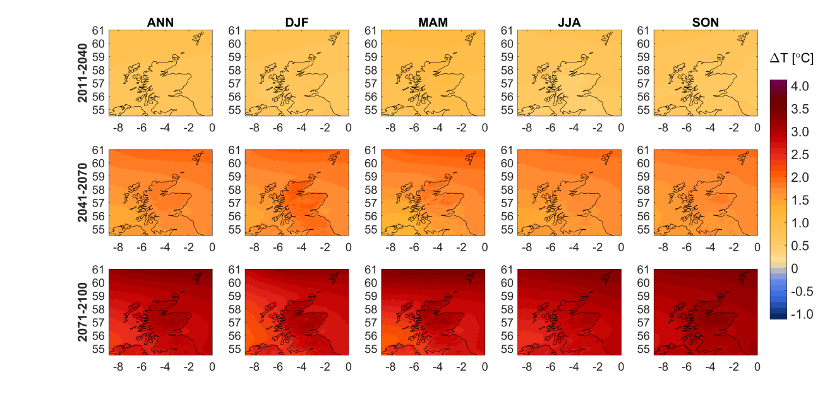
Figure S1. Annual (ANN) and seasonal temperature change (by monthly groupings) for Scotland under RCP8.5. Projection based on EC-Earth Earth System Model (Hazeleger et al. 2012) downscaled with the HIRHAM regional climate model (Christensen et al. 2006) at a spatial resolution of 12 km. Time periods shown are 2011-2040 (top row), 2041-2070 (middle row), and 2071-2100 (bottom row); and indicate projected changes in the mean range of those projected by CMIP5. Differences are relative to 1981-2010.

