Electronic Supplementary Material – Details of Statistical Methods and Results
Appendix 1 - Individual characteristics
The characteristics recorded included: home village; whether they were born in the village or not; the distance of the village to the closest market town; educational level; religion; age; gender; occupational characteristics including if they fished and where (open sea/outer reef/lagoon); their frequency of gardening per week; whether they were involved in the timber industry or not; whether they engaged in other paid work or not; whether they lived a full subsistence livelihood or not; the frequency they participated in community work; assets including whether they owned a canoe or not; the number of canoes owned; whether they owned land or not; and the number of plots of land owned (Table 2). More detail is provided in Table 3.
Community | 1 | 2 | 3 | 4 | 5 | 6 | 7 | 8 | 9 | Totals
Total number | 41 | 36 | 40 | 30 | 14 | 12 | 19 | 37 | 37 | 266
% Women | 51 (21) | 58 (21) | 55 (22) | 40 (12) | 50 (7) | 33 (4) | 53 (10) | 22 (8) | 27 (10) | 43 (115)
% Men | 49 (20) | 42 (15) | 43 (17) | 60 (18) | 50 (7) | 67 (8) | 47 (9) | 78 (29) | 73 (27) | 56 (150)
Mean Age | 46 | 42 | 42 | 40 | 46 | 44 | 43 | 43 | 43 | 43
% Fishers | 90 (37) | 86 (31) | 88 (35) | 87 (26) | 93 (13) | 92 (11) | 79 (15) | 92 (34) | 78 (29) | 87 (231)
% Not fishers | 10 (4) | 14 (5) | 13 (5) | 13 (4) | 7 (1) | 8 (1) | 21 (4) | 8 (3) | 22 (8) | 13 (35)
% 6y Edu | 61 (25) | 61 (22) | 55 (22) | 53 (16) | 71 (10) | 75 (9) | 58 (11) | 57 (21) | 65 (24) | 60 (160)
% 9y Edu | 32 (13) | 39 (14) | 35 (14) | 47 (14) | 29 (4) | 25 (3) | 37 (7) | 38 (14) | 32 (12) | 36 (95)
Table 2. The characteristics of each community for variables used in the statistical analysis, including gender, age, occupation (whether the individual considered themselves a fisher or not) and level of highest educational attainment (up to 6 or 9 years education).

Variables | Roviana Lagoon |  |  |  |  |  | Marovo/Nono Lagoons |  |  |  | Vella
 | Nusa Hope | Kindu | Nusa Banga | Olive | Kinda |  | Ninive | Bopo | Bareho |  | Leona
Number of respondents | 41 | 36 | 40 | 30 | 14 |  | 12 | 19 | 37 |  | 37
Mean age | 46 | 42 | 42 | 40 | 46 |  | 44 | 43 | 43 |  | 43
Range age | 22–62 | 25–76 | 20–71 | 22–67 | 23–73 |  | 27–71 | 27–70 | 28–68 |  | 25–77
% women | 51 | 58 | 55 | 40 | 50 |  | 33 | 53 | 22 |  | 27
% identified themselves as fishers | 90 | 86 | 88 | 87 | 93 |  | 92 | 79 | 92 |  | 78
% who own canoes | 93 | 78 | 70 | 80 | 86 |  | 75 | 74 | 92 |  | 81
Mean number of canoes | 1.5 | 1 | 1.1 | 1.2 | 1.1 |  | 0.5 | 1.5 | 1.7 |  | 1.3
% people fishing lagoon | 37 | 33 | 33 | 57 | 57 |  | 8 | 42 | 49 |  | 11
% people fishing reefs outside lagoon | 34 | 42 | 58 | 43 | 36 |  | 58 | 32 | 46 |  | 65
% people fishing barrier islands | 100 | 6 | 5 | 83 | 7 |  | 92 | 11 | 11 |  | 5
% people fishing open sea | 24 | 11 | 5 | 27 | 14 |  | 50 | 21 | 24 |  | 19
Mean frequency of fishing trips per week | 2.8 | 2.6 | 2.6 | 1.8 | 2.5 |  | 3.1 | 3.1 | 2.5 |  | 2
% people who own land | 100 | 97 | 100 | 100 | 93 |  | 100 | 100 | 92 |  | 92
Mean number of plots of land per person | 2 | 1.3 | 2.7 | 2.1 | 2 |  | 2.3 | 2.2 | 2 |  | 2.2
Mean frequency gardening trips per week | 3.3 | 2.4 | 2.9 | 2.8 | 4.1 |  | 5.3 | 3.4 | 2.3 |  | 2.5
% people involved in timber industry | 15 | 8 | 23 | 23 | 43 |  | 17 | 26 | 35 |  | 11
Mean frequency of days working in/for the community per week | 1.9 | 1.4 | 2.3 | 2 | 2 |  | 2 | 1.2 | 2 |  | 1.8
Mean education level (1-7)ª | 2.4 | 2.6 | 2.6 | 3.1 | 2.4 |  | 2.3 | 2.6 | 2.5 |  | 2.4
% religion Christian Fellowship Church | 61 | 64 | 98 | 80 | 79 |  | 0 | 0 | 0 |  | 0
% religion Seven Day Adventist | 2 | 0 | 0 | 3 | 0 |  | 0 | 0 | 89 |  | 0
% religion United Church | 24 | 31 | 0 | 0 | 0 |  | 92 | 90 | 8 |  | 95
% religion other | 12 | 6 | 2 | 17 | 21 |  | 8 | 10 | 3 |  | 5
% born in the same region as currently resides | 76 | 58 | 83 | 80 | 71 |  | 50 | 53 | 30 |  | 89
% engaged in paid work | 10 | 39 | 38 | 33 | 29 |  | 0 | 32 | 41 |  | 27
% subsistence livelihood only | 66 | 58 | 58 | 67 | 64 |  | 100 | 42 | 49 |  | 60
Distance to market town (km) | 22.75 N | 2.72 SW | 7.35 NW | 31.93 N | 11.12 SW |  | 14.63 E | 11.56 E | 6.12 S |  | 50.94 SW
. ª 1 = none, 2 = up to std 6, 3 = up to form 3, 4 = up to form 5, 5 = up to form 6, 6 = college or similar, 7 = university or similar

Table 3. Detailed respondent characteristics (adapted from Aswani et al. 2015)
Appendix 2 – Statistical analysis
Each respondent had the potential to make many alternative ‘choices’ when free listing changes. When all of the choices were coded for all respondents, they became too numerous to manage. In seeking confirmatory statistical analyses, the three perceived changes (including “no change”) with the highest frequencies of occurrence were selected for each of the six systems studied. All other changes suggested by the respondents were pooled together into a single fourth category, named ‘other’ (Table 4). In all six environmental systems, “no change” was one of the three most frequent responses, and for all three marine systems “no change” was the most frequent response. Also of interest is the number of different responses in different systems. The number of changes in agricultural land and weather were fewer, demonstrating more consensus among respondents than other systems.
System | Number of changes | Change 1  (1st highest freq) | Change 2  (2nd highest freq) | Change 3  (3rd highest freq)
Open sea | 14 | No change | Less fish/fishing difficult | Stronger current
Outer reef | 14 | No change | Less fish/fishing difficult | Coral reef damage
Lagoon | 18 | No change | Dirtier/turbid water | Less fish/fishing difficult
Terrestrial | 14 | Less vegetation | No change | Logging
Agriculture | 10 | Less productive crops | More pests | No change
Weather | 11 | More rain | Unpredictable seasons | No change
Table 4. Summary of top three perceived changes (or not) for each environmental system
In our data-analytic framework, each respondent could ‘choose’ from four choices for each environment. The obvious statistical model to use were multiple regression models. However, the qualitative dependent, or y variable available to us here, i.e., the perceived changes (or choices) of each interviewee, adds a complication, precluding ordinary least-square methods. Multinomial logit models (MLM) were selected instead because they are capable of assessing how choices (perceived changes) depend simultaneously as functions of multiple predictor variables (the respondents’ characteristics) (e.g. Croissant 2012). We can use the models to assess the impact of each predictor by, for example, keeping the other variables selected constant. In statistical terminology we are modelling, ‘nominal outcome variables in which the log odds (probability) of the outcomes are modelled as linear combinations of the predictor variables’. To simplify the analyses, each environmental system (e.g. open sea) was modelled separately, resulting in six final models. For each system (e.g., open sea) we fitted the MLMs using R (R Core Team 2013), exploiting the function ‘multinom’ available with the package ‘nnet’ (Venables and Ripley 1994).
After detailed exploration of the data, and consultation with Solomon Islands researchers, we opted to consider the following predictor variables in the modelling process: gender (2-level factor where ‘M’ is male, and ‘F’ is female); age (numeric variable); distance to market town in kilometres from home village (which can also be a proxy for community difference); occupation - whether the individual interviewed considered him/herself to be a fisher or not (2-level factor); and educational level (initially split into 5 groups: up to 6, 9, 11, 12 years, and >12 years education, but subsequently reduced to 2-level factor of either 6 or 9 years education, see ESM Appendix 1). The survey data was examined carefully for evidence of non-random sampling and collinearity (see Table in ESM Appendix 1, and ESM Appendix 3). “Distance to market town” was initially selected as an index of acculturation and monetization. The observations and prior research of the team suggested that the further the villages are from markets the less western products they consume, less monetary exchanges occur, the stronger the church, the more traditional the leadership, and the less land and sea tenure disputes occur.
Model selection proceeded as follows. For each of the six environmental systems the four possible changes were selected. Open sea, for example included “no change”, “less fish/fishing difficult”, “stronger current”, and “others”. For the other systems the choices examined are listed in Table 3. Note that “no change” is the reference, or base choice, against which the other choices are compared within the model. We then fitted the following model to each of the six systems:
Change selected/choice = gender + age + education + distance to market town + fisher + error
After this ‘full’ model was fitted we used the ‘step’ function in-built in R to find the best model using a forward and backwards search based on the Akaike Information Criteria (AIC) which attempts to find a balance between the goodness of fit of the model and its complexity (Akaike 1974). For example, in the open sea only gender and distance to market town were selected; the other predictors (e.g. education) not being statistically significant.

Appendix 3
The survey data was examined carefully for evidence of ‘confounding’ or ‘non-random sampling’. This was to avoid over-interpreting our data if none were available within particular categories. For example, very few people surveyed had 11 or more years of education, and those that did were mostly male (Figure 3). This means that it is impossible to assess and split the effects of age, gender and education for the higher educational levels because we simply do not have the information. We had only one female interviewed with 14 or more years education, and she is in the youngest age category (Figure 3). The only possible recourse was to omit all the more educated individuals from the analysis entirely. Educational level could thus only be considered as a 2-level factor of either 6 or 9 years education. To reiterate: this was done not because these groups did not contain any useful information. They were removed because it is not possible to conduct plausible statistical tests for the influence of years education given, say, gender or age when there are so few examples (or none) of people with high or low levels of education within these categories.
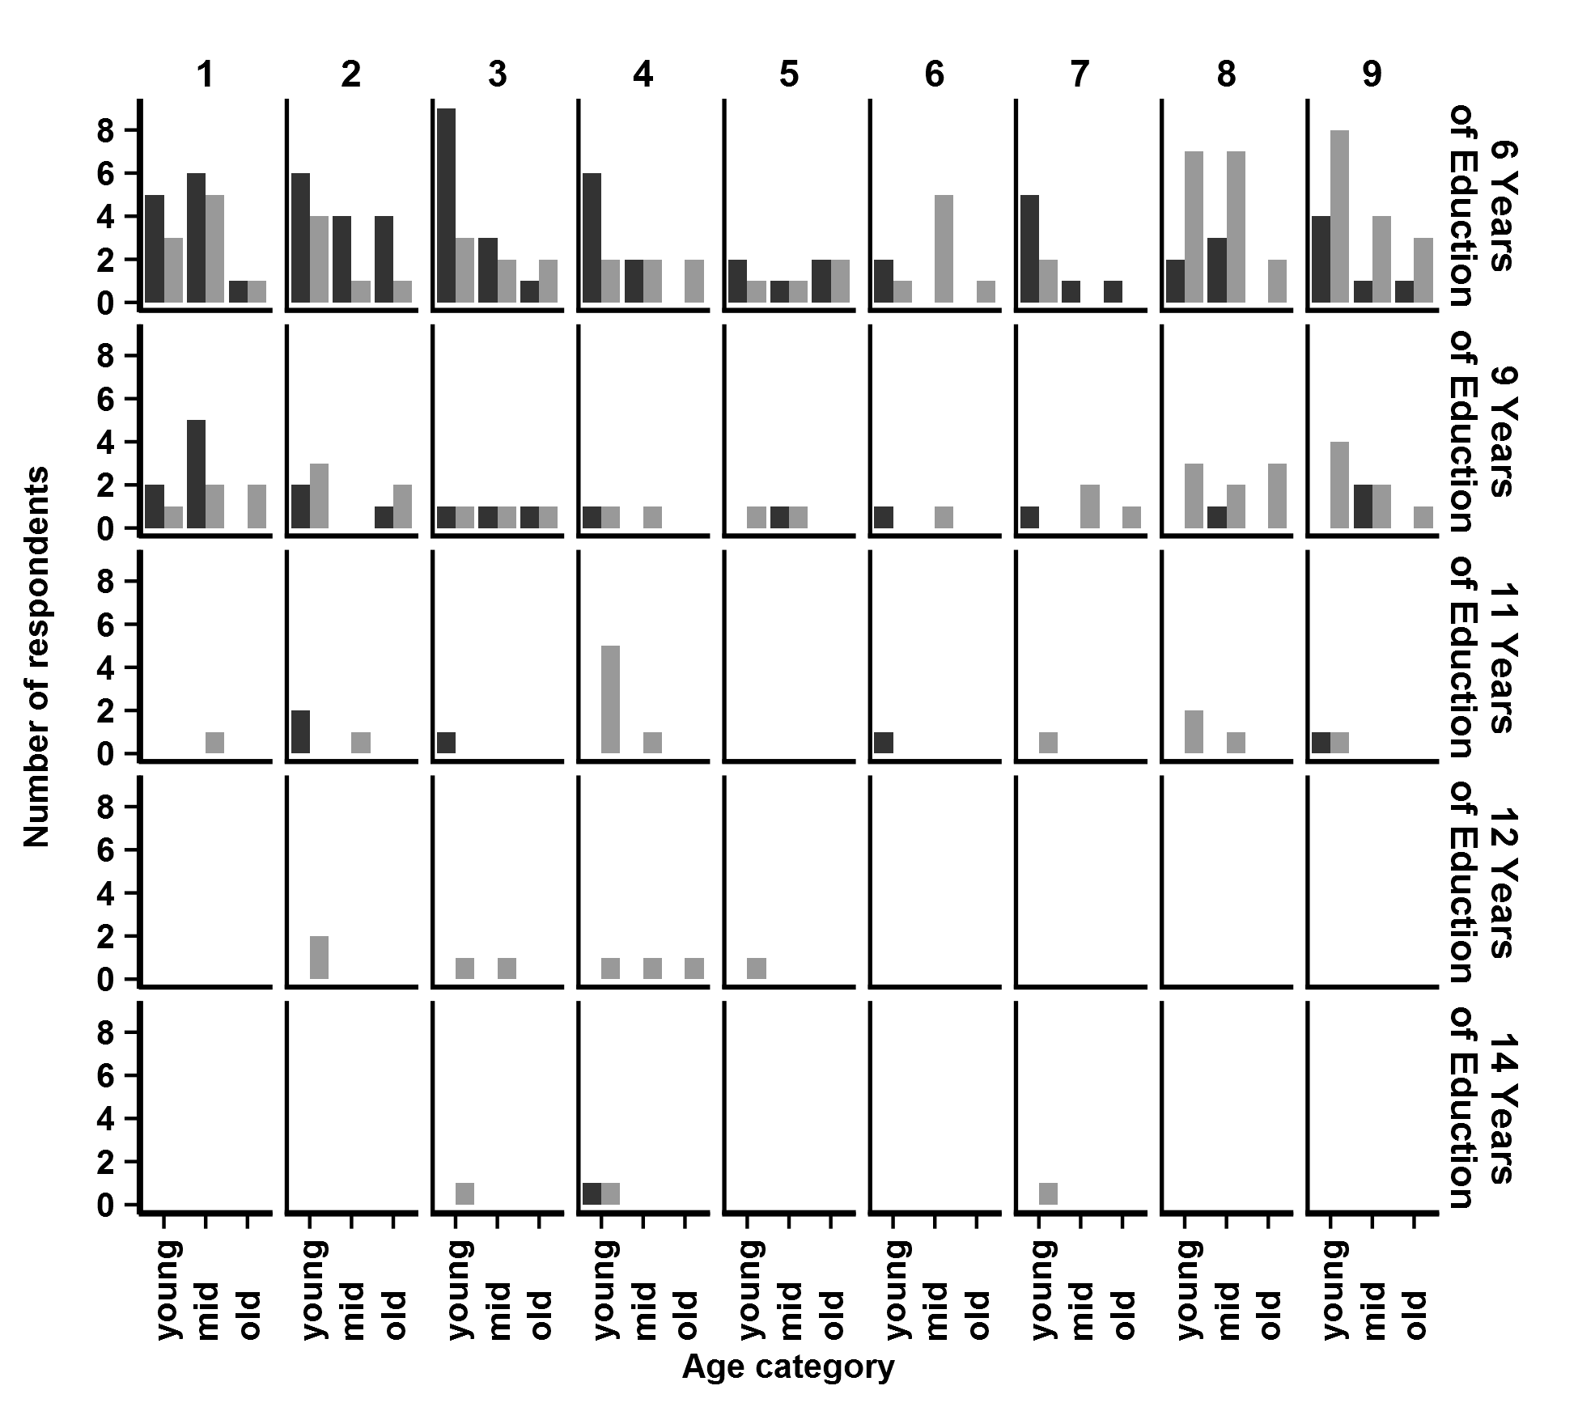
Fig 3 Number of respondents by gender (male = grey, female = black shading), age (split into ages categories: ‘young’ being <40, ‘mid’ being ≥40, <55, and ‘old’ being ≥55), and years of education. Communities are numbered at the top of the figure. Note for reference the bottom plot for Community 4 shows that there was 1 female and 1 male respondent from Olive with 14 years of education and that they were both 'young'.
Collinearity between the regressors or predictors is a difficult problem to address, particularly with “factor” variables such as gender. It is addressed here by calculating 'Variance Inflation Factors' (VIFs) according to Fox, J. and Weisberg, S. 2011. An R Companion to Applied Regression, Second Edition, Sage. For example the VIFs for the 'full' model fitted to the Lagoon data were (in parentheses): gender (3.69), fisher (1.33), education (1.59), distance to market town (2.26), and age (15.21). The usual 'rule of thumb' is to assume that collinearity is present when the square root of the VIF > 2 which is True here only for 'age'. In the subsequent model selection step, however, age is not selected, only distance to market town and education, so it does not make any difference to the final outcome. The VIFs for the final selected model are, education (1.51) and dtm (2.27), neither of which violate the rule described above.

Appendix 4 - Results of MLM regression models
Figures 4-8 for results of MLM regression models.
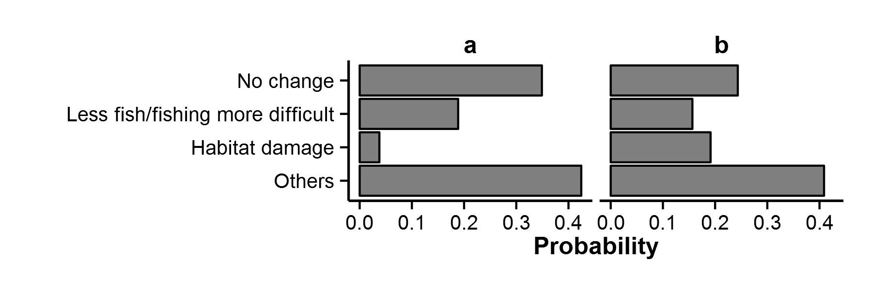
Fig 4 Outer reef: probabilities from MLM regression models for choices (perceived changes) made by (a) female and (b) male respondents

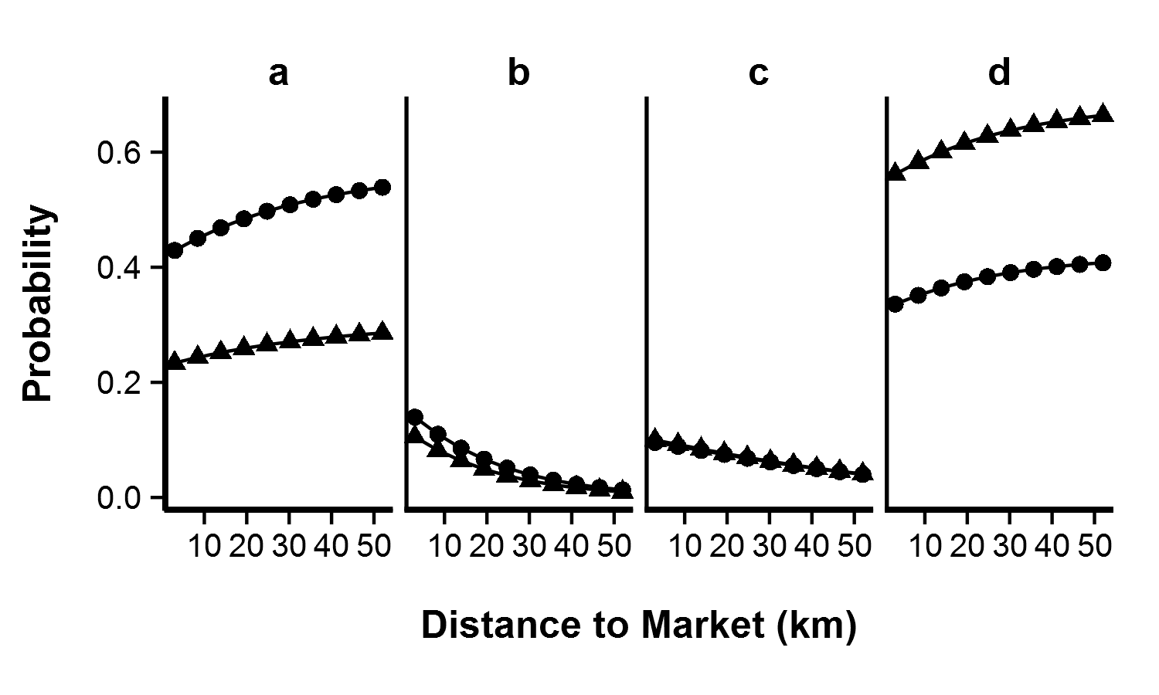Fig 5 Lagoon: probabilities from MLM regression models for choices (perceived changes) made by respondents of different education levels (circles = 6 years triangles = 9 years education), from villages of varying distances to market town (kms). Perceived changes were (a) No change, (b) Turbid water, (c) Less fish/fishing is harder, (d) Other

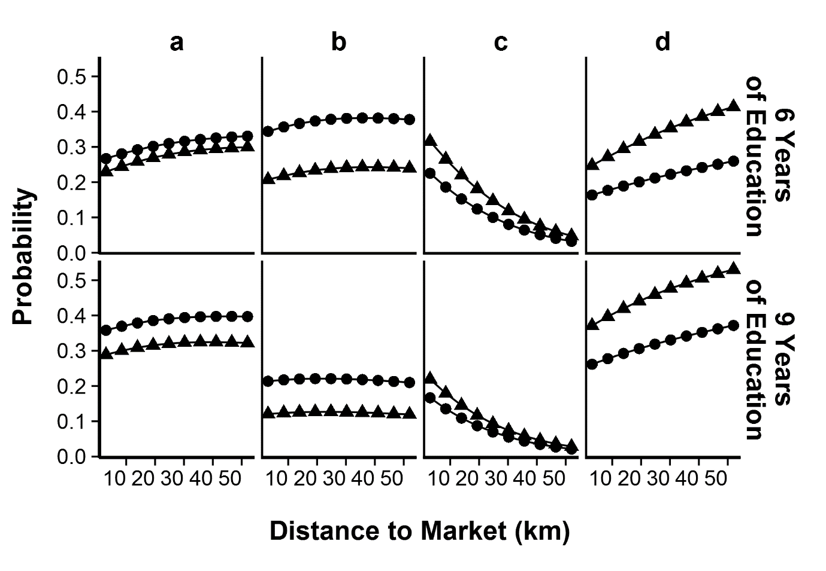Fig 6 Terrestrial: probabilities from MLM regression models for choices (perceived changes) made by male (triangles) and female (circles) respondents, of different years education, from villages of varying distances to market town (kms). Perceived changes were (a) Less vegetation, (b) No change, (c) Logging increase, (d) Other
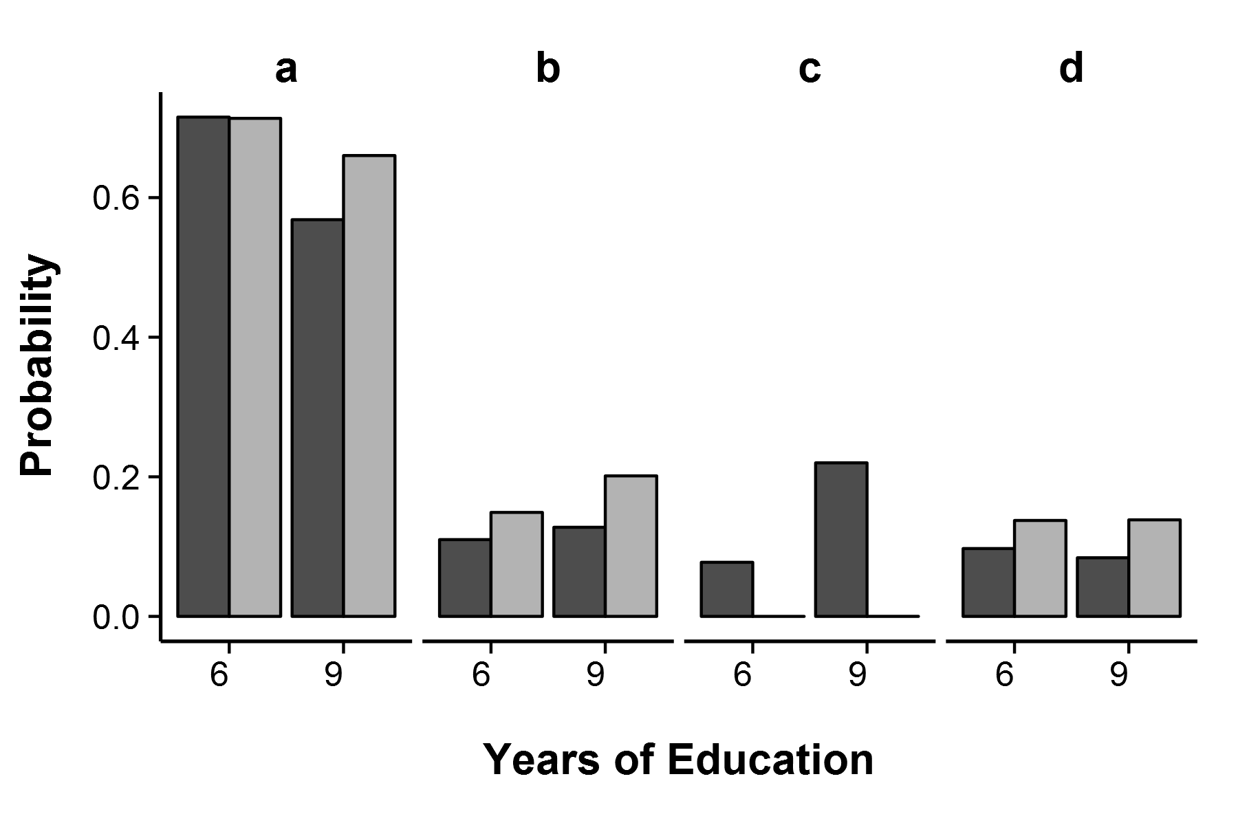Fig 7 Agriculture: probabilities from MLM regression models for choices (perceived changes) made by respondents of different education levels (6 = 6 years or 9 = 9 years education), with different occupational activities (dark grey = fisher, light grey = not a fisher). Perceived changes were (a) Lower crop productivity, (b) More pests, (c) No change, (d) Other
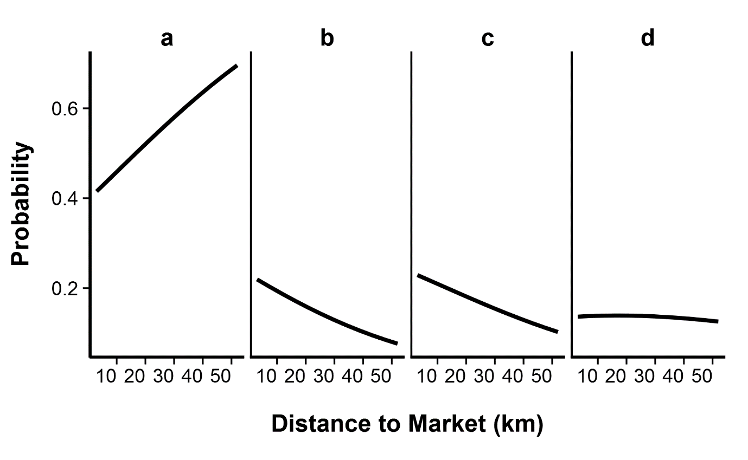Fig 8 Weather: probabilities from MLM regression models for choices (perceived changes) made by people from villages of varying distances to market town (kms). Perceived changes were (a) More rain, (b) Unpredictable seasons, (c) No change, (d) Other

Appendix 5 – Detailed statistical output
Results of the six multinomial logit models fitted to the data from each environmental system are shown in Tables 5-10. To illustrate, a summary of the ‘best’ or most appropriate model for the open sea environmental system is shown in Table 4. The best model for the open sea suggests that a unit increase in the variable, distance to market town is associated with an increase in the log-odds of choosing “less fish/fishing difficult” versus “others” of 0.0207. Similarly the log-odds of choosing “less fish/fishing difficult” will increase by 1.54 when moving from female to male. The model uses “no change” as the baseline against which the tests of significance are compared [Note: the fact that there are no coefficients listed for “no change” in the model output does not mean we have made a mistake]. To see the fitted probabilities from the model output, refer to Figure 3.
Choice | intercept | gender | distance to market town
Less fishing/fishing more difficult | -2.24 | 1.54 | 0.0207
Stronger current | -2.33 | 0.38 | 0.0296
Others | -0.61 | 0.96 | -0.005
Table 5. ‘Best’ fitting or most appropriate model for the Open Sea environmental system [Residual deviance = 522, AIC = 540].

Choice | intercept | gender
Habitat damage | -2.22 | 1.98
Less fishing/fishing more difficult | -0.62 | 0.17
Others | 0.19 | 0.32
Table 6. ‘Best’ fitting or most appropriate model for the Outer Reef environmental system [Residual deviance = 551, AIC = 563].

Choice | intercept | education | distance to market town
Dirtier/more turbid water | -2.24 | -1.61 | -0.053
Less fishing/fishing more difficult | -2.33 | -2.74 | -0.022
Others | -0.61 | -2.48 | -0.007
Table 7. ‘Best’ fitting or most appropriate model for the Lagoon environmental system [Residual deviance = 477, AIC = 495].

Choice | intercept | gender | education | distance to market town
Less vegetation | -1.80 | 0.36 | 0.256 | 0.0024
Logging introduced | -0.65 | 0.85 | 0.059 | -0.0416
Others | -2.65 | 0.92 | 0.032 | 0.0075
Table 8. ‘Best’ fitting or most appropriate model for the Land Ecology environmental system [Residual deviance = 576, AIC = 600].

Choice | intercept | fisher | education
Less productive crops | 4.77 | 7.94 | -0.42
More pests | 2.14 | 8.25 | -0.29
Others | 2.61 | 8.29 | -0.40
Table 9. ‘Best’ fitting or most appropriate model for the Agricultural practice environmental system [Residual deviance = 418, AIC = 436].

Choice | intercept | distance to market town
More rain | 0.51 | 0.0207
Unpredictable seasons | -0.027 | -0.005
Others | -0.561 | 0.014
Table 10. ‘Best’ fitting or most appropriate model for the Weather environmental system [Residual deviance = 532, AIC = 544].

