Online Resources 3 to “Perspectives of farmers and tourists on agricultural abandonment in east Lesvos, Greece” Regional Environmental Change
Cecilia ZAGARIA*, c.zagaria@vu.nl; Catharina J. E. SCHULP; Thanasis KIZOS; Peter H. VERBURG

*Address of corresponding author: Environmental Geography Group, Institute for Environmental Studies, Vrije Universiteit Amsterdam, De Boelelaan 1087, 1081 HV Amsterdam, the Netherlands

Includes:
Section A – Landscape photos ranked by tourists during the preference survey

- Landscape photos ranked by tourists during the preference survey

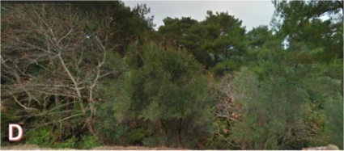
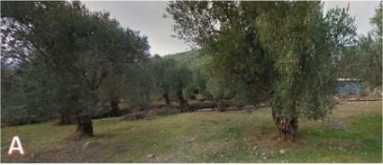
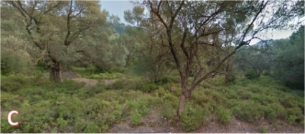
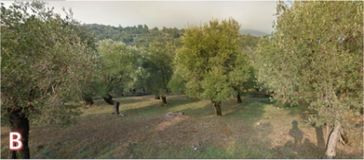
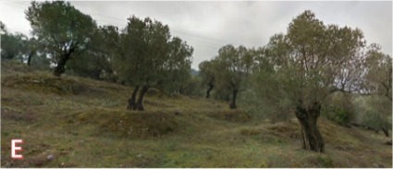
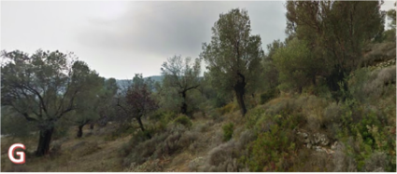
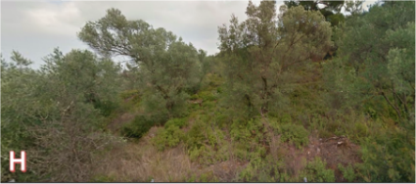
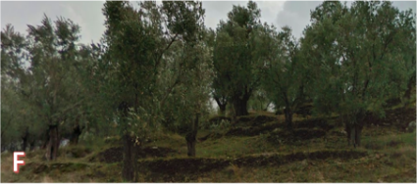
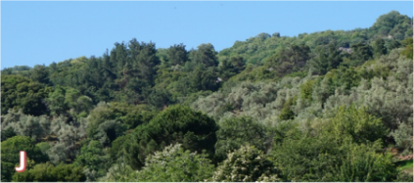
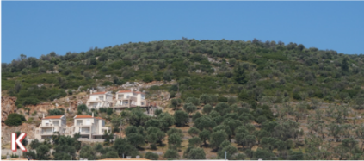
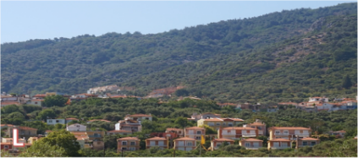
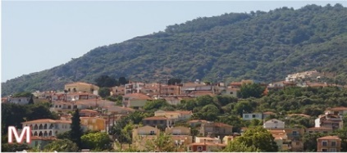
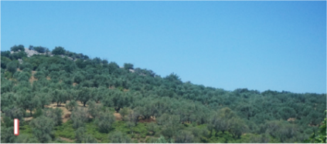
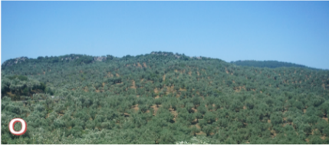
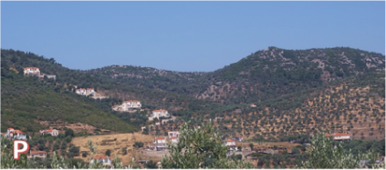
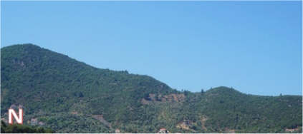
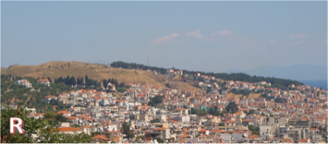
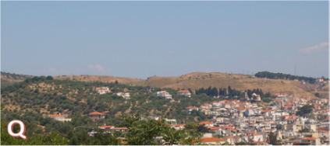
Agricultural abandonment: Set 1 Set 2
Low-input traditional
Intensive
Neglected
Abandoned
© 2015 Google

Housing sprawl / urbanization: Set 3 Set 4
Mixed forest
Olive forest
Scattered housing
Sparsely built village/
Suburbs
Densely built village/
City
J
I

Fig. 1 Landscapes ranked by tourists during the preference survey in respective sets illustrating processes of agricultural abandonment and housing sprawl (urbanization). Sets 1 and 2 utilize Google Street View (2015) panoramic imagery

