Supplementary Material
Information-link distribution among participants in intervention C environmental training (red) and among the members of the control group (black). Kernel density curves were computed using Gaussian windows with 0.4 smoothing bandwidth.
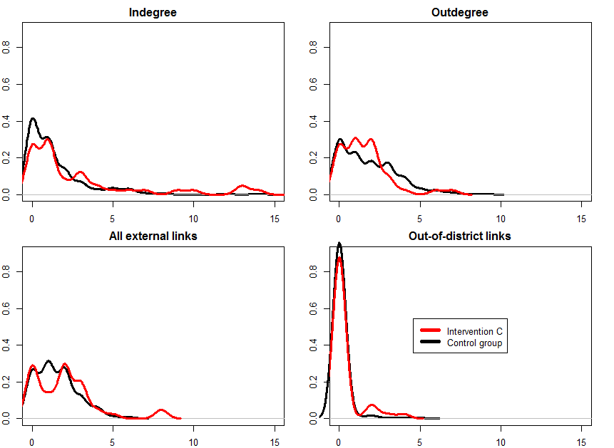

The intervention created some popular advisors with high indegrees, as depicted in red on the right-hand side of the indegree diagram. However, and remarkably, the intervention has also lifted the bottom of the distribution by decreasing the proportion of zero-indegree individuals on the left-hand side of the diagram.

