Appendix
Content
1. Land system map 2
1.2 Limitations of land system map for this study 3
2. Scenario implementation 4
2.1 ILM Stakeholder workshop 4
2.2 Demand 5
2.3 Productivity changes 7
2.4 Location suitability 7
2.5 Region files 8
2.6 Allowed conversions 9
2.7 Land use conversion matrix 10
2.8 Output matrix 10
3. Analysis 11
4. Results 14

Land system map
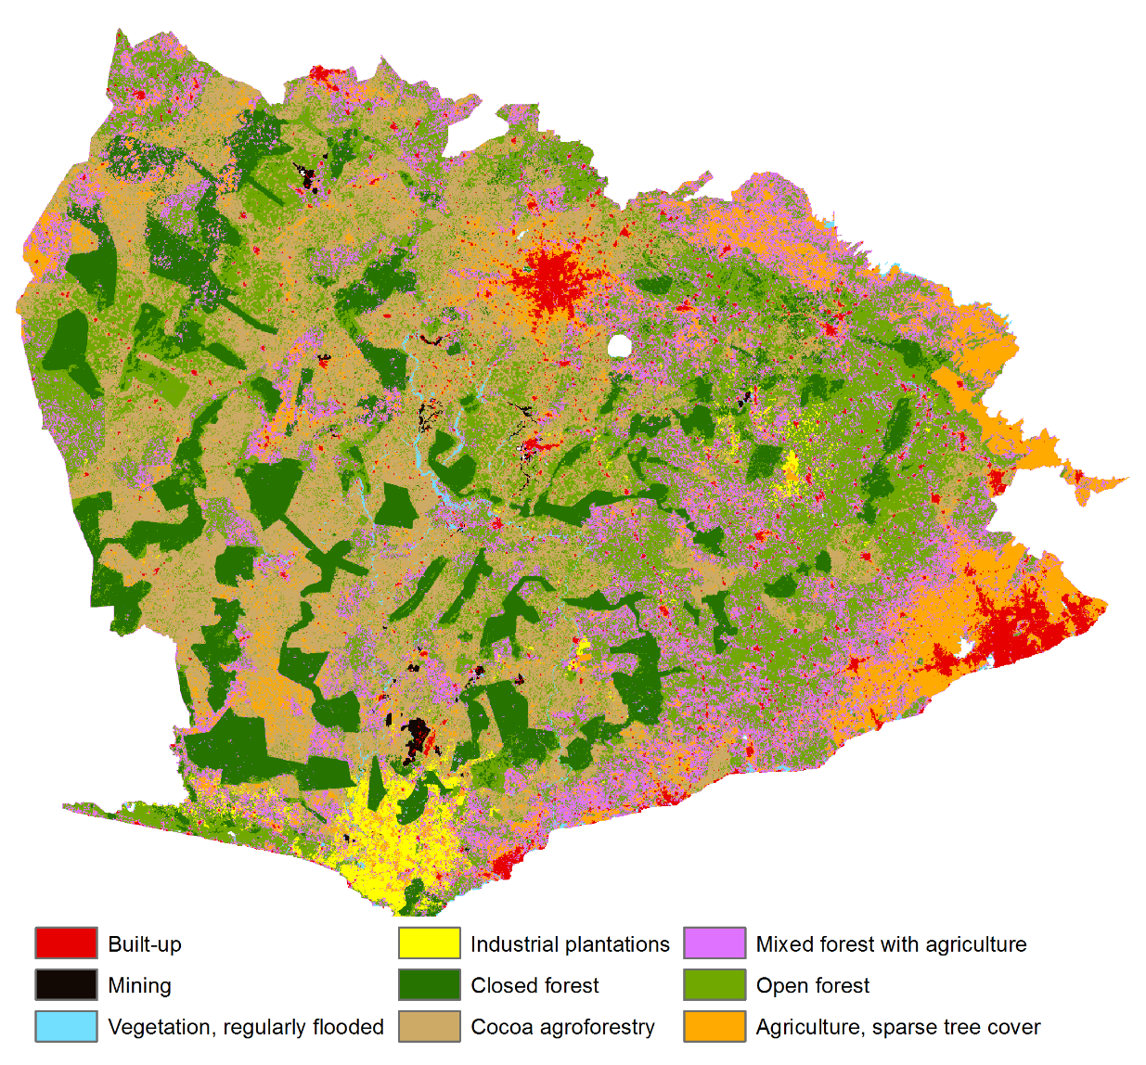
Fig. 7: Land system map of the case study area 2015
Table 2: Data integrated in land use / land system classification
Dataset | Components used | Year | Geometry/Resolution | Source
Land cover | Tree cover, shrub land, grassland, cropland, vegetation, regularly flooded, mosses and sparse vegetation, bare, built-up, open water | 2016 | Raster/ 20m | ESA (2016)
Land cover | Closed forest, open forest | 2015 | Raster/ 30m | Forestry Commission Ghana (2016)
Land use change forest | Forest loss between 2000-2010, 2010-2013, 2013-2015 | 2015 | Raster/ 30m | Forestry Commission Ghana (2016)
Land cover | Rubber plantation | 2015 | Raster/ 30m | Hackman et al (2017)
Palm oil plantations | Palm oil plantation | 2015-2016 | Polygon/ - | Satelligence (2017)
Land use | Cocoa areas | 2000 | Polygon/ - | CERSGIS (2000)
Mining concessions and mining area | Mining areas | 2010 | Polygon/ - | Digitalized from a paper map of the Minerals Commission using ArcGIS Imagery basemap
  - Limitations of land system map in the context of this study
The scenario results need to be interpreted considering the capacities and limitations of the underlying land system map used to model land system changes. Instead of using simply land use or land cover, land systems can allocate multiple demands simultaneously, such as climate mitigation and food production. However, there are a few shortcomings of our land system map mainly linked to data gaps. For example, we could not distinguish between different forest types of the HFZ. The closed forest includes both commercial forest plantations for timber production (e.g. teak and eucalyptus) and natural forest. Commercial forest plantations play an important role in forest restoration and in meeting global timber demand. Natural forests play an important role in forest biodiversity. Forest conversion from natural to plantation forests (e.g. to meet restoration targets), as well as deforestation of natural forest (e.g. to meet wood demand), could thus not be modeled. The latter is known to be an important local driver of deforestation in the region (Oduro et al. 2016). Besides forest patch size, the composition of forest types plays an important role in assessing the impact of land system changes on biodiversity. For example, we associated larger forest patches with a higher value for forest biodiversity. Due to the mentioned uncertainties, changes in forest patch size provides only limited information on the impact of land system change on biodiversity.
Table 3: Final land system classes, coverage, and classification of the land systems into types of agricultural use
Land system | Area (km²) | Area (%) | Subsistence | Commercial | Climate smart | Mixed | Specialized
Built up | 2 202 | 3% |  |  | .
Mining | 211 | 0%
Vegetation, regularly flooded | 401 | 1%
Industrial plantations | 1 338 | 2% |  | X
Closed forest | 9 865 | 14%
Cocoa agroforestry | 16 833 | 24% |  | X | X
Mixed forest with agriculture | 11 680 | 17% | X |  | X | X
Open forest | 20 182 | 29% | X
Agriculture, sparse tree cover | 7 340 | 10% | X |  |  |  | X
Total | 70 053 | 100%

Scenario implementation

2.1 ILM Stakeholder workshop
Table 4: Stakeholder that participated in the Atewa-Densu Workshop
Institution/ Community |  | Position | No. of Persons
Representatives from Regulatory Agencies |  | Representatives from Regulatory Agencies
Environmental Protection Agency |  | Regional Director | 1
Water Resources Commission |  | Densu Basin Officer | 1
Minerals Commission |  | Regional Inspectorate Director | 1
Forestry Commission |  | Regional Manager | 1
Eastern Region Regional Coordinating Council |  | Coordinating Director | 1
Climate Change Unit – Forestry Commission |  |  | 1
Cocoa Board – Eastern Region |  |  | 1
Densu Basin Chairperson |  |  | 1
University College for Environment and Agriculture (UCEAS) |  | Rep | 1
Ministry of Agriculture (MOFA) |  |  | 1
G.W.C.L |  | Regional Director | 1
G.W.C.L |  | Accra Weija Director | 1
Municipality 1 – Kasoa |  | Coordinating Director | 1
Municipality 2 – Dansoman |  | Coordinating Director | 1
Munipality 3 (Nsawam-Adoagyir) |  | Coordinating Director | 1
East Akim Municipal Assembly |  | Coordinating Director | 1
Atiwa District Assembly |  | Coordinating Director | 1
West Akim Municipal Assembly |  | Coordinating Director | 1
Denkyembour District Assembly |  | Coordinating Director | 1
Fanteakwa District Assembly |  | Coordinating Director | 1
Ayensuano District Assembly |  | Coordinating Director | 1
Kwabirem District Assembly |  | Coordinating Director | 1
AkyemAbuakwa Traditional Council |  |  | 2
BESNet (Blue Skies) |  |  | 1
WACAM |  |  | 1
Solidaridad |  |  | 1
Farmer Based Associations |  | Representatives | 1
OEF |  | National Director | 1
Saaman Assemblyman |  |  | 1
A Rocha Ghana/PBL/Eco-Agriculture/IUCN NL |  |  | 7
Total |  |  | 37

2.2 Demand
Table 6: Comparison of demand rationales between ILM and GS scenario
Demand (% increase) | ILM | GS | Source
Built-up (area) | Urbanization follows BAU developments | Urbanization is controlled and dense | Calculated based on population increases between 2000 and 2015 in the regions that fall within case study area, (Ghana, National Statistical , 2015)
Tree cover (area) | Following forest restoration/timber demand in line with Bonn Challenge/REDD+/Forest Investment plan for Ghana |  | Tree cover demand is composed of tree cover in 2015 (ESA, 2016) (minus the degraded forest area), demand for timber and forest restoration
Industrial plantations (tonnes) | Demand increases in line with historical patterns | Demand decreases for palm oil | Production data (tonnes/ha) used from FAOSTAT. In GS scenario, Industrial plantations include only rubber. In ILM scenario, they include rubber and palm oil.
Agricultural crops (tonnes) | Demand increases in line with historical trends | IMAGE projections for West Africa in GS scenario | Includes production data (tonnes/ha) of cassava, plantain and maize in 2015 (FAOSTAT). Total production was extrapolated between 2015/30, following historical national growth rates.
Cacoa crops (beans, tonnes) | Increase in line with historical trends |  | FAOSTAT area harvested and tonnes of production. Production was attributed to the share of cocoa crops in the HFZ.
Table 7: Annual demand changes ILM scenario
Year | Built-up area (km2) | Tree cover (km2) | Industrial crops (tonnes) | Agri. Crops (tonnes) | Cocoa (tones)
2015 | 1723325621 | 39658610765 | 2465427 | 12952274 | 840972497
2016 | 1769214304 | 40134514095 | 2542479 | 13427191 | 850503519
2017 | 1815102987 | 40610417424 | 2619531 | 13902107 | 860034540
2018 | 1860991671 | 41086320753 | 2696583 | 14377024 | 869565562
2019 | 1906880354 | 41562224082 | 2773636 | 14851941 | 879096584
2020 | 1952769037 | 42038127411 | 2850688 | 15326857 | 888627605
2021 | 1998657720 | 42514030741 | 2927740 | 15801774 | 898158627
2022 | 2044546403 | 42989934070 | 3004792 | 16276691 | 907689648
2023 | 2090435087 | 43465837399 | 3081844 | 16751608 | 917220670
2024 | 2136323770 | 43941740728 | 3158896 | 17226524 | 926751692
2025 | 2182212453 | 44417644057 | 3235948 | 17701441 | 936282713
2026 | 2228101136 | 44893547387 | 3313001 | 18176358 | 945813735
2027 | 2273989819 | 45369450716 | 3390053 | 18651274 | 955344757
2028 | 2319878503 | 45845354045 | 3467105 | 19126191 | 964875778
2029 | 2365767186 | 46321257374 | 3544157 | 19601108 | 974406800
2030 | 2411655869 | 46797160703 | 3621209 | 20076025 | 983937822
Total | 40% | 18% | 47% | 55% | 17%
Table 8: Annual demand changes GS scenario
Year | Built-up area (km2) | Tree cover (km2) | Rubber (tonnes) | Agri. Crops (tonnes) | Cocoa (tonnes)
2015 | 1723330000 | 38670076764 | 2465427 | 12952274 | 840972497
2016 | 1747460000 | 39134117685 | 2383246 | 13539444 | 850503519
2017 | 1795720000 | 39598158606 | 2301065 | 14126614 | 860034540
2018 | 1795720000 | 40062199528 | 2218884 | 14713783 | 869565562
2019 | 1831920000 | 40526240449 | 2136703 | 15300953 | 879096584
2020 | 1856050000 | 40990281370 | 2054523 | 15888123 | 888627605
2021 | 1874150000 | 41454322291 | 1972342 | 16475293 | 898158627
2022 | 1904310000 | 41918363212 | 1890161 | 17062462 | 907689648
2023 | 1925420000 | 42382404133 | 1807980 | 17649632 | 917220670
2024 | 1949550000 | 42846445055 | 1725799 | 18236802 | 926751692
2025 | 1975190000 | 43310485976 | 1643618 | 18823972 | 936282713
2026 | 1997820000 | 43774526897 | 1561437 | 19411141 | 945813735
2027 | 2022700000 | 44238567818 | 1479256 | 19998311 | 955344757
2028 | 2046830000 | 44702608739 | 1397075 | 20585481 | 964875778
2029 | 2070590000 | 45166649660 | 1314894 | 21172651 | 974406800
2030 | 2085220000 | 45630690582 | 1232714 | 21759820 | 983937822
Total | 21% | 18% | -50% | 68% | 17%

2.3 Productivity changes
Table 9: Annual productivity changes per land system
Land System | ILM | GS | Description | Source
Urban | 0.002% | 0.002% | Urban efficiency increases in line with IMAGE projections for West Africa | Doelman et al (2018)
Industrial plantations | 3.0% | 3.0% | Following historical patterns of FAO statistics rubber/palm oil for Ghana | FAOSTAT (2019)
Agriculture crops | 2.5% | 3.5% | Improvement of agricultural yields supported by technological investments. For ILM: based on own estimates, For GS: in line with IMAGE projections for West Africa. | Doelman et al (2018)
Cocoa crops | 3.0% | 4.0% | Improvements of cocoa yields as a result of investments. Higher in GS scenario due to REDD+ investments | FAOSTAT (2019), own estimate

2.4 Local suitability
Some of the targets were implemented by adapting local suitability for a specific land system. Local suitability can be specified by the user or estimated based on the empirical relationship between current distributions of land systems and socio-economic and biophysical location factors (e.g. access to roads, precipitation, slope) using a logistic regression model. Table 10 and 11 list the land systems for which location suitability was adapted manually by adding a factor (location specific preference addition) that increases the suitability of a specific land system at a defined location.
Table 10: Location specific preference additions ILM scenario
Land system | Location specific preference additions | Description
Built-up | 0.2 | Around Kumasi/ Accra and in medium sized cities
Mining | 0 | -
Vegetation reg. flooded | 0 | -
Industrial plantations | 0 | -
Closed forest | 0.6 | In forest reserves to stimulate the increase of closed forest (plantation forest) as part of restoration and plantation strategy; in abandoned mining areas
Cacoa-agroforestry | 0
Mixed forest with agriculture | 0.2 | In degraded forest areas
Open forest | 0 | -
Agriculture, sparse tree cover | 0 | -
Table 11: Location specific preference additions GS scenario
Land system | Location specific preference additions | Description
Built-up | 0.1 | Around Kumasi/Accra
Mining | 0 | -
Vegetation reg. flooded | 0 | -
Industrial plantations | 0 | -
Closed forest | 0.4 | In forest reserves to stimulate the increase of closed forest (plantation forest) in these areas as part of restoration and plantation strategy. In forest buffer zones.
Cacoa-agroforestry | 0.2 | In degraded forest areas as part as the REDD+ strategy
Mixed forest with agriculture | 0 | -
Open forest | 0 | -
Agriculture, sparse tree cover | 0 | -

Region files
Forest biodiversity was protected in national and international designated forest reserves by restricting closed forest systems from land-use change. In the ILM scenario, riparian buffer zones (i.e. buffer zones adjacent to all rivers, streams, lakes, and reservoirs) were protected from land-use change (1 cell buffer/ 200m) to maintain the native vegetation and to improve water quality, in line with the "Riparian Buffer Zone Policy" (Government of Ghana, 2011). In the GS scenario, mining areas were expanded by 1 cell around present mining areas.
Fig. 7: Areas restricted from land use change in the ILM (A) and GS scenario (B).

2.7 Land use conversion matrix
Conversion resistance indicates the costs of converting a particular land system to another. It is typically high for systems with high capital investments and for systems that are difficult to remove physically, such as urban areas. Extensive agricultural systems or semi-natural systems are examples of systems that are relatively easy to remove and thus have a lower conversion resistance (van Vliet and Verburg 2018).
Table 13: Land use conversion matrix
Land system | ILM | GS | Rationale
Built-up | 1 | 1
Mining | 1 | 1
Vegetation regularly. flooded | 1 | 1
Industrial plantations | 1 | 0.3 | In the ILM scenario, the demand for rubber and palm oil increases in the current plantation areas. In the GS scenario, demand for palm oil decreases which makes it easier to convert former plantations to other land uses.
Closed forest | 0.6 | 0.7 | Closed forest conversion resistance decreased outside forest reserves.
Cacoa-agroforestry | 0.7 | 0.7
Mixed forest with agriculture | 0.5 | 0.5
Open forest | 0.4 | 0.4
Agriculture, sparse tree cover | 0.6 | 0.8 | In ILM, land system can be more easily converted to mixed land systems. In GS, higher elasticity as current agricultural areas are further intensified to meet crop demand.

2.8 Output matrix
Table14: Output matrix ILM scenario
Land use conversion matrix | Urban |  | Tree cover | Rubber | Agri crops | Cocoa crops
Mining | 7 |  | 1 | 0 | 1 | -1
Vegetation regularly flooded | -1 |  | -1 | -1 | -1 | -1
Industrial plantations | -1 |  | -1 | -1 | -1 | -1
Closed forest | 0 |  | 2 | 6 | 0 | -1
Cacoa agroforestry | 0 |  | 7 | 0 | 1 | -1
Mixed forest with agriculture | 0 |  | 6 | 0 | 3 | 6
Open forest | 1 |  | 5 | 1 | 9 | 2
Agriculture, sparse tree cover | 0 |  | 3 | 0 | 2 | 1
Mining | 1 |  | 2 | 1 | 8 | -1
Table 15: Output matrix GS scenario
Land use conversion matrix | Urban |  | Tree cover | Rubber | Agri crops | Cocoa crops
Mining | 7 |  | 1 | 0 | 1 | -1
Vegetation regularly flooded | -1 |  | -1 | -1 | -1 | -1
Industrial plantations | -1 |  | -1 | -1 | -1 | -1
Closed forest | 0 |  | 2 | 6 | 0 | -1
Cacoa agroforestry | 0 |  | 7 | 0 | 1 | -1
Mixed forest with agriculture | 0 |  | 6 | 0 | 3 | 6
Open forest | 2 |  | 5 | 1 | 9 | 2
Agriculture, sparse tree cover | 0 |  | 3 | 0 | 2 | 1
Mining | 1 |  | 2 | 1 | 8 | -1

Analysis
Table15 Rationale of selected sustainability dimensions included in analysis
Indicator | Rationale | Calculation
Food production (SDG 2: Zero hunger)
Diversity in agricultural systems | Diversity in agricultural systems (i.e. land sharing) tends to benefit functional biodiversity and ES, while specialized agricultural systems (i.e. land sparing) are less beneficial to ES but tend to benefit biodiversity conservation at large. | Ratio mixed/ specialized agriculture
Agricultural production per person | Indicator for food security in the study region as a whole. | Ratio tons crop production/ population in 2030.
Increase in agricultural production in poorer districts | For many households, agriculture is the primary economic activity. Thus improving agricultural yields and diversification in these households supports food security. | Change in agricultural production (t/ha) in districts with poverty head count >25% relative to 2015.
Subsistence agriculture per person | Subsistence agriculture plays an important role in reducing the vulnerability of food insecure households and improves livelihoods. | Ratio agricultural production from subsistence /population in 2030
Commercial agriculture per person | Commercial agriculture benefits the economy and global market at large | Ratio agricultural production for commercial uses/population in 2030
Forest Biodiversity (SDG15: Life on land)
Change in closed forest area | Closed forests provide biodiversity, ES and wildlife resources. | Change in closed forest area (km2) relative to 2015.
Conversion of initial closed forest area | Intact closed forest landscapes hold high levels of biodiversity. | Percentage area of initial/intact closed forest area converted to other land systems.
Forest patch size - large to smaller closed forest patches | Larger forest fragments hold more species of trees/rare species than smaller patches. | Ratio very large forest patches > 845 km2 (20000 cells)/ all smaller patches.
Climate Change Mitigation (SDG13: Climate action)
Net loss of closed forest | Closed forest store most of CO₂ in the region. | Net loss of closed forest
Carbon emissions (Megatons) from conversion of forest to cocoa agro-forestry | Closed and open forests store much CO₂. Their conversion releases CO₂ in the atmosphere. Climate smart agroforestry provides an alternative to combine climate mitigation with cocoa production. | CO2e equivalents (megatons) of the loss of closed and open forest (km2) from conversion to cocoa agroforestry. Calculated based on table 4 (P32) of Ghana’s Forest Reference Level report (National REDD+ Secretariat 2017). Ratio between scenarios is calculated for comparison.
Change in climate smart agro- forestry in degraded areas | Degraded forest areas provide suitable areas to combine forest reforestation with cocoa production. | Change in the area of climate smart agro-forestry (cocoa agro-forestry, mixed forest with agriculture) in degraded forest areas relative to 2015.
Sustainable urbanization (SDG11: Sustainable cities and communities)
Built up expansion into forest and agriculture systems | Impact of urbanization on the environment. | Percentage share of forest (closed and open forest) and agricultural land systems (agriculture with sparse tree cover, mosaic forests with agriculture, cocoa agro-forestry) converted to built-up area (relative to other LS converted).
Change in settlement size –small to larger settlements | Improved market access/access to forest. | Ratio small settlements < 8.4 km2 (200 cells)/ larger settlements. Change calculated relative to 2015.
Change of forest systems in green belts | Mixed, open-, and closed forest are multi-functional forests that can provide ES to urban populations. | Change of forest systems in green belts (1km radius around settlements) relative to other land systems and 2015.

Results

Fig. 9: Land system change (km2) between 2015 and 2030, in the ILM and GS scenario.

Fig. 10: Percentage of land systems located around urban green belts (1km from settlement) in the reference (2015), ILM and GS scenario (2030).
Table 16: Indicators to assess synergies and trade-offs between the ILM and the GS scenario
Indicator | Land systems 2015 | ILM 2030 | GS 2030
Food production (SDG 2)
Diversity in agricultural systems (Ratio mixed/specialized agriculture) | 1.59  11680 km2/ 7334 km2 | 1.89 | 1.26
Agricultural production per person (Ratio tons crop production/ population in 2030) | 0.63 | 0.70 | 0.87
Subsistence agricultural production per person (Ratio agricultural production from subsistence /population in 2030) | 0.002 | 0.003 | 0.003
Commercial agricultural production per person (Ratio agricultural production for commercial uses/population in 2030) | 0.07 | 0.11 | 0.28
Increase in agricultural production in poorer districts (Percentage increase in total agricultural production in districts with poverty rate >25% relative to 2015) | 0.00  80377 Mt | 0.67 | 0.78
Forest biodiversity conservation (SDG 15)
Change in closed forest area (Ratio of forest area compared to 2015) | 1.00  9866 km2 | 1.28 | 1.21
Conversion of initial closed forest area (Percentage area of initial closed forest converted to other land systems) | 0.00  9866 km2 | 0.15 | 0.00
Forest patch size ratio of larger patches (> 845 km2 to smaller closed forest patches < 845km2) | 0.10 | 1.06 | 2.07
Net loss of closed forest | - | 0.00 | 0.00
Climate change mitigation (SDG 13)
Carbon emissions (Megatons) from conversion of forest to cocoa agroforestry (Ratio of ILM/GS scenario) | - | 2.19
Change in climate smart agroforestry in degraded areas (Change in the area of climate smart agroforestry in degraded forest areas relative to 2015) | 0  4535/2294 km2 | 0.29 | 0.43
Urbanization (SDG 11)
Built up expansion into forest and agriculture systems (Ratio to other land systems | - | 0.27 | 0.13
Change in settlement size (Change small settlements (< 8.4 km2)/change larger settlements > 8.4 km2)) | 0.48 % | 0.52/ 0.25 | 0.21/ 0.21
Percentage change in share of forest systems in green belts (1km radius around settlements, relative to other land systems and 2015) | 10524/21963km2 | 2.99 | -0.01
References
Hackman KO, Gong P, Wang J (2017) New land-cover maps of Ghana for 2015 using Landsat 8 and three popular classifiers for biodiversity assessment. Int J Remote Sens 38:4008–4021. doi: 10.1080/01431161.2017.1312619
National REDD+ Secretariat (2017) Ghana ’ s National Forest Reference Level. Accra
van Vliet J, Verburg PH (2018) A Short Presentation of CLUMondo. In: Olmedo Camacho MT, Paegelow M, Mas J-F, Escobar F (eds) Geomatic Approaches for Modeling Land Change Scenarios. Springer International Publishing, Switzerland, pp 511–519
Satelligence (2017) Fraction of oil palm per 500x500m blocks, based on Sentinel remote sensing data. Commissioned by the ILM project of the PBL Netherlands Environmental Assessment Agency.
Government of Ghana (2015) Ghana National spatial development framework (2015-2035)- Executive Summery. Accra
FAOSTAT (2018) Crop Statistics. Food and Agriculture Organization of the United Nations (FAO) http://www.fao.org/faostat/en/#data/QC. Accessed 21 September 2017
Doelman JC, Stehfest E, Tabeau A, et al (2018) Exploring SSP land-use dynamics using the IMAGE model: Regional and gridded scenarios of land-use change and land-based climate change mitigation. Glob Environ Chang 48:119–135. doi: 10.1016/j.gloenvcha.2017.11.014

Map was received from CERSGIS

