ELECTRONIC SUPPLEMENTARY MATERIAL

Regional Environmental Change

High genetic diversity and low future habitat suitability: will Cupressus atlantica, endemic to the High Atlas, survive under climate change?

Katarzyna Sękiewicz^{1*}, Łukasz Walas¹, Berika Beridze¹, Mohamed Fennane³, Monika Dering^{1,2}

¹Institute of Dendrology, Polish Academy of Sciences, Parkowa 5, 62-035 Kórnik, Poland
²Department of Forest Silviculture, Poznań University of Life Sciences, Wojska Polskiego 71A, 60-637, Poznań, Poland
³Institut Scientifique, Mohammed V University in Rabat, Agdal 10106, Rabat, Morocco

*Correspondence and requests for materials should be addressed to KS; email: ksekiewicz@man.poznan.pl

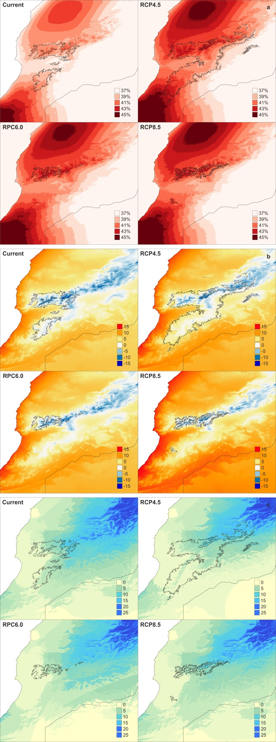
Online Resource 1 Climate trend maps based on bioclimatic variables with the highest contributions to the Cupressus atlantica distribution modelling for current (c. 1960–1990) and future climatic scenario (RPC; c. 2061–2080); a – isothermality (Bio3); b – minimim temperature of the coldest month (Bio6; °C) and c – precipitation of the driest quarter (Bio17; mm). The map was prepared with QGIS with a spatial resolution of 2.50′

