Forests protect aquatic communities from detrimental impact by volcanic deposits in the tropical Andes (Ecuador).
Encarni Montoya*, Frazer Matthews-Bird, Stephen J. Brooks and William D. Gosling.
* Corresponding author: Encarni Montoya. Department of Geography & Planning, School of Environmental Sciences, University of Liverpool, L69 7ZT Liverpool (UK). Phone: +44 (0) 151 794 9897. Email: emontoya@liverpool.ac.uk

Journal: Regional Environmental Change.

Supplementary Material: comprised of six tables and two figures.

Table S1. Approximated list of potential vegetation taxa currently present surrounding Laguna Baños based on field survey by Montoya in 2013 and regional data from Harling (1979) and Pillajo and Pillajo (2011). Family and plant type follow Jørgensen and León-Yánez (1999).
Taxa | Family | Type
Bomarea sp. | Alstroemeriaceae | Herb-Vine
Azorella sp. | Apiaceae | Herb
Baccharis sp. | Asteraceae | Shrub
Chuquiraga jussieui | Asteraceae | Shrub
Culcitium sp. | Asteraceae | Herb
Diplostephium rupestre | Asteraceae | Shrub
Hypochaeris sp. | Asteraceae | Herb
Loricaria spp. | Asteraceae | Shrub
Oritrophium sp. | Asteraceae | Herb
Senecio sp. | Asteraceae | Herb
Werneria sp. | Asteraceae | Herb
Draba sp. | Brassicaceae | Herb
Hypericum laricifolium | Clusiaceae | Shrub-Treelet
Lupinus sp. | Fabaceae | Herb-Subshrub
Gentiana sp. | Gentianaceae | Herb
Halenia sp. | Gentianacaee | Herb
Huperzia sp. | Lycopodiaceae | Herb
Lycopodium sp. | Lycopodiaceae | Herb
 | Melastomataceae | Shrub
Calamagrostis sp. | Poaceae | Herb
Festuca sp. | Poaceae | Herb
Jamesonia sp. | Pteridaceae | Herb
Ranunculus sp. | Ranunculaceae | Herb
Lachemilla sp. | Rosaceae | Herb-Subshrub
Polylepis sp. | Rosaceae | Shrub-Tree
Castilleja sp. | Scrophulariaceae | Herb
Valeriana microphylla | Valerianaceae | Shrub
Viola sp. | Violaceae | Herb

Table S2. List of main vegetation taxa currently present surrounding Laguna Pindo based on rough field survey by Luzuriaga in 2013 and Luzuriaga (2007). * refers to visual ID in field only by common name (Sapán negro). Family and plant type follow Jørgensen and León-Yánez (1999).
Taxon | Family | Type
Suarauia prainiana | Actinidaceae | Shrub-Treelet
Anthurrium sp. | Araceae | Epiphyte
Xanthosoma sp. | Araceae | Herb
Socratea exorrhiza | Arecaceae | Tree
Wettinia maynensis | Arecaceae | Tree
Pollalesta discolor | Asteraceae | Tree
Ceiba pentandra | Bombacaceae | Tree
Matisia cordata | Bombacaceae | Tree
Cordia alliodora | Boraginaceae | Tree
Dacryodes olivifera | Burseraceae | Tree
Macrolobium acaciifolium | Caesalpinaceae | Tree
Senna ruiziana | Caesalpinaceae | Tree
Viburnum ayavacense | Caprifoliaceae | Shrub
Cecropia engleriana | Cecropiaceae | Tree
Pouruma guianensis | Cecropiaceae | Tree
Clusia pallida | Clusiaceae | Hemiepiphyte
Vismia baccifera | Clusiaceae | Tree
Costus amazonicus | Costaceae | Herb
Alchornea leptogyna | Euphorbiaceae | Tree
Croton lechleri | Euphorbiaceae | Tree
Sapium marmieri | Euphorbiaceae | Tree
Laetia procera | Flacourtaceae | Tree
Heliconia stricta | Heliconiaceae | Herb
Aniba hostmannniana | Lauraceae | Tree
Nectandra coeloclada | Lauraceae | Tree
Ocotea cernua | Lauraceae | Tree
Calathea lutea | Maranthaceae | Herb
Miconia barbeyana | Melastomataceae | Shrub-Treelet-Tree
Miconia dielsi | Melastomataceae | Shrub-Tree
Miconia spledens | Melastomataceae | Shrub-Treelet-Tree
Miconia sp. | Melastomataceae | Shrub-Treelet-Tree
Cabralea canjerana | Meliaceae | Tree
Inga silanchensis | Mimosaceae | Tree
Inga velutina | Mimosaceae | Tree
Siparuna schimpffii | Monimiaceae | Shrub-Tree
Otoba parviflora | Myristicaceae | Tree
Eugenia cf. dibrachiata | Myrtaceae | Tree
Syzygium jambos | Myrtaceae | Tree
Piper aduncum | Piperaceae | Shrub-Treelet
Guadua angustifolia | Poaceae | Tree
Palicourea guianensis | Rubiaceae | Tree
Zanthoxylum kellermani | Rutaceae | Tree
Pouteria multiflora | Sapotaceae | Tree
Turpinia occidentalis | Staphylaceae | Tree
Celtis guianensis | Ulmaceae | Tree
Trema micrantha-t* | Ulmaceae | Tree
Vochysia braceliniae | Vocysiaceae | Tree

Table S3. Conventional (yr BP) and calibrated (cal yr BP) radiocarbon data used in the construction of chronologies for Laguna Baños and Laguna Pindo. * δ¹³C values were measured on a dual inlet stable isotope mass spectrometer (Thermo Scientific Delta V Plus) and are representative of δ¹³C in the pre-treated sample material. ¹ Weighted average; ª Bulk sediment samples; ^{b} Wood remains’ samples. Age-depth models have been already published in Matthews-Bird et al. (2017) and Montoya et al. (2018).
Publication code | Depth  (cm) | δ¹³C_{VPDB} (‰)* | ¹⁴C Age  (yr BP) | Calendar Age  (cal yr BP) 2σ | Median Age  (cal yr BP)¹
Laguna Baños
SUERC-50081ª | 24 | -26.4 | 1219 ± 35 | 1061-1189 | 1090
SUERC-54389ª | 40 | -24.7 | 1364 ± 41 | 1236-1346 | 1288
SUERC-43521ª | 63 | -26.0 | 1457 ± 36 | 1299-1402 | 1357
SUERC-43524ª | 98 | -23.5 | 1497 ± 38 | 1307-1420 | 1400
SUERC-43525ª | 202 | -26.7 | 1721 ± 38 | 1552-1711 | 1615
SUERC-54393ª | 312 | -25.3 | 3530 ± 42 | 3694-3920 | 3923
SUERC-50084ª | 356 | -25.3 | 4308 ± 37 | 4832-4964 | 4887
SUERC-43526ª | 402 | -27.3 | 5785 ± 39 | 6491-6671 | 6583
Laguna Pindo
SUERC-54395^{b} | 46 | -30.2 | 334 ± 42 | 289-470 | 377
SUERC-47634^{b} | 117 | -27.9 | 974 ± 36 | 769-923 | 846
SUERC-47635^{b} | 245 | -27.3 | 1973 ± 39 | 1812-1943 | 1882
SUERC-47569^{b} | 329 | -24.9 | 2335 ± 37 | 2293-2361 | 2292
SUERC-47572^{b} | 410 | -22.7 | 2829 ± 39 | 2781-2991 | 2887
SUERC-48854ª | 461 | -28.7 | 3974 ± 45 | 4241-4447 | 4366
SUERC-54385 ª | 483 | -27.9 | 4518 ± 40 | 4969-5300 | 5136
SUERC-54386 ª | 504 | -27.8 | 5641 ± 39 | 6298-6454 | 6375
SUERC-54387 ª | 510 | -27.4 | 6029 ± 42 | 6717-6946 | 6825
SUERC-61456 ª | 512 | -28.4 | 7897 ± 41 | 8542-8784 | 8669
SUERC-61457 ª | 514 | -28.1 | 11,697 ± 46 | 13,387-13,580 | 13,487
SUERC-61458 ª | 517 | -28.0 | 13,945 ± 54 | 16,581-17,073 | 16,783
SUERC-48855 ª | 521 | -28.0 | 13,982 ± 59 | 16,618-17,138 | 16,958
SUERC-54388 ª | 551 | -28.1 | 20,153 ± 104 | 23,907-24,450 | 24,178
SUERC-61459 ª | 579 | -29.5 | 28,332 ± 284 | 31,449-32,998 | 32,219
SUERC-45933 ^{b} | 605 | -23.6 | 33,417 ± 519 | 36,354-38,781 | 37,620
SUERC-61505 ª | 660 | -29.2 | 39,406 ± 1086 | 41,942-45,129 | 43,395
SUERC-56825 ^{b} | 725 | -26.7 | 43,425 ± 1788 | 44,725-49,907 | 47,078

Table S4. List of the pollen taxa found in Laguna Baños grouped in each of the assemblages established for community data comparison (Figure 3). Classification made following Jørgensen and León-Yánez (1999) and Pillajo and Pillajo (2011). Please note that Long distance forest refers to extra-local pollen whereas Local forest includes those taxa present in the woodland patches occurring within the páramo.
Herbs | Long distance forest | Local forest
Apiaceae  Apocynaceae  Arenaria  Asteraceae  Begonia-type  Calceolaria-type  Celastium/Stellaria  Chenopodiaceae/Amaranthaceae  Draba  Drymaria  Escallonia-type  Euphorbiaceae undiff.  Fabaceae undiff.  Gentianella  Heliamphora  Lachem/Lysiponia  Lamiaceae  Lamourouxia-type  Lysiponia-type  Malpighiaceae  Mimosaceae  Nertera-type  Papilionaceae  Plantago-type  Poaceae  Puya  Rumex  Sisyrrinchium  Styloceras  Valeriana  Vitaceae | Acalypha  Alchornea  Alnus  Artemisia  Bombacaceae  Bromeliaceae  Casearia-type  Cecropia  Celtis  Clethra-type  Cordyline-type  Croton-type  Dioscorea-type  Gunnera  Hedyosmum  Heliocarpus-type  Hesperomeles  Hyeronima  Myrica  Oreopanax  Pilea  Psycotria  Rubiaceae undiff.  Sapium-type  Sapotaceae  Solanaceae  Symplocos  Urticales  Vicia  Weinmannia | Dodonaea  Ericaceae  Miconia  Myrsine  Polylepis  Seriotheca  Thalictrum

Table S5. List of the most abundant pollen taxa found in Laguna Pindo grouped in each of the assemblages established for community data comparison (Figure 3). Classification made following Jørgensen and León-Yánez (1999).
Openness | Treelets/Shrubs/Lianas | Trees
Acidoton-type  Apiaceae  Begonia  Cecropia  Poaceae  Spermacoce  Pilea | Apocynaceae  Bromeliaceae  Ericaceae  Ficus  Ilex  Malpighiaceae  Menispermaceae  Mimosa  Mimosaceae (others)  Myrsine  Myrtaceae | Acalypha  Alchornea  Anacardiaceae  Araliaceae  Arecaceae  Asteraceae  Bignoniaceae  Burseraceae  Byrsonima  Casearia  Clethra-type  Croton  Dolyocarpus-type  Euphorbiaceae  Fabaceae  Genipa-type  Hedyosmum  Jatropra  Melastomataceae (others)  Miconia  Papilionidae  Phyllantus-type  Sapindaceae  Sapium-type  Sapotaceae  Urticales  Weinmannia  Xylosma-type

Table S6. List of chironomids taxa grouped in each of the assemblages established for community data comparison (Figure 3). Classification made following the dominance attained in the entire record (grouping of the dominant taxa), showed in Matthews-Bird et al. (2017).
 | Assemblage A | Assemblage B | Assemblage C
Laguna Baños | Polypedilum nubifer-type  Pseudochironomus | Cricotopus/Paratrichocladius type II  Corynoneura cf. coronara-type | Chaeotocladius  Chironomus anthracinus-type  Parachaetocladius  Parachironomus  Parametriocnemus-Paraphaenocladius  Pseudosmittia  Pseudorthocladius  Rheotanytarsus  Tanypodinae undiff.  Tanytarsus  Thiennemanniella
Laguna Pindo | Chaeotocladius  Chironomini type II  Corynoneura cf. coronara-type Polypedilum nubifer-type  Pseudorthocladius  Smittia  Tanytarsus type II | Beardius  Chironomus anthracinus-type  Dicrotendipes  Guttipelopia  Limnophyes  Parachironomus varus-type I  Paracricotopus  Phaenopsectra  Procladius  Pseudosmittia  Tanytarsus type I  Xestochironomus type II | Chironomus plumosus-type  Einfeldia  Endochironomus albipennis-type  Glyptotendipes  Labrundinia  Metriocnemus eurynotus  Parachironomus varus-type II  Parachironomus varus-type III  Stempellina  Xestochironomus type I

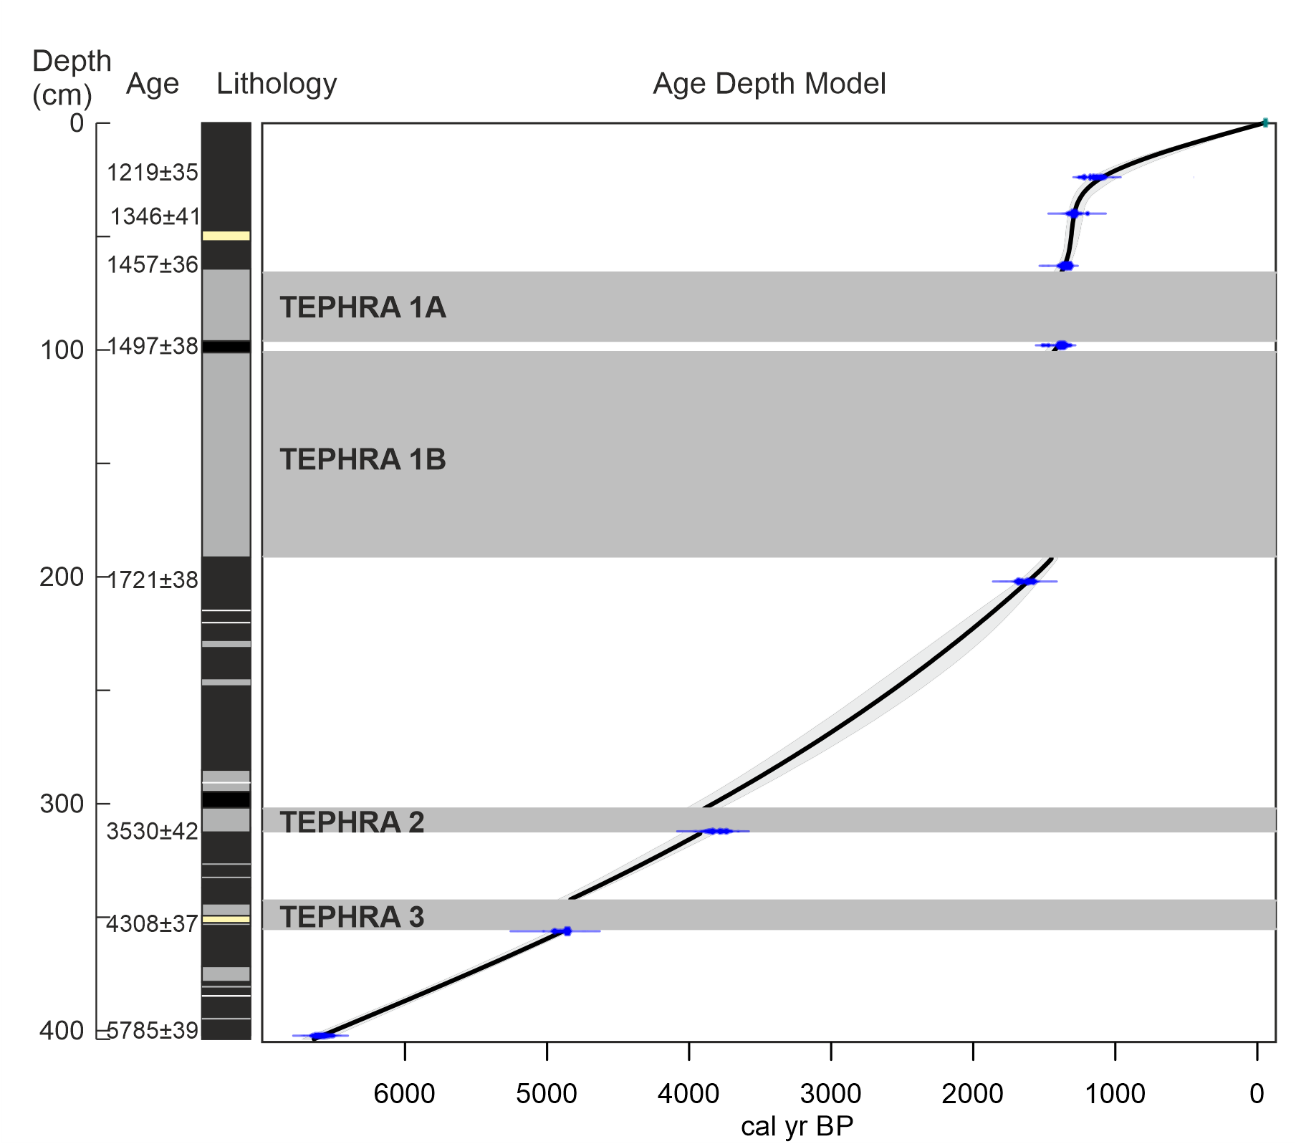
Figure S1. Simplified sediment lithology, radiocarbon dates (uncalibrated age), position of tephras (those > 5 cm wide are included in the age-depth model graph) and age-depth model of Laguna Baños. Colour key for sediment descriptions in the online version: Black: organic rich sediments (peat, clay); white: grey sandy intervals; grey: compacted grey clay sediments (tephra); yellow = sediment gap (no sediment). Please note the double deposition of the tephra under study in this work (Tephra 1), with the original ash fallout (1B) and the secondary deposit (1A). Modified from Matthews-Bird et al. (2017).
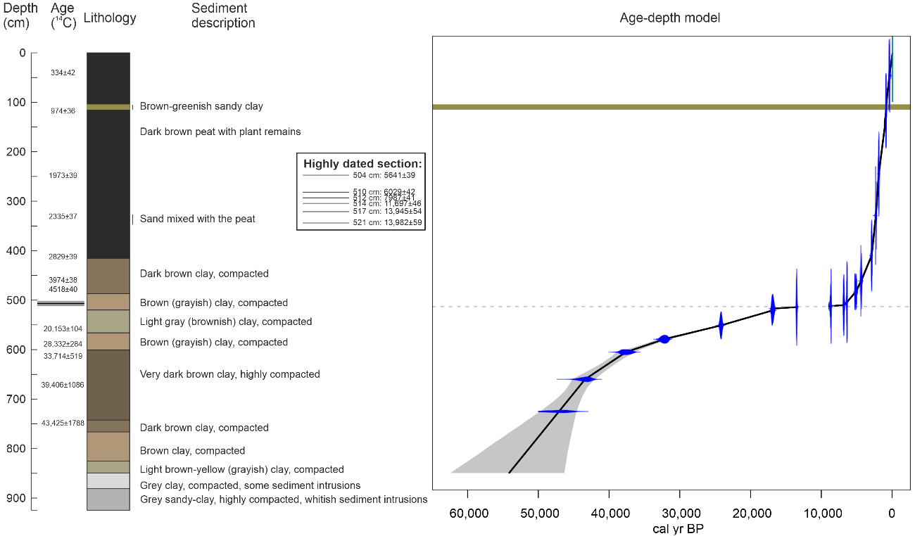
Figure S2. Simplified sediment description, radiocarbon dates (uncalibrated age), position of the tephra and age-depth model of Laguna Pindo. Dash line in the age-depth model marks the position of a hiatus, and the green band represents the Holocene tephra. Modified from Montoya et al. (2018).

References
Harling G (1979) The vegetation types of Ecuador - A brief survey. In: Larsen, K. & Holm-Nielsen, L.L. (Eds.) Tropical Botany. Academic press, New York, pp:165-174.
Jørgensen PM, León-Yánez S (Eds) (1999) Catalogue of the vascular plants of Ecuador. Missouri Botanical Garden Press, St. Louis (Missouri), USA.
Luzuriaga C (2007) Diagnóstico de flora estación biológica Pindo-Mirador. Universidad Tecnológica Equinoccial, Ecuador.
Matthews-Bird F, Brooks SJ, Gosling WD, Gulliver P, Mothes P et al. (2017) Aquatic community response to volcanic eruptions on the Ecuadorian Andean flank: Evidence from the palaeoecological record. J Paleolimnol 58: 437-453. doi: 10.1007/s10933-017-0001-0
Montoya E, Keen HF, Luzuriaga CX, Gosling WD (2018) Long-Term Vegetation Dynamics in a Megadiverse Hotspot: The Ice-Age Record of a Pre-montane Forest of Central Ecuador. Frontiers in Plant Science 9:196. doi: 10.3389/fpls.2018.00196
Pillajo P, and Pillajo M (2011) Plantas de Papallacta. Napo, Ecuador. Inkpirima, Quito, Ecuador.

