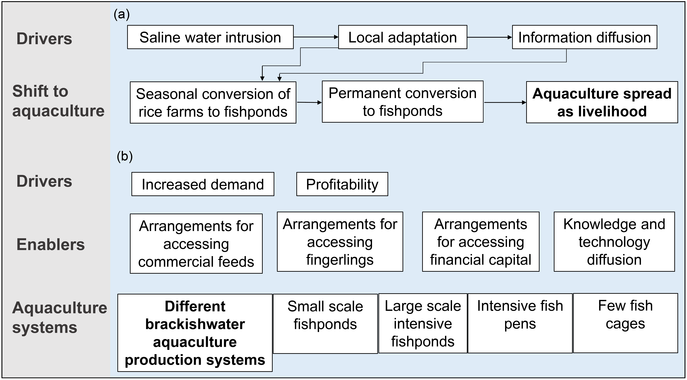
Fig. S2 (a) Factors influencing shift to aquaculture as a livelihood due to environmental change. (b) Factors contributing to the establishment of different aquaculture systems including intensive aquaculture.

