Supplementary Material
Typologies of European farmers: Approaches, methods and research gaps
Bartosz Bartkowski^{1,}*, Charlotte Schüßler¹, Birgit Müller²
¹ Helmholtz Centre for Environmental Research – UFZ, Department of Economics, Permoserstraße 15, 04318 Leipzig, Germany
² Helmholtz Centre for Environmental Research – UFZ, Department of Ecological Modelling, Permoserstraße 15, 04318 Leipzig, Germany
* corresponding author: bartosz.bartkowski@ufz.de, tel 0049 341 235 482402
1. Search strategy
Identification of studies via databases and registers

Articles from irrelevant disciplines and from outside Europe removed
Scopus (n = 376)
Web of Science (n = 298)

Duplicate records removed (n = 32)
Articles including search terms “farmer” and “type” identified from:
Scopus (n = 455)
Web of Science (n = 341)

Identification

Articles screened
(n = 90)
Records excluded (no typology, no original research, not European study)
(n = 63)

Records excluded (no typology, no original research)
(n = 7)
Articles subjected to full-text analysis
(n = 27)
Screening

Articles added based on own knowledge
(n = 20 + 16)

Articles included in review
(n = 36)
Included

Figure SM2.1: PRISMA flowchart, based on Page et al. (2021)

Final search strings applied to Web of Science and SCOPUS applied on 30 September 2020 (note: country and discipline-related restrictions were applied in a second step, manually using each database’s graphical interface)

WoS: TS = (farmer NEAR/0 typ*) NOT CU = (USA OR TAIWAN OR PARAGUAY OR CANADA OR PHILIPPINES OR INDONESIA OR MEXICO OR SYRIA OR AUSTRALIA OR PAKISTAN OR VIETNAM OR PEOPLES R CHINA OR TURKEY OR BOTSWANA OR ZIMBABWE OR COLOMBIA OR JAPAN OR GHANA OR ISRAEL OR LAOS OR SOUTH KOREA OR IRAN OR MALAYSIA OR BRAZIL OR UGANDA OR MOROCCO OR ARGENTINA OR BENIN OR PANAMA OR KENYA OR BURKINA FASO OR PERU OR SOUTH AFRICA OR CHILE OR EGYPT OR SAUDI ARABIA OR SUDAN OR ETHIOPIA OR TRINIDAD TOBAGO OR NEW ZEALAND OR MALI OR TUNISIA OR INDIA OR NIGER OR URUGUAY OR NIGERIA OR VENEZUELA ) NOT WC = (RADIOLOGY NUCLEAR MEDICINE MEDICAL IMAGING OR ENGINEERING BIOMEDICAL OR NUCLEAR SCIENCE TECHNOLOGY OR ONCOLOGY )

SCOPUS: TITLE-ABS-KEY ( farmer PRE/0 typ* ) AND ( LIMIT-TO ( AFFILCOUNTRY , "United Kingdom" ) OR LIMIT-TO ( AFFILCOUNTRY , "Netherlands" ) OR LIMIT-TO ( AFFILCOUNTRY , "Germany" ) OR LIMIT-TO ( AFFILCOUNTRY , "Sweden" ) OR LIMIT-TO ( AFFILCOUNTRY , "France" ) OR LIMIT-TO ( AFFILCOUNTRY , "Denmark" ) OR LIMIT-TO ( AFFILCOUNTRY , "Austria" ) OR LIMIT-TO ( AFFILCOUNTRY , "Belgium" ) OR LIMIT-TO ( AFFILCOUNTRY , "Italy" ) OR LIMIT-TO ( AFFILCOUNTRY , "Spain" ) OR LIMIT-TO ( AFFILCOUNTRY , "Switzerland" ) OR LIMIT-TO ( AFFILCOUNTRY , "Ireland" ) OR LIMIT-TO ( AFFILCOUNTRY , "Greece" ) OR LIMIT-TO ( AFFILCOUNTRY , "Poland" ) OR LIMIT-TO ( AFFILCOUNTRY , "Finland" ) OR LIMIT-TO ( AFFILCOUNTRY , "Portugal" ) OR LIMIT-TO ( AFFILCOUNTRY , "Romania" ) OR LIMIT-TO ( AFFILCOUNTRY , "Hungary" ) OR LIMIT-TO ( AFFILCOUNTRY , "Malta" ) OR LIMIT-TO ( AFFILCOUNTRY , "Norway" ) OR LIMIT-TO ( AFFILCOUNTRY , "Undefined" ) ) AND ( EXCLUDE ( SUBJAREA , "MEDI" ) OR EXCLUDE ( SUBJAREA , "BIOC" ) OR EXCLUDE ( SUBJAREA , "HEAL" ) OR EXCLUDE ( SUBJAREA , "PHYS" ) )

2. Supplementary figures
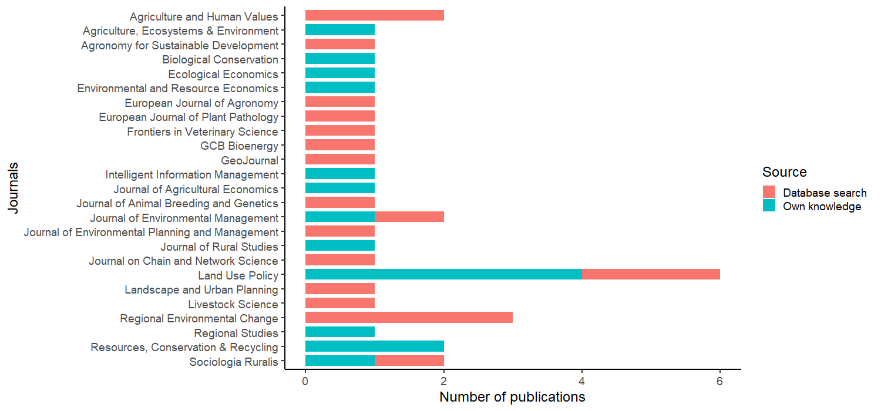
Figure SM2.2. Number of publications per journal. Discriminating between publications included based on database search (red) or own knowledge (blue).
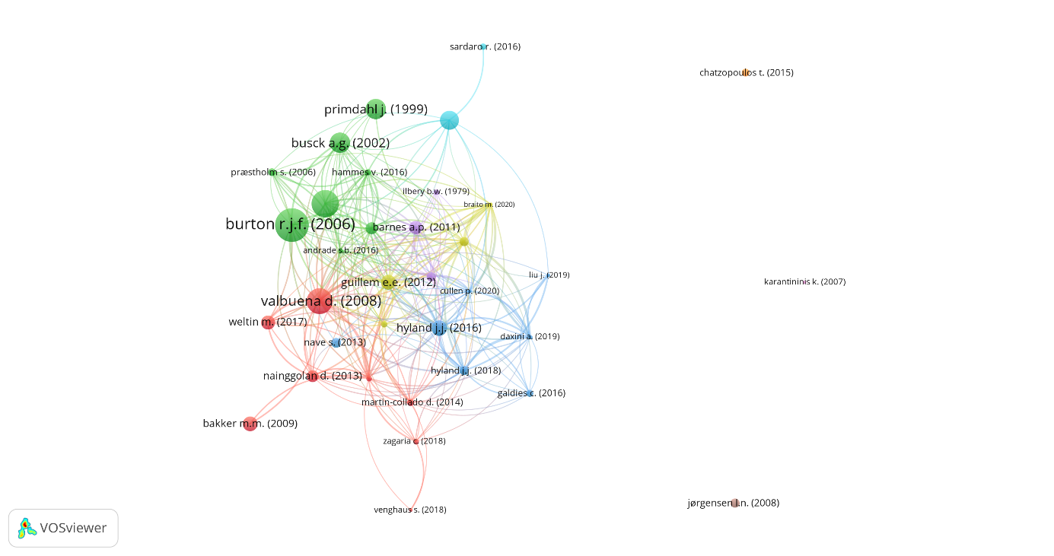
Figure SM2.3. Bibliographic coupling among European farmer typology studies (size of nodes reflects number of overall citations; edges reflect that the linked publications cited the same publication(s)). The figure was generated in VOSviewer, version 1.6.16, using citation data from the Scopus database (van Eck and Waltman, 2010).
References
Page, M.J., McKenzie, J.E., Bossuyt, P.M., Boutron, I., Hoffmann, T.C., Mulrow, C.D., Shamseer, L., Tetzlaff, J.M., Akl, E.A., Brennan, S.E., Chou, R., Glanville, J., Grimshaw, J.M., Hróbjartsson, A., Lalu, M.M., Li, T., Loder, E.W., Mayo-Wilson, E., McDonald, S., McGuinness, L.A., Stewart, L.A., Thomas, J., Tricco, A.C., Welch, V.A., Whiting, P., Moher, D., 2021. The PRISMA 2020 statement: an updated guideline for reporting systematic reviews. BMJ n71. https://doi.org/10.1136/bmj.n71
van Eck, N.J., Waltman, L., 2010. Software survey: VOSviewer, a computer program for bibliometric mapping. Scientometrics 84, 523–538. https://doi.org/10.1007/s11192-009-0146-3

