Journal name: Regional Environmental Change

Supplementary material of.
Can the cropping systems of the Nile basin be adapted to climate change?
Albert Nkwasa¹, Katharina Waha², Ann van Griensven^{1,3}
¹ Hydrology and Hydraulic Engineering Department, Vrije Universiteit Brussel (VUB), 1050 Brussel, Belgium
²CSIRO, Agriculture & Food, 306 Carmody Rd, St Lucia, QLD, Australia
³ Water Science & Engineering Department, IHE Delft Institute for Water Education, 2611 AX Delft, The Netherlands
Correspondence to: Albert Nkwasa (albert.nkwasa@vub.be)

Supplementary material B: Hydrological Mass Balance calibration (HMBC)
HMBC utilizes soft data (information on individual processes e.g., surface runoff, ET and groundwater) to enhance the calibration process for large scale models at lower computation and time costs. In this study, the surface runoff ratio, ET ratio and ground water ratio between the observed and simulated values improved towards the objective ratios derived from long-term data, resulting in an improvement in the discharge simulations. Fig. B1 (a) and (b) show the statistical comparison of discharge at the GRDC gauging stations with 75% of the stations having a Nash Sutcliffe efficiency (NSE) of > 0.1, a significant improvement to the default model results with all stations having an NSE < 0. In addition, 90% of the stations had a Percent of Bias (PBIAS) with in ± 20%.
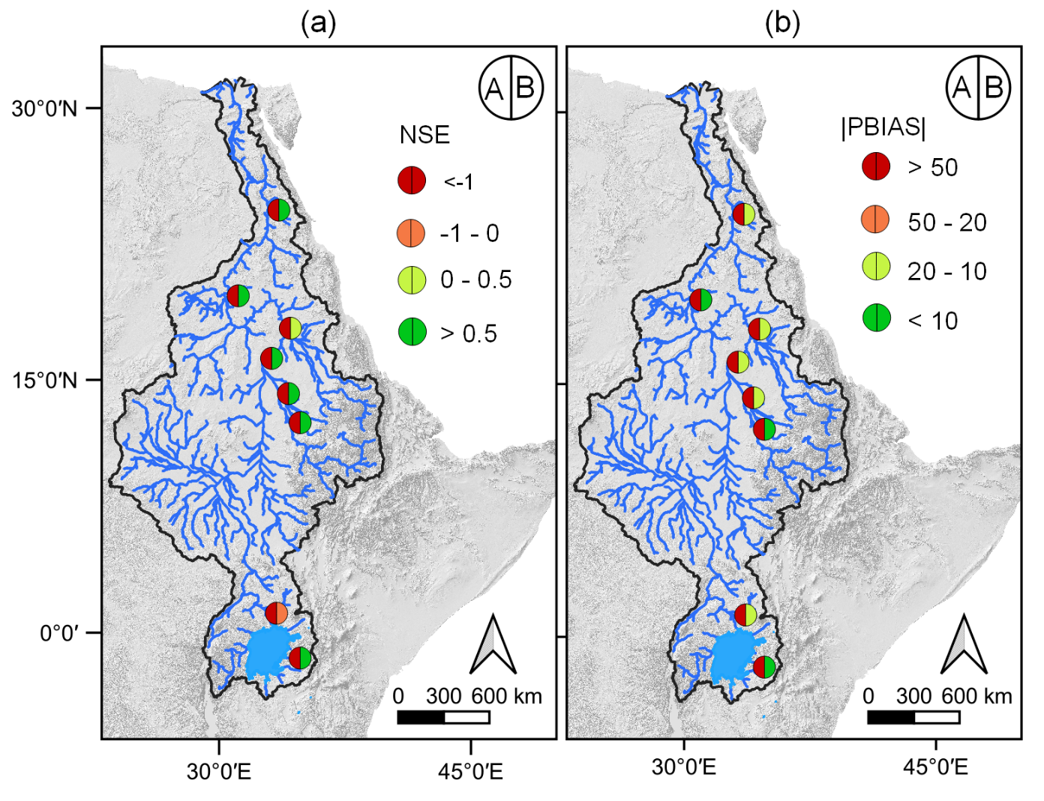
Fig. B1: Model performance of NSE (a) and PBIAS (b) at flow gauging stations after implementing HMBC (A – default model and B – revised model) (extract from Nkwasa et al., 2022)
References
Nkwasa, A., Chawanda, C.J., van Griensven, A., 2022. Regionalization of the SWAT+ model for projecting climate change impacts on sediment yield: An application in the Nile basin. J. Hydrol. Reg. Stud. 42, 101152. https://doi.org/10.1016/j.ejrh.2022.101152

