Journal name: Regional Environmental Change

Supplementary material of.
Can the cropping systems of the Nile basin be adapted to climate change?
Albert Nkwasa¹, Katharina Waha², Ann van Griensven^{1,3}
¹ Hydrology and Hydraulic Engineering Department, Vrije Universiteit Brussel (VUB), 1050 Brussel, Belgium
²CSIRO, Agriculture & Food, 306 Carmody Rd, St Lucia, QLD, Australia
³ Water Science & Engineering Department, IHE Delft Institute for Water Education, 2611 AX Delft, The Netherlands
Correspondence to: Albert Nkwasa (albert.nkwasa@vub.be)

Supplementary material, C: Crop yield validation
C.1 Crop yields validation
The yields for all the three crops were manually calibrated by adjusting the harvest index (harv_idx) and radiation use efficiency (RUE) parameters (Table C1).
Table C1: Adjusted parameters for crop yield in SWAT+
Parameter |  | Crop
 |  | Wheat | Maize | Soybean
Harvest index | Default value | 0.42 | 0.55 | 0.31
 | Calibrated value | 0.39 | 0.58 | 0.50
RUE | Default value | 35 | 40 | 25
 | Calibrated value | 34 | 42 | 29
As shown in Table C2, the regional annual average simulated crop yields were well adjusted to the observed yields as the SWAT+ model predicted well the crop yields with a small relative error calculated as;
$relative error=\left(\frac{simulated yield - observed yield}{observed yield}\right)x 100$
In principle, slightly higher simulated yields are expected since the model does not account for diseases, weeds, and pests (crop yields are not affected by any pest infestation) or extreme flooding situations that could affect crop growth which may possibly explain the discrepancies. Additionally, with the adoption of fixed planting and harvest dates, we have ignored the modification of dates that could have been done by farmers at a local scale due to weather conditions. Nevertheless, the regional crop yield validation results are satisfactory over the long-term average with relative error less than 7%.
Table C2: Analysis of simulated and observed crop yield for (1980 - 2012)
Crop | Average Yield (ton/ha) |  |  | Range
Crop | Observed | Simulated |  | Observed | Simulated | Relative error (%)
maize | 1.95 ± 0.21 | 2.08 ± 0.32 |  | 1.46 – 2.40 | 1.38 – 3.06 | 6.67
wheat | 1.99 ± 0.24 | 2.02 ± 0.29 |  | 1.42 – 2.50 | 1.50 – 2.60 | 1.51
soybean | 0.91 ± 0.13 | 0.87 ± 0.19 |  | 0.73 – 1.24 | 0.48 – 1.41 | - 4.40
Furthermore, weighted country average yields for the three crops in this study in 10 Nile basin countries were compared to FAO yields (Figure C1, C2 and C3) for the same period (1980 – 2012). The Nash-Sutcliffe efficiency (NSE) was calculated as an additional measure of agreement (Nash and Sutcliffe, 1970). The SWAT+ country average crop yields broadly compared well with the FAO yields with NSE > 0.4 and relative error < 15% for the selected crops.
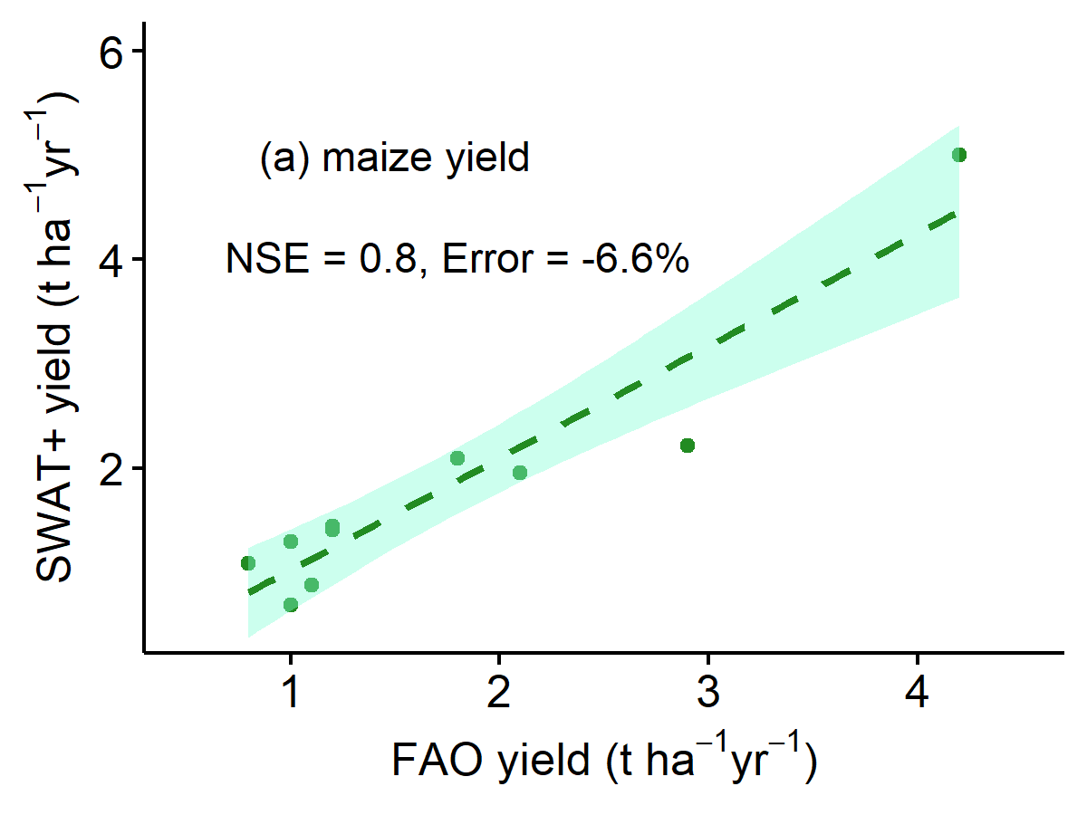
Fig. C1: Comparison of FAO and SWAT+ maize yields. One point in the graph represents one country.
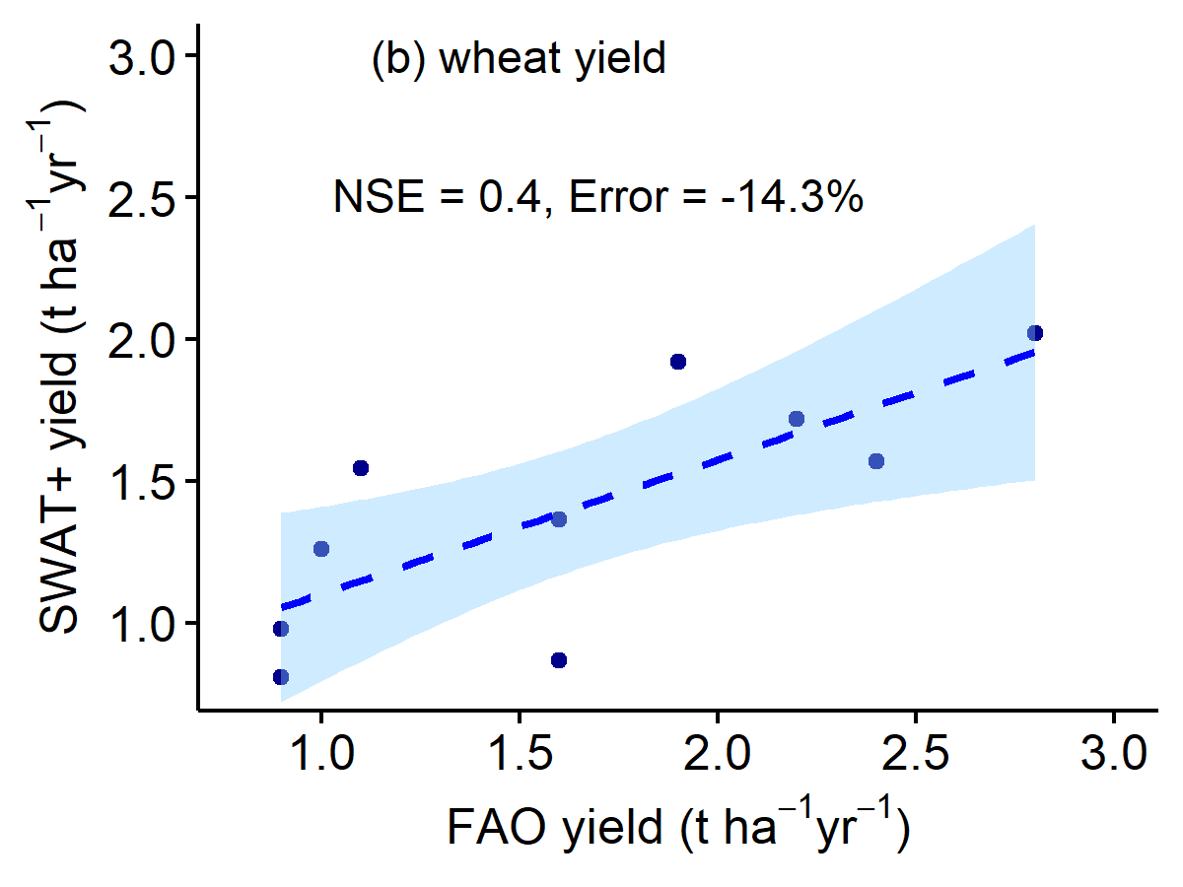
Fig. C2: As Figure C1 but for wheat.
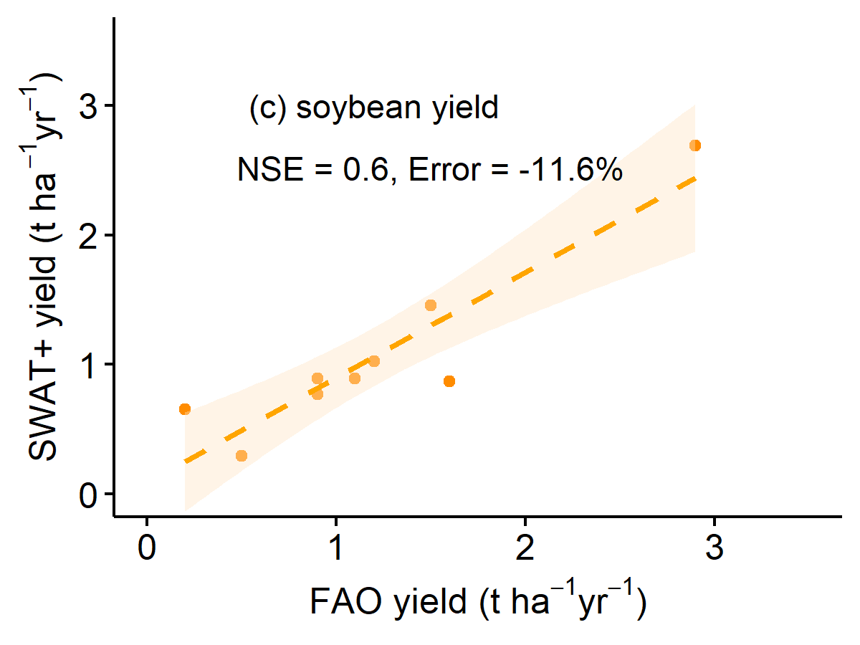
Fig. C3: As Figure C1 but for soybean.
References
Nash, J.E., Sutcliffe, J.V., 1970. River flow forecasting through conceptual models part I — A discussion of principles. J. Hydrol. 10, 282–290. https://doi.org/10.1016/0022-1694(70)90255-6

