Journal name: Regional Environmental Change

Supplementary material of.
Can the cropping systems of the Nile basin be adapted to climate change?
Albert Nkwasa¹, Katharina Waha², Ann van Griensven^{1,3}
¹ Hydrology and Hydraulic Engineering Department, Vrije Universiteit Brussel (VUB), 1050 Brussel, Belgium
²CSIRO, Agriculture & Food, 306 Carmody Rd, St Lucia, QLD, Australia
³ Water Science & Engineering Department, IHE Delft Institute for Water Education, 2611 AX Delft, The Netherlands
Correspondence to: Albert Nkwasa (albert.nkwasa@vub.be)

Supplementary material D: Leaf Area Index validation
The simulated LAI shows a strong seasonality with remote sensing (RS) derived LAI in Fig. D1 and Fig. D2 for the single and double cropping systems respectively. In the Upper Blue Nile (Fig. D1a) and Fig. D1b), the LAI peaks between the months of July to October for the single cropping system. However, the double cropping system (Fig. D2d) has an additional peak in the months of December to April (irrigated second cropping season) that coincides with the dry period (October to January) and extends into the short rainy period (February to May). According to Musayev et al. (2021), farmers that irrigate can have an additional cropping season in either the dry period or the short rainy period. The growing season of double cropping system in the Victoria catchment is well aligned with the two rainy seasons (Fig. D2a) and Fig. D2b)
However, in the Victoria catchment, located in the equatorial region, we observe a single growing season in areas where we have two rainfall seasons (Fig. D1c) and Fig. D1d). This shows that there is still potential for crop intensification by adding a second cropping season (sequential cropping) during the second rainy season or some multiple cropping areas are not captured in the multiple cropping dataset (Waha et al., 2020) used. It is worth mentioning that in other parts of the basin with only one rainy season, potentially a second irrigated season could be added if resources and management practices allow.
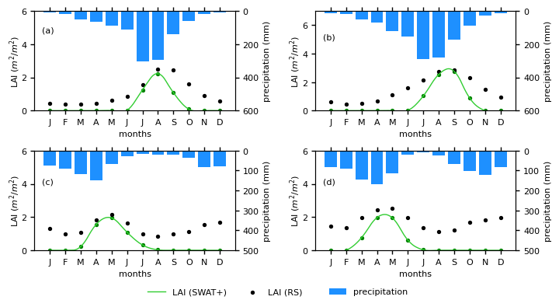
Fig. D1: Seasonal LAI simulations of single cropping systems for selected HRU’s for; (a) rainfed wheat and (b) rainfed maize in the Upper Blue Nile catchment; (c) rainfed maize and (d) rainfed soy in the Victoria catchment
In the Nile delta (Fig. D2c), we only have an irrigated double cropping system whose LAI signal agrees with the remote sensing signal. In both Fig. D1 and Fig. D2, the result of the different catchments in the Nile basin show that the crop phenology is strongly coupled to rainfall seasonality in regard to both spatial and temporal patterns in the basin. It is also worth noting that the LAI signal of the remote sensing does not go to zero due to the likely presence of other vegetation in a pixel e.g weeds unlike the LAI signal from the SWAT+ model that goes to zero once the crop is harvested. Additionally, 3.4 % of crop area had a triple cropping system which was adjusted to a double cropping system as the LAI from the seasons mismatched the LAI from RS. Another limitation of this LAI validation is that validation was only done on the largest HRUs that occupied the catchments. This may not be representative of the whole catchment e.g overlaps in seasonal cropping in different parts of the region. Hence, for local application, a detailed validation is required with farmer practices.
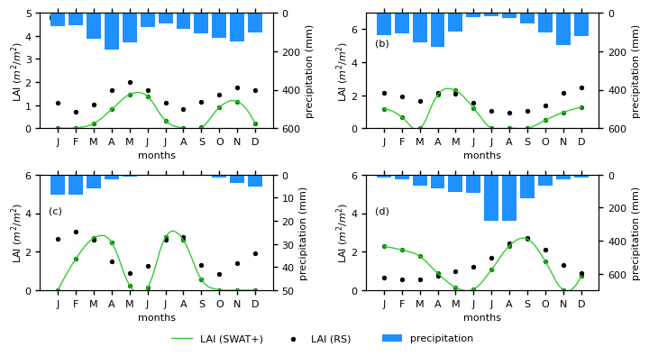
Fig. D2: Seasonal LAI simulations of double cropping systems for; (a) irrigated wheat and (b) irrigated soy in the Victoria catchment; (c) irrigated wheat in the Nile delta; (d) irrigated maize in the Upper Blue Nile catchment
References
Musayev, S., Mellor, J., Walsh, T., Anagnostou, E., 2021. Development of an Agent-Based Model for Weather Forecast Information Exchange in Rural Area of Bahir Dar, Ethiopia. Sustainability 13, 4936. https://doi.org/10.3390/su13094936
Waha, K., Dietrich, J.P., Portmann, F.T., Bondeau, A., Herrero Acosta, M., 2020. Multiple Cropping Systems of the World. V2 CSIRO Data Collect. https://doi.org/10.25919/5f1f7bb3270bb

