Appendix 1: Relative location of preserved vegetation type that falls under Critical Biodiversity Areas (CBAs) in the Free State National Botanical Garden.
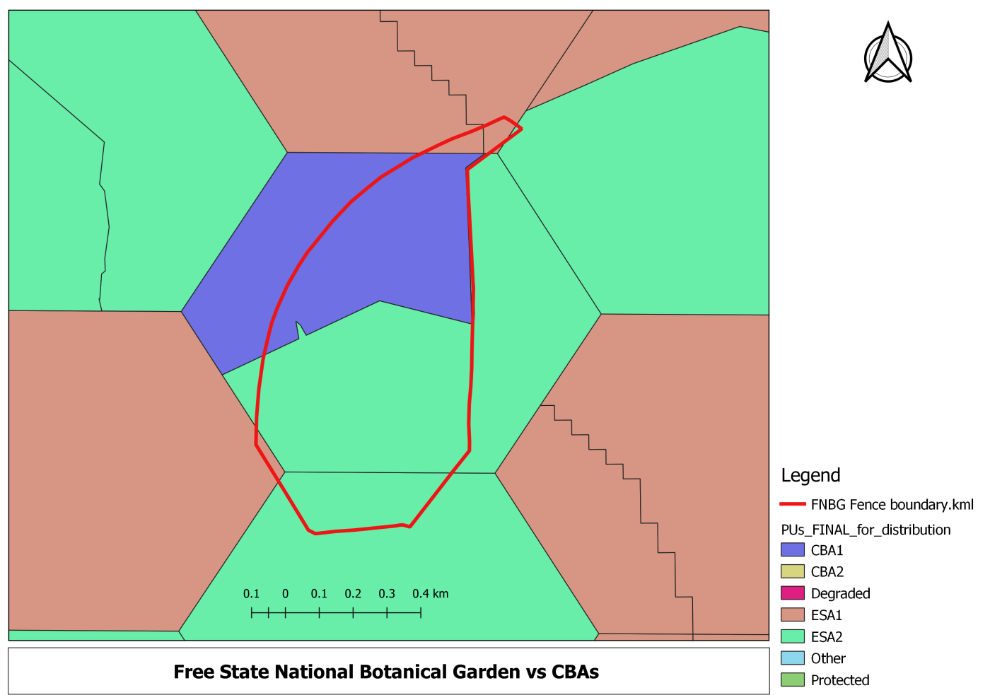

Appendix 2: Critical Biodiversity Area (CBA) categories as per SANBI 2017
CBA Map Category | Description
Protected area | Areas that are formally protected in terms of the Protected Areas Act.
CBA | Areas that must remain in good ecological condition in order to meet biodiversity targets. CBAs are often distinguished into two sub-categories:  CBA1/CBA Irreplaceable: These are areas that are irreplaceable or near-irreplaceable (i.e. high selection frequency) for meeting biodiversity targets. There are no, or very few other, options for meeting biodiversity targets for the features associated with these areas.  CBA2/CBA Optimal: These are areas that have been selected as the best option for meeting biodiversity targets, based on complementarity, efficiency, connectivity and/or avoidance of conflict with other uses of land or resources.
ESA1 | Areas that must remain in at least fair ecological condition in order to meet biodiversity targets, support ecological functioning, or deliver ecosystem services.
ESA2 | Areas in which further deterioration in ecological condition must be avoided in order to meet biodiversity targets, support ecological functioning, or deliver ecosystem services.
Other Natural Areas | Natural or semi-natural areas that are not required to meet biodiversity targets, support ecological functioning, or deliver ecosystem services (provided that protected areas, CBAs and ESAs remain intact).
No Natural Remaining | Areas in which no natural habitat remains.

Appendix 3: Overall step-by-step layout of the process of vegetation cover data analysis: A) a process for sourcing satellite images; B) the selection of a combination of channels; and C) the distribution of the vegetation cover in the study area according to the NDVI index analysis.

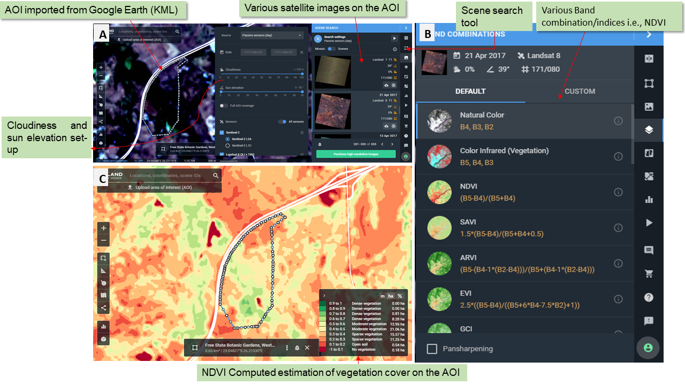

Appendix 4: The human settlement encroachment within buffer area of 1 km width outside the FSNBG boundary (Satellite imagery of 2021).

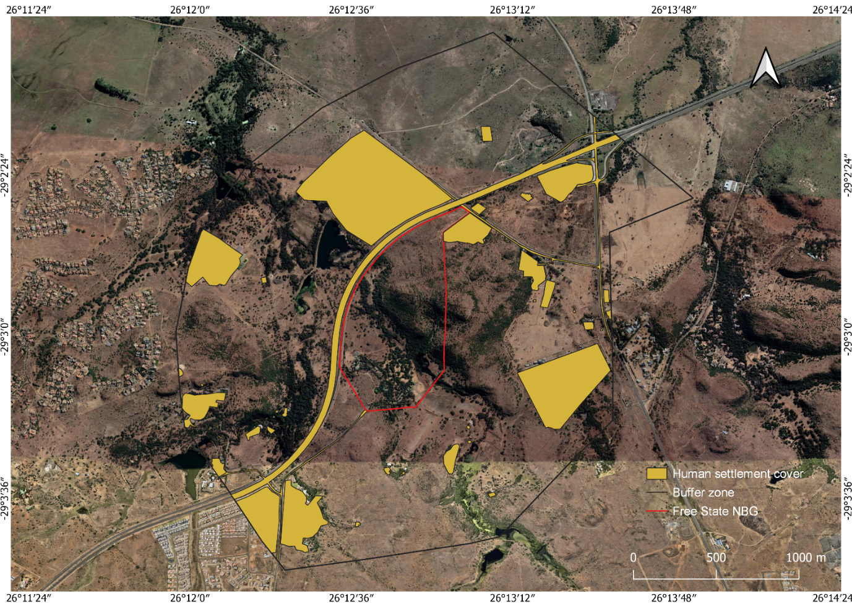

Appendix 5: National Environmental Management: Biodiversity Act No. 10 of 2004- Alien and Invasive Species Regulations (NEM:BA-AIS Regs) 2020.

NEM:BA-AIS Regs | Description
Category 1a | Invasive species that must be combated and eradicated. Any form of trade or planting is strictly prohibited.
Category 1b | Invasive species that must be controlled and, wherever possible, removed and destroyed. Any form of trade or planting is strictly prohibited.
Category 2 | Invasive species deemed to be potentially invasive, in that a permit is required to carry out a restricted activity. Category 2 species include commercially important species such as pine, wattle, and gum trees. Plants in Riparian areas are Category 1b.
Category 3 | Invasive species that may remain in prescribed areas or provinces. Further planting, propagation, or trade is prohibited. Plants in Riparian areas are Category 1b.

Appendix 6: Aerial photographs of the study site (FSNBG) showing the encroachment of woody cover over past 78 years.

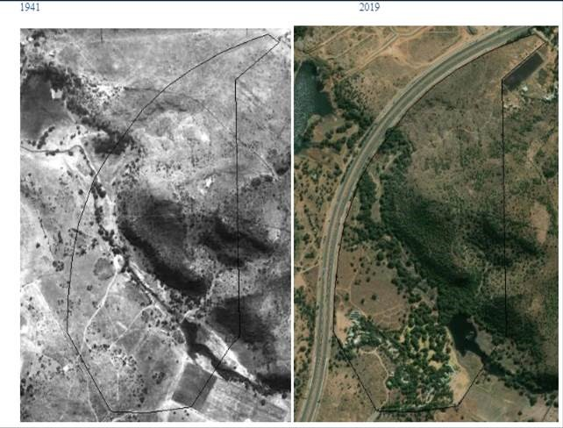

Appendix 7: Wald statistics for comparison of counts of alien and invasive plant species in different classification criteria (country of origin, NEM:BA-A&IS categories, and plant life growth forms) recorded in the FSNBG.
Predictor variables | Parameter | B | Std. error | 95% Wald confidence interval |  | Hypothesis test
 |  |  |  | Lower | Upper | Wald chi-square | df | P-value.
Continental level | Africa | .521 | 1.1000 | -1.635 | 2.677 | .224 | 1 | 0.636
 | Asia | -.368 | .7288 | -1.796 | 1.060 | .255 | 1 | 0.613
 | Australia | -1.435 | .8057 | -3.015 | .144 | 3.174 | 1 | 0.075
 | North America | -.123 | .7153 | -1.525 | 1.279 | .030 | 1 | 0.863
 | South America | 0ª
NEMBA categories | Category 1b | -1.371 | 1.1125 | -3.552 | .809 | 1.519 | 1 | 0.218
 | Category 2 | -1.328 | 1.5678 | -4.401 | 1.745 | .718 | 1 | 0.397
 | Category 3 | -2.258 | 1.2198 | -4.649 | .133 | 3.427 | 1 | 0.064
 | Unknown | 0ª
Plant growth form | Climber | -2.566 | .8901 | -4.310 | -.821 | 8.308 | 1 | 0.004
 | Herb | -2.206 | .9203 | -4.010 | -.403 | 5.748 | 1 | 0.017
 | Succulent | -1.614 | .7448 | -3.074 | -.154 | 4.697 | 1 | 0.030
 | Woody | 0ª
 | (Scale) | 1^{b}

