Appendix.
Table A1. Definition of Main Variables for Regression Analysis

Table A2. Descriptive Statistics (N= 401)

Table A3. Robustness Analysis: Ordered Logit and Ordered Probit Estimation
Note: Variables as defined in Table A1. Robust standard errors in parentheses; *** indicates significance at the 1% level, ** at 5%, * at 10%.

Table A4. Construction of risk index

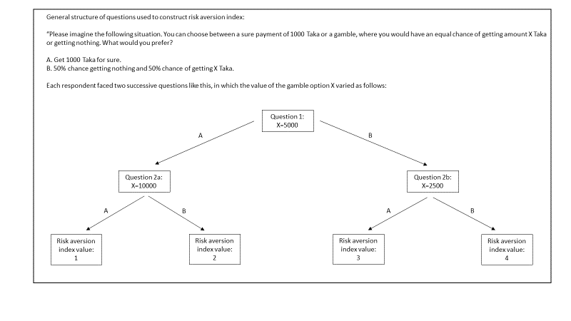

Table A5. Construction of impatience index
a