Supplementary Information

Recreation and its synergies and trade-offs with other ecosystem services of (pre-)Alpine grasslands

Supplementary Information
- Fodder production: Remote sensing of cutting intensities

The timing and frequency of cutting events derived from the satellite data (Sentinel-2) was aggregated from pixel-resolution (10m x 10m) to parcel level with a majority approach. The detected cuts were validated with an independent dataset and resulted in an accuracy (F1-Score) of 0.64 for entire Germany (Reinermann et al. 2022) and 0.82 for the Ammer catchment area study region.

- Calculation of total payments for Agri-Environmental Schemes per field

Our calculation of payments for Agri-Environmental-Schemes (AES), used as an indicator for payments for non-provisioning ecosystem services, was based on data from the Integrated Administration and Control System (IACS) for the year 2019. The ICAS dataset includes the spatial location of fields, the use of the field (crop), and the type of AES (101 different measures in 2019, including some that are only offered as an extension to a basic measure). Two different AES programs exist in Bavaria, the cultural landscape program (KULAP) and the nature conservation program (VNP). To calculate an estimate of payments per field, we used additional information published annually by the Bavarian Ministry of Food, Agriculture and Forestry (“Merkblatt AUM 2019-2023”). In particular, the remuneration height for adopting a certain AES on the fields and what types of AES can be combined on one field. The combination of several measures (in 2019 up to 11 AES on one field), complicates the calculation of the total sum. Regarding the payment, different cases of combination types are possible:
- “additive” type = the sum of all individual AES (original remuneration height) is paid
- “higher” type = only the highest original AES remuneration height is paid
- “top-up” type = a (smaller) top-up payment for an additional AES is granted

The methodological approach is not yet published elsewhere. In the following, we illustrate the steps undertaken in detail.

Step 1: Identifying clearly assignable cases
For the majority of fields with AES (94.3 %), we could assign the payment height with a high certainty. Those were:
- Fields with only one single AES (66.7 %)
- Fields with two “additive” measures (KULAP/VNP) or exclusively VNP measures, being all “additive” (23.2 %)
- Fields with the combination type “higher” of two AES (3.4 %)
- Fields with the KULAP measures “organic farming” in combination with certain “additive” VNP measures (0.8 %)
- Fields with the combination type “top-up” of two AES (0.2 %)

Step 2: Assigning the most plausible payment height to ambiguous cases
The following procedure was taken for the remaining “complicated” cases of three or more AES on one field (5.7 % of fields with AES), with no combination type assigned after step 1. Certain AES require that farms participate fully (e.g., subsidies for organic farming are only paid if the entire farm is certified organic) or with an entire branch of operation (e.g., all areas that are used to cultivate forage). These requirements for participation in measures are specifically marked (“betriebsbezogen” / “betriebszweigbezogen”). We assumed that those AES were sometimes added to all fields of a farm (or branch of operation of a farm) in the database without considering if the resulting combination of AES is possible. Therefore, we differentiated three cases for KULAP measures:
- Only AES applicable to the entire farm / a branch of operation were present on a field => assignment of type “higher” (2.0 %)
- Apart from the AES applicable to the entire farm / a branch of operation, only combinations of measures with the type “additive” remained => we added up all original remuneration heights for those ones (1.3 %)
- Apart from the AES applicable to the entire farm / a branch of operation, only combinations of measures with the type “higher” remained => highest sum was chosen (0.4 %)
No undefined combination types of KULAP remained after this procedure.

For the remaining ambiguous combinations of KULAP with VNP measures (2.0 %), we assumed that after the removal of AES applicable to the entire farm / a branch of operation, the remaining AES (in most cases only “additive” VNP measures) received the full sum of all individual measures (“additive” combinations).

Step 3: Accounting for alteration of payments
Under certain circumstances, there is no payment for a certain measure, or the payment height is reduced or increased. This is true for the following cases (all of these were corrected accordingly):
- The AES measure is not compatible with a certain field use
- For a specific area setting, payments will not be made (because of existing legal requirements that do not allow for the payment of subsidies). Those areas are marked with four different codes in the dataset (e.g., no liquid manure allowed)
- A reduced livestock density (B20, B21) receives only a reduced payment for areas classified as alpine pastures (use code 455)
- Organic farming (B10) receives higher payment rates for permanent crops and for vegetable production.

Step 4: Making assumptions about payment heights
As some AES do not have a fixed remuneration per area but are based on other factors, we had to make certain assumptions in a few cases. Those were:
- For the measures subsidizing low-emission fertilizer application (B25 / B26), payments are based on the volume of liquid manure applied. As the quantities were unknown, we calculated the payment based on the Bavarian average per hectare (personal communication with the Bavarian Ministry of Food, Agriculture and Forestry).
- For the measure subsidizing the mowing of steep slope meadows (B51), we used the payment height applicable for slopes between 30-49 %
- For the measure subsidizing alpine herding (B52), we used the payment height applicable for (accessible) alpine pasture units with a size smaller than 60 hectares.
- For the measures subsidizing high-stem orchards (B57/H28/W07), payments are made per tree. As tree numbers per area are unknown, we calculated the payment based on the Bavarian average per hectare (personal communication with the Bavarian Ministry of Food, Agriculture and Forestry).
- For the measure subsidizing pasture grazing in summer (B60) payments are made per livestock unit. As those livestock units were unknown, we calculated the payment based on the Bavarian average per hectare (personal communication with the Bavarian Ministry of Food, Agriculture and Forestry).

Step 5: Validation of results
- Due to the complex payment allocations and assumptions taken, the results are only an approximation of the actual payments. To validate our calculated payment heights, we compared them to a freely available dataset of payments per farm (with indicated zip code). Payments for organic farming are listed as a separate category. Not considered in this “validation” dataset are the location of fields, which could be in a different zip code than the farm’s address or even outside Bavaria. Our calculated payments and the “validation” dataset were aggregated per zipcode and then compared. Comparison of payments for organic farming:
- Our calculated payments were 7.1 % lower than the “validation” data.
The deviation could be due to (i) organic farms situated in Bavaria that have fields located outside of Bavaria or (ii) mistakenly removed payments for organic farming in “complicated combinations” (see step 2).
- The correlation coefficient of payments per zip code area was 0.90
- Comparison of total payments (without payments for grazing premiums, as they are most likely not included in the “validation” data):
  - Our calculated payments were 50.0 % higher than the “validation” data.
This deviation could be due to (i) farms/payment receiver situated outside of Bavaria that have fields located in Bavaria or (ii) assumptions in the calculation of payment heights that lead to an overestimation. The mapped deviations per zip code show highest overestimates in two areas that are military training areas (payment receivers likely not based in Bavaria, or not included in the “validation data”) as well as in the northern and southern border regions of Bavaria.
- The correlation coefficient of payments per zip code area was also 0.90

- Classification of Agri-environmental schemes

We classified agri-environmental schemes into several categories based on their impacts on biodiversity and ecosystem services.

Table S1. Details on the classification of the agri-environmental schemes applicable to permanent grassland into classes used for the statistical analysis. KULAP = Cultural Landscape Program. VNP = Nature Conservation Program.
AES  code | AES_description | AES program | AES  scope | Area  type | AES classification | Value for biodiversity
B10 | Ökologischer Landbau | KULAP | farm | all | organic farming | 2a
B11 | Ökokontrollverfahren | KULAP | farm | all | organic farming | 2a
B20 | Extensive Grünlandnutzung und max. 1,40 GV/ha HFF mit Verzicht auf Mineraldüngung | KULAP | branch of operation | grassland | extensive grassland mgmt. | 2a
B21 | Extensive Grünlandnutzung und max. 1,76 GV/ha HFF (Almen/Alpen) mit Verzicht auf Mineraldüngung | KULAP | branch | grassland | extensive grassland mgmt. | 2a
B22 | Extensive Grünlandnutzung und max. 1,40 GV/ha HFF (Almen/Alpen) mit Verzicht auf Mineraldüngung | KULAP | branch | grassland | extensive grassland mgmt. | 2a
B23 | Extensive Grünlandnutzung und max. 1,76 GV/ha HFF (Almen/Alpen) mit Verzicht auf Mineraldüngung | KULAP | branch | grassland | extensive grassland mgmt. | 2a
B25 | Emissionsarme Wirtschaftsdüngerausbringung (Eigenmechanisierung) | KULAP | farm | all | fertilization technique | 3
B26 | Emissionsarme Wirtschaftsdüngerausbringung (überbetriebliche Ausbringung) | KULAP | farm | all | fertilization technique | 3
B28 | Umwandlung von Ackerland in Grünland entlang von Gewässern und in sonstigen sensiblen Gebieten | KULAP | field | grassland | other | 2a
B29 | Umwandlung von Ackerland in Grünland in der Gebietskulisse Moore | KULAP | field | grassland | other | 2a
B30 | Extensive Grünlandnutzung entlang von Gewässern und in sonstigen sensiblen Gebieten, Verzicht auf jegliche Düngung und chemischen  Pflanzenschutz (Förderkulisse) | KULAP | field | grassland | extensive grassland mgmt. | 2a
B40 | Artenreiches Grünland | KULAP | field | grassland | extensive grassland mgmt. | 1a
B41 | Grünland an Waldrändern | KULAP | field | grassland | extensive grassland mgmt. | 1a
B49 | Erneuerung von Hecken und Feldgehölzen | KULAP | field | all | other | 1a
B50 | Heumilch, (nur kombinierbar mit B20/B21/B10) | KULAP | branch | grassland | extensive grassland mgmt. | 2a
B51 | Steilhangwiesen (Erosionsschutz) | KULAP | field | meadow | other | 1a
B52 | Behirtung Almen/Alpen (jährliche Beweidung) | KULAP | field | pasture | other | 1a
B59 | Landschaftselemente | KULAP | field | all | other | 1a
B60 | Sommerweidehaltung | KULAP | branch | meadow | other | 2a
F22 | Schnittzeitpunkt 15.06. (Erschwernisausgleich) | VNP | field | meadow | extensive grassland mgmt. | 1a
F23 | Schnittzeitpunkt 01.07. (Erschwernisausgleich) | VNP | field | meadow | extensive grassland mgmt. | 1a
F24 | Schnittzeitpunkt 01.08. (Erschwernisausgleich)  + ohne Düngung / chemischer Pflanzenschutz | VNP | field | meadow | extensive grassland mgmt. | 1a
F25 | Schnittzeitpunkt 01.09. (Erschwernisausgleich)  + ohne Düngung / chemischer Pflanzenschutz | VNP | field | meadow | extensive grassland mgmt. | 1a
F26 | Mahd bis 14.06. Bewirtschaftungsruhe 15.06-31.08. | VNP | field | meadow | extensive grassland mgmt. | 1a
F31 | Extensive Weidenutzung | VNP | field | pasture | extensive grassland mgmt. | 1a
F32 | Extensive Weidenutzung (Almen) | VNP | field | pasture | extensive grassland mgmt. | 1a
F33 | Extensive Weidenutzung mit Ziegen | VNP | field | pasture | extensive grassland mgmt. | 1a
H20 | Umwandlung von Ackerland | VNP | field | grassland | other | 1a
H21 | Schnittzeitpunkt 01.06. | VNP | field | meadow | extensive grassland mgmt. | 1a
H22 | Schnittzeitpunkt 15.06. | VNP | field | meadow | extensive grassland mgmt. | 1a
H23 | Schnittzeitpunkt 01.07. | VNP | field | meadow | extensive grassland mgmt. | 1a
H24 | Schnittzeitpunkt 01.08. | VNP | field | meadow | extensive grassland mgmt. | 1a
H25 | Schnittzeitpunkt 01.09. | VNP | field | meadow | extensive grassland mgmt. | 1a
H26 | Mahd bis 14.06. und Bewirtschaftungsruhe bis 31.08. | VNP | field | meadow | extensive grassland mgmt. | 1a
H27 | Düngeverzicht | VNP | field | meadow | extensive grassland mgmt. | 1a
H29 | Brachlegung von Wiesen | VNP | field | meadow | extensive grassland mgmt. | 1a
H30 | Ergebnisorientierte GL-Nutzung | VNP | field | grassland | extensive grassland mgmt. | 1a
H31 | Extensive Weidenutzung | VNP | field | pasture | extensive grassland mgmt. | 1a
H32 | Extensive Weidenutzung auf Almen | VNP | field | pasture | extensive grassland mgmt. | 1a
H33 | Extensive Weidenutzung mit Ziegen | VNP | field | pasture | extensive grassland mgmt. | 1a
N21 | Verzicht Düng. | VNP | field | meadow | extensive grassland mgmt. | 1a
N22 | Verzicht auf Düngung (außer Festmist) und chem. Pflanzenschutz | VNP | field | meadow | extensive grassland mgmt. | 1a
U02 | Vorweide verboten | VNP | field | meadow | extensive grassland mgmt. | 1a
U03 | Frühmahdstreifen bzw. -flächen | VNP | field | meadow | extensive grassland mgmt. | 1a
VNP | Alt-VNP | VNP | field | all | other | 1a
W08 | Verwendung eines Messermähwerkes | VNP | field | meadow | extensive grassland mgmt. | 1a
W09 | Verwendung von Spezialmaschinen | VNP | field | meadow | extensive grassland mgmt. | 1a
W10 | Verwendung von Motormäher | VNP | field | meadow | extensive grassland mgmt. | 1a
W11 | Handmahd | VNP | field | meadow | extensive grassland mgmt. | 1a
W12 | Zusammenrechen per Hand | VNP | field | meadow | extensive grassland mgmt. | 1a
W13 | Zusatzschnitt | VNP | field | meadow | extensive grassland mgmt. | 1a
W14 | Verpflichtender Erhalt von Altgrasstreifen/-flächen auf 5 bis 20% der Fläche | VNP | field | meadow | extensive grassland mgmt. | 1a
W15 | Feuchtezuschlag | VNP | field | meadow | other | 1a
W16 | Tierschonende Mahd | VNP | field | meadow | extensive grassland mgmt. | 1a
W17 | Bewirtschaftungsruhe ab 15.03. bzw. 1.4. bis zum vereinbarten Schnittzeitpunkt | VNP | field | meadow | extensive grassland mgmt. | 1a
W18 | Mitführen von Ziegen | VNP | field | pasture | extensive grassland mgmt. | 1a
W19 | Bewirtschaftungseinheit maximal 2 ha (Kleinflächenzuschlag) | VNP | field | pasture | other | 1a

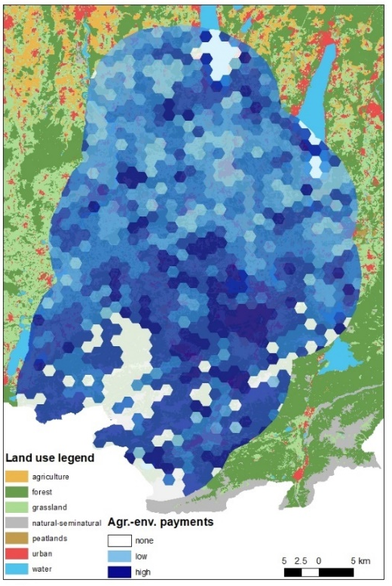
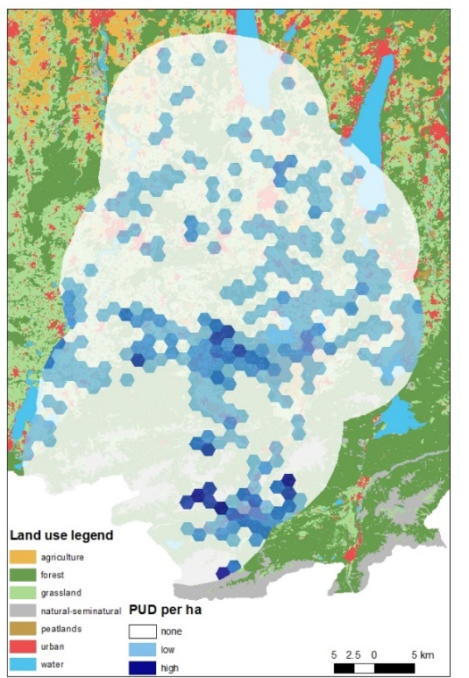
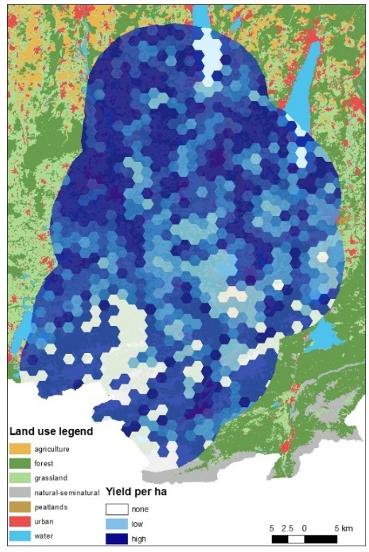
- Individual visualization of grassland ecosystem service supply in the study area
Figure S1. Distribution of yield (top left), agri-environmental payments (top right) and Photo-User-Days (bottom right) averaged to 2km-hexagon polygons.

5. Supply of regulating and habitat ecosystem services in the study area

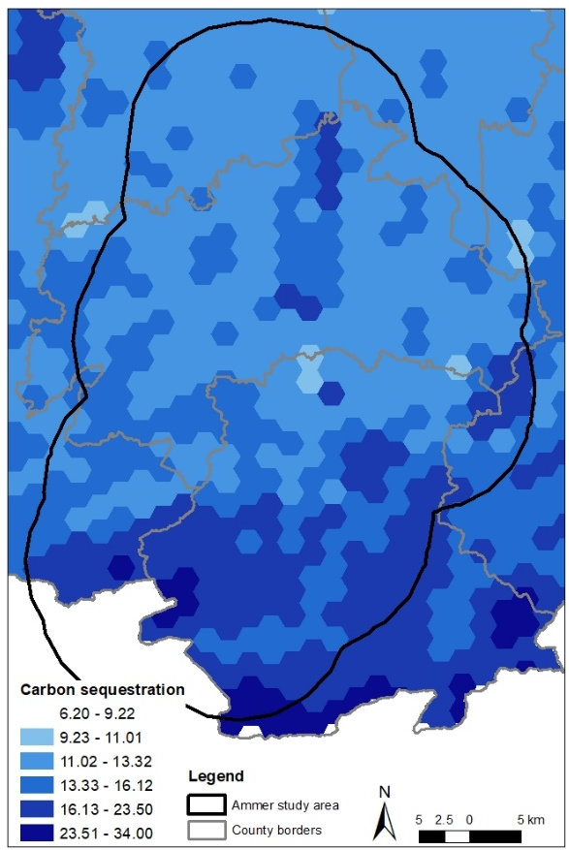
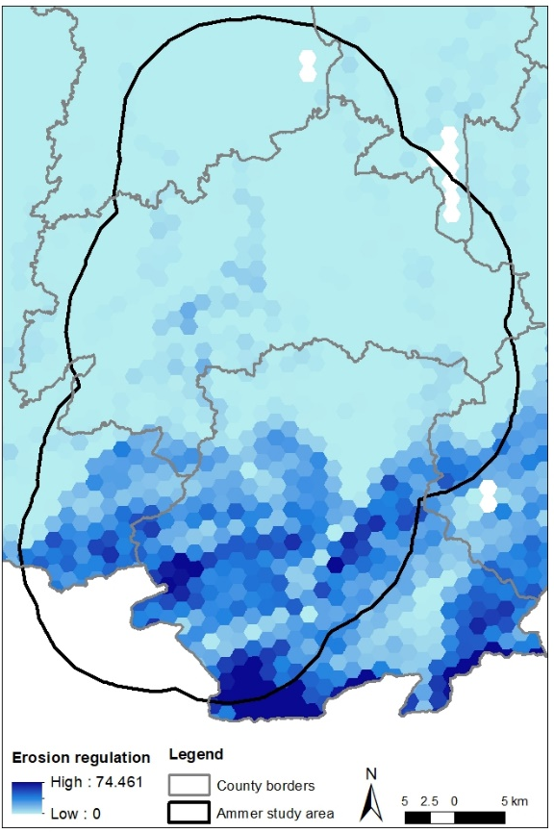
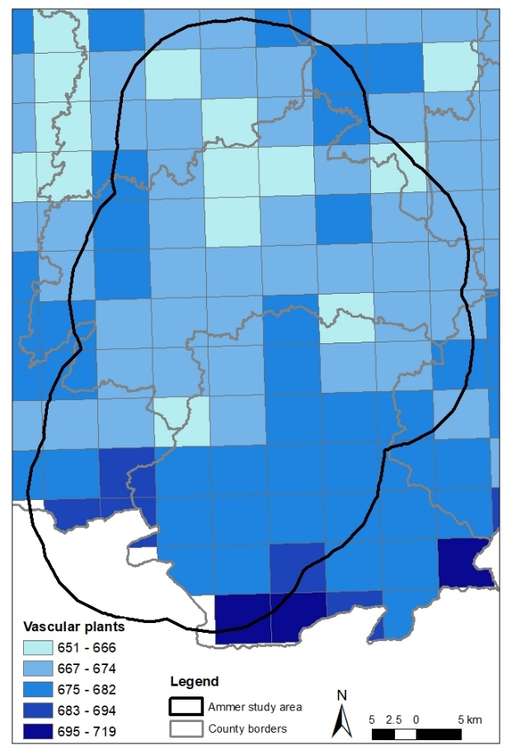
The study used agri-environmental payemnts - substituting a loss of yield in favour of regulating ecosystem services and biodiversity - as an indictor for regulating and habitat ecosystem services. To descriptively compare the representativity of the indicator, the following figures provide an overview of ecosystem services supply in the study area, which are publicly available at the atlas of ecosystem services in Bavaria. For methodological information, please see http://atlas.oekosystemleistung.bayern.

Fig. S2. Distributin of ecosystem services supply in the study area, namely mean vascular plant diversity (top left), soil carbon sequestration (top right) and erosion regulation (bottom left). The calculations are based on secondary calculations.

https://www.stmelf.bayern.de/kulap
Payment data published by the German Federal Agency for Agriculture and Food (BLE) on the website: https://agrar-fischerei-zahlungen.de/. Combined dataset retrieved in 2022 from: https://farmsubsidy.org/
Based on: Horlitz T, Achtermann B, Pabst H, Schramek J (2018) Ermittlung des geplanten finanziellen Umfangs von Naturschutzmaßnahmen im Rahmen der ELER-Programme zur Entwicklung des ländlichen Raums 2014-2020 - Herausforderungen, Methode und Ergebnisse. 1 = high; 2 = medium; 3 = low.

