Supplementary materials ESM_1

Consequence of habitat specificity: a rising risk of habitat loss for endemic woody species under climate change in the Hyrcanian region

Katarzyna Sękiewicz¹, Montserrat Salvà-Catarineu², Łukasz Walas¹, Angel Romo³, Hamid Gholizadeh⁴, Alireza Naqinezhad^{5,6}, Vahid Farzaliyev⁷, Małgorzata Mazur⁸, Adam Boratyński¹

¹Institute of Dendrology, Polish Academy of Sciences, Kórnik, Poland
²Department of Geography, Universitat de Barcelona, Barcelona, Spain
³Botanical Institute of Spanish National Research Council, CSIC, Barcelona, Spain
⁴Department of Life Sciences, University of Siena, Siena, Italy
⁵Department of Environmental Sciences, College of Science and Engineering, University of Derby, Derby, United Kingdom
⁶Department of Plant Biology, Faculty of Basic Sciences, University of Mazandaran, Babolsar, Mazandaran, Iran
⁷Forest Development Service, Ministry of Ecology and Natural Resources of Azerbaijan, Baku, Azerbaijan
⁸Kazimierz Wielki University in Bydgoszcz, Bydgoszcz, Poland

ORCID:
KS: 0000-0002-1830-0816
MSC: 0000-0002-2815-1375
ŁW: 0000-0002-4060-9801
AR: 0000-0001-8135-8570
HG: 0000-0002-6048-0988
AN: 0000-0002-4602-6279
MM: 0000-0003-0043-3706
AB: 0000-0003-0678-4304

Fig. 1. Potential present-day habitat suitability with the occurrence points (used in the species distribution modelling) and exposition with altitudinal range for Hyrcanian endemic taxa (upper panel), and distribution modelling under future climatic scenarios (RCP4.5 and RCP8.5; ca. 2071–2100) (down panel)
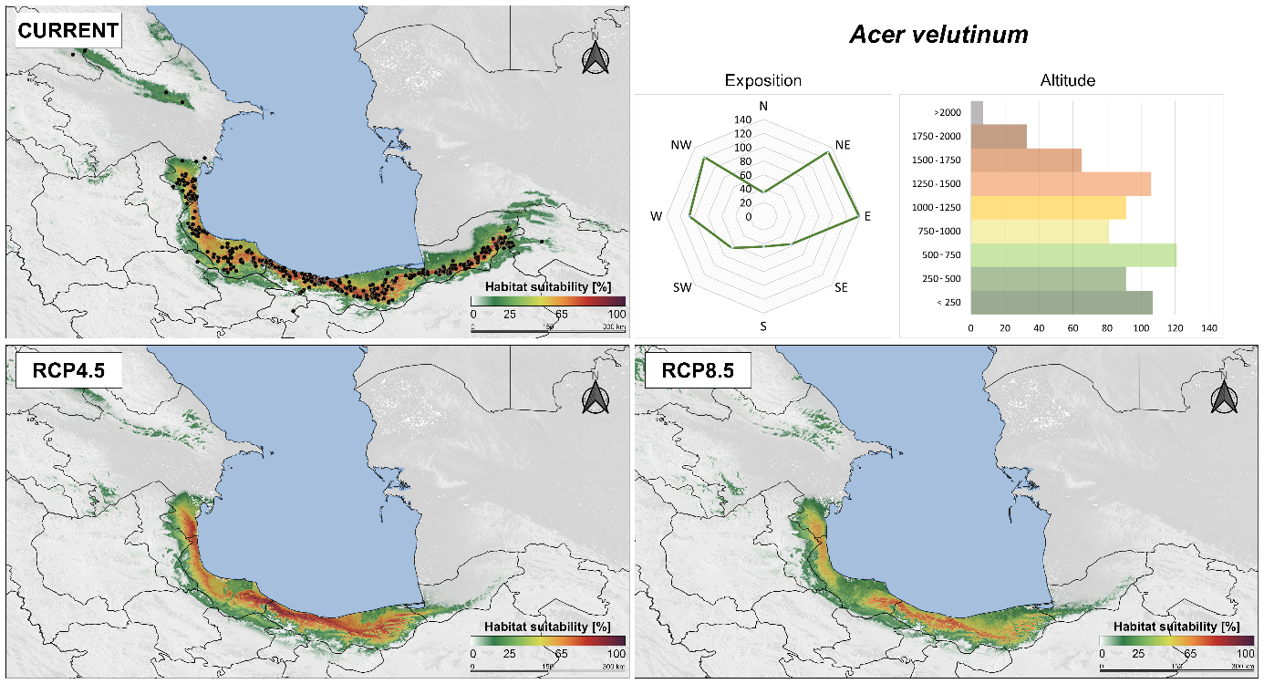
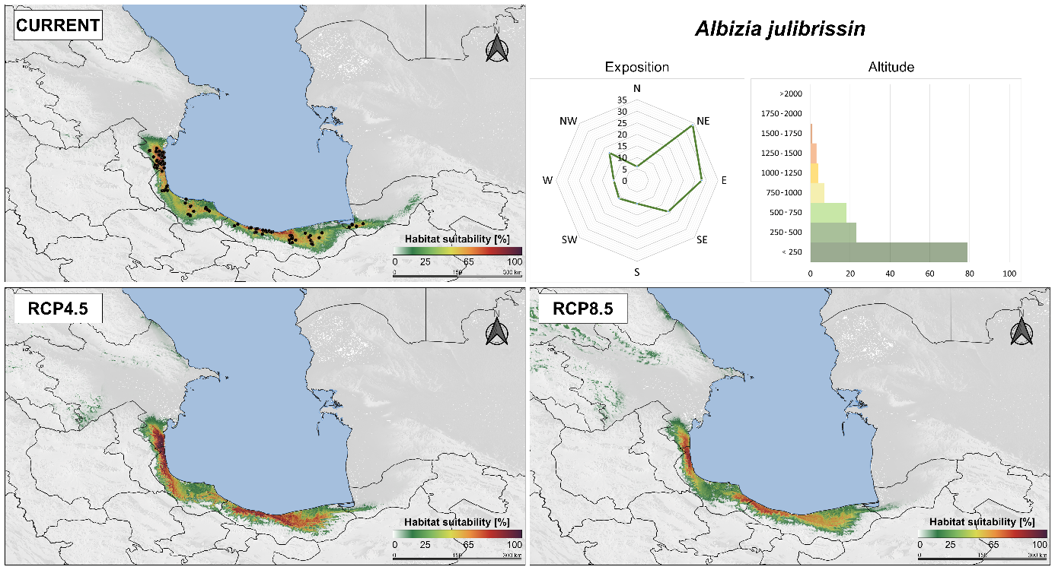
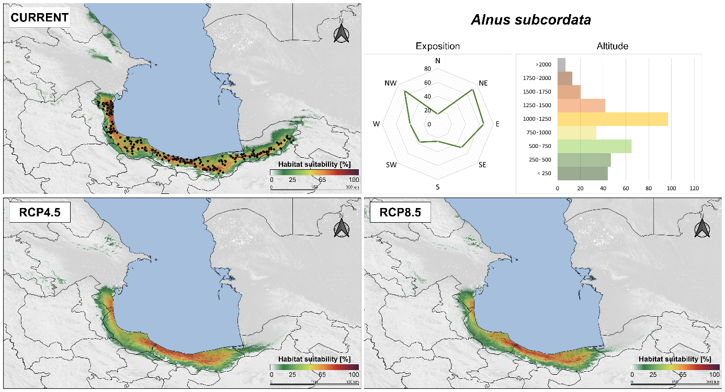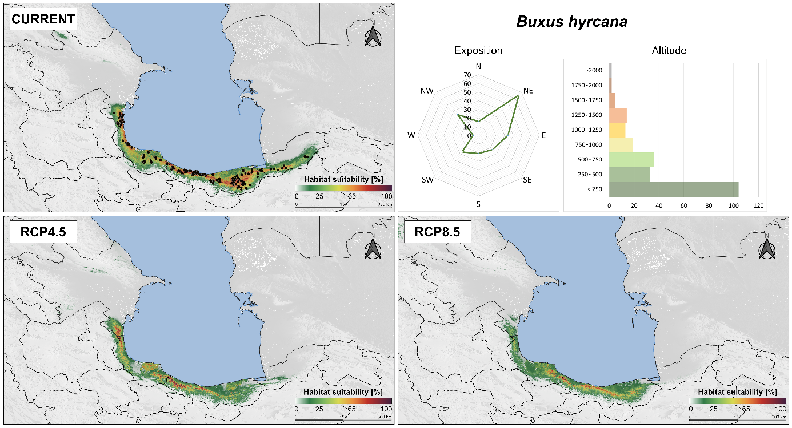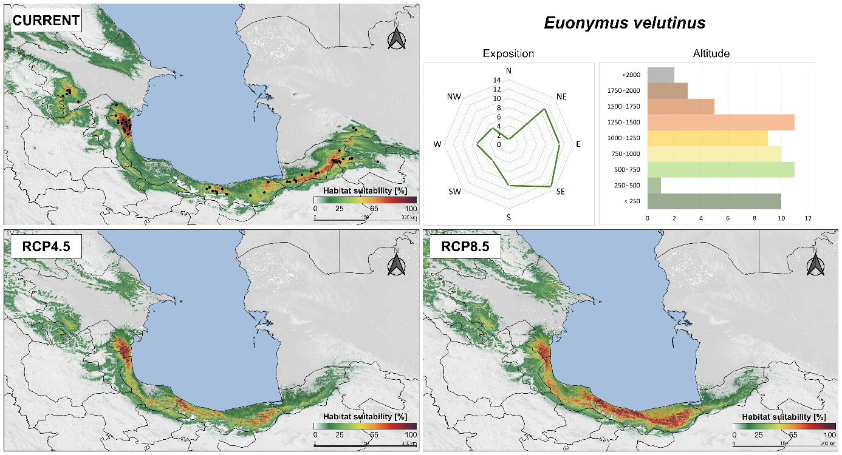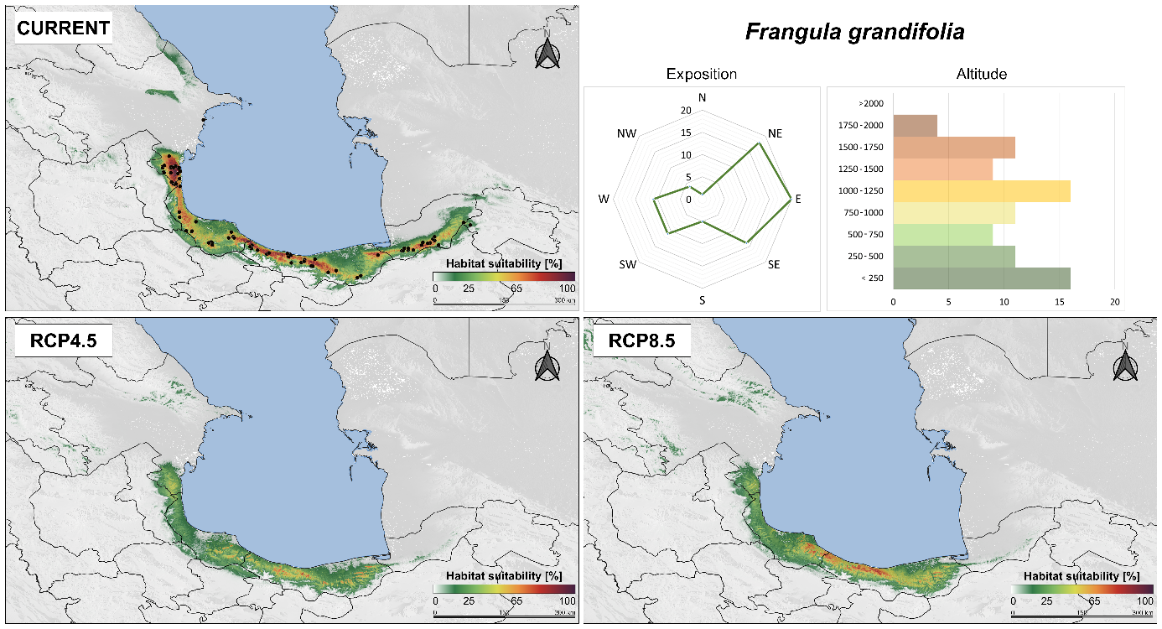
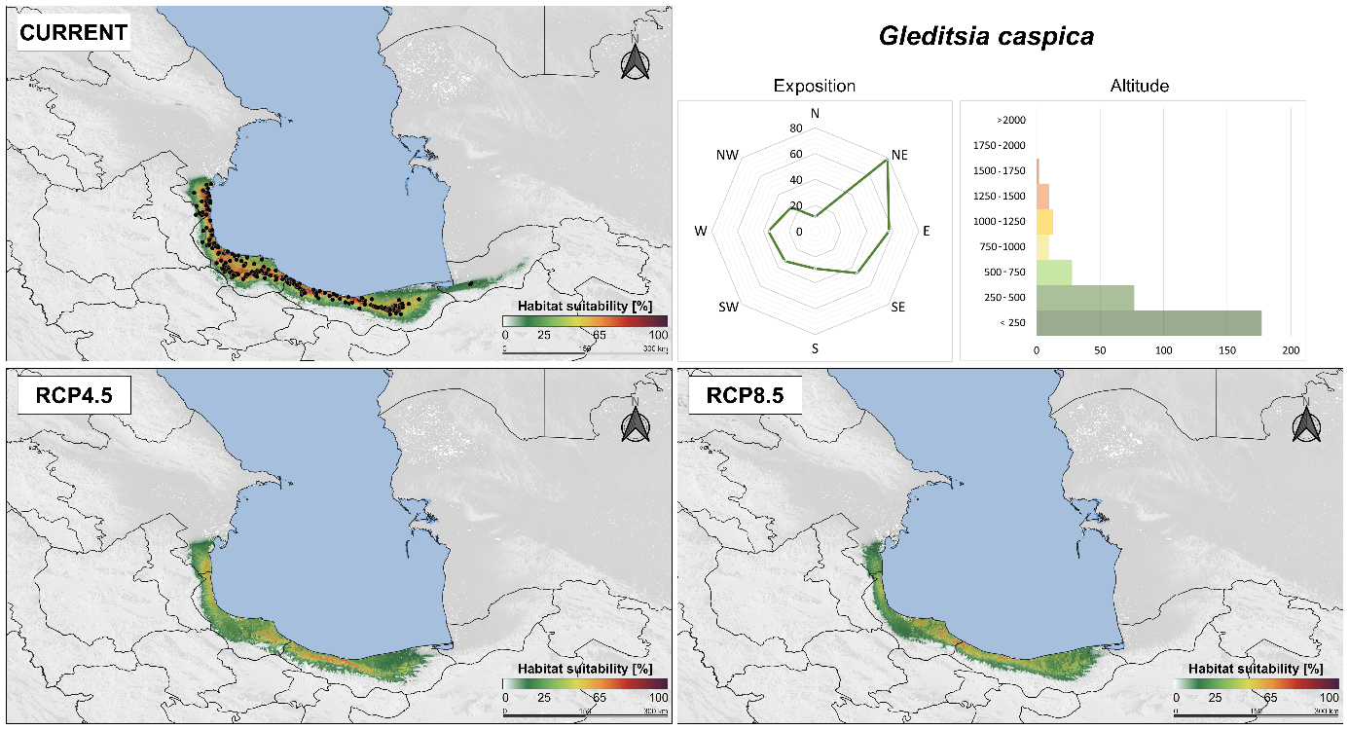
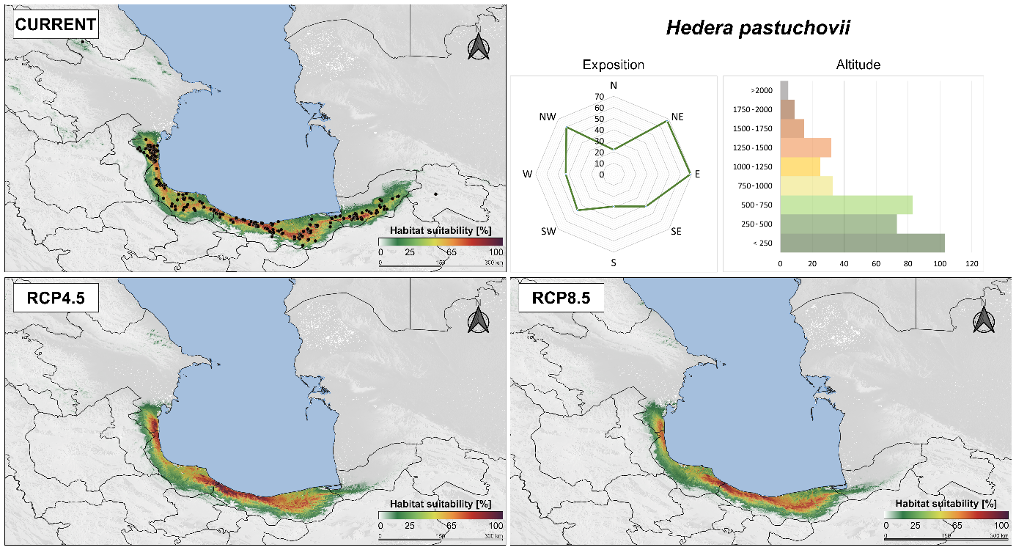
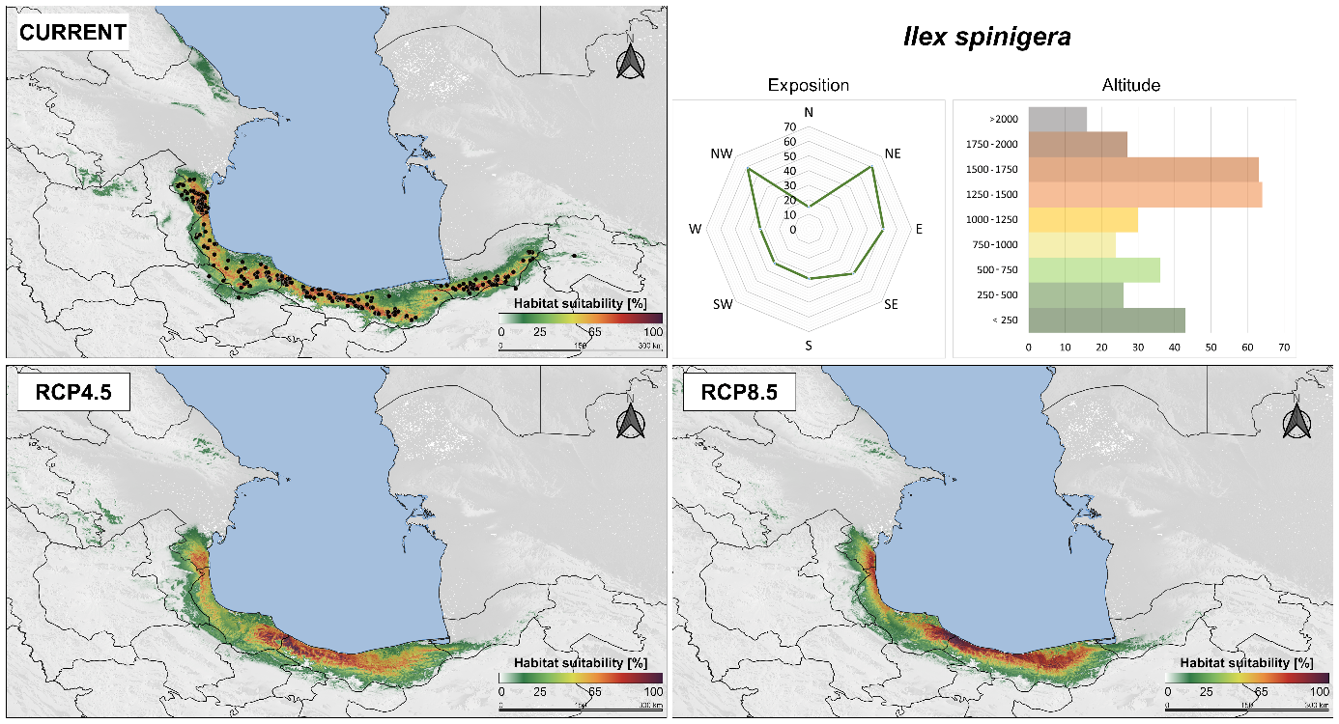
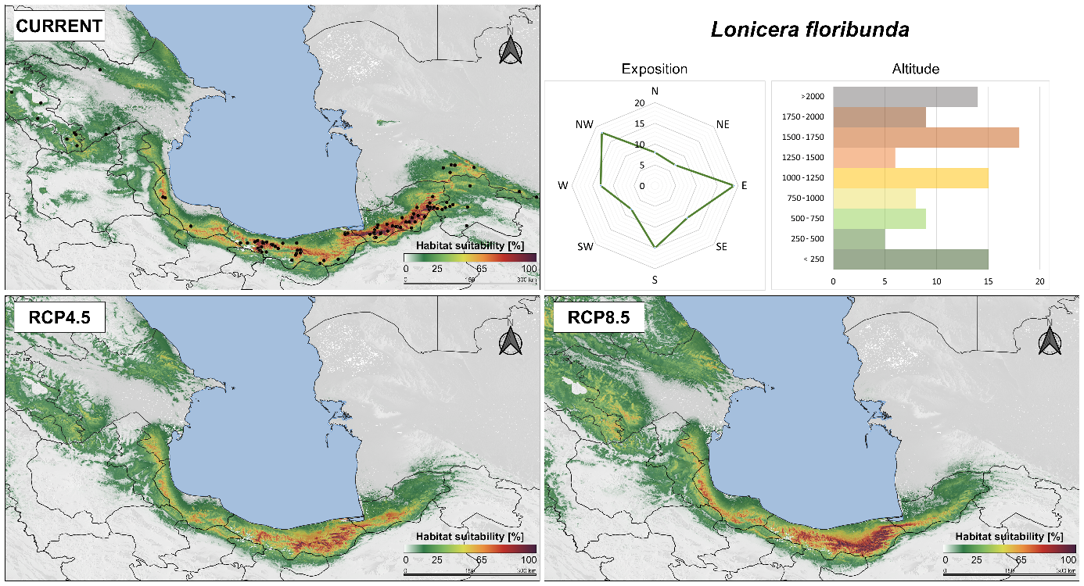
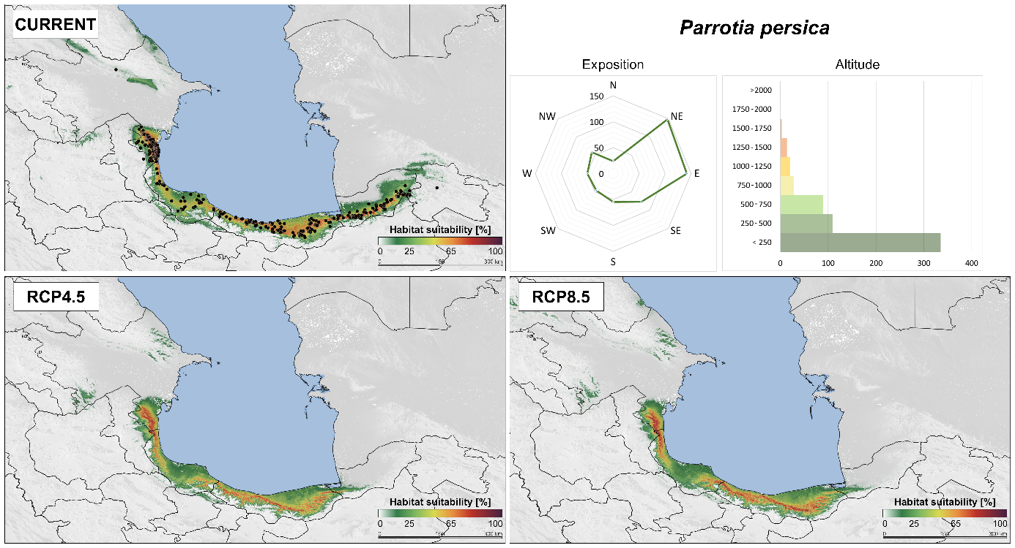
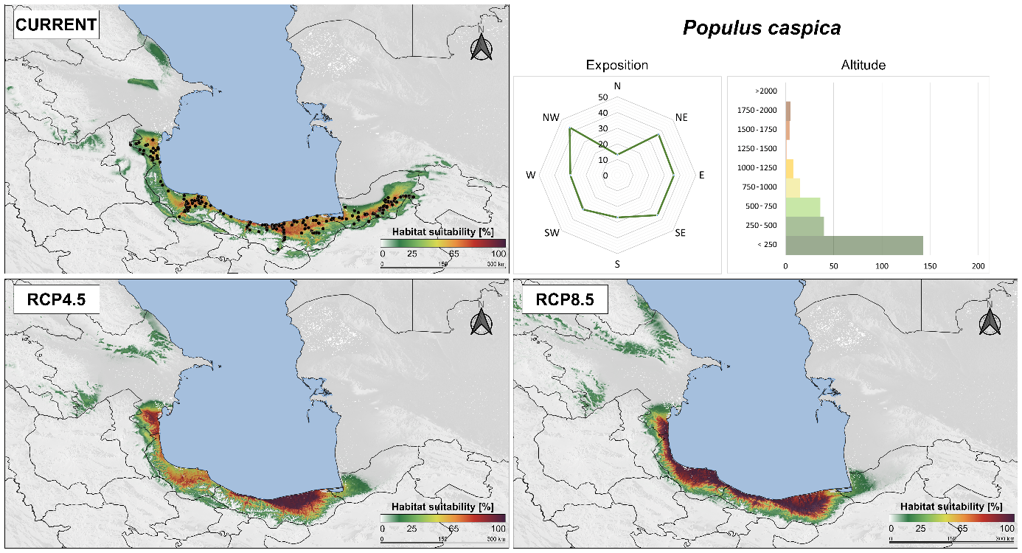
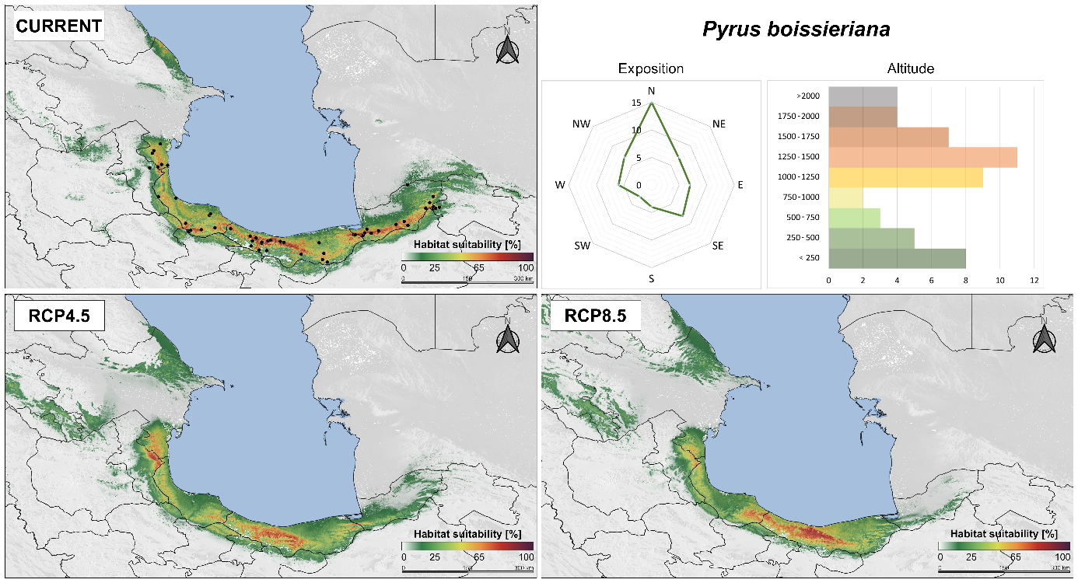
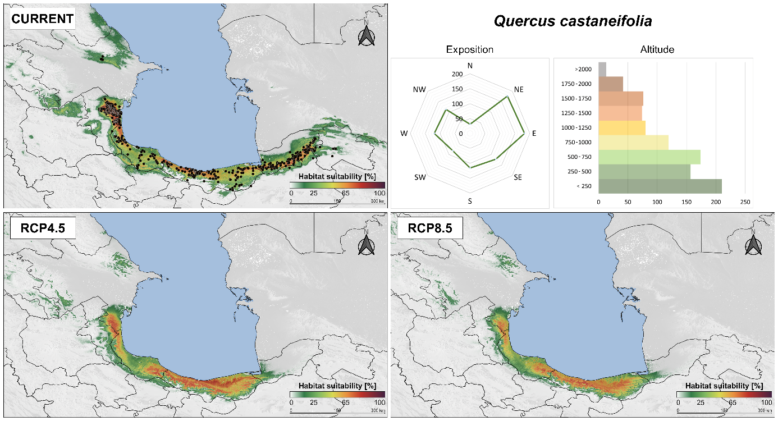
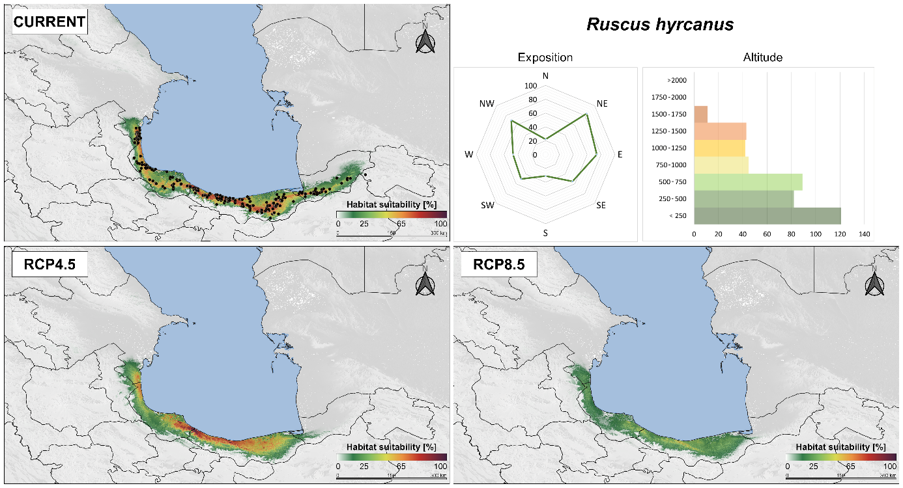

Fig. 2a. Present-day habitat suitability for Acer velutinum, Albizia julibrissin, Alnus subcordata and Buxus hyrcana projected by Maxent models and projected changes in the suitable area of the taxa for the year 2100 based on the binary output maps according to the respective RCP climatic scenarios using 25% presence thresholds in three categories: gain: area unsuitable at present but becomes suitable in future; stable: area suitable at present and in future; loss: area suitable at present but becomes unsuitable in future. Results of SDM projections across the landscape were visualized using QGIS (QGIS.org, 2022).
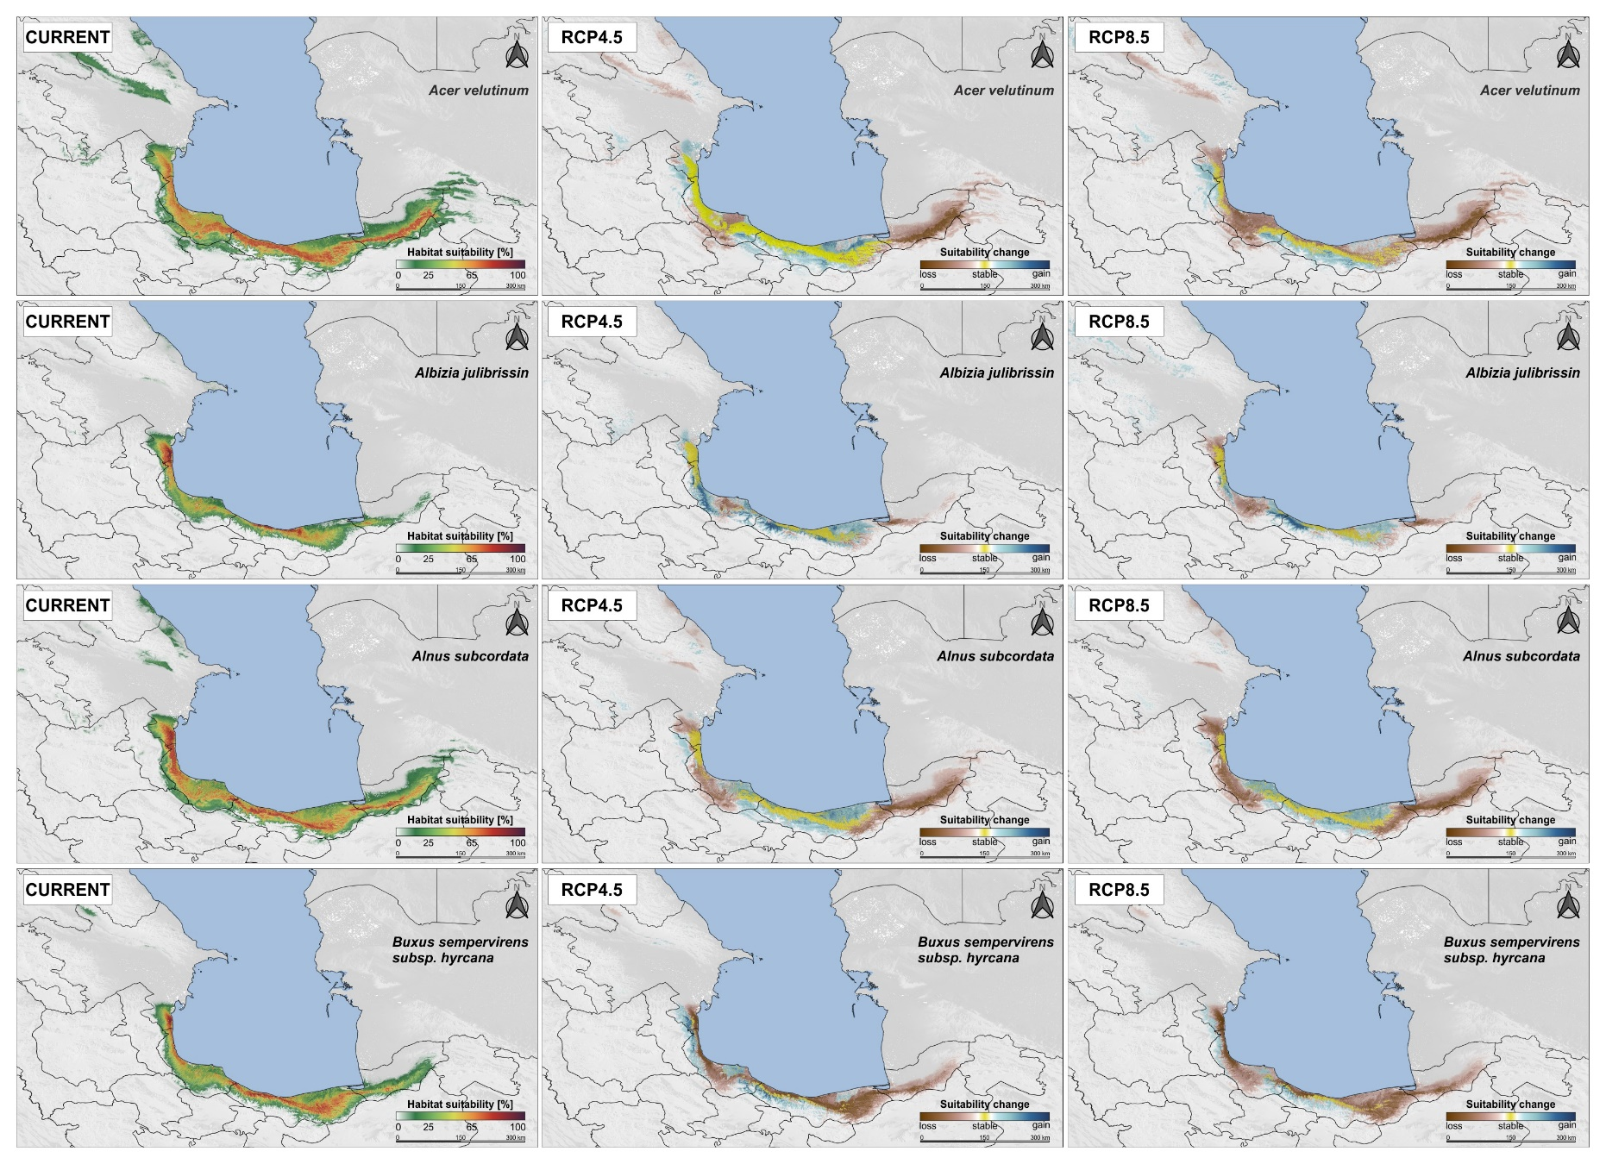
Fig. 2b. Present-day habitat suitability for Euonymus velutinus, Frangula grandifolia, Gleditsia caspica and Hedera pastuchovii projected by Maxent models and projected changes in the suitable area of the taxa for the year 2100 based on the binary output maps according to the respective RCP climatic scenarios using 25% presence thresholds in three categories: gain: area unsuitable at present but becomes suitable in future; stable: area suitable at present and in future; loss: area suitable at present but becomes unsuitable in future. Results of SDM projections across the landscape were visualized using QGIS (QGIS.org, 2022).
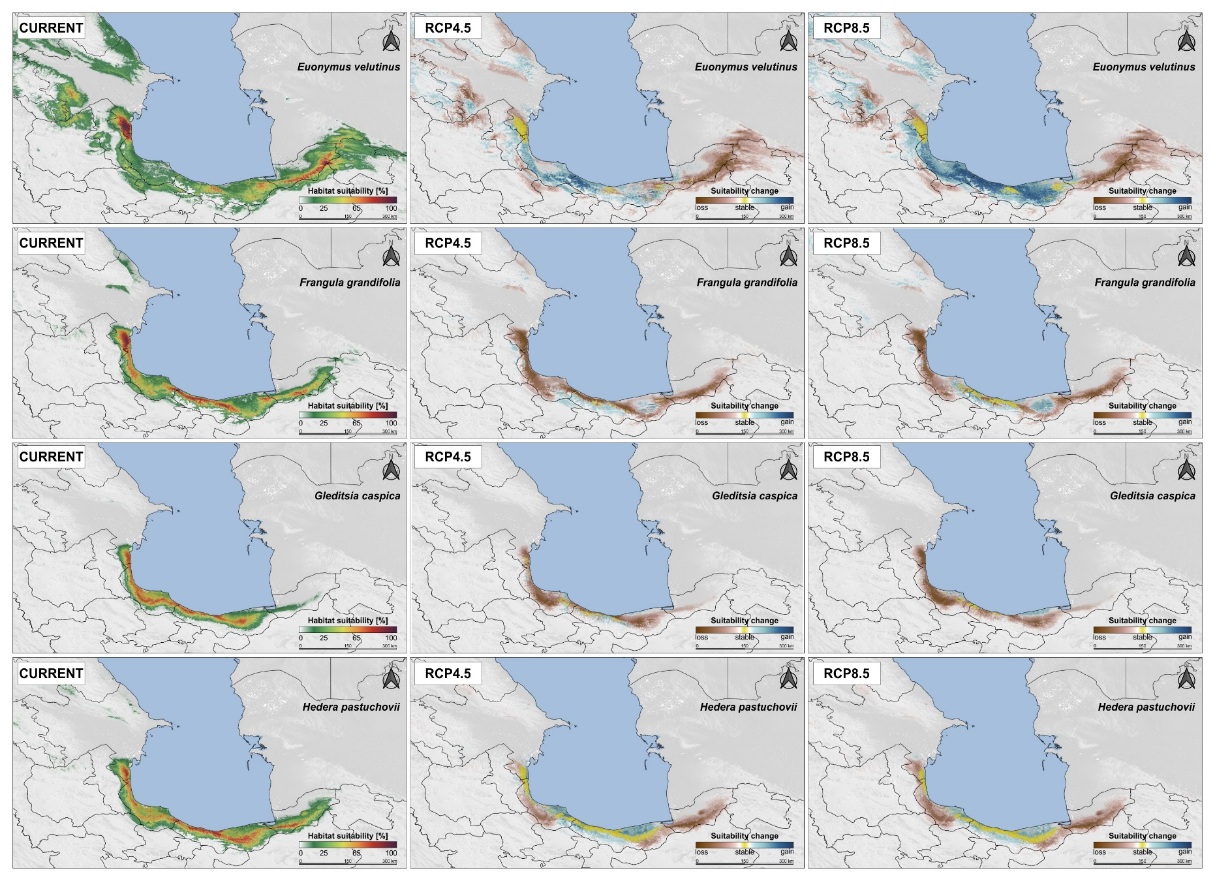
Fig. 2c. Present-day habitat suitability for Ilex spinigera, Lonicera floribunda, Parrotia persica and Populus caspica projected by Maxent models projected changes in the suitable area of the taxa for the year 2100 based on the binary output maps according to the respective RCP climatic scenarios using 25% presence thresholds in three categories: gain: area unsuitable at present but becomes suitable in future; stable: area suitable at present and in future; loss: area suitable at present but becomes unsuitable in future. Results of SDM projections across the landscape were visualized using QGIS (QGIS.org, 2022).
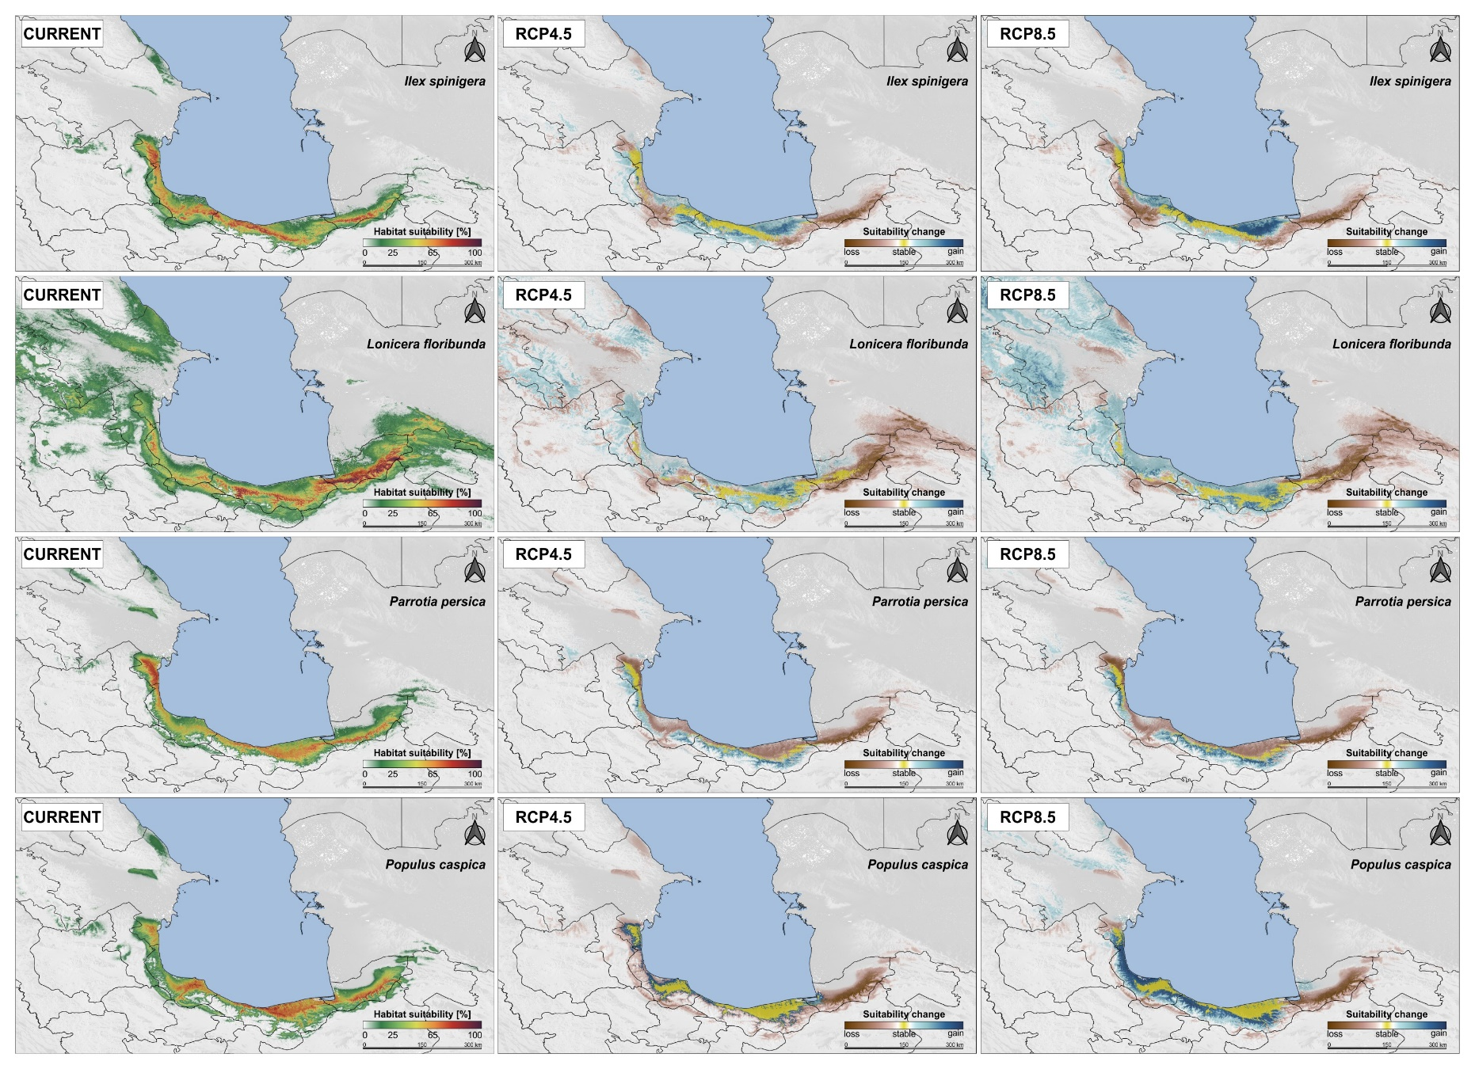
Fig. 2d. Present-day habitat suitability for Pyrus boissieriana, Quercus castaneifolia and Ruscus hyrcanus projected by Maxent models projected changes in the suitable area of the taxa for the year 2100 based on the binary output maps according to the respective RCP climatic scenarios using 25% presence thresholds in three categories: gain: area unsuitable at present but becomes suitable in future; stable: area suitable at present and in future; loss: area suitable at present but becomes unsuitable in future. Results of SDM projections across the landscape were visualized using QGIS (QGIS.org, 2022).
