Supplementary material
Table S1 Methodological summary including methodological approaches, data sources and sample sizes.
Type of data | Method | Data source | Sample size
Quantitative | Quantitative analyses | Public database, websites | 452
Qualitative | Semi-structured interviews | Farmers that converted to CSA | 10

Table S2 Interview guide in tabular form.
Global factors | Areas of interest | Questions and probes
Introduction of the study and formal issues | Put the interview in context of the research project | - Brief introduction of the research project  - Idea and objective of the interviews  - Time frame of the interview  - Information about the recording  - Confidential handling of data, permission of quotes and publication  - Informed consent
Introduction of the interview partners | Icebreaker / introductory question | - Please describe shortly your tasks and field of competence in the CSA  - For how long have you been working in the CSA or the farm in general?  - How many years ago did you convert your farm to the CSA model?
Introduction of the farm | Awareness of the concept / farm characteristics | - Did you know about the CSA model before conversion? Where did you see it for the first time?  - How many CSA farms did you know or see before you converted to CSA?  - For farm characteristics: see form to complete
Process of conversion | Triggers / points of decision  Number of shares  Alternative actions  Actors involved  Advisory services | - How was your conversion process? Remember the moment you decided to convert, how did you come to the decision?  - Which triggers made you decide to convert?  - Did the farm change hands / were there financial bottlenecks / a change in values / an approach of a founding a group / other?  - How many shares did you plan to implement before the conversion and how many did you implement at last?  - Did you consider alternatives? Why did you decide against them and for the conversion to CSA?  - With whom did you talk about your ideas? Have there been people that supported you?  - Did you make use of advisory services, e.g. from the German CSA network?
Barriers of conversion | Explorative approach of barriers  Actors involved  Time course  Stop criterion | - What have been barriers of conversion? What did not go well?  - Consider differentiating social, environmental, organizational and individual barriers. If the interviewee “only” talks about one aspect try to ask about the others.  - Have there been actors hindering the conversion process?  - Have there been differences in the time course of conversion? Have there been different barriers in the beginning compared to a later stage of conversion?  - Did you ever get to the point that you wanted to give up and stop the conversion?
Motives of conversion | Explorative approach of motives  Actors involved  Time course | - What did motivate you to convert? What went right?  - Have there been actors supporting your conversion process?  - Have there been differences in the time course of conversion? Have there been different motivational aspects at the beginning compared to a later stage of conversion?
Role of innovation service providers (ISP) | Role of the chamber or board of agriculture  Role of additional ISP | - Did the chamber or board of agriculture play and role in your conversion process?  - Have there been other actors that have not been mentioned yet that influenced your conversion process?
Role of fear of the future | Fear of the future  CSA as a coping strategy  Other coping strategies | - Did fear of the future play any role in your decision to convert to CSA? Did you have any worries about the future of your farm before you converted to CSA?  - If yes, was the conversion to CSA a strategy to deal with that worries?  - What kind of strategies did you have additionally to address your worries?  - Do you still today have worries about the future of your farm?  - What are the most important challenges for the future of your farm before you converted and today? (e.g. climate change, biodiversity loss, industrialization, market competition)
Role of women | Explorative approach of the role of women | - Did women play a role in your decision to convert to CSA?  - Did specific women like your wife or daughters influence your decision to convert to CSA?
Demographic variables | Age  Gender  Income | - In which year where you born?  - Which gender are you? (men, women, diverse, other)  - Average monthly income
Perspectives | Outlook  Summary  Concrete next steps open questions  Contact information | - Is there anything you would do different next time? Is there something that you would like to tell farms that are interested in converting to CSA as an advice?  - We slowly reach the end of the interview. Thanks for participating and your time.  - The key aspects of the interview today for me are: …  - Is there anything you would like to add?  - If you have further remarks or ideas you would like to share with us, please contact us via E-Mail: jana2.schmidt@uni-siegen.de.

Table S3 Codes and subcodes of the coding guide used for the analysis of the interview data. Codes were based on theory or inductively derived during the analyses (written in in italics).
Code | Subcodes | Reference
Operating data  of the farm | - history of the farm  - key characteristics of the farm before and after conversion:  - economic orientation, management practices, legal form, operating area, founding year, working conditions, logistics of the CSA, organization of the members  - further operational pillars  - operational vision
Personal Information  (of the interviewee) | - demographics  - biographical information  - personal traits
Conversion: pathways and triggers for  converting to CSA | - familiarity with the CSA model  - trigger for conversion:  - farm handovers, financial bottlenecks, changing values, founding group approaches, customers’ wishes, extreme weather events, other crises (i.e. covid, war)  - conversion process  - preliminary stages of direct marketing  - actors supporting conversion  - actors hindering conversion
Motives | - gain-oriented motives  - normative motives  - ecological, socio-political  - hedonistic motives | Lindenberg and Steg (2007)
Barriers | - individual barriers  - capacities, skills, expectations, personal traits  - organizational barriers  - lock-in-effects, liquidity, fit of the farm, influence of employees  - environmental barriers  - infrastructural (labour force, customer potential), political / regulatory (subventions), values / mentality of society, geographical (climate change)  - social barriers  - social norms, lack of contacts, difficulties in cooperation | Hauschildt et al. (2023); Gemünden and Walter (1999); Mirow (2010); Klein (2002)
Fear  of the future |  | i.e. Boddenberg et al. (2017)
Role of women |  | i.e. Kimani, Njuguna, Joseph et al. (2013)

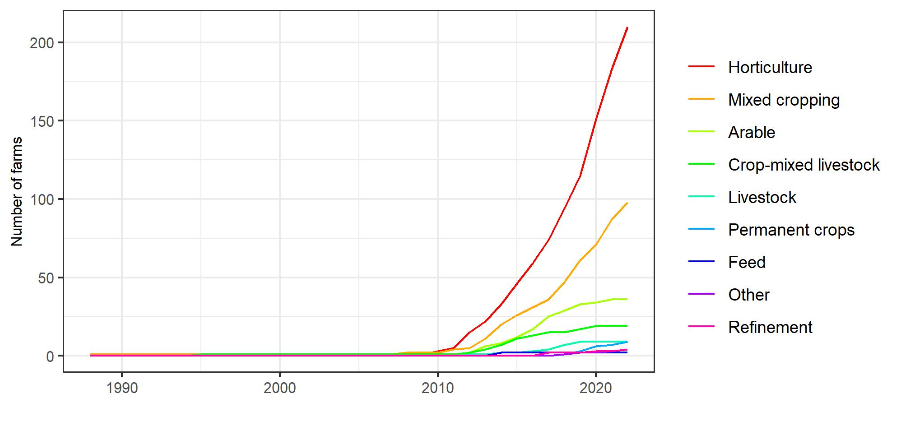
Fig. S1 Temporal development of CSA farms in Germany distinguished by their economic orientation (n = 391).

Fig. S2 Number of normative, gain-oriented and hedonistic motives for converting to community-supported agriculture identified in ten semi-structured interviews with farmers that converted to CSA.

Fig. S3 Number of social, environmental, organizational, and individual barriers for converting to community-supported agriculture identified in ten semi-structured interviews with farmers that converted to CSA.

