Unveiling invisible climate im/mobilities. Mixed-methods case study of a drought-prone rural area of Kersa, Ethiopia

Supplementary material

SPM I: The variables included in the multiple-factor analysis and the clustering analysis
The typology described in section 4 is a result of a multiple-factor analysis (MFA) and a clustering analysis (CA), conducted on household-level data collected during the economic assessment of households in the Kersa HDSS site in 2014 and complemented with information retrieved at the individual level. The MFA focused on the following list of the 22 variables (table SPM1A) covering three dimensions: assets & housing conditions (17 variables), literacy (2 variables), & perceived satisfaction with living conditions (3 variables).
Table SPM1A List of the 22 variables
Dimensions | Recoded variables with their modalities
Assets & Housing conditions | 1- What is the main source of drinking water for members of your household?  1 Piped water or protected water source; 2 Unprotected tube or bore well or water in nature  2- Where is the source of water located?  1 In own dwelling or in own compound; 2 Elsewhere  3- What kind of toilet facilities does your household have?  1 Ventilated improved pit latrine or traditional pit latrine; 2 No latrine, use field, bush  4- In what condition is the main house?  1 In good shape; 2 Requires some repair; 3 In bad shape  5- Does the house have rooms used only for sleeping?  1 Yes; 2 No  6- The main house has window:  1 Yes; 2 No  7- The main material of the wall of the house  1 Bricks/cement 2 Others (Tree trunks with mud; Stone with mud; Bamboo/Wood)  8- The roof of the house is made of:  1 Corrugated iron; 2 Others (Plastic sheet; Thatched/Leaf)  9- The floor of the house is made of:  1 Finished floor/cemented; 2 Others (Wood or bamboo; Natural floor/earth/sand/mud)  10- What type of fuel does your household mainly use for cooking?  1 Electricity or kerosene or charcoal; 2 natural resources such as wood…)  11- Does your household own any land that can be used for agriculture?  1 Yes; 2 No  12- Does your household own any of those animals (cows, oxen, horses, mules, donkeys)?  1 Yes; 2 No  13- Does your household own any of those animals (goats, sheep, chickens)?  1 Yes; 2 No  14- Does your household have a fixed telephone?  1 Yes; 2 No  15- Does any member of the household own a mobile phone?  1 Yes; 2 No  16- Does any member have a mean of transportation?  1 At least one; 2 No  17- Does any member of this household have an account with a bank/credit association/micro finance?  1 Yes; 2 no
Literacy | 1- Literacy rate of all household members >= 13 years old at the entry time in the dataset.  2- Literacy status of the head of the household at the entry time in the dataset.  Both variables come from the individual literacy status  0 Illiterate; 1 Literate
Perceived satisfaction on living conditions | The average satisfaction per household has been estimated from three questions:  1- Are you satisfied with the change in your household income over the last 5 years?  1 Very dissatisfied; 2 Dissatisfied; 3 Indifferent; 4 Satisfied; 5 Very satisfied  2- Considering your household’s total economic and living status last year, how is the change this year?  1 Very Low; 2 Low; 3 Just equal; 4 High; 5 Very High  3- As compared to your neighbours, where do you put your household in economic status?  1 Very Low; 2 Low; 3 Just equal; 4 Above average; 5 At high status
Additional variables have been used to better interpret the scores of the two factorial axes of the MFA (table SPM1B).
Table SPM1B The supplementary variables
Additional dimensions | Recoded variables with their modalities
Administrative unit | 1- Kebeles  12 different kebeles
Geographical feature | 1- Typology of kebeles  1 Rural Highland; 2 Rural Lowland; 3 Rural Midland; 4 Rural Midland with irrigation; 5 Town
Migration | 1- Number of out-migration events during the period of observation for individuals 13 years old and older
Occupation & income | 1- Assessment of the monthly income per household (by the head of the household):  1 <900 ETB; 2 900-1100 ETB; 3 1100-1300 ETB; 4 >1300 ETB  2- Do you have your own income?  1 Yes; 2 no  3- The occupation of the head of the household:  1 Housewife; 2 Government employee; 3 NGO employee; 4 Farmer; 5 Student; 6 Pity trader; 7 Merchant; 8 Retired; 9 Daily labourer

SPM II: The four groups from the clustering analysis
The four groups described in section 4, resulting from the clustering analysis are presented in figure SPM2. Group 1 – in blue – represents the households with poor adaptive capacity and a risk of involuntary immobility. Group 2 – in green – gathers the households with possible in-situ adaptation. Group 3 – in red – brings together what could correspond to an upper-intermediate group with slightly higher adaptive capacity. Group 4 – in purple – collects the households with the highest adaptive capacity, including those who might employ migration as an adaptive strategy.
Fig. SPM2 A multidimensional index of the households of the HDSS site in Kersa, Ethiopia
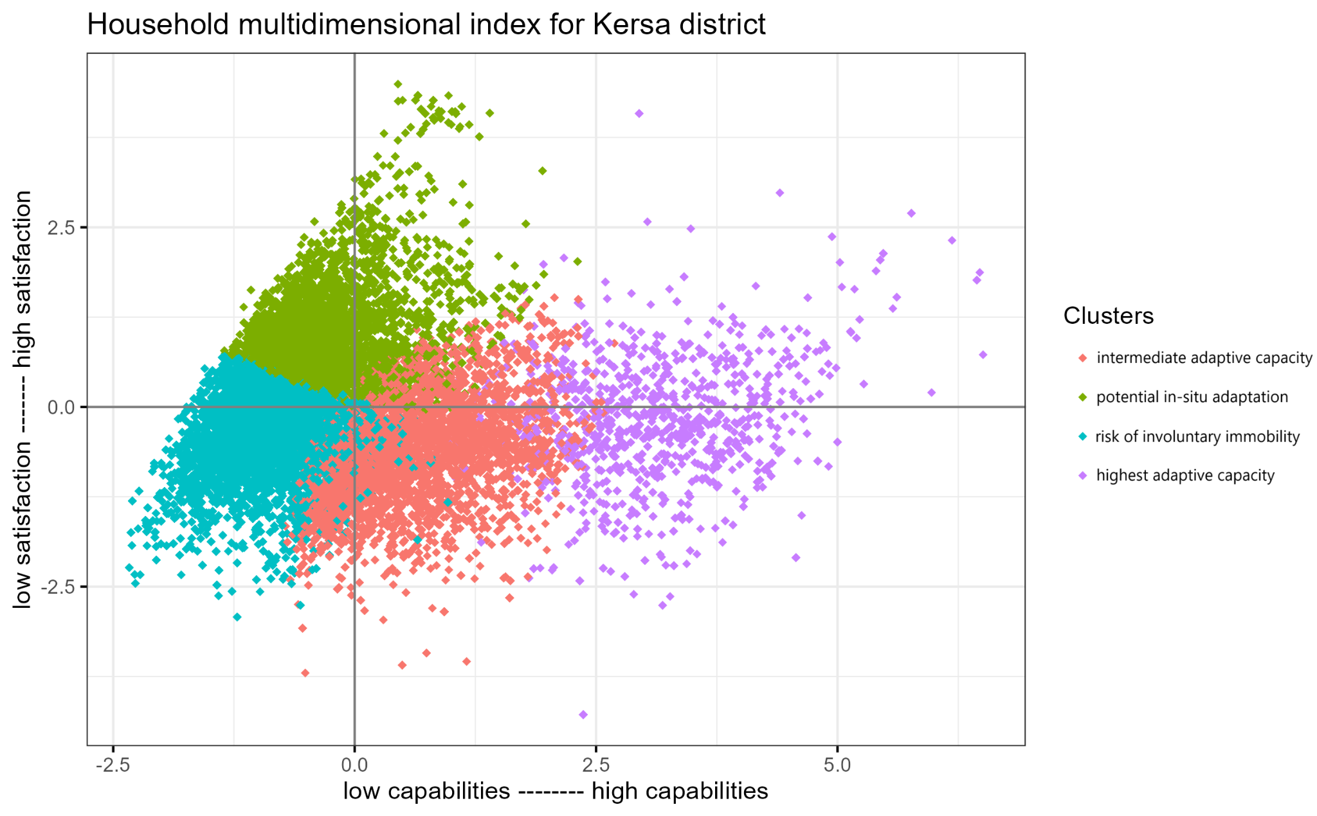

SPM III: The household multidimensional index for Walta Bilisuma
Walta Bilisuma has the district's lowest scores for both satisfaction with living conditions and capabilities with 88% and 90% of households, respectively, having a score below zero. However, there is some variation between households. The top 10% of households exhibit significantly higher capabilities than the bottom 10% in absolute terms.
Fig. SPM3 Household multidimensional index for Walta Bilisuma