Supplementary Table 1. Studies investigating the impacts of tourists on the marine environment in this literature review
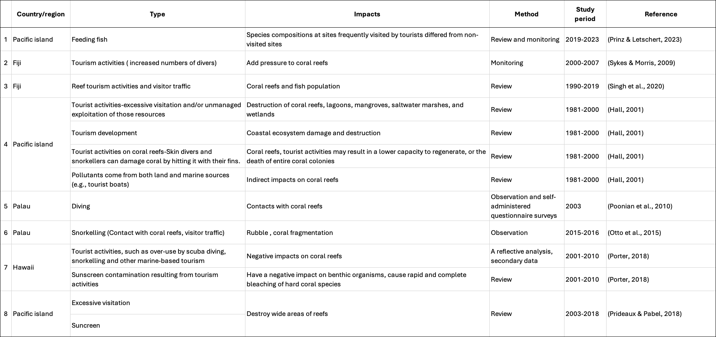
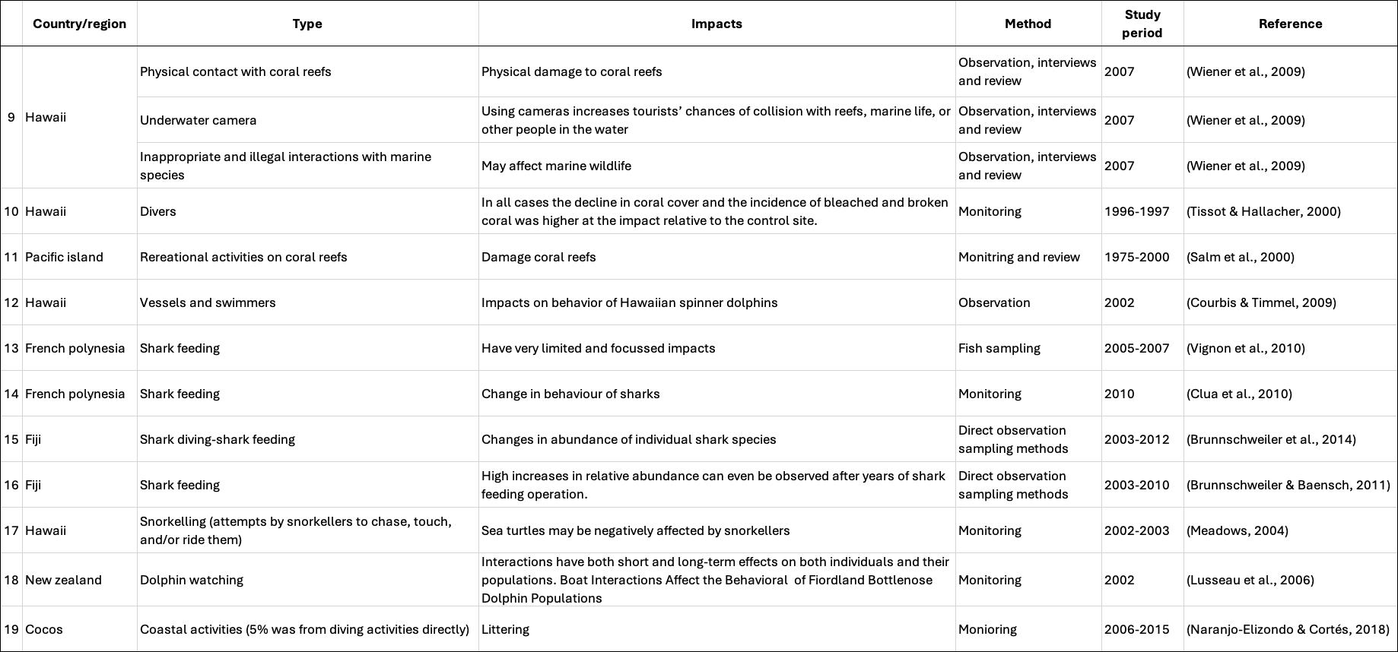
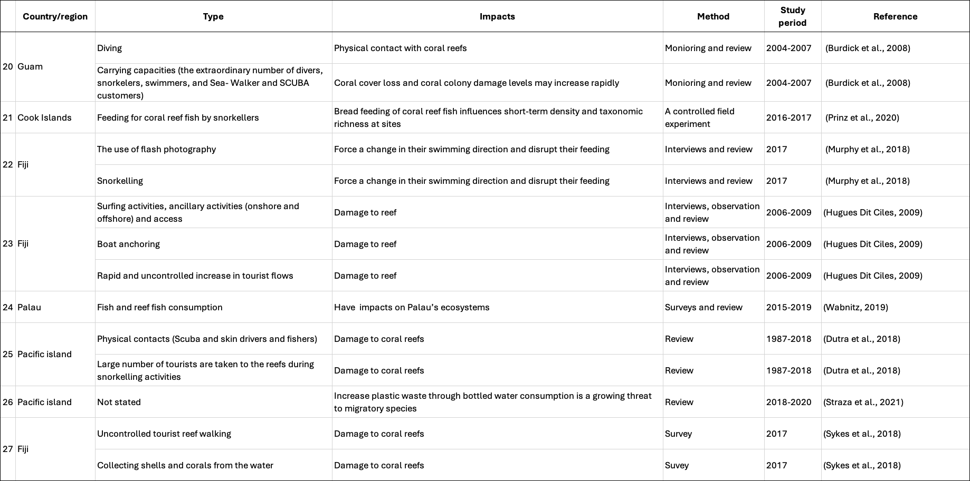
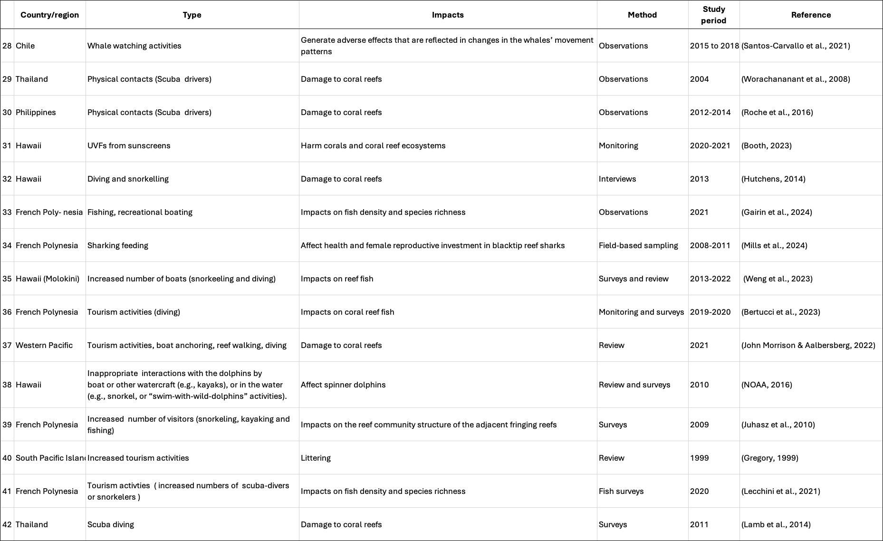

Reference:
Bertucci, F., Feeney, W. E., Cowan, Z. L., Gache, C., Madi Moussa, R., Berthe, C., Minier, L., Bambridge, T., & Lecchini, D. (2023). Effects of COVID-19 lockdown on the observed density of coral reef fish along coastal habitats of Moorea, French Polynesia. Regional Environmental Change, 23(1), Article 16. https://doi.org/10.1007/s10113-022-02011-0
Booth, H. S. A. L. (2023). Temporal and Spatial Occurrence of Oxybenzone and Octocrylene in the Coastal Waters of Oʻahu (Order No. 30634821). Available from ProQuest Dissertations & Theses Global. (2869407490). https://www.proquest.com/dissertations-theses/temporal-spatial-occurrence-oxybenzone/docview/2869407490/se-2
Brunnschweiler, J. M., Abrantes, K. G., & Barnett, A. (2014). Long-term changes in species composition and relative abundances of sharks at a provisioning site. PloS one, 9(1), e86682-e86682. https://doi.org/10.1371/journal.pone.0086682
Brunnschweiler, J. M., & Baensch, H. (2011). Seasonal and long-term changes in relative abundance of bull sharks from a tourist shark feeding site in Fiji. PloS one, 6(1), e16597-e16597. https://doi.org/10.1371/journal.pone.0016597
Burdick, D.R., Brown, V., Asher, J., Gawel, M.J., Goldman, L., Hall, A., Kenyon, J.C., Leberer, T., Lundblad, E.R., McIlwain, J.L., Miller, J.L., Minton, D., Nadon, M.O., Pioppi, N., Raymundo, L.J., Richards, B.I., Schroeder, R.E., Schupp, P.J., Smith, E., & Zgliczynski, B.J. (2008). The State of Coral Reef Ecosystems of Guam. Bureau of Statistics and Plans, Guam Coastal Management Program. https://bsp.guam.gov/wp-bsp-content/uploads/2016/10/GU.CoralReef_2008.pdf. Assessed 15 January, 2025
Clua E, Buray N, Legendre P, Mourier J, & Planes S. (2010). Behavioural response of sicklefin lemon sharks Negaprion acutidens to underwater feeding for ecotourism purposes. Marine Ecology Progress Series, 414, 257–266. http://www.jstor.org/stable/24875219. Accessed 15 January 2025
Courbis, S., & Timmel, G. (2009). Effects of vessels and swimmers on behavior of Hawaiian spinner dolphins (Stenella longirostris) in Kealake ‘akua, Honaunau, and Kauhako bays, Hawai ‘i. Marine mammal science, 25(2), 430-440.
Dutra, L., Haywood, M. D., Singh, S. S., Piovano, S., Ferreira, M., Johnson, J. E., Veitayaki, J., Kininmonth, S. J., & Morris, C. W. (2018). Effects of climate change on corals relevant to the Pacific Islands. Pacific marine climate change report card, 132-158.
Gairin, E., Bertucci, F., Roux, N., Minier, L., Berthe, C., Waqalevu, V., Maueau, T., Sturny, V., Sang, G. T., & Mills, S. C. (2024). Coral reef fish density at a tourist destination responded rapidly to COVID-19 restrictions. Oecologia, 205(3), 533-543.
Gregory, M. R. (1999). Plastics and South Pacific island shores: Environmental implications [Article]. Ocean and Coastal Management, 42(6-7), 603-615. https://doi.org/10.1016/S0964-5691(99)00036-8
Hall, C. M. (2001). Trends in ocean and coastal tourism: the end of the last frontier? Ocean & Coastal Management, 44(9-10), 601-618. https://doi.org/10.1016/s0964-5691(01)00071-0
Hugues Dit Ciles, E. K. (2009). The sustainability of surfing tourism at remote destinations.
Hutchens, C. (2014). Conceptual Framework for Marine Ecosystem Management (Publication Number 3726267) [D.M., Colorado Technical University]. ProQuest Dissertations & Theses Global; SciTech Premium Collection. United States -- Colorado.
John Morrison, R., & Aalbersberg, W. G. L. (2022). Anthropogenic Environmental Impacts on Coral Reefs in the Western and South-Western Pacific Ocean. In Zhang, J., Yeemin, T., Morrison, R.J. & Hong, G.H. (Eds), Coral Reefs of the Western Pacific Ocean in a Changing Anthropocene. Coral Reefs of the World, vol 14. Springer, Cham. https://doi.org/10.1007/978-3-030-97189-2_2
Juhasz, A., Ho, E., Bender, E., & Fong, P. (2010). Does use of tropical beaches by tourists and island residents result in damage to fringing coral reefs? A case study in Moorea French Polynesia. Marine pollution bulletin, 60(12), 2251-2256. https://doi.org/10.1016/j.marpolbul.2010.08.011
Lamb, J. B., True, J. D., Piromvaragorn, S., & Willis, B. L. (2014). Scuba diving damage and intensity of tourist activities increases coral disease prevalence. Biological Conservation, 178, 88-96.
Lecchini, D., Brooker, R. M., Waqalevu, V., Gairin, E., Minier, L., Berthe, C., Besineau, R., Blay, G., Maueau, T., Sturny, V., Bambridge, T., Sang, G. T., & Bertucci, F. (2021). Effects of COVID-19 pandemic restrictions on coral reef fishes at eco-tourism sites in Bora-Bora, French Polynesia. Marine Environmental Research, 170, Article 105451. https://doi.org/10.1016/j.marenvres.2021.105451
Lusseau, D., & Bejder, L. (2007). The long-term consequences of short-term responses to disturbance experiences from whalewatching impact assessment. International Journal of Comparative Psychology, 20(2).
Meadows, D. (2004). Behavior of green sea turtles in the presence and absence of recreational snorkelers. Marine Turtle Newsletter, 103(1), 4.
Mills, S. C., Planes, S., & Mourier, J. (2024). Shark feeding affects health and female reproductive investment in blacktip reef sharks from French Polynesia [Article]. Animal Conservation. https://doi.org/10.1111/acv.13005
Murphy, S. E., Campbell, I., & Drew, J. A. (2018). Examination of tourists’ willingness to pay under different conservation scenarios; Evidence from reef manta ray snorkeling in Fiji. PloS one, 13(8). https://doi.org/doi.org/10.1371/journal.pone.0198279
Naranjo-Elizondo, B., & Cortés, J. (2018). Observations of Litter Deposited in the Deep Waters of Isla del Coco National Park, Eastern Tropical Pacific. Frontiers in Marine Science, 5, 91. https://doi.org/10.3389/fmars.2018.00091
NOAA. (2016). Enhancing protections for Hawaiian spinner dolphins to prevent disturbance. Draft environmental impact statement and regulatory impact review. https://www.fisheries.noaa.gov/s3//dam-migration/2016_08_12_spinner_deis_final_508--unsecured.pdf. Accessed 15 January, 2025
Otto, E. I., Gouezo, M., Koshiba, S., Mereb, G., Jonathan, R., Olsudong, D., & Golbuu, Y. (2015). Impact of snorkelers on shallow coral reef communities in Palau (PICRC Technical Report 16-15). www.picrc.org. Accessed 14 January, 2025
Poonian, C., Davis, P., & McNaughton, C. (2010). Impacts of Recreational Divers on Palauan Coral Reefs and Options for Management 1. Pacific Science, 64(4). https://doi.org/10.2984/64.4.557
Porter, B. A., Pabel, A., & Prideaux, B. (2018). Impacts of vessel-based day tours on coral reefs: Observations from snorkel tours in Maui, Hawai’i. In Prideaux B. & Pabel A.(Eds.), Coral Reefs: Tourism, Conservation and Management (1st ed., pp. 212–224). Routledge. https://doi.org/10.4324/9781315537320-15
Prideaux, B., & Pabel, A. (2018). Coral reefs: Tourism, conservation and management. Routledge.
Prinz, N., & Letschert, J (2023) Pacific Island case study: Impact of tourism on small island marine ecosystems: Insights from two Pacific archipelagos. In M. Wolff, S. C. Ferse, & H. Govan (Eds.), Challenges in tropical coastal zone management: Experiences and lessons learned (pp. 53–72). Springer. https://doi.org/10.1007/978-3-031-17879-5_5
Prinz, N., Story, R., Lyon, S., Ferse, S. C., & Bejarano, S. (2020). To Feed or Not to Feed? Coral Reef Fish Responses to Artificial Feeding and Stakeholder Perceptions in the Aitutaki Lagoon, Cook Islands. Frontiers in Marine Science, 7, 145.
Roche, R. C., Harvey, C. V., Harvey, J. J., Kavanagh, A. P., McDonald, M., Stein-Rostaing, V. R., & Turner, J. R. (2016). Recreational diving impacts on coral reefs and the adoption of environmentally responsible practices within the SCUBA diving industry. Environmental Management, 58(1), 107-116.
Salm, R. V., Clark, J. R., & Siirila, E. (2000). Marine and coastal protected areas: a guide for planners and managers. IUCN.
Santos-Carvallo, M., Barilari, F., Pérez-Alvarez, M. J., Gutiérrez, L., Pavez, G., Araya, H., Anguita, C., Cerda, C., & Sepúlveda, M. (2021). Impacts of Whale-Watching on the Short-Term Behavior of Fin Whales (Balaenoptera physalus) in a Marine Protected Area in the Southeastern Pacific [Article]. Frontiers in Marine Science, 8, Article 623954. https://doi.org/10.3389/fmars.2021.623954
Singh, S., Bhat, J., Shah, S., & Pala, N. (2020). Coastal resource management and tourism development in Fiji Islands: a conservation challenge. Environment, Development and Sustainability, 23(3), 3009-3027. https://doi.org/10.1007/s10668-020-00764-4
Straza, T., Amanda, Paul, Callebaut, J., & Lagi. (2021). State of Environment and Conservation in the Pacific Islands: 2020 Regional Report. https://doi.org/10.13140/RG.2.2.13666.45762
Sykes, H., Mangubhai, S., & Manley, M. (2018). Contribution of Marine Conservation Agreements to Biodiversity Protection, Fisheries Management and Sustainable Financing. Wildlife Conservation Society. https://library.sprep.org/sites/default/files/wcs-mca-fiji.pdf
Sykes, H., & Morris, C. (2009). Status of coral reefs in the Fiji Islands, 2007. South-West Pacific status of coral reefs report, 2007, CRISP, Suva, pp.1-52.
Tissot, B.N. & Hallacher, L.E. (2000). Diver Impacts on Corals at Kealakekua Bay. Hawaii. Technical Report, Division of Aquatic Resources, Honolulu, HI, 10 p.
Vignon, M., Sasal, P., Johnson, R., & Galzin, R. (2010). Impact of shark-feeding tourism on surrounding fish populations off Moorea Island (French Polynesia). Marine and Freshwater Research - MAR FRESHWATER RES, 61. https://doi.org/10.1071/MF09079
Wabnitz, C. C. (2019). Adapting tourist seafood consumption practices in Pacific Islands to climate change. In Cheung, W., Ota, Y., & Cisneros-Montemayor, A. (Eds.), Predicting Future Oceans: Sustainability of Ocean and Human Systems Amidst Global Environmental Change (pp. 215-225). https://doi.org/10.1016/B978-0-12-817945-1.00020-4
Weng, K. C., Friedlander, A. M., Gajdzik, L., Goodell, W., & Sparks, R. T. (2023). Decreased tourism during the COVID-19 pandemic positively affects reef fish in a high use marine protected area. PloS one, 18(4 April), Article e0283683. https://doi.org/10.1371/journal.pone.0283683
Wiener, C. S., Needham, M. D., & Wilkinson, P. F. (2009). Hawaii's real life marine park: interpretation and impacts of commercial marine tourism in the Hawaiian Islands. Current Issues in Tourism, 12(5-6), 489-504. https://doi.org/10.1080/13683500902736855
Worachananant, S., Carter, R. W., Hockings, M., & Reopanichkul, P. (2008). Managing the impacts of SCUBA divers on Thailand’s coral Reefs. Journal of Sustainable Tourism, 16(6), 645-663. https://doi.org/10.1080/09669580802159677

