Appendix 1- Supplementary results

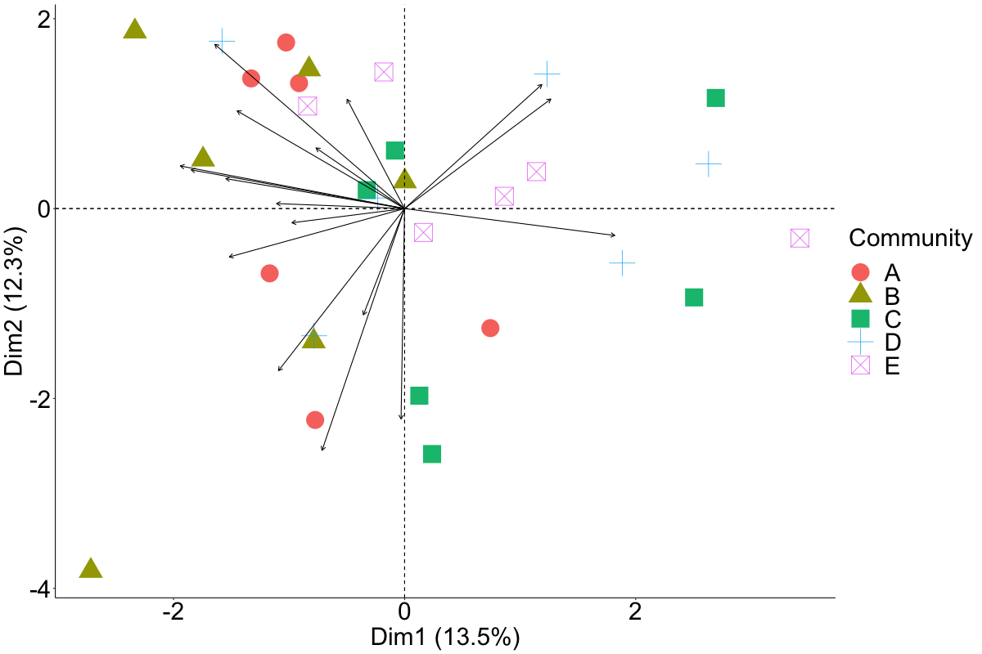
Figure S1: PCA Biplot showing variation in respondentsacross the 5 communities based on the responses they employed.

Table S1 Full list of adaptive responses. Based on final NVivo codebook.
Response category (used in primary figures in Ch. 5) | Specific responses (raw open coding)
Coping strategies
Dietary changes | Buying low quality food  Consuming different foods to normal  Foraging for wild vegetables  Reducing dietary diversity  Eating less overall  Skipping meals
Consuming assets, loans | Borrowing money or other assets  Buying food on credit  Loans from traders (to be paid in future fish catches)  Selling or consuming assets (e.g., livestock)  Using savings
Fish-based activities (minor) | Increase fish price  Increased existing fishing activities  Selling locally  No longer selling fish on credit
Minor COVID-19 measures | Diligent social distancing, masks, and caution during social interactions etc  Distributing information by word of mouth instead of meetings  Increased supervision and control over children  Not participating in social activities even after restrictions eased  Sticking to close social groups and not interacting with outsiders
Mental health strategies | Consciously altering mental frameworks/thinking positively  Increased religious practice e.g., prayer  Sports and other social engagements to fill time and relieve stress while not working
Social support | Food sharing  Depending on food aid
Illegal activities | Crime  Fishing illegally  Secretly trading during curfew hours
Resource allocation | Planning and budgeting food expenditure  Reducing other expenditure to afford food  Prioritising feeding children  Selling proportionally less, maintaining, or increasing consumption  Consuming less catch or stock directly, selling proportionally more  Doing tasks themselves they would normally pay someone else to do  Cooking foods at home you would normally buy out  Buying individual food items from stalls instead of buying in bulk and cooking  Stocking up on food
Non-fish livelihoods (minor) | Casual vs. salaried employment in same industry
Incremental Adaptations
Post-harvest activities (major) | Buying ice to preserve fish until curfew hours end  Change in fish marketing strategy  Change in or introduction of processing activities  Collaboration between fishers to sell fish to traders  Freezing fish until traders can come buy it  Mama Karangas supplementing buying fish direct from fishers with buying from fish shops
Non-fish livelihoods (major) | Changing proportional effort of existing livelihood activities  - Increased engagement in informal economic activities  Diversifying farming  Mama Karangas diversifying what they sell e.g., vegetables as well as fish
Fishing (major) | Change in fishing method  Change in type of fish targeted or traded  Collaborations between fishers to share effort and profit  Working individually and in shifts  Using personal equipment/not sharing
Food acquisition | Buying food from wholesalers and having it delivered  Buying maize in bulk and milling it into flour instead of buying small flour packets  Direct exchange instead of cash transactions
Major COVID-19 measures | Active widespread and substantive changes in behaviour and social practices to prevent contracting or spreading COVID-19  Altering daily schedules and routines to fit around curfew hours and other regulations
Household economic strategy | Intentionally saving  Household members combining assets (finances often kept separate)  Increasing investments in livestock as future buffer  Investing in new/better equipment  Major construction projects for homes/businesses
Transformations
New livelihood | Engagement in a completely new type of livelihood activity
Migration | Moving to a different community

Table S2: Examples of how each of the domains of adaptive capacity influenced responses through each of the three mechanisms: 1) Facilitated- high capacity in a particular domain enabled people to take a specific action; 2) Lack forced- low capacity in a particular domain forced people to take a specific undesirable action; and 3) Barrier- low capacity in a particular domain prevented people from taking a desired action. Icons are adapted from Cinner and Barnes (2019).
AC domain | Facilitated | Lack forced | Barrier
 | A) Flexibility to switch between locations and strategies for selling fish, for example going door to door allowed people to maintain income when markets closed.  “We used to get challenges to sell. Sometimes we used to fry them and put in a basin and go around door to door to show people that we have fish.” (M, 45, community B) | B) Forced to increase fishing effort and fish illegally at night due to lack of alternative income sources:  “The fishing duration was short, and you were forced to secretly fish more hours. I was forced to go fishing at night although it was dangerous as I could be arrested.” (anonymised) | C) Unwillingness or inability (whether perceived or objective) to do anything other than fishing/fish trading prevented income diversification:  “We are used to fish trading and cannot leave doing it.” (F, 38, community A)
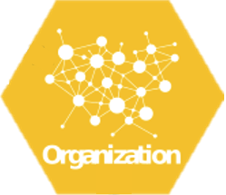 | D) Social capital allowed people to obtain food on credit:  “I was going to the shop and taking my bundle of maize flour, take baking flour, like 10kg, then I write in an agreement that when I get money, I will pay…And at the time like that I was trusted so much because I was taking food from other shops on credit and was paying in bits until I was clear.” (M, 27, community E). | E) Lack of trust that other people would obey rules led to people not going to church and other social activities:  “The church is attended by different people, and you cannot easily know who is good and who is bad. People are also disobeying rules and so I reduced going there.” (M, 21, community A) | F) A lack of connections prevented access to financial support:  “I have not seen any support. I am just seeing things happen and yet I have a family just like that. I don’t know which door the support is passing through. Even I don’t know who ate the money…Every Monday people are getting KSH2000, but myself I am not self-dependant, and I am getting nothing and have children.” (F, 46, community C)
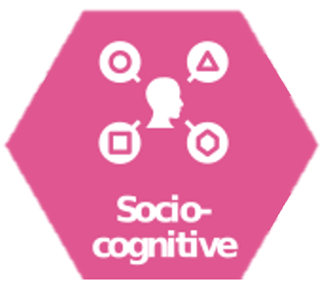 | G) Perceived risk and strong sense of social obligation to protect others led to the adoption of COVID-19 mitigation strategies:  “I observed how everyone behaves and realised everyone believes in themselves, washes hands, wears face masks and when leaving the house wears gloves so that we protect ourselves well. When one gets dirty, they wash hands, as I tell everyone to be cautious because we are one family and should avoid touching each other as we are close to each other so that we are safe. (F, 42, community D) | (Not applicable, as you cannot have a “lack” of socio-cognitive constructs, as they are a way of thinking rather than something that can be quantified.) | H) Social norms around self-sufficiency lead to a lack of support from leaders:  “That’s an individual case whereby you try to see what your family will eat. As a community, it’s just to give each one a hand of advice but not a handout in order to support each other, and that is why the Swahili came up with a saying that ‘Everyone is to carry his cross,’ okay?” (Leader, community E)
 | I) High self-efficacy facilitated strategic planning and proactive livelihood diversification:  “I had thought to sit down with my husband to talk about how life is and see how we can improve on our wellbeing…The biggest business I have seen here that can help me in my life is to build a rental house…therefore I have a piece of land to build.” (F, 38, community C) | J) Forced to sell fish to traders on credit and wait for them to pay when they receive income due to lack of power:  “You are forced to sell fish on credit, and you may be given KES200 (1.6USD) and told you will be given the balance later but every day you just wait and be told the same thing.” (M, 30, community D) | K) Perceived lack of alternative options and family obligations prevented migrating to find work:  “No, I have not done anything for now. I don’t know what to do or where to go. What will I leave my family with before I go anywhere? If I had something to leave behind, I would go look for income somewhere else because I will be going to start a new life while leaving a burden at home.” (M, 30, community A)
 | L) Ability to interpret and respond to other people’s fishing practices and market supply and demand trends lead to switching gears to target potentially less exploited species and/or fill a market gap.  “We stopped using spearguns as many were using them and we looked for nets.” (M, 21, community B) | (No examples identified) | M) Lack of knowledge and experience, and an inability to learn quickly and effectively limited the success of new livelihood activities:  “Remember, you have been forced to change to a place where you don’t have any skills to utilise to get your daily needs. Therefore, you are just going there to try to do something but in the real sense you’re not doing it. So, the income they are getting from what they are doing cannot sustain the demand they have” (Leader, community B)
 | N) Assets like electricity connections and farmland allowed livelihood diversification:  “The change that we made is that I looked for small hustles at home. For example, we have electricity that I used to sell water to the villagers and planted some vegetables which I used to sell to people.” (M, 25, community C) | O) Selling productive assets at low prices due to lack of cash income:  “People have been forced to slaughter many animals before they reach maturity to meet their needs because they have nothing… again when you look at the environment you find that whatever you have, you’re forced to sell at throwaway prices so that you get money to use. Therefore, we have been losing our assets cheaply like that” (Leader, community B) | P) A lack of start-up capital prevented livelihood diversification:  “I don’t have an alternative livelihood apart from mining business. I used to play merry-go-round but when corona came and made me lose my fish business, it became very hard for me to be a member of merry-go-round. That could have been the only means to get capital to restart my fish business.” (F, 29, community D)

Appendix 2-Participant demographic information
Table S3 Interviewee demographics
Participant # | Gender | Age
Community A
A1 | M | 21
A2 | F | 29
A3 | M | 30
A4 | F | 38
A5 | M | 51
A6 | F | 45
A7_L | M | 45
Community B
B1 | M | 24
B2 | F | 29
B3 | M | 45
B4 | F | 42
B5 | M | 48
B6 | F | 46
B7-L | M | 43
Community C
C1 | M | 25
C2 | F | 29
C3 | M | 42
C4 | F | 38
C5 | M | 55
C6 | F | 46
C7_L | M | 43
Community D
D1 | M | 28
D2 | F | 29
D3 | M | 30
D4 | F | 42
D5 | M | 69
D6 | F | 45
D7_L | M | 50
Community E
E1 | F | 29
E2 | M | 27
E3 | M | 43
E4 | F | 40
E5 | F | 58
E6 | M | 61
E7_L | M | NA

Appendix 3 Individual interview template
I’d like to hear about the changes you and your household have experienced in the past month, related to COVID-19 and government rules that have been put in place.
General
- What are the main changes you have experienced since March 2020?
Livelihoods
- Please tell me about how COVID-19 has impacted how you and your family have brought in food and income compared to how you normally would at this time of year.
  - Have you and your family made any changes to cope with these impacts? Please tell me about them.
- I am interested in understanding how COVID-19 has affected how you and your family have been fishing and gleaning.
- Has COVID-19 changed how much you’ve been catching compared to how you normally would at this time of year? How so?
- Has COVID-19 changed the type of catch you’ve been catching compared to how you normally would at this time of year? How so?
  - Have you and your family made any changes to cope with these impacts? Please tell me about them.
    - [If they say that they’re catching less fish (above), ask] Are you selling less fish, eating less fish or a combination, or something else?
Fishing and access to markets
- Please tell me about how COVID-19 has impacted how you [buy and] sell fish (including markets)?
  - Have you and your family made any changes to cope with these impacts? Please tell me about them.
- Is it easier or harder or the same to access markets (or buyers) to buy and sell fish compared to normally at this time of year? Why?
  - Have you and your family made any changes to cope with these impacts? Please tell me about them.
- Has the price of fish changed to buy and to sell compared to this time of year normally? How?
  - Have you and your family made any changes to cope with these impacts? Please tell me about them.
Food security
- Please tell me about how COVID-19 has affected the types and variety of food you and your family are eating now, compared to normally at this time of year.
- Are there foods you normally eat at this time of year that you are not eating at the moment? Why?
- Is store-bought food easier or harder to get? Why?
  - Have you and your family made any changes to cope with these impacts? Please tell me about them.
Wellbeing
- How has COVID-19 impacted other aspects other aspects of your quality of life, for example your normal routines, social interactions and level of happiness and day-to-day life compared to normal? (E.g., Church, soccer/ football).
- Have your social relations with others in the community changed? How?
  - Have you made any changes to cope with these impacts? Please tell me about them.
General
- Is there anything you’d like to add?

Appendix 4 Leader interview template
I’d like to hear about the changes the community has experienced due to the COVID-19 pandemic and the government rules that have been put in place.
General
- What are the main changes that COVID-19 has had on the community?
Institutions
- Please tell me about changes caused by COVID-19 to meetings and activities in the community compared to before? Are there regular community meetings? Has COVID-19 impacted fisheries (or reef) management? How?
Migration
- Please tell me about changes that COVID-19 is having on people coming and going in the community? Have more people come here or more people left? If so, what impact is that having?
  - Has the community made any changes to cope with these impacts? Please tell me about them.
Livelihoods
- Please tell me about impacts that COVID-19 has had on livelihoods in the community. Have the number of people fishing changed? Has the intensity of fishing changed?
  - Has the community made any changes to cope with these impacts? If so, what are these changes?
Access to markets
- Please tell me about impacts that COVID-19 has had on buying and selling fish. Are people in the community able to access markets? Why/ why not?
  - Has the community made any changes to cope with these impacts? Please tell me about them.
Food security
- Please tell me about impacts that COVID-19 has on food. How is the community making food last for everyone? Are there any projects or plans to support the community to access food? Are people in the community changing how they access food?
  - Has the community made any changes to cope with these impacts? Please tell me about them.
Wellbeing
- Please tell me about impacts that COVID-19 has on the wellbeing and day to day lives of the community as a whole, for example, have church gatherings continued, are sports still played? Have social relations in the community changed? How?
  - Has the community made any changes to cope with these impacts? Please tell me about them.
- Do you think COVID-19 has impacted some people in the community more than others? How and why?
Support
- Has there been any external support? E.g., government, CBOs, NGOs? What sort?
- What further outside support is needed? (Specify that we don’t provide this – we will pass this on as recommendation.
General
- Is there anything you’d like to add?

Appendix 5 Fish trader interview template
- I’d like to understand the timeline of the coronavirus, from March until now. Can you please tell me what happened when COVID-19 started in March? For example, what rules were put in place, and also how these rules have changed since March?
- How has the coronavirus and the government rules impacted you as a fish trader?
  - In what ways has it impacted how you obtain fish from fishers?
  - In what ways has it impacted how you transport and sell fish?
  - How has it impacted the price of fish to buy and sell?
  - How have these changes impacted you personally?
    - Livelihood/income
      - Has this influenced your ability to buy food for you and your family?
    - Lifestyle/wellbeing
  - Have you made any changes to cope with these impacts?
- Is there anything else you would like to tell us?

