Rising allergenic risk in cities: A progressive pollen calendar analysis in response to climate change in Central Europe

Jana Ščevková, Mária Tropeková, Jozef Dušička, Janka Lafférsová, Ondřej Rybníček, Eva Zahradníková, Michal Hrabovský

Fig. S1 Quality control assessment for filtering incomplete years using risk-based categorisation. The data with risk level 4–5 were removed from the analysis. The years 2005 in PR and 2010 in LI were removed completely. Pollen-type abbreviations are provided in Section 2.2.
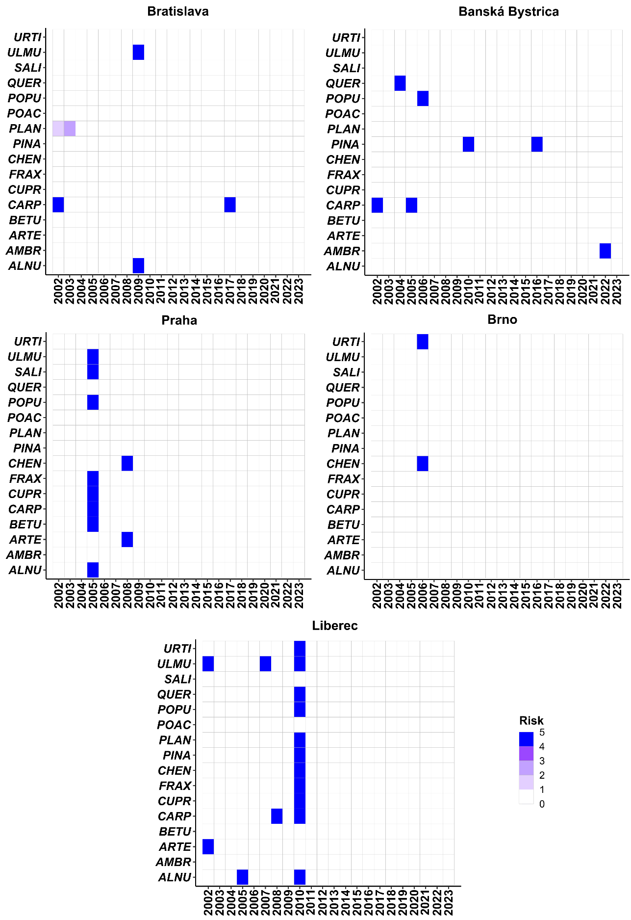
Table S1 The average values of the start of the main pollen season (expressed as DOY – day of the year from 1 January) for selected taxa in the study areas during 2002−2012 (past) and 2013−2023 (recent). Pollen-type abbreviations are provided in Section 2.2.

Taxon | Bratislava |  |  | Banská Bystrica |  |  | Praha |  |  | Brno |  |  | Liberec
Taxon | past | recent |  | past | recent |  | past | recent |  | past | recent |  | past | recent
ALNU | 53 | 52 |  | 64 | 55 |  | 60 | 49 |  | 62 | 52 |  | 57 | 56
AMBR | 226 | 225 |  | 223 | 200 |  | 232 | 235 |  | 225 | 225 |  | 235 | 228
ARTE | 212 | 213 |  | 208 | 207 |  | 186 | 204 |  | 211 | 212 |  | 191 | 208
BETU | 90 | 89 |  | 98 | 99 |  | 86 | 96 |  | 95 | 95 |  | 102 | 101
CARP | 79 | 80 |  | 79 | 92 |  | 86 | 93 |  | 98 | 91 |  | 84 | 95
CHEN | 181 | 185 |  | 181 | 172 |  | 166 | 187 |  | 157 | 187 |  | 161 | 183
CUPR | 70 | 56 |  | 79 | 69 |  | 64 | 57 |  | 73 | 65 |  | 70 | 72
FRAX | 79 | 69 |  | 93 | 86 |  | 83 | 87 |  | 82 | 82 |  | 79 | 88
PINA | 120 | 119 |  | 112 | 113 |  | 124 | 125 |  | 122 | 124 |  | 112 | 127
PLAN | 145 | 148 |  | 146 | 139 |  | 144 | 144 |  | 137 | 147 |  | 132 | 153
POAC | 127 | 132 |  | 137 | 137 |  | 140 | 137 |  | 137 | 136 |  | 145 | 143
POPU | 77 | 68 |  | 68 | 74 |  | 69 | 72 |  | 76 | 67 |  | 70 | 74
QUER | 104 | 95 |  | 103 | 98 |  | 111 | 115 |  | 109 | 110 |  | 102 | 117
SALI | 77 | 78 |  | 78 | 78 |  | 71 | 79 |  | 79 | 78 |  | 78 | 82
ULMU | 65 | 62 |  | 78 | 69 |  | 70 | 77 |  | 75 | 70 |  | 70 | 87
URTI | 133 | 141 |  | 164 | 159 |  | 165 | 161 |  | 148 | 161 |  | 155 | 169

Table S2 Mann-Kendall trend test (test tau column) and Sen’s slope estimate (Q column) of the start of the main pollen season for selected taxa in the study areas during 2002−2023. Pollen-type abbreviations are provided in Section 2.2.

Taxon | Bratislava |  |  | Banská Bystrica |  |  | Praha |  |  | Brno |  |  | Liberec
Taxon | tau | Q |  | tau | Q |  | tau | Q |  | tau | Q |  | tau | Q
ALNU | -0.329* | -1 |  | -0.355* | -1.3 |  | -0.486** | -1.388 |  | ns | - |  | ns | -
AMBR | ns | - |  | ns | - |  | ns | - |  | ns | - |  | ns | -
ARTE | ns | - |  | ns | - |  | ns | - |  | ns | - |  | ns | -
BETU | ns | - |  | ns | - |  | ns | - |  | ns | - |  | ns | -
CARP | ns | - |  | ns | - |  | ns | - |  | -0.381* | -0.67 |  | ns | -
CHEN | ns | - |  | ns | - |  | ns | - |  | ns | - |  | ns | -
CUPR | -0.437** | -1.25 |  | ns | - |  | -0.414** | -1.4 |  | ns | - |  | ns | -
FRAX | -0.372* | -1.17 |  | ns | - |  | ns | - |  | ns | - |  | ns | -
PINA | ns | - |  | ns | - |  | ns | - |  | ns | - |  | ns | -
PLAN | ns | - |  | ns | - |  | ns | - |  | 0.385* | 1 |  | ns | -
POAC | ns | - |  | ns | - |  | ns | - |  | ns | - |  | ns | -
POPU | -0.333* | -1.06 |  | ns | - |  | ns | - |  | -0.351* | -1.17 |  | ns | -
QUER | -0.377* | -1 |  | -0.571*** | -1.09 |  | ns | - |  | ns | - |  | ns | -
SALI | ns | - |  | ns | - |  | ns | - |  | ns | - |  | ns | -
ULMU | -0.371* | -1.17 |  | ns | - |  | ns | - |  | ns | - |  | ns | -
URTI | ns | - |  | ns | - |  | ns | - |  | ns | - |  | ns | -
*p < 0.05; **p < 0.01; ***p < 0.001

Table S3 The average values of the end of the main pollen season (expressed as DOY – day of the year from 1 January) for selected taxa in the study areas during 2002−2012 (past) and 2013−2023 (recent). Pollen-type abbreviations are provided in Section 2.2.

Taxon | Bratislava |  |  | Banská Bystrica |  |  | Praha |  |  | Brno |  |  | Liberec
Taxon | past | recent |  | past | recent |  | past | recent |  | past | recent |  | past | recent
ALNU | 77 | 81 |  | 85 | 84 |  | 78 | 82 |  | 91 | 82 |  | 73 | 85
AMBR | 261 | 263 |  | 259 | 239 |  | 261 | 265 |  | 260 | 261 |  | 265 | 265
ARTE | 251 | 260 |  | 246 | 241 |  | 214 | 240 |  | 244 | 251 |  | 218 | 234
BETU | 112 | 113 |  | 120 | 118 |  | 105 | 118 |  | 119 | 117 |  | 121 | 120
CARP | 100 | 102 |  | 95 | 112 |  | 102 | 116 |  | 118 | 111 |  | 97 | 118
CHEN | 259 | 260 |  | 256 | 257 |  | 231 | 252 |  | 222 | 257 |  | 228 | 247
CUPR | 99 | 111 |  | 133 | 129 |  | 87 | 91 |  | 92 | 95 |  | 103 | 115
FRAX | 109 | 103 |  | 131 | 125 |  | 101 | 115 |  | 115 | 108 |  | 100 | 116
PINA | 152 | 170 |  | 137 | 139 |  | 148 | 153 |  | 152 | 152 |  | 140 | 156
PLAN | 242 | 244 |  | 246 | 245 |  | 240 | 232 |  | 224 | 245 |  | 223 | 241
POAC | 213 | 224 |  | 214 | 206 |  | 206 | 213 |  | 215 | 212 |  | 206 | 205
POPU | 102 | 101 |  | 100 | 105 |  | 93 | 105 |  | 104 | 100 |  | 90 | 99
QUER | 125 | 126 |  | 121 | 137 |  | 135 | 134 |  | 131 | 133 |  | 122 | 140
SALI | 115 | 115 |  | 105 | 113 |  | 107 | 124 |  | 122 | 119 |  | 108 | 122
ULMU | 85 | 94 |  | 110 | 101 |  | 94 | 92 |  | 101 | 97 |  | 80 | 110
URTI | 244 | 247 |  | 237 | 239 |  | 234 | 236 |  | 206 | 238 |  | 218 | 236

Table S4 Mann-Kendall trend test (test tau column) and Sen’s slope estimate (Q column) of the end of the main pollen season for selected taxa in the study areas during 2002−2023. Pollen-type abbreviations are provided in Section 2.2.

Taxon | Bratislava |  |  | Banská Bystrica |  |  | Praha |  |  | Brno |  |  | Liberec
Taxon | tau | Q |  | tau | Q |  | tau | Q |  | tau | Q |  | tau | Q
ALNU | ns | - |  | ns | - |  | ns | - |  | ns | - |  | ns | -
AMBR | 0.329* | 0.36 |  | ns | - |  | ns | - |  | ns | - |  | ns | -
ARTE | 0.394* | 1 |  | ns | - |  | ns | - |  | ns | - |  | -0.319* | -0.56
BETU | ns | - |  | ns | - |  | ns | - |  | ns | - |  | ns | -
CARP | ns | - |  | ns | - |  | ns | - |  | ns | - |  | ns | -
CHEN | ns | - |  | ns | - |  | ns | - |  | ns | - |  | ns | -
CUPR | ns | - |  | ns | - |  | ns | - |  | ns | - |  | ns | -
FRAX | -0.411** | -0.6 |  | ns | - |  | ns | - |  | -0.351* | -0.56 |  | ns | -
PINA | ns | - |  | ns | - |  | ns | - |  | ns | - |  | ns | -
PLAN | ns | - |  | ns | - |  | -0.377* | -0.8 |  | ns | - |  | ns | -
POAC | 0.351* | 1.22 |  | ns | - |  | ns | - |  | ns | - |  | ns | -
POPU | ns | - |  | ns | - |  | ns | - |  | ns | - |  | ns | -
QUER | ns | - |  | ns | - |  | ns | - |  | ns | - |  | 0.357* | 0.65
SALI | ns | - |  | 0.411** | 1.09 |  | ns | - |  | ns | - |  | ns | -
ULMU | ns | - |  | ns | - |  | -0.333* | -0.96 |  | -0.359* | -0.7 |  | ns | -
URTI | 0.351* | 0.43 |  | ns | - |  | ns | - |  | 0.371* | 0.64 |  | ns | -
*p < 0.05; **p < 0.01

Table S5 The average duration of the main pollen season (expressed in number of days) for selected taxa in the study areas during 2002−2012 (past) and 2013−2023 (recent). Pollen-type abbreviations are provided in Section 2.2.

Taxon | Bratislava |  |  | Banská Bystrica |  |  | Praha |  |  | Brno |  |  | Liberec
Taxon | past | recent |  | past | recent |  | past | recent |  | past | recent |  | past | recent
ALNU | 24 | 29 |  | 20 | 29 |  | 18 | 33 |  | 28 | 30 |  | 17 | 29
AMBR | 35 | 38 |  | 36 | 38 |  | 29 | 30 |  | 35 | 35 |  | 31 | 38
ARTE | 40 | 47 |  | 38 | 34 |  | 28 | 37 |  | 33 | 39 |  | 27 | 26
BETU | 22 | 24 |  | 22 | 19 |  | 20 | 22 |  | 24 | 21 |  | 19 | 19
CARP | 21 | 22 |  | 16 | 20 |  | 16 | 23 |  | 20 | 20 |  | 14 | 23
CHEN | 77 | 76 |  | 75 | 85 |  | 65 | 65 |  | 65 | 70 |  | 66 | 63
CUPR | 29 | 54 |  | 54 | 60 |  | 23 | 34 |  | 18 | 30 |  | 33 | 43
FRAX | 29 | 34 |  | 38 | 39 |  | 18 | 27 |  | 33 | 26 |  | 21 | 28
PINA | 32 | 51 |  | 25 | 26 |  | 24 | 28 |  | 30 | 28 |  | 28 | 28
PLAN | 96 | 96 |  | 101 | 106 |  | 95 | 87 |  | 87 | 98 |  | 91 | 88
POAC | 86 | 92 |  | 77 | 69 |  | 66 | 76 |  | 78 | 76 |  | 61 | 62
POPU | 26 | 33 |  | 32 | 30 |  | 23 | 33 |  | 28 | 33 |  | 20 | 25
QUER | 21 | 31 |  | 19 | 38 |  | 24 | 19 |  | 22 | 23 |  | 19 | 23
SALI | 38 | 37 |  | 27 | 35 |  | 37 | 44 |  | 42 | 41 |  | 30 | 39
ULMU | 20 | 32 |  | 32 | 32 |  | 24 | 15 |  | 26 | 27 |  | 9 | 24
URTI | 111 | 106 |  | 73 | 80 |  | 70 | 74 |  | 58 | 77 |  | 63 | 67

Table S6 Mann-Kendall trend test (test tau column) and Sen’s slope estimate (Q column) of the duration of the main pollen season for selected taxa in the study areas during 2002−2023. Pollen-type abbreviations are provided in Section 2.2.

Taxon | Bratislava |  |  | Banská Bystrica |  |  | Praha |  |  | Brno |  |  | Liberec
Taxon | tau | Q |  | tau | Q |  | tau | Q |  | tau | Q |  | tau | Q
ALNU | ns | - |  | 0.455** | 0.71 |  | 0.405* | 0.75 |  | ns | - |  | ns | -
AMBR | 0.307* | 0.38 |  | ns | - |  | ns | - |  | ns | - |  | ns | -
ARTE | ns | - |  | ns | - |  | ns | - |  | ns | - |  | ns | -
BETU | ns | - |  | ns | - |  | ns | - |  | ns | - |  | ns | -
CARP | ns | - |  | ns | - |  | ns | - |  | ns | - |  | ns | -
CHEN | ns | - |  | ns | - |  | ns | - |  | ns | - |  | ns | -
CUPR | 0.385* | 1.46 |  | ns | - |  | 0.333* | 0.83 |  | 0.407** | 0.54 |  | ns | -
FRAX | ns | - |  | ns | - |  | ns | - |  | ns | - |  | ns | -
PINA | ns | - |  | ns | - |  | ns | - |  | ns | - |  | ns | -
PLAN | ns | - |  | ns | - |  | -0.39* | -0.87 |  | ns | - |  | -0.362* | -1.23
POAC | ns | - |  | ns | - |  | ns | - |  | ns | - |  | ns | -
POPU | ns | - |  | ns | - |  | ns | - |  | ns | - |  | ns | -
QUER | 0.355* | 0.8 |  | 0.486** | 1.58 |  | ns | - |  | ns | - |  | ns | -
SALI | ns | - |  | 0.368* | 1 |  | ns | - |  | ns | - |  | ns | -
ULMU | 0.424** | 0.95 |  | ns | - |  | ns | - |  | ns | - |  | ns | -
URTI | ns | - |  | ns | - |  | ns | - |  | 0.314* | 0.86 |  | ns | -
*p < 0.05; **p < 0.01

Table S7 The average values of the seasonal pollen integral (expressed in pollen*day/m³) for selected taxa in the study areas during 2002−2012 (past) and 2013−2023 (recent). Pollen-type abbreviations are provided in Section 2.2.

Taxon | Bratislava |  |  | Banská Bystrica |  |  | Praha |  |  | Brno |  |  | Liberec
Taxon | past | recent |  | past | recent |  | past | recent |  | past | recent |  | past | recent
ALNU | 1,157 | 2,234 |  | 2,220 | 5,535 |  | 906 | 1,311 |  | 1,938 | 2,819 |  | 554 | 1,000
AMBR | 1,485 | 2,149 |  | 1,417 | 1,857 |  | 232 | 78 |  | 967 | 737 |  | 64 | 43
ARTE | 786 | 356 |  | 1,265 | 1,214 |  | 474 | 212 |  | 665 | 370 |  | 268 | 146
BETU | 7,354 | 6,604 |  | 4,396 | 11,807 |  | 7,992 | 9,507 |  | 6,186 | 6,995 |  | 5,470 | 5,257
CARP | 666 | 806 |  | 921 | 3,210 |  | 292 | 427 |  | 470 | 911 |  | 134 | 207
CHEN | 468 | 397 |  | 418 | 371 |  | 187 | 164 |  | 338 | 336 |  | 45 | 41
CUPR | 3,692 | 4,335 |  | 1,493 | 3,985 |  | 2,520 | 5,557 |  | 11,132 | 17,625 |  | 236 | 493
FRAX | 1,127 | 3,243 |  | 870 | 2,647 |  | 1,258 | 1,073 |  | 1,754 | 2,069 |  | 79 | 416
PINA | 2,353 | 3,270 |  | 4,705 | 11,170 |  | 4,448 | 6,701 |  | 5,209 | 6,410 |  | 3,515 | 4,722
PLAN | 474 | 713 |  | 359 | 975 |  | 334 | 415 |  | 289 | 377 |  | 167 | 179
POAC | 1,680 | 1,941 |  | 4,066 | 7,828 |  | 1,734 | 2,530 |  | 2,350 | 2,176 |  | 1,818 | 2,278
POPU | 2,058 | 3,636 |  | 518 | 1,107 |  | 585 | 793 |  | 807 | 798 |  | 149 | 300
QUER | 602 | 2,040 |  | 1,307 | 2,698 |  | 1,857 | 2,206 |  | 2,289 | 1,826 |  | 1,174 | 1,392
SALI | 384 | 655 |  | 259 | 494 |  | 266 | 719 |  | 419 | 578 |  | 387 | 270
ULMU | 147 | 277 |  | 470 | 385 |  | 61 | 42 |  | 119 | 159 |  | 43 | 65
URTI | 6,056 | 7,054 |  | 8,527 | 12,715 |  | 7,602 | 8,850 |  | 6,879 | 6,723 |  | 3,456 | 3,633

Table S8 Mann-Kendall trend test (test tau column) and Sen’s slope estimate (Q column) of the seasonal pollen integral for selected taxa in the study areas during 2002−2023. Pollen-type abbreviations are provided in Section 2.2.

Taxon | Bratislava |  |  | Banská Bystrica |  |  | Praha |  |  | Brno |  |  | Liberec
Taxon | tau | Q |  | tau | Q |  | tau | Q |  | tau | Q |  | tau | Q
ALNU | ns | - |  | 0.359* | 268.67 |  | ns | - |  | ns | - |  | ns | -
AMBR | ns | - |  | 0.333* | 87.27 |  | -0.32* | -9.5 |  | ns | - |  | ns | -
ARTE | -0.455** | -29.46 |  | ns | - |  | -0.543*** | -24.46 |  | -0.433** | -27.8 |  | -0.305* | -6.66
BETU | ns | - |  | 0.463** | 525.5 |  | ns | - |  | ns | - |  | ns | -
CARP | ns | - |  | 0.337* | 68.94 |  | ns | - |  | ns | - |  | ns | -
CHEN | ns | - |  | ns | - |  | ns | - |  | ns | - |  | ns | -
CUPR | ns | - |  | 0.42** | 162.4 |  | 0.562*** | 226.74 |  | 0.333* | 489.3 |  | 0.381* | 17.13
FRAX | 0.403** | 136.27 |  | 0.403** | 94.14 |  | ns | - |  | ns | - |  | 0.543*** | 16.23
PINA | ns | - |  | 0.495** | 691.25 |  | ns | - |  | ns | - |  | ns | -
PLAN | 0.307* | 15.91 |  | 0.567*** | 42.54 |  | ns | - |  | ns | - |  | ns | -
POAC | ns | - |  | 0.455** | 291.8 |  | 0.338* | 32.4 |  | ns | - |  | ns | -
POPU | ns | - |  | 0.362* | 36.36 |  | ns | - |  | ns | - |  | 0.319* | 10.85
QUER | 0.472** | 84.4 |  | 0.371* | 90.33 |  | ns | - |  | ns | - |  | ns | -
SALI | 0.42** | 27.8 |  | ns | - |  | 0.457** | 39.18 |  | 0.385* | 14.33 |  | ns | -
ULMU | ns | - |  | ns | - |  | ns | - |  | ns | - |  | ns | -
URTI | ns | - |  | ns | - |  | ns | - |  | ns | - |  | ns | -
*p < 0.05; **p < 0.01; ***p < 0.001

Table S9 The average daily peak pollen concentrations (expressed in pollen/m³) for selected taxa in the study areas during 2002−2012 (past) and 2013−2023 (recent). Pollen-type abbreviations are provided in Section 2.2.

Taxon | Bratislava |  |  | Banská Bystrica |  |  | Praha |  |  | Brno |  |  | Liberec
Taxon | past | recent |  | past | recent |  | past | recent |  | past | recent |  | past | recent
ALNU | 180 | 444 |  | 565 | 949 |  | 303 | 248 |  | 493 | 503 |  | 149 | 197
AMBR | 171 | 282 |  | 277 | 305 |  | 55 | 36 |  | 200 | 167 |  | 24 | 13
ARTE | 78 | 38 |  | 150 | 146 |  | 50 | 30 |  | 94 | 47 |  | 39 | 20
BETU | 1,515 | 1,567 |  | 718 | 2,027 |  | 1,064 | 1,826 |  | 1,169 | 1,268 |  | 1,115 | 1,092
CARP | 169 | 133 |  | 175 | 782 |  | 53 | 95 |  | 87 | 196 |  | 43 | 72
CHEN | 20 | 24 |  | 41 | 20 |  | 11 | 15 |  | 26 | 24 |  | 6 | 5
CUPR | 997 | 856 |  | 171 | 503 |  | 571 | 1,206 |  | 3,688 | 4,898 |  | 51 | 115
FRAX | 199 | 567 |  | 129 | 349 |  | 259 | 233 |  | 289 | 413 |  | 24 | 93
PINA | 367 | 477 |  | 602 | 1,202 |  | 641 | 913 |  | 645 | 790 |  | 716 | 701
PLAN | 23 | 35 |  | 22 | 43 |  | 18 | 26 |  | 26 | 18 |  | 14 | 12
POAC | 96 | 107 |  | 321 | 663 |  | 106 | 151 |  | 160 | 121 |  | 171 | 217
POPU | 442 | 617 |  | 92 | 190 |  | 130 | 130 |  | 178 | 153 |  | 35 | 72
QUER | 118 | 339 |  | 214 | 392 |  | 361 | 387 |  | 419 | 329 |  | 185 | 262
SALI | 58 | 67 |  | 35 | 70 |  | 27 | 78 |  | 72 | 93 |  | 74 | 65
ULMU | 41 | 42 |  | 74 | 82 |  | 13 | 18 |  | 22 | 27 |  | 7 | 18
URTI | 242 | 282 |  | 434 | 566 |  | 396 | 423 |  | 401 | 347 |  | 270 | 196

Table S10 Mann-Kendall trend test (test tau column) and Sen’s slope estimate (Q column) of the peak pollen concentrations for selected taxa in the study areas during 2002−2023. Pollen-type abbreviations are provided in Section 2.2.

Taxon | Bratislava |  |  | Banská Bystrica |  |  | Praha |  |  | Brno |  |  | Liberec
Taxon | tau | Q |  | tau | Q |  | tau | Q |  | tau | Q |  | tau | Q
ALNU | 0.314* | 16.36 |  | ns | - |  | ns | - |  | ns | - |  | ns | -
AMBR | ns | - |  | ns | - |  | ns | - |  | ns | - |  | ns | -
ARTE | -0.468** | -2.6 |  | ns | - |  | -0.4* | -2.25 |  | -0.325* | -2.89 |  | -0.338* | -1.58
BETU | ns | - |  | 0.463** | 113.94 |  | ns | - |  | ns | - |  | ns | -
CARP | ns | - |  | ns | - |  | ns | - |  | ns | - |  | ns | -
CHEN | ns | - |  | ns | - |  | ns | - |  | ns | - |  | ns | -
CUPR | ns | - |  | 0.55** | 23.89 |  | 0.419** | 43.77 |  | ns | - |  | ns | -
FRAX | ns | - |  | 0.325* | 8.81 |  | ns | - |  | ns | - |  | 0.395* | 2.48
PINA | ns | - |  | 0.426** | 61.45 |  | ns | - |  | ns | - |  | ns | -
PLAN | ns | - |  | 0.519*** | 1.91 |  | ns | - |  | ns | - |  | ns | -
POAC | ns | - |  | 0.307* | 20.13 |  | ns | - |  | ns | - |  | ns | -
POPU | ns | - |  | ns | - |  | ns | - |  | ns | - |  | ns | -
QUER | 0.351* | 11.25 |  | ns | - |  | ns | - |  | ns | - |  | ns | -
SALI | ns | - |  | 0.342* | 2.41 |  | 0.462** | 3.08 |  | ns | - |  | ns | -
ULMU | ns | - |  | ns | - |  | ns | - |  | ns | - |  | ns | -
URTI | ns | - |  | ns | - |  | ns | - |  | ns | - |  | ns | -
*p < 0.05; **p < 0.01; ***p < 0.001

Fig. S2 Changes in the recent pollen calendar (2013–2022) compared to the past period (2002–2012) across five study sites. Pollen-type abbreviations are provided in Section 2.2.
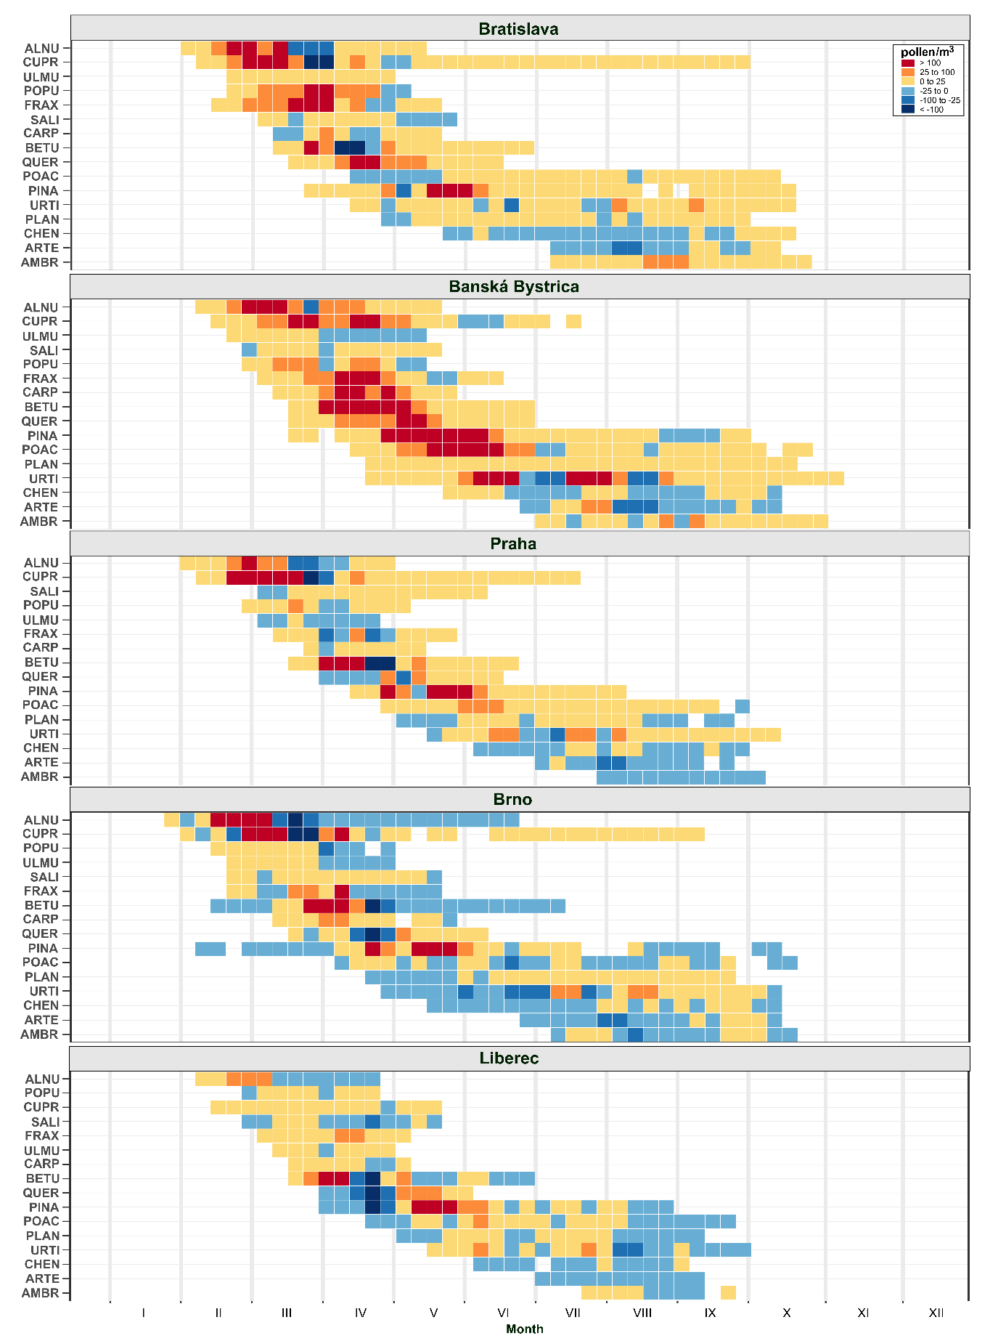

Fig. S3 Simplified pollen calendars for the study areas in 2013–2023, with three risk categories: low (< 25 pollen/m³), moderate (25–100 pollen/m³), and high (> 100 pollen/m³). Pollen-type abbreviations are provided in Section 2.2.
