Regional Environmental Change
SUPPORTING INFORMATION

Reconstructing limnological and vegetation changes in the Eastern Carpathians (Ukraine) over the past 200 years inferred from sediments of three contrasting alpine lakes

Slobodníková et al.

Supplementary Material S1: The chronology of sediment profiles of the three study lakes

Natural and artificial radionuclides (²¹⁰Pb method and ¹³⁷Cs) were employed to estimate the age of each sediment layer. The ²¹⁰Pb method is based on the law of radioactive decay and variations in the concentration of the so-called unsupported lead (²¹⁰Pb_{unsup}). The total ²¹⁰Pb comprises supported lead, which accumulates in situ and is incorporated into the sediment, and unsupported lead from atmospheric deposition. The value of ²¹⁰Pb_{unsup} was determined by subtracting the value of ²¹⁰Pb_{sup} from ²¹⁰Pb_{total}. The constant rate of supply (CRS) model was used to estimate the age (Szarlowicz et al. 2013; Szarlowicz et al. 2022).
The isotope ¹³⁷Cs is a product of ²³⁵U fission and its presence in sediment is a consequence of uncontrolled distribution during nuclear weapon testing (notably with peak fallout in 1963) as well as the Chernobyl accident (1986). As a result of these events, a significant concentration of cesium is expected to appear as a distinct peak in the sediment core.
A total of 66 samples were analyzed from the three lakes: 22 from Dohyaska, 21 from Nesamovyte and 23 from Brebeneskul. The part of the sediment sequences that could be dated using ²¹⁰Pb covered 13 cm of the Brebeneskul sequence, and 20 cm of each of the Dohyaska and Nesamovyte sequences. The methodology entailed freeze-drying the sediments, followed by grinding and sieving through a 0.5 mm sieve to ensure homogenization. The homogenized sediments were then packed into flat containers, sealed tightly, and left for one month to attain equilibrium between radium (²²⁶Ra) and radon (²²²Rn). Thereafter, gamma spectrometry measurements were conducted utilizing a spectrometer equipped with a high-purity germanium detector (BE 3830, 34% relative efficiency, Canberra), incorporating low-background shielding (0.1 cm copper; 0.5 cm cadmium; 5.5 cm low activity lead; and 7.5 cm standard lead) along with a specialized filtration system to minimize background interference (Jędrzejek & Szarlowicz 2024). Each sample was measured for no less than three days, with spectral analysis conducted using Genie-2000 software. The radionuclides ¹³⁷Cs and ²¹⁰Pb_{total} were directly quantified employing energy lines of 661.6 keV and 46.5 keV, respectively. Supported Pb (²¹⁰Pb_{sup}) was calculated based on radioactive equilibrium in the uranium-radium series, using the daughter radionuclides of ²²⁶Ra, at the following energies: 609.3 keV (²¹⁴Bi_{equi.}) and 295.2 keV; 351.9 keV (²¹⁴Pb_{equi.}). The results were corroborated utilizing reference materials provided by the International Atomic Energy Agency (IAEA).

Results of the ²¹⁰Pb and ¹³⁷Cs dating of the three analyzed lake sediments. Samples associated with the increase in ¹³⁷Cs concentrations (Chernobyl and nuclear weapon test) are marked in bold. MDA – minimum detectable activity. LLD – lower limit detection.
Method | ²¹⁰Pb |  |  |  | ¹³⁷Cs
Lake | Doh | Nes | Bre |  | Dohyaska |  |  | Nesamovyte |  |  | Brebeneskul
Depth/Age | Age ± uncertainties |  |  |  | year | [Bq/kg] ± uncert |  | year | [Bq/kg] ± uncert |  | year | [Bq/kg] ± uncert
0.5 |  |  |  |  |  |  |  | 2017 | 497±28
1.0 | 8±1 | 2±0.2 |  |  | 2011 | 153±11 |  | 2017 | 398±25
1.5 |  |  | 10±2 |  | 2007 | 137±14 |  |  |  |  | 2011 | 394±21
2.0 | 17±2 | 4±0.2 | 16±3 |  | 2002 | 141.7±8.7 |  | 2015 | 360±22 |  | 2005 | 376±20
2.5 |  |  | 22±4 |  |  |  |  |  |  |  | 1999 | 339±18
3.0 | 21±2 | 6±1 | 25±5 |  | 1998 | 125.2±9.9 |  | 2013 | 722±40 |  | 1996 | 185±10
3.5 |  |  | 27±5 |  |  |  |  |  |  |  | 1994 | 307±16
4.0 | 25±2 | 9±1 | 32±6 |  | 1994 | 128.7±8.3 |  | 2010 | 651±36 |  | 1989 | 367±19
4.5 |  |  | 38±9 |  |  |  |  |  |  |  | 1983 | 269±14
5.0 | 31±3 | 12±1 | 44±11 |  | 1988 | 142.3±9.4 |  | 2007 | 754±42 |  | 1977 | 175.5±3.8
5.5 |  |  | 49±13 |  |  |  |  |  |  |  | 1972 | 139.4±8.4
6.0 | 37±4 | 15±1.5 | 54±15 |  | 1982 | 138.8±9.0 |  | 2004 | 822±12 |  | 1967 | 149.5±8.3
6.5 |  |  | 61±19 |  |  |  |  |  |  |  | 1960 | 143.0±5.1
7.0 | 43±4 | 20±2 | 68±24 |  | 1976 | 164.0±9.4 |  | 1999 | 879±49 |  | 1953 | 162.6±8.9
7.5 |  |  | 78±34 |  |  |  |  |  |  |  | 1943 | 49.9±3.8
8.0 | 50±5 | 25±3 | 81±35 |  | 1969 | 174.4±11 |  | 1994 | 956±17 |  | 1940 | 32.7±3.2
9.0 | 58±6 | 31±4 | 86±38 |  | 1961 | 152.7±8.8 |  | 1988 | 1055±56 |  | 1935 | 12.0±4.4
9.5 |  |  | 95±43 |  |  |  |  |  |  |  | 1926 | LLD
10.0 | 66±8 | 38±4 | 98±42 |  | 1953 | 112.9±6.6 |  | 1981 | 991±13 |  | 1923 | MDA
10.5 |  |  | 106±43 |  |  |  |  |  |  |  | 1915 | MDA
11.0 | 72±9 | 46±6 | 121±61 |  | 1947 | 141.7±8.1 |  | 1973 | 1090±17 |  | 1900 | 8.2±2.5
11.5 |  |  | 130±66 |  |  |  |  |  |  |  | 1891 | MDA
12.0 | 80±11 | 58±8 |  |  | 1939 | 165.1±4.2 |  | 1961 | 1137±21
12.5 |  |  | 137±61 |  |  |  |  |  |  |  | 1884 | MDA
13.0 | 95±17 | 74±13 | 143±61 |  | 1924 | 86.2±3.1 |  | 1945 | 769±40 |  | 1878 | LLD
13.5 |  |  | 166±74 |  |  |  |  |  |  |  | 1855 | LLD
14.0 | 107±24 | 88±20 |  |  | 1912 | 22.7±2.2 |  | 1931 | 549±30
15.0 | 110±24 | 105±32 |  |  | 1909 | 17.5±2.8 |  | 1914 | 316.2±6.1
16.0 | 115±24 | 120±45 |  |  | 1904 | 11.7±2.8 |  | 1899 | 217.5±8.6
17.0 | 123±25 | 133±48 |  |  | 1896 | 17.4±2.5 |  | 1886 | 148.0±11
18.0 | 134±28 | 154±52 |  |  | 1885 | 10.5±1.8 |  | 1865 | 77.3±3.0
19.0 | 144±30 | 174±70 |  |  | 1875 | 15.5±2.6 |  | 1845 | 54.8±3.3
20.0 | 167±35 | 185±83 |  |  | 1852 | 19.2±2.5 |  | 1834 | 33.3±3.4

References

Jędrzejek J, Szarłowicz K (2024) Evaluation and reduction of background interference caused by airborne particles in gamma spectrometry measurements. Measurement 232:114730 doi: 10.1016/j.measurement.2024.114730
Szarłowicz K, Reczynski W, Misiak R, Kubica B (2013) Radionuclides and heavy metal concentrations as complementary tools for studying the impact of industrialization on the environment. J Radioanal Nucl Ch 298:1323-1333. doi: 10.1007/s10967-013-2548-1
Szarłowicz K, Stobiński M, Jedrzejek F, Kubica B (2022) Sedimentary conditions based on the vertical distribution of radionuclides in small dystrophic lakes: A case study of Toporowe Stawy Lakes (Tatra Mountains, Poland). Environ Sci Pollut Res 29:89530-89541. doi: 10.1007/s11356-022-21922-3

Supplementary Material S2: Pictures of the immediate catchments of the study lakes
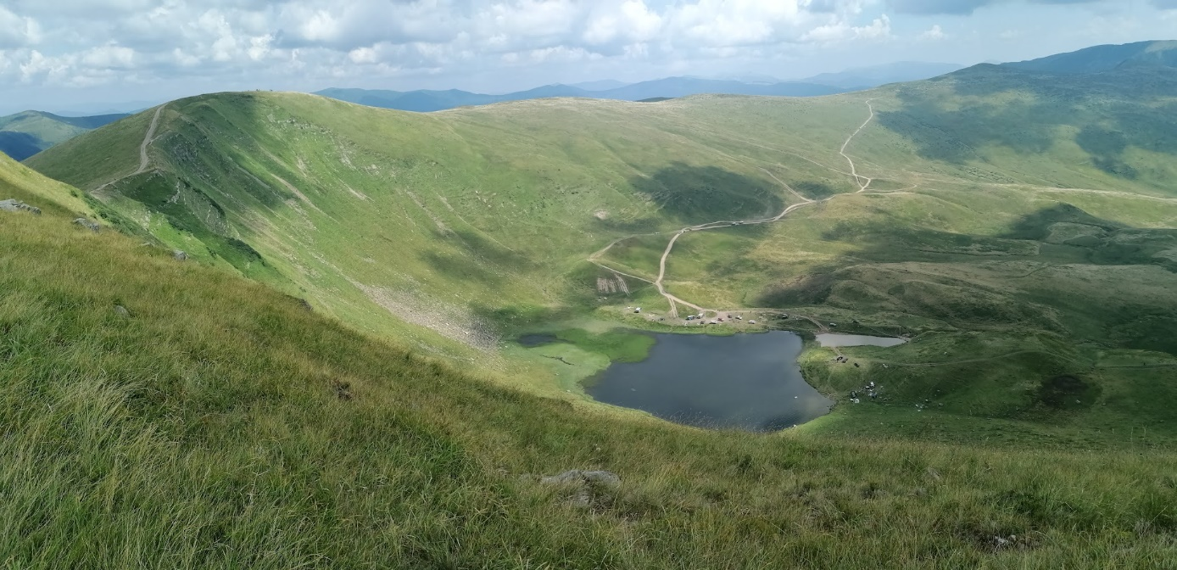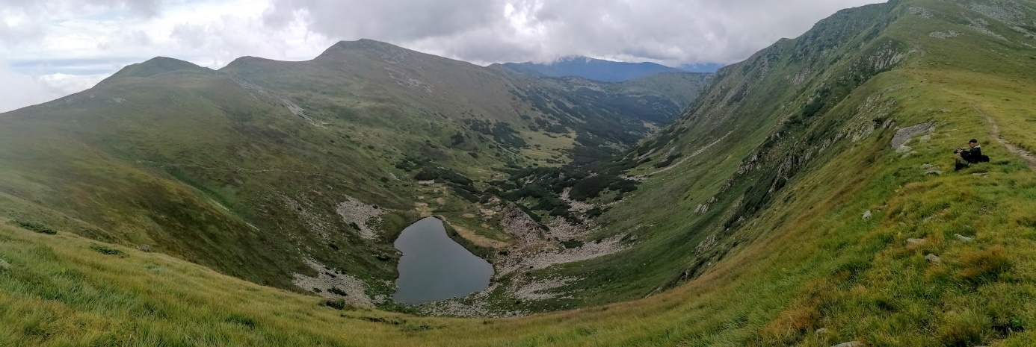
a
b
Photographs showing the catchment vegetation of lake Dohyaska (a) and lake Brebeneskul (b).
In the Svydovets Massif (Dohyaska), occurrence of Pinus mugo is limited, and in general, subalpine shrub communities, particularly along the main ridge and in the vicinity of lake Dohyaska, are largely absent, except for Alnus viridis stands on extremely steep slopes. In contrast, the Chornohora Massif (Brebeneskul) supports the most extensive P. mugo communities in the Ukrainian Carpathians. Although only scattered patches of P. mugo occur within the immediate catchment of Lake Brebeneskul, the species forms continuous stands further down the valley (see figure).

