Appendix A
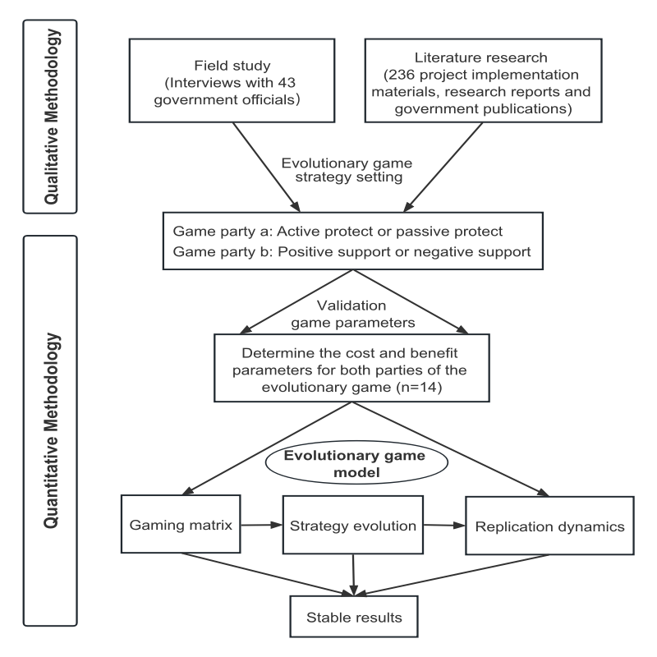
Appendix A Research design and analytical workflow. The diagram depicts the application of a mixed-methods strategy, demonstrating how qualitative insights from fieldwork and literature inform the construction of the evolutionary game model.

