Impacts of climate variability on rice yield and diseases in coastal Bangladesh

Regional Environmental Change

Moriom Akter Mousumi ^{a,b,*}, Spyridon Paparrizos ª, Md Kamrul Hasan ^{c}, Md Ektear Uddin ^{c}, Fulco Ludwig ª

ª Water Systems and Global Change Group, Wageningen University and Research, P.O. Box 47,
6700 AA Wageningen, the Netherlands
^{b} Department of Plant Pathology, Faculty of Agriculture, Patuakhali Science and Technology
University, Patuakhali 8602, Bangladesh
^{c} Department of Agricultural Extension and Rural Development, Faculty of Agriculture,
Patuakhali Science and Technology University, Patuakhali 8602, Bangladesh

*Corresponding author. E-mail: moriomakter.mousumi@wur.nl, mousumi67@pstu.ac.bd (Moriom A. Mousumi).

Appendix 1: Search query used in the Scopus database:
TITLE-ABS-KEY (“Climate Variability*” OR "Climate Change*" OR "Global Warming”) AND TITLE-ABS-KEY (“Rice Production" OR "Rice Yield”) OR ("Rice disease*" OR "Rice Pathogen*" OR " Plant Pathogen") AND TITLE-ABS KEY (“Bangladesh” OR " Southeast Asia" OR “Asia” OR “India”)

Appendix 2: Conversion of the various statistical outputs such as correlation coefficients, regression coefficients, R² values into a common effect size (Cohen's d) using the following equations:

Cohen’s d from correlation coefficients (r):
$$d=2r/\sqrt{1-r^{2}}$$

Cohen’s d from regression coefficients (β):
$$d=\frac{2β}{{σy}/{σx}}$$

Where β is the regression coefficient, σy and σx ​ are the standard deviation of the dependent variable and independent variable respectively.

Cohen’s d from R² values:
$$d= \sqrt{\frac{R^{2}}{1-R^{2}}}$$

Appendix 3: Mann-Kendall test-
The Mann-Kendall test is a rank-based technique commonly used to identify long-term trends in meteorological data in climate studies (Burn and Hag Elnur 2002; Paparrizos et al. 2016; Yue and Wang 2004). It is robust to extreme cases and performs well even with skewed distributions. This test is essential for understanding climate variability in rice production systems. For all indices, we used a 95% confidence level to assess the significance of trends. At this significance level, the null hypothesis of ‘no trend’ is rejected if the absolute value of the Z statistic (|Z|) is greater than 1.96. In another nonparametric trend test, we used Sen's (1968) slope estimator to estimate the magnitude of change in the climate data. While the Mann-Kendall test identifies the direction of change or trend, Sen's slope estimator quantifies the rate of change.

Appendix 4: Rice yield impact analysis using quadratic polynomial regression-
We used a quadratic polynomial regression (Eq. 1), adapted from Lobell et al. (2011) and Hasan and Kumar (2021), to regress aman rice yields against a series of climate variables to quantify the impacts of temperature, rainfall, and humidity trends on rice yields. These researchers use both fixed and random effects (mixed effects) in their study. As we conduct our study in only one location and one crop, there are no random effects except for the fixed effects (climate effect).
For this analysis, data on average temperature, total rainfall, and average humidity were aggregated for the aman rice-growing season over the time period 1981–2018.

$Log \left(Y_{i}\right)= α+ β_{1}t+ β_{2}t^{2}+ β_{3}T+β_{4}R+β_{5}H+ ε_{i}$, (1)

where Y_{i} is the aman rice yield (ton/ha), α is the intercept, β₁...β₅ are the regression coefficients of the predictor variables, and t is time (year). T, R, and H are the climate variables, namely, average temperature (°C), total rainfall (mm), and average humidity (%), respectively, for the aman rice-growing season, and ε_{i} is the residual errors, which are assumed to be independently and usually distributed. The logarithm of yield was regarded as a linear combination of the aforementioned predictors, as the crop yield data closely resembles a log-normal distribution (Lobell et al., 2011). The yield curve increases rapidly when the time (year) variable is squared, which may be a result of evolving farming practices and the impact of technological advancements (Hasan and Kumar 2021). Therefore, we added t (time) and t² (time squared) to mask out the effects of improved farming practices and technological advancements (both being non-climatic factors) from the impacts of climate on rice yields, as these non-climatic factors are not accounted for in the current study.

We employed the procedure outlined by Lobell et al. (2011) to evaluate the yield effect of climate trends in three steps. First, the yearly series of climate variables were detrended. The detrended series ($D_{t})$of the climate variables were estimated by deducting the predicted or fitted values of the regressions ($P_{t}$) from the observed time series values ($O_{t}$) and adding the initial value ($I_{1981}$) (Eq. 2) (Lobell et al. 2011; Hasan and Kumar 2021).
$$D_{t}= O_{t}-P_{t}+ I_{1981}$$ (2)

Second, rice yields were modelled using various combinations of the observed and the detrended series, as follows:
- F(T, R, H) = yield predicted by observed climate variables, i.e., temperature, rainfall, and humidity
- F(T_{d}, R, H) = yield predicted by detrended temperature, observed rainfall, and observed humidity
- F(T, R_{d}, H) = yield predicted by observed temperature, detrended rainfall, and observed humidity
- F(T, R, H_{d}) = yield predicted by observed temperature, observed rainfall, and detrended humidity
- F(T_{d}, R_{d}, H_{d}) = yield predicted by detrended climate variables, i.e., temperature, rainfall, and humidity

Third, the differences F(T, R, H) − F(T_{d}, R, H), F(T, R, H) − F(T, R_{d}, H), F(T, R, H) – F(T, R, H_{d}), and F(T, R, H) − F(T_{d}, R_{d}, H_{d}) were computed to quantify the yield impacts of trends in temperature, rainfall, humidity, and the combined effects of temperature, rainfall, and humidity, respectively.

References

Lobell DB, Schlenker W, Costa-Roberts J (2011) Climate trends and global crop production since 1980. Science 333:616–620. https://doi.org/10.1126/science.1204531
Hasan MK, & Kumar L (2021) Yield trends and variabilities explained by climatic change in coastal and non-coastal areas of Bangladesh. Sci Total Environ 795:148814. https://doi.org/10.1016/j.scitotenv.2021.148814

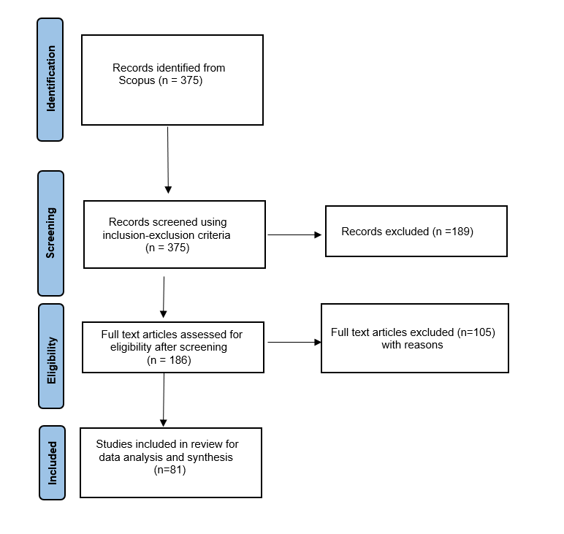

Fig. S1 PRISMA Flow diagram depicting the literature selection procedure

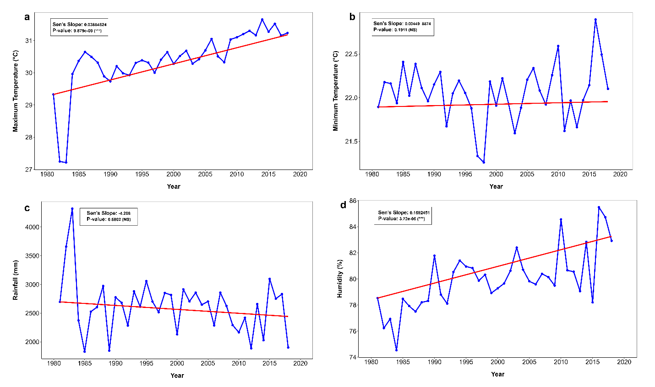

Fig. S2 Trend in annual average (a) maximum temperature (°C); (b) minimum temperature (°C); (c) annual total rainfall (mm); and, (d) annual average humidity (%) in the coastal Patuakhali region, during aman season (Jun-Dec) in the period 1981-2018

Table S1 Inclusion and exclusion criteria for literature screening
Inclusion criteria | Exclusion criteria
- Time: 2000 - October 2022 | - Time: before 2000 and after 2022
- Language in English | - Languages other than English
- Document type is article, review, or book chapter | - Document type is other than review, article, or book chapter (e.g., thesis, book review, conference paper)
- Documents containing keywords related to climate change and climate variability impact on rice yield and diseases (e.g., climate variability, climate change, global warming, rice yield, rice disease, rice pathogen, etc.) | - Documents containing keywords other than those related to climate change and climate variability impact on rice yield and diseases
- Addresses at least one type of document  (climate change impact on rice yield, or rice diseases) | - Addresses other than one of these two types
- Subject areas focusing on Agricultural and biological science, environmental science, and multidisciplinary | - Subject areas focusing on other than Agricultural and biological science, environmental science, and multidisciplinary

Table S2 summary of regression results between rice yield and climatic variables over the period 1981-2018 in coastal Patuakhali region

Climatic variables | Coefficient/slope | t-Value | p-Value | R² | Standard error
Temperature | 7.256e-01 | 4.911 | 2.24e-05*** | 0.6275 | 0.2599
Rainfall | -1.216e-04 | -1.143 | 0.2609 | 0.6275 | 0.2599
Humidity | 3.792e-02 | 1.823 | 0.0772 | 0.6275 | 0.2599
*, ** and *** indicate significance, respectively, at 0.10, 0.05 and 0.01 levels of probability

Table S3 Summary of Pearson correlation coefficient (r) between rice yield and climatic variables over the period 1981-2018 in the coastal Patuakhali region

Climatic variables | r | P value
Temperature | 0.7543658 ** | 4.511e-08
Rainfall | -0.3243919* | 0.04692
Humidity | 0.5716851** | 0.0001774
*α=0.001 level of significance, **α=0.01 level of significance, ***α=0.05 level of significance

Table S4 Threshold levels used to determine the number of favorable days for the occurrence of three major rice diseases
Name of the Diseases | Favorable weather conditions for disease development | References
Sheath blight of rice | Average temperature 28-32°C, relative humidity above 80% | BAMIS (2023)
Blast of rice | Minimum temperature 16-20°C, maximum temperature 25-30°C, relative humidity above 90% | BAMIS (2023),  Salam et al. (2020)
Bacterial leaf blight of rice | Average temperature 25-34°C, relative humidity 70-90%, rainfall above 30mm | Haque et al. (2022), BAMIS (2023)

References
BAMIS (2023) Bangladesh Agro-Meteorological Information Service (BAMIS). www.bamis.gov.bd. Retrieved December 5, 2023, from https://www.bamis.gov.bd/en/thresholds/1/all/76/
Salam M, Krupnik TJ, Montes C, Nessa B, Khatun M, Ali MP, & Uddin MS (2020) Potential impact of climate change on crop insect pests and diseases in Bangladesh: Future scenarios and strategies for climate services
Haque MM, Mita MM, Bashar S, Masud MM, Protic IA, Mozumdar UK, & Islam MR (2022) Weather parameters largely regulate the outbreak of the rice bacterial blight: an endemic disease poses a threat to food security in Bangladesh. Asian-Australas J Food Saf Secur 6(1):35–47. https://doi.org/10.3329/aajfss.v6i1.59851

Table S5 Six thematic categories used to organize findings from the Systematic literature review with definition and example
Six thematic categories | Definition | Example
a) overall impact of climate variability on rice yield | Refers to how changes in climatic factors, namely temperature, rainfall, and humidity, affect rice growth and yield. | climate variability in terms of maximum temperature and excess rainfall negatively affects rice yield, whereas minimum temperature positively affects rice yield in India (Bhardwaj 2022).
i) Impact of temperature on rice yield | Refers to how variations in minimum and maximum temperature affect rice yield. | High minimum temperature negatively affects rice yield in Asia (Khairulbahri 2022).
ii) Impact of rainfall and humidity on rice yield | Refers to how changes in rainfall patterns (e.g., droughts, floods) and humidity affect rice yield. | Intense rainfall and higher humidity have negative and positive effects, respectively, on rice yield in Bangladesh (Amin et al. 2014).
b) overall impact of climate variability on rice disease | Refers to how fluctuations in climate conditions (such as temperature, rainfall, humidity) affect rice diseases. | climate variability in terms of Increased temperature and increased humidity will increase sheath blight disease in south Korea (Kim and Cho 2016).
i) Impact of temperature on rice disease | Refers to how temperature changes influence rice diseases. | increasing temperature will increase bacterial leaf blight disease in Tanzania Duku et al. 2016).
ii) Impact of humidity and rainfall on rice disease | Refers to how changes in humidity affect rice diseases. | Higher humidity increase the occurrence of sheath blight disease in in India (Pal 2017).

Table S6 Summary of publications that focus on the impact of climate variability on rice yield
Publication details. | Country/region | Climatic variables/ stresses | Time | Model used | Climate variability impact | Effect size (Cohen’s d, 95% CI)
01. Baig et al. (2022) | India | Increasing and decreasing temperature, excess and less rainfall | 1991–2018 | NARDL and Granger causality | Increasing temperature or decreasing temperature >- Rice yield in the long run  Increasing temperature or decreasing temperature >+ Rice yield in the short run  Excess rainfall >- Rice yield  A decrease in rainfall>+ Rice yield in the long and short run | Tmean,  d = 1.31 (0.49, 2.12)  Raverage,  d = 0.67 (-0.09, 1.43)
02. Bhardwaj (2022) | India | Maximum temperature,  minimum temperature,  excess rainfall | 1981–2017 | FMOLS, DOLS, PMG | Maximum temperature >- Rice yield  Minimum temperature >+ Rice yield  Excess rainfall >- Rice yield | Tmax,  d = 0.52 (0.33, 0.71)  Tmin,  d = 0.18 (−0.01, 0.37)  Raverage,  d = 0.33 (0.14, 0.52)
03. Zhao (2022) | Southeast Asia, Africa, South America, North America | Increase or decrease number of warm days, extremely heavy precipitation | 1950–2100 | multivariate nonlinear model | Increase or decrease number of warm days >- Rice yield at  the end of the 21st century in  Southeast Asia and South America  extremely heavy precipitation >- Rice yield  Increase or decrease number of warm days, extremely heavy precipitation >+ Rice yield at African and North American country in the mid-21st century | No. of warming days,  d = 1.46 (1.03, 1.89)  Total heavy precipitation,  d = 0.95 (0.52, 1.38)
04. Aziz et al. (2023) | Bangladesh | increased and decreased rainfall | 1970-2060 | geospatial techniques | Increased or decreased rainfall in Kharif-II season >- Aman Rice yield | NA
05. Khairulbahri (2022) | Asia | High minimum temperature |  | system archetypes | High minimum temperature >- Rice yield | NA
06. Chandio et al. (2021) | Asia | Average temperature changes | 1961–2016 | DOLS ,Dumitrescu and Hurlin  causality test | Average temperature changes >- Rice yield | Tmean,  d = 0.6 (0.31, 0.89)  Raverage,  d = 0.1 (-0.18, 0.37)
07. Mondol et al. (2021) | Bangladesh | Drought | 1979–2018 | Mann-Kendall test and Sen Slope estimation | Drought >- Rice yield | Drought,  d = -0.177 (-0.57, 0.22)
08. Dubey et al. (2021) | India | Increasing temperature |  | quantile mapping method | Increasing temperature>- Rice yield | NA
09. Kashyap and Agarwal, (2021) | India | Increase in minimum temperature, maximum temperature, mean temperature | 1986–2017 | CROPWAT, and Path analysis, Mann–  Kendall test | Increase in minimum temperature, maximum temperature, mean temperature >- Rice yield | Tem,  d = 0.18 (-0.21, 0.58)  rain,  d = 0.35 (-0.04, 0.75)
10. Debnath et al. (2021) | India | increase in maximum temperature, minimum temperature and rainfall | 1981–2050 | DSSAT model | increase in maximum temperature, minimum temperature and rainfall >-  Rice yield | NA
11. Jakariya et al. (2020) | Bangladesh | shortage of rain and increasing temperatures | 1981–2030 | Stochastic Model of multiple regression analysis, ARIMA model | shortage of rain and increasing temperatures >- Rice yield | Tmean,  d = -0.22(−0.36, -0.08)  rain,  d = 0.00 (-0.14, 0.14)
12. Wu et al. (2021) | Asia | Rise in the  maximum temperature, increase in the minimum temperature, rising precipitation |  | meta-analysis | Rise in the  maximum temperature >+ Rice yield  increase in the minimum temperature >- Rice yield  rising precipitation  >+ Rice yield | Tmax,  d = 0.52 (0.37, 0.66)  Tmin,  d = 1.33 (1.19, 1.48)  rain,  d = 0.33 (0.19, 0.47)
13. Jha et al. (2020) | India | change in temperature, the increase in precipitation | 2020 to 2059 | DSSAT, CERES-Rice mode | change in temperature >- Rice yield  the increase in precipitation >+ Rice yield | NA
14. Hasan and Rahman, (2020) | Bangladesh | Changes of monthly average temperatures, Variability in rainfall pattern and humidity | 2008-2070 | DSSAT, PRECIS | Changes of monthly average temperatures >- Rice yield  Variability in rainfall pattern >- Rice yield  Variability in humidity >- Rice yield | NA
15. Kinose et al. (2020) | Indonesia | higher air temperature | 2018-2042 | MATCRO-Rice | higher air temperature >- Rice yield | NA
16. Sarker et al. (2017) | Bangladesh | increase in maximum temperature,  increase in minimum temperature,  increase in  rainfall | 1964–2012 | stochastic yield function approach | 1% increase in maximum temperature >+ Rice yield  an increase in minimum temperature >- Rice yield  1% increase in  Rainfall >+ Rice yield | Tmax,  d = 6.96 (6.87, 7.05)  Tmin,  d = 1.85 (1.76, 1.94)  rain,  d = 0.00 (-0.09, 0.09)
17. Gupta and Mishra, (2019) | India | increasing  temperature, precipitation | 1976–2095 | CSM-CERES-Rice v4.5) of DSSAT | increasing  temperature, precipitation >- Rice yield RCP 8.5 till the end of 21st century | NA
18. Bhatt et al. (2019) | India | increase in minimum temperature | 1971 to 2013 | time-series non-parametric Mann-Kendall trend test | increase in minimum temperature >- Rice yield | Tmax,  d = -0.03 (-0.40, 0.32)  Tmin,  d = 0.30 (-0.07, 0.67)  rainfall,  d = 0.00 (-0.36, 0.36)
19. Duc et al. (2019) | Vietnam | Changes in the rainfall and temperature patterns | 1975–2014 | geostatistical techniques, Mann-Kendall trend test | Changes in the rainfall and temperature patterns >- Rice yield | NA
20. Mall et al. (2018) | India | more number of days with temperature greater than 40 °C | 1971–2000 | quantile mapping approach, DSSAT | more number of days with temperature greater than 40 °C >- Rice yield | NA
21. Pranuthi and Tripathi, (2018) | India | increased maximum temperature | 1961–2090 | PRECIS RCM, Mann- Kendall’s test, DSSAT CERES rice model | increased maximum temperature >- Rice yield | Tmax,  d = -8.77 ( -8.33, -9.20)  Tmin,  d = -8.78 (-8.35, -9.21)  rainfall,  d = -7.77 (-7.34, -8.20)
22. Prabnakorn et al. (2018) | Thailand | increases in Tmin and Tmax | 1984–2013 | SPEI | increases in Tmin and Tmax >- Rice yield  precipitation >+ Rice yield | Tmax,  d = 0.44 (0.07, 0.82)  Tmin,  d = 0.45 (0.07, 0.83)  Rainfall,  d = 0.42 (0.05, 0.79)
23. Dkhar et al. (2017) | India | increase in monsoon maximum temperature, increase in June  rainfall | 1975–2009 | yield regression model | 1% increase in monsoon maximum temperature >+ Rice yield  1% increase in June  rainfall >+ Rice yield | Tmax,  d = 2.67 (1.94, 3.41)  Tmin,  d = -0.87 (−3.13, 1.41)  Rainfall,  d = 1.19 (0.64,1.76)
24. Balasubramanian et al. (2017) | India | temperature increased |  |  | temperature increased >- Rice yield | NA
25. Maniruzzaman et al. (2017) | Bangladesh | Increase in maximum and minimum temperature | 1971 to 2010 | MAKESENS model | maximum temperature changes by  1o C >+ Boro Rice yield,  one degree rise in minimum temperature >-Boro Rice yield | Tmax,  d = 3.19 (3.62, 2.76)  Tmin,  d = -8.04 (-8.47, -7.61)
26. Singh et al. (2017) | India | increase in temperature, maximum and minimum, Precipitation decreases | 1950- 2060 | CERES-Rice Model, DSSAT | increase in temperature, maximum and minimum >- Rice yield  Precipitation decreases >- Rice yield | NA
27. Abeysingha et al. (2016) | India | increase in rainfall | 1982-2099 | SWAT | increase in rainfall  >+ Rice yield | NA
28. Hasan et al. (2016) | Bangladesh | change in average temperature, increase in seasonal rainfall | 1972–2013 | Regression model | change in average temperature >- Rice yield  1% increase in seasonal rainfall >+ Aman Rice yield | Taverag,  d = 2.97 (2.31, 3.63)  Rainfall,  d = 3.83 (3.32, 4.34)
29. Ara et al. (2016) | Bangladesh | Temperature and rainfall | 1981–2010 | Linear mixed models | Temperature and rainfall >- Rice yield | Tem,  d = -4.32 (-4.77, -3.87)  rainfall,  d = -2.50 (-3.28, -1.72)
30. Chun et al. (2016) | Southeast Asia | warming trend for temperature | 1991–2100 | GLAM-Rice and CERES-Rice crop models | warming trend for temperature >- Rice yield | NA
31. Banerjee et al. (2016) | India | Temperature increase | 1980- 2050 | CGSM, PRECIS | Temperature increase >- Rice yield | Tem,  d = 1.00 (-0.95, 2.95)
32. Sailaja et al. (2015) | India | Temperature increase | 2011 | Oryza2000 model | Temperature increase >- Rice yield | Tem,  d = -1.76 (-8.53, 5.01)
33. Prajapati, (2015) | India | Increased precipitation | 1971–2005 | Quantile regression | Increased precipitation >+ Rice yield | NA
34. Amin et al. (2014) | Bangladesh | temperature  extremes, intense rainfall and humidity | 1972–2010 | HAC and FGLS method | temperature  extremes, intense rainfall >- Aman  Rice yield  Higher temperature>- BoroRice yield  Higher humidity > +Aman yield | Tmax,  d = -2.68 (-2.25, -3.11)  Tmin,  d = -4.32 (-3.88, -4.75)  rainfall,  d = -0.00 (-0.43, 0.43)  NA
35. Pattanayak and Kumar, (2014) | India | Daytime maximum temperature | 1969–2007 | multivariate fixed effects panel data regression models | Daytime maximum temperature >-  Rice yield | Tmax,  d = 3.03 (2.44, 3.63)  Tmin,  d = 0.71 (0.57, 0.84)  rainfall,  d = 0.07 (0.06,0.08)
36. Saxena and Soora, (2014) | India | increased temperature | 1970-2005 | InfoCrop-RICE model | increased temperature >-  Rice yield | Tem,  d = 1.70 (-0.61, 3.41)
37. Zacharias et al. (2014) | India | Extreme high temperature and rainfall intensity days | 2070-2100 | PRECIS | Extreme high temperature and rainfall intensity days >-  Rice yield | NA
38. Haris et al. (2013) | India | increases in temperature | 1961–2080 | InfoCrop model | increases in temperature>-  Rice yield in long-duration variety | Tem,  d = 5.69 (4.95, 6.43)
39. Lyman et al. (2013) | USA | increases in growing-season temperature | 2007-2010 | OLS multiple regression model | increases in growing-season temperature >-  Rice yield | Tem,  d = 1.20 (0.89, 1.51)
40. Soora et al. (2013) | India | Increase in rainfall, change in temperature | 1969-2080 | InfoCrop-rice model | Increase in rainfall>+  Rice yield in low  rainfall region  change in temperature >-  Rice yield | NA
41. Sarker et al. (2012) | Bangladesh | minimum and maximum temperature,  rainfall | 1972 to 2009 | Just–Pope yield function | minimum and maximum temperature >-  Rice yield  rainfall >-  Aus Rice yield | NA
42. Barnwal and Kotani, (2013) | India | increase in temperature and precipitation | 1971 to 2004 | quantile regression approach | increase in temperature >-  Kharif Rice yield  increase in precipitation >-  Kharif Rice yield | Tem,  d = -1.47 (-102.17, 99.23)  rain,  d = 2.19 (1.81, 2.57)
43. Kim et al. (2013) | East Asia | temperature increases | 1986–2112 | CERES-Rice 4.0 | temperature increases >-  Rice yield | Temperature,  d = 1.34 (0.99, 1.69)
44. Hossain et al. (2013) | Bangladesh | higher temperature |  |  | higher temperature>-  Rice yield | NA
45. Sarker et al. (2012) | Bangladesh | Maximum temperature,  Minimum temperature | 1972–2009 | OLS and QR models | Maximum temperature >-  Boro Rice yield  Minimum temperature >-  Aman Rice yield  Maximum temperature >+  Aus and Aman Rice yield  Minimum temperature>+  Boro Rice yield | Tmax,  d = 0.09 (-0.03, 0.21)  Tmin,  d = 0.03 (-0.07, 0.13)  Rain,  d = 0.05 (−2.71, 1.94)
46. Auffhammer et al. (2012) | India | warmer  nights, Drought, extreme rainfall and lower rainfall | 1966–2002 | Regression model | warmer  nights >-  Rice yield  Drought, extreme rainfall and lower rainfall >-  Rice yield | Tmin,  d = 0.99 (0.66, 1.32)  Rain,  d = 1.59 (1.26, 1.92)
47. Karim et al. (2012) | Bangladesh | high temperature, rainfall pattern and distribution | 2000–2100 | ORYZA2000 | high temperature >- Rice yield  rainfall pattern and distribution >- Rice yield | NA
48. Swain, (2010) | India | high temperature | 2008 | CERES, DSSAT | high temperature  >- Rice yield in long duration variety | Tem,  d = -2.92 (-3.31, -2.53)
49. Welch et al. (2010) | Asia | Higher minimum and maximum temperature | 1994–1999 | multiple regression model | Higher minimum temperature >- Rice yield  higher  maximum temperature>+ Rice yield | Tmax,  d = -1.78 (-2.17, -1.39)  Tmin,  d = 0.6 (0.21, 0.99)
50. Xiong et al. (2009) | China | higher temperature | 1961–1990 | PRECIS ,CERES | higher temperature >- Rice yield | NA
51. Swain, (2009) | India | Increase in average air temperature | 1974-2000 | CERES-rice | Increase in average air temperature >- Rice yield | NA
52. Tao et al. (2008) | China | increase in growing season maximum temperature | 1951–2002 | simple linear regression, multiple  linear regressions | increase in growing season maximum temperature >- Rice yield | Tmax,  d = 1.84 (1.19, 2.59)  Tmin,  d = 1.89 (1.15, 2.63)  rain,  d = 1.27 (0.53, 2.01)
53. Saseendran et al. (2000) | India | increase in monsoon seasonal mean surface temperature | 1951-2049 | CERES-Rice v3 | increase in monsoon seasonal mean surface temperature >- Rice yield | NA
Note: >- and >+ indicate the variable(s) preceding the >- and >+ symbols had negative and positive impacts, respectively, on rice yield; NA- Not applicable.

Table S7 Summary of studies that focus on climate variability impact on rice diseases
Sl. No. | Authors | Disease(s) focused /pathogen (s) | Main findings | Climatic variables | Geographic scope
01. | Wang et al. (2022) | Blast of rice (Pyricularia  oryzae)  Sheath blight of rice (Rhizoctonia solani) | Rice blast will become more severe in lower latitudes as temperatures rise.  Rising temperatures will raise the risk of blast epidemics in cool subtropical zones like northern China.  Rising temperatures will reduce the risk of blast in the humid tropics and warm humid subtropics.  Under high temperature microclimatic conditions (28-32 °C), sheath blight has a high infection rate. | Increased temperature | Global
02. | Juroszek et al. (2022) | Blast of rice (Pyricularia  oryzae) | Rice leaf blast risk will most likely decrease in Asia in the future. | Increased temperature | Global
03. | Shew et al. (2019) | Bacterial Panicle Blight (Burkholderia glumae) | According to the 1˚C warming scenario, the rise in BPB and accompanying yield losses would have resulted in 51% greater overall yield losses than those projected in the baseline. | Increased temperature | USA
04. | Velásquez et al. (2018) | Bacterial leaf blight of rice (Xanthomonas oryzae)  Sheath blight of rice (Rhizoctonia solani) | In Asia, rice bacterial leaf blight and sheath blight infection could be increased as temperatures increase | Increased temperature | Global
05. | Gautam et al. (2013) | Blast of rice (Pyricularia oryzae)  Sheath blight of rice (Rhizoctonia solani) | Elevated temperature is also posing higher threat to blast and sheath blight disease of rice | Increased temperature | Global
06. | Luck et al. (2011) | Blast of rice (Pyricularia oryzae) | An increase above normal temperatures resulted in  more severe blast epidemics in rice | Increased temperature | Global
07. | Haq et al. (2011) | Sheath blight of rice (Rhizoctonia solani)  Blast of rice (Pyricularia oryzae) | Increased temperature and humidity will increase sheath blight and blast incidence in Bangladesh | Increased temperature and increased humidity | Bangladesh
08. | Kim and Cho, (2016) | Sheath blight of rice (Rhizoctonia solani)  Blast of rice (Pyricularia oryzae) | sheath blight will remain to be one of the rice diseases to be favored by a climate change regime | Increased temperature and increased humidity | South Korea
09. | Chakraborty, (2000) | Blast of rice (Pyricularia oryzae) | An increased risk of serious rice blast was predicted for cool, subtropical rice growing zones, such as Japan. In the humid tropics and subtropical zones, such as in the Philippines, blast development would be inhibited at higher temperatures. | Higher temperature | Global
10. | Ghini et al. (2008) | Blast of rice (Pyricularia oryzae) | In cool subtropical zones, higher temperatures caused increases in disease severity, because higher risk of epidemics occurs under higher temperatures. In humid tropical and humid warm subtropical zones, such as Southern China, Philippines and Thailand, the opposite effect was observed. Lower temperatures increased the risk of rice blast epidemics since the current temperatures in these regions are above favorable values for the occurrence of this disease | Higher temperature | Global
11. | Luck et al. (2011) | Blast of rice (Pyricularia oryzae) | Temperature change emerged as the main determinant of crop loss; in the cool subtropics such as Japan and northern China, an increase above normal temperature resulted in more severe blast epidemics, whilst in the warm ⁄ cool humid subtropics, temperature increase caused significantly fewer blast epidemics. | Increased temperature | Global
12. | Duku et al. (2016) | Bacterial leaf blight of rice (Xanthomonas oryzae)  Blast of rice (Pyricularia oryzae) | Bacterial leaf blight is predicted to increase than leaf blast in the future due to increasing temperature | Increased temperature | Tanzania
13. | Viswanath et al. (2017) | Blast of rice (Pyricularia oryzae) | Leaf blast is projected to increase during the winter season (December–March) in 2020 (2010–2039) and 2050 (2040–2069) climate scenarios due to temperature rise | Rising temperature | India
14. | Das, (2017) | Blast of rice (Pyricularia oryzae)  Sheath blight of rice (Rhizoctonia solani) | Rice diseases such as rice blast, sheath, blight could become more widespread in South East Asia due to rising temperature | Rising temperature | South east Asia
15. | Kirtphaiboon et al. (2021) | Blast of rice (Pyricularia oryzae) | If the temperature increases, the severity of blast disease will decrease. On the other hand, the severity will increase when the relative humidity increases. | Increased temperature and humidity | Thailand
16. | Webb et al. (2010) | Bacterial leaf blight of rice (Xanthomonas oryzae) | Higher temperatures are predicted to accelerate higher disease pressure of bacterial leaf blight | Higher temperatures | Philippines
17. | Pal, (2017) | Sheath blight of rice (Rhizoctonia solani) | Higher temperature and higher humidity increase the occurrence of sheath blight | Higher temperature and humidity | India
18. | Kim et al. (2015) | Blast of rice (Pyricularia oryzae)  Sheath blight of rice (Rhizoctonia solani) | Higher temperature is the major factor that determined the increased trends of both leaf blast and sheath blight disease epidemics | Higher Temperature | Korea
19. | Sharma et al. (2007) | Bacterial leaf blight of rice (Xanthomonas oryzae) |  | High temperature and relative humidity | India
  Significant and positive correlations were found between bacterial leaf blight severity and high temperature and relative humidity
20. | Singh et al. (2019) | Sheath blight of rice (Rhizoctonia solani) | High temperature and humidity played major role in the progression of the sheath blight disease | High temperature and humidity | India
21. | Gupta et al. (2018) | Blast of rice (Pyricularia oryzae)  Sheath blight of rice (Rhizoctonia solani) | Rise in temperature and humidity will increase rice blast and sheath blight severity | Rising temperature and humidity | Global
22. | Fahad et al. (2019) | Blast of rice (Pyricularia oryzae)  Sheath blight of rice (Rhizoctonia solani)  Bacterial leaf blight of rice (Xanthomonas oryzae) | High temperature and humidity favor the infection of blast, sheath blight and bacterial leaf blight disease | High temperature and humidity | Global
23. | Castejón-Muñoz, (2008) | Blast of rice (Pyricularia oryzae) | A rise in temperature of 1°C in early August (mid tillering stage) may have caused an increase in mean leaf blast intensity | Rising Temperature | Spain
24. | Shafaullah et al. (2011) | Blast of rice (Pyricularia oryzae) | Increased in humidity and rainfall will rise blast incidence. | Increased humidity and rainfall | Pakistan
25. | Asibi et al. (2019) | Blast of rice (Pyricularia oryzae)  Sheath blight of rice (Rhizoctonia solani) | increased air temperature due to climate change are projected to spread major rice diseases to new area | Increased temperature | Global
26. | Rajput et al. (2017) | Blast of rice (Pyricularia oryzae) | Rise in temperature leads to increase in growth and sporulation of blast pathogen | Rise in temperature | Tropical and subtropical regions
27. | Bregaglio et al. (2013) | Blast of rice (Pyricularia oryzae) | number of infection events of blast disease is projected to increase Europe | Rising temperature | Europe
28. | Lee et al. (2022) | Blast of rice (Pyricularia oryzae) | rice blast epidemics increase until the mid-2040s but decrease thereafter until 2100 | Rise in temperature | Korea

References
Abeysingha NS, Singh M, Islam A, Sehgal VK (2016) Climate change impacts on irrigated rice and wheat production in Gomti River basin of India: a case study. SpringerPlus 5(1):1250. https://doi.org/10.1186/s40064-016-2905-y
Amin MR, Zhang J, Yang M (2014) Effects of climate change on the yield and cropping area of major food crops: a case of Bangladesh. Sustainability 7(1):898–915. https://doi.org/10.3390/su7010898
Ara I, Lewis M, Ostendorf B (2016) Spatio-temporal analysis of the impact of climate, cropping intensity and means of irrigation: an assessment on rice yield determinants in Bangladesh. Agric Food Secur 5:1–11. https://doi.org/10.1186/s40066-016-0061-9
Asibi AE, Chai Q, Coulter JA (2019) Rice blast: a disease with implications for global food security. Agronomy 9(8):451. https://doi.org/10.3390/agronomy9080451
Auffhammer M, Ramanathan V, Vincent JR (2012) Climate change, the monsoon, and rice yield in India. Clim Change 111:411–424. https://doi.org/10.1007/s10584-011-0208-4.
Aziz MA, Shohan HUS, Rahman NMF, Rahman MC, Nihad SAI, Hassan SQ, … Rukshanara Z (2023) Projection of future precipitation in Bangladesh at Kharif-II season using geospatial techniques. Earth Syst Environ 7(1):255–266. https://doi.org/10.1007/s41748-022-00319-9.
Baig IA, Chandio AA, Ozturk I, Kumar P, Khan ZA, Salam MA (2022) Assessing the long- and short-run asymmetrical effects of climate change on rice production: empirical evidence from India. Environ Sci Pollut Res 1–22. https://doi.org/10.1007/s11356-021-18014-z
Balasubramanian R, Saravanakumar V, Boomiraj K (2017) Ecological footprints of and climate change impact on rice production in India. In: The Future Rice Strategy for India. Academic Press, pp 69–106
Banerjee S, Das S, Mukherjee A, Mukherjee A, Saikia B (2016) Adaptation strategies to combat climate change effect on rice and mustard in Eastern India. Mitig Adapt Strateg Glob Change 21:249–261. https://doi.org/10.1007/s11027-014-9595-y
Barnwal P, Kotani K (2013) Climatic impacts across agricultural crop yield distributions: an application of quantile regression on rice crops in Andhra Pradesh, India. Ecol Econ 87:95–109. https://doi.org/10.1016/j.ecolecon.2012.11.024
Bhardwaj M, Kumar P, Kumar S, Dagar V, Kumar A (2022) A district-level analysis for measuring the effects of climate change on production of agricultural crops, i.e., wheat and paddy: evidence from India. Environ Sci Pollut Res 29(21):31861–31885. https://doi.org/10.1007/s11356-021-17994-2
Bhatt D, Sonkar G, Mall RK (2019) Impact of climate variability on the rice yield in Uttar Pradesh: an agro-climatic zone based study. Environ Process 6:135–153. https://doi.org/10.1007/s40710-019-00360-3.
Bregaglio S, Donatelli M, Confalonieri R (2013) Fungal infections of rice, wheat, and grape in Europe in 2030–2050. Agron Sustain Dev 33:767–776. https://doi.org/10.1007/s13593-013-0149-6
Castejón-Muñoz M (2008) The effect of temperature and relative humidity on the airborne concentration of Pyricularia oryzae spores and the development of rice blast in southern Spain. Span J Agric Res 6(1):61–69. https://doi.org/10.5424/sjar/2008061-294
Chakraborty S, Tiedemann AV, Teng PS (2000) Climate change: potential impact on plant diseases. Environ Pollut 108(3):317–326. https://doi.org/10.1016/S0269-7491(99)00158-0
Chandio AA, Gokmenoglu KK, Ahmad M, Jiang Y (2021) Towards sustainable rice production in Asia: the role of climatic factors. Earth Syst Environ 5:1–14. https://doi.org/10.1007/s41748-021-00210-z
Chun JA, Li S, Wang Q, Lee WS, Lee EJ, Horstmann N, … Vang S (2016) Assessing rice productivity and adaptation strategies for Southeast Asia under climate change through multi-scale crop modeling. Agric Syst 143:14–21. https://doi.org/10.1016/j.agsy.2015.12.001
Das SK (2017) Rice cultivation under changing climate with mitigation practices: a mini review. Univ J Agric Res 5(6):333–337. https://doi.org/10.13189/ujar.2017.050603
Debnath S, Mishra A, Mailapalli DR, Raghuwanshi NS, Sridhar V (2021) Assessment of rice yield gap under a changing climate in India. J Water Clim Change 12(4):1245–1267. https://doi.org/10.2166/wcc.2020.086
Dkhar DK, Feroze SM, Singh R, Ray LI (2017) Effect of rainfall variability on rice yield in north eastern hills of India: A case study. Agric Res 6:341–346. https://doi.org/10.1007/s40003-017-0276-4
Dubey M, Mishra A, Singh R (2021) Climate change impact analysis using bias-corrected multiple global climate models on rice and wheat yield. J Water Clim Change 12(4):1282–1296. https://doi.org/10.2166/wcc.2020.191
Duc, Kien Nguyen, Tiho Ancev, and Alan Randall. "Evidence of climatic change in Vietnam: Some implications for agricultural production." J Environ Manage 231 (2019): 524-545.
Duku C, Sparks AH, Zwart SJ (2016) Spatial modelling of rice yield losses in Tanzania due to bacterial leaf blight and leaf blast in a changing climate. Clim Change 135:569–583. https://doi.org/10.1007/s10584-015-1580-2
Fahad S, Adnan M, Noor M, Arif M, Alam M, Khan IA, … Wang D (2019) Major constraints for global rice production. In: Advances in Rice Research for Abiotic Stress Tolerance. Woodhead Publishing, pp 1–22
Gautam HR, Bhardwaj ML, Kumar R (2013) Climate change and its impact on plant diseases. Curr Sci 104:1685–1691
Ghini R, Hamada E, Bettiol W (2008) Climate change and plant diseases. Sci Agric 65:98–107
Gupta S, Sharma D, Gupta M (2018) Climate change impact on plant diseases: opinion, trends and mitigation strategies. Microb Clim Resil Agric 41–56
Haq M, Mia MT, Rabbi MF, Ali MA (2011) Incidence and severity of rice diseases and insect pests in relation to climate change. In: Climate Change and Food Security in South Asia, pp 445–457
Haris AA, Bhatt BP, Chhabra V, Biswas S, Elanchezhian R (2013) Climate change impacts on yields of phenologically different rice varieties over a sub-humid climatic environment. Agric Res 2:319–329. https://doi.org/10.1007/s40003-013-0079-1
Hasan MM, Rahman MM (2020) Simulating climate change impacts on T. aman (BR‐22) rice yield: a predictive approach using DSSAT model. Water Environ J 34:250–262. https://doi.org/10.1111/wej.12523
Hasan MM, Sarker MAR, Gow J (2016) Assessment of climate change impacts on Aman and Boro rice yields in Bangladesh. Clim Change Econ 7(03):1650008. https://doi.org/10.1142/s2010007816500081
Jakariya M, Sarker SR, Sayem SM, Saad S, Islam MN, Rahman A, … Akter D (2021) Nexus among rice production and environmental factors in the coastal region of Bangladesh: a stochastic modeling approach for future forecasting. Model Earth Syst Environ 7:1121–1131. https://doi.org/10.1007/s40808-020-00969-6
Jha RK, Kalita PK, Cooke RA, Kumar P, Davidson PC, Jat R (2020) Predicting the water requirement for rice production as affected by projected climate change in Bihar, India. Water 12(12):3312. https://doi.org/10.3390/w12123312
Juroszek P, Bartsch L, Fontaine JF, Racca P, Kleinhenz B (2022) Summary of the worldwide available crop disease risk simulation studies that were driven by climate change scenarios and published during the past 20 years. Plant Pathol 71(9):1815–1838. https://doi.org/10.1111/ppa.13634
Karim MR, Ishikawa M, Ikeda M, Islam MT (2012) Climate change model predicts 33% rice yield decrease in 2100 in Bangladesh. Agron Sustain Dev 32:821–830. https://doi.org/10.1007/s13593-012-0096-7
Kashyap D, Agarwal T (2021) Temporal trends of climatic variables and water footprint of rice and wheat production in Punjab, India from 1986 to 2017. J Water Clim Change 12(4):1203–1219. https://doi.org/10.2166/wcc.2020.093
Khairulbahri M (2022) Understanding the Impacts of Climate Change on Rice Production: A Qualitative Perspective. Sci Technol Asia 169–179.
Kim HY, Ko J, Kang S, Tenhunen J (2013) Impacts of climate change on paddy rice yield in a temperate climate. Glob Change Biol 19(2):548–562. https://doi.org/10.1111/gcb.12047
Kim KH, Cho J (2016) Predicting potential epidemics of rice diseases in Korea using multi-model ensembles for assessment of climate change impacts with uncertainty information. Clim Change 134(1-2):327–339. https://doi.org/10.1007/s10584-015-1503-2
Kim KH, Cho J, Lee YH, Lee WS (2015) Predicting potential epidemics of rice leaf blast and sheath blight in South Korea under the RCP 4.5 and RCP 8.5 climate change scenarios using a rice disease epidemiology model, EPIRICE. Agric For Meteorol 203:191–207. https://doi.org/10.1016/j.agrformet.2015.01.011
Kinose Y, Masutomi Y, Shiotsu F, Hayashi K, Ogawada D, Gomez-Garcia M, … Fukushi K (2020) Impact assessment of climate change on the major rice cultivar Ciherang in Indonesia. J Agric Meteorol 76(1):19–28. https://doi.org/10.2480/agrmet.D-19-00045
Kirtphaiboon S, Humphries U, Khan A, Yusuf A (2021) Model of rice blast disease under tropical climate conditions. Chaos Solitons Fractals 143:110530. https://doi.org/10.1016/j.chaos.2020.110530
Kumar U, Werners S, Paparrizos S, Datta DK, Ludwig F (2020) Hydroclimatic information needs of smallholder farmers in the lower Bengal delta, Bangladesh. Atmosphere 11(9):1009. https://doi.org/10.3390/atmos11091009
Lee KT, Jeon HW, Park SY, Cho J, Kim KH (2022) Comparison of projected rice blast epidemics in the Korean Peninsula between the CMIP5 and CMIP6 scenarios. Clim Change 173(1-2):12. https://doi.org/10.1007/s10584-022-03410-2
Luck J, Spackman M, Freeman A, Trebicki P, Griffiths W, Finlay K, Chakraborty S (2011) Climate change and diseases of food crops. Plant Pathol 60(1):113–121. https://doi.org/10.1111/j.1365-3059.2010.02414.x
Lyman NB, Jagadish KS, Nalley LL, Dixon BL, Siebenmorgen T (2013) Neglecting rice milling yield and quality underestimates economic losses from high-temperature stress. PLoS ONE 8(8):e72157. https://doi.org/10.1371/journal.pone.0072157
Mall RK, Singh N, Singh KK, Sonkar G, Gupta A (2018) Evaluating the performance of RegCM4.0 climate model for climate change impact assessment on wheat and rice crop in diverse agro-climatic zones of Uttar Pradesh, India. Clim Change 149:503–515. https://doi.org/10.1007/s10584-018-2255-6
Maniruzzaman M, Muttaleb MA, Choudhury AK, Akhter S, Ahmed F, Aziz MA, … Kalra N (2017) Characterization of inter-seasonal climatic variability through dry-season rice productivity in the North-west Region of Bangladesh. Ital J Agrometeorol 2017(1). https://doi.org/10.19199/2017.1.2038-5625.005
Mondol MAH, Zhu X, Dunkerley D, Henley BJ (2021) Observed meteorological drought trends in Bangladesh identified with the Effective Drought Index (EDI). Agric Water Manage 255:107001. https://doi.org/10.1016/j.agwat.2021.107001
Pal R, Mandal D, Biswas MK, Panja BN (2017) Effect of weather parameters on the initiation and progression of sheath blight of rice. J Agrometeorol 19(1):39–43
Pattanayak A, Kumar KK (2014) Weather sensitivity of rice yield: evidence from India. Clim Change Econ 5(04):1450011. https://doi.org/10.1142/s2010007814500110
Prabnakorn S, Maskey S, Suryadi FX, de Fraiture C (2018) Rice yield in response to climate trends and drought index in the Mun River Basin, Thailand. Sci Total Environ 621:108–119. https://doi.org/10.1016/j.scitotenv.2017.11.136
Prajapati HR (2015) Climate Change and Indian Agriculture: Impacts, Solutions, and Adaptation. In: Climate Change Modelling, Planning and Policy for Agriculture, pp 151–165
Pranuthi G, Tripathi SK (2018) Assessing the climate change and its impact on rice yields of Haridwar district using PRECIS RCM data. Clim Change 148:265–278. https://doi.org/10.1007/s10584-018-2176-4
Rajput LS, Sharma T, Madhusudhan P, Sinha P (2017) Effect of temperature on growth and sporulation of rice leaf blast pathogen Magnaporthe oryzae. Int J Curr Microbiol Appl Sci 6(3):394–401. https://doi.org/10.20546/ijcmas.2017.603.045
Rimi RH, Rahman SH, Karmakar S, Hussain SG (2009) Trend analysis of climate change and investigation on its probable impacts on rice production at Satkhira, Bangladesh. Pak J Meteorol 6(11):37–50
Sailaja B, Voleti SR, Gayatri S, Subrahmanyam D, Meera SN, Kumar RN, Rao PR (2015) Vulnerability of rice yields under changed climatic conditions
Sarker MAR, Alam K, Gow J (2012) Exploring the relationship between climate change and rice yield in Bangladesh: An analysis of time series data. Agric Syst 112:11–16. https://doi.org/10.1016/j.agsy.2012.06.004
Sarker MAR, Alam K, Gow J (2017) Performance of rain-fed Aman rice yield in Bangladesh in the presence of climate change. Renew Agric Food Syst 34(4):304–312. https://doi.org/10.1017/S1742170517000473
Saseendran SA, Singh KK, Rathore LS, Singh SV, Sinha SK (2000) Effects of climate change on rice production in the tropical humid climate of Kerala, India. Clim Change 44:495–514. https://doi.org/10.1023/A:1005542414134
Saxena R, Kumar SN (2014) Simulating the impact of projected climate change on rice (Oryza sativa L.) yield and adaptation strategies in major rice growing regions of India. J Agrometeorol 16(1):18–25. https://doi.org/10.54386/jam.v16i1.1481
Shafaullah MAK, Khan NA, Mahmood Y (2011) Effect of epidemiological factors on the incidence of paddy blast (Pyricularia oryzae) disease. Pak J Phytopathol 23(2):108–111
Sharma VK, Thind TS, Singh PP, Mohan C, Arora JK, Raj P (2007) Disease-weather relationships and forecasting of bacterial leaf blight of rice. Plant Dis Res 22(1):52–56
Shew AM, Durand-Morat A, Nalley LL, Zhou XG, Rojas C, & Thoma G (2019) Warming increases Bacterial Panicle Blight (Burkholderia glumae) occurrences and impacts on USA rice production. PLoS One 14(7), e0219199. https://doi.org/10.1371/journal.pone.0219199
Singh PK, Singh KK, Bhan SC, Baxla AK, Singh S, Rathore LS, Gupta A (2017) Impact of projected climate change on rice (Oryza sativa L.) yield using CERES-rice model in different agroclimatic zones of India. Curr Sci 112:108–115. https://doi.org/10.18520/cs/v112/i01/108-115
Singh P, Mazumdar P, Harikrishna JA, Babu S (2019) Sheath blight of rice: a review and identification of priorities for future research. Planta 250:1387–1407
Soora NK, Aggarwal PK, Saxena R, Rani S, Jain S, Chauhan N (2013) An assessment of regional vulnerability of rice to climate change in India. Clim Change 118:683–699. https://doi.org/10.1007/s10584-013-0698-3
Swain DK, Thomas D (2010) Climate change impact assessment and evaluation of agro-adaptation measures for rice production in Eastern India. J Environ Inform 16:94–101. https://doi.org/10.3808/jei.201000181
Swain DK, Yadav A (2009) Simulating the impact of climate change on rice yield using CERES-rice model. J Environ Inform 13. https://doi.org/10.3808/jei.200900145
Tao F, Yokozawa M, Liu J, Zhang Z (2008) Climate–crop yield relationships at provincial scales in China and the impacts of recent climate trends. Clim Res 38:83–94. https://doi.org/10.3354/cr00771
Velásquez AC, Castroverde CDM, He SY (2018) Plant-pathogen warfare under changing climate conditions. Curr Biol 28:R619–R634. https://doi.org/10.1016/j.cub.2018.03.054
Viswanath K, Sinha P, Naresh Kumar S, Sharma T, Saxena S, Panjwani S, Pathak H, Shukla SM (2017) Simulation of leaf blast infection in tropical rice agro-ecology under climate change scenario. Clim Change 142:155–167. https://doi.org/10.1007/s10584-017-1942-z
Wang BX, Hof AR, Ma CS (2022) Impacts of climate change on crop production, pests and pathogens of wheat and rice. Front Agric Sci Eng 9:4–18. https://doi.org/10.15302/J-FASE-2021432
Webb KM, Ona I, Bai J, Garrett KA, Mew T, Vera Cruz CM, Leach JE (2010) A benefit of high temperature: increased effectiveness of a rice bacterial blight disease resistance gene. New Phytol 185:568–576. https://doi.org/10.1111/j.1469-8137.2009.03076.x
Welch JR, Vincent JR, Auffhammer M, Moya PF, Dobermann A, Dawe D (2010) Rice yields in tropical/subtropical Asia exhibit large but opposing sensitivities to minimum and maximum temperatures. Proc Natl Acad Sci U S A 107:14562–14567. https://doi.org/10.1073/pnas.1001222107
Wu F, Wang Y, Liu Y, Liu Y, Zhang Y (2021) Simulated responses of global rice trade to variations in yield under climate change: evidence from main rice-producing countries. J Clean Prod 281:124690. https://doi.org/10.1016/j.jclepro.2020.124690
Xiong W, Conway D, Lin E, Holman I (2009) Potential impacts of climate change and climate variability on China’s rice yield and production. Clim Res 40:23–35. https://doi.org/10.3354/cr00802
Zacharias M, Naresh Kumar S, Singh SD, Swaroopa Rani DN, Aggarwal PK (2014) Assessment of impacts of climate change on rice and wheat in the Indo-Gangetic plains. J Agrometeorol. https://doi.org/10.54386/jam.v16i1.1480
Zhao W, Chou J, Li J, Xu Y, Li Y, Hao Y (2022) Impacts of Extreme Climate. Int J Environ Res Public Health 19: 4437. https://doi.org/10.3390/ijerph19084437

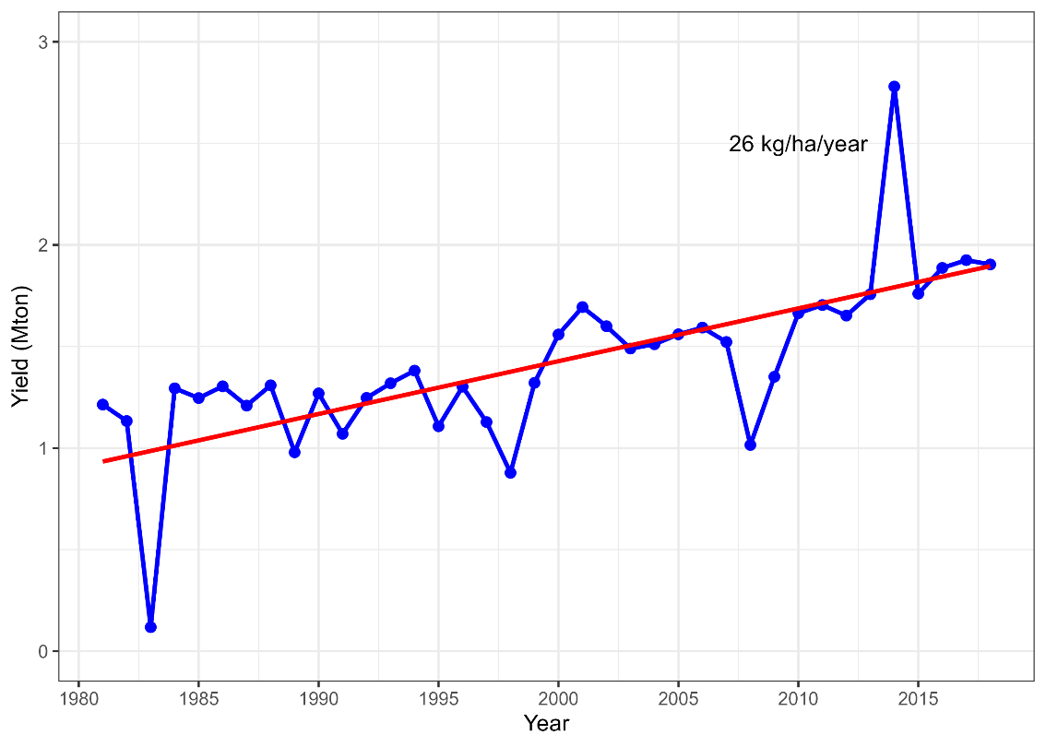
Fig. S3 Trend in rice yields over the 38 years under study (1981–2018) in the coastal Patuakhali district of Bangladesh

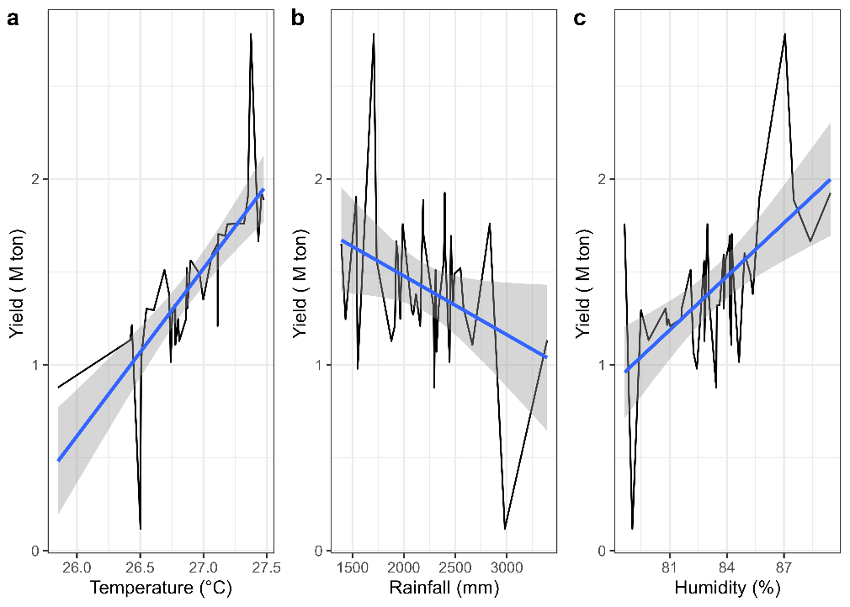

Fig. S4 Relationship between rice yields and climate variables: (a) temperature (°C), (b) rainfall (mm), and (c) humidity (%) over the period 1981-2018

