Supplementary information

Impacts of climate change on the phenology and distribution range of Castanea sativa (Mill.) varieties in Cévennes mountainous region, Southern France

Regional Environmental Change

Nicolas Ponsa¹, Yildiz Aumeeruddy-Thomas¹, Valentine Delrieu¹, Florent Mouillot¹, Isabelle Chuine¹
¹ CEFE, Univ Montpellier, CNRS, EPHE, IRD, Montpellier, France

Nicolas Ponsa: nicolas.ponsa@cefe.cnrs.fr, nicolasponsa@yahoo.fr
Supplementary Materials
Climatic data
Although the most recent IPCC assessments are framed using SSP (Shared Socioeconomic Pathway) scenarios, our study relies on RCP (Representative Concentration Pathways). The two RCP scenarios we have used, RCP4.5 and RCP8.5 have direct equivalent SSP scenarios: SSP2-4.5 and SSP5-8.5 respectively (IPCC 2023). RCP4.5 and SSP2-4.5 have equivalent radiative forcing in 2100 (4.5 Wm⁻²) as do RCP8.5 and SSP5-8.5 scenarios (8.5 Wm⁻²).
Downscaling Methods
Downscaling and predictive modelling of topo-climatic variables are detailed by Delrieu et al. (2025). The produced downscaled projections include (1) global solar radiations, (2) minimum (Tmin), maximum (Tmax) and mean (Tmean) air temperatures, (3) potential evapotranspiration and (4) precipitation.
Daily clearsky solar radiation was calculated from standard astrophysical equations relating incoming direct radiation with solar angle as a function of day of the year (DOY), latitude and topographical features, including projected shading effects, and diffuse radiation based on the skyview topographical index (Druel et al. 2025). Global solar radiation then resulted in the combination of direct and diffuse radiation attenuated by the cloudiness proxy index from Hargreaves & Samani (1982) derived from Tmax-Tmin.
Our study additionally provided a refined data-driven topoclimatic interpolation of temperature Tmin and Tmax, beyond the usual lapse-rate considering the effect of altitude on temperature decrease. We built a random forest regression model (‘randomForest’ R package) investigating daily Tmin and Tmax measured in the Meteorological stations as a function of the reference Météo France station corresponding temperatures T_{min}ref and T_{max}ref, wind speed as an index of daily atmospheric turbulences, the corresponding Meteorological station’s altitudes, heat load index (HLI) defined as the integrated solar radiation received during hottest hours of the day occurring between 1:00pm and 3:00pm (Geiger et al. 2009), the daily solar radiation as a seasonal index, and the skyview index differentiating valley bottoms and ridge crests (Zaksek et al. 2011). To balance predictive accuracy with computational efficiency, we manually tested several combinations of Random Forest parameters (mtry, min.node.size, and num.trees) on representative subsets of the dataset. The final configuration (num.trees = 500, mtry = 3, min.node.size = 5) provided the best compromise between accuracy, measured by the root mean square error (RMSE), and processing time. This model was then applied to all the pixels of the study area represented by their topographical feature as altitude, daily HLI and skyview, and the daily wind and solar radiation of the reference meterological station. This same model was then applied to future climates of the reference Meteo France station, projected with the quantile method bias correction of DRIAS scenarios for the corresponding reference pixel (Ruffault et al. 2013).
Daily potential evapotranspiration (PET) used for drought assessment in PHENOFIT was then computed from solar radiation and mean air temperature with a simplified Priestley-Taylor equation (Anupoju et al. 2025, Allen et al. 1998). Soil water holding capacity was derived from the EU Soil Hydraulic Grid at 1km (Toth et al. 2017) and Soil Grids (Poggio et al. 2021; Turek et al 2023).
Precipitations were interpolated using the bilinear reprojection function raster::projectRaster() of the 8km resolution SAFRAN gridded data, thus assuming no particular topographical effect beside the one already included if the raw data.
Phenology models
General model structure
The general structure of phenology models can be described as followed: $t_{n}$ the occurrence date of a phenology event taking place at the end of development phase $n$ such that $S_{n,t}= \sum_{t_{n-1}}^{t_{n}}{R_{n,t}\left(Z\right)=S_{n}^{*} }$where the cumulative development state $S_{n,t}$ on day $t$ increases daily according to the development rate $R_{n,t}$, which is a function of meteorological variables. This progression starts at $t_{n-1}$, the end of the previous phase $n-1$, and continues until $t_{n}$, the end of the current phase. The phase is considered complete when the cumulative sum from $t_{n-1} to t_{n}$of daily development rates $R_{n,t}$ reaches the critical threshold $S_{n}^{*}$. A model can describe several phases of development that can overlap or sequentially follow each other (Chuine and Régnière 2017).

Model calibration
Leaf unfolding and flowering sub-models
Since for chestnut trees flowers are in the same bud as leaves (Breisch 1995), we first calibrated a 2-phase model for leaf unfolding date (BBCH 15) and then a 1-phase model for the delay between leaf unfolding and flowering (BBCH 65). Similarly, because we had more data on the budburst stage (BBCH 09), we first calibrated a 2-phase model for this stage and then a 1-phase model for the delay between budburst and leaf unfolding. This calibration process allowed us making the most of our data. The first phase of a 2-phase model aims to describe for endodormancy and the second phase describe the ecodormancy, while a 1-phase model describe only the ecodormancy. The rate of development during endodormancy was described with a negative threshold function of temperature (Eq. 1) while the rate of development during ecodormancy was described with a growing degree-day function (Eq. 2).

Eq. 1: $f_{Thresholf_{inferior}}\left(T_{d}\right)= \begin{matrix}1 if T_{d}<T_{b} \\ 0 if T_{d}≥ T_{b}\end{matrix}$
Eq. 2: $f_{GDD}\left(T_{d}\right)=Max(0;T_{d}-T_{b})$

Fruit maturation sub-model
For fruit ripening date (BBCH85) we used a 2-phases model since fruits with slow growth periods tend to exhibit a 2-phase growth pattern with first cellular multiplication after pollination before cellular enlargement (Pei et al. 2020) and then an accumulation of photosynthetic assimilates (Chuine and Beaubien 2001). The rate of development of the first phase was described by a sigmoid function and the rate of development of the second phase was described with a Wang function (Eq. 3) (Wang and Engel 1998).
Eq. 3: $f_{Wang}=Max\left[\left(2{\left(T_{d}-T_{min}\right)}^{α}{\left(T_{opt}- T_{min}\right)}^{α_{}}\frac{(T_{d}- {T_{min})}^{2α}}{(T_{opt}- {T_{min})}^{2α}}\right), 0\right];$
$$with α=\ln\left(2\right)/ln⁡(\frac{T_{max}-T_{min}}{T_{opt}-T_{min}})$$

Leaf senescence sub-model
Leaf senescence date (BBCH95) in deciduous trees is mainly regulated by cold temperatures (Estralla and Menzel 2006) and short photoperiod (Keskitalo et al. 2005). We had fewer data for leaf senescence than for other stages so we gathered all observations across varieties and used a 1-phase model whose response function was a sigmoid negative (Eq. 4).
Eq. 4: $f_{Sigmoid}\left(T_{d}\right)=1/(1+exp\left[a\left(T_{d}-b\right)\right])$

Supplementary Fig. S1 Schematic description of PHENOFIT4 (Van der Meersch 2025) with ecophysiological processes and functional traits simulated by the model (Chuine and Beaubien 2001) adapted to chestnut tree’s phenology (pictures ©Ponsa).
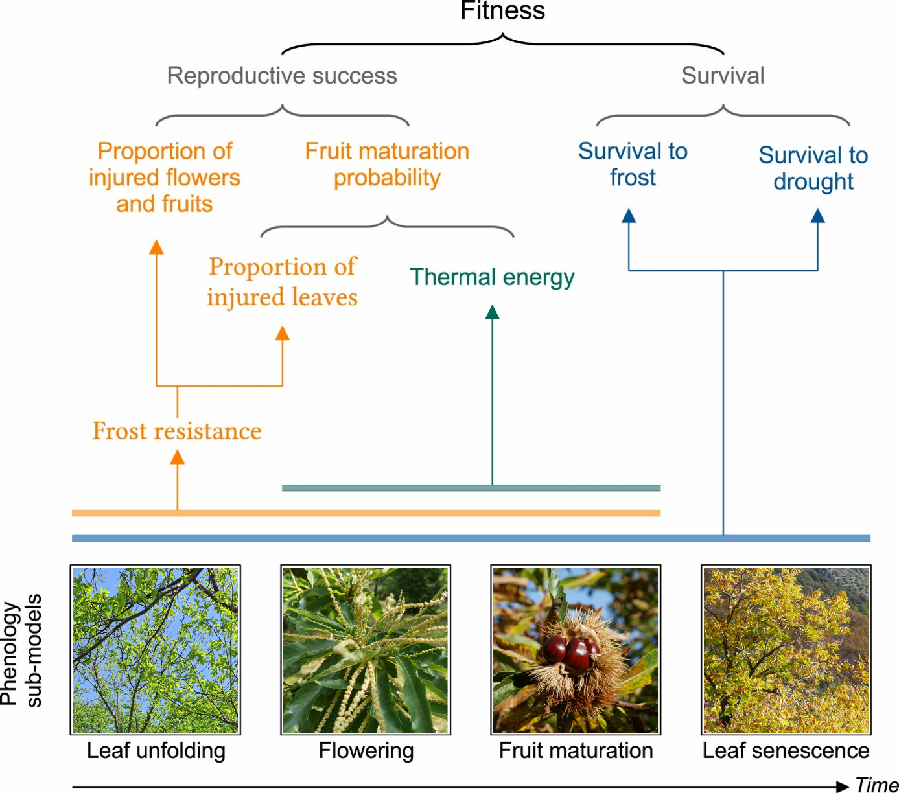

Supplementary Table S1 BBCH scale of the five stages observed, adapted to chestnut trees for field observations with farmers.
Phenological stage
Stage 0 – Bud development | Budburst  (BBCH 06) | Green leaf tips have emerged (BBCH 07)
Stage 1 - Leaf development | 10% leaves unfolded, horizontally (BBCH 11) | 50 % leaves unfolded, horizontally (BBCH 15)
Stage 6 - Flowering | 10% of unisexual male catkins mature (BBCH 61) | 50 % of unisexual male catkins mature (BBCH 65)
Stage 8 - Fruit maturity | 10% of chestnut fallen  (BBCH 81) | 50 % of chestnut fallen  (BBCH 85)
Stage 9 - Leaf senescence | 10% of leaves turned yellow (BBCH 91) | 50 % of leaves turned yellow (BBCH 95)

Supplementary Table S2 PHENOFIT parameters for chestnut tree. When no value is indicated, please refer to Table 3 showing parameter values for each variety.
Process | Subprocess | Function | Parameter | Set values | Definition
Leaf unfolding | Endodormancy | Threshold inferior | $t_{0}$ | -122 | Starting date of the endodormancy phase
Leaf unfolding | Endodormancy | Threshold inferior | $$V_{b}$$ |  | Threshold temperature of the Threshold inferior function
Leaf unfolding | Endodormancy | Threshold inferior | $$C_{crit}$$ |  | Critical state of development corresponding to dormancy break
Leaf unfolding | Ecodormancy | GDD | $$T_{b}$$ |  | Threshold temperature of the GDD function
Leaf unfolding | Ecodormancy | GDD | $$F_{crit}^{leaf}$$ |  | Critical state of development corresponding to leaf unfolding
Flowering | Endodormancy | Threshold inferior | $$t_{0}$$ | -122 | Starting date of the endodormancy phase
Flowering | Endodormancy | Threshold inferior | $$V_{b}$$ |  | Threshold temperature of the Threshold inferior function
Flowering | Endodormancy | Threshold inferior | $$C_{crit}$$ |  | Critical state of development corresponding to dormancy break
Flowering | Ecodormancy | GDD | $$T_{b}$$ |  | Threshold temperature of the GDD function
Flowering | Ecodormancy | GDD | $$F_{crit}^{flower}$$ |  | Critical state of development corresponding to leaf unfolding
Fruit maturation | Cell multiplication and growth | Sigmoid | $$aa$$ |  | Slope at the inflection point of the sigmoid function
Fruit maturation | Cell multiplication and growth | Sigmoid | $$bb$$ |  | Mid-response temperature of the sigmoid function
Fruit maturation | Cell multiplication and growth | Sigmoid | $$F_{crit}^{fruit}$$ |  | Accumulation threshold above which accumulation starts
Fruit maturation | Photosynthetic assimilate accumulation | Wang & Engel (1998) | $$T_{opt}$$ |  | Optimal temperature of the Wang function
Fruit maturation | Photosynthetic assimilate accumulation | Wang & Engel (1998) | $${Mat}_{moy}$$ |  | Accumulation threshold above which maturation occurs
Fruit maturation | Photosynthetic assimilate accumulation | Wang & Engel (1998) | $$σ$$ |  | Standard deviation
Fruit maturation | Photosynthetic assimilate accumulation | Wang & Engel (1998) | $${pfe}_{50}$$ | 0.6 | Prop. of injured leaves reducing by 50% the flux of photosynthetic assimilates
Leaf senescence |  | Sigmoid negative | $$d$$ | 40 | Critical temperature at the inflection point
Leaf senescence |  | Sigmoid negative | $$e$$ |  | Slope at the inflection point of the sigmoid function
Leaf senescence |  | Sigmoid negative | $$F_{crit}$$ |  | Accumulation threshold above which accumulation starts
Leaf senescence |  | Sigmoid negative | $$σ$$ |  | Standard deviation
Frost hardening | Death |  | $$T_{death}$$ | -30 | Lethal temperature
Frost hardening | Leaf |  | ${FH}_{min}^{leaf}$ | -2 | Minimum level of frost hardiness
Frost hardening | Leaf |  | ${FH}_{max}^{leaf}$ | -30 | Maximum level of frost hardiness
Frost hardening | Flower |  | $${FH}_{min}^{flower}$$ | -5.3 | Minimum level of frost hardiness
Frost hardening | Flower |  | $${FH}_{max}^{flower}$$ | -30 | Maximum level of frost hardiness
Frost hardening | Fruit |  | $${FH}_{max1}$$ | -6 | Maximum level of frost hardiness of young fruit
Frost hardening | Fruit |  | $${FH}_{max2}$$ | -20 | Maximum level of frost hardiness of mature fruit
Frost hardening | Thermal control |  | $${Te}_{1}$$ | 10 | Upper limit of the effective range of temperature
Frost hardening | Thermal control |  | $${Te}_{2}$$ | -16 | Lower limit of the effective range of temperature
Frost hardening | Photoperiod control |  | $${NL}_{1}$$ | 10 | Lower limit of the effective range of photoperiod
Frost hardening | Photoperiod control |  | $${NL}_{2}$$ | 16 | Upper limit of the effective range of photoperiod
Water stress | Precipitation range |  | $${pp}_{min}$$ | 500 | Minimum level of precipitation
Water stress |  |  | $${pp}_{max}$$ | 3500 | Maximum level of precipitation

Supplementary Results
Supplementary Fig. S2 Boxplot of fruit maturation date with the mean for each variety and climatic condition.
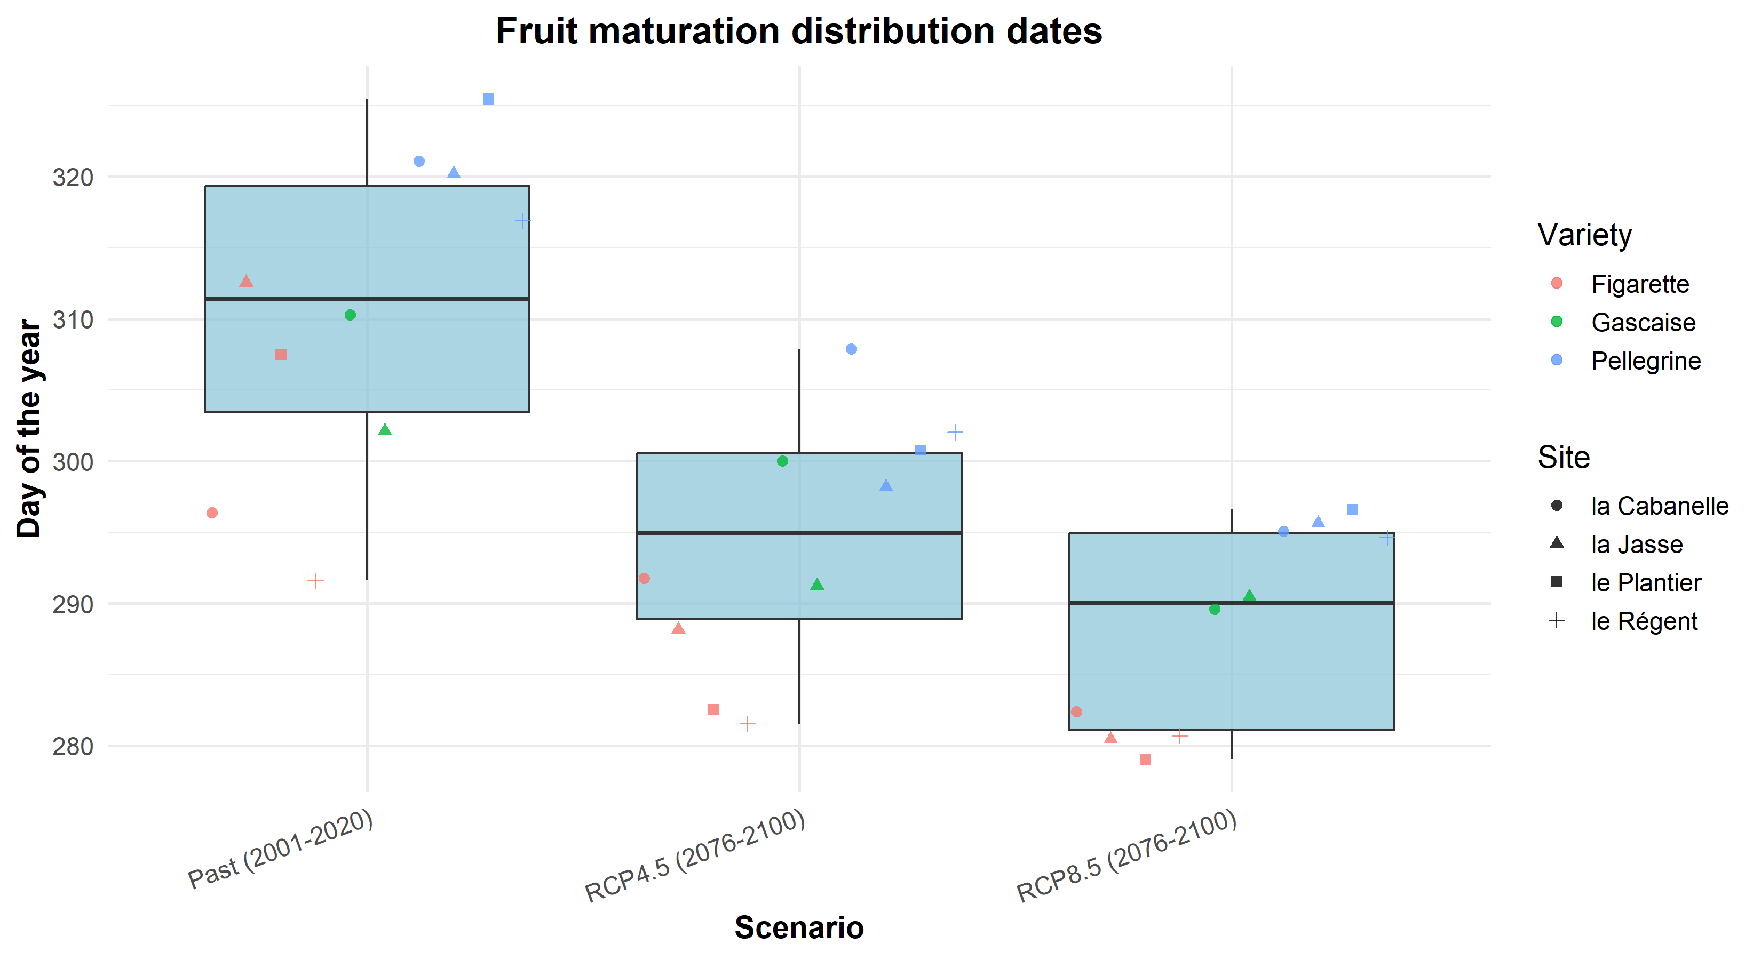
Supplementary Fig. S3 Projections of PHENOFIT4 results representing for each variety under each climatic scenario. a) survival as a product of temperatures, drought and carbon survival, b) fruit maturation index, c) carbon survival and d) leaf index. Colour scale represents their probability between 0 and 1. e) flowering date and f) leaf senescence date. Colour scale represents the day of the year predicted for the completion of phenological stage in the studied area. Areas in grey are outside a realistic range.
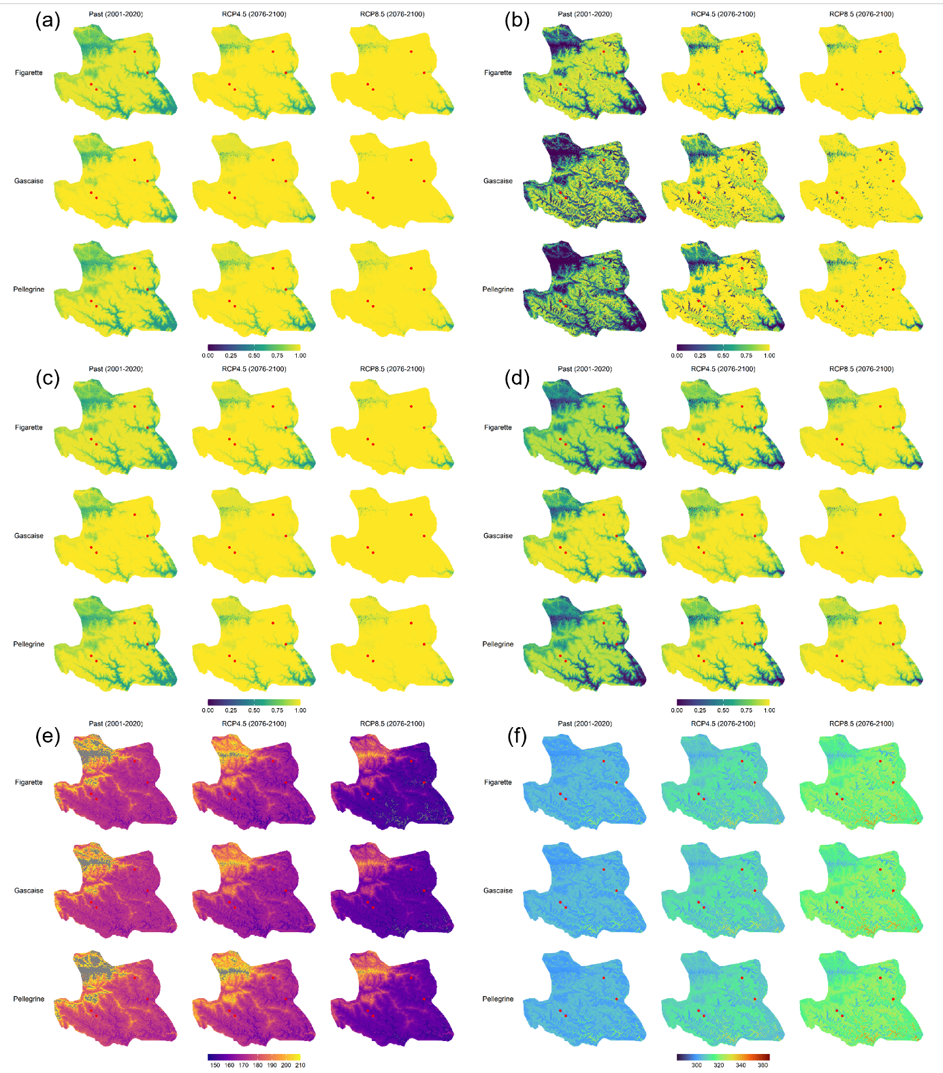

Supplementary Fig. S4 Projections of standard deviation to each phenological stage predicted with PHENOFIT for each variety and climatic conditions. a) leaf unfolding date, b) flowering date, c) fruit maturation date and d) leaf senescence date. Colour scale represents the standard deviation in days to the mean DOY represented in Fig. 3.
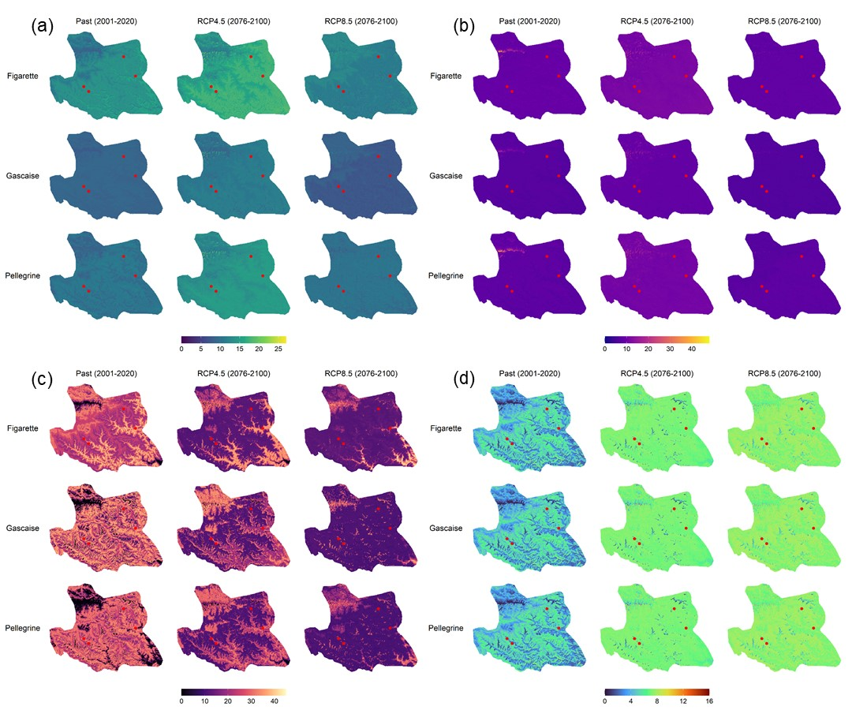
Supplementary climatic results
Supplementary Fig. S5 Projections representing the evolution of minimum temperatures during winter (December, January, February) under each climatic scenario. a) interannual mean of winter minimum temperatures, b) interannual standard deviation of winter minimum temperatures.
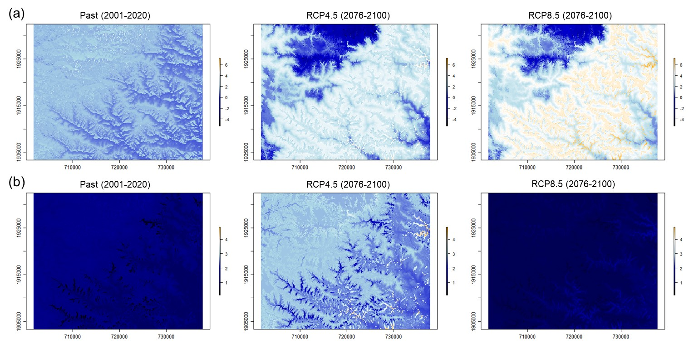
Supplementary Fig. S6 Projections representing the evolution of cumulated days of frost in a year under each climatic scenario. a) interannual mean of frost days, b) interannual standard deviation of frost days.
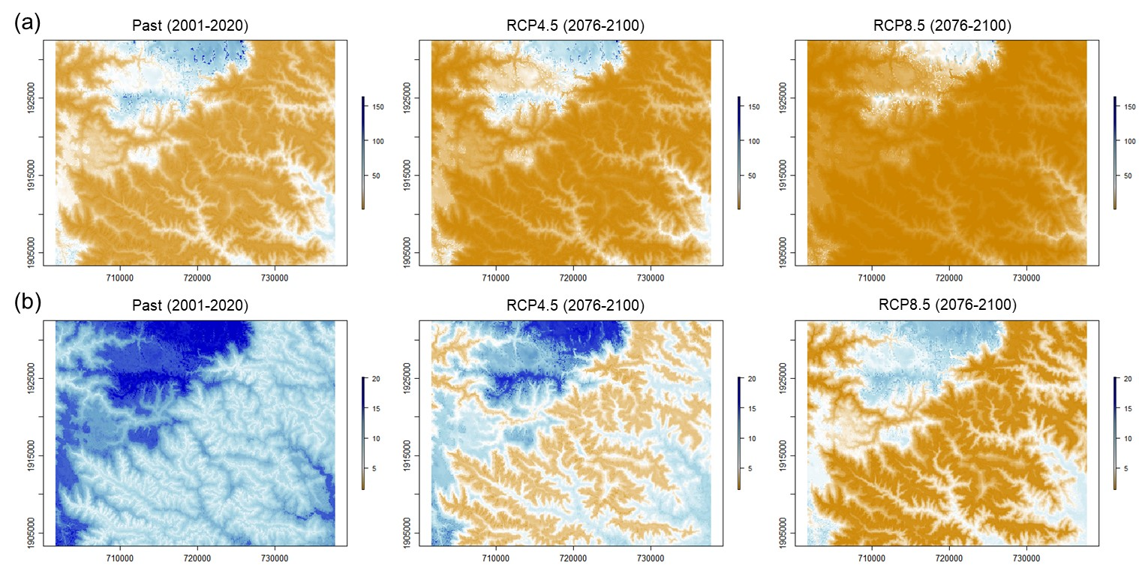

Supplementary Fig. S7 Projections representing the evolution of maximum temperatures during summer (July, August) under each climatic scenario. a) interannual mean of summer maximum temperatures, b) interannual standard deviation of summer maximum temperatures.
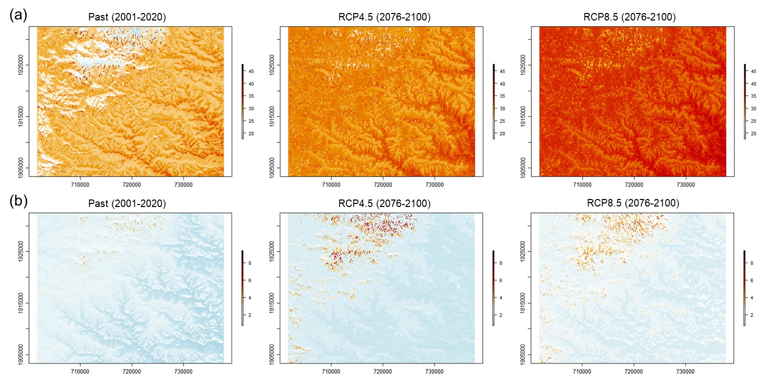
Supplementary Fig. S8 Projections representing the evolution of cumulated growing degree days (in degree Celsius with temperatures above -3°C) in a year under each climatic scenario. a) interannual mean of growing degree days, b) interannual standard deviation of growing degree days.
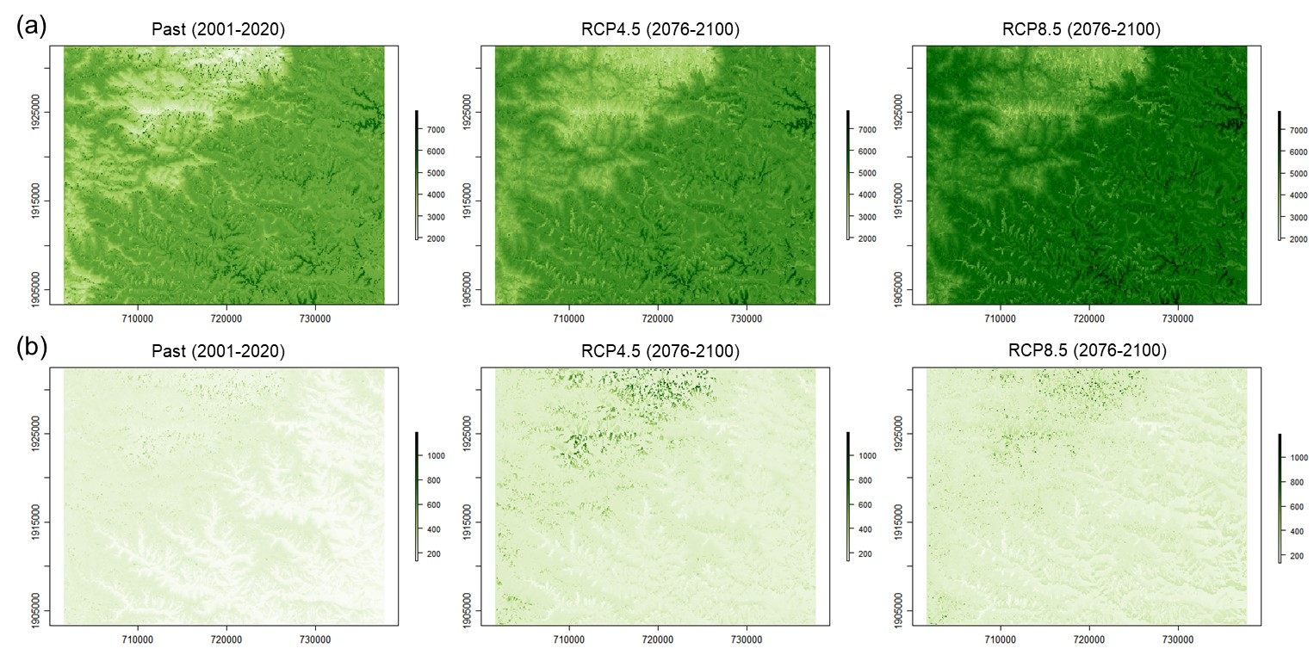

Reference list
Allen RG, Pereira LA, Raes D, Smith M (1998) “Crop evapotranspiration.” FAO irrigation and drainage paper 56, FAO, Rome.
Anupoju V, Kambhammettu BP, Peddinti SR (2025) Comparative Analysis of FAO Dual Kc, Priestley-Taylor and Flux Variance Similarity Methods in Partitioning Evapotranspiration from Flood-Irrigated Rice Fields. Irrigation and Drainage 74:569-85. https://doi.org/10.1002/ird.3039
Breisch, H. (1995) Châtaignes et marrons. CTIFL, France.
Chuine I, Beaubien EG (2001) Phenology Is a Major Determinant of Tree Species Range. Ecology Letters 4: 500510. https://doi.org/10.1046/j.1461-0248.2001.00261.x
Chuine I, Régnière J (2017) Process-Based Models of Phenology for Plants and Animals. Annual Review of Ecology, Evolution, and Systematics 48:159-82. https://doi.org/10.1146/annurev-ecolsys-110316-022706
Delrieu V, Mouillot F, Chuine I, Ponsa N, Aumeeruddy-Thomas Y (2025) Downscaling of daily topo-climatic variables within chestnut tree orchards in Lozère, France: Temperatures, global radiations, potential evapotranspiration and precipitation. CEFE (Centre d’écologie fonctionnelle évolutive), 1919 route de Mende, 34293 Montpellier. https://hal.science/hal-05180085
Druel A, Ruffault J, Davi H, Chanzy A, Marloie O, De Cáceres M, Olioso A, Mouillot F, François C, Soudani K, Martin-StPaul NK (2025) Enhancing environmental models with a new downscaling method for global radiation in complex terrain, Biogeosciences, 22: 1–18, https://doi.org/10.5194/bg-22-1-2025
Estrella N, Menzel A (2006) Responses of Leaf Colouring in Four Deciduous Tree Species to Climate and Weather in Germany. Climate Research 32 (octobre): 253-67. https://doi.org/10.3354/cr032253
Geiger R, Aron R, Todhunter P (2009) The climate near the ground, 7th edn. Rowman & Littlefield, Lanham.
Hargreaves GH, Samani ZA (1982) Estimating potential evaporation. Journal of the Irrigation Drainage Division 108: 225-230. https://doi.org/10.1061/JRCEA4.0001390
Intergovernmental Panel On Climate Change (Ipcc). 2023. Climate Change 2022 - Impacts, Adaptation and Vulnerability: Working Group II Contribution to the Sixth Assessment Report of the Intergovernmental Panel on Climate Change. 1re éd. Cambridge University Press. https://doi.org/10.1017/9781009325844
Keskitalo J, Bergquist G, Gardeström P, Jansson S (2005) A Cellular Timetable of Autumn Senescence. Plant Physiology 139 (4): 1635-48. https://doi.org/10.1104/pp.105.066845
Pei MS, Cao SH, Wu L, Wang GM, Xie Z, Gu C, Zhang, SL (2020) Comparative Transcriptome Analyses of Fruit Development among Pears, Peaches, and Strawberries Provide New Insights into Single Sigmoid Patterns. BMC Plant Biology 20 (1): 108. https://doi.org/10.1186/s12870-020-2317-6
Poggio L, de Sousa LM, Batjes NH, Heuvelink GBM, Kempen B, Ribeiro E, Rossiter D (2021) SoilGrids 2.0: producing soil information for the globe with quantified spatial uncertainty. SOIL. 7: 217–240. https://doi.org/10.5194/soil-7-217-2021
Ruffault J, Martin-StPaul NK, Duffet C, Goge F, Mouillot F (2013) Projecting future drought in Mediterranean forests: bias correction of climate models matters!. Theoretical Applied Climatology 117: 113–122. https://doi.org/10.1007/s00704-013-0992-z
Tóth B, Weynants M, Pásztor L, Hengl T (2017) 3D Soil Hydraulic Database of Europe at 250 m resolution. Hydrological Processes 31 (14): 2662-66. https://doi.org/10.1002/hyp.11203
Turek ME, Poggio L., Batjes NH, Armindo RA, de Jong van Lier Q, de Sousa LM, Heuvelink GBM (2023) Global mapping of volumetric water retention at 100, 330 and 15 000 cm suction using the WoSIS database. International Soil and Water Conservation Research. 11-2: 225-239. https://doi.org/10.1016/j.iswcr.2022.08.001
Van der Meersch V, Chuine I (2025) Can inverse calibration help improving process-explicit species distribution models? Ecological Modelling 506: 111132. https://doi.org/10.1016/j.ecolmodel.2025.111132
Wang E, Engel T (1998) Simulation of phenological development of wheat crops. Agricultural Systems 58 (1): 1-24. https://doi.org/10.1016/S0308-521X(98)00028-6
Zakšek K, Oštir K, Kokalj Ž (2011) Sky-View Factor as a Relief Visualization Technique. Remote Sensing 3 (2): 398-415. https://doi.org/10.3390/rs3020398

