Heat Exposure and Mortality in Aotearoa New Zealand: A Time-Stratified Case-Crossover Study

Appendix

Appendix A. Imputation metrics and TA-level results
The masking exercise provides a diagnostic check on the plausibility of the imputed radiation and wind inputs. Performance is summarised using the root mean squared error (RMSE), mean absolute error (MAE), and their percentage-scaled counterparts relative to the TA-specific observed mean. The resulting errors are generally modest relative to the TA-specific observed means, although performance varies across TAs and variables. These diagnostics support the construction of a complete national exposure panel. The regression-based sensitivity analyses in Appendix I provide the main check on whether the estimated heat-mortality associations are sensitive to excluding TAs with imputed radiation or wind inputs.
Eq. (A1). Definitions of RMSE, MAE, and their percentage forms.
 | $$\begin{matrix} & RMSE=\sqrt{\frac{1}{n}\sum_{t=1}^{n}{ } {\left({\overset{ˆ}{y}}_{t}-y_{t}\right)}^{2}}, MAE=\frac{1}{n}\sum_{t=1}^{n}{ } \left|{\overset{ˆ}{y}}_{t}-y_{t}\right|, \\ & RMSE\%=100×\frac{RMSE}{\overset{‾}{y}}, MAE\%=100×\frac{MAE}{\overset{‾}{y}}.\end{matrix}$$ | (A.1)
In Eq. (A1), $y_{t}$ denotes the observed station-day value on comparison day $t$ (radiation in MJ/m² or wind speed in m/s), ${\hat{y}}_{t}$ is its imputed counterpart, $n$ is the number of comparison observations with observed data, and $\overset{ˉ}{y}=n^{-1}\sum_{t=1}^{n}{y_{t}}$ is the TA-level mean of the observed series computed over those non-missing station-day observations. RMSE captures the typical deviation with greater weight on large misses; MAE captures the average absolute deviation. The percentage forms, RMSE% and MAE%, normalize these errors by $\overset{ˉ}{y}$ to yield scale-free measures that are comparable across TAs and variables.

Table A1. TA-level RMSE/MAE and RMSE (%)/MAE (%) results for radiation and wind imputations
Notes: RMSE and MAE are reported in the original units of the imputed variable (radiation: MJ/m²/day; wind speed: m/s). RMSE (%) and MAE (%) report relative errors as a percentage of the TA-specific mean of observed values.
Territorial Authority | Imputed Variables | RMSE | MAE | RMSE (%) | MAE (%)
Clutha District | Radiation | 0.9489 | 0.6084 | 7.5904 | 4.8665
Ruapehu District | Radiation | 0.9906 | 0.6868 | 7.5183 | 5.2123
Stratford District | Radiation | 0.5612 | 0.3909 | 3.9316 | 2.7388
Taupo District | Radiation | 0.7253 | 0.4735 | 5.0062 | 3.2681
Waimakariri District | Radiation | 0.6912 | 0.4587 | 5.0713 | 3.3657
Waitomo District | Radiation | 0.7584 | 0.4866 | 5.3979 | 3.4637
Kaikoura District | Radiation | 1.7277 | 1.2443 | 12.6985 | 9.1459
Waipa District | Radiation | 0.0787 | 0.0608 | 8.3357 | 6.4362
Grey District | Radiation | 0.6001 | 0.4004 | 4.6336 | 3.0920
Grey District | Wind | 0.2743 | 0.1675 | 7.8953 | 4.8203
Thames-Coromandel District | Radiation | 1.1987 | 0.8903 | 8.4421 | 6.2698
Thames-Coromandel District | Wind | 0.6230 | 0.4020 | 20.080 | 12.950

Appendix B. Computation of WBGT

B.1 Notation and units
Convert daily global short-wave radiation from MJ/m² to W/m² using 1 MJ/m² per day = 11.574 W/m². Unless stated otherwise, surface pressure $p_{s}=1010$ hPa. Impose a minimum wind speed of 0.1 m/s for numerical stability. The solar zenith angle $θ_{z}$ is evaluated from the TA-centroid latitude/longitude using a representative midday approximation for each calendar day.

B.2 Globe temperature $T_{g}$
Obtain $T_{g}$ from the steady-state energy balance:
 | $$α_{g}K_{abs}+ε_{g}L_{abs}=h_{c,g}\left(T_{g}-T_{a}\right)+ε_{g}σ\left(T_{g}^{4}-T_{rad}^{4}\right).$$ | (B.1)
Here $K_{\text{abs }}$ is the absorbed short-wave flux, including direct, diffuse, and ground-reflected components determined by $θ_{z}$ and optical parameters. The convective heat-transfer coefficient for crossflow over a sphere is:
 | $$Nu=2+0.6{Re}^{1/2}⁡{Pr}^{1/3}, h_{c,g}=\frac{k_{a}Nu}{D_{g}}, Re=\frac{ρUD_{g}}{μ}.$$ | (B.2)
Evaluate air properties at the film temperature $T_{f}=\left(T_{g}+T_{a}\right)/2$. Solve (B1)-(B2) iteratively for $T_{g}$.

B.3 Natural wet-bulb temperature $T_{\text{nwb }}$
Solve the coupled energy-mass balance at the wetted surface, writing $T_{w}≡T_{\text{nwb }}$,
 | $$R_{abs}\left(T_{w}\right)=h_{e}\left[p^{*}\left(T_{w}\right)-p_{a}\right]+h_{c,w}\left(T_{w}-T_{a}\right)+ε_{w}σ\left(T_{w}^{4}-T_{rad}^{4}\right).$$ | (B.3)
Link heat and mass transfer using the Lewis/Chilton-Colburn relation,
 | $$h_{e}≈\frac{h_{c,w}}{ρc_{p}{Le}^{2/3}}, h_{c,w}=\frac{k_{a}{Nu}_{cyl}}{D_{w}}.$$ | (B.4)
Saturation and ambient vapour pressures are:
 | $$e_{s}\left(T\right)=0.6108exp\left(\frac{17.27T}{T+237.3}\right)\left(kPa\right),$$  $$e_{a}=\frac{RH}{100}e_{s}\left(T_{a}\right)\text{ or }e_{a}=e_{s}\left(T_{d}\right).$$ | (B.5)
with $T_{d}$ the dew-point temperature when available. Iterate (B.3)-(B.5) until $\left|ΔT_{w}\right|$ falls below a small tolerance to obtain $T_{\text{nwb }}$.

B.4 Numerical settings and inputs
The calculation uses fixed geometric and optical constants for the globe, a radiative split between direct and diffuse short-wave components, and an iterative convergence criterion for the globe and natural wet-bulb temperature solutions. The meteorological inputs are daily air-temperature, relative humidity or dew point, radiation, and wind speed. The empirical analysis uses three daily-summary WBGT indices. WBGT-T_{mean}, WBGT-T_{max}, and WBGT-T_{min} are calculated by pairing the Liljegren algorithm with daily mean, maximum, and minimum air-temperature inputs, respectively, together with same-day TA-level humidity, radiation, wind speed, and dew-point inputs. These series are then merged to the mortality risk sets at the TA-day level. The final WBGT value is computed as $WBGT=0.7T_{nwb}+0.2T_{g}+0.1T_{a}$. The resulting values are summarised at the TA–day level.

Appendix C. Distributed-Lag Non-Linear Modelling within a Time-Stratified Case-Crossover Design
We estimate short-run heat-mortality associations using a time-stratified case-crossover (TS-CCO) design with conditional logistic regression. Strata are defined by month $×$ day-of-week, and we retain strata that contain at least one case day and at least one control day; strata in which the exposure is constant across the case and all matched control days drop out of the conditional likelihood and carry zero estimating weight. For any calendar day $t$ (case or control), we construct a 1 × 8 exposure history vector comprising the same-day exposure and the seven preceding days,
$$\left[T_{0},T_{1},…,T_{7}\right]$$
where $T_{0}$ is exposure on day $t$, $T_{1}$ is exposure on $t-1$, and so forth to $t-7$.
To represent the non-linear and lagged nature of the association, we embed a distributed-lag non-linear model (DLNM) via a cross-basis. The exposure dimension is modelled with a natural cubic spline $B_{x}(x)$ whose internal knots are fixed from the full pooled sample at the empirical 0.50, 0.90, and 0.99 quantiles $\left(Q_{50},Q_{90},Q_{99}\right)$. These knots are held constant across all panels and days to preserve comparability. Thus, any exposure value $x$ is mapped to a $K_{x}$-vector of basis values $B_{x}(x)=ns⁡(x; knots =\left.\left(Q_{50},Q_{90},Q_{99}\right)\right)$ (typically $K_{x}=4$ ).
The lag dimension spans integer lags 0-7. We represent the lag-response relationship using a natural cubic spline with 3 degrees of freedom on a log-scaled lag axis (with boundary knots at 0 and 7), which provides greater flexibility at shorter lags and smoother behavior at longer lags. For each day t, the cross-basis features are formed by the tensor product of exposure and lag bases, aggregated over lags:
$$Z_{t}=\sum_{l=0}^{7}{\left[B_{x}\left(x_{t-l}\right)⊗L\left(l\right)\right]},$$
a $K_{x}×K_{l}$ vector that enters the conditional logistic regression. Estimation delivers the coefficient vector $\hat{β}$. For interpretation, we center predictions at the full-sample median exposure $Q_{50}$. The cumulative log-odds ratio for an exposure level $x$ relative to $Q_{50}$ is obtained by summing lag-specific contributions,
$$\sum_{l=0}^{7}{{\left(B_{x}\left(x\right)-B_{x}\left(Q_{50}\right)\right)}^{⊤}}\hat{β}L\left(l\right),$$
and the cumulative odds ratio (OR) is the exponential of this sum. We report cumulative ORs over lags 0–7 relative to $Q_{50}$ on a grid across the exposure distribution (e.g., 1st–99th percentiles), together with 95% confidence intervals. All estimation and prediction are implemented in R (DLNM within the TS-CCO framework; see Gasparrini et al., 2010; Gasparrini, 2014). This specification ensures that (i) exposure non-linearity is referenced to fixed, full-sample knots ($Q_{50},Q_{90},Q_{99}$) for cross-panel comparability, (ii) lag flexibility is concentrated where short-run heat associations are often most variable, especially near lag 0 via the log-scaled lag axis, and (iii) the reported cumulative exposure-mortality associations are interpretable as the cumulative odds-ratio contrast over lags 0–7 when moving from the median exposure to any target exposure level.

Appendix D. TA-level distributions and warm-season maps
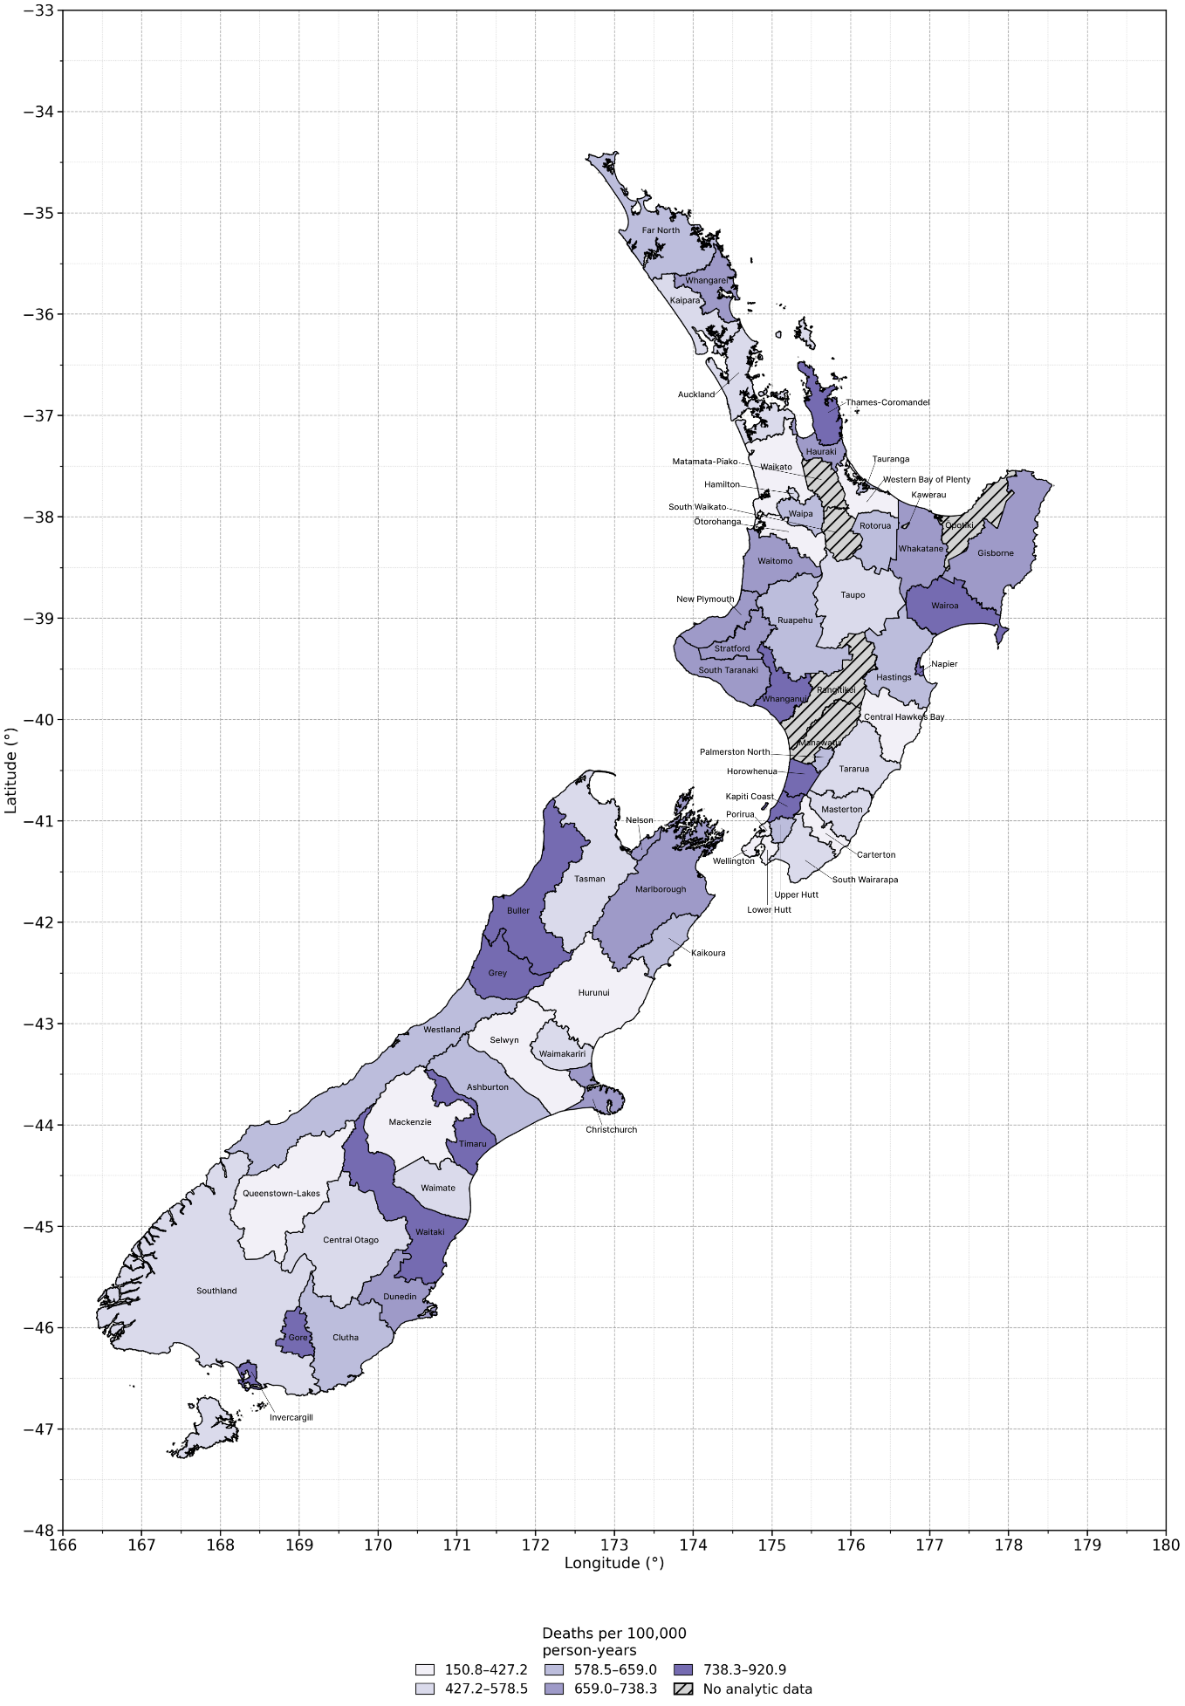
Figure D1. Annualised all-cause mortality rate by Territorial Authority, full-year all-cause panel. Rates are deaths per 100,000 person-years.

- T_{max} daily values by TA (ordered by the TA-specific median, descending);
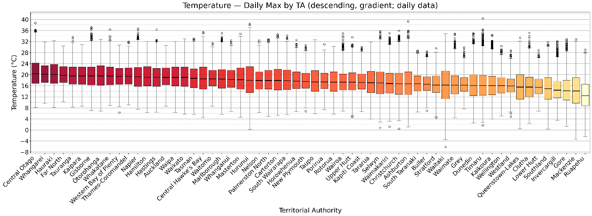
- T_{max} 90th Percentile daily values by TA (same ordering rule within panel);
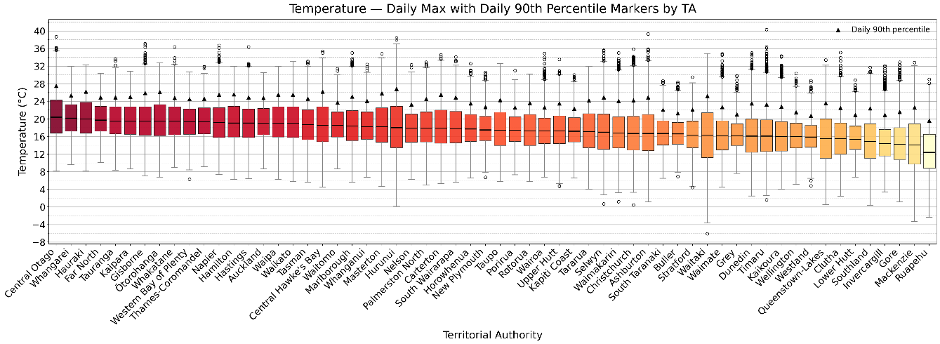
- T_{mean} daily values by TA (same ordering rule within panel)
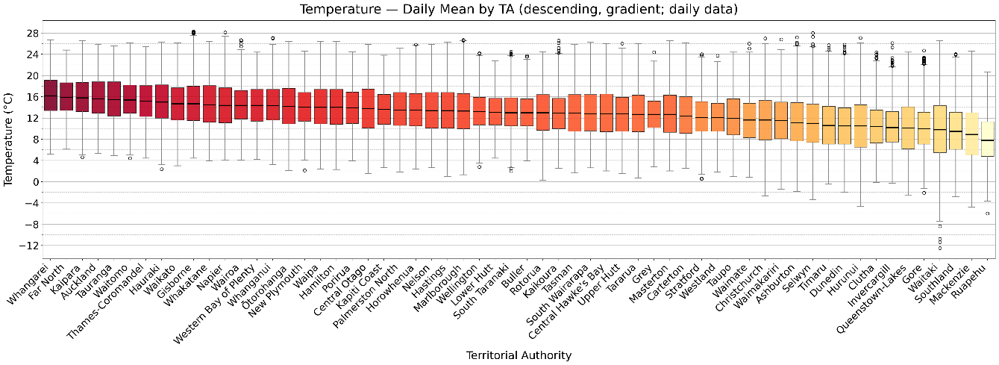
Figure D2. Distributions of Temperature by Territorial Authority (TA). Daily T_{max,} daily T_{max} with TA-specific daily P90 markers, and daily T_{mean} by TA. TAs are ordered by the TA-specific median of daily T_{max} (descending).
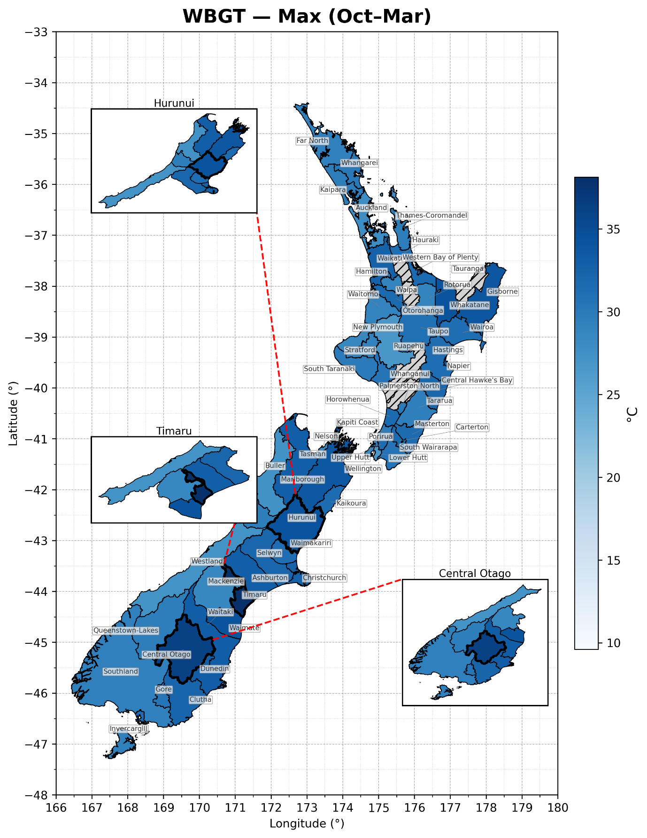
Figure D3. Warm-season WBGT-T_{max} by TA.
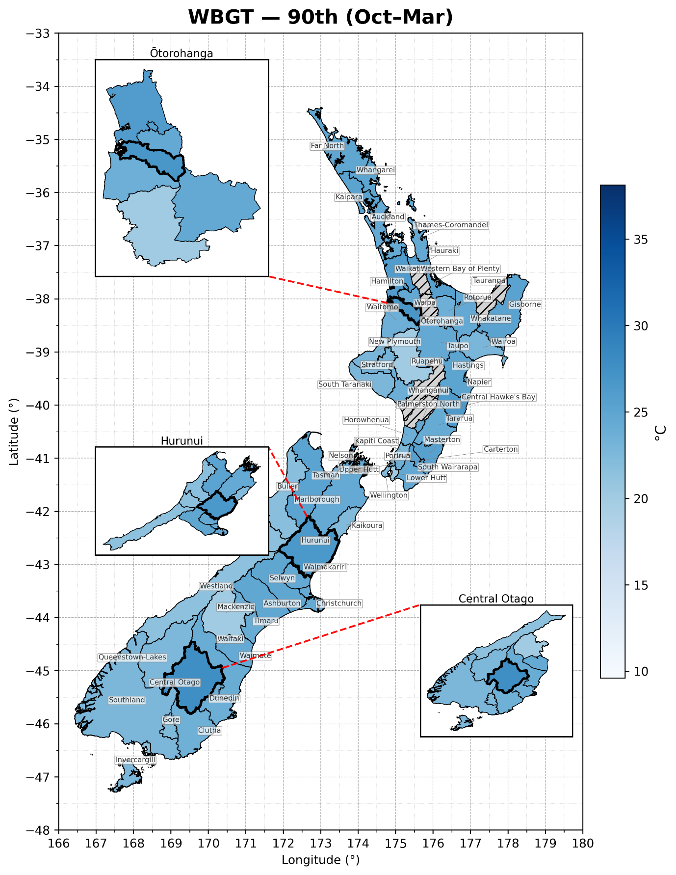
Figure D4. Warm-season WBGT-T_{P90} by TA.

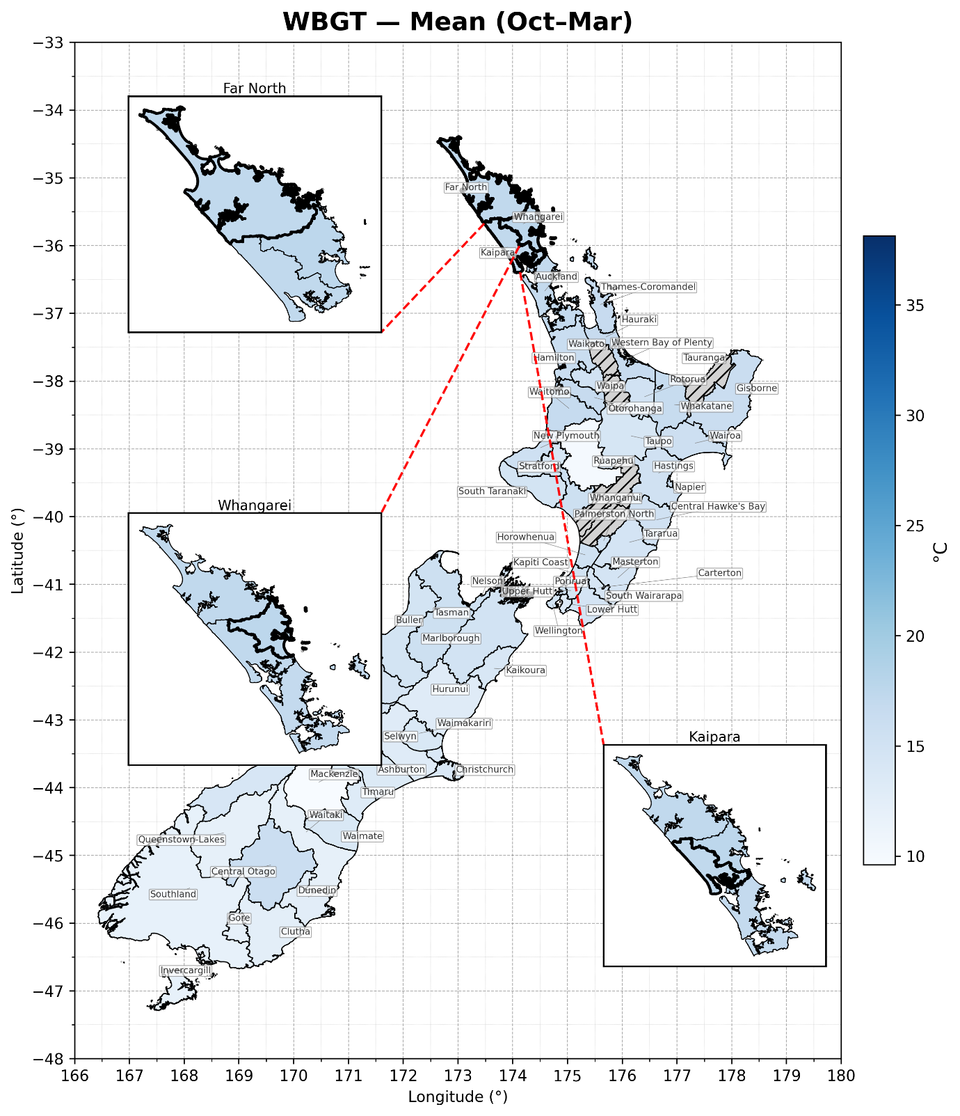
Figure D5. Warm-season WBGT-T_{mean} by TA.

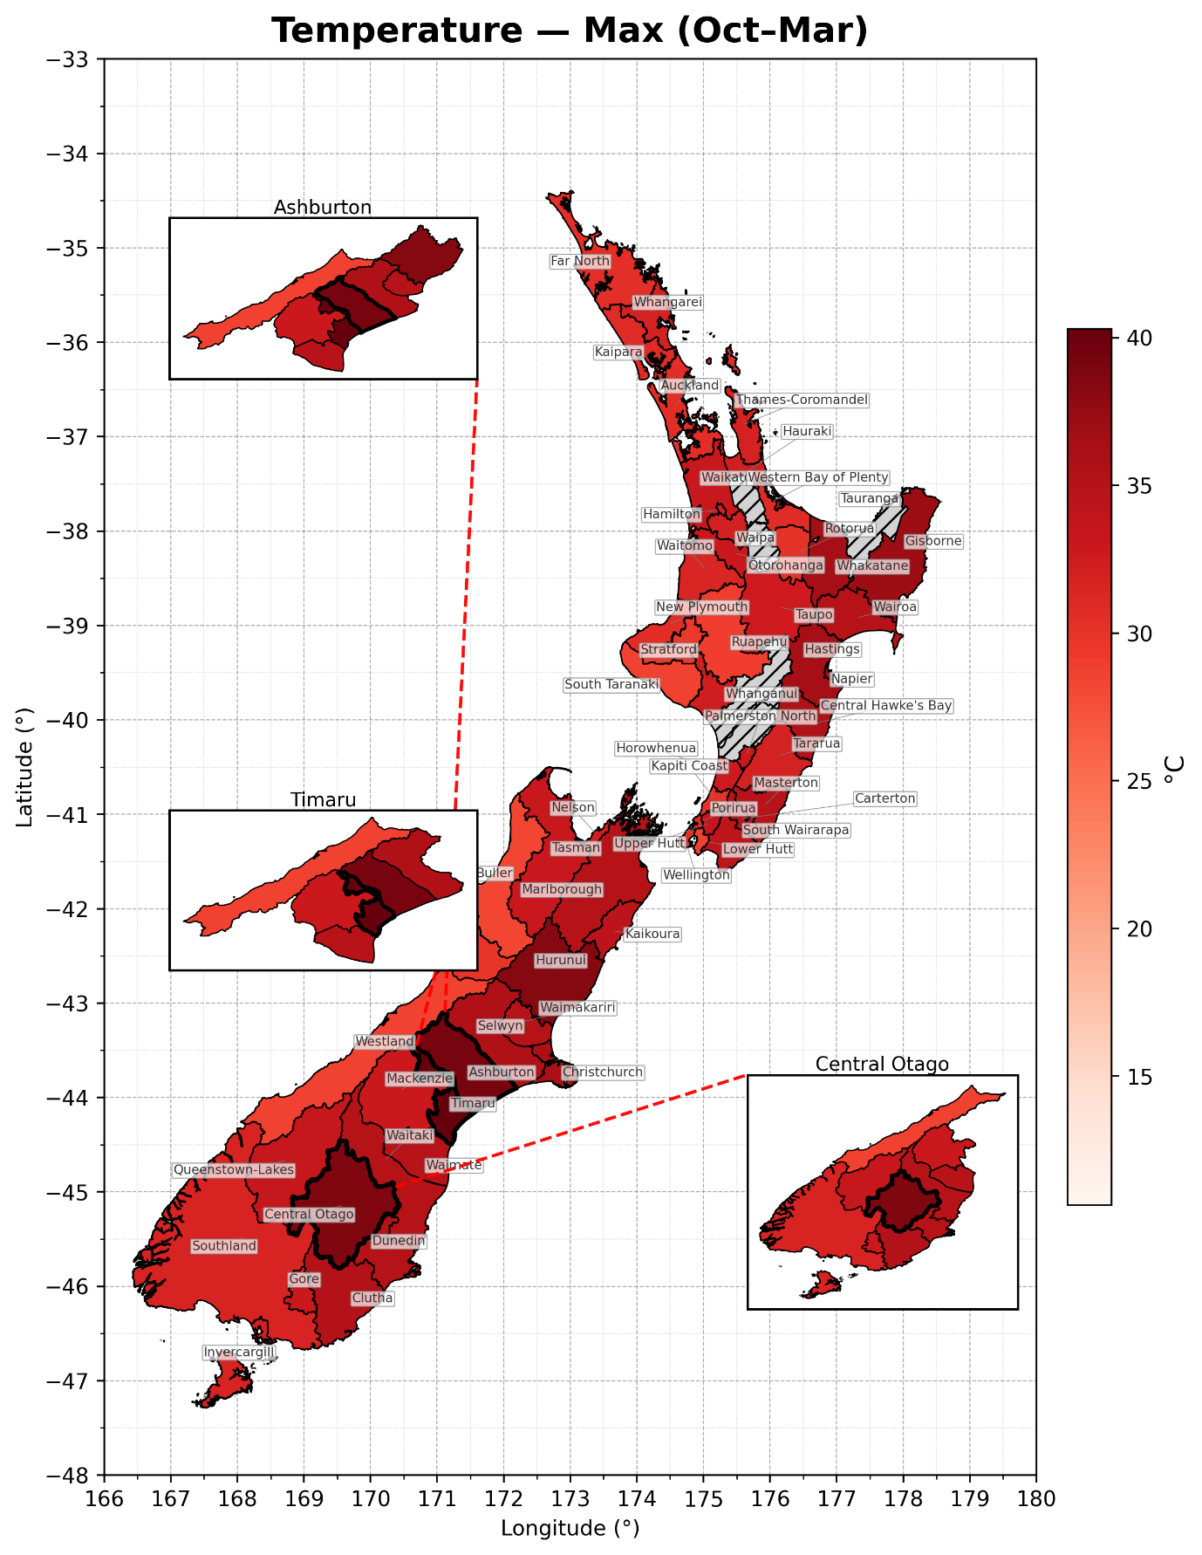
Figure D6. Warm-season T_{max} by TA.

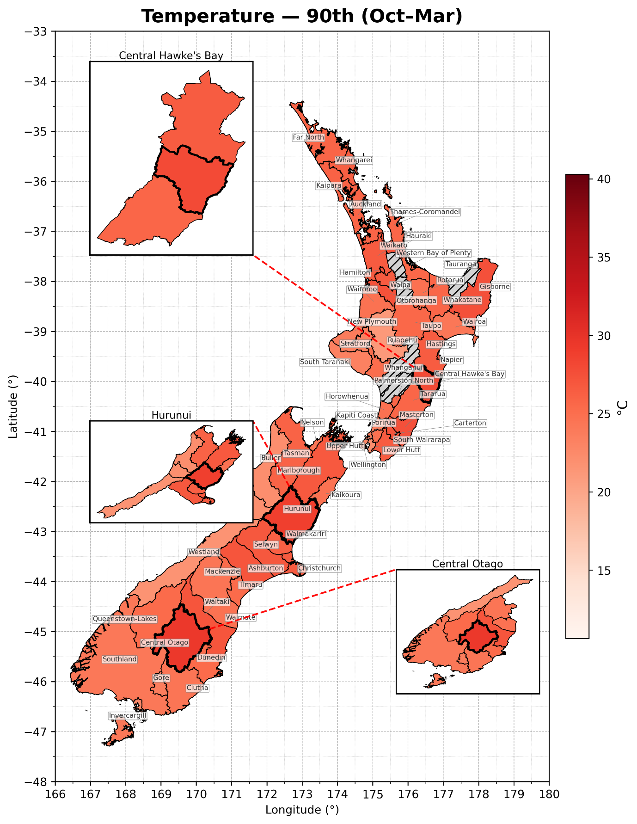
Figure D7. Warm-season T_{P90} by TA.

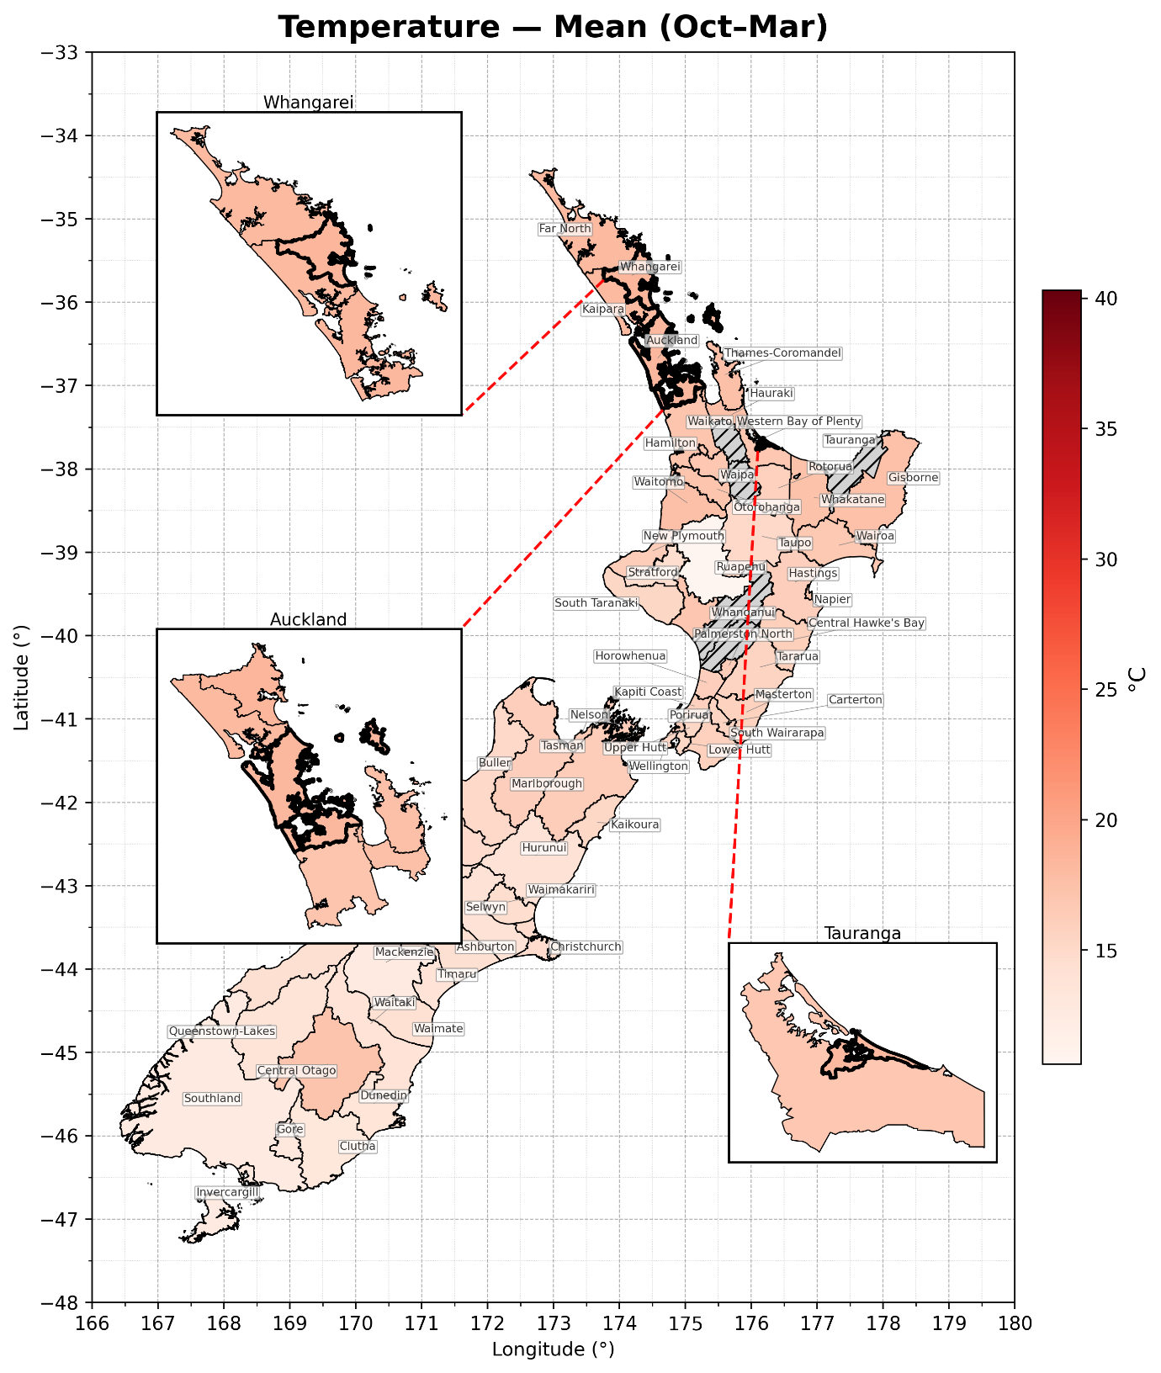
Figure D8. Warm-season T_{mean} by TA.

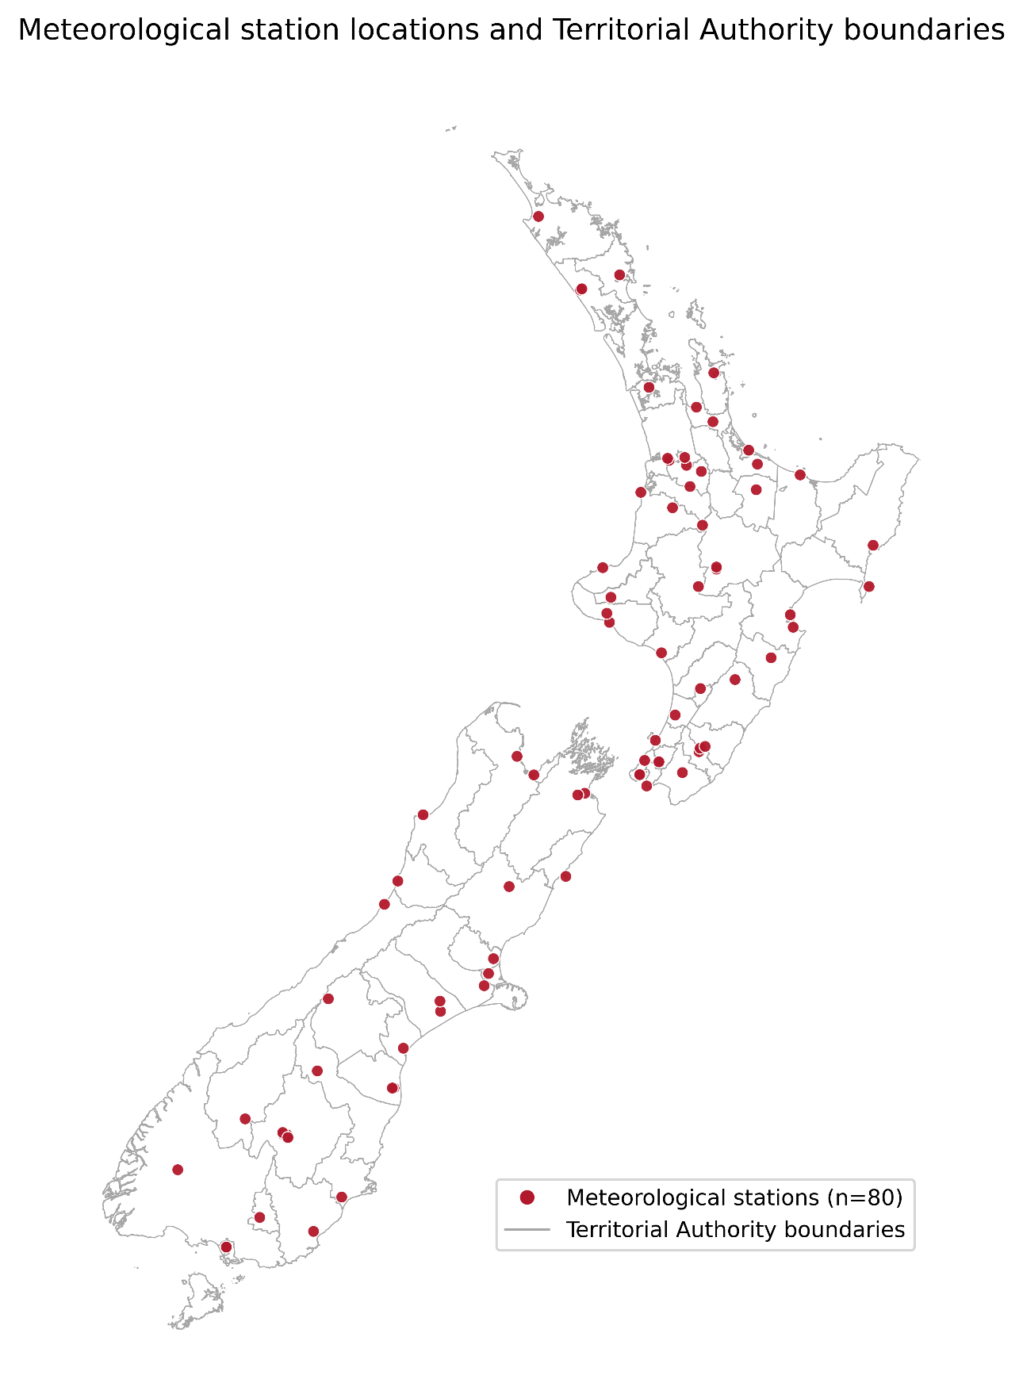
Figure D9. Meteorological station locations and Territorial Authority boundaries

Appendix E. Main regression result and excess deaths

E.1 Continuous regression results
Table E1. Continuous regression results for all-cause and non-injury mortality.
Notes: ORs = odds ratios; lcl/ucl = lower/upper bounds of the 95% confidence interval; Cases is the number of deaths; Odds change (%) is calculated as (ORs-1) × 100.
All-cause & Full-year |  |  |  |  |  | Non-injury & Full-year
Exposure metric | ORs | lcl | ucl | Cases | Odds change (%) | Exposure metric | ORs | lcl | ucl | Cases | Odds change (%)
WBGT-T_{mean} | 1.0044 | 1.0032 | 1.0055 | 721,908 | 0.44 | WBGT-T_{mean} | 1.0039 | 1.0026 | 1.0052 | 550,770 | 0.39
WBGT-T_{max} | 1.0036 | 1.0026 | 1.0047 | 721,908 | 0.36 | WBGT-T_{max} | 1.0032 | 1.0019 | 1.0044 | 550,773 | 0.32
WBGT-T_{min} | 1.0027 | 1.0018 | 1.0036 | 721,908 | 0.27 | WBGT-T_{min} | 1.0025 | 1.0015 | 1.0035 | 550,770 | 0.25
T_{mean} | 1.0039 | 1.0028 | 1.0050 | 721,848 | 0.39 | T_{mean} | 1.0036 | 1.0024 | 1.0049 | 550,734 | 0.36
T_{max} | 1.0031 | 1.0020 | 1.0041 | 721,767 | 0.31 | T_{max} | 1.0028 | 1.0016 | 1.0040 | 550,665 | 0.28
T_{min} | 1.0025 | 1.0016 | 1.0033 | 721,785 | 0.25 | T_{min} | 1.0023 | 1.0013 | 1.0033 | 550,671 | 0.23
All-cause & Warm-season |  |  |  |  |  | Non-injury & Warm-season
Exposure metric | ORs | lcl | ucl | Cases | Odds change (%) | Exposure metric | ORs | lcl | ucl | Cases | Odds change (%)
WBGT-T_{mean} | 1.0057 | 1.0040 | 1.0073 | 339,429 | 0.57 | WBGT-T_{mean} | 1.0051 | 1.0031 | 1.007 | 255129 | 0.51
WBGT-T_{max} | 1.0047 | 1.0032 | 1.0061 | 339,429 | 0.47 | WBGT-T_{max} | 1.0046 | 1.0029 | 1.0062 | 255132 | 0.46
WBGT-T_{min} | 1.0037 | 1.0023 | 1.005 | 339,429 | 0.37 | WBGT-T_{min} | 1.0029 | 1.0013 | 1.0045 | 255132 | 0.29
T_{mean} | 1.0051 | 1.0035 | 1.0067 | 339,399 | 0.51 | T_{mean} | 1.0049 | 1.003 | 1.0068 | 255111 | 0.49
T_{max} | 1.0039 | 1.0025 | 1.0053 | 339,354 | 0.39 | T_{max} | 1.0042 | 1.0026 | 1.0058 | 255072 | 0.42
T_{min} | 1.0033 | 1.0019 | 1.0046 | 339,321 | 0.33 | T_{min} | 1.0027 | 1.0011 | 1.0042 | 255039 | 0.27

E.2 Comparison between WBGT and temperature metrics

To assess whether WBGT indices added information beyond conventional temperature summaries, we compared paired models for the mean, maximum, and minimum exposure metrics in the all-cause full-year sample. For each pair, we estimated a temperature-only model, a WBGT-only model, and a combined model including both metrics. Model fit was summarised using log-likelihood and Akaike information criterion (AIC) values. The AIC was calculated as $-2l+2k$, where $l$ is the model log-likelihood and $k$ is the number of exposure parameters. Nested model comparisons were assessed using likelihood-ratio tests, calculated as $2\left(l_{larger}-l_{smaller}\right)$, with one degree of freedom because each comparison adds one exposure parameter to the single-metric model. To compare coefficient magnitudes, both exposure metrics were standardised before estimation, and Wald tests were used to compare the paired standardised coefficients in the combined models.
Across all three daily summary forms, the WBGT-only models had lower AIC values than the corresponding temperature-only models. Adding WBGT to the paired temperature model improved fit for the mean, maximum, and minimum comparisons. Adding temperature to the paired WBGT model provided weaker additional evidence for the mean comparison and clearer additional evidence for the maximum and minimum comparisons. Wald tests comparing standardised coefficients in the combined models were also consistent with larger WBGT contributions.
Table E2. Paired model-comparison results for WBGT-T and temperature metrics, all-cause full-year sample.
Notes: The table reports paired comparisons between conventional temperature summaries and the corresponding WBGT indices in the all-cause full-year sample. The mean pair compares Tmean with WBGT-T_{mean}, the maximum pair compares Tmax with WBGT-T_{max}, and the minimum pair compares Tmin with WBGT-Tmin. The temperature-only and WBGT-only models include one exposure metric; the combined model includes both paired metrics. $\text{∆}$AIC is calculated as AIC temperature-only – AIC WBGT-only, so positive values indicate lower AIC for the WBGT-only model. Likelihood-ratio tests compare each single-metric model with the paired combined model. Wald tests compare the paired standardised coefficients in the combined model.
Pair | AIC:  Temp only | AIC:  WBGT only | AIC:  combined | $\text{∆}$AIC  Temp-WBGT | LRT:  WBGT  adds to  temp, $χ^{2}$ | p | LRT:  temp  adds to  WBGT, $χ^{2}$ | p | Wald z | Wald p
Mean | 2070667.61 | 2070657.89 | 2070657.12 | 9.73 | 12.49 | 0.0004 | 2.76 | 0.0965 | 2.61 | 0.0090
Maximum | 2070680.68 | 2070670.32 | 2070667.96 | 10.37 | 14.73 | 0.0001 | 4.36 | 0.0368 | 2.99 | 0.0028
Minimum | 2070682.43 | 2070678.22 | 2070673.92 | 4.21 | 10.52 | 0.0012 | 6.30 | 0.0120 | 2.88 | 0.0039

E.3 Annual numbers of death by panel
Table E3 reports the annual number of deaths in each calendar year for the four analysis panels. For each of the four analysis panels $j$ (all-cause full-year, all-cause warm-season, non-injury full-year, and non-injury warm-season), let $n_{jt}$ denote the number of deaths observed in calendar year $t$. The average annual number of deaths in panel $j$ is:
 | $D_{j}=\frac{1}{T_{j}}\sum_{t=1}^{T_{j}}{ }n_{jt}$. | (E.1)
where $T_{j}$ denotes the number of complete calendar years in that panel $j$. The last row of Table E3 reports the corresponding averages $D_{j}$; for the all-cause series, the partial year 2025 is excluded from this calculation.
Table E3. Annual numbers of death by panel and average annual deaths over the study period.
year | All-cause,  full-year. | All-cause,  warm-season. | Non-injury,  full-year. | Non-injury,  warm-season.
1999 | 28,791 | 13,284 | 28,713 | 13,215
2000 | 27,303 | 13,116 | 25,680 | 12,312
2001 | 28,479 | 13,122 | 26,817 | 12,261
2002 | 28,728 | 13,443 | 27,045 | 12,618
2003 | 28,431 | 13,005 | 26,631 | 12,126
2004 | 29,139 | 13,713 | 27,411 | 12,795
2005 | 27,807 | 13,440 | 26,118 | 12,543
2006 | 29,142 | 13,680 | 27,357 | 12,750
2007 | 28,938 | 13,782 | 27,111 | 12,873
2008 | 29,880 | 14,025 | 27,981 | 13,062
2009 | 29,673 | 14,205 | 27,765 | 13,257
2010 | 29,265 | 13,890 | 27,285 | 12,912
2011 | 30,936 | 14,856 | 28,917 | 13,752
2012 | 30,819 | 14,544 | 28,926 | 13,566
2013 | 30,120 | 14,262 | 28,356 | 13,320
2014 | 31,695 | 15,000 | 29,820 | 14,073
2015 | 32,298 | 15,282 | 30,366 | 14,292
2016 | 31,941 | 15,150 | 29,973 | 14,136
2017 | 34,158 | 15,759 | 31,992 | 14,727
2018 | 33,789 | 16,056 | 31,548 | 14,910
2019 | 34,818 | 16,185 | 32,391 | 14,901
2020 | 33,399 | 16,545 | 31,245 | 15,411
2021 | 35,643 | 17,052
2022 | 39,504 | 18,465
2023 | 38,838 | 18,750
2024 | 38,235 | 18,087
2025 (partial year) | 8,679 | 8,625
Average | 31,606.5 | 14,949.9 | 28,611.3 | 13,446

E.4 Illustrative +1°C scaling calculation
To place the continuous same-day estimates on a more interpretable scale, we conduct a simplified +1°C scaling calculation, following the algebra of the attributable-fraction framework described by (Gasparrini & Leone, 2014). In its standard form, for a given time $t$ and exposure contrast with relative risk $RR_{t}$, the attribution fraction is defined as:
 | $${AF}_{t}= \frac{{RR}_{t}-1}{{RR}_{t}}.$$ | (E.2)
In the present analysis, the time-stratified case-crossover models estimate conditional odds ratios. We therefore apply the same scaling form to the estimated conditional odds ratios as an approximate magnitude calculation. For panel $j$ and exposure metric $X$, let ${OR}_{jX}$ denote the estimated conditional odds ratio for a +1 °C increase. The scaling is:
 | $${SF}_{jX}= \frac{{OR}_{jX}-1}{{OR}_{jX}}.$$ | (E.3)
The illustrative annual excess-death equivalent is then calculated as:
$${ED}_{jX}= {SF}_{jX} × D_{j},$$
where $D_{j}$ is the mean annual number of deaths in panel $j$, as defined in Eq. (E.1). The lower and upper bounds are calculated by replacing ${OR}_{jX}$ with the lower and upper 95% confidence limits of the conditional odds ratio.

E.5 Summary of excess deaths per +1 °C
Applying equations (E.1), (E.3) gives the illustrative annual excess-death equivalents reported in Table E4. These values represent scale illustrations under a uniform +1°C scenario.
Table E4. Illustrative annual excess-death equivalents under a +1°C shift in heat exposure.
Panel | Exposure metric | Mean annual deaths ($D_{j}$) | Conditional OR per +1 °C ($OR_{jX}$) | Illustrative excess-death equivalent per year, 95 % CI
All-cause,  full-year | WBGT-T_{mean} | 31,606 | 1.0044 | 138 (101, 173)
All-cause,  full-year | T_{mean} | 31,606 | 1.0039 | 123 (88, 157)
Non-injury,  full-year | WBGT-T_{mean} | 28,611 | 1.0039 | 111 (74, 148)
Non-injury,  full-year | T_{mean} | 28,611 | 1.0036 | 103 (69, 140)
All-cause,  warm-season | WBGT-T_{mean} | 14,950 | 1.0057 | 85 (60, 108)
All-cause,  warm-season | T_{mean} | 14,950 | 1.0051 | 76 (52, 99)
Non-injury, warm-season | WBGT-T_{mean} | 13,446 | 1.0051 | 68 (42, 93)
Non-injury, warm-season | T_{mean} | 13,446 | 1.0049 | 66 (40, 91)

Appendix F. Bin-specific exposure-mortality associations and EB shrinkage

F.1 Methods
Let bins within a given exposure metric be indexed by $i=1,…,k$. For each bin we observe the odds ratio ${OR}_{i}$ with its 95% confidence limits $\left[{lcl}_{i},{ucl}_{i}\right]$. We work on the log-odds-ratio scale and denote by $y_{i}=log⁡\left({OR}_{i}\right)$ the bin-specific log odd, by $s_{i}$ its standard error, by $w_{i}=1/s_{i}^{2}$ the inverse-variance weight, by $\overset{‾}{θ}$ the within-metric centre, by $τ^{2}$ the between-bin variance, and by $θ_{i}^{EB}$ the empirical-Bayes (BLUP) estimate of the log odd for bin $i$.
The inputs are reconstructed from the reported confidence limits via:
 | $$y_{i}=log⁡\left({OR}_{i}\right), s_{i}=\frac{log⁡\left({ucl}_{i}\right)-log⁡\left({lcl}_{i}\right)}{2×1.96}$$ | (F.1)
Smaller $s_{i}$ indicates higher information content for the bin. Within each metric, the fixed-odd centre is the precision-weighted mean:
 | $$w_{i}=\frac{1}{s_{i}^{2}}, \overset{‾}{θ}=\frac{\sum_{i=1}^{k}{ } w_{i}y_{i}}{\sum_{i=1}^{k}{ } w_{i}}$$ | (F.2)
Between-bin heterogeneity is represented by the variance parameter $τ^{2}$. We estimate $τ^{2}$ by the DerSimonian-Laird method of moments (DerSimonian and Laird, 1986). Given $\overset{‾}{θ}$ and $τ^{2}$, the empirical-Bayes (BLUP) log-odd for bin $i$ is:
 | $$θ_{i}^{EB}=\frac{y_{i}/s_{i}^{2}+\overset{‾}{θ}/τ^{2}}{1/s_{i}^{2}+1/τ^{2}}=\frac{τ^{2}}{s_{i}^{2}+τ^{2}}y_{i}+\frac{s_{i}^{2}}{s_{i}^{2}+τ^{2}}\overset{‾}{θ}$$ | (F.3)
so that high-information bins ($s_{i}^{2}$ small) remain virtually unchanged, whereas low-information bins are gently pulled toward $\overset{‾}{θ}$. For presentation, we report $exp⁡\left(θ_{i}^{EB}\right)$ on the odds-ratio scale and the corresponding odds-change percentage as $\left(exp⁡\left(θ_{i}^{EB}\right)-1\right)×100\%$; uncertainty is shown using Wald intervals based on the posterior standard error implied by the normal-normal model.
Plotting both original and EB-shrunken estimates makes information content visible: dense bins show little change, while sparse bins have moderated point estimates. The original confidence intervals remain the primary uncertainty estimates for bin-specific results, and EB-shrunken intervals are reported only as model-based stabilisation summaries.

F.2 Exposure-mortality associations across bins
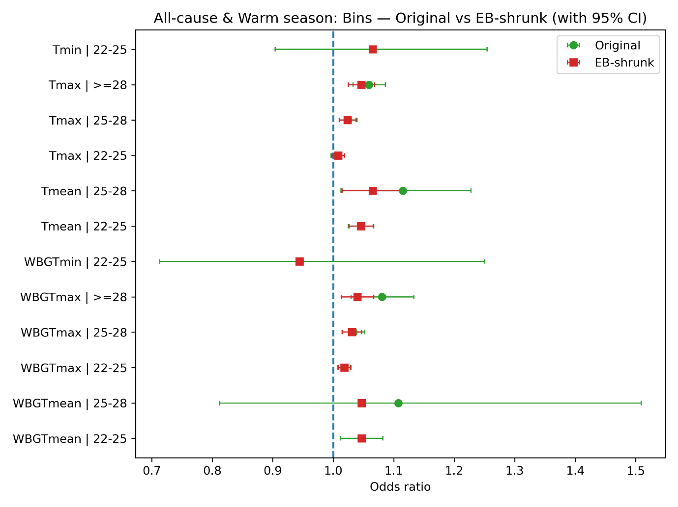
Figure F1. All-cause (Warm-season, Oct–Mar): Original vs EB-shrunken bin-specific odds ratios (95% CIs). The maximum measures rise monotonically: WBGT-T_{ma}x increases 1.86% → 3.08% → 3.99% across 22–25 °C → 25–28 °C → ≥28 °C, while T_{max} increases 0.82% → 2.37% → 4.65%, with T_{max} exceeding WBGT-T_{max} at the top tail (4.65% vs 3.99%). For the mean measures, WBGT-T_{mean} is flat at 4.69% in both 22–25 °C and 25–28 °C, whereas T_{mean} strengthens from 4.60% to 6.50%; the ≥ 28 °C mean bin is empirically absent in this sample. For the minimum measures, only 22–25 °C is observed, with WBGT-T_{min} = −15.22% (OR: 0.8478) and T_{min} = 6.49% (OR:1.0649); these come from modest cell counts and very wide original CIs (e.g., WBGT-T_{min} 95% CI: 0.55–1.31).
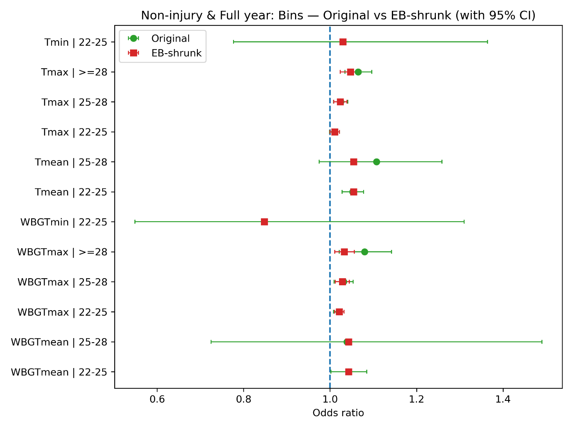
Figure F2. Non-injury (Full-year): Original vs EB-shrunken bin-specific odds ratios (95% CIs). The estimates show a similar ordering across bins. WBGT-T_{max} increases 2.11% → 2.83% → 3.32%, and T_{max} increases 1.10% → 2.37% → 4.75%, again with T_{max} larger than WBGT-T_{max} at ≥ 28 °C. Mean exposures are high within the bins that occur: WBGT-T_{mean} is 4.27% at 22–25 °C and 4.27% at 25–28 °C, while T_{mean} is 5.43% in both bins; the ≥ 28 °C mean bin is empirically absent in this sample. Only the 22–25 °C minimum bin appears (WBGT-T_{min} = −15.22%, T_{min} = 2.95%).
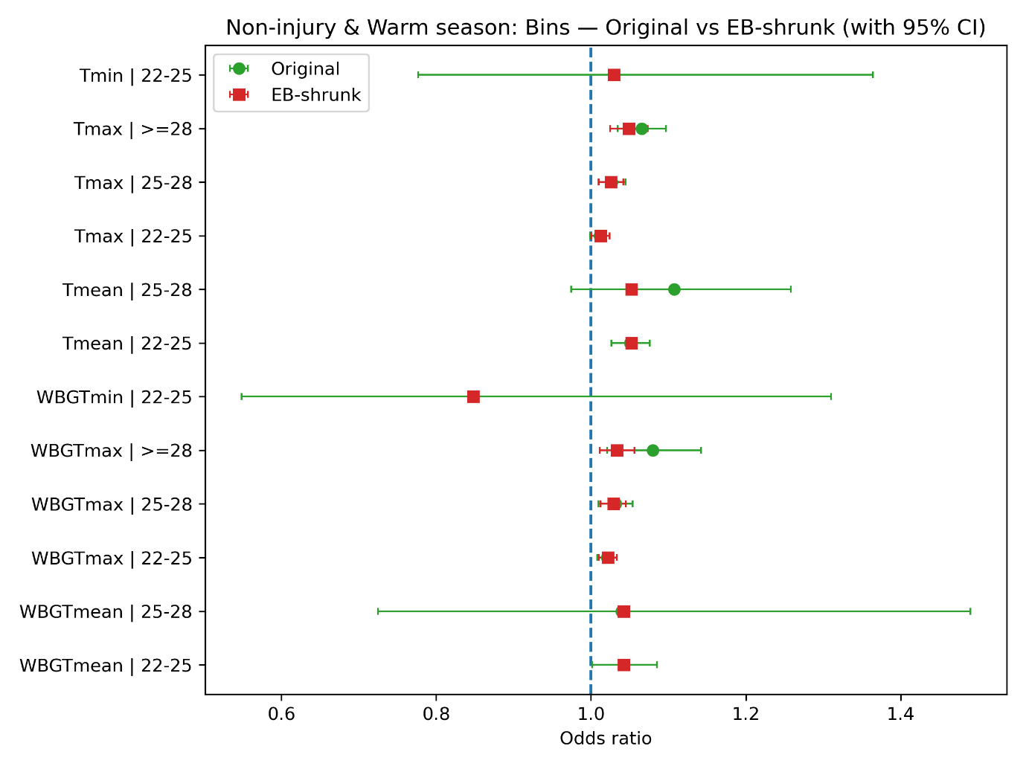
Figure F3. Non-injury (Warm-season, Oct–Mar): Original vs EB-shrunken bin-specific odds ratios (95% CIs). Results again echo the main pattern with a small right-shift. WBGT-T_{max} rises 2.18% → 2.89% → 3.35%, and T_{max} rises 1.22% → 2.60% → 4.87%. Mean exposures remain elevated: WBGT-T_{mean} = 4.25% in 22–25 °C and 4.25% in 25–28 °C, while T_{mean} = 5.25% in both; the ≥ 28 °C mean bin is empirically absent in this sample . Only 22–25 °C is available for minimum measures (WBGT-T_{min} = −15.22%, T_{min} = 2.95%), again with wide uncertainty.

Table F1. All-cause & Full-year: Original and EB-shrunken estimates by exposure metric and exposure bin.
Notes: ORs = odds ratios; lcl/ucl = lower/upper bounds of the 95% confidence interval; Cases is the number of deaths; Odds change (%) is calculated as (ORs-1) × 100. SE is the standard error of estimate; $\overset{ˉ}{θ}$ is the pooled mean; and τ² is the estimated between-bin variance.
All-cause & Full-year
Exposure metric | Bin | ORs | lcl | ucl | Cases | Odds change (%) | ORs (Shrunk) | lcl (Shrunk) | ucl (Shrunk) | Odds change % (Shrunk) | SE | $$\overset{ˉ}{θ}$$ | τ²
WBGT-T_{mean} | 22-25 | 1.0462 | 1.012 | 1.0816 | 5,236 | 4.62 | 1.0469 | 1.0469 | 1.0469 | 4.69 | 0.017 | 0.0458 | 0
WBGT-T_{mean} | 25-28 | 1.1074 | 0.8126 | 1.5092 | 55 | 10.74 | 1.0469 | 1.0469 | 1.0469 | 4.69 | 0.1579 | 0.0458 | 0
WBGT-T_{mean} | >=28
WBGT-T_{max} | 22-25 | 1.0197 | 1.0092 | 1.0302 | 81,467 | 1.97 | 1.0203 | 1.0104 | 1.0303 | 2.03 | 0.0053 | 0.0249 | 0.0002
WBGT-T_{max} | 25-28 | 1.0343 | 1.016 | 1.053 | 21,540 | 3.43 | 1.0319 | 1.0162 | 1.0478 | 3.19 | 0.0091 | 0.0249 | 0.0002
WBGT-T_{max} | >=28 | 1.0814 | 1.0306 | 1.1346 | 2,450 | 8.14 | 1.0404 | 1.0145 | 1.067 | 4.04 | 0.0245 | 0.0249 | 0.0002
WBGT-T_{min} | 22-25 | 0.9442 | 0.7129 | 1.2506 | 64 | -5.58 | 0.9442 | 0.9442 | 0.9442 | -5.58 | 0.1434 | 0.0574 | 0
WBGT-T_{min} | 25-28
WBGT-T_{min} | >=28
T_{mean} | 22-25 | 1.0479 | 1.0271 | 1.0691 | 16,078 | 4.79 | 1.0483 | 1.0288 | 1.068 | 4.83 | 0.0102 | 0.0494 | 0.0007
T_{mean} | 25-28 | 1.1157 | 1.0135 | 1.2283 | 572 | 11.57 | 1.0651 | 1.0173 | 1.1152 | 6.51 | 0.049 | 0.0494 | 0.0007
T_{mean} | >=28
T_{max} | 22-25 | 1.0098 | 0.9999 | 1.0197 | 103,790 | 0.98 | 1.0104 | 1.0009 | 1.02 | 1.04 | 0.005 | 0.0191 | 0.0004
T_{max} | 25-28 | 1.0253 | 1.0112 | 1.0397 | 45,251 | 2.53 | 1.0245 | 1.0113 | 1.038 | 2.45 | 0.0071 | 0.0191 | 0.0004
T_{max} | >=28 | 1.0616 | 1.0356 | 1.0883 | 10,308 | 6.16 | 1.0482 | 1.0268 | 1.07 | 4.82 | 0.0127 | 0.0191 | 0.0004
T_{min} | 22-25 | 1.0649 | 0.9042 | 1.2542 | 204 | 6.49 | 1.0649 | 1.0649 | 1.0649 | 6.49 | 0.0835 | 0.0629 | 0
T_{min} | 25-28
T_{min} | >=28

Table F2. Non-injury & Full-year: Original and EB-shrunken estimates.
Non-injury & Full-year
Exposure metric | Bin | ORs | lcl | ucl | Cases | Odds change (%) | ORs (Shrunk) | lcl (Shrunk) | ucl (Shrunk) | Odds change % (Shrunk) | SE | $$\overset{ˉ}{θ}$$ | τ²
WBGT-T_{mean} | 22-25 | 1.0427 | 1.0019 | 1.0851 | 3,615 | 4.27 | 1.0427 | 1.0427 | 1.0427 | 4.27 | 0.0204 | 0.0418 | 0
WBGT-T_{mean} | 25-28 | 1.0393 | 0.7249 | 1.49 | 40 | 3.93 | 1.0427 | 1.0427 | 1.0427 | 4.27 | 0.1838 | 0.0418 | 0
WBGT-T_{mean} | >=28
WBGT-T_{max} | 22-25 | 1.0202 | 1.0079 | 1.0326 | 57,573 | 2.02 | 1.0211 | 1.0101 | 1.0322 | 2.11 | 0.0062 | 0.0245 | 0.0002
WBGT-T_{max} | 25-28 | 1.0311 | 1.0094 | 1.0532 | 15,060 | 3.11 | 1.0283 | 1.0121 | 1.0448 | 2.83 | 0.0108 | 0.0245 | 0.0002
WBGT-T_{max} | >=28 | 1.0801 | 1.0212 | 1.1424 | 1,784 | 8.01 | 1.0332 | 1.0106 | 1.0563 | 3.32 | 0.0286 | 0.0245 | 0.0002
WBGT-T_{min} | 22-25 | 0.8478 | 0.5486 | 1.3103 | 26 | -15.22 | 0.8478 | 0.8478 | 0.8478 | -15.22 | 0.2221 | -0.1651 | 0
WBGT-T_{min} | 25-28
WBGT-T_{min} | >=28
T_{mean} | 22-25 | 1.0525 | 1.028 | 1.0775 | 11,802 | 5.25 | 1.0543 | 1.0543 | 1.0543 | 5.43 | 0.012 | 0.0528 | 0
T_{mean} | 25-28 | 1.1077 | 0.9748 | 1.2587 | 321 | 10.77 | 1.0543 | 1.0543 | 1.0543 | 5.43 | 0.0652 | 0.0528 | 0
T_{mean} | >=28
T_{max} | 22-25 | 1.0102 | 0.9988 | 1.0217 | 75,997 | 1.02 | 1.011 | 1.0001 | 1.022 | 1.1 | 0.0058 | 0.0192 | 0.0004
T_{max} | 25-28 | 1.0245 | 1.008 | 1.0412 | 32,140 | 2.45 | 1.0237 | 1.0086 | 1.039 | 2.37 | 0.0083 | 0.0192 | 0.0004
T_{max} | >=28 | 1.065 | 1.0344 | 1.0966 | 7,377 | 6.5 | 1.0475 | 1.0236 | 1.0718 | 4.75 | 0.0149 | 0.0192 | 0.0004
T_{min} | 22-25 | 1.0295 | 0.7769 | 1.3643 | 65 | 2.95 | 1.0295 | 1.0295 | 1.0295 | 2.95 | 0.1436 | 0.0290 | 0
T_{min} | 25-28
T_{min} | >=28

Table F3. All-cause & Warm-season: Original and EB-shrunken estimates.
All-cause & Warm-season
Exposure metric | Bin | ORs | lcl | ucl | Cases | Odds change (%) | ORs (Shrunk) | lcl (Shrunk) | ucl (Shrunk) | Odds change % (Shrunk) | SE | $$\overset{ˉ}{θ}$$ | τ²
WBGT-T_{mean} | 22-25 | 1.0462 | 1.0119 | 1.0817 | 5,206 | 4.62 | 1.0469 | 1.0469 | 1.0469 | 4.69 | 0.017 | 0.0458 | 0
WBGT-T_{mean} | 25-28 | 1.1074 | 0.8126 | 1.5091 | 55 | 10.74 | 1.0469 | 1.0469 | 1.0469 | 4.69 | 0.1579 | 0.0458 | 0
WBGT-T_{mean} | >=28
WBGT-T_{max} | 22-25 | 1.0179 | 1.0069 | 1.0289 | 76,364 | 1.79 | 1.0186 | 1.0082 | 1.029 | 1.86 | 0.0055 | 0.0237 | 0.0002
WBGT-T_{max} | 25-28 | 1.0332 | 1.0147 | 1.052 | 21,287 | 3.32 | 1.0308 | 1.0149 | 1.047 | 3.08 | 0.0092 | 0.0237 | 0.0002
WBGT-T_{max} | >=28 | 1.0803 | 1.0295 | 1.1335 | 2,447 | 8.03 | 1.0399 | 1.0134 | 1.0671 | 3.99 | 0.0246 | 0.0237 | 0.0002
WBGT-T_{min} | 22-25 | 0.9442 | 0.7129 | 1.2506 | 64 | -5.58 | 0.9442 | 0.9442 | 0.9442 | -5.58 | 0.1434 | -0.057 | 0
WBGT-T_{min} | 25-28
WBGT-T_{min} | >=28
T_{mean} | 22-25 | 1.0457 | 1.0248 | 1.067 | 15,920 | 4.57 | 1.046 | 1.0264 | 1.0661 | 4.6 | 0.0103 | 0.0474 | 0.0008
T_{mean} | 25-28 | 1.1152 | 1.013 | 1.2277 | 572 | 11.52 | 1.065 | 1.0148 | 1.1178 | 6.5 | 0.049 | 0.0474 | 0.0008
T_{mean} | >=28
T_{max} | 22-25 | 1.0074 | 0.9966 | 1.0184 | 92,164 | 0.74 | 1.0082 | 0.9978 | 1.0188 | 0.82 | 0.0055 | 0.0181 | 0.0004
T_{max} | 25-28 | 1.0245 | 1.0098 | 1.0394 | 44,041 | 2.45 | 1.0237 | 1.01 | 1.0376 | 2.37 | 0.0074 | 0.0181 | 0.0004
T_{max} | >=28 | 1.0591 | 1.033 | 1.086 | 10,246 | 5.91 | 1.0465 | 1.0249 | 1.0686 | 4.65 | 0.0128 | 0.0181 | 0.0004
T_{min} | 22-25 | 1.0649 | 0.9042 | 1.2542 | 204 | 6.49 | 1.0649 | 1.0649 | 1.0649 | 6.49 | 0.0835 | 0.0629 | 0
T_{min} | 25-28
T_{min} | >=28

Table F4. Non-injury & Warm-season: Original and EB-shrunken estimates.
Non-injury & Warm-season
Exposure metric | Bin | ORs | lcl | ucl | Cases | Odds change (%) | ORs (Shrunk) | lcl (Shrunk) | ucl (Shrunk) | Odds change % (Shrunk) | SE | $$\overset{ˉ}{θ}$$ | τ²
WBGT-T_{mean} | 22-25 | 1.0425 | 1.0016 | 1.0851 | 3,588 | 4.25 | 1.0425 | 1.0425 | 1.0425 | 4.25 | 0.0204 | 0.0416 | 0
WBGT-T_{mean} | 25-28 | 1.0393 | 0.7249 | 1.4899 | 40 | 3.93 | 1.0425 | 1.0425 | 1.0425 | 4.25 | 0.1838 | 0.0416 | 0
WBGT-T_{mean} | >=28
WBGT-T_{max} | 22-25 | 1.0207 | 1.0078 | 1.0336 | 54,222 | 2.07 | 1.0218 | 1.0105 | 1.0332 | 2.18 | 0.0064 | 0.0252 | 0.0001
WBGT-T_{max} | 25-28 | 1.0317 | 1.0098 | 1.054 | 14,906 | 3.17 | 1.0289 | 1.0127 | 1.0453 | 2.89 | 0.0109 | 0.0252 | 0.0001
WBGT-T_{max} | >=28 | 1.0798 | 1.0208 | 1.1422 | 1,781 | 7.98 | 1.0335 | 1.0112 | 1.0562 | 3.35 | 0.0287 | 0.0252 | 0.0001
WBGT-T_{min} | 22-25 | 0.8478 | 0.5486 | 1.3103 | 26 | -15.22 | 0.8478 | 0.8478 | 0.8478 | -15.22 | 0.2221 | -0.1651 | 0
WBGT-T_{min} | 25-28
WBGT-T_{min} | >=28
T_{mean} | 22-25 | 1.0507 | 1.0262 | 1.0758 | 11,691 | 5.07 | 1.0525 | 1.0525 | 1.0525 | 5.25 | 0.012 | 0.0512 | 0
T_{mean} | 25-28 | 1.1073 | 0.9745 | 1.2583 | 321 | 10.73 | 1.0525 | 1.0525 | 1.0525 | 5.25 | 0.0652 | 0.0512 | 0
T_{mean} | >=28
T_{max} | 22-25 | 1.0112 | 0.9986 | 1.0239 | 67,798 | 1.12 | 1.0122 | 1.0003 | 1.0243 | 1.22 | 0.0064 | 0.0215 | 0.0004
T_{max} | 25-28 | 1.0269 | 1.0098 | 1.0444 | 31,263 | 2.69 | 1.026 | 1.0104 | 1.042 | 2.6 | 0.0086 | 0.0215 | 0.0004
T_{max} | >=28 | 1.0654 | 1.0346 | 1.0972 | 7,355 | 6.54 | 1.0487 | 1.0247 | 1.0734 | 4.87 | 0.015 | 0.0215 | 0.0004
T_{min} | 22-25 | 1.0295 | 0.7769 | 1.3643 | 65 | 2.95 | 1.0295 | 1.0295 | 1.0295 | 2.95 | 0.1436 | 0.0291 | 0
T_{min} | 25-28
T_{min} | >=28

Appendix G. Additional DLNM results
- All-cause + Full-year | - Non-injury + Full-year
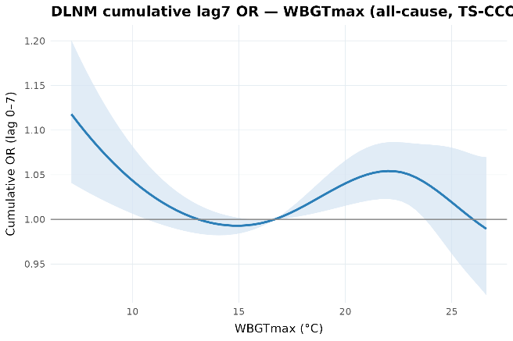 | 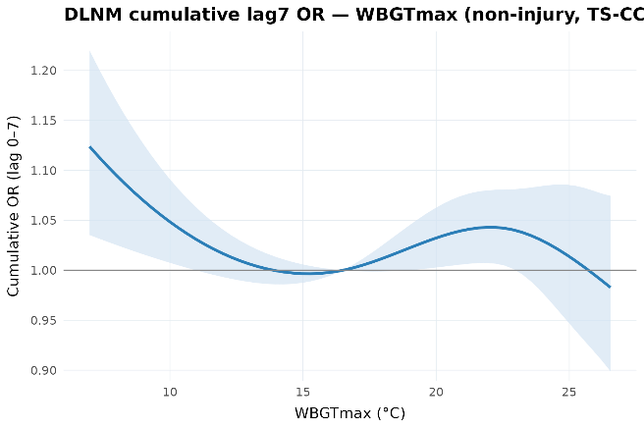
- All-cause + Warm-season | - Non-injury + Warm-season
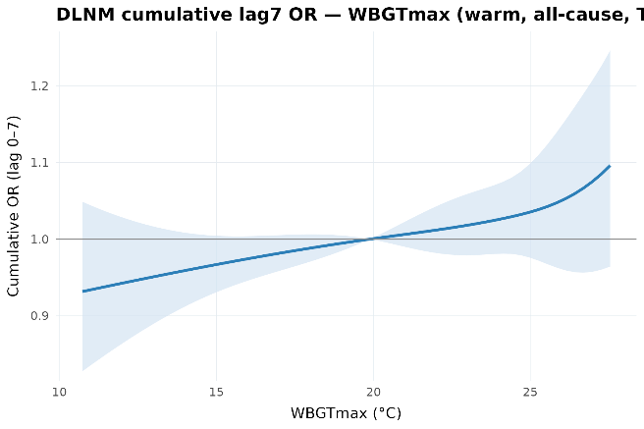 | 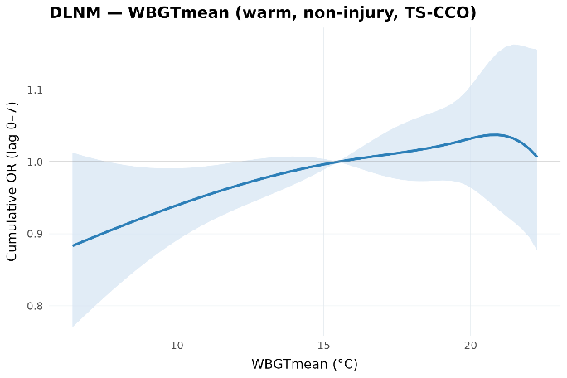
Figure G1. 0-7 cumulative mortality association with daily WBGT-T_{max}, estimated using distributed-lag non-linear models.

- All-cause + Full-year | - Non-injury + Full-year
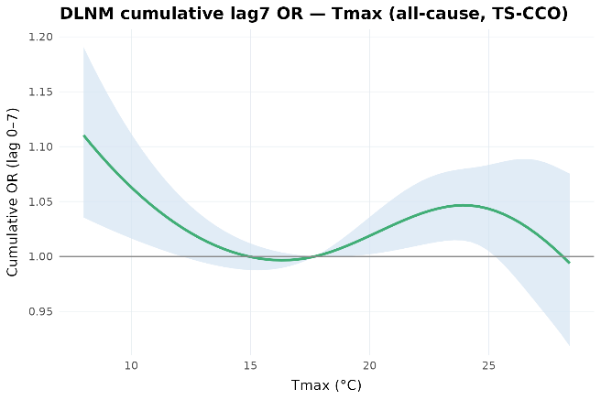 | 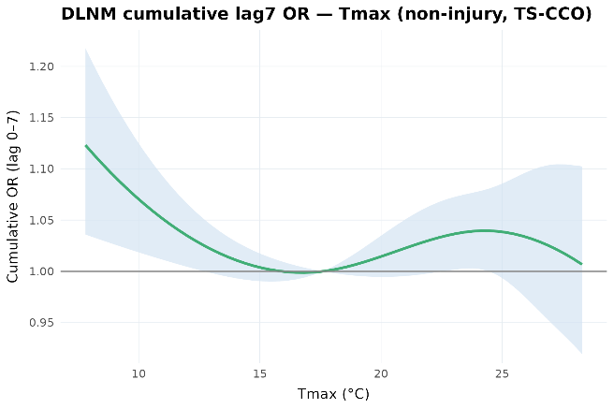
- All-cause + Warm-season | - Non-injury + Warm-season
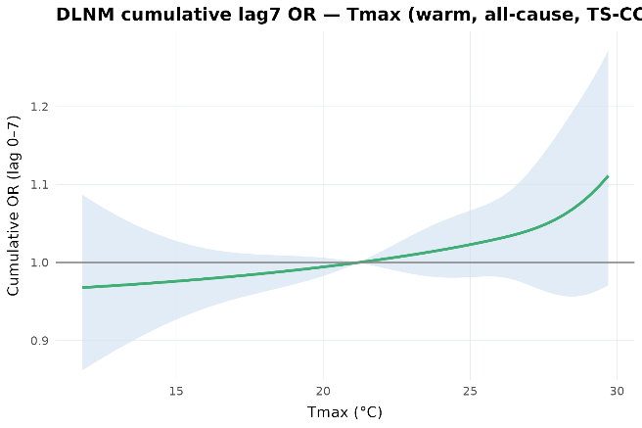 | 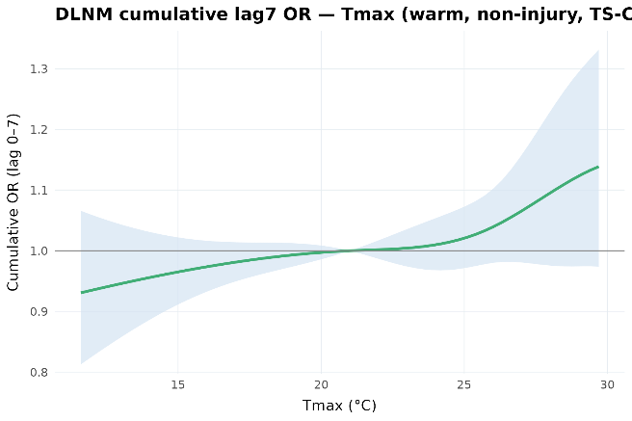
Figure G2. 0-7 cumulative mortality association with daily T_{max}, estimated using distributed-lag non-linear models.

- All-cause + Full-year | - Non-injury + Full-year
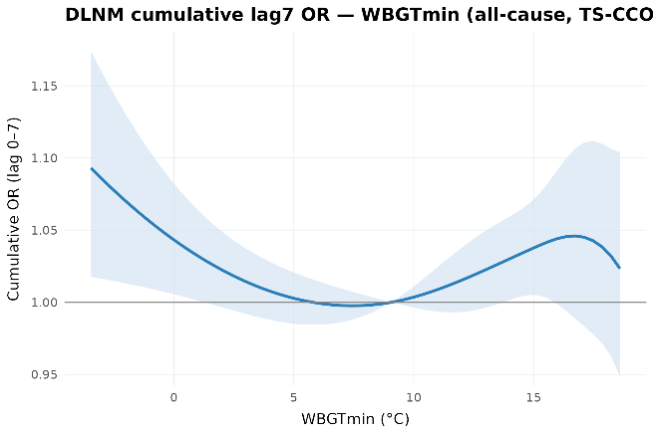 | 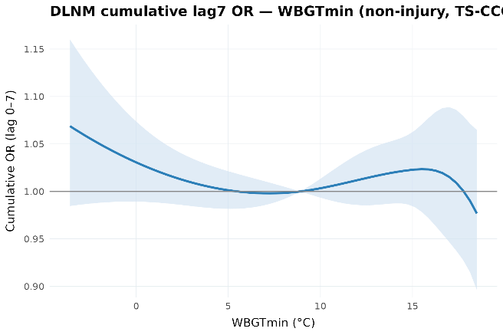
- All-cause + Warm-season | - Non-injury + Warm-season
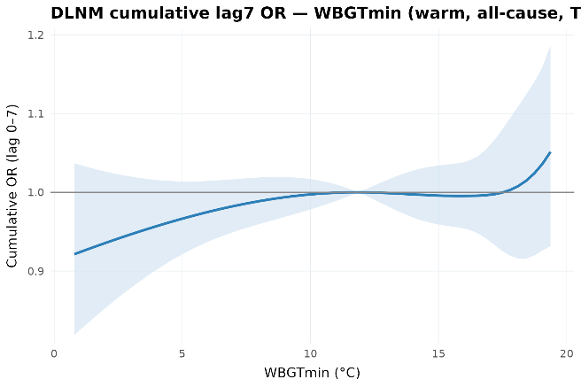 | 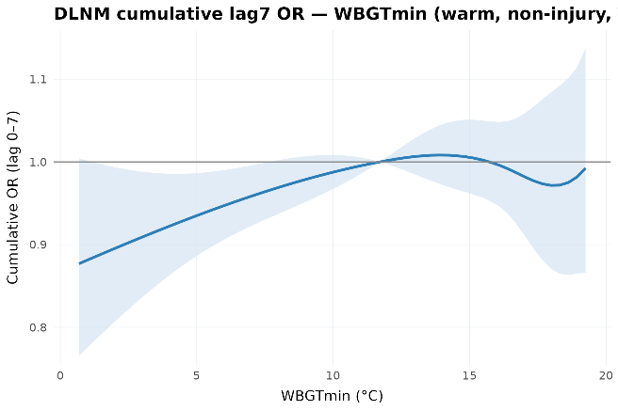
Figure G3. 0-7 cumulative mortality association with daily WBGT-T_{min}, estimated using distributed-lag non-linear models.

- All-cause + Full-year | - Non-injury + Full-year
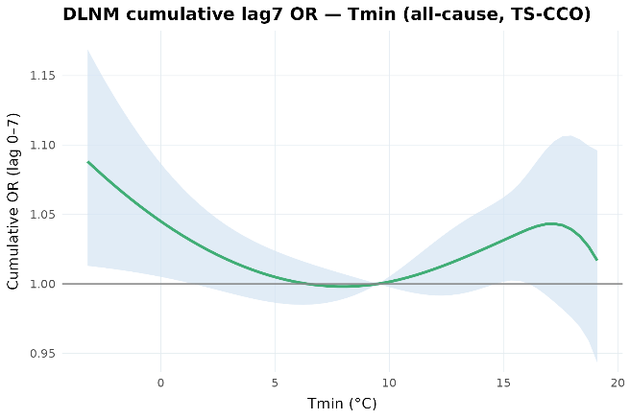 | 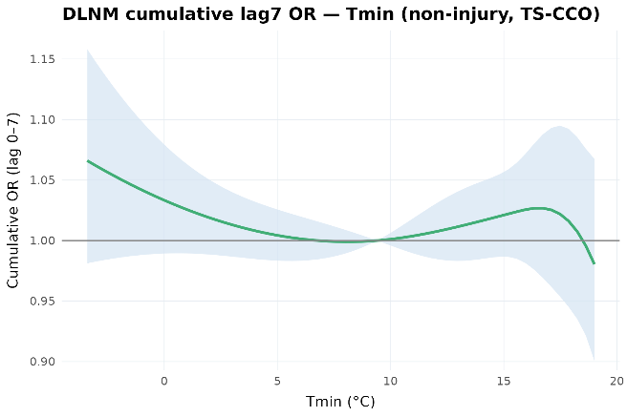
- All-cause + Warm-season | - Non-injury + Warm-season
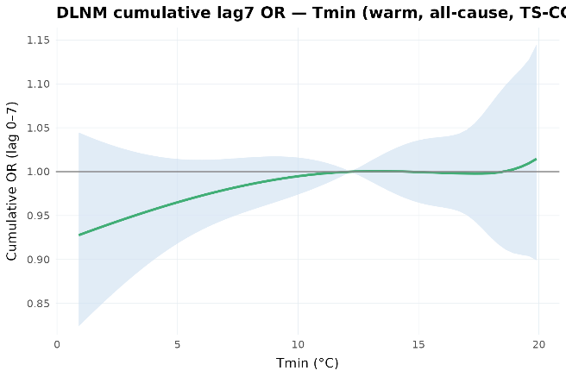 | 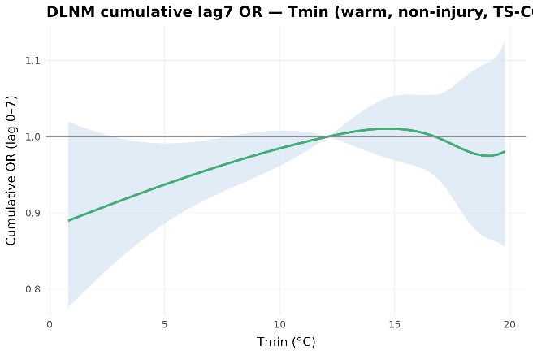
Figure G4. 0-7 cumulative mortality association with daily T_{min}, estimated using distributed-lag non-linear models.

Appendix H. Heterogeneity analyses

H.1 TA-level estimates
Table H1. Same-day mortality odds ratios per 1 °C increase in T_{mean}, by TA climate tertile.
Notes: ORs = odds ratios; lcl/ucl = lower/upper bounds of the 95% confidence interval; Cases is the number of deaths; Odds change (%) is calculated as (ORs-1) × 100. Group classifies TAs into cool, moderate, and hot climate tertiles based on each TA’s mean warm-season T_{mean.}
Exposure metric | ORs | lcl | ucl | Cases | Group | Odds change (%)
WBGT-T_{mean} | 1.0015 | 0.9996 | 1.0034 | 172,674 | cool | 0.1474
WBGT-T_{mean} | 1.0038 | 1.0016 | 1.0061 | 169,074 | moderate | 0.3835
WBGT-T_{mean} | 1.0062 | 1.0045 | 1.008 | 378,831 | hot | 0.6245
T_{mean} | 1.0015 | 0.9995 | 1.0036 | 172,701 | cool | 0.1512
T_{mean} | 1.0046 | 1.0023 | 1.0069 | 169,122 | moderate | 0.4607
T_{mean} | 1.0064 | 1.0047 | 1.0082 | 378,897 | hot | 0.6445
Using TAs as the unit of analysis, we estimated TA-specific same-day associations and applied empirical-Bayes shrinkage to stabilise estimates from smaller strata. The shrunken estimates are reported to summarise spatial heterogeneity while reducing the influence of imprecise TA-specific estimates (Table H2-H7).
Table H2. TA-Original and EB-shrunken WBGT-T_{mean} estimates.
Notes: ORs = odds ratios; lcl/ucl = lower/upper bounds of the 95% confidence interval; Cases is the number of deaths; Odds change (%) is calculated as (ORs-1) × 100. SE is the standard error of estimate.
Territorial Authority | ORs | lcl | ucl | Cases | Odds change (%) | ORs (Shrunk) | lcl (Shrunk) | ucl (Shrunk) | Odds change % (Shrunk) | SE
Ashburton District | 1 | 0.9899 | 1.0102 | 6,489 | 0 | 1.0034 | 0.9984 | 1.0085 | 0.34 | 0.0052
Auckland | 1.0069 | 1.0043 | 1.0094 | 200,097 | 0.69 | 1.0065 | 1.0042 | 1.0088 | 0.65 | 0.0013
Buller District | 1.0016 | 0.9761 | 1.0277 | 2,202 | 0.16 | 1.0044 | 0.9987 | 1.0101 | 0.44 | 0.0131
Carterton District | 1.0233 | 0.9886 | 1.0592 | 594 | 2.33 | 1.0051 | 0.9993 | 1.0108 | 0.51 | 0.0176
Central Hawke's Bay District | 1.005 | 0.9844 | 1.0261 | 1,785 | 0.5 | 1.0046 | 0.999 | 1.0102 | 0.46 | 0.0106
Central Otago District | 1.0074 | 0.9889 | 1.0262 | 3,123 | 0.74 | 1.0048 | 0.9992 | 1.0104 | 0.48 | 0.0095
Christchurch City | 1.0025 | 0.9994 | 1.0056 | 72,216 | 0.25 | 1.003 | 1.0002 | 1.0057 | 0.3 | 0.0016
Clutha District | 1.0064 | 0.9908 | 1.0223 | 3,252 | 0.64 | 1.0048 | 0.9993 | 1.0103 | 0.48 | 0.008
Dunedin City | 1.0014 | 0.996 | 1.0067 | 24,525 | 0.14 | 1.0028 | 0.9989 | 1.0068 | 0.28 | 0.0027
Far North District | 1.0118 | 1.0014 | 1.0223 | 12,894 | 1.18 | 1.0063 | 1.0012 | 1.0114 | 0.63 | 0.0053
Gisborne District | 0.9974 | 0.9882 | 1.0067 | 10,152 | -0.26 | 1.0025 | 0.9976 | 1.0075 | 0.25 | 0.0047
Gore District | 1.01 | 0.9941 | 1.0261 | 3,126 | 1 | 1.0052 | 0.9997 | 1.0107 | 0.52 | 0.0081
Grey District | 0.9992 | 0.9787 | 1.0202 | 2,982 | -0.08 | 1.0042 | 0.9986 | 1.0098 | 0.42 | 0.0106
Hamilton City | 1.0106 | 1.0042 | 1.0171 | 21,975 | 1.06 | 1.0073 | 1.003 | 1.0116 | 0.73 | 0.0033
Hastings District | 1.0068 | 0.9994 | 1.0142 | 15,180 | 0.68 | 1.0054 | 1.0008 | 1.01 | 0.54 | 0.0037
Hauraki District | 0.9907 | 0.9766 | 1.005 | 4,407 | -0.93 | 1.0026 | 0.9972 | 1.008 | 0.26 | 0.0073
Horowhenua District | 0.993 | 0.9832 | 1.0029 | 8,586 | -0.7 | 1.0016 | 0.9966 | 1.0066 | 0.16 | 0.0051
Hurunui District | 1.0108 | 0.9914 | 1.0305 | 1,545 | 1.08 | 1.0051 | 0.9995 | 1.0107 | 0.51 | 0.0099
Invercargill City | 1.0043 | 0.9963 | 1.0124 | 12,714 | 0.43 | 1.0045 | 0.9998 | 1.0092 | 0.45 | 0.0041
Kaikoura District | 0.9865 | 0.9515 | 1.0228 | 735 | -1.35 | 1.0041 | 0.9983 | 1.0099 | 0.41 | 0.0184
Kaipara District | 1.019 | 1.0003 | 1.0381 | 3,786 | 1.9 | 1.0058 | 1.0003 | 1.0114 | 0.58 | 0.0095
Kapiti Coast District | 1.0073 | 0.9991 | 1.0155 | 12,906 | 0.73 | 1.0055 | 1.0007 | 1.0102 | 0.55 | 0.0042
Lower Hutt City | 1.0082 | 0.9983 | 1.0181 | 10,692 | 0.82 | 1.0055 | 1.0005 | 1.0105 | 0.55 | 0.005
Mackenzie District | 1.0275 | 0.9914 | 1.065 | 528 | 2.75 | 1.0051 | 0.9994 | 1.0109 | 0.51 | 0.0183
Marlborough District | 1.0045 | 0.9956 | 1.0136 | 9,780 | 0.45 | 1.0045 | 0.9997 | 1.0094 | 0.45 | 0.0046
Masterton District | 1.0041 | 0.9914 | 1.0171 | 4,305 | 0.41 | 1.0045 | 0.9992 | 1.0098 | 0.45 | 0.0065
Napier City | 1.0042 | 0.9961 | 1.0123 | 13,572 | 0.42 | 1.0044 | 0.9997 | 1.0091 | 0.44 | 0.0041
Nelson City | 1.0051 | 0.9948 | 1.0155 | 10,725 | 0.51 | 1.0047 | 0.9996 | 1.0098 | 0.47 | 0.0053
New Plymouth District | 1.0051 | 0.9972 | 1.0131 | 16,833 | 0.51 | 1.0047 | 1.0001 | 1.0095 | 0.47 | 0.004
Ōtorohanga District | 1.019 | 0.9919 | 1.0468 | 1,173 | 1.9 | 1.0052 | 0.9995 | 1.0109 | 0.52 | 0.0137
Palmerston North City | 1.007 | 0.9996 | 1.0144 | 14,970 | 0.7 | 1.0055 | 1.0009 | 1.0101 | 0.55 | 0.0037
Porirua City | 1.0041 | 0.9853 | 1.0232 | 2,517 | 0.41 | 1.0045 | 0.9989 | 1.0101 | 0.45 | 0.0096
Queenstown-Lakes District | 1.0139 | 0.9957 | 1.0323 | 2,514 | 1.39 | 1.0054 | 0.9999 | 1.011 | 0.54 | 0.0092
Rotorua District | 1.0032 | 0.9951 | 1.0113 | 13,431 | 0.32 | 1.0041 | 0.9994 | 1.0088 | 0.41 | 0.0041
Ruapehu District | 0.9878 | 0.9687 | 1.0072 | 2,208 | -1.22 | 1.0032 | 0.9976 | 1.0088 | 0.32 | 0.0099
Selwyn District | 0.9932 | 0.9795 | 1.0072 | 3,801 | -0.68 | 1.0029 | 0.9975 | 1.0083 | 0.29 | 0.0071
South Taranaki District | 0.9992 | 0.9861 | 1.0125 | 5,349 | -0.08 | 1.0037 | 0.9984 | 1.009 | 0.37 | 0.0067
South Wairarapa District | 1.0094 | 0.9886 | 1.0308 | 1,701 | 0.94 | 1.0049 | 0.9993 | 1.0105 | 0.49 | 0.0107
Southland District | 0.988 | 0.9748 | 1.0013 | 3,924 | -1.2 | 1.0019 | 0.9966 | 1.0073 | 0.19 | 0.0069
Stratford District | 1.0025 | 0.98 | 1.0256 | 1,995 | 0.25 | 1.0044 | 0.9988 | 1.0101 | 0.44 | 0.0116
Tararua District | 1.0022 | 0.9851 | 1.0196 | 2,574 | 0.22 | 1.0043 | 0.9988 | 1.0099 | 0.43 | 0.0088
Tasman District | 1.0067 | 0.9956 | 1.0179 | 7,689 | 0.67 | 1.005 | 0.9999 | 1.0102 | 0.5 | 0.0056
Taupo District | 1.0014 | 0.9905 | 1.0124 | 6,378 | 0.14 | 1.0039 | 0.9987 | 1.009 | 0.39 | 0.0056
Tauranga City | 1.0116 | 1.005 | 1.0183 | 25,977 | 1.16 | 1.0076 | 1.0033 | 1.012 | 0.76 | 0.0034
Thames-Coromandel District | 1.0158 | 1.0039 | 1.0278 | 7,959 | 1.58 | 1.0067 | 1.0015 | 1.012 | 0.67 | 0.006
Timaru District | 0.9938 | 0.986 | 1.0017 | 11,736 | -0.62 | 1.0008 | 0.9961 | 1.0055 | 0.08 | 0.004
Upper Hutt City | 1.0127 | 1.0029 | 1.0225 | 8,025 | 1.27 | 1.0067 | 1.0017 | 1.0117 | 0.67 | 0.0049
Waikato District | 0.9942 | 0.9828 | 1.0057 | 8,505 | -0.58 | 1.0024 | 0.9973 | 1.0076 | 0.24 | 0.0059
Waimakariri District | 1.0008 | 0.9912 | 1.0105 | 8,226 | 0.08 | 1.0035 | 0.9986 | 1.0085 | 0.35 | 0.0049
Waimate District | 0.9962 | 0.9708 | 1.0223 | 1,188 | -0.38 | 1.0041 | 0.9985 | 1.0098 | 0.41 | 0.0132
Waipa District | 1.0044 | 0.9951 | 1.0137 | 9,588 | 0.44 | 1.0045 | 0.9996 | 1.0094 | 0.45 | 0.0047
Wairoa District | 0.989 | 0.9647 | 1.014 | 1,875 | -1.1 | 1.0037 | 0.9981 | 1.0094 | 0.37 | 0.0127
Waitaki District | 1.0055 | 0.9942 | 1.017 | 5,442 | 0.55 | 1.0047 | 0.9996 | 1.01 | 0.47 | 0.0058
Waitomo District | 0.9881 | 0.9627 | 1.0142 | 1,890 | -1.19 | 1.0038 | 0.9981 | 1.0095 | 0.38 | 0.0133
Wellington City | 1.0027 | 0.9963 | 1.0091 | 24,585 | 0.27 | 1.0037 | 0.9994 | 1.008 | 0.37 | 0.0033
Western Bay of Plenty District | 1.0174 | 0.9997 | 1.0355 | 2,889 | 1.74 | 1.0058 | 1.0003 | 1.0114 | 0.58 | 0.009
Westland District | 0.9654 | 0.9378 | 0.9938 | 1,416 | -3.46 | 1.003 | 0.9973 | 1.0087 | 0.3 | 0.0148
Whakatane District | 1.008 | 0.996 | 1.0202 | 6,936 | 0.8 | 1.0052 | 1 | 1.0105 | 0.52 | 0.0061
Whanganui District | 1.0035 | 0.9945 | 1.0125 | 12,093 | 0.35 | 1.0042 | 0.9993 | 1.0091 | 0.42 | 0.0046
Whangarei District | 1.0083 | 0.9999 | 1.0168 | 18,153 | 0.83 | 1.0058 | 1.001 | 1.0106 | 0.58 | 0.0043

Table H3. TA-Original and EB-shrunken WBGT-T_{max} estimates.
Territorial Authority | ORs | lcl | ucl | Cases | Odds change (%) | ORs (Shrunk) | lcl (Shrunk) | ucl (Shrunk) | Odds change % (Shrunk) | SE
Ashburton | 1.0014 | 0.9937 | 1.0092 | 6489 | 0.14 | 1.003 | 0.9985 | 1.0075 | 0.3 | 0.0023
Auckland | 1.0075 | 1.0048 | 1.0102 | 200097 | 0.75 | 1.0068 | 1.0044 | 1.0092 | 0.68 | 0.0012
Buller | 1.0017 | 0.9734 | 1.0308 | 2202 | 0.17 | 1.0037 | 0.9983 | 1.0091 | 0.37 | 0.0028
Carterton | 1.0129 | 0.9818 | 1.0448 | 597 | 1.29 | 1.0041 | 0.9986 | 1.0095 | 0.41 | 0.0028
Central Hawke's Bay | 1.0017 | 0.9849 | 1.0188 | 1785 | 0.17 | 1.0036 | 0.9983 | 1.0088 | 0.36 | 0.0027
Central Otago | 1.0011 | 0.9854 | 1.0171 | 3123 | 0.11 | 1.0035 | 0.9983 | 1.0087 | 0.35 | 0.0027
Christchurch | 0.9999 | 0.9974 | 1.0024 | 72219 | -0.01 | 1.0006 | 0.9983 | 1.0028 | 0.06 | 0.0012
Clutha | 1.0047 | 0.9928 | 1.0169 | 3255 | 0.47 | 1.0039 | 0.9989 | 1.009 | 0.39 | 0.0026
Dunedin | 1.0019 | 0.9977 | 1.0061 | 24528 | 0.19 | 1.0026 | 0.9993 | 1.0059 | 0.26 | 0.0017
Far North | 1.0059 | 0.995 | 1.0169 | 12894 | 0.59 | 1.0042 | 0.9993 | 1.0091 | 0.42 | 0.0025
Gisborne | 1.0058 | 0.9975 | 1.0141 | 10152 | 0.58 | 1.0044 | 0.9998 | 1.009 | 0.44 | 0.0023
Gore | 1.0063 | 0.9936 | 1.0193 | 3126 | 0.63 | 1.0042 | 0.9991 | 1.0093 | 0.42 | 0.0026
Grey | 1.0003 | 0.9784 | 1.0227 | 2982 | 0.03 | 1.0036 | 0.9982 | 1.0089 | 0.36 | 0.0027
Hamilton | 1.0099 | 1.0026 | 1.0173 | 21975 | 0.99 | 1.006 | 1.0016 | 1.0104 | 0.6 | 0.0022
Hastings | 1.0077 | 1.0008 | 1.0146 | 15183 | 0.77 | 1.0053 | 1.001 | 1.0096 | 0.53 | 0.0022
Hauraki | 0.9943 | 0.9776 | 1.0113 | 4407 | -0.57 | 1.0029 | 0.9976 | 1.0081 | 0.29 | 0.0027
Horowhenua | 0.9969 | 0.9855 | 1.0084 | 8586 | -0.31 | 1.0025 | 0.9975 | 1.0075 | 0.25 | 0.0025
Hurunui | 1.0067 | 0.9924 | 1.0212 | 1545 | 0.67 | 1.0042 | 0.999 | 1.0093 | 0.42 | 0.0026
Invercargill | 1.0026 | 0.9956 | 1.0095 | 12714 | 0.26 | 1.0033 | 0.999 | 1.0076 | 0.33 | 0.0022
Kaikoura | 0.9959 | 0.97 | 1.0225 | 735 | -0.41 | 1.0034 | 0.9981 | 1.0089 | 0.34 | 0.0027
Kaipara | 1.0192 | 1.0016 | 1.0371 | 3789 | 1.92 | 1.0052 | 0.9999 | 1.0105 | 0.52 | 0.0027
Kapiti Coast | 1.0071 | 0.9973 | 1.0171 | 12906 | 0.71 | 1.0046 | 0.9998 | 1.0094 | 0.46 | 0.0024
Lower Hutt | 1.0082 | 0.9991 | 1.0174 | 10692 | 0.82 | 1.005 | 1.0002 | 1.0097 | 0.5 | 0.0024
Mackenzie | 1.0094 | 0.9792 | 1.0405 | 528 | 0.94 | 1.004 | 0.9985 | 1.0094 | 0.4 | 0.0028
Marlborough | 1.007 | 0.9987 | 1.0153 | 9783 | 0.7 | 1.0048 | 1.0002 | 1.0094 | 0.48 | 0.0023
Masterton | 0.991 | 0.9797 | 1.0024 | 4305 | -0.9 | 1.0014 | 0.9964 | 1.0063 | 0.14 | 0.0025
Napier | 1.0073 | 1 | 1.0146 | 13572 | 0.73 | 1.0051 | 1.0007 | 1.0095 | 0.51 | 0.0022
Nelson | 1.0029 | 0.9918 | 1.0141 | 10725 | 0.29 | 1.0036 | 0.9987 | 1.0086 | 0.36 | 0.0025
New Plymouth | 1.0066 | 0.9967 | 1.0166 | 16833 | 0.66 | 1.0044 | 0.9996 | 1.0093 | 0.44 | 0.0025
Ōtorohanga | 1.0364 | 1.006 | 1.0677 | 1173 | 3.64 | 1.0048 | 0.9994 | 1.0103 | 0.48 | 0.0028
Palmerston North | 1.0113 | 1.0036 | 1.019 | 14970 | 1.13 | 1.0064 | 1.0019 | 1.0109 | 0.64 | 0.0023
Porirua | 1.0202 | 0.9985 | 1.0423 | 2520 | 2.02 | 1.0048 | 0.9994 | 1.0101 | 0.48 | 0.0027
Queenstown-Lakes | 1.0123 | 0.9969 | 1.028 | 2514 | 1.23 | 1.0047 | 0.9995 | 1.01 | 0.47 | 0.0026
Rotorua | 1.0049 | 0.9957 | 1.0143 | 13434 | 0.49 | 1.0041 | 0.9993 | 1.0088 | 0.41 | 0.0024
Ruapehu | 0.9918 | 0.9754 | 1.0086 | 2208 | -0.82 | 1.0026 | 0.9974 | 1.0079 | 0.26 | 0.0027
Selwyn | 1.0038 | 0.9929 | 1.0148 | 3801 | 0.38 | 1.0038 | 0.9989 | 1.0087 | 0.38 | 0.0025
South Taranaki | 1.0021 | 0.9878 | 1.0167 | 5349 | 0.21 | 1.0036 | 0.9984 | 1.0087 | 0.36 | 0.0026
South Wairarapa | 0.9987 | 0.9789 | 1.019 | 1701 | -0.13 | 1.0034 | 0.9981 | 1.0088 | 0.34 | 0.0027
Southland | 0.9939 | 0.9821 | 1.0058 | 3927 | -0.61 | 1.002 | 0.997 | 1.007 | 0.2 | 0.0025
Stratford | 1.0061 | 0.9837 | 1.029 | 1995 | 0.61 | 1.0039 | 0.9986 | 1.0093 | 0.39 | 0.0027
Tararua | 1.0043 | 0.9882 | 1.0206 | 2574 | 0.43 | 1.0038 | 0.9986 | 1.0091 | 0.38 | 0.0027
Tasman | 1.0049 | 0.9944 | 1.0156 | 7689 | 0.49 | 1.004 | 0.9991 | 1.0089 | 0.4 | 0.0025
Taupo | 1.008 | 0.9965 | 1.0197 | 6378 | 0.8 | 1.0046 | 0.9996 | 1.0096 | 0.46 | 0.0025
Tauranga | 1.012 | 1.0044 | 1.0196 | 25977 | 1.2 | 1.0066 | 1.0022 | 1.0111 | 0.66 | 0.0023
Thames-Coromandel | 1.0148 | 1.0014 | 1.0284 | 7962 | 1.48 | 1.0054 | 1.0003 | 1.0105 | 0.54 | 0.0026
Timaru | 0.9979 | 0.986 | 1.004 | 11736 | -0.21 | 1.0008 | 0.9971 | 1.0052 | 0.11 | 0.0021
Upper Hutt | 1.0076 | 1.0029 | 1.0177 | 8025 | 0.76 | 1.0067 | 0.9998 | 1.0095 | 0.47 | 0.0025
Waikato | 0.9978 | 0.9828 | 1.0086 | 8505 | -0.22 | 1.0024 | 0.9976 | 1.0075 | 0.25 | 0.0025
Waimakariri | 0.9987 | 0.9912 | 1.0062 | 8229 | -0.13 | 1.0035 | 0.9976 | 1.0064 | 0.2 | 0.0023
Waimate | 0.9906 | 0.9708 | 1.0107 | 1188 | -0.94 | 1.0041 | 0.9975 | 1.0082 | 0.29 | 0.0027
Waipa | 1.0078 | 0.9951 | 1.0192 | 9591 | 0.78 | 1.0045 | 0.9996 | 1.0095 | 0.46 | 0.0025
Wairoa | 0.9881 | 0.9647 | 1.0093 | 1875 | -1.19 | 1.0037 | 0.9975 | 1.0081 | 0.28 | 0.0027
Waitaki | 1.001 | 0.9942 | 1.0103 | 5442 | 0.1 | 1.0047 | 0.9983 | 1.0078 | 0.31 | 0.0024
Waitomo | 0.9754 | 0.9627 | 1.0035 | 1893 | -2.46 | 1.0038 | 0.9973 | 1.0082 | 0.27 | 0.0028
Wellington | 1.0015 | 0.9963 | 1.0074 | 24585 | 0.15 | 1.0037 | 0.9987 | 1.0067 | 0.27 | 0.002
Western Bay of Plenty | 1.006 | 0.9997 | 1.0247 | 2889 | 0.6 | 1.0058 | 0.9987 | 1.0093 | 0.4 | 0.0027
Westland | 0.9721 | 0.9378 | 1.0047 | 1419 | -2.79 | 1.003 | 0.9975 | 1.0084 | 0.29 | 0.0028
Whakatane | 1.0087 | 0.996 | 1.0237 | 6939 | 0.87 | 1.0052 | 0.9992 | 1.0096 | 0.44 | 0.0026
Whanganui | 0.9998 | 0.9945 | 1.0086 | 12093 | -0.02 | 1.0042 | 0.998 | 1.0073 | 0.27 | 0.0024
Whangarei | 1.0063 | 0.9999 | 1.0148 | 18153 | 0.63 | 1.0058 | 0.9999 | 1.0092 | 0.45 | 0.0023

Table H4. TA-Original and EB-shrunken WBGT-T_{min} estimates.
Territorial Authority | ORs | lcl | ucl | Cases | Odds change (%) | ORs (Shrunk) | lcl (Shrunk) | ucl (Shrunk) | Odds change % (Shrunk) | SE
Ashburton | 0.9985 | 0.9894 | 1.0076 | 6489 | -0.15 | 1.0017 | 0.9971 | 1.0063 | 0.17 | 0.0024
Auckland | 1.0041 | 1.002 | 1.0061 | 200097 | 0.41 | 1.0039 | 1.002 | 1.0058 | 0.39 | 0.001
Buller | 1.0005 | 0.9815 | 1.0199 | 2202 | 0.05 | 1.0026 | 0.9975 | 1.0078 | 0.26 | 0.0026
Carterton | 1.0153 | 0.9902 | 1.041 | 597 | 1.53 | 1.0033 | 0.9981 | 1.0086 | 0.33 | 0.0027
Central Hawke's Bay | 1.0054 | 0.9893 | 1.0217 | 1785 | 0.54 | 1.003 | 0.998 | 1.0081 | 0.3 | 0.0026
Central Otago | 1.0011 | 0.9892 | 1.0132 | 3123 | 0.11 | 1.0025 | 0.9976 | 1.0074 | 0.25 | 0.0025
Christchurch | 1.0032 | 1.0008 | 1.0057 | 72219 | 0.32 | 1.0032 | 1.0009 | 1.0054 | 0.32 | 0.0011
Clutha | 1.0041 | 0.9904 | 1.0179 | 3255 | 0.41 | 1.003 | 0.998 | 1.008 | 0.3 | 0.0025
Dunedin | 0.9997 | 0.9953 | 1.0041 | 24528 | -0.03 | 1.0009 | 0.9975 | 1.0043 | 0.09 | 0.0017
Far North | 1.0101 | 1.0022 | 1.0181 | 12894 | 1.01 | 1.0051 | 1.0007 | 1.0095 | 0.51 | 0.0023
Gisborne | 0.9936 | 0.9864 | 1.0008 | 10152 | -0.64 | 0.9995 | 0.9953 | 1.0039 | -0.05 | 0.0022
Gore | 1.0091 | 0.9939 | 1.0246 | 3126 | 0.91 | 1.0035 | 0.9985 | 1.0086 | 0.35 | 0.0026
Grey | 0.9992 | 0.983 | 1.0157 | 2982 | -0.08 | 1.0024 | 0.9974 | 1.0075 | 0.24 | 0.0026
Hamilton | 1.0063 | 1.0019 | 1.0106 | 21975 | 0.63 | 1.0049 | 1.0015 | 1.0083 | 0.49 | 0.0017
Hastings | 1.0024 | 0.9973 | 1.0075 | 15183 | 0.24 | 1.0026 | 0.9989 | 1.0063 | 0.26 | 0.0019
Hauraki | 0.9937 | 0.9845 | 1.003 | 4407 | -0.63 | 1.0005 | 0.9959 | 1.0052 | 0.05 | 0.0024
Horowhenua | 0.9943 | 0.9874 | 1.0012 | 8586 | -0.57 | 0.9996 | 0.9954 | 1.0038 | -0.04 | 0.0022
Hurunui | 1.0104 | 0.9937 | 1.0273 | 1545 | 1.04 | 1.0035 | 0.9984 | 1.0086 | 0.35 | 0.0026
Invercargill | 1.0038 | 0.9971 | 1.0106 | 12714 | 0.38 | 1.0032 | 0.999 | 1.0074 | 0.32 | 0.0021
Kaikoura | 0.9733 | 0.9353 | 1.0129 | 735 | -2.67 | 1.0023 | 0.997 | 1.0076 | 0.23 | 0.0027
Kaipara | 1.0099 | 0.9949 | 1.0251 | 3789 | 0.99 | 1.0036 | 0.9986 | 1.0086 | 0.36 | 0.0026
Kapiti Coast | 1.0041 | 0.9987 | 1.0096 | 12906 | 0.41 | 1.0035 | 0.9996 | 1.0073 | 0.35 | 0.0019
Lower Hutt | 1.0043 | 0.9954 | 1.0133 | 10692 | 0.43 | 1.0032 | 0.9986 | 1.0078 | 0.32 | 0.0023
Mackenzie | 1.0378 | 1.0042 | 1.0725 | 528 | 3.78 | 1.0037 | 0.9984 | 1.009 | 0.37 | 0.0027
Marlborough | 1.0007 | 0.9936 | 1.0079 | 9783 | 0.07 | 1.0021 | 0.9978 | 1.0063 | 0.21 | 0.0022
Masterton | 1.0103 | 1.0011 | 1.0197 | 4305 | 1.03 | 1.0047 | 1.0001 | 1.0093 | 0.47 | 0.0024
Napier | 1.0012 | 0.9949 | 1.0074 | 13572 | 0.12 | 1.0021 | 0.998 | 1.0062 | 0.21 | 0.0021
Nelson | 1.0035 | 0.9957 | 1.0114 | 10725 | 0.35 | 1.003 | 0.9986 | 1.0074 | 0.3 | 0.0022
New Plymouth | 1.0027 | 0.9972 | 1.0081 | 16833 | 0.27 | 1.0027 | 0.9989 | 1.0066 | 0.27 | 0.0019
Ōtorohanga | 1.0037 | 0.9859 | 1.0217 | 1173 | 0.37 | 1.0029 | 0.9977 | 1.008 | 0.29 | 0.0026
Palmerston North | 1.0019 | 0.9964 | 1.0073 | 14970 | 0.19 | 1.0023 | 0.9985 | 1.0062 | 0.23 | 0.0019
Porirua | 0.997 | 0.9842 | 1.01 | 2520 | -0.3 | 1.002 | 0.997 | 1.0069 | 0.2 | 0.0025
Queenstown-Lakes | 1.0113 | 0.9956 | 1.0272 | 2514 | 1.13 | 1.0037 | 0.9986 | 1.0088 | 0.37 | 0.0026
Rotorua | 1.0012 | 0.9957 | 1.0068 | 13434 | 0.12 | 1.002 | 0.9982 | 1.0059 | 0.2 | 0.002
Ruapehu | 0.9922 | 0.9772 | 1.0075 | 2208 | -0.78 | 1.0016 | 0.9966 | 1.0067 | 0.16 | 0.0026
Selwyn | 0.9891 | 0.9776 | 1.0007 | 3801 | -1.09 | 1.0004 | 0.9956 | 1.0053 | 0.04 | 0.0025
South Taranaki | 0.9978 | 0.9879 | 1.0078 | 5349 | -0.22 | 1.0017 | 0.997 | 1.0064 | 0.17 | 0.0024
South Wairarapa | 1.0116 | 0.9968 | 1.0266 | 1701 | 1.16 | 1.0038 | 0.9988 | 1.0089 | 0.38 | 0.0026
Southland | 0.9882 | 0.9776 | 0.9989 | 3927 | -1.18 | 0.9999 | 0.9951 | 1.0047 | -0.01 | 0.0024
Stratford | 0.9989 | 0.9816 | 1.0166 | 1995 | -0.11 | 1.0025 | 0.9974 | 1.0076 | 0.25 | 0.0026
Tararua | 0.9994 | 0.9861 | 1.0129 | 2574 | -0.06 | 1.0023 | 0.9974 | 1.0073 | 0.23 | 0.0025
Tasman | 1.0047 | 0.9963 | 1.0131 | 7689 | 0.47 | 1.0033 | 0.9988 | 1.0079 | 0.33 | 0.0023
Taupo | 0.9982 | 0.9911 | 1.0053 | 6378 | -0.18 | 1.0011 | 0.9969 | 1.0054 | 0.11 | 0.0022
Tauranga | 1.0069 | 1.0021 | 1.0117 | 25977 | 0.69 | 1.0051 | 1.0015 | 1.0086 | 0.51 | 0.0018
Thames-Coromandel | 1.0086 | 1.0009 | 1.0163 | 7962 | 0.86 | 1.0047 | 1.0003 | 1.0091 | 0.47 | 0.0022
Timaru | 0.9942 | 0.9877 | 1.0007 | 11736 | -0.58 | 0.9994 | 0.9952 | 1.0035 | -0.06 | 0.0021
Upper Hutt | 1.0085 | 1.002 | 1.0151 | 8025 | 0.85 | 1.0051 | 1.001 | 1.0093 | 0.51 | 0.0021
Waikato | 0.9946 | 0.9862 | 1.0029 | 8505 | -0.54 | 1.0004 | 0.9959 | 1.0049 | 0.04 | 0.0023
Waimakariri | 1.002 | 0.9941 | 1.0099 | 8229 | 0.2 | 1.0025 | 0.9981 | 1.007 | 0.25 | 0.0023
Waimate | 1.0047 | 0.9805 | 1.0294 | 1188 | 0.47 | 1.0029 | 0.9977 | 1.0081 | 0.29 | 0.0027
Waipa | 1.0015 | 0.9953 | 1.0077 | 9591 | 0.15 | 1.0022 | 0.9982 | 1.0063 | 0.22 | 0.0021
Wairoa | 0.9944 | 0.97 | 1.0194 | 1875 | -0.56 | 1.0024 | 0.9972 | 1.0077 | 0.24 | 0.0027
Waitaki | 1.0078 | 0.998 | 1.0176 | 5442 | 0.78 | 1.0039 | 0.9993 | 1.0087 | 0.39 | 0.0024
Waitomo | 0.9988 | 0.9784 | 1.0197 | 1893 | -0.12 | 1.0025 | 0.9974 | 1.0077 | 0.25 | 0.0026
Wellington | 1.0032 | 0.9974 | 1.0091 | 24585 | 0.32 | 1.003 | 0.999 | 1.0069 | 0.3 | 0.002
Western Bay of Plenty | 1.0149 | 1.0021 | 1.0279 | 2889 | 1.49 | 1.0046 | 0.9997 | 1.0096 | 0.46 | 0.0025
Westland | 0.9743 | 0.9539 | 0.9951 | 1419 | -2.57 | 1.0011 | 0.9959 | 1.0063 | 0.11 | 0.0026
Whakatane | 1.0045 | 0.9965 | 1.0125 | 6939 | 0.45 | 1.0033 | 0.9989 | 1.0078 | 0.33 | 0.0023
Whanganui | 1.0047 | 0.9973 | 1.0122 | 12093 | 0.47 | 1.0035 | 0.9991 | 1.0078 | 0.35 | 0.0022
Whangarei | 1.0068 | 1.0002 | 1.0135 | 18153 | 0.68 | 1.0044 | 1.0002 | 1.0085 | 0.44 | 0.0021

Table H5. TA-Original and EB-shrunken T_{mean} estimates.
Territorial Authority | ORs | lcl | ucl | Cases | Odds change (%) | ORs (Shrunk) | lcl (Shrunk) | ucl (Shrunk) | Odds change % (Shrunk) | SE
Ashburton | 1.0002 | 0.9914 | 1.0092 | 6489 | 0.02 | 1.003 | 0.9983 | 1.0077 | 0.3 | 0.0024
Auckland | 1.0065 | 1.0038 | 1.0091 | 200073 | 0.65 | 1.006 | 1.0036 | 1.0084 | 0.6 | 0.0012
Buller | 0.9944 | 0.9676 | 1.0219 | 2199 | -0.56 | 1.0036 | 0.9982 | 1.0091 | 0.36 | 0.0028
Carterton | 1.0179 | 0.9859 | 1.0508 | 597 | 1.79 | 1.0044 | 0.999 | 1.0099 | 0.44 | 0.0028
Central Hawke's Bay | 1.0063 | 0.987 | 1.0259 | 1785 | 0.63 | 1.0042 | 0.9989 | 1.0096 | 0.42 | 0.0027
Central Otago | 1.0108 | 0.9917 | 1.0304 | 3120 | 1.08 | 1.0046 | 0.9992 | 1.0099 | 0.46 | 0.0027
Christchurch | 1.0019 | 0.9991 | 1.0047 | 72201 | 0.19 | 1.0023 | 0.9998 | 1.0049 | 0.23 | 0.0013
Clutha | 1.0045 | 0.9893 | 1.02 | 3252 | 0.45 | 1.0041 | 0.9989 | 1.0093 | 0.41 | 0.0027
Dunedin | 1.0013 | 0.9964 | 1.0062 | 24525 | 0.13 | 1.0025 | 0.9988 | 1.0062 | 0.25 | 0.0019
Far North | 1.0122 | 1.0008 | 1.0237 | 12891 | 1.22 | 1.0056 | 1.0006 | 1.0106 | 0.56 | 0.0025
Gisborne | 1.0008 | 0.9924 | 1.0093 | 10152 | 0.08 | 1.0031 | 0.9984 | 1.0077 | 0.31 | 0.0024
Gore | 1.0078 | 0.9929 | 1.0229 | 3126 | 0.78 | 1.0045 | 0.9993 | 1.0097 | 0.45 | 0.0027
Grey | 1.0024 | 0.9809 | 1.0244 | 2982 | 0.24 | 1.0039 | 0.9985 | 1.0093 | 0.39 | 0.0027
Hamilton | 1.0102 | 1.0038 | 1.0166 | 21954 | 1.02 | 1.0067 | 1.0025 | 1.0109 | 0.67 | 0.0021
Hastings | 1.0047 | 0.9979 | 1.0116 | 15174 | 0.47 | 1.0043 | 1 | 1.0086 | 0.43 | 0.0022
Hauraki | 0.991 | 0.9773 | 1.0049 | 4407 | -0.9 | 1.0022 | 0.9971 | 1.0074 | 0.22 | 0.0026
Horowhenua | 0.9929 | 0.9833 | 1.0027 | 8586 | -0.71 | 1.0013 | 0.9965 | 1.0062 | 0.13 | 0.0025
Hurunui | 1.0108 | 0.9938 | 1.0281 | 1545 | 1.08 | 1.0047 | 0.9994 | 1.01 | 0.47 | 0.0027
Invercargill | 1.0047 | 0.997 | 1.0125 | 12705 | 0.47 | 1.0043 | 0.9998 | 1.0088 | 0.43 | 0.0023
Kaikoura | 0.9832 | 0.9534 | 1.0139 | 735 | -1.68 | 1.0034 | 0.9979 | 1.0089 | 0.34 | 0.0028
Kaipara | 1.0173 | 0.9979 | 1.0372 | 3786 | 1.73 | 1.005 | 0.9997 | 1.0104 | 0.5 | 0.0027
Kapiti Coast | 1.0064 | 0.9983 | 1.0145 | 12906 | 0.64 | 1.0048 | 1.0002 | 1.0094 | 0.48 | 0.0023
Lower Hutt | 1.0065 | 0.9965 | 1.0167 | 10689 | 0.65 | 1.0046 | 0.9997 | 1.0095 | 0.46 | 0.0025
Mackenzie | 1.0307 | 0.9998 | 1.0627 | 528 | 3.07 | 1.0049 | 0.9994 | 1.0104 | 0.49 | 0.0028
Marlborough | 1.004 | 0.9959 | 1.0122 | 9783 | 0.4 | 1.004 | 0.9994 | 1.0086 | 0.4 | 0.0023
Masterton | 1.0039 | 0.9923 | 1.0156 | 4305 | 0.39 | 1.004 | 0.999 | 1.009 | 0.4 | 0.0026
Napier | 1.0059 | 0.9988 | 1.0131 | 13569 | 0.59 | 1.0048 | 1.0004 | 1.0092 | 0.48 | 0.0022
Nelson | 1.0021 | 0.9914 | 1.0129 | 10722 | 0.21 | 1.0036 | 0.9987 | 1.0086 | 0.36 | 0.0025
New Plymouth | 1.0043 | 0.996 | 1.0125 | 16830 | 0.43 | 1.0041 | 0.9995 | 1.0087 | 0.41 | 0.0023
Ōtorohanga | 1.0153 | 0.9888 | 1.0425 | 1170 | 1.53 | 1.0045 | 0.9991 | 1.01 | 0.45 | 0.0028
Palmerston North | 1.0055 | 0.9982 | 1.0129 | 14967 | 0.55 | 1.0046 | 1.0002 | 1.009 | 0.46 | 0.0023
Porirua | 1.0027 | 0.9839 | 1.0219 | 2514 | 0.27 | 1.0039 | 0.9986 | 1.0093 | 0.39 | 0.0027
Queenstown-Lakes | 1.0147 | 0.9985 | 1.0313 | 2514 | 1.47 | 1.0052 | 0.9999 | 1.0104 | 0.52 | 0.0027
Rotorua | 1.0028 | 0.9945 | 1.0112 | 13431 | 0.28 | 1.0037 | 0.999 | 1.0083 | 0.37 | 0.0024
Ruapehu | 0.9882 | 0.9693 | 1.0074 | 2205 | -1.18 | 1.0028 | 0.9975 | 1.0082 | 0.28 | 0.0027
Selwyn | 0.9967 | 0.9843 | 1.0093 | 3801 | -0.33 | 1.0028 | 0.9977 | 1.0079 | 0.28 | 0.0026
South Taranaki | 0.9975 | 0.9845 | 1.0107 | 5346 | -0.25 | 1.003 | 0.9979 | 1.0082 | 0.3 | 0.0026
South Wairarapa | 1.0086 | 0.9897 | 1.028 | 1701 | 0.86 | 1.0044 | 0.9991 | 1.0098 | 0.44 | 0.0027
Southland | 0.9867 | 0.9744 | 0.9992 | 3924 | -1.33 | 1.0012 | 0.9961 | 1.0063 | 0.12 | 0.0026
Stratford | 1.0003 | 0.9768 | 1.0243 | 1995 | 0.03 | 1.0038 | 0.9984 | 1.0093 | 0.38 | 0.0028
Tararua | 1.0015 | 0.9857 | 1.0177 | 2574 | 0.15 | 1.0038 | 0.9985 | 1.009 | 0.38 | 0.0027
Tasman | 1.0071 | 0.9955 | 1.0188 | 7686 | 0.71 | 1.0046 | 0.9996 | 1.0096 | 0.46 | 0.0026
Taupo | 1.0011 | 0.9901 | 1.0121 | 6372 | 0.11 | 1.0034 | 0.9985 | 1.0084 | 0.34 | 0.0025
Tauranga | 1.0109 | 1.0039 | 1.0179 | 25953 | 1.09 | 1.0067 | 1.0024 | 1.0111 | 0.67 | 0.0022
Thames-Coromandel | 1.0131 | 1.0016 | 1.0246 | 7959 | 1.31 | 1.0058 | 1.0008 | 1.0108 | 0.58 | 0.0025
Timaru | 0.9959 | 0.9884 | 1.0034 | 11733 | -0.41 | 1.0012 | 0.9967 | 1.0056 | 0.12 | 0.0023
Upper Hutt | 1.0131 | 1.0038 | 1.0224 | 8022 | 1.31 | 1.0064 | 1.0016 | 1.0112 | 0.64 | 0.0024
Waikato | 0.9926 | 0.9811 | 1.0042 | 8490 | -0.54 | 1.0019 | 0.9969 | 1.0069 | 0.19 | 0.0026
Waimakariri | 1.0004 | 0.9916 | 1.0093 | 8226 | 0.2 | 1.003 | 0.9983 | 1.0077 | 0.3 | 0.0024
Waimate | 0.9962 | 0.9697 | 1.0234 | 1188 | 0.47 | 1.0037 | 0.9983 | 1.0092 | 0.37 | 0.0028
Waipa | 1.0047 | 0.9953 | 1.0143 | 9579 | 0.15 | 1.0042 | 0.9994 | 1.009 | 0.42 | 0.0024
Wairoa | 0.9907 | 0.9662 | 1.0158 | 1875 | -0.56 | 1.0034 | 0.998 | 1.0088 | 0.34 | 0.0028
Waitaki | 1.0057 | 0.9956 | 1.0159 | 5439 | 0.78 | 1.0044 | 0.9995 | 1.0093 | 0.44 | 0.0025
Waitomo | 0.9893 | 0.9625 | 1.0167 | 1890 | -0.12 | 1.0034 | 0.998 | 1.0089 | 0.34 | 0.0028
Wellington | 1.0017 | 0.9949 | 1.0084 | 24570 | 0.32 | 1.0031 | 0.9988 | 1.0074 | 0.31 | 0.0022
Western Bay of Plenty | 1.0247 | 1.004 | 1.0458 | 2889 | 1.49 | 1.0054 | 1.0001 | 1.0108 | 0.54 | 0.0027
Westland | 0.9621 | 0.933 | 0.9922 | 1419 | -2.57 | 1.0027 | 0.9972 | 1.0082 | 0.27 | 0.0028
Whakatane | 1.0089 | 0.9964 | 1.0216 | 6936 | 0.45 | 1.0048 | 0.9997 | 1.0099 | 0.48 | 0.0026
Whanganui | 1.0042 | 0.9955 | 1.0131 | 12093 | 0.47 | 1.0041 | 0.9994 | 1.0088 | 0.41 | 0.0024
Whangarei | 1.0074 | 0.9989 | 1.0161 | 18141 | 0.68 | 1.005 | 1.0004 | 1.0097 | 0.5 | 0.0024

Table H6. TA-Original and EB-shrunken T_{max} estimates.
Territorial Authority | ORs | lcl | ucl | Cases | Odds change (%) | ORs (Shrunk) | lcl (Shrunk) | ucl (Shrunk) | Odds change % (Shrunk) | SE
Ashburton | 1.0013 | 0.9946 | 1.0081 | 6486 | 0.13 | 1.0025 | 0.9984 | 1.0066 | 0.25 | 0.0021
Auckland | 1.0073 | 1.0043 | 1.0102 | 200004 | 0.73 | 1.0063 | 1.0037 | 1.0088 | 0.63 | 0.0013
Buller | 0.9927 | 0.9629 | 1.0234 | 2202 | -0.73 | 1.0029 | 0.9977 | 1.008 | 0.29 | 0.0026
Carterton | 1.0103 | 0.981 | 1.0405 | 594 | 1.03 | 1.0034 | 0.9983 | 1.0086 | 0.34 | 0.0026
Central Hawke's Bay | 1.0028 | 0.9867 | 1.0191 | 1785 | 0.28 | 1.0031 | 0.9982 | 1.0081 | 0.31 | 0.0025
Central Otago | 1.0031 | 0.9865 | 1.0199 | 3123 | 0.31 | 1.0032 | 0.9982 | 1.0082 | 0.32 | 0.0025
Christchurch | 0.9997 | 0.9975 | 1.0019 | 72204 | -0.03 | 1.0002 | 0.9982 | 1.0023 | 0.02 | 0.001
Clutha | 1.0034 | 0.9917 | 1.0153 | 3252 | 0.34 | 1.0032 | 0.9984 | 1.008 | 0.32 | 0.0024
Dunedin | 1.0017 | 0.9979 | 1.0056 | 24522 | 0.17 | 1.0023 | 0.9991 | 1.0054 | 0.23 | 0.0016
Far North | 1.0041 | 0.9919 | 1.0165 | 12879 | 0.41 | 1.0033 | 0.9985 | 1.0082 | 0.33 | 0.0025
Gisborne | 1.008 | 1.0004 | 1.0156 | 10146 | 0.8 | 1.0047 | 1.0004 | 1.009 | 0.47 | 0.0022
Gore | 1.0047 | 0.9927 | 1.0168 | 3126 | 0.47 | 1.0034 | 0.9986 | 1.0082 | 0.34 | 0.0024
Grey | 1.0043 | 0.9806 | 1.0285 | 2979 | 0.43 | 1.0032 | 0.9981 | 1.0084 | 0.32 | 0.0026
Hamilton | 1.0097 | 1.0021 | 1.0172 | 21960 | 0.97 | 1.0053 | 1.001 | 1.0096 | 0.53 | 0.0022
Hastings | 1.0057 | 0.9993 | 1.012 | 15171 | 0.57 | 1.0042 | 1.0002 | 1.0082 | 0.42 | 0.002
Hauraki | 0.9943 | 0.977 | 1.0118 | 4401 | -0.57 | 1.0024 | 0.9974 | 1.0075 | 0.24 | 0.0026
Horowhenua | 0.9971 | 0.9854 | 1.009 | 8577 | -0.29 | 1.0022 | 0.9974 | 1.007 | 0.22 | 0.0024
Hurunui | 1.0073 | 0.9945 | 1.0203 | 1542 | 0.73 | 1.0038 | 0.9989 | 1.0086 | 0.38 | 0.0025
Invercargill | 1.003 | 0.9963 | 1.0098 | 12708 | 0.3 | 1.0031 | 0.999 | 1.0073 | 0.31 | 0.0021
Kaikoura | 0.9933 | 0.9716 | 1.0156 | 735 | -0.67 | 1.0027 | 0.9976 | 1.0078 | 0.27 | 0.0026
Kaipara | 1.0197 | 1.0005 | 1.0393 | 3786 | 1.97 | 1.0043 | 0.9993 | 1.0094 | 0.43 | 0.0026
Kapiti Coast | 1.0067 | 0.996 | 1.0175 | 12900 | 0.67 | 1.0039 | 0.9992 | 1.0086 | 0.39 | 0.0024
Lower Hutt | 1.0063 | 0.9971 | 1.0156 | 10677 | 0.63 | 1.0039 | 0.9994 | 1.0085 | 0.39 | 0.0023
Mackenzie | 1.0159 | 0.9907 | 1.0419 | 528 | 1.59 | 1.0037 | 0.9986 | 1.0088 | 0.37 | 0.0026
Marlborough | 1.006 | 0.9987 | 1.0134 | 9780 | 0.6 | 1.0041 | 0.9999 | 1.0084 | 0.41 | 0.0022
Masterton | 0.9918 | 0.9813 | 1.0024 | 4305 | -0.82 | 1.001 | 0.9963 | 1.0057 | 0.1 | 0.0024
Napier | 1.008 | 1.0018 | 1.0143 | 13566 | 0.8 | 1.0052 | 1.0012 | 1.0092 | 0.52 | 0.002
Nelson | 0.9984 | 0.9873 | 1.0097 | 10716 | -0.16 | 1.0023 | 0.9976 | 1.0071 | 0.23 | 0.0024
New Plymouth | 1.0054 | 0.9945 | 1.0163 | 16824 | 0.54 | 1.0036 | 0.9989 | 1.0083 | 0.36 | 0.0024
Ōtorohanga | 1.036 | 1.0042 | 1.0687 | 1170 | 3.6 | 1.0041 | 0.9989 | 1.0092 | 0.41 | 0.0026
Palmerston North | 1.0105 | 1.0026 | 1.0184 | 14961 | 1.05 | 1.0054 | 1.0011 | 1.0098 | 0.54 | 0.0022
Porirua | 1.0215 | 0.9982 | 1.0453 | 2517 | 2.15 | 1.0041 | 0.999 | 1.0092 | 0.41 | 0.0026
Queenstown-Lakes | 1.0138 | 0.9998 | 1.0281 | 2514 | 1.38 | 1.0045 | 0.9996 | 1.0094 | 0.45 | 0.0025
Rotorua | 1.0048 | 0.995 | 1.0147 | 13419 | 0.48 | 1.0035 | 0.9989 | 1.0082 | 0.35 | 0.0023
Ruapehu | 0.9923 | 0.9764 | 1.0084 | 2208 | -0.77 | 1.0021 | 0.9972 | 1.0071 | 0.21 | 0.0025
Selwyn | 1.005 | 0.9954 | 1.0147 | 3798 | 0.5 | 1.0036 | 0.999 | 1.0082 | 0.36 | 0.0023
South Taranaki | 1 | 0.9851 | 1.0152 | 5346 | 0 | 1.0028 | 0.9979 | 1.0078 | 0.28 | 0.0025
South Wairarapa | 0.999 | 0.9802 | 1.0182 | 1701 | -0.1 | 1.0029 | 0.9979 | 1.0079 | 0.29 | 0.0026
Southland | 0.992 | 0.9808 | 1.0034 | 3921 | -0.8 | 1.0012 | 0.9965 | 1.006 | 0.12 | 0.0024
Stratford | 1.0043 | 0.9803 | 1.0288 | 1995 | 0.43 | 1.0032 | 0.9981 | 1.0084 | 0.32 | 0.0026
Tararua | 1.0035 | 0.9879 | 1.0193 | 2571 | 0.35 | 1.0032 | 0.9983 | 1.0082 | 0.32 | 0.0025
Tasman | 1.0046 | 0.9937 | 1.0155 | 7680 | 0.46 | 1.0034 | 0.9987 | 1.0082 | 0.34 | 0.0024
Taupo | 1.0086 | 0.9967 | 1.0207 | 6375 | 0.86 | 1.0041 | 0.9993 | 1.0089 | 0.41 | 0.0024
Tauranga | 1.0092 | 1.0015 | 1.017 | 25968 | 0.92 | 1.0051 | 1.0008 | 1.0094 | 0.51 | 0.0022
Thames-Coromandel | 1.0127 | 0.9987 | 1.0268 | 7953 | 1.27 | 1.0043 | 0.9995 | 1.0093 | 0.43 | 0.0025
Timaru | 0.9993 | 0.9937 | 1.0049 | 11736 | -0.07 | 1.0014 | 0.9975 | 1.0052 | 0.14 | 0.0019
Upper Hutt | 1.0097 | 0.9994 | 1.02 | 8022 | 0.97 | 1.0045 | 0.9999 | 1.0092 | 0.45 | 0.0024
Waikato | 0.9961 | 0.9846 | 1.0077 | 8499 | -0.39 | 1.002 | 0.9972 | 1.0068 | 0.2 | 0.0024
Waimakariri | 0.9987 | 0.992 | 1.0055 | 8226 | -0.13 | 1.0015 | 0.9974 | 1.0056 | 0.15 | 0.0021
Waimate | 0.9912 | 0.9713 | 1.0115 | 1188 | -0.88 | 1.0024 | 0.9974 | 1.0075 | 0.24 | 0.0026
Waipa | 1.0083 | 0.9971 | 1.0196 | 9582 | 0.83 | 1.0041 | 0.9994 | 1.0088 | 0.41 | 0.0024
Wairoa | 0.9907 | 0.971 | 1.0109 | 1872 | -0.93 | 1.0024 | 0.9973 | 1.0075 | 0.24 | 0.0026
Waitaki | 1.0016 | 0.9934 | 1.0099 | 5442 | 0.16 | 1.0027 | 0.9983 | 1.0072 | 0.27 | 0.0022
Waitomo | 0.9747 | 0.9456 | 1.0048 | 1887 | -2.53 | 1.0023 | 0.9972 | 1.0075 | 0.23 | 0.0026
Wellington | 1.0003 | 0.9941 | 1.0065 | 24576 | 0.03 | 1.002 | 0.998 | 1.006 | 0.2 | 0.002
Western Bay of Plenty | 1.008 | 0.9868 | 1.0296 | 2889 | 0.8 | 1.0035 | 0.9984 | 1.0085 | 0.35 | 0.0026
Westland | 0.9715 | 0.9381 | 1.006 | 1419 | -2.85 | 1.0025 | 0.9973 | 1.0077 | 0.25 | 0.0026
Whakatane | 1.0086 | 0.9937 | 1.0237 | 6936 | 0.86 | 1.0038 | 0.9988 | 1.0087 | 0.38 | 0.0025
Whanganui | 1.0004 | 0.9916 | 1.0092 | 12090 | 0.04 | 1.0024 | 0.998 | 1.007 | 0.24 | 0.0023
Whangarei | 1.0053 | 0.9965 | 1.0142 | 18144 | 0.53 | 1.0037 | 0.9992 | 1.0082 | 0.37 | 0.0023

Table H7. TA-Original and EB-shrunken T_{min} estimates.
Territorial Authority | ORs | lcl | ucl | Cases | Odds change (%) | ORs (Shrunk) | lcl (Shrunk) | ucl (Shrunk) | Odds change % (Shrunk) | SE
Ashburton | 0.998 | 0.9893 | 1.0068 | 6489 | -0.2 | 1.0014 | 0.997 | 1.0058 | 0.14 | 0.0023
Auckland | 1.0038 | 1.0018 | 1.0058 | 200022 | 0.38 | 1.0036 | 1.0018 | 1.0055 | 0.36 | 0.0009
Buller | 0.9974 | 0.9784 | 1.0168 | 2199 | -0.26 | 1.0022 | 0.9973 | 1.0072 | 0.22 | 0.0025
Carterton | 1.0131 | 0.9892 | 1.0376 | 597 | 1.31 | 1.003 | 0.998 | 1.008 | 0.3 | 0.0026
Central Hawke's Bay | 1.0052 | 0.99 | 1.0207 | 1785 | 0.52 | 1.0028 | 0.998 | 1.0077 | 0.28 | 0.0025
Central Otago | 1.0017 | 0.9903 | 1.0133 | 3120 | 0.17 | 1.0024 | 0.9977 | 1.0071 | 0.24 | 0.0024
Christchurch | 1.0031 | 1.0007 | 1.0055 | 72198 | 0.31 | 1.003 | 1.0009 | 1.0052 | 0.3 | 0.0011
Clutha | 1.0034 | 0.9901 | 1.0168 | 3255 | 0.34 | 1.0026 | 0.9979 | 1.0074 | 0.26 | 0.0024
Dunedin | 0.9998 | 0.9956 | 1.0041 | 24519 | -0.02 | 1.0009 | 0.9977 | 1.0042 | 0.09 | 0.0017
Far North | 1.0101 | 1.0023 | 1.018 | 12888 | 1.01 | 1.0048 | 1.0005 | 1.0091 | 0.48 | 0.0022
Gisborne | 0.9946 | 0.9878 | 1.0014 | 10152 | -0.54 | 0.9997 | 0.9956 | 1.0038 | -0.03 | 0.0021
Gore | 1.0083 | 0.9935 | 1.0233 | 3123 | 0.83 | 1.0032 | 0.9983 | 1.008 | 0.32 | 0.0025
Grey | 1.0005 | 0.9845 | 1.0167 | 2982 | 0.05 | 1.0023 | 0.9975 | 1.0072 | 0.23 | 0.0025
Hamilton | 1.0059 | 1.0017 | 1.0101 | 21963 | 0.59 | 1.0045 | 1.0013 | 1.0078 | 0.45 | 0.0017
Hastings | 1.0015 | 0.9966 | 1.0064 | 15174 | 0.15 | 1.002 | 0.9984 | 1.0055 | 0.2 | 0.0018
Hauraki | 0.9941 | 0.9852 | 1.003 | 4404 | -0.59 | 1.0004 | 0.996 | 1.0049 | 0.04 | 0.0023
Horowhenua | 0.9943 | 0.9877 | 1.001 | 8583 | -0.57 | 0.9995 | 0.9954 | 1.0035 | -0.05 | 0.0021
Hurunui | 1.0089 | 0.9934 | 1.0248 | 1545 | 0.89 | 1.0032 | 0.9983 | 1.0081 | 0.32 | 0.0025
Invercargill | 1.004 | 0.9975 | 1.0106 | 12714 | 0.4 | 1.0031 | 0.9991 | 1.0072 | 0.31 | 0.0021
Kaikoura | 0.9681 | 0.932 | 1.0056 | 735 | -3.19 | 1.0019 | 0.9968 | 1.007 | 0.19 | 0.0026
Kaipara | 1.008 | 0.9936 | 1.0226 | 3783 | 0.8 | 1.0032 | 0.9983 | 1.008 | 0.32 | 0.0025
Kapiti Coast | 1.0036 | 0.9984 | 1.0088 | 12903 | 0.36 | 1.003 | 0.9994 | 1.0067 | 0.3 | 0.0019
Lower Hutt | 1.0045 | 0.9955 | 1.0136 | 10692 | 0.45 | 1.003 | 0.9986 | 1.0075 | 0.3 | 0.0023
Mackenzie | 1.0382 | 1.0072 | 1.0702 | 528 | 3.82 | 1.0035 | 0.9985 | 1.0086 | 0.35 | 0.0026
Marlborough | 1.0004 | 0.9936 | 1.0072 | 9780 | 0.04 | 1.0018 | 0.9977 | 1.0059 | 0.18 | 0.0021
Masterton | 1.01 | 1.0012 | 1.0189 | 4305 | 1 | 1.0044 | 1 | 1.0089 | 0.44 | 0.0023
Napier | 1.001 | 0.9951 | 1.0069 | 13566 | 0.1 | 1.0019 | 0.998 | 1.0057 | 0.19 | 0.002
Nelson | 1.0029 | 0.9953 | 1.0106 | 10722 | 0.29 | 1.0027 | 0.9984 | 1.0069 | 0.27 | 0.0022
New Plymouth | 1.0023 | 0.997 | 1.0077 | 16827 | 0.23 | 1.0024 | 0.9987 | 1.0062 | 0.24 | 0.0019
Ōtorohanga | 1.002 | 0.985 | 1.0193 | 1173 | 0.2 | 1.0025 | 0.9976 | 1.0074 | 0.25 | 0.0025
Palmerston North | 1.001 | 0.9957 | 1.0064 | 14967 | 0.1 | 1.0018 | 0.9981 | 1.0055 | 0.18 | 0.0019
Porirua | 0.9964 | 0.9842 | 1.0089 | 2520 | -0.36 | 1.0016 | 0.9969 | 1.0064 | 0.16 | 0.0024
Queenstown-Lakes | 1.0087 | 0.9941 | 1.0235 | 2511 | 0.87 | 1.0032 | 0.9984 | 1.0081 | 0.32 | 0.0025
Rotorua | 1.001 | 0.9956 | 1.0064 | 13431 | 0.1 | 1.0018 | 0.9981 | 1.0055 | 0.18 | 0.0019
Ruapehu | 0.9924 | 0.9777 | 1.0074 | 2208 | -0.76 | 1.0015 | 0.9966 | 1.0063 | 0.15 | 0.0025
Selwyn | 0.9894 | 0.9783 | 1.0007 | 3798 | -1.06 | 1.0003 | 0.9956 | 1.005 | 0.03 | 0.0024
South Taranaki | 0.9974 | 0.9878 | 1.0071 | 5346 | -0.26 | 1.0014 | 0.9969 | 1.006 | 0.14 | 0.0023
South Wairarapa | 1.0096 | 0.9958 | 1.0237 | 1698 | 0.96 | 1.0034 | 0.9986 | 1.0082 | 0.34 | 0.0024
Southland | 0.9887 | 0.9786 | 0.9988 | 3924 | -1.13 | 0.9997 | 0.9952 | 1.0043 | -0.03 | 0.0023
Stratford | 0.9979 | 0.9808 | 1.0153 | 1995 | -0.21 | 1.0022 | 0.9973 | 1.0071 | 0.22 | 0.0025
Tararua | 0.9997 | 0.9872 | 1.0124 | 2574 | -0.03 | 1.0021 | 0.9974 | 1.0069 | 0.21 | 0.0024
Tasman | 1.0044 | 0.9962 | 1.0126 | 7683 | 0.44 | 1.0031 | 0.9987 | 1.0074 | 0.31 | 0.0022
Taupo | 0.998 | 0.9912 | 1.0048 | 6378 | -0.2 | 1.0009 | 0.9968 | 1.005 | 0.09 | 0.0021
Tauranga | 1.0064 | 1.0017 | 1.0111 | 25953 | 0.64 | 1.0047 | 1.0012 | 1.0081 | 0.47 | 0.0018
Thames-Coromandel | 1.0071 | 0.9998 | 1.0144 | 7956 | 0.71 | 1.0041 | 0.9999 | 1.0083 | 0.41 | 0.0021
Timaru | 0.9949 | 0.9885 | 1.0014 | 11733 | -0.51 | 0.9996 | 0.9956 | 1.0036 | -0.04 | 0.0021
Upper Hutt | 1.008 | 1.0019 | 1.0142 | 8022 | 0.8 | 1.0048 | 1.0008 | 1.0087 | 0.48 | 0.002
Waikato | 0.9947 | 0.9867 | 1.0028 | 8499 | -0.53 | 1.0003 | 0.996 | 1.0046 | 0.03 | 0.0022
Waimakariri | 1.0022 | 0.9946 | 1.0099 | 8220 | 0.22 | 1.0024 | 0.9982 | 1.0067 | 0.24 | 0.0022
Waimate | 1.0062 | 0.9823 | 1.0308 | 1182 | 0.62 | 1.0027 | 0.9977 | 1.0077 | 0.27 | 0.0026
Waipa | 1.0015 | 0.9953 | 1.0078 | 9585 | 0.15 | 1.0021 | 0.9982 | 1.0061 | 0.21 | 0.002
Wairoa | 0.9956 | 0.9707 | 1.0212 | 1869 | -0.44 | 1.0023 | 0.9973 | 1.0073 | 0.23 | 0.0026
Waitaki | 1.0071 | 0.9981 | 1.0162 | 5442 | 0.71 | 1.0036 | 0.9992 | 1.0081 | 0.36 | 0.0023
Waitomo | 0.9997 | 0.9799 | 1.02 | 1890 | -0.03 | 1.0024 | 0.9974 | 1.0074 | 0.24 | 0.0025
Wellington | 1.0023 | 0.9964 | 1.0081 | 24576 | 0.23 | 1.0024 | 0.9986 | 1.0063 | 0.24 | 0.002
Western Bay of Plenty | 1.0172 | 1.004 | 1.0307 | 2886 | 1.72 | 1.0045 | 0.9997 | 1.0093 | 0.45 | 0.0024
Westland | 0.9743 | 0.9539 | 0.9952 | 1419 | -2.57 | 1.001 | 0.996 | 1.006 | 0.1 | 0.0025
Whakatane | 1.0046 | 0.9967 | 1.0125 | 6930 | 0.46 | 1.0032 | 0.9989 | 1.0075 | 0.32 | 0.0022
Whanganui | 1.0054 | 0.9982 | 1.0125 | 12087 | 0.54 | 1.0035 | 0.9993 | 1.0077 | 0.35 | 0.0021
Whangarei | 1.0056 | 0.9992 | 1.012 | 18150 | 0.56 | 1.0037 | 0.9997 | 1.0077 | 0.37 | 0.002

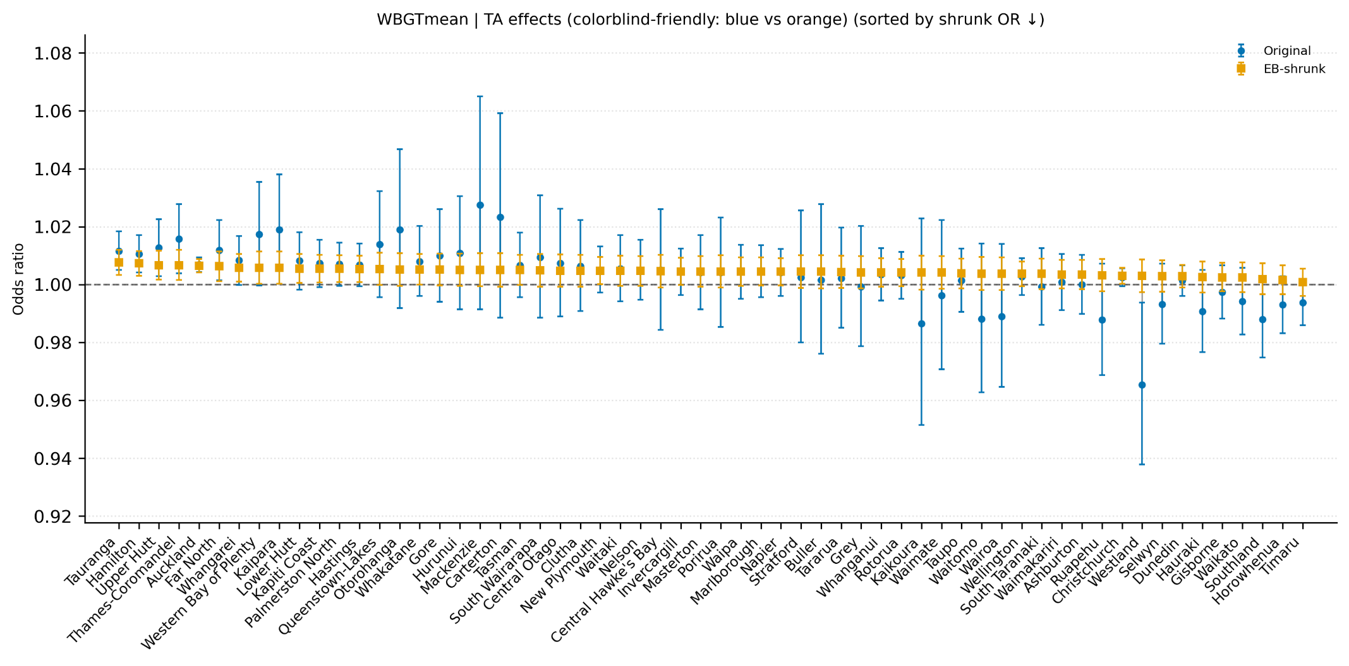
Figure H1. TA-level heat-mortality associations for WBGT-T_{mean}; original & EB-shrunk estimates. The x-axis lists Territorial Authorities (TAs; n = 60), ordered from left to right by the shrunk TA-specific odds ratio (highest to lowest). The y-axis shows the odds. Points denote ORs and lines indicate 95% confidence intervals.
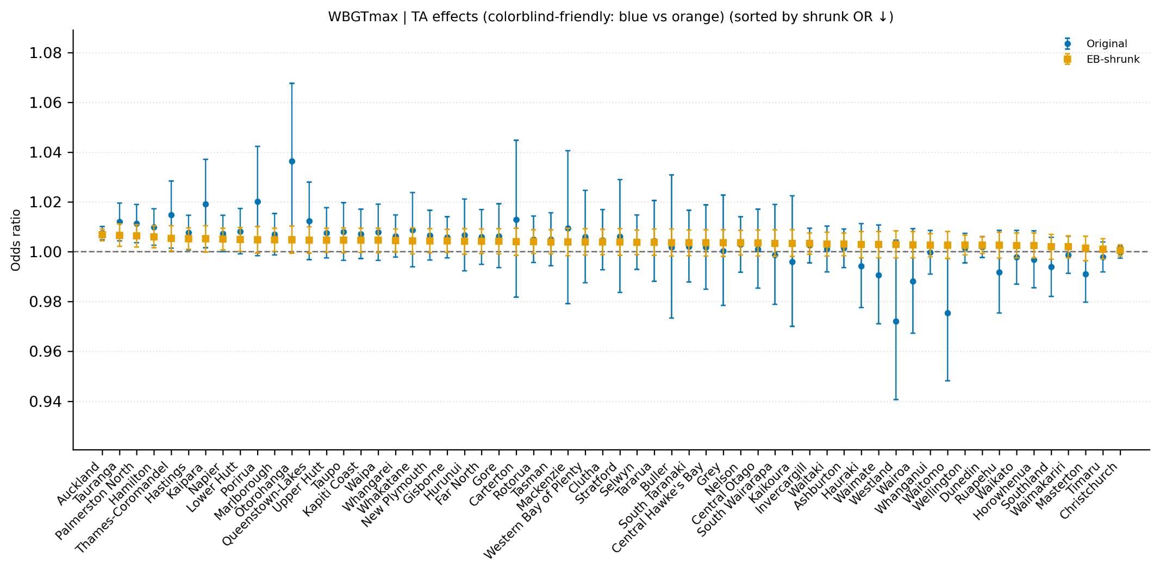
Figure H2. TA-level heat-mortality associations for WBGT-T_{max}; original & EB-shrunk estimates.
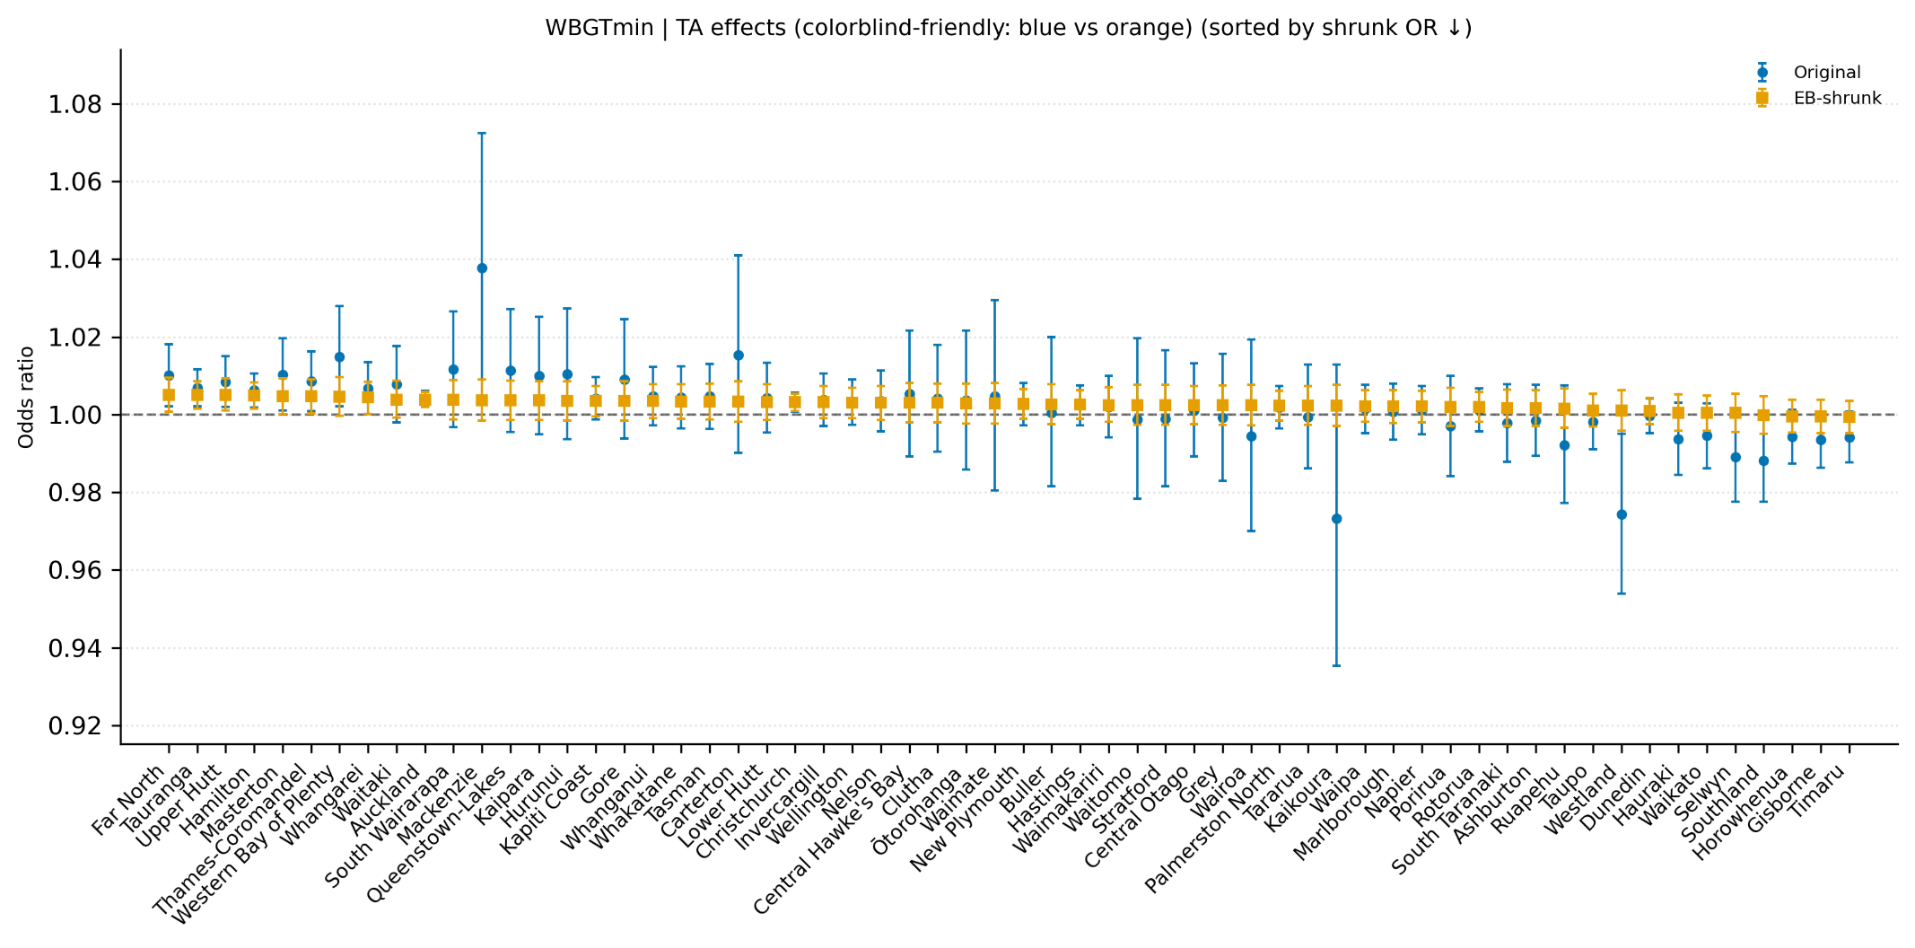
Figure H3. TA-level heat-mortality associations for WBGT-T_{min}; original & EB-shrunk estimates.

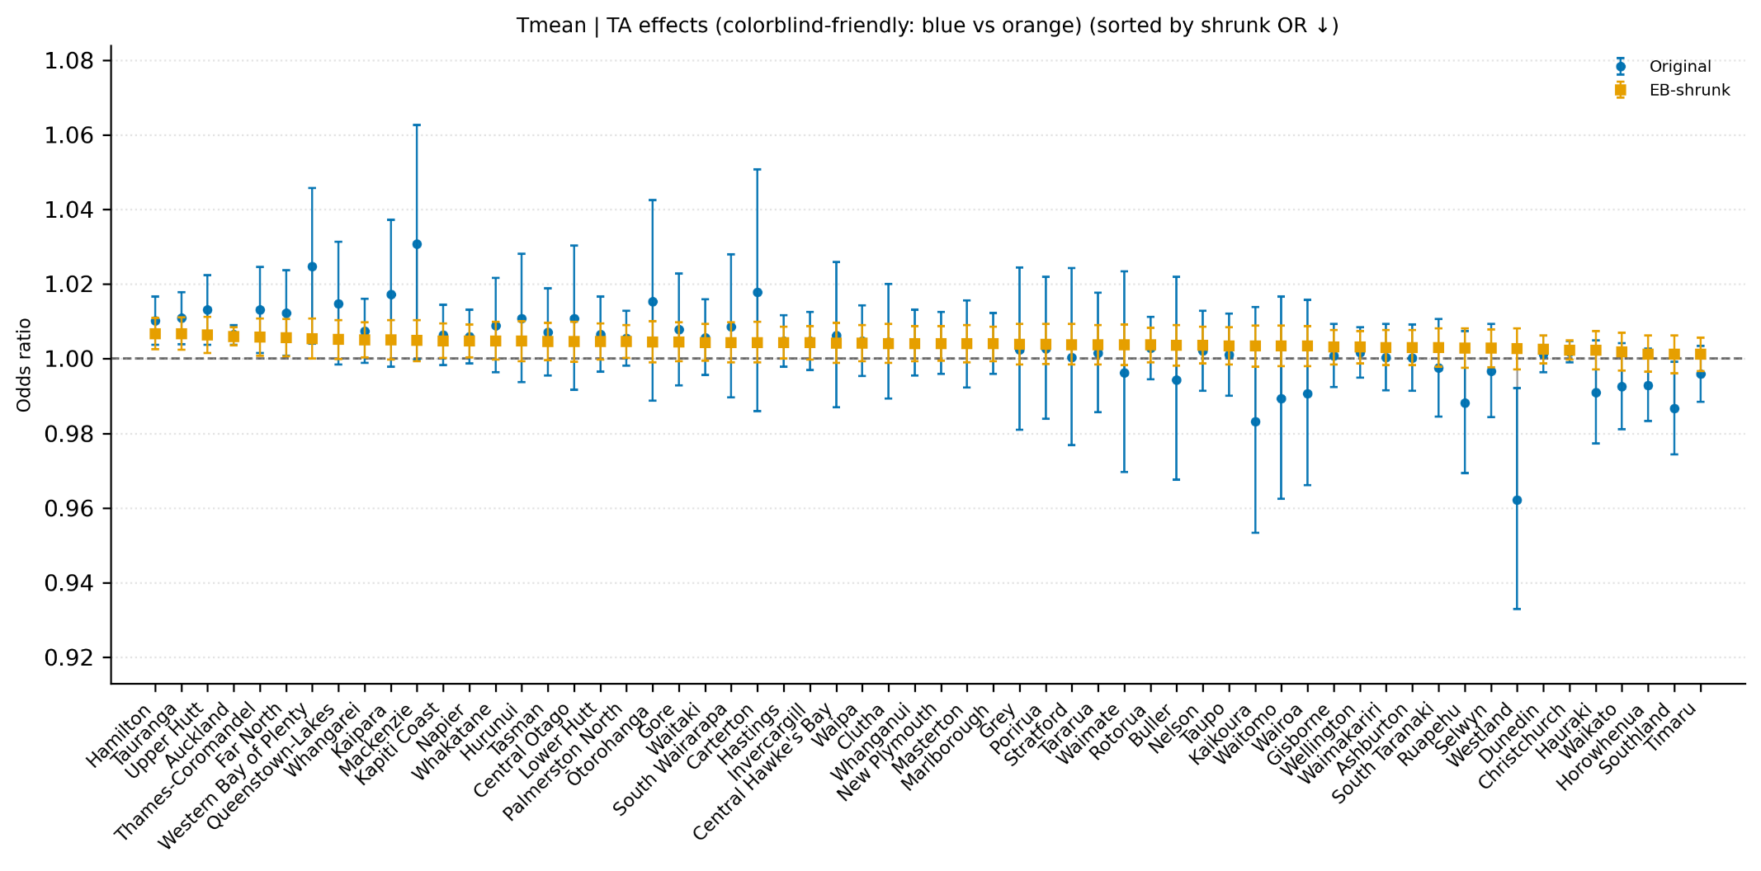
Figure H4. TA-level heat-mortality associations for T_{mean}; original & EB-shrunk estimates.
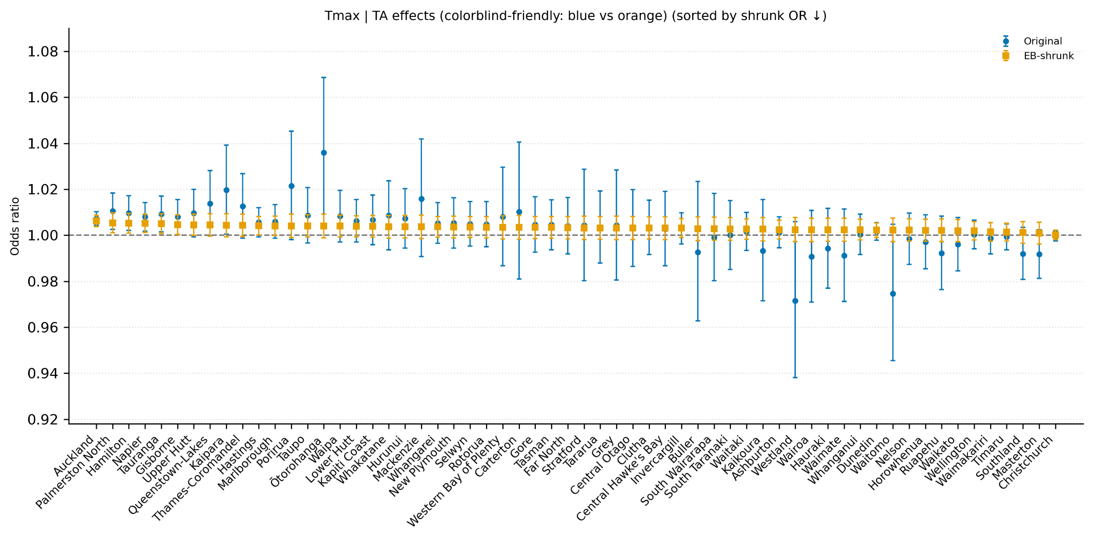
Figure H5. TA-level heat-mortality associations for T_{max}; original & EB-shrunk estimates.

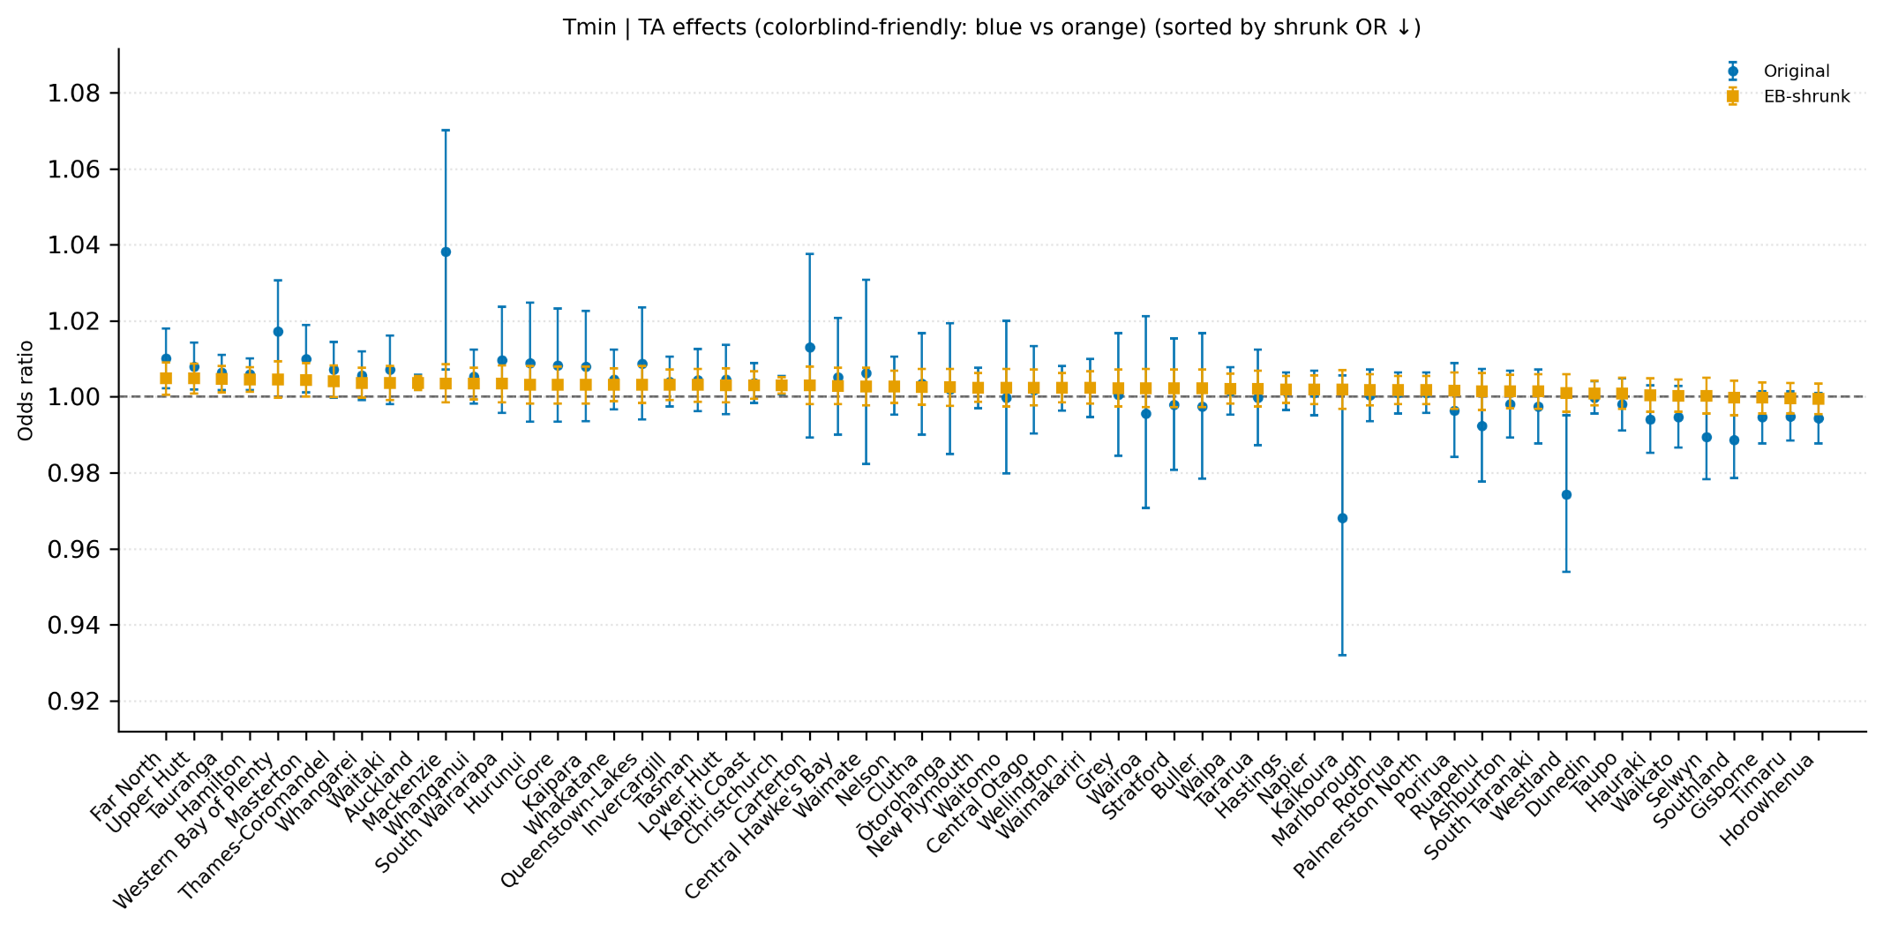
Figure H6. TA-level heat-mortality associations for T_{min}; original & EB-shrunk estimates.

H.2 Sex-specific estimates
Table H8. Sex-Original estimates.
Panel A: WBGT-T_{mean}
Gender | ORs | lcl | ucl | Cases | Odds change (%)
Male | 1.0034 | 1.0018 | 1.0050 | 364,578 | 0.34
Female | 1.0053 | 1.0037 | 1.0069 | 357,225 | 0.53
Panel B: WBGT-T_{max}
Male | 1.0033 | 1.0018 | 1.0048 | 364,581 | 0.33
Female | 1.004 | 1.0025 | 1.0056 | 357,225 | 0.4
Panel C: WBGT-T_{min}
Male | 1.0017 | 1.0005 | 1.003 | 364,581 | 0.17
Female | 1.0037 | 1.0024 | 1.0049 | 357,225 | 0.37
Panel D: T_{mean}
Male | 1.0029 | 1.0013 | 1.0045 | 364,548 | 0.29
Female | 1.0049 | 1.0033 | 1.0065 | 357,198 | 0.49
Panel E: T_{max}
Male | 1.0027 | 1.0012 | 1.0041 | 364,509 | 0.27
Female | 1.0035 | 1.0021 | 1.005 | 357,156 | 0.35
Panel F: T_{min}
Male | 1.0015 | 1.0003 | 1.0027 | 364,518 | 0.15
Female | 1.0034 | 1.0022 | 1.0046 | 357,165 | 0.34

H.3 Age-specific estimates
Table H9. Age-Original estimates.
Panel A: WBGT-T_{mean}
Age band | ORs | lcl | ucl | Cases | Odds change (%)
<20 | 1.0054 | 0.9986 | 1.0122 | 21,222 | 0.54
20-39 | 1.0014 | 0.9946 | 1.0082 | 20,646 | 0.14
40-59 | 1.003 | 0.9994 | 1.0066 | 74,037 | 0.30
60+ | 1.0046 | 1.0033 | 1.0058 | 605,973 | 0.46
Panel B: WBGT-T_{max}
<20 | 1.0022 | 0.9957 | 1.0087 | 21,222 | 0.22
20-39 | 1.0039 | 0.9974 | 1.0103 | 20,649 | 0.39
40-59 | 1.0037 | 1.0003 | 1.0071 | 74,040 | 0.37
60+ | 1.0037 | 1.0025 | 1.0048 | 605,976 | 0.37
Panel C: WBGT-T_{min}
<20 | 1.0049 | 0.9997 | 1.0101 | 21,222 | 0.49
20-39 | 0.9997 | 0.9945 | 1.005 | 20,649 | -0.03
40-59 | 1.0009 | 0.9982 | 1.0037 | 74,040 | 0.09
60+ | 1.0029 | 1.002 | 1.0039 | 605,976 | 0.29
Panel D: T_{mean}
<20 | 1.0055 | 0.9988 | 1.0122 | 21,216 | 0.55
20-39 | 1.0023 | 0.9957 | 1.009 | 20,643 | 0.23
40-59 | 1.002 | 0.9985 | 1.0055 | 74,031 | 0.2
60+ | 1.0041 | 1.0029 | 1.0053 | 605,928 | 0.41
Panel E: T_{max}
<20 | 1.002 | 0.9956 | 1.0084 | 21,222 | 0.2
20-39 | 1.0047 | 0.9984 | 1.011 | 20,640 | 0.47
40-59 | 1.0026 | 0.9993 | 1.006 | 74,013 | 0.26
60+ | 1.0031 | 1.002 | 1.0042 | 605,868 | 0.31
Panel F: T_{min}
<20 | 1.005 | 0.9999 | 1.0101 | 21,216 | 0.5
20-39 | 0.9999 | 0.9948 | 1.0049 | 20,640 | -0.01
40-59 | 1.0006 | 0.9979 | 1.0032 | 74,022 | 0.06
60+ | 1.0027 | 1.0017 | 1.0036 | 605,880 | 0.27
Table H10. Age 60+_by Sex estimates.
Exposure | ORs | lcl | ucl | Cases | Odds change (%) | Group
T_{mean} | 1.0032 | 1.0015 | 1.0049 | 295,941 | 0.32 | Male
T_{mean} | 1.005 | 1.0033 | 1.0067 | 309,978 | 0.50 | Female
WBGT-T_{mean} | 1.0037 | 1.0019 | 1.0055 | 295,965 | 0.37 | Male
WBGT-T_{mean} | 1.0054 | 1.0037 | 1.0072 | 310,002 | 0.54 | Female

Appendix I. Robustness and sensitivity analyses

I.1 Alternative referent window
Table I1. Alternative referent window robustness: Continuous regression results for all-cause & full-year mortality.
Notes: ORs = odds ratios; lcl/ucl = lower/upper bounds of the 95% confidence interval; Cases is the number of deaths; Odds change (%) is calculated as (ORs-1) × 100.
Exposure metric | ORs | lcl | ucl | Cases | Odds change (%)
WBGT-T_{mean} | 1.0033 | 1.0023 | 1.0043 | 723,135 | 0.33
WBGT-T_{max} | 1.0028 | 1.0019 | 1.0037 | 723,135 | 0.28
WBGT-T_{min} | 1.0022 | 1.0014 | 1.0029 | 723,135 | 0.22
T_{mean} | 1.0029 | 1.002 | 1.0039 | 723,132 | 0.29
T_{max} | 1.0024 | 1.0015 | 1.0033 | 723,132 | 0.24
T_{min} | 1.002 | 1.0012 | 1.0027 | 723,132 | 0.2

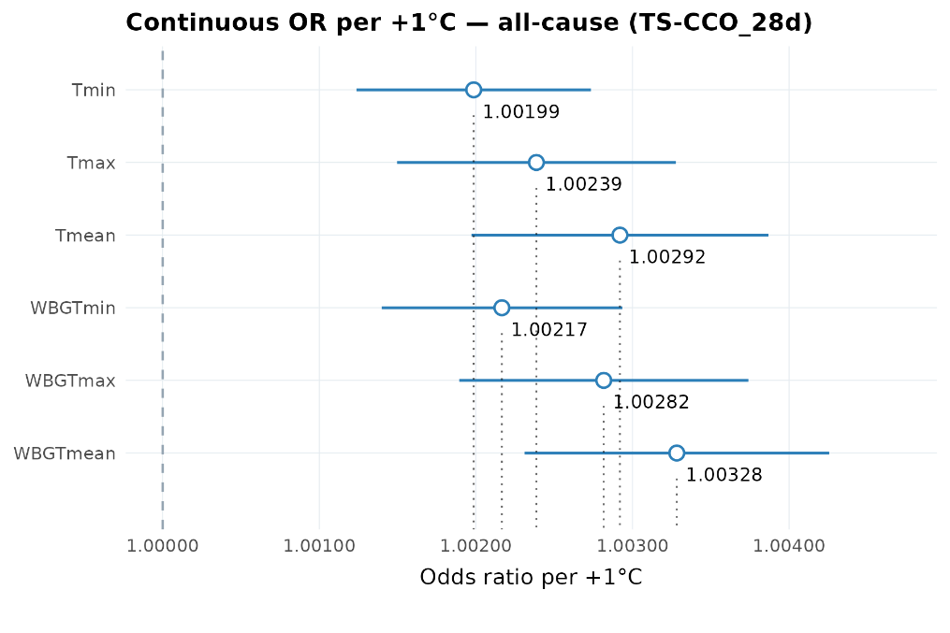
Figure I1. Alternative referent window robustness: Continuous same-day exposure-mortality association per +1 °C.

I.2 Alternative bin cut-points
Table I2. Alternative bin cut-points robustness: Original and EB-shrunken estimates by exposure metric and exposure bin (All-cause & Full-year).
Exposure metric | Bin | ORs | lcl | ucl | Cases | Odds change (%) | ORs (Shrunk) | lcl (Shrunk) | ucl (Shrunk) | Odds change % (Shrunk) | SE | $$\overset{ˉ}{θ}$$ | τ²
WBGT-T_{mean} | 21-24 | 1.0435 | 1.0212 | 1.0663 | 13,587 | 4.35 | 1.0442 | 1.0442 | 1.0442 | 4.42 | 0.011 | 0.043223 | 0
WBGT-T_{mean} | 24-27 | 1.0665 | 0.9418 | 1.2077 | 339 | 6.65 | 1.0442 | 1.0442 | 1.0442 | 4.42 | 0.0634 | 0.043223 | 0
WBGT-T_{mean} | >=27
WBGT-T_{max} | 21-24 | 1.0186 | 1.0088 | 1.0284 | 101,508 | 1.86 | 1.0193 | 1.0101 | 1.0286 | 1.93 | 0.0049 | 0.024735 | 0.0002
WBGT-T_{max} | 24-27 | 1.032 | 1.017 | 1.0472 | 37,737 | 3.2 | 1.0305 | 1.0173 | 1.0438 | 3.05 | 0.0075 | 0.024735 | 0.0002
WBGT-T_{max} | >=27 | 1.0646 | 1.031 | 1.0993 | 5,730 | 6.46 | 1.0413 | 1.02 | 1.0631 | 4.13 | 0.0164 | 0.024735 | 0.0002
WBGT-T_{min} | 21-24 | 1.0118 | 0.9065 | 1.1294 | 468 | 1.18 | 1.0118 | 1.0118 | 1.0118 | 1.18 | 0.0561 | 0.011772 | 0
WBGT-T_{min} | 24-27
WBGT-T_{min} | >=27
T_{mean} | 21-24 | 1.0386 | 1.0233 | 1.054 | 33,105 | 3.86 | 1.0388 | 1.0239 | 1.0538 | 3.88 | 0.0075 | 0.04202 | 0.001
T_{mean} | 24-27 | 1.0873 | 1.035 | 1.1423 | 2,340 | 8.73 | 1.07 | 1.0294 | 1.1121 | 7 | 0.0252 | 0.04202 | 0.001
T_{mean} | >=27 | 1.3409 | 0.9403 | 1.9121 | 45 | 34.09 | 1.0508 | 0.9883 | 1.1172 | 5.08 | 0.1811 | 0.04202 | 0.001
T_{max} | 21-24 | 1.0102 | 1.0008 | 1.0197 | 117,720 | 1.02 | 1.0108 | 1.0017 | 1.02 | 1.08 | 0.0048 | 0.018991 | 0.0003
T_{max} | 24-27 | 1.0202 | 1.0075 | 1.0332 | 65,568 | 2.02 | 1.0201 | 1.0081 | 1.0323 | 2.01 | 0.0064 | 0.018991 | 0.0003
T_{max} | >=27 | 1.0566 | 1.0362 | 1.0774 | 19,014 | 5.66 | 1.0477 | 1.03 | 1.0658 | 4.77 | 0.0099 | 0.018991 | 0.0003
T_{min} | 21-24 | 1.047 | 0.9669 | 1.1337 | 888 | 4.7 | 1.047 | 1.047 | 1.047 | 4.7 | 0.0406 | 0.045893 | 0
T_{min} | 24-27
T_{min} | >=27

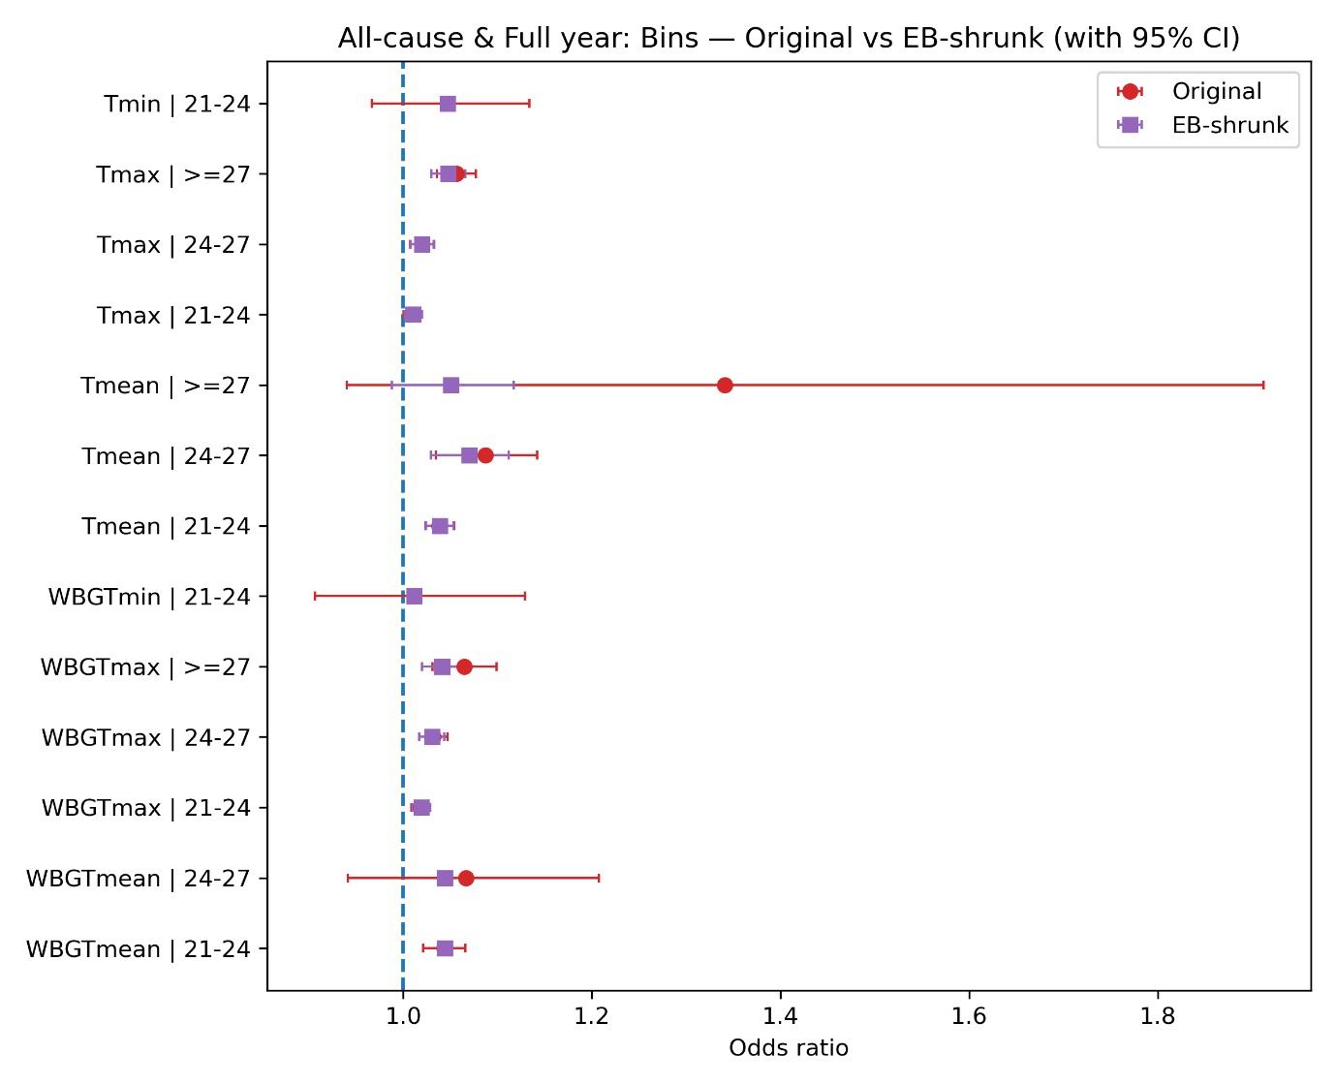
Figure I2. Alternative bin cut-points robustness: Original vs EB-shrunken bin-specific odds ratios with 95% Cis (alternative bin cut-points).

I.3 Sub-period and year-by-exposure sensitivity analyses
Table I3. Sub-period sensitive analyses: heat-mortality associations across three period windows. The table reports ORs and 95% CIs for six exposure metrics re-estimated separately for 1999-2008, 2009-2016, and 2017-2024 (all-cause, full-year sample).
Exposure metric | Period | ORs | lcl | ucl | Cases
WBGT-T_{mean} | 1999-2008 | 1.0037 | 1.0017 | 1.0057 | 245,340
WBGT-T_{max} | 1999-2008 | 1.0039 | 1.002 | 1.0058 | 245,340
WBGT-T_{min} | 1999-2008 | 1.0018 | 1.0003 | 1.0033 | 245,340
T_{mean} | 1999-2008 | 1.0032 | 1.0013 | 1.0051 | 245,316
T_{max} | 1999-2008 | 1.0033 | 1.0014 | 1.0051 | 245,298
T_{min} | 1999-2008 | 1.0016 | 1.0002 | 1.0031 | 245,319
WBGT-T_{mean} | 2009-2016 | 1.0053 | 1.0033 | 1.0074 | 219,192
WBGT-T_{max} | 2009-2016 | 1.0042 | 1.0023 | 1.0061 | 219,192
WBGT-T_{min} | 2009-2016 | 1.0035 | 1.0019 | 1.0051 | 219,192
T_{mean} | 2009-2016 | 1.0049 | 1.003 | 1.0069 | 219,183
T_{max} | 2009-2016 | 1.0038 | 1.0019 | 1.0056 | 219,132
T_{min} | 2009-2016 | 1.0032 | 1.0017 | 1.0047 | 219,108
WBGT-T_{mean} | 2017-2024 | 1.0041 | 1.0022 | 1.006 | 257,379
WBGT-T_{max} | 2017-2024 | 1.0029 | 1.0011 | 1.0047 | 257,379
WBGT-T_{min} | 2017-2024 | 1.0029 | 1.0014 | 1.0043 | 257,379
T_{mean} | 2017-2024 | 1.0036 | 1.0017 | 1.0054 | 257,352
T_{max} | 2017-2024 | 1.0023 | 1.0006 | 1.0041 | 257,340
T_{min} | 2017-2024 | 1.0026 | 1.0012 | 1.004 | 257,358

Table I4. Year-specific same-day mortality associations for WBGT-Tmean.
Note: year-specific odds ratios for all-cause mortality per 1 °C increase in WBGT-Tmean, estimated from exposure × calendar-year interaction models in the full-year sample, 1999-2024.
Exposure metric | Year | ORs | lcl | ucl | Cases
WBGT-T_{mean} | 1999 | 1.0039 | 0.9973 | 1.0105 | 19,638
WBGT-T_{mean} | 2000 | 1.0016 | 0.9951 | 1.0081 | 22,947
WBGT-T_{mean} | 2001 | 1.0024 | 0.9965 | 1.0083 | 24,957
WBGT-T_{mean} | 2002 | 1.0018 | 0.9955 | 1.0082 | 24,585
WBGT-T_{mean} | 2003 | 1.007 | 1.0007 | 1.0134 | 24,282
WBGT-T_{mean} | 2004 | 0.9955 | 0.9893 | 1.0017 | 25,362
WBGT-T_{mean} | 2005 | 1.0082 | 1.0019 | 1.0145 | 24,561
WBGT-T_{mean} | 2006 | 1.0038 | 0.9977 | 1.01 | 25,545
WBGT-T_{mean} | 2007 | 1.0071 | 1.0011 | 1.0131 | 26,193
WBGT-T_{mean} | 2008 | 1.0054 | 0.9993 | 1.0116 | 27,279
WBGT-T_{mean} | 2009 | 1.0074 | 1.0018 | 1.013 | 26,466
WBGT-T_{mean} | 2010 | 1.0018 | 0.9957 | 1.008 | 25,458
WBGT-T_{mean} | 2011 | 1.0044 | 0.9985 | 1.0103 | 27,708
WBGT-T_{mean} | 2012 | 1.007 | 1.001 | 1.0129 | 27,900
WBGT-T_{mean} | 2013 | 0.999 | 0.993 | 1.005 | 26,631
WBGT-T_{mean} | 2014 | 1.0052 | 0.9996 | 1.011 | 27,771
WBGT-T_{mean} | 2015 | 1.0079 | 1.0027 | 1.0132 | 28,719
WBGT-T_{mean} | 2016 | 1.0083 | 1.0025 | 1.0142 | 28,548
WBGT-T_{mean} | 2017 | 1.0015 | 0.9958 | 1.0073 | 30,714
WBGT-T_{mean} | 2018 | 1.0004 | 0.995 | 1.0059 | 30,858
WBGT-T_{mean} | 2019 | 1.0003 | 0.9946 | 1.0061 | 30,567
WBGT-T_{mean} | 2020 | 1.0072 | 1.0017 | 1.0127 | 29,058
WBGT-T_{mean} | 2021 | 1.0058 | 1.0005 | 1.0112 | 31,593
WBGT-T_{mean} | 2022 | 1.0073 | 1.0024 | 1.0123 | 34,269
WBGT-T_{mean} | 2023 | 1.0016 | 0.9964 | 1.0068 | 32,199
WBGT-T_{mean} | 2024 | 1.0072 | 1.0016 | 1.0128 | 31,929
Table I5. Year-specific same-day mortality associations for WBGT-Tmax.
Exposure metric | Year | ORs | lcl | ucl | Cases
WBGT-T_{max} | 1999 | 1.0024 | 0.996 | 1.0089 | 19,638
WBGT-T_{max} | 2000 | 1.002 | 0.9956 | 1.0084 | 22,947
WBGT-T_{max} | 2001 | 1.0048 | 0.9992 | 1.0105 | 24,957
WBGT-T_{max} | 2002 | 1.0058 | 0.9997 | 1.0119 | 24,585
WBGT-T_{max} | 2003 | 1.0059 | 0.9998 | 1.012 | 24,282
WBGT-T_{max} | 2004 | 0.9956 | 0.9896 | 1.0017 | 25,362
WBGT-T_{max} | 2005 | 1.0085 | 1.0026 | 1.0144 | 24,561
WBGT-T_{max} | 2006 | 1.0027 | 0.9969 | 1.0085 | 25,545
WBGT-T_{max} | 2007 | 1.0071 | 1.0014 | 1.0127 | 26,193
WBGT-T_{max} | 2008 | 1.0031 | 0.9975 | 1.0088 | 27,279
WBGT-T_{max} | 2009 | 1.0086 | 1.0033 | 1.014 | 26,466
WBGT-T_{max} | 2010 | 1.0011 | 0.9955 | 1.0066 | 25,458
WBGT-T_{max} | 2011 | 0.9992 | 0.9941 | 1.0044 | 27,708
WBGT-T_{max} | 2012 | 1.0047 | 0.999 | 1.0104 | 27,900
WBGT-T_{max} | 2013 | 0.9998 | 0.9942 | 1.0054 | 26,631
WBGT-T_{max} | 2014 | 1.0062 | 1.0007 | 1.0116 | 27,771
WBGT-T_{max} | 2015 | 1.0049 | 0.9999 | 1.0098 | 28,719
WBGT-T_{max} | 2016 | 1.0086 | 1.0032 | 1.014 | 28,548
WBGT-T_{max} | 2017 | 0.9995 | 0.9941 | 1.0048 | 30,714
WBGT-T_{max} | 2018 | 0.9993 | 0.9944 | 1.0042 | 30,858
WBGT-T_{max} | 2019 | 0.9981 | 0.9928 | 1.0034 | 30,567
WBGT-T_{max} | 2020 | 1.0053 | 1.0002 | 1.0105 | 29,058
WBGT-T_{max} | 2021 | 1.0062 | 1.0011 | 1.0114 | 31,593
WBGT-T_{max} | 2022 | 1.0052 | 1.0003 | 1.0101 | 34,269
WBGT-T_{max} | 2023 | 1.0044 | 0.9993 | 1.0095 | 32,199
WBGT-T_{max} | 2024 | 1.0039 | 0.9984 | 1.0094 | 31,929

Table I6. Year-specific same-day mortality associations for WBGT-Tmin.
Exposure metric | Year | ORs | lcl | ucl | Cases
WBGT-T_{min} | 1999 | 1.0032 | 0.9981 | 1.0082 | 19,638
WBGT-T_{min} | 2000 | 1.0004 | 0.9956 | 1.0052 | 22,947
WBGT-T_{min} | 2001 | 0.9996 | 0.995 | 1.0042 | 24,957
WBGT-T_{min} | 2002 | 0.999 | 0.9941 | 1.0039 | 24,585
WBGT-T_{min} | 2003 | 1.0046 | 0.9998 | 1.0093 | 24,282
WBGT-T_{min} | 2004 | 0.9974 | 0.9928 | 1.0021 | 25,362
WBGT-T_{min} | 2005 | 1.0042 | 0.9993 | 1.009 | 24,561
WBGT-T_{min} | 2006 | 1.0024 | 0.9978 | 1.0071 | 25,545
WBGT-T_{min} | 2007 | 1.0033 | 0.9986 | 1.0079 | 26,193
WBGT-T_{min} | 2008 | 1.0038 | 0.999 | 1.0085 | 27,279
WBGT-T_{min} | 2009 | 1.0037 | 0.9994 | 1.008 | 26,466
WBGT-T_{min} | 2010 | 1.0015 | 0.9967 | 1.0063 | 25,458
WBGT-T_{min} | 2011 | 1.0054 | 1.0007 | 1.01 | 27,708
WBGT-T_{min} | 2012 | 1.0049 | 1.0005 | 1.0093 | 27,900
WBGT-T_{min} | 2013 | 0.9996 | 0.995 | 1.0042 | 26,631
WBGT-T_{min} | 2014 | 1.002 | 0.9977 | 1.0064 | 27,771
WBGT-T_{min} | 2015 | 1.0067 | 1.0025 | 1.0109 | 28,719
WBGT-T_{min} | 2016 | 1.0035 | 0.9991 | 1.008 | 28,548
WBGT-T_{min} | 2017 | 1.0021 | 0.9976 | 1.0066 | 30,714
WBGT-T_{min} | 2018 | 1.0009 | 0.9964 | 1.0054 | 30,858
WBGT-T_{min} | 2019 | 1.0009 | 0.9965 | 1.0054 | 30,567
WBGT-T_{min} | 2020 | 1.0053 | 1.0012 | 1.0094 | 29,058
WBGT-T_{min} | 2021 | 1.003 | 0.9989 | 1.0071 | 31,593
WBGT-T_{min} | 2022 | 1.0055 | 1.0017 | 1.0094 | 34,269
WBGT-T_{min} | 2023 | 0.9992 | 0.9952 | 1.0032 | 32,199
WBGT-T_{min} | 2024 | 1.0052 | 1.0011 | 1.0094 | 31,929

Table I7. Year-specific same-day mortality associations for Tmean.
Exposure metric | Year | ORs | lcl | ucl | Cases
T_{mean} | 1999 | 1.0045 | 0.998 | 1.0111 | 19,638
T_{mean} | 2000 | 1.0009 | 0.9946 | 1.0072 | 22,947
T_{mean} | 2001 | 1.001 | 0.9951 | 1.0069 | 24,954
T_{mean} | 2002 | 1.0034 | 0.9972 | 1.0097 | 24,585
T_{mean} | 2003 | 1.0063 | 1.0001 | 1.0125 | 24,282
T_{mean} | 2004 | 0.9957 | 0.9897 | 1.0018 | 25,362
T_{mean} | 2005 | 1.0087 | 1.0025 | 1.0149 | 24,558
T_{mean} | 2006 | 1.0032 | 0.9972 | 1.0092 | 25,542
T_{mean} | 2007 | 1.0047 | 0.9989 | 1.0106 | 26,193
T_{mean} | 2008 | 1.0039 | 0.9979 | 1.0099 | 27,264
T_{mean} | 2009 | 1.0072 | 1.0017 | 1.0127 | 26,466
T_{mean} | 2010 | 1.0015 | 0.9953 | 1.0076 | 25,458
T_{mean} | 2011 | 1.0037 | 0.998 | 1.0095 | 27,702
T_{mean} | 2012 | 1.0067 | 1.001 | 1.0125 | 27,897
T_{mean} | 2013 | 1.0003 | 0.9944 | 1.0062 | 26,631
T_{mean} | 2014 | 1.0042 | 0.9987 | 1.0098 | 27,768
T_{mean} | 2015 | 1.0075 | 1.0024 | 1.0126 | 28,719
T_{mean} | 2016 | 1.0067 | 1.0012 | 1.0123 | 28,548
T_{mean} | 2017 | 1.0016 | 0.9959 | 1.0074 | 30,711
T_{mean} | 2018 | 1.0008 | 0.9954 | 1.0062 | 30,858
T_{mean} | 2019 | 0.9994 | 0.9938 | 1.005 | 30,567
T_{mean} | 2020 | 1.0067 | 1.0014 | 1.0119 | 29,055
T_{mean} | 2021 | 1.0058 | 1.0006 | 1.0111 | 31,593
T_{mean} | 2022 | 1.0065 | 1.0016 | 1.0114 | 34,269
T_{mean} | 2023 | 0.9999 | 0.9948 | 1.005 | 32,193
T_{mean} | 2024 | 1.0068 | 1.0015 | 1.0121 | 31,920

Table I8. Year-specific same-day mortality associations for Tmax.
Exposure metric | Year | ORs | lcl | ucl | Cases
T_{max} | 1999 | 1.0029 | 0.9966 | 1.0092 | 19,635
T_{max} | 2000 | 1.0011 | 0.9951 | 1.0072 | 22,947
T_{max} | 2001 | 1.0035 | 0.9979 | 1.0091 | 24,948
T_{max} | 2002 | 1.0071 | 1.0013 | 1.013 | 24,573
T_{max} | 2003 | 1.0047 | 0.9988 | 1.0106 | 24,279
T_{max} | 2004 | 0.996 | 0.9903 | 1.0018 | 25,359
T_{max} | 2005 | 1.0087 | 1.0031 | 1.0143 | 24,558
T_{max} | 2006 | 1.002 | 0.9964 | 1.0076 | 25,542
T_{max} | 2007 | 1.0045 | 0.9992 | 1.0099 | 26,193
T_{max} | 2008 | 1.0016 | 0.9962 | 1.0069 | 27,276
T_{max} | 2009 | 1.0081 | 1.0029 | 1.0133 | 26,466
T_{max} | 2010 | 1.0007 | 0.9953 | 1.0062 | 25,458
T_{max} | 2011 | 0.9985 | 0.9935 | 1.0036 | 27,705
T_{max} | 2012 | 1.0047 | 0.9992 | 1.0102 | 27,891
T_{max} | 2013 | 1.001 | 0.9956 | 1.0065 | 26,583
T_{max} | 2014 | 1.005 | 0.9997 | 1.0103 | 27,771
T_{max} | 2015 | 1.0045 | 0.9997 | 1.0092 | 28,719
T_{max} | 2016 | 1.0072 | 1.0021 | 1.0123 | 28,548
T_{max} | 2017 | 0.9996 | 0.9943 | 1.0048 | 30,714
T_{max} | 2018 | 0.9995 | 0.9947 | 1.0044 | 30,858
T_{max} | 2019 | 0.997 | 0.9919 | 1.0022 | 30,567
T_{max} | 2020 | 1.0048 | 0.9999 | 1.0098 | 29,049
T_{max} | 2021 | 1.0063 | 1.0013 | 1.0113 | 31,590
T_{max} | 2022 | 1.004 | 0.9992 | 1.0088 | 34,263
T_{max} | 2023 | 1.0026 | 0.9977 | 1.0076 | 32,187
T_{max} | 2024 | 1.0034 | 0.9983 | 1.0086 | 31,920

Table I9. Year-specific same-day mortality associations for Tmin.
Exposure metric | Year | ORs | lcl | ucl | Cases
T_{min} | 1999 | 1.0035 | 0.9986 | 1.0084 | 19,638
T_{min} | 2000 | 1.0005 | 0.9959 | 1.0051 | 22,947
T_{min} | 2001 | 0.9989 | 0.9944 | 1.0034 | 24,957
T_{min} | 2002 | 0.9995 | 0.9948 | 1.0042 | 24,585
T_{min} | 2003 | 1.0044 | 0.9997 | 1.009 | 24,273
T_{min} | 2004 | 0.9975 | 0.993 | 1.0021 | 25,359
T_{min} | 2005 | 1.0042 | 0.9995 | 1.0089 | 24,558
T_{min} | 2006 | 1.0019 | 0.9974 | 1.0065 | 25,542
T_{min} | 2007 | 1.0026 | 0.9981 | 1.0071 | 26,190
T_{min} | 2008 | 1.0036 | 0.999 | 1.0082 | 27,279
T_{min} | 2009 | 1.0033 | 0.9991 | 1.0075 | 26,466
T_{min} | 2010 | 1.0015 | 0.9968 | 1.0061 | 25,455
T_{min} | 2011 | 1.0053 | 1.0008 | 1.0099 | 27,705
T_{min} | 2012 | 1.0045 | 1.0003 | 1.0087 | 27,834
T_{min} | 2013 | 0.9996 | 0.9952 | 1.0041 | 26,628
T_{min} | 2014 | 1.0017 | 0.9975 | 1.0058 | 27,768
T_{min} | 2015 | 1.0062 | 1.0021 | 1.0103 | 28,719
T_{min} | 2016 | 1.0027 | 0.9984 | 1.007 | 28,542
T_{min} | 2017 | 1.0022 | 0.9979 | 1.0066 | 30,714
T_{min} | 2018 | 1.0009 | 0.9965 | 1.0053 | 30,855
T_{min} | 2019 | 1.001 | 0.9968 | 1.0053 | 30,567
T_{min} | 2020 | 1.0046 | 1.0007 | 1.0086 | 29,049
T_{min} | 2021 | 1.0027 | 0.9988 | 1.0067 | 31,590
T_{min} | 2022 | 1.0052 | 1.0015 | 1.0089 | 34,269
T_{min} | 2023 | 0.9985 | 0.9946 | 1.0023 | 32,199
T_{min} | 2024 | 1.0052 | 1.0012 | 1.0092 | 31,926

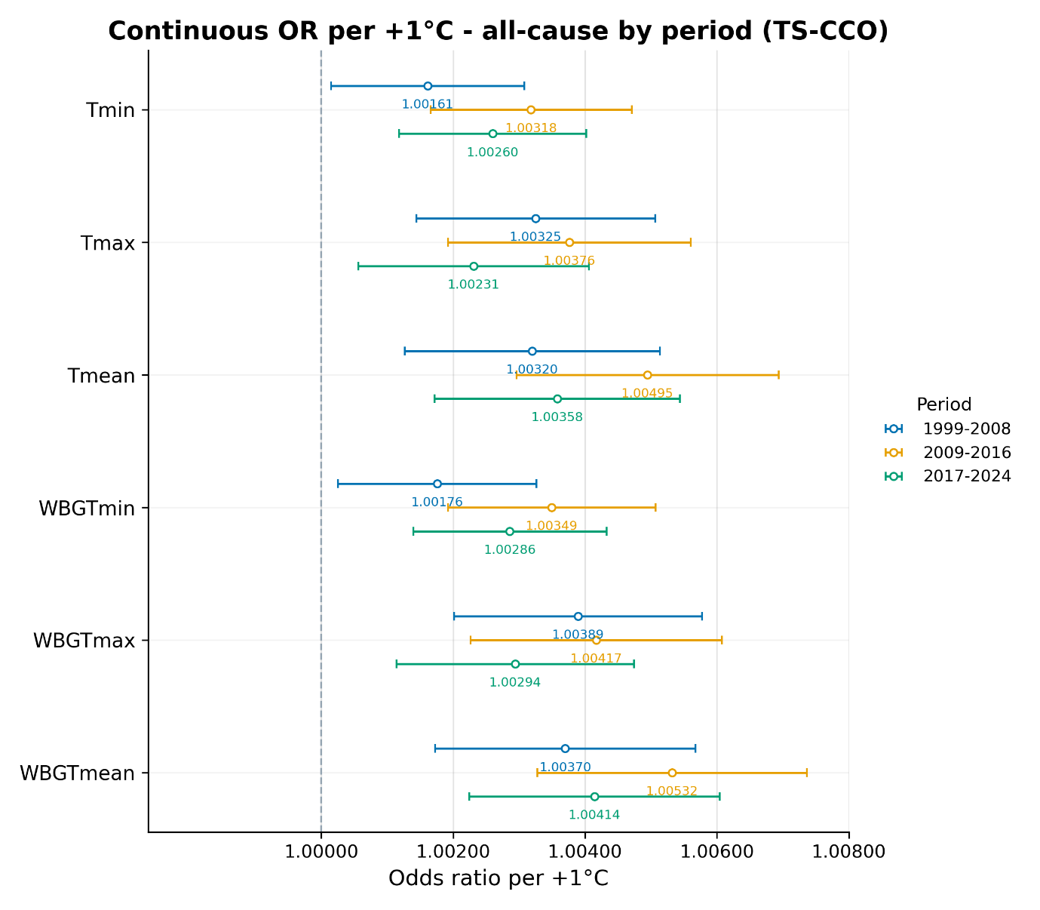
Figure I3. Sub-period sensitive analyses: sub-period comparison of heat exposure-mortality associations (1999-2008, 2009-2016, 2017-2024). Points show sub-period ORs for each exposure metric and horizontal bars show 95 CIs (all-cause, full-year).

I.4 Alternative DLNM lag windows
- WBGT: All-cause + Full-year | - Temperature: All-cause + Full-year
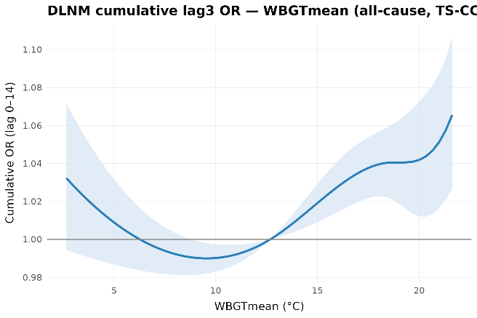 | 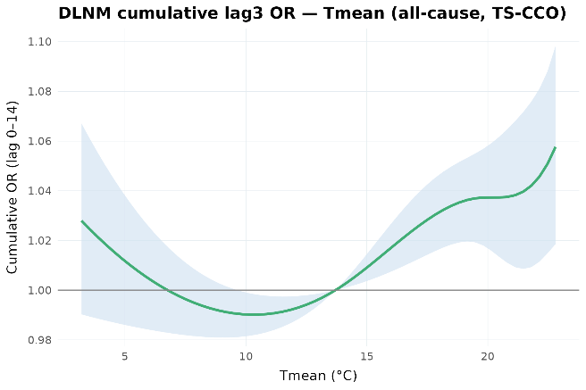
Figure I4. Alternative DLNM lag windows robustness: 0-3 cumulative mortality association with daily mean WBGT & Temperature, estimated using distributed-lag non-linear models (All-cause, Full-year).
- WBGT: All-cause + Full-year | - Temperature: All-cause + Full-year
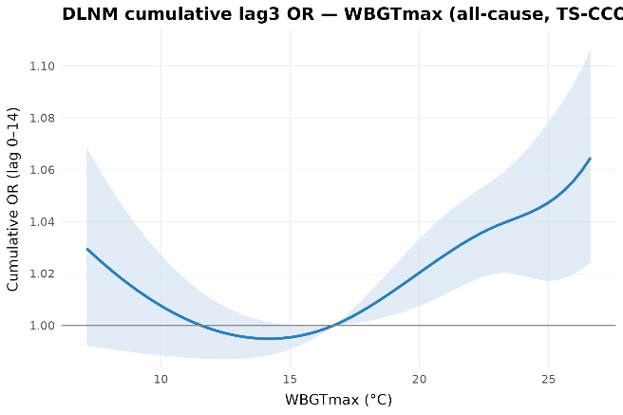 | 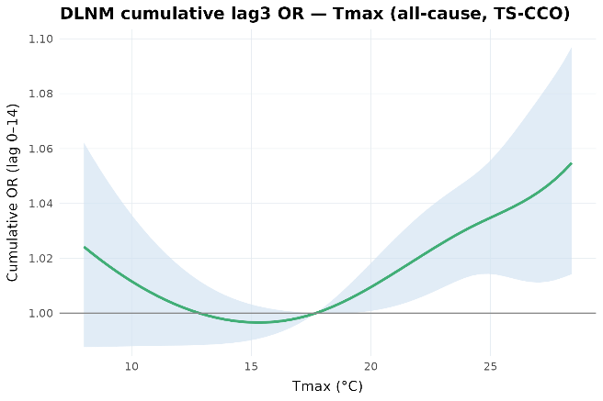
Figure I5. Alternative DLNM lag windows robustness: 0-3 cumulative mortality association with daily max WBGT & Temperature, estimated using distributed-lag non-linear models (All-cause, Full-year).
- WBGT: All-cause + Full-year | - Temperature: All-cause + Full-year
 | 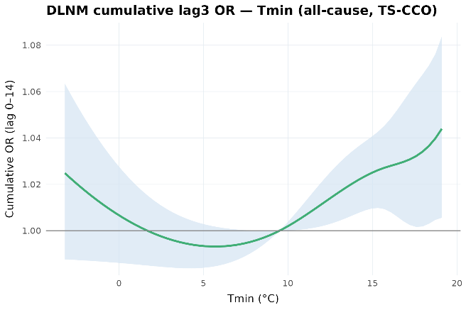
Figure I6. Alternative DLNM lag windows robustness: 0-3 cumulative mortality association with daily min WBGT & Temperature, estimated using distributed-lag non-linear models (All-cause, Full-year).

- WBGT: All-cause + Full-year | - Temperature: All-cause + Full-year
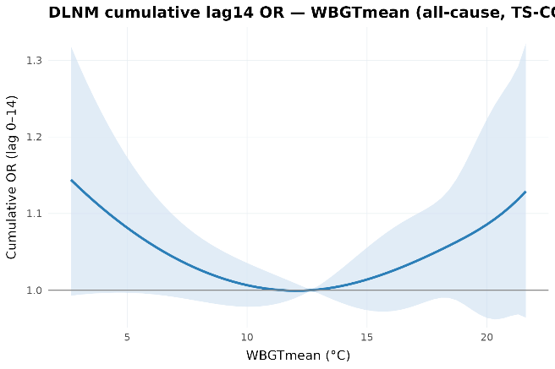
Figure I7. Alternative DLNM lag windows robustness: 0-14 cumulative mortality association with daily mean WBGT & Temperature, estimated using distributed-lag non-linear models (All-cause, Full-year).
- WBGT: All-cause + Full-year | - Temperature: All-cause + Full-year
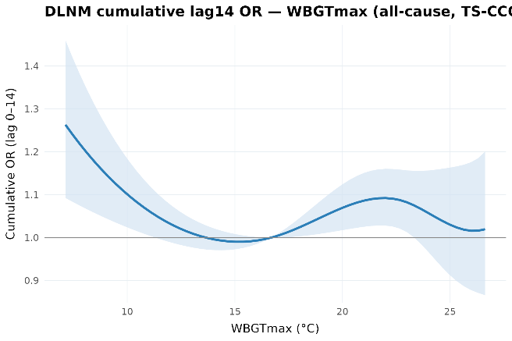 | 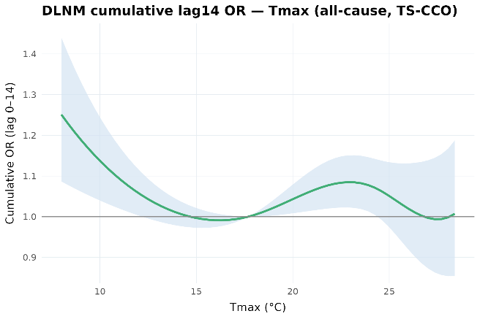
Figure I8. Alternative DLNM lag windows robustness: 0-14 cumulative mortality association with daily max WBGT & Temperature, estimated using distributed-lag non-linear models (All-cause, Full-year).
- WBGT: All-cause + Full-year | (b)Temperature: All-cause + Full-year
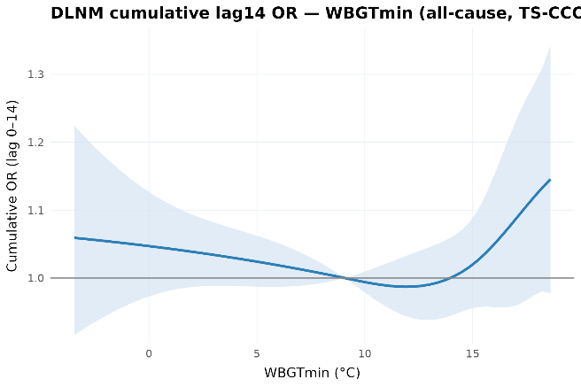 | 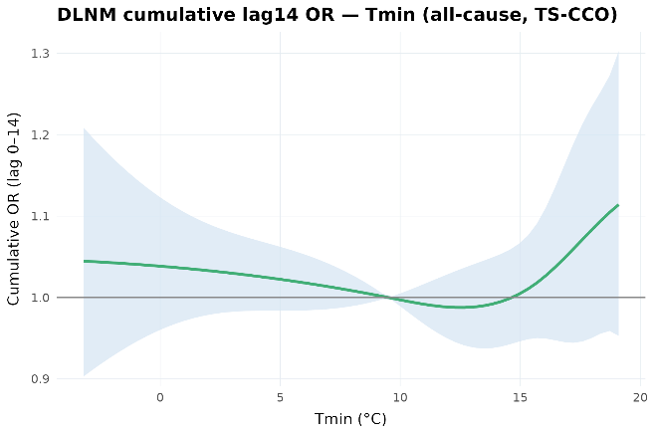
Figure I9. Alternative DLNM lag windows robustness: 0-14 cumulative mortality association with daily min WBGT & Temperature, estimated using distributed-lag non-linear models (All-cause, Full-year).

I.5 Exclusion of selected Territorial Authorities
Table I10-I12 reports all-cause full-year continuous estimates after excluding selected Territorial Authorities (TAs) related to exposure-data construction. Three samples are considered: excluding TAs with imputed radiation or wind inputs, excluding TAs with day-count coverage below 75% of the sample period, and excluding the union of these two groups.
Table I10. Exclusion of imputed Territorial Authorities: Continuous regression results for all-cause & full-year mortality.
Excluding imputed-input TAs
Exposure metric | ORs | lcl | ucl | Cases | Odds change (%)
WBGT-T_{mean} | 1.0045 | 1.0033 | 1.0057 | 675,918 | 0.45
WBGT-T_{max} | 1.0037 | 1.0026 | 1.0048 | 675,918 | 0.37
WBGT-T_{min} | 1.0028 | 1.0019 | 1.0038 | 675,918 | 0.28
T_{mean} | 1.004 | 1.0029 | 1.0052 | 675,849 | 0.40
T_{max} | 1.0032 | 1.0021 | 1.0042 | 675,759 | 0.32
T_{min} | 1.0026 | 1.0017 | 1.0035 | 675,777 | 0.26
Table I11. Exclusion of low-day-count Territorial Authorities: Continuous regression results for all-cause & full-year mortality.
Excluding low-day-count TAs
Exposure metric | ORs | lcl | ucl | Cases | Odds change (%)
WBGT-T_{mean} | 1.0043 | 1.0031 | 1.0055 | 681,261 | 0.43
WBGT-T_{max} | 1.0036 | 1.0025 | 1.0047 | 681,261 | 0.36
WBGT-T_{min} | 1.0026 | 1.0017 | 1.0035 | 681,261 | 0.26
T_{mean} | 1.0038 | 1.0026 | 1.0049 | 681,189 | 0.38
T_{max} | 1.003 | 1.0019 | 1.0041 | 681,120 | 0.30
T_{min} | 1.0024 | 1.0015 | 1.0033 | 681,129 | 0.24
Table I12. Exclusion of imputed or low-day-count Territorial Authorities: Continuous regression results for all-cause & full-year mortality.
Excluding imputed-input or low-day-count TAs
Exposure metric | ORs | lcl | ucl | Cases | Odds change (%)
WBGT-T_{mean} | 1.0045 | 1.0033 | 1.0057 | 635,286 | 0.45
WBGT-T_{max} | 1.0037 | 1.0026 | 1.0049 | 635,286 | 0.37
WBGT-T_{min} | 1.0028 | 1.0018 | 1.0037 | 635,286 | 0.28
T_{mean} | 1.0039 | 1.0027 | 1.0051 | 635,205 | 0.39
T_{max} | 1.0031 | 1.002 | 1.0042 | 635,127 | 0.31
T_{min} | 1.0025 | 1.0016 | 1.0034 | 635,130 | 0.25

References
DerSimonian, R., & Laird, N. (1986). Meta-analysis in clinical trials. Controlled Clinical Trials, 7(3), 177–188. https://doi.org/10.1016/0197-2456(86)90046-2
Gasparrini, A. (2014). Modeling exposure–lag–response associations with distributed lag non-linear models. Statistics in Medicine, 33(5), 881–899. https://doi.org/10.1002/sim.5963
Gasparrini, A., & Leone, M. (2014). Attributable risk from distributed lag models. BMC Medical Research Methodology, 14(1), 55. https://doi.org/10.1186/1471-2288-14-55
Gasparrini, A., Armstrong, B., & Kenward, M. G. (2010). Distributed lag non-linear models. Statistics in Medicine, 29(21), 2224–2234. https://doi.org/10.1002/sim.3940
Liljegren, J. C., Carhart, R. A., Lawday, P., Tschopp, S., & Sharp, R. (2008). Modeling the Wet Bulb Globe Temperature Using Standard Meteorological Measurements. Journal of Occupational and Environmental Hygiene, 5(10), 645–655. https://doi.org/10.1080/15459620802310770

