Reimagining Adaptation as Coping: Agroecological Misalignment, Institutional Thinness, and Shifting Socio-Cultural Norms in Climate-Vulnerable Mountain Agrarian Peripheries
Appendix 1 presents the Mann–Kendall trend analysis for precipitation, indicating no statistically significant long-term trend; however, April exhibits a significant increasing trend (p = 0.037), indicating a gradual rise in early pre-monsoon rainfall, possibly linked to enhanced western disturbances or early convective activity. In contrast, December shows a significant decreasing trend (p = 0.022), reflecting drying conditions during the early winter months. All other months show no statistically significant trends (p ≥ 0.05), although some months, particularly August, display moderate negative Tau values, suggesting declining tendencies. The monsoon months (June–September) remain largely stable, with no significant trend despite substantial interannual variability.
Appendix 1. Monthly Mann–Kendall trend results for precipitation in Bajhang (1984–2023), showing trend direction, significance level, and rate of change (mm per decade)
Month | Trend | p-value | τ | Slope (mm/decade) | Significance
Jan–Mar | No trend | > 0.15–0.52 | 0.08–0.16 | 13–89 | Not significant
Apr | Increasing | 0.037 | 0.23 | +60.6 | Significant (95%)
May–Nov | No trend | > 0.06–0.97 | –0.20–0.12 | –247–+56 | Not significant
Dec | Decreasing | 0.022 | –0.25 | –27.6 | Significant (95%)

Note: τ indicates the strength and direction of the monotonic trend, the slope represents the Sen’s slope (rate of change per decade), and the p-value denotes the statistical significance of the trend (p < 0.05 significant; p < 0.01 highly significant).

The Mann–Kendall trend results for mean temperature in Bajhang (1984–2023), in Appendix 2 shows that on a monthly scale, statistically significant warming was detected mainly during the monsoon and post-monsoon months (July–December), with the most pronounced increases in September (τ = 0.52, p = 0.000003) and October (τ = 0.41, p = 0.0002) while the early months (January–June) exhibited no significant trends (Appendix 1).
Appendix 2. Monthly Mann–Kendall trend results for mean temperature in Bajhang (1984–2023), showing trend direction, significance level, and magnitude of change (°C per decade).
Month | Trend | p-value | τ | Slope (°C /decade) | Significance Level
Jan–Jun | No trend | > 0.05 | 0.07–0.19 | < 3.2 | Not significant
Jul | Increasing | 0.004 | 0.32 | 2.87 | Significant (95%)
Aug | Increasing | 0.000007 | 0.50 | 3.66 | Highly significant (99%)
Sep | Increasing | 0.000003 | 0.52 | 4.36 | Highly significant (99%)
Oct | Increasing | 0.0002 | 0.41 | 5.40 | Highly significant (99%)
Nov | Increasing | 0.0013 | 0.35 | 4.33 | Highly significant (99%)
Dec | Increasing | 0.0338 | 0.23 | 3.37 | Significant (95%)
Note: τ indicates the strength and direction of the monotonic temperature trend, the slope represents the Sen’s slope (°C /decade), and the p-value denotes the statistical significance of the trend (p < 0.05 significant; p < 0.01 highly significant)

Appendix 3 gives the land use maps for the years 1992 and 2022 that were obtained from the ESA-CCI Land Cover portal. These maps are characterized by a spatial resolution of 300 meters. The classification of land use encompasses 21 detailed categories. Please refer to Table 1 and Figure 1 for detailed information on LULC Statistics and dynamics between 1992 and 2022.
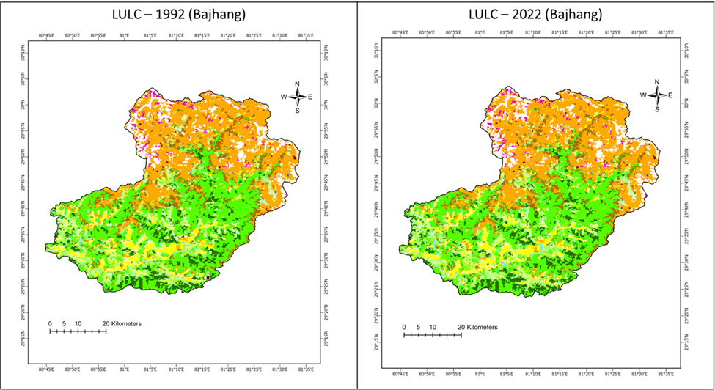
Figure 1.
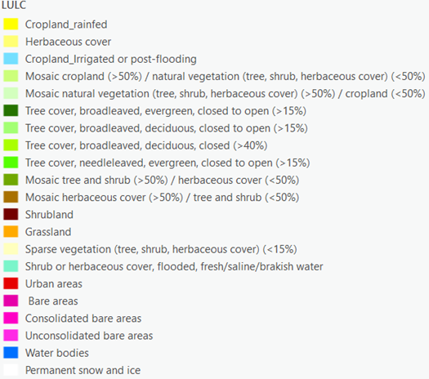
Legend
Table 1. LULC Area (Sq Km)
LULC code | LULC name | 1992 Area (sq Km) | 2022 Area (sq Km) | Difference (1992-2022)
10 | Cropland_rainfed | 185 | 185 | 0
11 | Herbaceous cover | 110 | 127 | -17
20 | Cropland_irrigated or post‐flooding | 11 | 11 | -1
30 | Mosaic cropland (>50%) / natural vegetation (tree, shrub, herbaceous cover) (<50%) | 67 | 65 | 2
40 | Mosaic natural vegetation (tree, shrub, herbaceous cover) (>50%) / cropland (<50%) | 166 | 148 | 18
50 | Tree cover, broadleaved, evergreen, closed to open (>15%) | 230 | 234 | -4
60 | Tree cover, broadleaved, deciduous, closed to open (>15%) | 247 | 243 | 5
61 | Tree cover, broadleaved, deciduous, closed (>40%) | 85 | 85 | 0
70 | Tree cover, needleleaved, evergreen, closed to open (>15%) | 985 | 981 | 5
100 | Mosaic tree and shrub (>50%) / herbaceous cover (<50%) | 75 | 75 | -1
110 | Mosaic herbaceous cover (>50%) / tree and shrub (<50%) | 209 | 213 | -4
120 | Shrubland | 9 | 8 | 1
130 | Grassland | 1110 | 1112 | -2
150 | Sparse vegetation (tree, shrub, herbaceous cover) (<15%) | 9 | 10 | -1
180 | Shrub or herbaceous cover, flooded, fresh/saline/brakish water | 2 | 2 | 0
190 | Urban areas | 0 | 0 | 0
200 | Bare areas | 33 | 35 | -1
201 | Consolidated bare areas | 2 | 2 | 0
202 | Unconsolidated bare areas | 10 | 10 | 0
210 | Water bodies | 1 | 1 | 0
220 | Permanent snow and ice | 216 | 216 | 0
To enhance comprehension, we have streamlined the detailed Land Use/Land Cover (LULC) classifications by consolidating them into 12 distinct categories. This merging was based on similarities in characteristics and attributes among the original 21 LULC classes (Table 2).

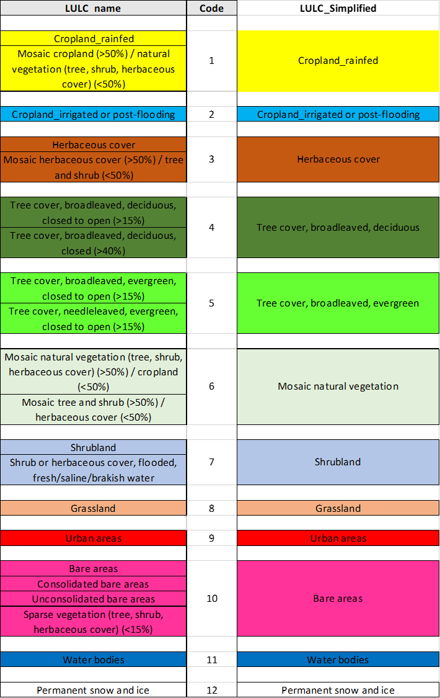
Table 2. Simplified LULC classes
Table 3. Simplified LULC dynamics
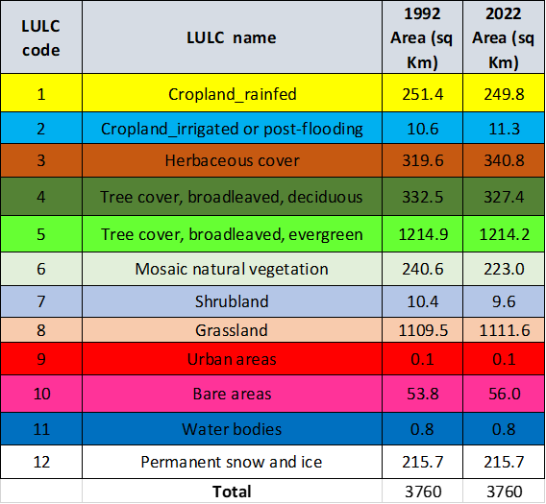
Land Use/Land Cover (LULC) Dynamics between 1992 and 2022 in Bajhang district, Nepal
The comparative analysis of Land Use/Land Cover (LULC) data from 1992 and 2022 reveals a landscape that has remained largely stable over the past three decades, with only moderate fluctuations across specific classes. A total of twelve LULC categories were evaluated, covering an area of approximately 3,760 km². Minor spatial transitions indicate that land-use pressures and natural processes have been balanced, resulting in a relatively steady land cover configuration.
Agricultural Land Dynamics
The analysis indicates a marginal contraction in rainfed cropland, which decreased from 251.4 km² in 1992 to 249.8 km² in 2022 (−0.64%). This minor reduction may reflect a gradual shift in cultivation practices, abandonment of marginal agricultural land, or conversion to other vegetation forms. Conversely, irrigated or post-flooding cropland increased slightly by 0.7 km² (+6.6%), suggesting localized improvements in irrigation infrastructure and water availability, especially increased paddy cultivation under submerged condition. These changes, though very modest, imply a slow transition toward more controlled agricultural systems or adaptation to climatic variability.
Tree and Vegetation Cover Transitions
Vegetation-related classes show differentiated patterns. Herbaceous cover recorded a notable gain of 21.2 km² (+6.63%), indicative of either natural regeneration or expansion of grass-dominated communities in previously disturbed or cleared areas. Broadleaved deciduous tree cover declined from 332.5 km² to 327.4 km² (−1.53%), likely reflecting selective clearing or minor canopy degradation. Broadleaved evergreen forests remained effectively stable, with a negligible decline of 0.7 km² (−0.06%), demonstrating ecological resilience and stability within these forest systems.
The mosaic natural vegetation category exhibited a reduction of 17.6 km² (−7.32%), possibly associated with simplification of vegetation structures or conversion to homogeneous grassland or cropland. This pattern suggests gradual landscape homogenization, possibly under moderate anthropogenic influence.
Grassland and Shrubland Dynamics
Open vegetation categories remained generally stable. Grassland expanded slightly by 2.1 km² (+0.19%), while shrubland experienced a minor reduction of 0.8 km² (−7.69%). These trends may indicate a subtle successional shift from shrub-dominated to grass-dominated systems, potentially influenced by grazing pressure, fire regimes, or climatic variability.
Built-up area
The urban area class remained negligible at 0.1 km², suggesting minimal built-up expansion over the 30-year period. Bare areas increased moderately by 2.2 km² (+4.09%), possibly reflecting localized soil exposure, erosion, or vegetation loss in sparsely vegetated zones.

