Supplementary material for:

Footprints of global change in Patagonian kelp forests after half a century

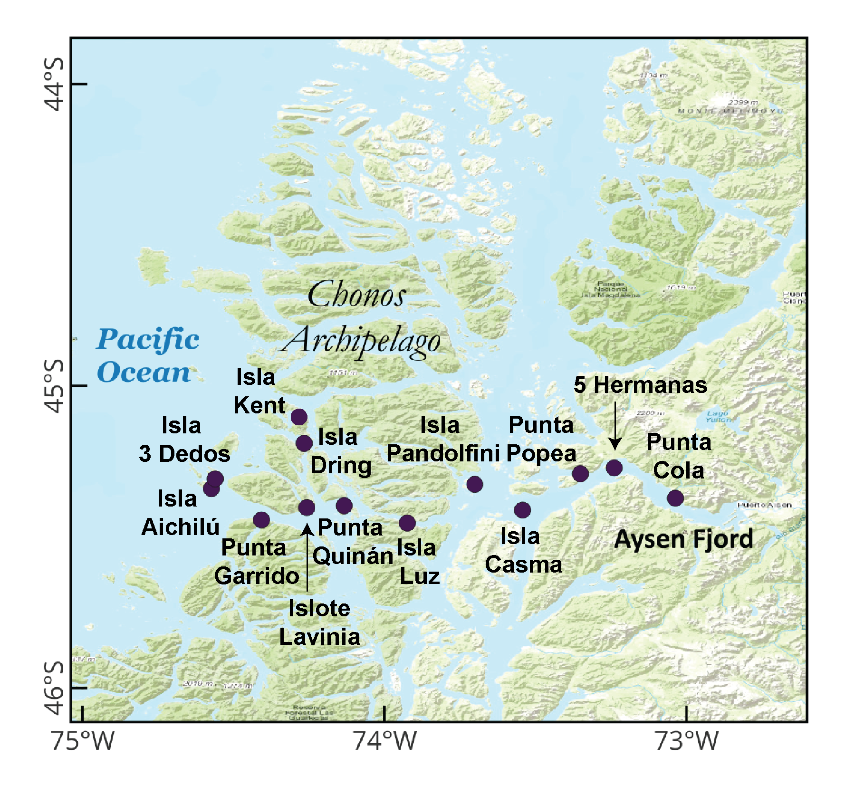Figure S1. Map of study sites with names of the stations sampled.
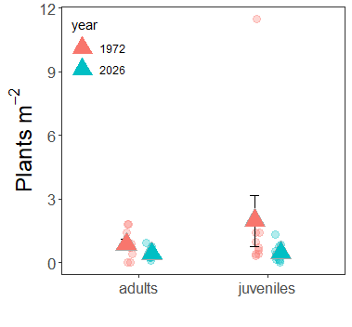
Figure S2. Density of plants across different life stages and the two study periods.

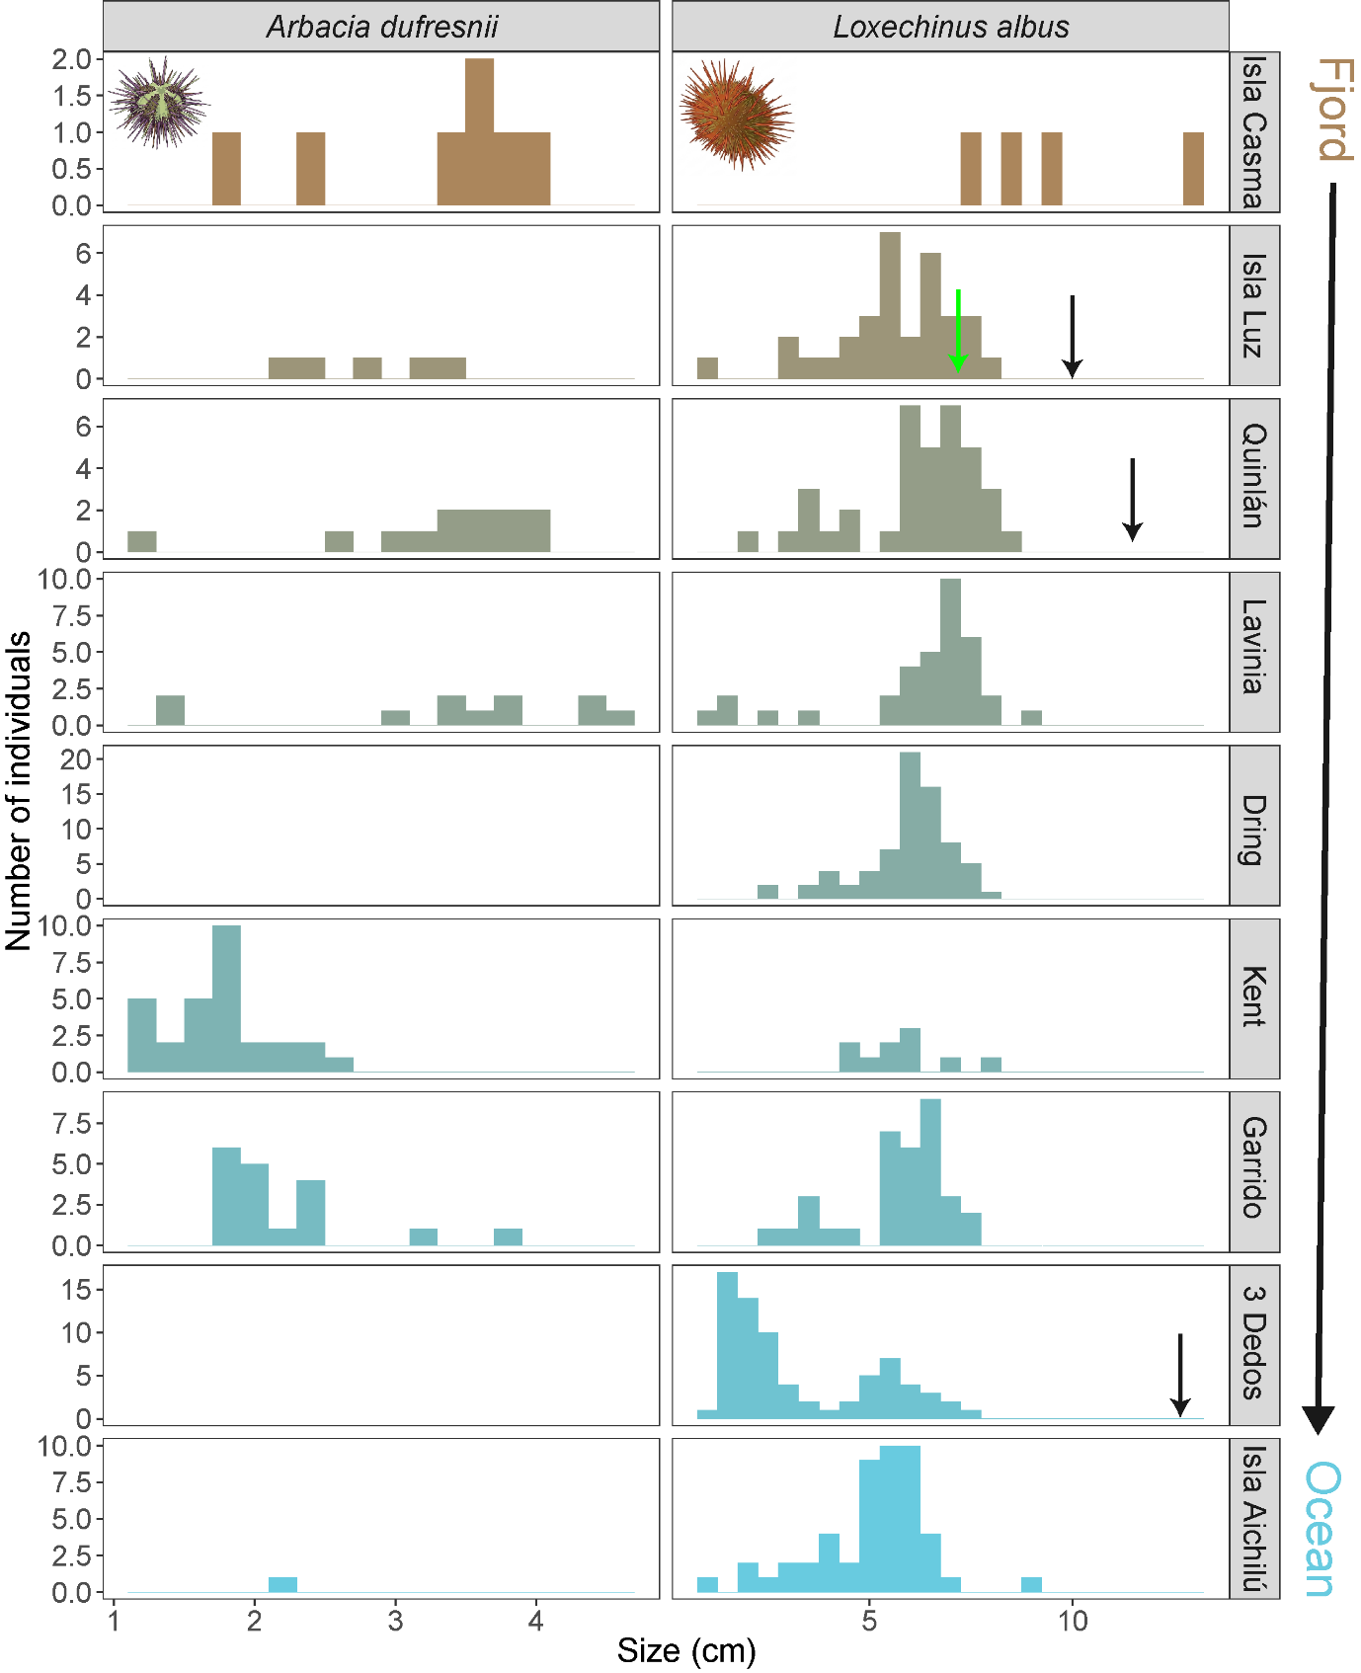
Figure S3. Size-frequency distribution of the two dominant sea urchin species across a subset of sites. Histogram size classes are set to 0.2 cm and 0.5 cm for Arbacia dufresnii and Loxechinus albus due to differences in total maximum size. Where available, black arrows indicate the maximum sea urchin size documented in November 1972 by Dayton, with green arrows showing the maximum size in May 1973.

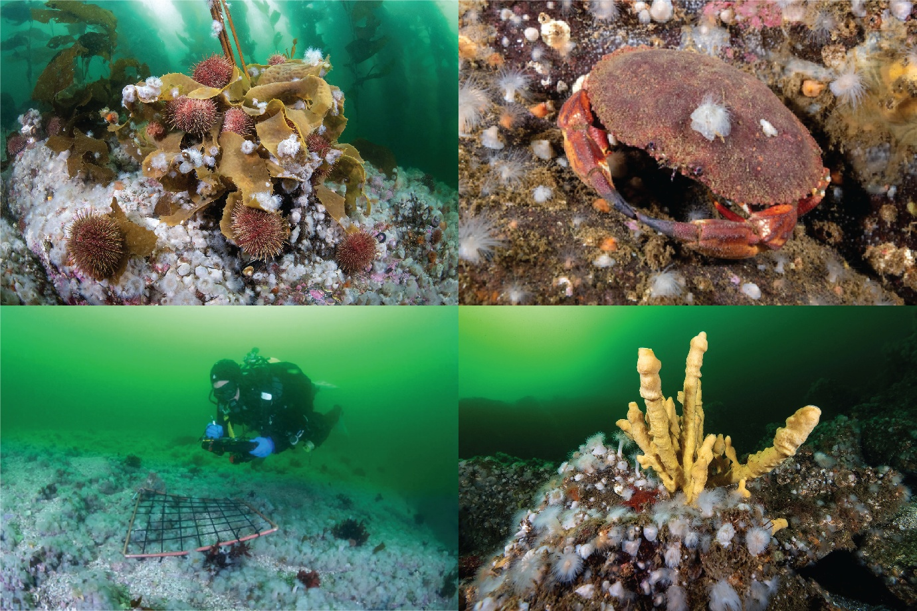
Figure S4. Metridium senile colonizing different substrates. Photo credits: Eduardo Sorensen/Rewilding Chile.

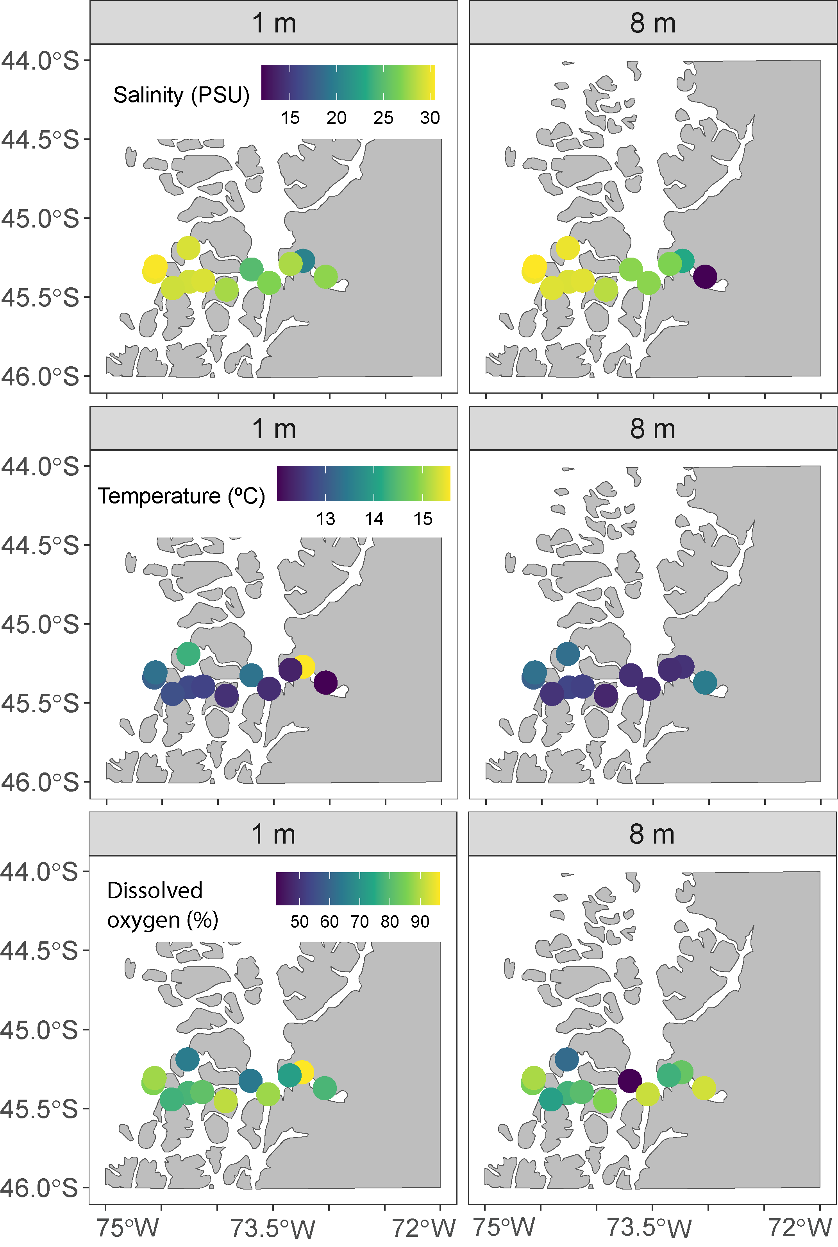
Figure S5. Environmental parameters across the study sites at 1 and 8 m depth (not corrected by tide).

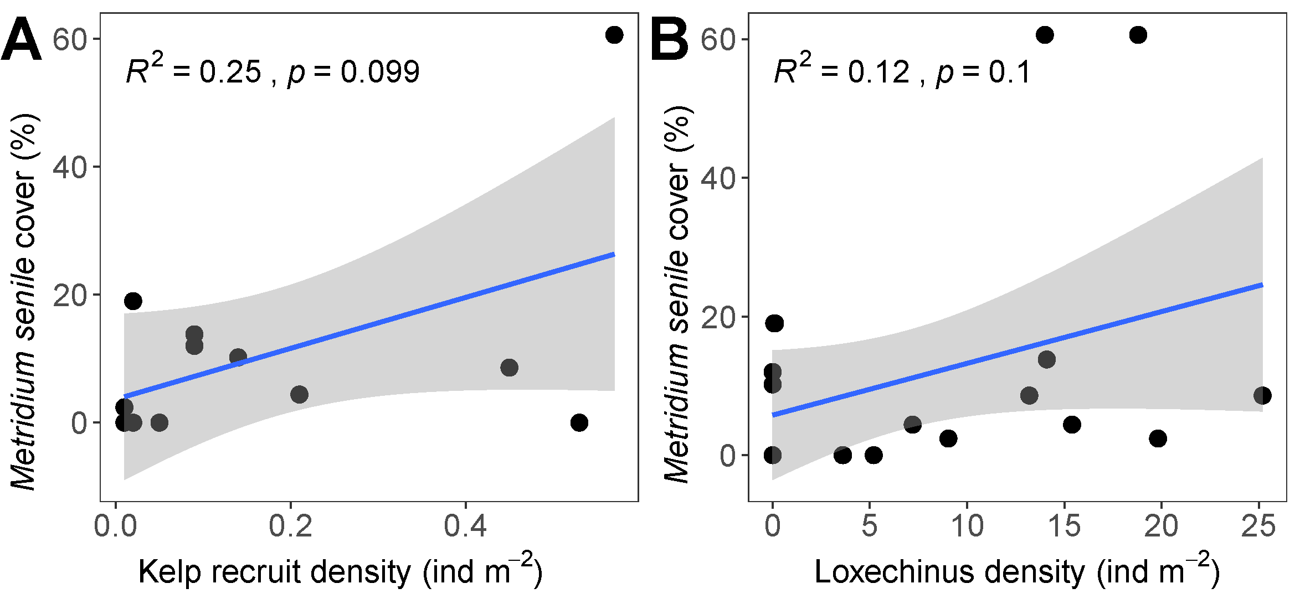

Figure S6. Relationship between average site-level Metridium senile cover and kelp recruit sea urchin (Loxechinus albus) density.

