Supplementary material of

“Country-scale forest carbon modelling to support national greenhouse gas inventories in Croatia and Slovakia”
Maša Zorana Ostrogović Sever¹, Laura Dobor², Ján Merganič³, Doroteja Bitunjac¹, Hrvoje Marjanović¹, Tomáš Hlásny², Mislav Anić⁴, Dóra Hidy⁵, Zoltán Barcza^{5,6}, Ivan Barka⁷, Petra Mendaš¹, Katarína Merganičová^{2,8}
¹ Croatian Forest Research Institute, Cvjetno naselje 41, 10450 Jastrebarsko, Croatia; masao@sumins.hr (MZOS); doroteja@sumins.hr (DB); hrvojem@sumins.hr (HM); petram@sumins.hr (PM)
² Faculty of Forestry and Wood Sciences, Czech University of Life Sciences Prague, Kamýcká 129,
165 00 Praha-Suchdol, Czech Republic; dobor.laura@gmail.com (LD); tomas.hlasny@gmail.com (TH); merganicova@fld.czu.cz (KM)
³ Forestry Faculty, Technical University Zvolen, T. G. Masaryka 24, 960 01 Zvolen, Slovakia; merganic@tuzvo.sk (JM)
⁴ Croatian Meteorological and Hydrological Service, Ravnice 48, 10000 Zagreb, Croatia; mislav.anic@cirus.dhz.hr (MA)
⁵ Global Change Research Institute, Czech Academy of Sciences 603 00 Brno, Czech Republic; dori.hidy@gmail.com (DH)
⁶ Institute of Geography and Earth Sciences, ELTE Eötvös Loránd University, Department of Meteorology, H-1117 Budapest, Pázmány P. sétány 1/A, Hungary; zoltan.barcza@ttk.elte.hu (ZB)
⁷ National Forest Centre, T.G. Masaryka 22, Zvolen, Slovakia; ivan.barka@nlcsk.org (IB)
⁸ Institute of Landscape Ecology, Slovak Academy of Sciences, Štefánikova 3, 814 99 Bratislava, Slovakia; katarina.merganicova@forim.sk (KM)
Corresponding author:
Maša Zorana Ostrogović Sever
Croatian Forest Research Institute, Cvjetno naselje 41, 10450 Jastrebarsko, Croatia; masao@sumins.hr; +385 99 3176 093
In this supplementary material we provide:
S1 Data and methods – EXTENDED: extended version of the section Data and methods of the main article, with its corresponding structure and accompanying tables and figures, and
S2 Results – ADDITIONAL: additional figures and tables

S1 Data and methods – EXTENDED

S1.1 Study area
Table S1 Main description parameters of the two case studies. Data source is given in brackets
Description parameter | Croatia | Slovakia
Total country area (kha) | 5,659.4 | 4,903.6
Total forest area (kha) | 2,759.0 [1] | 2,028.2 [3]
Total forested area (kha) ª | 2,311.0 [2] | 1,955.5 [3]
Productive forest area (kha) | 1,771.4 [2] | 1,422.7 [3]
Protective forest area (kha) | 474.3 [2] | 341.4 [3]
Strictly protected forest area (kha) ^{b} | 65.4 [2] | 87.9 [3]
Forest structural composition (high forests : coppice forests) | 86 : 14 [1] | 98 : 2 [3]
Forest owner composition (state : private) | 76 : 24 [1] | 51 : 49 [3]
Main tree species volume shares (%) | [1] | [3]
Common beech (Fagus sylvatica L.) | 37.2 | 35.4
Oaks (Quercus sp.) | 21.0 | 10.3
Norway spruce (Picea abies (L.) H. Karst.) | 2.3 | 21.1
Common hornbeam (Carpinus betulus L.) | 8.4 | 6.0
Silver fir (Abies alba Mill.) | 7.9 | 4.0
Pines (Pinus sp.) | 2.9 | 6.4
Sources | [1] ŠGOP (2016)  [2] NFAP (2019) | [3] ZS (2024)
ª Refers to total forest area excluding garigue & scrub (they do not meet the definition criteria for forest) and all uncovered area (e.g. roads, pipelines, water streams, swamps, clearings, barren land, infrastructure, etc). In line with the total forest area submitted in NFAP (2019).
^{b} Refers to forest areas where no biomass removal is allowed.

S1.2 Study design and workflow

S1.2.1 Stratification for modelling purposes

Environmental stratification - case study Croatia
The first level of stratification was built upon bioclimatic zones used in the First Croatian National Forest Inventory (CRONFI) (Čavlović 2010), which were slightly adjusted according to the Global Ecological Zones and differences in precipitation regimes. In particular, the mountain zone was enlarged to account for mountain Učka, which was originally situated within the Mediterranean CRONFI bioclimatic zone, and the lowland zone was divided into dry and wet parts to account for the east-west precipitation gradient. With adjustments, we tend to gain homogeneous conditions in each stratum regarding orography and climate to ensure that model results are representative for the entire stratum. In total, six bioclimatic zones were defined: lowland dry (LLD, 10%), lowland wet (LLW, 9%), submontane (SMTN, 48%), montane (MTN, 20%), sub-Mediterranean (SMED, 10%), and Mediterranean (MED, 3%). The second level of stratification refers to soil texture. Data on clay, silt and sand content were acquired from the SoilGrids 2.0 database (Poggio et al. 2021; ISRIC 2021), in original 250 m spatial resolution at depth of 0-5 cm, reprojected to WGS 84 projection (EPSG:4326) and clipped to the country boundaries. A soil texture map was created using the Build virtual raster tool in QGIS by assigning the clay variable to Band 1 (red), sand variable to Band 2 (green) and silt variable to Band 3 (blue) (Fig. S1). This provided the overview of the spatial distribution of soil texture at the country scale. Based on visual analysis, two main soil texture groups were defined: loamy soils (with clay content < 30%) and clayey soils (with clay content >= 30%). After classifying, the clay content raster was converted into a vector using the Polygonize tool in QGIS and two obtained polygons were overlaid over bioclimatic zones. In two bioclimatic zones (LLD and LLW), shares of these two soil texture groups were almost equal, while for other bioclimatic zones, one soil texture group prevailed. Therefore, only for LLD and LLW zones, additional stratification for soil texture was performed (LLDclayey, LLDloamy, LLWclayey, LLWloamy). The final stratification level included soil depth. Raster soil depth data were used from Križan et al. (2024). Using depth to bedrock layer, expressed in centimetres, for the SMTN bioclimatic zone there was a differentiation regarding soil depth into two areas: shallow soils (with depth <= 1 m), and deeper soils (with soil depth > 1 m). In total, 9 environmental strata were created for Croatia (Fig. S2). The environmental stratification of Croatia was performed in QGIS 3.34.1 Prizren environment (QGIS Development Team 2024).
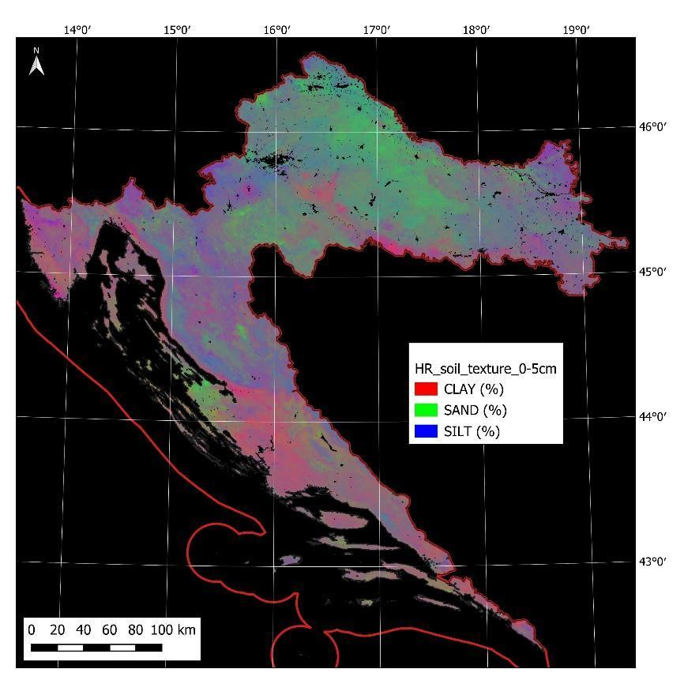
Fig. S1 Soil texture map of Croatia at the depth of 0-5 cm

Environmental stratification - case study Slovakia
The first level of stratification was based upon the concept of geobiotopes (Kulla and Bošeľa 2013). Geobiotopes were grouped into six site types (Kulla et al. 2019), hereafter referred to as bioclimatic zones: lowland dry (LLD, 8%), lowland wet (LLW, 11%), submontane (SMTN, 45%), montane (MTN, 31%), subalpine (SALP, 3%), and azonal (A, 2%). The second level of stratification was performed with regard to soil texture. Data on soil texture classes were acquired from the database called Forest soil units (NLC 2025a), which is based on the forest soil classification system of Slovak forests used by the National Forest Centre Zvolen. Similarly, as for Croatia, two main soil texture groups were defined: loamy soils (with clay content < 30%) and clayey soils (with clay content >= 30%). Afterwards, the soil map was overlaid with bioclimatic zones and environmental strata were obtained. For each of the bioclimatic zones, the shares of the two soil texture groups were calculated. In the SALP zone, loamy soils represented more than 99% of the area, due to which we did not consider the clayey soil group in this zone. A stratification based on soil depth was not performed since the majority of forest soils in Slovakia do not exceed 1m in depth. Hence, in total, we created 11 environmental strata for Slovakia. The stratification of Slovakia was performed in QGIS 3.38.0 Grenoble environment (QGIS Development Team 2024).

Forest stratification - case study Croatia
According to the National Forestry Accounting Plan (NFAP) (2019) total forested area of 2.31 mil. ha is stratified into three main forest categories: Deciduous, Coniferous and forests Out of yield (OOY). The last category is very heterogeneous, as it includes Mediterranean maquis and continental shrubs, and therefore, it is currently not possible to simulate its carbon stock dynamic with the BBGCMuSo model since it has not been parameterised for such an ecosystem type yet. Considering that the contribution of the OOY category to the net CO₂ emissions/removals under the LULUCF sector, currently accounting only for living biomass, makes 3.3% (HR NID 2025), it was justifiable to omit this category from the model simulations and account for its contribution from deadwood, litter and soil using a simple statistical estimate.
The remaining forested area (1,845.34 kha) is stratified into managed and unmanaged forests. Managed forests include all productive forest stands and are further divided with respect to management type into even-aged and uneven-aged stands. Unmanaged forests include strictly protected areas with no biomass removal. Protective forests are completely within the OOY category, which was not simulated. Further forest stratification was based on the main tree species. All forests were grouped into four main forest types: broadleaved oak-associated forests (hereafter referred to as oaks, 34%), beech-dominated forests (beech, 28%), fir-dominated forests (fir, 12%), and pine-associated forests (pines, 8%) (Table S2). All coppice stands, regardless of the tree species, were grouped together (coppice, 19%) (Table S2). Finally, even-aged stands were divided into age classes (from one to seven, depending on the species-specific rotation period), each of 20 years, except for the coppice group that had a 10-year age class width. In total, 54 forest strata were defined (Table S3).

Forest stratification - case study Slovakia
Forest area in Slovakia was stratified using the data from the Slovak national database of Forest Management Plans valid for the year 2023 (NLC 2025b). The total forested area was divided into managed and unmanaged forests. Managed forests included all productive forest stands. Unmanaged forests include all protective, strictly protected and special purpose forests, most of which are usually left to self-development. Further forest stratification was based on tree species. We grouped forests into four main forest types: broadleaved oak-associated forests (oaks, 27%), broadleaved beech-associated forests (beech, 37%), coniferous spruce-associated forests (spruce, 26%), and coniferous pine-associated forests (pines, 10%) (Table S2). All forests were further stratified into seven age classes, each of 20 years. In total, 56 forest strata were defined for Slovakia (Table S3).
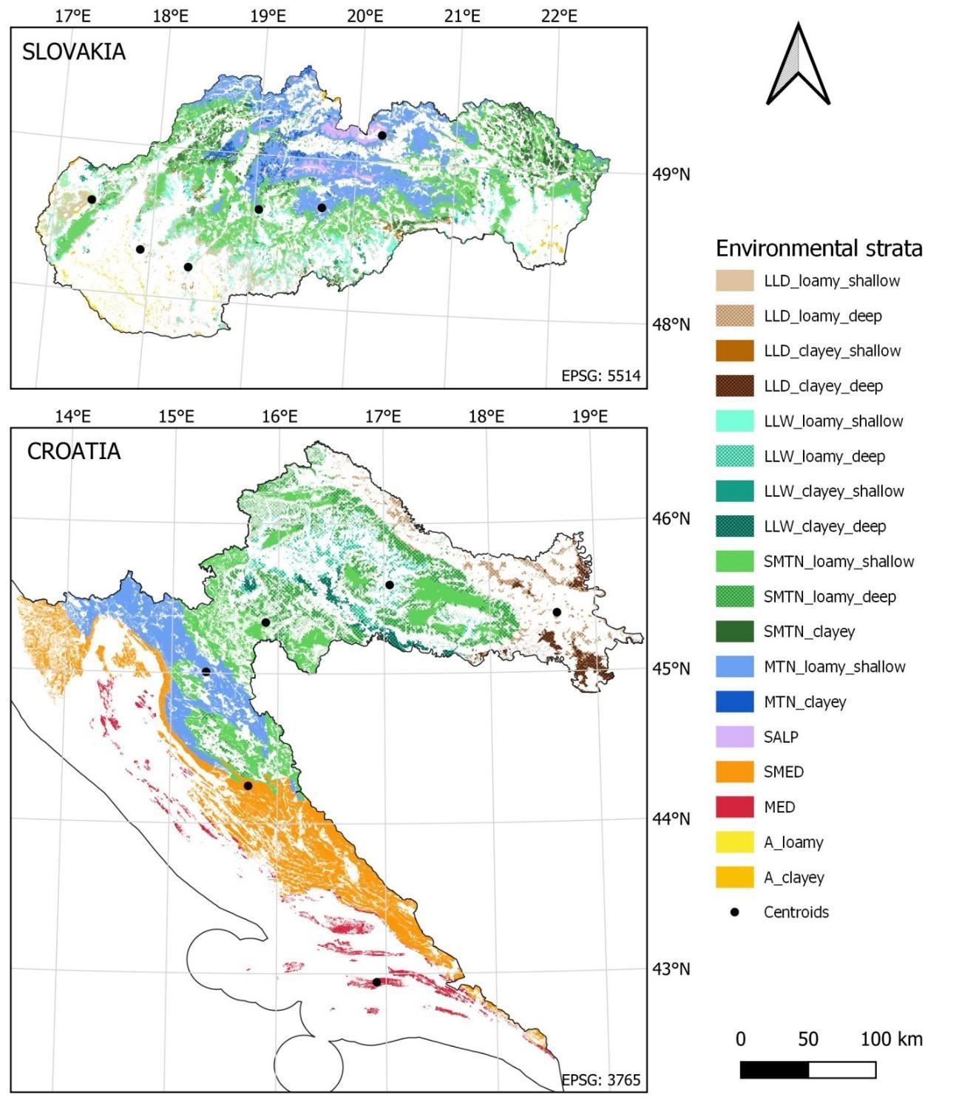
Fig. S2 Environmental stratification of Croatia and Slovakia into bioclimatic zones (LLD – Lowland dry, LLW – lowland wet, SMTN – submontane, MTN – montane, SALP – subalpine, SMED − sub-Mediterranean, MED – Mediterranean, A – azonal) by predominant soil type (loamy, clayey) and depth (shallow, deep) with indicated centroids for each zone.
Table S2 Forest stands grouped under main forest types
Forest type | Croatia | Slovakia
OAKS | - 72% of high forest stands of Quercus robur, Q. petraea and Q. cerris;  - 9% of high forest stands of Carpinus betulus;  - 19% of high forest stands of Fraxinus angustifolia and other broadleaved species (mainly Alnus glutionosa, Salix alba) | - 48% of forest area dominated Quercus robur, Q. petraea and Q. cerris;  - 22% Carpinus betulus;  - 30% other broadleaved species (mainly Robinia pseudoacacia, Betula spp., Salix spp., Alnus spp., Sorbus spp., Populus spp.)
BEECH | - 99% of high forest stands of Fagus sylvatica;  - 1% of high forest stands of other broadleaved species (Acer pseudoplatanus, Castanea sativa) | - 94% of forest area dominated by Fagus sylvatica;  - 6% other broadleaved species (mainly Fraxinus spp., Tilia spp., Ulmus spp., Acer spp.)
PINES | - 73% of high forest stands and monocultures of Pinus halepensis, P. nigra and P. sylvestris;  - 27% of all other monocultures | - 60% of forest area dominated by Pinus sylvestris;  - 25% Larix decidua;  - 10% Pinus mugo;  - 5% other Pinus spp.
FIR | - 98% of high forest stands dominated by Abies alba;  - 2% of high forest stands dominated by Picea abies | Under spruce forest type
SPRUCE | Under fir forest type | - 85% of forest area dominated by Picea abies;  - 15% by Abies alba
COPPICE | - 49% of Quercus pubescens, Q. cerris, Q. petraea and Q. ilex coppice stands;  - 27% of F. sylvestris coppice stands;  - 10% of C. betulus coppice stands;  - 14% of other broadleaved coppice stands (mainly Robinia pseudoacacia and C. sativa) | Under oaks forest type
Table S3 Forest stratification and management regimes applied in simulations of forest dynamics in Croatia and Slovakia. Age class is a group of stands within a 10-year age interval for coppice and 20-year age interval for other forest types (0-20, 21-40, etc.)
Country | Forest management | Forest type | Management regime | Thinning intensities (%) / Thinning frequency (y) | No. age-classes / forest strata | Forest area  (kha) | Forest area  (%)
Croatia | Even-aged (managed) | OAKS | MGM1 | 7–16 / 10 | 7 | 426.23 | 23.10
Croatia | Even-aged (managed) | BEECH | MGM2 | 9–16 / 10 | 6 | 251.19 | 13.61
Croatia | Even-aged (managed) | COPPICE | MGM3 | 10–16 / 10 | 6 | 81.32 | 4.41
Croatia | Even-aged (managed) | PINES | MGM4 | 11 / 10 | 5 | 94.12 | 5.10
Croatia | Uneven-aged (managed) | OAKS,  BEECH,  PINES,  FIR | MGM5 | 12 / 10 | 1 | 188.56 | 10.22
 |  |  |  |  | 1 | 247.23 | 13.40
 |  |  |  |  | 1 | 41.57 | 2.25
 |  |  |  |  | 1 | 204.15 | 11.06
Croatia | Uneven-aged (managed) | COPPICE | MGM6 | 6 / 10 | 1 | 269.95 | 14.63
Croatia | No active management (unmanaged) | OAKS | MGM7 | No biomass removal | 7 | 4.46 | 0.24
Croatia | No active management (unmanaged) | BEECH | MGM8 | No biomass removal | 6 | 17.82 | 0.97
Croatia | No active management (unmanaged) | COPPICE | MGM9 | No biomass removal | 6 | 3.34 | 0.18
Croatia | No active management (unmanaged) | PINES | MGM10 | No biomass removal | 5 | 3.79 | 0.21
Croatia | No active management (unmanaged) | FIR | MGM11 | No biomass removal | 1 | 11.61 | 0.63
Croatia | Total |  |  |  | 54 | 1,845.34 | 100.00
Slovakia | Managed | OAKS | MGM12 | 5–42 / 10 | 7 | 400.03 | 20.46
Slovakia | Managed | BEECH | MGM13 | 5–50 / 10 | 7 | 549.46 | 28.10
Slovakia | Managed | PINES | MGM14 | 4–24 / 10 | 7 | 111.48 | 5.70
Slovakia | Managed | SPRUCE | MGM15 | 5–31 / 10 | 7 | 361.93 | 18.51
Slovakia | No active management (unmanaged) | OAKS | MGM16 | No biomass removal | 7 | 125.26 | 6.41
Slovakia | No active management (unmanaged) | BEECH | MGM16 | No biomass removal | 7 | 188.96 | 9.66
Slovakia | No active management (unmanaged) | PINES | MGM16 | No biomass removal | 7 | 81.90 | 4.19
Slovakia | No active management (unmanaged) | SPRUCE | MGM16 | No biomass removal | 7 | 136.49 | 6.98
Slovakia | Total |  |  |  | 56 | 1,955.5 | 100.00

S1.2.2 Forest carbon simulations and upscaling

Meteorological dataset
Daily gridded data of the ERA Land reanalysis dataset were used for the period 1951-2023 to provide the meteorological conditions for the simulations. Centroids were defined for six bioclimatic zones in Croatia and six in Slovakia using a point-to-surface tool in the QGIS environment (QGIS Development Team 2024). Pixels including the centroids were selected from the meteorological database to obtain data for daily maximum, minimum temperature, precipitation and solar radiation data. Vapour pressure deficit (VPD) and daylength data were estimated using the MTCLIM Software (Hungerford et al. 1989). Site-specific elevation, needed for running the MTCLIM, was estimated from a 100m DM and site-specific slope, also required by the software, was assumed flat. Pre-industrial meteorological conditions were assumed for the spin-up simulation using the period of 1951-1985. Next, time series were expanded to the past until the year 1850 to allow the simulation of the oldest stands in 7th age-class at the age of 140 years, targeting the year 1990. Period 1850-1950 was constructed from a randomly sampled year time series from a period 1951-1985, then merged with the 1951-2023 time series. Finally, the constructed time-series from 1850 until 2023 were used in the model experiments. The simulated sites cover a wide climatic gradient (Fig. S3). In general, Croatian sites are warmer (all except the Croatian MTN). In Slovakia, the most distinct bioclimatic zone is the subalpine (SALP) with MAT lower than 5°C, and in Croatia, it is the Mediterranean (MED) with MAT higher than 15 °C. The wettest bioclimatic zones are SMED and MTN in Croatia.
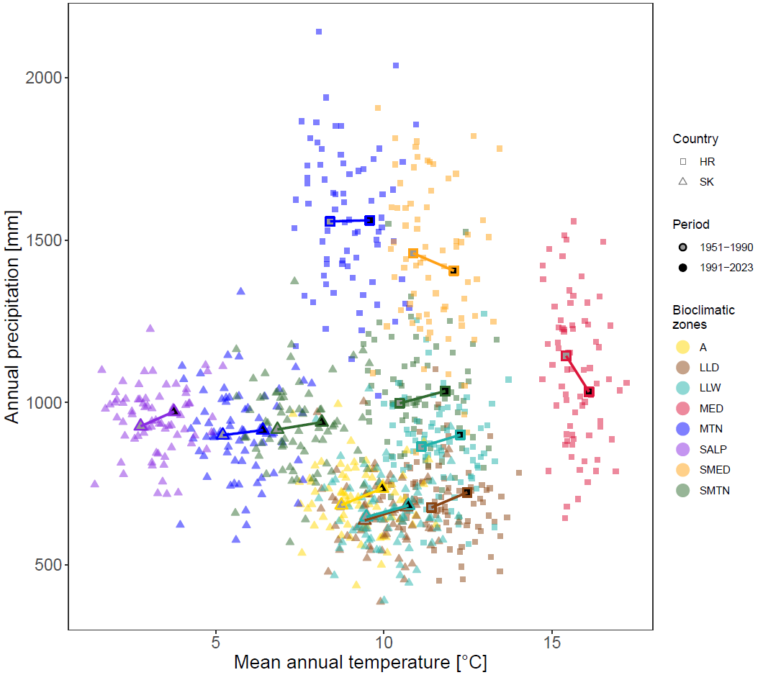
Fig. S3 Temperature and precipitation conditions of bioclimatic zones in Croatia and Slovakia

Eco-physiological parameters
Genus-specific parametrization for main forest types was based on the recent calibration studies (Bitunjac, 2024; Merganičová et al., 2024) and regional and cross-regional calibrations (unpublished results). For the coppice forest type, oaks parameters were used, given that oak species represent approximately 50% of the total coppice area (Table S2).
Within the current model structure, C allocation parameters (distribution of C into leaf, stem, and fine and coarse roots) are listed under eco-physiological parameters, although it is known that these parameters are highly sensitive to environmental conditions (Merganičová et al. 2019). To overcome this model limitation and address the plant plasticity to environmental conditions, we applied two, a priori C allocation schemes that represent investment patterns for the species under the different climate and soil conditions of the two countries (Fig. S3 and Fig. S4). This approach of parameter selection is known as the hybrid approach (Merganičová et al. 2024) as it combines parameters obtained from a multi-site calibration and site-specific parameters. The final list of eco-physiological parameters used in this research is given in Table S4.

Soil characteristics
The list of soil-related parameters used in this study is based on Hidy et al. (2022) and Merganičová et al. (2024). Soil characteristics specific to each bioclimatic zone were derived from the best available data sources for individual countries. Although the SoilGrids database was used for delineation of clay and loamy soil strata within specific bioclimatic regions in Croatia, it was not directly used as a source of soil texture and pH data due to the very poor accuracy of these variables (Radočaj et al. 2023). Mean clay, silt and sand content and mean pH were estimated from the database on forest ecosystem variables (ForecoDB) at 274 plots distributed across the country, collected within the project MODFLUX (HRZZ IP-2019-04-6325). Mean soil depth for Croatia was derived from Križan et al. (2024). For Slovakia, the national database called Forest soil units (NLC 2025a) was used to derive the mean soil depth and the proportions of clay, silt and sand for each environmental stratum.
Overall, sites are characterized by very different soil texture properties (Fig. S4). Similarly, to climate, soils in countries substantially differ, with Croatian soils having a much lower proportion of sand than soils in Slovakia. Moreover, Slovak sites have a more pronounced distinction between clayey and loamy sites, that is not clearly visible at the Croatian sites. The Slovak SALP bioclimatic zone is the most different from all others with more than 60% of sand and the lowest share of clay. Two bioclimatic zones with the highest clay content are SMED and MED in Croatia. The final list of soil-related parameters used in this research is given in Table S5).
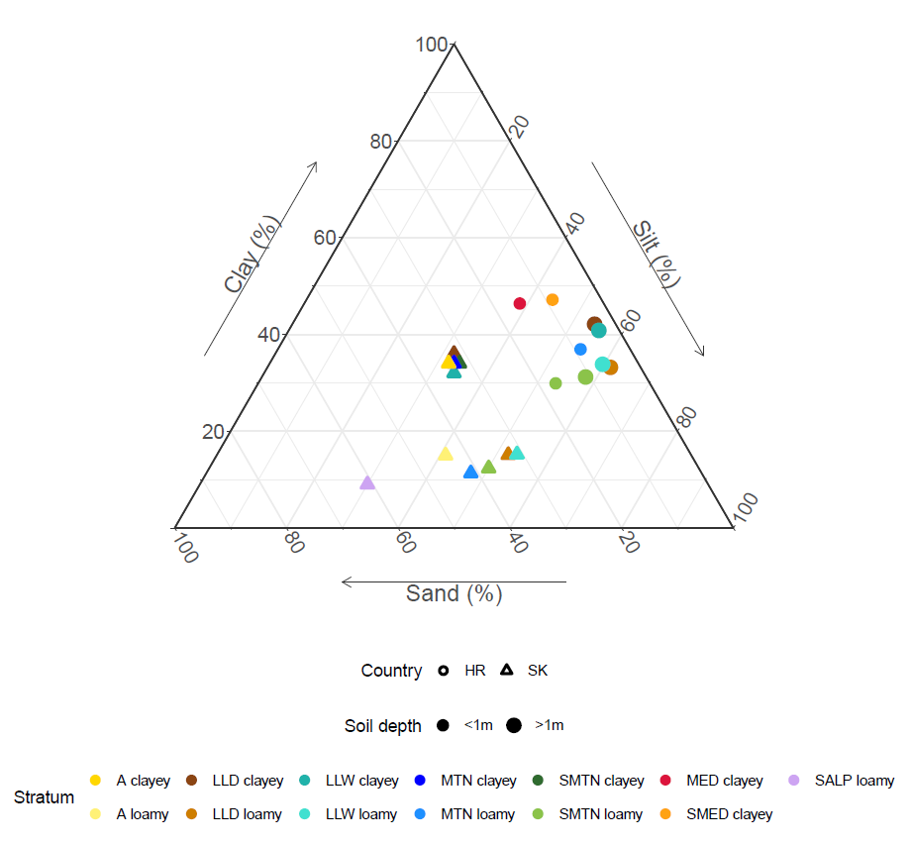
Fig. S4 Soil texture diagram of environmental strata in Croatia and Slovakia

Forest management regimes
Forest management is simulated through prescribed thinning frequency and intensity, which affects biomass pools (Hidy et al. 2016), while the timing of the final harvest indirectly determines stand age. For both case studies, the business-as-usual (BAU) forest management regimes were defined based on nationally available data. For Croatia, rotation periods and thinning frequencies were defined based on the Ordinance on forest management (POUŠ 2018), while thinning rates were estimated from thinning and harvest intensities published in NFAP (2019). For Slovakia, the BAU forest management was defined based on national yield tables (Halaj and Petráš 1998). For each main species in every environmental stratum, we calculated the mean site index from the Slovak national database of Forest Management Plans valid for the year 2023 (NLC 2025b), which determined thinning intensities taken from yield tables (Halaj and Petráš 1998, Table 2).
For both case studies the final cut at the end of the rotation period was simulated as 100% cut down wood, out of which 90% was extracted from forest. All together, we defined 16 different management regimes for both countries (Table S3).
Table S4 Eco-physiological constants for the Biome-BGCMuSo v6.2 model, for different forest types. Species-specific parameters are obtained from the following sources: 1) for beech from Merganičová et al. (2024), 2) for oaks from Bitunjac (2024) and calibration conducted using data from five Eastern European countries (Merganičová et al. 2024) (unpublished results), 3) for fir/spruce from calibration conducted using data from five Eastern European countries (Merganičová et al. 2024) (unpublished results), and 4) for pines from calibration conducted using data from five Eastern European countries (Merganičová et al. 2024) (unpublished results) and calibration modelling study in Istria (unpublished results).
Parameter name | Unit | Forest types |  |  |  | Remarks
Parameter name | Unit | BEECH | OAKS/COPPICE | FIR/SPRUCE | PINES | Remarks
biome type flag (1 = woody 0 = non-woody) | (flag) | 1 | 1 | 1 | 1
woody type flag (1 = evergreen 0 =deciduous) | (flag) | 0 | 0 | 1 | 1
photosynthesis type flag (1 = C3 PSN 0 = C4 PSN) | (flag) | 1 | 1 | 1 | 1
transfer growth period as fraction of growing season | (prop.) | 0.2 | 0.3 | 0.3 | 0.3
litterfall as fraction of growing season | (prop.) | 0.2 | 0.3 | 0.3 | 0.3
base temperature | (Celsius) | 5 | 5 | 5 | 0
annual leaf and fine root turnover fraction | (1/yr) | 1 | 1 | 0.195 | 0.14
annual live wood turnover fraction | (1/yr) | 0.7 | 0.7 | 0.7 | 0.7
annual fire mortality fraction | (1/yr) | 0 | 0 | 0 | 0
whole-plant mortality fraction in vegetation period | (1/year) | 0.02 | 0.015 | 0.005 | 0.013
C:N of leaves | (kgC/kgN) | 26.9 | 22.76 | a) 38.56135  b) 38.95 | 33.1 | Country-specific data for Slovakia (a), and for Croatia (b).
C:N of leaf litter, after retranslocation | (kgC/kgN) | 44 | 33.96 | a) 50.6  b) 48.35 | 132 | Country-specific data for Slovakia (a), and for Croatia (b).
C:N of fine roots | (kgC/kgN) | 47.6 | 43 | 45 | 38
C:N of fruit | (kgC/kgN) | 33 | 66.42 | 59 | 0
C:N of soft stem | (kgC/kgN) | 0 | 0 | 0 | 0
C:N of live wood | (kgC/kgN) | 50 | 73.5 | 50 | 50
C:N of dead wood | (kgC/kgN) | 550 | 451 | 535 | 1400
leaf litter labile proportion | (DIM) | 0.124 | 0.2 | 0.44 | 0.257
leaf litter cellulose proportion | (DIM) | 0.561 | 0.56 | 0.35 | 0.493
fine root labile proportion | (DIM) | 0.34 | 0.34 | 0.427 | 0.252
fine root cellulose proportion | (DIM) | 0.44 | 0.44 | 0.381 | 0.495
fruit litter labile proportion | (DIM) | 0.3 | 0.3 | 0.68 | 0
fruit litter cellulose proportion | (DIM) | 0.29 | 0.29 | 0.23 | 0
soft stem litter labile proportion | (DIM) | 0 | 0 | 0 | 0
soft stem litter cellulose proportion | (DIM) | 0 | 0 | 0 | 0
dead wood cellulose proportion | (DIM) | 0.77 | 0.75 | 0.71 | 0.71
canopy water interception coefficient | (1/LAI/d) | 0.034 | 0.038 | 0.036 | 0.051
canopy light extinction coefficient | (DIM) | 0.661627 | 0.54 | 0.67 | 0.7
potential radiation use efficiency | (g/MJ) | 2 | 2 | 2 | 3.67
radiation parameter1 (Jiang et al.2015) | (DIM) | 0.781 | 0.781 | 0.781 | 0.781
radiation parameter2 (Jiang et al.2015) | (DIM) | -13.596 | -13.596 | -13.596 | -13.596
all-sided to projected leaf area ratio | (DIM) | 2 | 2 | 2.6 | 2.6
ratio of shaded SLA:sunlit SLA | (DIM) | 2 | 2 | 2 | 2
fraction of leaf N in Rubisco | (DIM) | 0.1383 | 0.12 | 0.12 | 0.17
maximum stomatal conductance (projected area basis) | (m/s) | 0.005102 | 0.007 | 0.003 | 0.001
cuticular conductance (projected area basis) | (m/s) | 0.00006 | 0.00006 | 0.00006 | 0.00001
boundary layer conductance (projected area basis) | (m/s) | 0.01 | 0.005 | 0.05 | 0.009
maximum depth of rooting zone | (m) | 2 | 3 | 0.5 | 2
root distribution parameter | (DIM) | 3.67 | 1.5 | 3.67 | 3.67
root weight corresponding to max root depth | (kgC/m²) | 0.4 | 0.4 | 0.4 | 0.4
root depth function shape parameter (slope) | (DIM) | 0.5 | 0.5 | 0.5 | 0.5
root weight to root length conversion factor | (m/kg) | 1000 | 1000 | 1000 | 1000
growth resp per unit of C grown | (DIM) | 0.3 | 0.3 | 0.2 | 0.3
maintenance respiration in kgC/day per kg of tissue N | (kgC/kgN/d) | 0.218 | 0.218 | 0.35 | 0.24
theoretical maximum prop. of non-structural and structural carbohydrates | (DIM) | 0.1 | 0.1 | 0.1 | 0.1
prop. of non-structural carbohydrates available for maintenance respiration | (DIM) | 0.3 | 0.3 | 0.1 | 0.1
symbiotic+asymbiotic fixation of N | (kgN/m²/yr) | 0.009111 | 0.0023 | 0.0005 | 0.01
time delay for temperature in photosynthesis acclimation | (day) | 10 | 10 | 10 | 0
SWC ratio to calc. soil moisture limit 1 (prop. to FC-WP) | (prop) | 0.1 | 0.1 | 0.1 | 0.1
SWC ratio to calc. soil moisture limit 2 (prop. to SAT-FC) | (DIM) | 0.99 | 0.985 | 0.99 | 0.99
minimum of soil moisture limit2 multiplicator (full anoxic stress value) | (prop) | 0.4 | 0.4 | 0.4 | 0.4
vapor pressure deficit: start of conductance reduction | (Pa) | 600 | 200 | 500 | 500
vapor pressure deficit: complete conductance reduction | (Pa) | 2910 | 2550 | 3500 | 2500
maximum senescence mortality coefficient of aboveground plant material | (prop.) | 0.001 | 0.001 | 0.00025 | 0.00001
maximum senescence mortality coefficient of belowground plant material | (prop.) | 0.001 | 0.001 | 0.001 | 0.001
maximum senescence mortality coefficient of non-structured plant material | (prop.) | 0.0001 | 0.0001 | 0.0001 | 0.0001
lower limit extreme high temperature effect on senescence mortality | (Celsius) | 30 | 30 | 35 | 35
upper limit extreme high temperature effect on senescence mortality | (Celsius) | 40 | 40 | 40 | 40
turnover rate of wilted standing biomass to litter | (prop.) | 0.01 | 0.01 | 0.01 | 0.01
turnover rate of non-woody cut-down biomass to litter | (prop.) | 0.01 | 0.05 | 0.01 | 0.01
turnover rate of woody cut-down biomass to litter | (prop.) | 0.0009 | 0.0009 | 0.0009 | 0.0009
drought tolerance parameter (critical value of DSWS) | (prop.) | 100 | 100 | 100 | 100
effect of soil stress factor on photosynthesis (1: full effect, 0: no effect) | (dimless) | 0 | 0 | 0 | 0
crit. amount of snow limiting photosyn. | (kg/m2) | 5 | 5 | 5 | 5
limit1 (under:full constrained) of HEATSUM index | (Celsius) | 1 | 1 | 0 | 0
limit2 (above:unconstrained) of HEATSUM index | (Celsius) | 10 | 10 | 5 | 5
limit1 (under:full constrained) of TMIN index | (Celsius) | -2 | -2 | -2 | -2
limit2 (above:unconstrained) of TMIN index | (Celsius) | 5 | 5 | 3 | 3
limit1 (above:full constrained) of VPD index | (Pa) | 4000 | 4000 | 5000 | 5000
limit2 (under:unconstrained) of VPD index | (Pa) | 1000 | 1000 | 2000 | 2000
limit1 (under:full constrained) of DAYLENGTH index | (s) | 0 | 0 | 0 | 0
limit2 (above:unconstrained) of DAYLENGTH index | (s) | 0 | 0 | 0 | 0
moving average (to avoid the effects of extreme events) | (day) | 10 | 10 | 10 | 10
GSI limit1 (greater that limit -> start of vegper) | (dimless) | 0.1 | 0.1 | 0.1 | 0.1
length of phenophase | (Celsius) | 100000 | 100000 | 100000 | 100000
leaf ALLOCATION | (ratio) | a) 0.173  b) 0.2024 | 0.2024 | 0.3308 | c) 0.211  d) 0.198 | a) Slovakia, based on original calibration;  b) Croatia, a-priori based on available data for deciduous forests;  c) Slovakia, based on regional calibration (unpublished results);  d) Croatia, based on regional calibration (unpublished results)
fine root ALLOCATION | (ratio) | a) 0.094  b) 0.3006 | 0.3006 | 0.1759 | c) 0.11  d) 0.198
fruit ALLOCATION | (ratio) | 0.000 | 0 | 0 | 0
soft stem ALLOCATION | (ratio) | 0.000 | 0 | 0 | 0
live woody stem ALLOCATION | (ratio) | a) 0.101  b) 0.059 | 0.059 | 0.0285 | c) 0.031  d) 0.032
dead woody stem ALLOCATION | (ratio) | a) 0.556  b) 0.343 | 0.343 | 0.3539 | c) 0.495  d) 0.388
live coarse root ALLOCATION | (ratio) | a) 0.012  b) 0.015 | 0.015 | 0.0065 | c) 0.009  d) 0.014
dead coarse root ALLOCATION | (ratio) | a) 0.064  b) 0.08 | 0.08 | 0.1044 | c) 0.144  d) 0.17
canopy average specific leaf area (projected area basis) | (m²/kgC) | 34.5 | 34.5 | 9.4 | 13
current growth proportion | (prop.) | 0.5 | 0.5 | 0.5
maximum lifetime of plant tissue | (°Cd) | 10000 | 10000 | 10000

Table S5 Soil-related parameters for the Biome-BGCMuSo v6.2 model. The main list is obtained from Hidy et al. (2022) with adjustments according to Merganičová et al. (2024).
Parameter name | Unit | Value | Remark
SOIL GENERIC PARAMETERS
depth of soil | (m) | 1 | site-specific
C:N ratio of stable soil pool (soil4) | (ppm) | 12
NH₄ mobilen proportion | (prop.) | 0.1
aerodynamic resistance (Wallace and Holwill, 1997) | (s/m) | 107
DECOMPOSITION, NITRIFICATION AND DENITRIFICATION PARAMETERS
parameter 1 for tscalar function of decomposition | (dimless) | 1.75
parameter 2 for tscalar function of decomposition | (dimless) | 17
parameter 3 for tscalar function of decomposition | (dimless) | 2.6
parameter 4 for tscalar function of decomposition | (dimless) | 40
minimum soil temperature for decomposition | (Celsius) | -10
e-folding depth of decomposition rate depth scalar | (m) | 10
net mineralization proportion of nitrification | (prop.) | 0.2
maximum nitrification rate | (1/day) | 0.1
coefficient of N₂O emission of nitrification | (prop.) | 0.02
parameter 1 for pHscalar function of nitrification | (dimless) | 0.15
parameter 2 for pHscalar function of nitrification | (dimless) | 1
parameter 3 for pHscalar function of nitrification | (dimless) | 5.2
parameter 4 for pHscalar function of nitrification | (dimless) | 0.55
parameter 1 for tscalar function of nitrification | (dimless) | 1
parameter 2 for tscalar function of nitrification | (dimless) | 12
parameter 3 for tscalar function of nitrification | (dimless) | 2.6
parameter 4 for tscalar function of nitrification | (dimless) | 30
minimum WFPS for scalar of nitrification calculation | (prop.) | 0.1
lower optimum WFPS for scalar of nitrification calculation | (prop.) | 0.45
higher optimum WFPS for scalar of nitrification calculation | (prop.) | 0.55
minimum value for saturated WFPS scalar of nitrification calculation | (prop.) | 0.2
soil respiration related denitrification rate | (1/gCO₂) | 0.05
denitrification related N₂/N₂O ratio multiplier | (dimless) | 2
critical WFPS value for denitrification | (prop) | 0.55
RATE SCALARS
respiration fractions for fluxes between compartments (l1s1) | (DIM) | 0.39
respiration fractions for fluxes between compartments (l2s2) | (DIM) | 0.77
respiration fractions for fluxes between compartments (l4s3) | (DIM) | 0.406
respiration fractions for fluxes between compartments (s1s2) | (DIM) | 0.28
respiration fractions for fluxes between compartments (s2s3) | (DIM) | 0.646
respiration fractions for fluxes between compartments (s3s4) | (DIM) | 0.55
rate constant scalar of labile litter pool – RCS1 | (1/day) | 0.7
rate constant scalar of cellulose litter pool – RCS2 | (1/day) | 0.042
rate constant scalar of lignin litter pool – RCS3 | (1/day) | 0.0084
rate constant scalar of fast microbial recycling pool – RCS4 | (1/day) | 0.07
rate constant scalar of medium microbial recycling pool – RCS5 | (1/day) | 0.014
rate constant scalar of slow microbial recycling pool – RCS6 | (1/day) | 0.0014
rate constant scalar of recalcitrant SOM (humus) pool – RCS7 | (1/day) | 0.0001
rate constant scalar of physical fragmentation of coarse woody debris – RCS8 | (1/day) | 0.00024
limit of first stage evaporation | (mm) | 9.6
maximum height of pond water | (mm) | 32
curvature of soil stress function | (dimless) | 0.4
measured runoff curve number (0: no runoff, -9999: model estimation) | (dimless) | -9999
fraction of dissolved part of SOIL1 organic matter | (prop.) | 0.0015
fraction of dissolved part of SOIL2 organic matter | (prop.) | 0.0015
fraction of dissolved part of SOIL3 organic matter | (prop.) | 0.001
fraction of dissolved part of SOIL4 organic matter | (prop.) | 0.001
surface residue (e.g. mulch) parameter: layer effect | (dimless) | 2
surface residue (e.g. mulch) parameter: critical amount | (kgC/m2) | 1
parameter 1 for surface residue function | (dimless) | 100
parameter 2 for surface residue function | (dimless) | 0.75
parameter 3 for surface residue function | (dimless) | 0.75
surface residue parameter: evaporation reduction | (dimless) | 0.5
parameter 1 for diffusion calculation (tipping) | (dimless) | 0.88
parameter 2 for diffusion calculation (tipping) | (dimless) | 35.4
parameter 3 for diffusion calculation (tipping) | (dimless) | 100
flag for GW-method | (flag) | 0
capillary fringe [m] | (m) | -9999
CH4 PARAMETERS
soil CH₄ emission bulk density dependence parameter1 | (DIM) | 212.5
soil CH₄ emission bulk density dependence parameter2 | (DIM) | 1.81
soil CH₄ emission soil water content dependence parameter1 | (DIM) | -1.353
soil CH₄ emission soil water content dependence parameter2 | (DIM) | 0.2
soil CH₄ emission soil water content dependence parameter3 | (DIM) | 1.781
soil CH₄ emission soil water content dependence parameter4 | (DIM) | 6.786
soil CH₄ emission soil temperature dependence parameter1 | (DIM) | 0.01
SOIL COMPOSITION AND CHARACTERISTIC VALUES (-9999: no measured data)
sand percentage by volume in rock‑free soil | (%) | 13.2 | site-specific
silt percentage by volume in rock-free soil | (%) | 40.8 | site-specific
soil pH | (dimless) | 5.1 | site-specific
soilB | (dimless) | -9999
bulk density | (g/cm3) | -9999
SWC at saturation | (m3/m3) | -9999
SWC at field capacity | (m3/m3) | -9999
SWC at wilting point | (m3/m3) | -9999
SWC at hygroscopic water content | (m3/m3) | -9999
drainage coefficient | (dimless) | -9999
hydraulic conductivity at saturation | (cm/day) | -9999

S1.2.3 Model validation
Table S6 Country-specific variants of conversion factors. BWD – basic wood density, BEF – biomass expansion factor, CF – carbon fraction
Country | Var | Conv. factors | EPC |  |  |  |  |  | Source
Country | Var | Conv. factors | BEECH | OAKS | PINES | SPRUCE | FIR | COPPICE | Source
Croatia | 1 | BWD | 0.560 | 0.560 | 0.390 |  | 0.390 | 0.680 | HR NID 2025
Croatia | 1 | BEF | 1.190 | 1.190 | 1.040 |  | 1.040 | 1.150 | HR NID 2025
Croatia | 1 | CF | 0.480 | 0.480 | 0.510 |  | 0.510 | 0.470 | HR NID 2025
Croatia | 2 | BWD | 0.589 | 0.581 | 0.479 |  | 0.501 | 0.762 | Bitunjac et al. 2023
Croatia | 2 | BEF | 1.39 | 1.35 | 1.34 |  | 1.3 | 1.35 | Wirth et al. 2004
Croatia | 2 | CF | 0.4887 | 0.489 | 0.51 |  | 0.489 | 0.478 | Bitunjac et al. 2023
Slovakia | 3 | BWD | 0.68 | 0.65 | 0.5 | 0.4 |  |  | SK NID 2025
Slovakia | 3 | BEF | 1.154 | 1.356 | 1.351 | 1.122 |  |  | SK NID 2025¹
Slovakia | 3 | CF | 0.48 | 0.48 | 0.51 | 0.51 |  |  | SK NID 2025
Slovakia | 4 | BWD | 0.57 | 0.55 | 0.43 | 0.38 |  |  | Merganič et al. 2017
Slovakia | 4 | BEF | 1.358 | 1.549 | 1.509 | 1.253 |  |  | Yield tables²
Slovakia | 4 | CF | 0.48 | 0.48 | 0.51 | 0.51 |  |  | SK NID 2025
¹ BEF estimated as the mean value of all years in the GHG reporting.
² BEF estimated from a geometric mean of the volumes in Yield tables.

S1.2.4 Application of the model results in National GHG reporting
Simulations of deadwood, litter, and soil carbon stocks during the reporting period 1990-2023 (HR NID 2025, SK NID 2025) were used to estimate carbon stocks change (CSC) factors that can be directly used in the calculation of net CO₂ emissions/removals in the Common Reporting Tables (CRT) of the National GHG inventories. Strata-wise model results need to be multiplied by the area they represent to be upscaled to the country level, therefore, in the case of a large stratum, a substantial decrease in C stocks can be expected in the year when this stratum reaches its rotation age in simulations. To overcome this issue, we used slope parameters of the carbon stock dynamics over the reporting period as proxies of an average carbon stock change of the corresponding pool instead of using annual changes.
In the case of Croatia, the reporting subcategory Forest land remaining forest land (FL-FL) is further stratified into Deciduous forests, Coniferous forests and forests Out of yield (HR NID 2025). CSC factors were therefore estimated separately for deciduous forests (represented by the beech and oaks) and coniferous forests (represented by pines and fir). Forests Out of yield were not included in the simulations due to the limitations described in Section S1.2.1 (Forest stratification – case study Croatia). Net CO₂ emissions/removals under deadwood, litter and soil within this category were estimated as follows:
$OOY=\sum_{n=1}^{i}{\frac{{OOY}_{LB}×\left({DEC}_{i}+{CON}_{i}\right)}{1- {OOY}_{LB}}}$; $i=\left\{deadwood, litter, mineral soil\right\}$ (Eq. S1)
where OOY - net CO₂ emissions/removals from deadwood, litter and mineral soil carbon pool under forests Out of yield, OOY_{LB} – share of net CO₂ emissions/removals of live biomass in the total net CO₂ emissions/removals under forest Out of yield (3.3%), DEC - net CO₂ emissions/removals under deciduous forests, CON - net CO₂ emissions/removals under coniferous forests, i - carbon pools (deadwood, litter and mineral soil).
Applying the estimated CSC factors for the missing pools in each country (deadwood, litter and mineral soil in Croatia, and litter and mineral soil in Slovakia), and adding the contribution of the OOY subcategory in the case of Croatia, we recalculated net CO₂ emissions/removals following the calculation method presented in the diagram (Fig. S5).
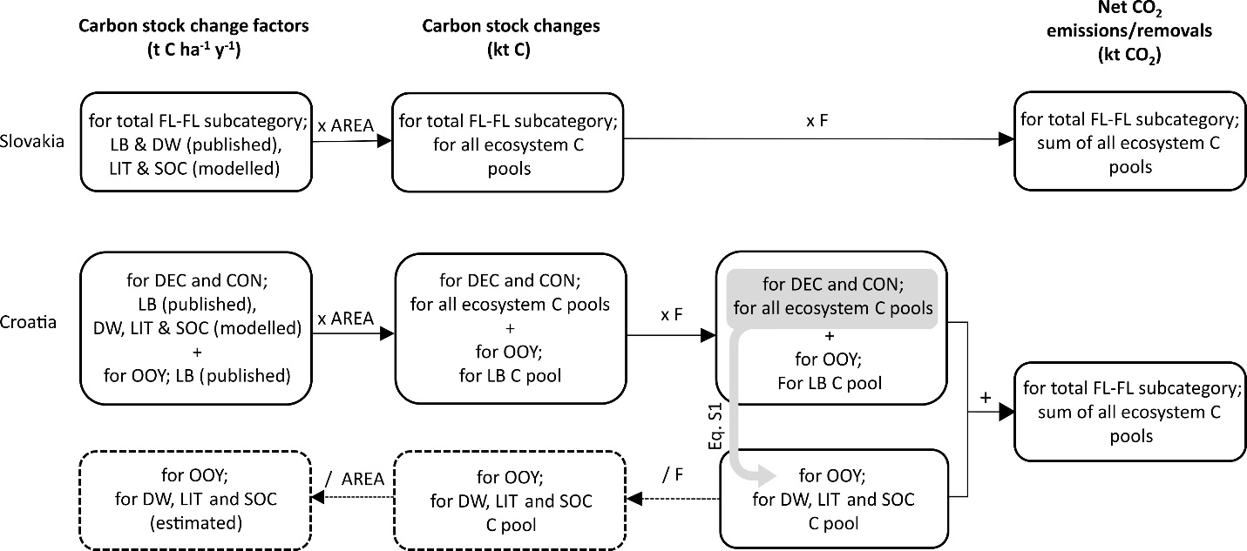
Fig. S5 Calculation method. FL-FL – Forest land remaining forest land; DEC - deciduous forests; CON - coniferous forests; OOY - forests Out of yield; LB – living biomass; DW – deadwood; LIT – litter; SOC – mineral soil; F – factor for conversion of C to CO₂

S1.3 Workflow sensitivity and uncertainty assessment
Environmental stratification-related sensitivity was approximated by quantifying the area-weighted variability (coefficient of variation, CV) of simulated growing stock (GS) among environmental strata within each forest stratum, using an area-weighted standard deviation (SD_{w}) as the basis for aggregation. Management scenario-related sensitivity was quantified by comparing growing stock variability among alternative management regimes while allowing associated age-class distributions to vary, thereby capturing the combined effects of management practices and stand development dynamics on simulated growing stock. Both approaches were applied because alternative stratification schemes or management options could not be explicitly evaluated.
Uncertainty due to the use of different conversion factors was quantified by calculating variability of growing stock estimates obtained using four alternative combinations of conversion factors (i.e., biomass expansion factors, basic wood density, and carbon fraction), applied to the simulated aboveground wood carbon stocks. Similarly, stocking correction uncertainty was quantified by calculating relative difference in growing stock estimates between model outputs with and without application of the stocking correction factor.
Upscaling uncertainty was quantified by Monte Carlo propagation of model residuals derived from the validation dataset, where residual errors were repeatedly sampled and added to modelling strata-level growing stock estimates to generate an ensemble of country-scale growing stock estimates, with the coefficient of variation of this ensemble representing the propagated uncertainty.

S2 Results - ADDITIONAL
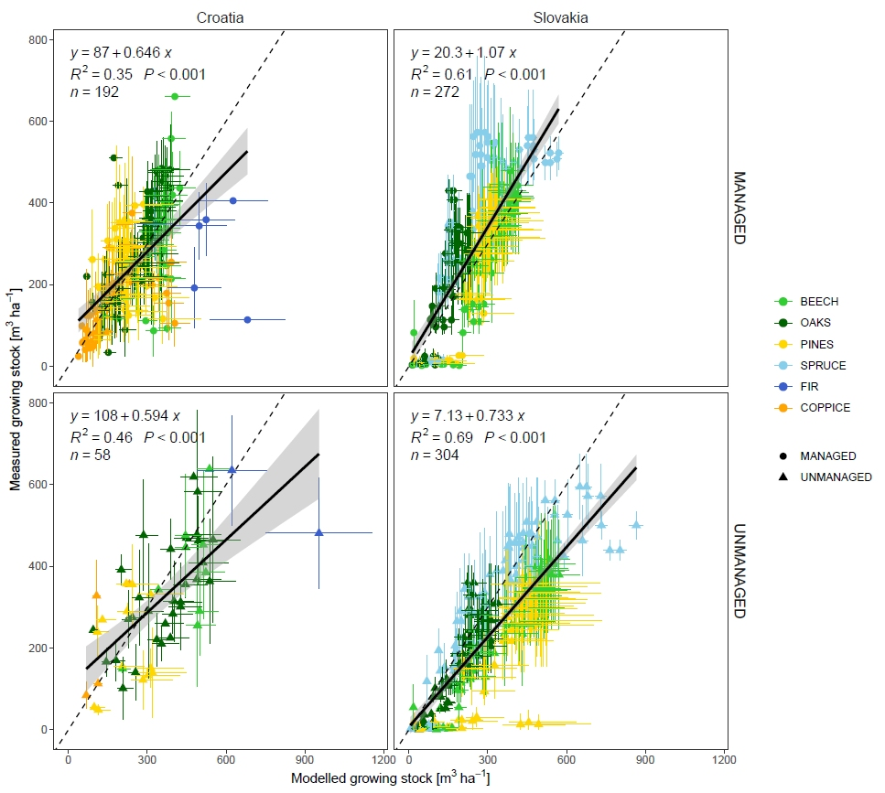
Fig. S6 Comparison of observed (mean ± st. dev) and simulated growing stock (mean ± range) at managed and unmanaged sites, in the year 2022 (Croatia) and 2023 (Slovakia). Note: range of the simulated data is a result of using four variants of conversion factors.
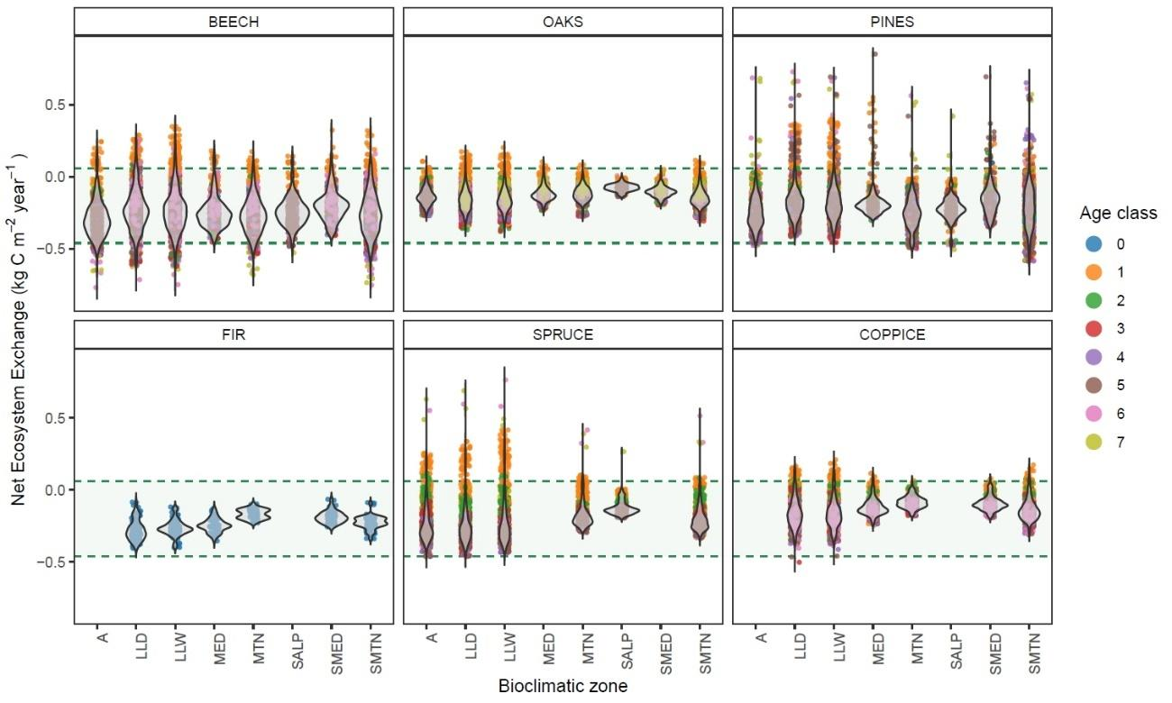
Fig. S7 Annual Net Ecosystem Exchange (NEE) sums for specific forestry types and environmental strata groups at the joint area of both countries. Light-green areas with dashed horizontal border lines represent plausible ranges on NEE based on literature review.
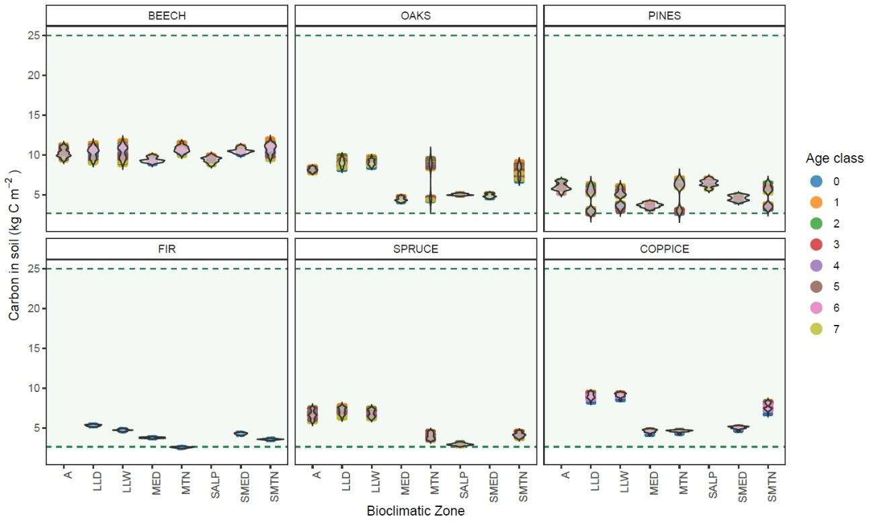
Fig. S8 Carbon stocks in soil for specific forest types and environmental strata groups at the joint area of both countries. Light-green areas with dashed horizontal border lines represent plausible ranges for soil organic carbon based on literature review.
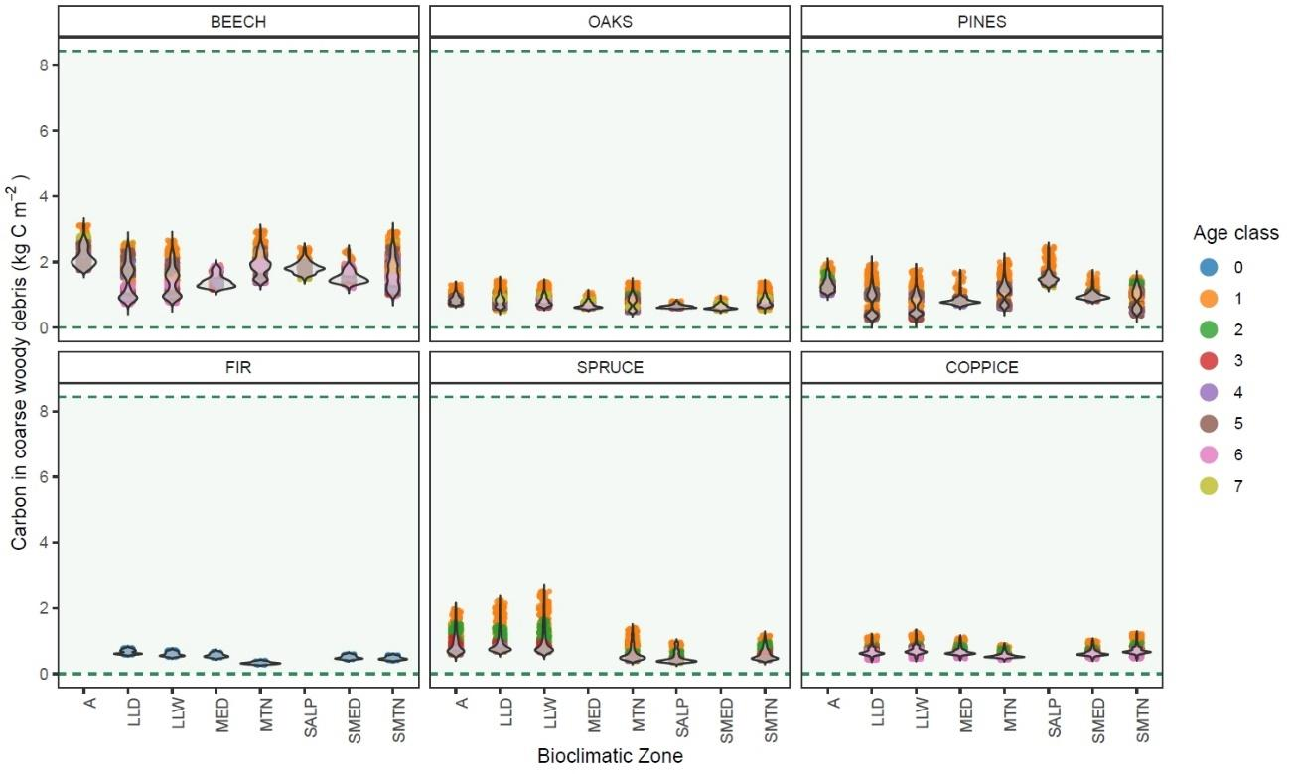
Fig. S9 Carbon stocks in coarse woody debris for specific forest types and environmental strata groups at the joint area of both countries. Light-green areas with dashed horizontal border lines represent plausible ranges for deadwood carbon stocks based on literature review.
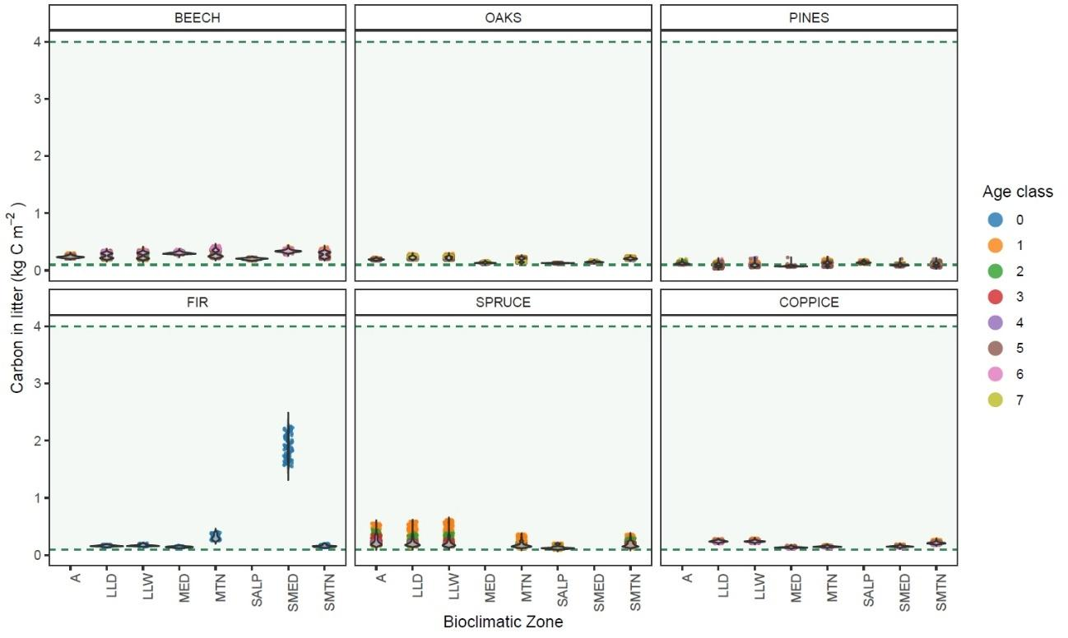
Fig. S10 Carbon stocks in litter for specific forest types and environmental strata groups at the joint area of both countries. Light-green areas with dashed horizontal border lines represent plausible ranges for litter carbon stocks based on literature review.
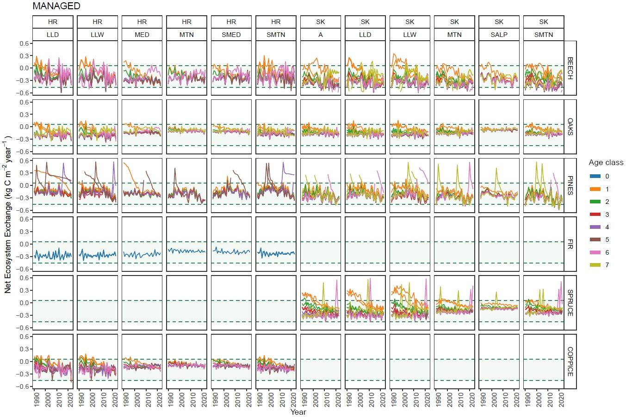
Fig. S11 Annual Net Ecosystem Exchange (NEE) time-series during the period 1990-2023 for different forest types and environmental strata in Croatia and Slovakia. Dashed lines represent upper and lower uncertainty limit (average ± uncertainty) of EU-25 Eddy-covariance dataset (Luyssart et al. 2010).
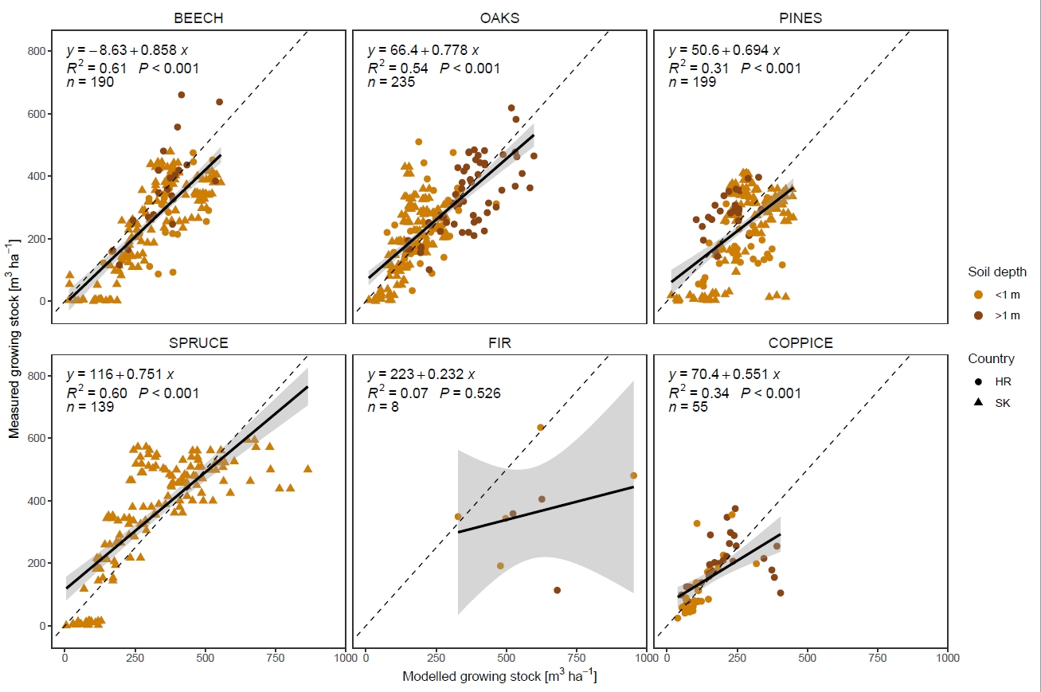
Fig. S12 Comparison of observed and modelled growing stock in the year 2022 (Croatia) and 2023 (Slovakia) by different forest types and soil depth. n - number of data points, R² - coefficient of determination.
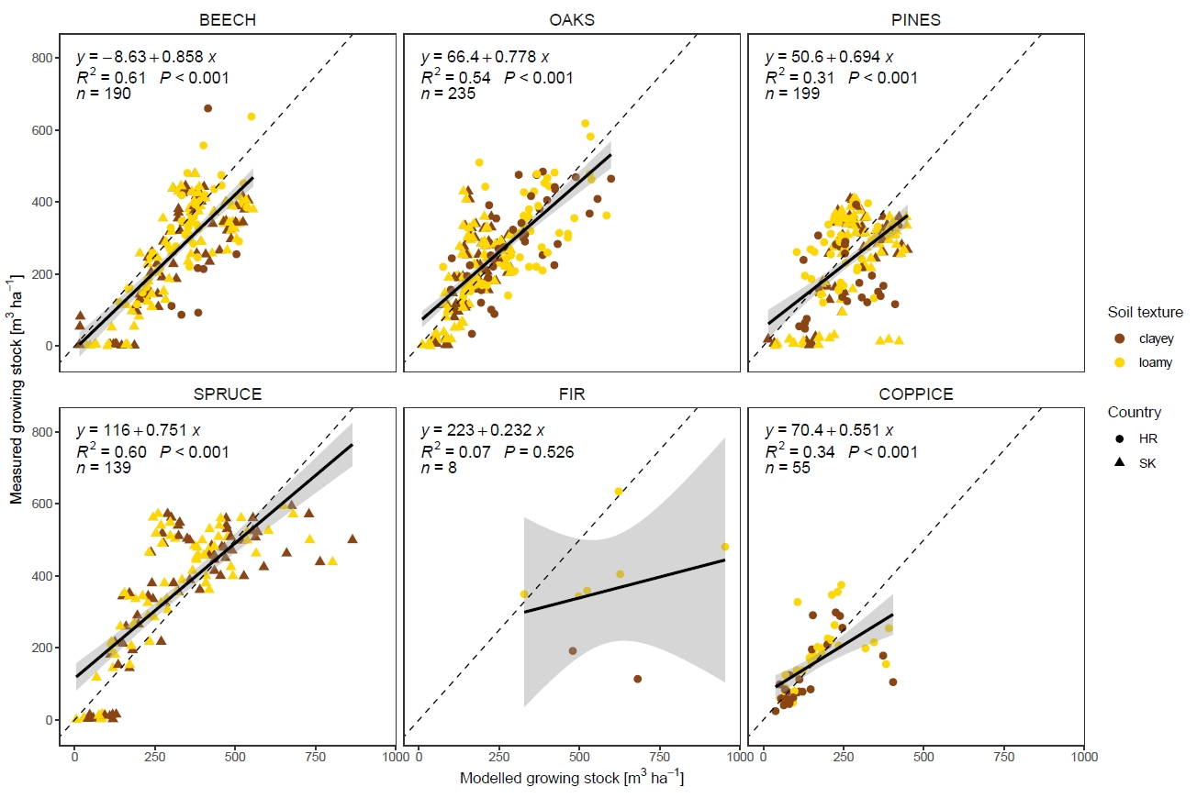
Fig. S13 Comparison of observed and modelled growing stock in the year 2022 (Croatia) and 2023 (Slovakia) by different forest types and soil texture. n - number of data points, R² - coefficient of determination.
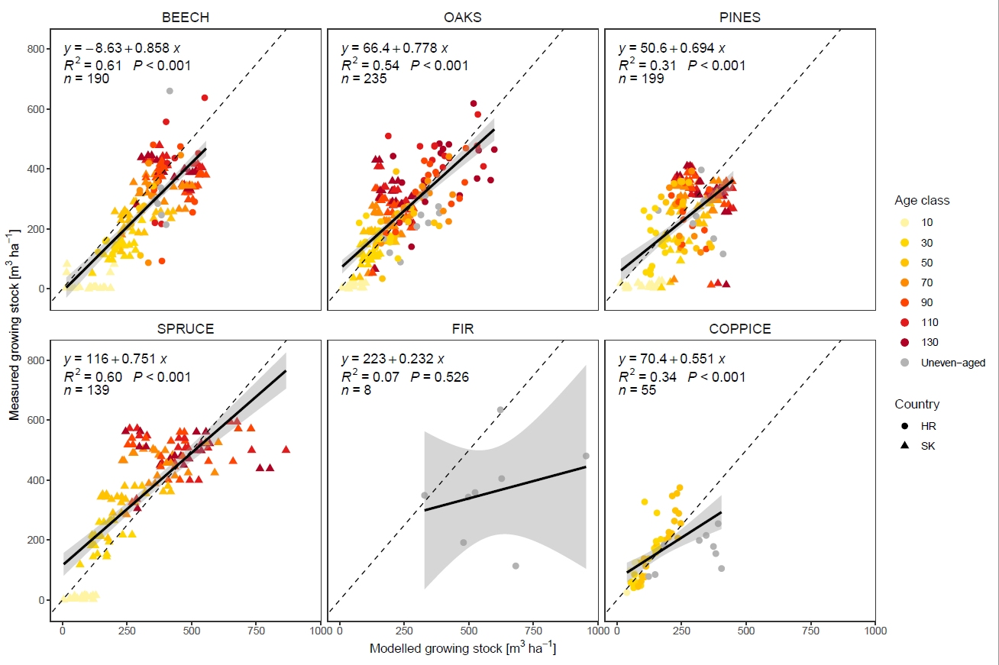
Fig. S14 Comparison of observed and modelled growing stock in the year 2022 (Croatia) and 2023 (Slovakia) by different forest types and age classes. n - number of data points, R² - coefficient of determination.

4. References
Bitunjac D, Sever MZO, Sever K, Merganičová K, Marjanović H (2023) Dead wood volume-to-carbon conversion factors by decay class for ten tree species in Croatia and eight tree genera globally. For Ecol Manag 549:121431. https://doi.org/10.1016/j.foreco.2023.121431
Bitunjac D (2024) Stocks and stock changes of carbon in dead organic matter and soil in Croatia’s forests. Dissertation, University of Zagreb
Čavlović J (2010) First national forest inventory in the Republic of Croatia. Ministry of Regional Development and Forestry & Faculty of Forestry Zagreb, Zagreb [in Croatian]
Halaj J, Petráš R (1998) Rastové tabuľky hlavných drevín. Slovak Akad. Press, Bratislava [in Slovak]
Hidy D, Barcza Z, Marjanović H, Ostrogović Sever MZ, Dobor L et al (2016) Terrestrial ecosystem process model Biome-BGCMuSo v4.0: summary of improvements and new modeling possibilities. Geosci Model Dev 9(12):4405-4437. https://doi.org/10.5194/gmd-9-4405-2016
Hidy D, Barcza Z, Hollós R, Dobor L, Acs T et al (2022) Soil-related developments of the Biome-BGCMuSo v6.2 terrestrial ecosystem model. Geosci Model Dev 15(5):2157-2181. https://doi.org/10.5194/gmd-15-2157-2022
Hollós R, Fodor N, Merganičová K, Hidy D, Árendás T et al. (2022) Conditional interval reduction method: A possible new direction for the optimization of process based models. Environ Model Softw 158:105556. https://doi.org/10.1016/j.envsoft.2022.105556
HR NID (2025) Croatian greenhouse gas inventory for the period 1990-2023 (National Inventory Document 2025). Republic of Croatia, Ministry of Environmental Protection and Green Transition, Zagreb. https://unfccc.int/documents/646451. Accessed 10 August 2025
Hungerford RD, Nemani RR, Running SW, Coughlan JC (1989) Mtclim - a mountain microclimate simulation model. US Department of Agriculture, Forest Service, Intermountain Research Station, Research Paper
ISRIC – World Soil Information (2021) SoilGrids 2.0 global gridded soil information at 250 m resolution. Retrieved from https://soilgrids.org. Accessed 8 January 2025
Jiang B, Zhang Y, Liang SL, Wohlfahrt G, Arain A et al. (2015) Empirical estimation of daytime net radiation from shortwave radiation and ancillary information. Agric For Meteorol 211-212:23-36. https://doi.org/10.1016/j.agrformet.2015.05.003
Križan J, Antonić L, Hengl T, Antonić O (2024) Towards detailed and public data on Croatian soil as a prerequisite for sustainable environmental management and nature conservation. Int Conf Environ Remote Sens GIS 129-133. https://doi.org/10.5281/zenodo.11585221
Kulla L, Bošeľa M (2013) Koncept geobiotopu ako možnej vyššej stanovištnej jednotky pre diferencovanie manažmentu lesov. Lesn Časopis - For J 59(2):81-94 [in Slovak]
Kulla L, Murgaš V, Štěrbová M, Bošeľa M, Barka I et al. (2019) Modely adaptácie lesov Slovenska na zmenu klímy. Národné lesnícke centrum, Ministerstvo pôdohospodárstva a rozvoja vidieka Slovenskej republiky, Bratislava [in Slovak]
Luyssaert S, Ciais P, Piao SL, Schulze ED, Jung M et al (2010) The European carbon balance. Part 3: forests. Glob Change Biol 16(5):1429-1450. https://doi.org/10.1111/j.1365-2486.2009.02056.x
Merganič J, Merganičová K, Konôpka B, Kučera M (2017) Country and regional carbon stock in forest cover – estimates based on the first cycle of the Czech National Forest Inventory data (2001–2004). Cent. Eur For J 63 (4): 113-125. https://doi.org/10.1515/forj-2017-0018
Merganičová K, Merganič J, Lehtonen A, Vacchiano G, Ostrogović Sever MZ et al (2019) Forest carbon allocation modelling under climate change. Tree Physiol 39(12):1937-1960. https://doi.org/10.1093/treephys/tpz105
Merganičová K, Merganič J, Dobor L, Hollós R, Barcza Z et al (2024) The biogeochemical model Biome-BGCMuSo v6.2 provides plausible and accurate simulations of the carbon cycle in central European beech forests. Geosci Model Dev 17(20):7317-7346. https://doi.org/10.5194/gmd-17-7317-2024
NFAP (2019). National forestry accounting plan for the Republic of Croatia. Republic of Croatia, Ministry of Environment and Energy, Ministry of Agriculture, Zagreb, Croatia, 86 p https://mzozt.gov.hr/UserDocsImages//KLIMA/SZKAIZOS//NFAP_FIAL_March_2019_HRV.pdf. Accessed 3 June 2025
NLC (Národné lesnícke centrum) 2025a: Lesné pôdne jednotky (Forest soil units). Slovak National Open Data Catalogue. https://data.slovensko.sk/datasety/c2c5bffa-8b3a-4871-855e-43ca3a80b6b3. Accessed 11 February 2026
NLC (Národné lesnícke centrum) 2025b: Programy starostlivosti o lesy 2023 (Forest management plans 2023). Slovak National Open Data Catalogue. https://data.slovensko.sk/datasety/ba0a44c7-620b-47f2-b70b-5afedda9c6d6. Accessed 11 February 2026
Poggio L, de Sousa LM, Batjes NH, Heuvelink GBM, Kempen B et al. (2021): SoilGrids 2.0: producing soil information for the globe with quantified spatial uncertainty. SOIL 7:217-240. https://doi.org/10.5194/soil-7-217-2021
POUŠ (2018) Pravilnik o uređivanju šuma. Republic of Croatia. Official Gazette No. 97/2018. [in Croatian]
QGIS Development Team (2024). QGIS 3.38.0 “Grenoble”. Open Source Geospatial Foundation Project
R Core Team (2023) R: A language and environment for statistical computing. R Foundation for Statistical Computing, Vienna, Austria. https://www.R-project.org/. Accessed 9 December 2024
Radočaj D, Jurišić M, Rapčan I, Domazetović F, Milošević R et al. (2023) An independent validation of SoilGrids accuracy for soil texture components in Croatia. Land 12(5):1034. https://doi.org/10.3390/land12051034
SK NID (2025) National Greenhouse Gas Inventory Document 1990 – 2023 under the Paris Agreement (National Inventory Document 2025). Slovak Republic, Slovak Hydrometeorological Institute, Ministry of Environment of the Slovak Republic, Bratislava. https://unfccc.int/documents/646463. Accessed 10 August 2025
ŠGOP (2016) Forest management area plan for the Republic of Croatia for the period 2016–2025. Croatian Forests Ltd, Zagreb, Croatia. Available online: https://poljoprivreda.gov.hr/istaknute-teme/sume-112/sumarstvo/sumskogospodarskaosnova-2016-2025/250. Accessed 23 July 2021 [in Croatian]
Wallace JS, Holwill CJ (1997) Soil evaporation from tiger-bush in south-west Niger. J Hydrol 188-189:426-442. https://doi.org/10.1016/S0022-1694(96)03185-X
Wirth C, Schulze E-D, Schwalbe G, Tomczyk S, Weber G et al. (2004) Dynamik der Kohlenstoffvorräte in den Wäldern Thüringens: Abschlussbericht zur 1. Phase des BMBF-Projektes “Modelluntersuchung zur Umsetzung des Kyoto-Protokolls”. Thüringer Landesanstalt für Wald, Jagd und Fischerei, Gotha, pp. 308.
ZS (2024) Správa o lesnom hospodárstve v Slovenskej republike za rok 2023 (Zelená správa). Ministerstvo pôdohospodárstva a rozvoja vidieka Slovenskej republiky, Národné lesnícke centrum, Bratislava, 59 pp. https://www.mpsr.sk/download.php?fID=25480. Accessed 23 July 2021 [in Slovak]

