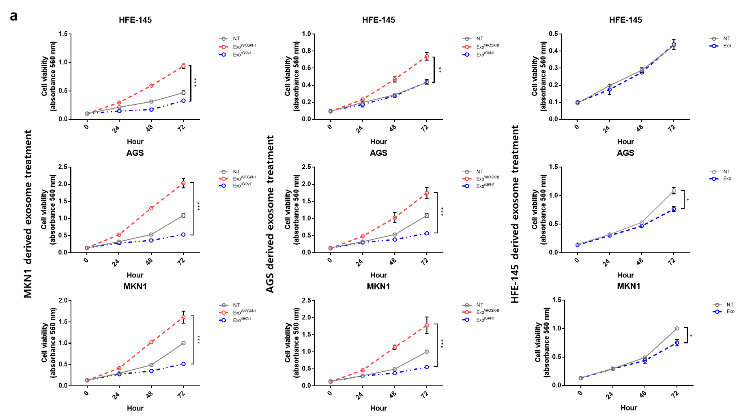
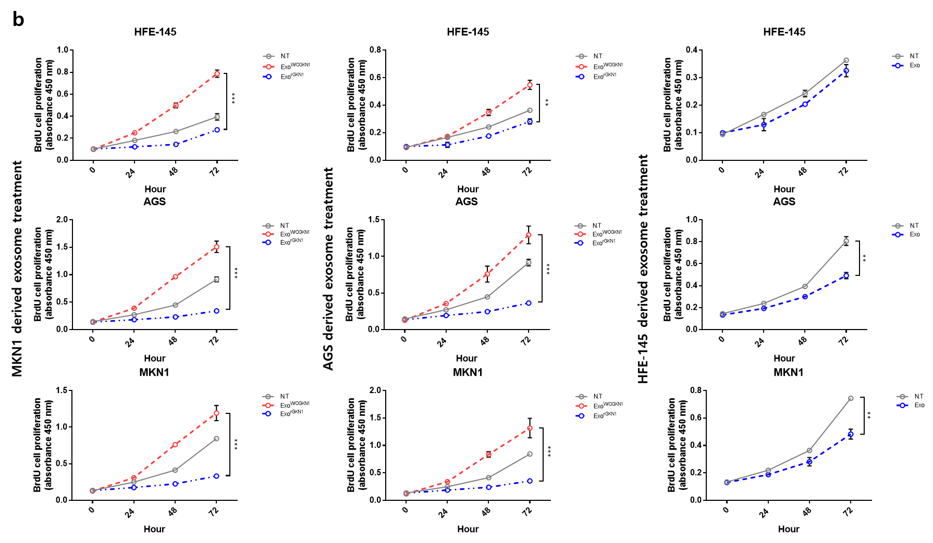
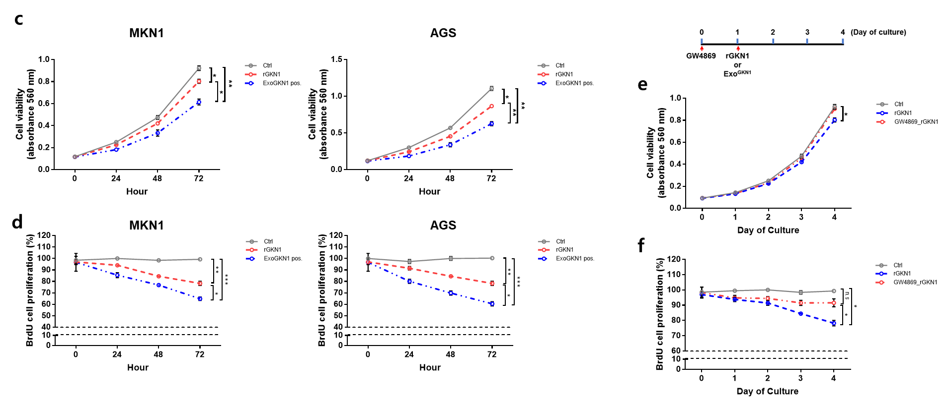
Supplementary Figure 1. GKN1-positive exosomes inhibited cell growth and proliferation. (a, b) Exosomes derived from AGS and MKN1 cells induced a time-dependent increase in cell viability (a) and proliferation (b) in HFE-145, AGS, and MKN1 cells, whereas the exosomes that carried GKN1 decreased cell viability and proliferation. (c, d) Exosomal GKN1 and rGKN1 markedly decreased cell viability (c) and cell proliferation (d) in AGS cancer cells over 48 hrs after treatment. The time-dependent inhibitory effects on cell viability and cell proliferation of exosomal GKN1 were more significant than those of rGKN1. (e, f) When we treated MKN1 cells with an exosome biogenesis/release inhibitor (GW4869), exosomal protein concentration decreased significantly in a time-dependent manner (e) and the effects of GKN1 on cell viability and proliferation were markedly inhibited (f).

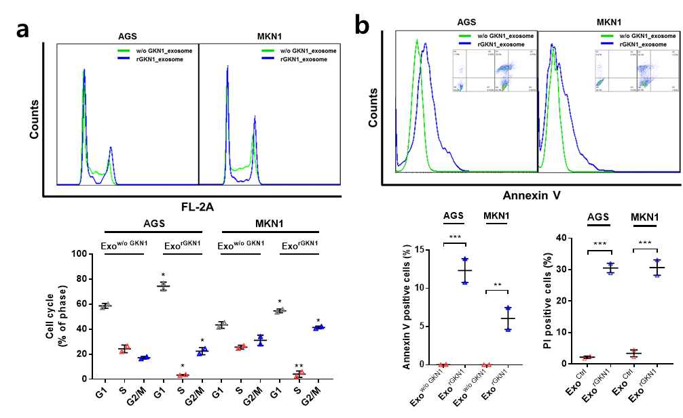
Supplementary Figure 2. Exosomes derived from AGS cells treated with rGKN1 induced cell cycle arrest and apoptosis. (a) Exosomes derived from AGS cells treated with rGKN1 increased cell populations at the G1 and G2/M phases and decreased cell population at the S phase (n=2). (b) In Annexin V staining assay, exosomes derived from AGS cells treated with rGKN1 increased apoptotic cell death in AGS and MKN1 cells (n=2).

