Efficacy and safety of trifluridine/tipiracil in older and younger patients with metastatic gastric or gastroesophageal junction cancer: subgroup analysis of a randomized phase 3 study (TAGS)

Kohei Shitara,Toshihiko Doi, Hisashi Hosaka, Peter Thuss-Patience, Armando Santoro, Federico Longo, Ozgur Ozyilkan, Irfan Cicin, David Park, Aziz Zaanan, Carles Pericay, Mustafa Özgüroğlu, Maria Alsina, Lukas Makris, Karim A. Benhadji, David H. Ilson
Corresponding author: Kohei Shitara
Department of Gastrointestinal Oncology, National Cancer Center Hospital East
kshitara@east.ncc.go.jp

Journal Name: Gastric Cancer

Supplementary Data

Table S1 Patient disposition
 | Number of patients (%)
 | < 65 years |  | ≥ 65 years |  | ≥ 75 years
 | FTD/TPI | Placebo | FTD/TPI | Placebo | FTD/TPI | Placebo
Intent-to-treat population | 183 (100) | 96 (100) | 154 (100) | 74 (100) | 51 (100) | 18 (100)
As-treated population | 182 (99) | 96 (100) | 153 (99) | 72 (97) | 50 (98) | 17 (94)
Ongoingª | 8 (4) | 2 (2) | 11 (7) | 1 (1) | 5 (10) | 0
Discontinued study treatmentª | 174 (96) | 94 (98) | 142 (93) | 71 (99) | 45 (90) | 17 (100)
Radiological/clinical progressionª | 131 (72) | 80 (83) | 115 (75) | 65 (90) | 38 (76) | 15 (88)
Adverse eventª | 22 (12) | 8 (8) | 11 (7) | 3 (4) | 4 (8) | 1 (6)
Patient withdrew consentª | 9 (5) | 3 (3) | 5 (3) | 1 (1) | 1 (2) | 1 (6)
Physician’s decisionª | 4 (2) | 2 (2) | 7 (5) | 1 (1) | 2 (4) | 0
Deathª | 8 (4) | 1 (1) | 3 (2) | 1 (1) | 0 | 0
Otherª | 0 | 0 | 1 (<1) | 0 | 0 | 0
FTD/TPI trifluridine/tipiracil.
ªPercentage of the as-treated population.

Table S2 Study drug exposureª
 | < 65 years |  | ≥ 65 years |  | ≥ 75 years
 | FTD/TPI  (n = 182) | Placebo  (n = 96) | FTD/TPI  (n = 153) | Placebo  (n = 72) | FTD/TPI  (n = 50) | Placebo  (n = 17)
Cycles initiated, median (range) | 2 (1–12) | 2 (1–12) | 2 (1–14) | 2 (1–16) | 3 (1–14) | 2 (1–8)
Median duration of treatment (range), weeks | 6.0 (0.4–52.4) | 5.7 (0.1–46.0) | 7.6 (0.7–62.7) | 5.7 (0.7–63.0) | 9.6 (1.1–62.7) | 5.7 (1.3–29.7)
Median relative dose intensity (range) | 0.90 (0.15–1.01) | 0.96 (0.10–1.04) | 0.89 (0.43–1.01) | 0.94 (0.42–1.10) | 0.87 (0.43–1.01) | 0.94 (0.42–1.02)
Mean (SD) dose intensity, mg/m²/wk | 146.1 (30.6) | 155.3 (30.1) | 150.7 (21.2) | 154.5 (24.8) | 149.3 (21.2) | 153.8 (27.3)
Mean cumulative dose (SD), mg/m² | 1995.9 (1575.0) | 1505.9 (1239.7) | 2284.6 (1731.2) | 1520.2 (1440.5) | 2627.0 (2057.7) | 1678.1 (1347.0)
FTD/TPI trifluridine/tipiracil; SD standard deviation; wk week.
ªAs-treated population.

Table S3 OS and PFS by renal function status in patients aged ≥ 65 yearsª
 | Normal renal function  CrCl ≥ 90 mL/min |  | Mild renal impairment  CrCl 60–89 mL/min |  | Moderate renal impairment  CrCl 30–59 mL/min
 | FTD/TPI  (n = 31) | Placebo  (n = 19) | FTD/TPI  (n = 71) | Placebo  (n = 31) | FTD/TPI  (n = 49) | Placebo  (n = 21)
OS, months
Median (95% CI) | 5.7 (3.9–9.0) | 3.9 (2.1–6.3) | 6.2 (4.5–11.0) | 6.3 (4.9–11.0) | 6.3 (4.6–7.5) | 4.1 (2.1–9.4)
HR (95% CI) | 0.71 (0.33–1.57) |  | 0.86 (0.50–1.49) |  | 0.79 (0.42–1.48)
OS rates, %
6-month (95% CI) | 45 (27–62) | 34 (14–56) | 50 (38–61) | 53 (33–69) | 54 (39–68) | 48 (26–67)
PFS, months
Median (95% CI) | 2.1 (1.9–3.7) | 1.8 (1.1–1.9) | 2.1 (1.9–3.5) | 1.9 (1.7–1.9) | 2.8 (1.9–3.7) | 1.7 (1.0–2.0)
HR (95% CI) | 0.31 (0.14–0.66) |  | 0.49 (0.29–0.81) |  | 0.60 (0.33–1.10)
PFS rates, %
4-month (95% CI) | 25 (11–41) | 0 | 30 (20–42) | 5 (<1–18) | 30 (17–43) | 14 (4–32)
CI confidence interval; CrCl creatinine clearance; FTD/TPI trifluridine/tipiracil; HR hazard ratio; OS overall survival; PFS progression-free survival.
ªAs-treated population; does not include 3 patients with severe renal impairment and 3 patients whose renal status was missing.

Table S4 Summary of grade ≥ 3 adverse eventsª

 | Number of patients (%)
 | < 65 years |  | ≥ 65 years |  | ≥ 75 years
 | FTD/TPI  (n = 182) | Placebo  (n = 96) | FTD/TPI  (n = 153) | Placebo  (n = 72) | FTD/TPI  (n = 50) | Placebo  (n = 17)
Grade ≥ 3 AEs of any cause | 145 (80) | 60 (62) | 122 (80) | 37 (51) | 40 (80) | 9 (53)
Grade ≥ 3 treatment-related AEs | 89 (49) | 14 (15) | 87 (57) | 8 (11) | 28 (56) | 2 (12)
Grade ≥ 3 AEs of any cause in ≥10% of patients in any group
Hematologic
Neutropenia^{b} | 53 (29) | 0 | 61 (40) | 0 | 20 (40) | 0
Anemia^{c} | 36 (20) | 7 (7) | 28 (18) | 6 (8) | 11 (22) | 3 (18)
Leukopenia^{d} | 17 (9) | 0 | 14 (9) | 0 | 7 (14) | 0
Gastrointestinal
Vomiting | 10 (5) | 3 (3) | 2 (1) | 0 | 0 | 0
Abdominal pain | 11 (6) | 10 (10) | 3 (2) | 5 (7) | 0 | 2 (12)
Ascites | 9 (5) | 7 (7) | 3 (2) | 4 (6) | 2 (4) | 1 (6)
Gastric hemorrhage | 3 (2) | 1 (1) | 0 | 3 (4) | 0 | 2 (12)
Other AEs
Asthenia | 8 (4) | 7 (7) | 8 (5) | 4 (6) | 3 (6) | 2 (12)
Decreased appetite | 15 (8) | 7 (7) | 14 (9) | 4 (6) | 5 (10) | 2 (12)
Fatigue | 12 (7) | 7 (7) | 11 (7) | 3 (4) | 4 (8) | 2 (12)
General physical health deterioration | 15 (8) | 8 (8) | 7 (5) | 7 (10) | 1 (2) | 1 (6)
AE adverse event; FTD/TPI trifluridine/tipiracil.
ªAs-treated population.
^{b}Includes decreased neutrophil count.
^{c}Includes decreased hemoglobin.
^{d}Includes decreased white blood cell count.

Table S5 Summary of safety by renal function status in patients aged ≥ 65 yearsª

 | Number of patients (%)
 | Normal renal function  CrCl ≥ 90 mL/min |  | Mild renal impairment  CrCl 60–89 mL/min |  | Moderate renal impairment  CrCl 30–59 mL/min
 | FTD/TPI  (n = 31) | Placebo  (n = 19) | FTD/TPI  (n = 71) | Placebo  (n = 31) | FTD/TPI  (n = 49) | Placebo  (n = 21)
AEs of any cause | 30 (97) | 18 (95) | 68 (96) | 26 (84) | 47 (96) | 21 (100)
Grade ≥ 3 | 23 (74) | 12 (63) | 59 (83) | 14 (45) | 38 (78) | 10 (48)
Treatment-related AEs | 25 (81) | 8 (42) | 58 (82) | 18 (58) | 37 (76) | 10 (48)
Grade ≥ 3 | 14 (45) | 3 (16) | 43 (61) | 3 (10) | 28 (57) | 2 (10)
Actions taken because of AEs of any cause
Dosing modification | 19 (61) | 5 (26) | 42 (59) | 5 (16) | 31 (63) | 6 (29)
Discontinuation | 4 (13) | 2 (11) | 6 (8) | 4 (13) | 8 (16) | 3 (14)
Most common AEs of any cause and grade (≥ 15% of patients)
Hematologic
Neutropenia^{b} | 16 (52) | 0 | 43 (61) | 1 (3) | 25 (51) | 2 (10)
Anemia^{c} | 12 (39) | 1 (5) | 26 (37) | 6 (19) | 31 (63) | 4 (19)
Leukopenia^{d} | 5 (16) | 0 | 14 (20) | 0 | 15 (31) | 1 (5)
Thrombocytopenia^{e} | 4 (13) | 0 | 14 (20) | 1 (3) | 10 (20) | 3 (14)
Gastrointestinal
Abdominal pain | 6 (19) | 2 (11) | 12 (17) | 5 (16) | 6 (12) | 5 (24)
Vomiting | 6 (19) | 5 (26) | 13 (18) | 6 (19) | 11 (22) | 3 (14)
Nausea | 5 (16) | 3 (16) | 21 (30) | 6 (19) | 13 (27) | 6 (29)
Diarrhea | 3 (10) | 3 (16) | 19 (27) | 5 (16) | 13 (27) | 3 (14)
Constipation | 4 (13) | 2 (11) | 8 (11) | 4 (13) | 9 (18) | 2 (10)
Upper abdominal pain | 2 (6) | 3 (16) | 1 (1) | 1 (3) | 3 (6) | 1 (5)
Other AEs
Decreased appetite | 12 (39) | 4 (21) | 25 (35) | 8 (26) | 19 (39) | 5 (24)
Fatigue | 9 (29) | 5 (26) | 14 (20) | 11 (36) | 15 (31) | 0
Asthenia | 5 (16) | 6 (32) | 17 (24) | 7 (23) | 12 (24) | 4 (19)
Increased blood alkaline phosphatase | 3 (10) | 2 (11) | 6 (9) | 6 (19) | 5 (10) | 1 (5)
AE adverse event; CrCl creatinine clearance; FTD/TPI trifluridine/tipiracil.
ªAs-treated population.
^{b}Includes decreased neutrophil count.
^{c}Includes decreased hemoglobin.
^{d}Includes decreased leukocyte count.
^{e}Includes decreased platelet count.

Table S6. Time to deterioration by ≥ 5 points in EORTC QLQ-C30 global health status scores by ageª
 | < 65 years |  | ≥ 65 years |  | ≥ 75 years
 | FTD/TPI  (n = 159) | Placebo  (n = 76) | FTD/TPI  (n = 129) | Placebo  (n = 54) | FTD/TPI  (n = 42) | Placebo  (n = 12)
Median time to deterioration (months) | 2.3 | 1.9 | 3.3 | NE | 3.3 | 3.8
95% CI | 2.0–2.6 | 1.2–4.6 | 2.4–4.9 | 1.9–NE | 2.1–4.8 | 1.0–NE
HR (95% CI) | 1.30 (0.70–2.43) |  | 1.64 (0.80–3.36) |  | 0.78 (0.07–8.88)
CI confidence interval; EORTC QLQ-C30, European Organization for Research and Treatment of Cancer Quality of Life questionnaire; FTD/TPI trifluridine/tipiracil; HR hazard ratio; NE, not estimable.
ªIncludes patients with QLQ-C30 assessments completed at baseline and at least one follow-up visit.

Fig. S1 Incidences of most common adverse events in FTD/TPI-treated patients by age.
FTD/TPI trifluridine/tipiracil.

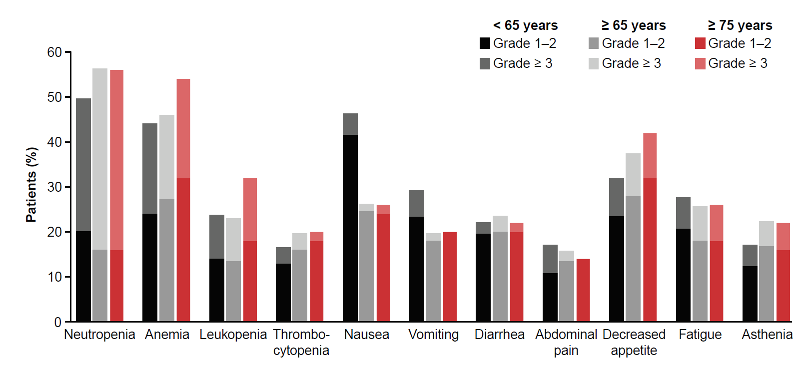
Fig. S2 Odds ratioª of common adverse events in patients aged (a) < 65 years, (b) ≥ 65 years, and (c) ≥ 75 years.
ªOdds ratio > 1 indicates a greater treatment effect (FTD/TPI vs placebo).
FTD/TPI trifluridine/tipiracil.
