Supplementary Table 1. Gastric non-cardia and cardia cancer patients stratified by calendar period, age, sex, CCI, surgical treatment, chemotherapy and cancer stage.

Variable | Gastric non-cardia cancer n (%) | Gastric cardia cancer n (%) | Total n (%)
Total | 22502 (83.6) | 4418 (16.4) | 26920 (100)
Calendar period
1987-1991 | 5145 (22.9) | 740 (16.7) | 5885 (21.9)
1992-1996 | 4317 (19.2) | 727 (16.5) | 5044 (18.7)
1997- 2001 | 3682 (16.4) | 778 (17.6) | 4460 (16.6)
2002-2006 | 3493 (15.5) | 704 (15.9) | 4197 (15.6)
2007- 2011 | 3169 (14.1) | 763 (17.3) | 3932 (14.6)
2012- 2016 | 2696 (12.0) | 706 (16.0) | 3402 (12.6)
Age
>50 | 1644 (7.3) | 312 (7.1) | 1956 (7.3)
50-59 | 2789 (12.4) | 636 (14.4) | 3425 (12.7)
60-69 | 5181 (23.0) | 1147 (26.0) | 6328 (23.5)
70-79 | 7067 (31.4) | 1382 (31.3) | 8449 (31.4)
80-89 | 5099 (22.7) | 831 (18.8) | 5930 (22.0)
90+ | 722 (3.2) | 110 (2.5) | 832 (3.1)
Sex
Female | 10800 (48.0) | 1421 (32.2) | 12221 (45.4)
Male | 11702 (52.0) | 2997 (67.8) | 14699 (54.6)
CCI
0 | 13967 (62.1) | 2554 (57.8) | 16521 (61.4)
1 | 5102 (22.7) | 1074 (24.3) | 6176 (22.9)
2 | 2207 (9.8) | 493 (11.2) | 2700 (10.0)
3+ | 1226 (5.4) | 297 (6.7) | 1523 (5.7)
Surgery
Yes | 9069 (40.3) | 1478 (33.5) | 10547 (39.2)
No | 13433 (59.7) | 2940 (66.5) | 16373 (60.8)
Chemotherapy
No | 13589 (60.4) | 2311 (52.3) | 15900 (59.1)
Yes | 2881 (12.8) | 714 (16.2) | 3595 (13.4)
Missing | 6032 (26.8) | 1393 (31.5) | 7425 (27.6)
Stage
Local | 4091 (18.2) | 618 (14.0) | 4709 (17.5)
Locally advanced | 2269 (10.1) | 475 (10.8) | 2744 (10.2)
Advanced | 7831 (34.8) | 1503 (34.0) | 9334 (34.7)
Unclear or missing | 8311 (36.9) | 1822 (41.2) | 10133 (37.6)

CCI: Charlson Comorbidity Index
Supplementary Table 2. One- year, 3-years and 5- years survival in gastric cancer (cardia and non-cardia) stratified by treatment during 1987-2016.

 | Gastric non- cardia cancer |  |  |  | Gastric cardia cancer
 | Patients | Survival in % |  |  | Patients | Survival in %
Calendar period | Number (%) | 1 year | 3 years | 5 years | Number (%) | 1 year | 3 years | 5 years
All patients
1987-1991 | 5145 (22.9) | 41 | 25 | 19 | 740 (16.7) | 36 | 16 | 11
1992-1996 | 4317 (19.2) | 43 | 26 | 21 | 727 (16.5) | 36 | 17 | 13
1997- 2001 | 3682 (16.4) | 45 | 27 | 23 | 778 (17.6) | 42 | 22 | 16
2002-2006 | 3493 (15.5) | 46 | 27 | 22 | 704 (15.9) | 43 | 23 | 18
2007- 2011 | 3169 (14.1) | 46 | 27 | 23 | 763 (17.3) | 48 | 25 | 19
2012- 2016 | 2696 (12.0) | 47 | 28 | 24 | 706 (16.0) | 51 | 26 | 22
Surgery
1987-1991 | 2216 (24.4) | 63 | 39 | 31 | 283 (19.1) | 55 | 25 | 18
1992-1996 | 1950 (21.5) | 67 | 41 | 33 | 293 (19.8) | 56 | 31 | 24
1997- 2001 | 1627 (17.9) | 70 | 45 | 37 | 294 (19.9) | 68 | 40 | 31
2002-2006 | 1395 (15.4) | 72 | 46 | 37 | 206 (13.9) | 78 | 50 | 42
2007- 2011 | 1085 (12.0) | 78 | 51 | 40 | 196 (13.3) | 87 | 56 | 45
2012- 2016 | 796 (8.8) | 79 | 53 | 44 | 206 (13.9) | 89 | 59 | 45
No surgery
1987-1991 | 2929 (21.8) | 24 | 14 | 11 | 457 (15.5) | 23 | 8 | 6
1992-1996 | 2367 (17.6) | 24 | 14 | 11 | 434 (14.8) | 24 | 10 | 6
1997- 2001 | 2055 (15.3) | 25 | 14 | 12 | 484 (16.5) | 26 | 11 | 7
2002-2006 | 2098 (15.6) | 27 | 15 | 13 | 498 (16.9) | 29 | 11 | 8
2007- 2011 | 2084 (15.5) | 31 | 17 | 15 | 567 (19.3) | 34 | 13 | 10
2012- 2016 | 1900 (14.1) | 33 | 18 | 15 | 500 (17.0) | 36 | 14 | 12

Supplementary Table 3. One-year, 3-year-, and 5-year survival in histologically confirmed gastric adenocarcinoma (non-cardia and cardia) stratified by treatment type during 1987-2016.

 | Gastric non- cardia adenocarcinoma |  |  |  | Gastric cardia adenocarcinoma
 | Patients | Survival in % |  |  | Patients | Survival in %
Calendar period | Number (%) | 1 year | 3 years | 5 years | Number (%) | 1 year | 3 years | 5 years
Surgery
1987-1991 | 2051 (24.7) | 62 | 37 | 29 | 270 (20.5) | 54 | 23 | 16
1992-1996 | 1817 (21.9) | 66 | 40 | 31 | 280 (21.2) | 56 | 32 | 24
1997- 2001 | 1505 (18.1) | 69 | 43 | 35 | 271 (20.5) | 68 | 38 | 28
2002-2006 | 1293 (15.6) | 71 | 44 | 35 | 171 (13.0) | 76 | 44 | 36
2007- 2011 | 995 (12.0) | 77 | 50 | 37 | 176 (13.3) | 86 | 58 | 43
2012- 2016 | 632 (7.6) | 77 | 50 | 38 | 152 (11.5) | 90 | 54 | 40
Chemotherapy only
1987-1991 | 125 (9.1) | 28 | 6 | 4 | 25 (6.3) | 16 | 0 | 0
1992-1996 | 122 (8.9) | 32 | 4 | 1 | 31 (7.8) | 32 | 0 | 0
1997- 2001 | 238 (17.3) | 26 | 4 | 3 | 66 (16.5) | 34 | 4 | 2
2002-2006 | 302 (22.0) | 34 | 6 | 2 | 103 (25.8) | 30 | 2 | 2
2007- 2011 | 357 (26.0) | 38 | 9 | 6 | 115 (28.8) | 48 | 6 | 3
2012- 2016 | 229 (16.7) | 38 | 10 | 7 | 59 (14.8) | 50 | 8 | 5
No treatment
1987-1991 | 2015 (29.5) | 16 | 8 | 6 | 332 (23.7) | 20 | 6 | 5
1992-1996 | 1537 (22.5) | 14 | 7 | 5 | 319 (22.7) | 18 | 4 | 3
1997- 2001 | 1061 (15.5) | 13 | 5 | 4 | 245 (17.5) | 16 | 4 | 2
2002-2006 | 1013 (14.8) | 13 | 4 | 3 | 215 (15.3) | 18 | 3 | 1
2007- 2011 | 859 (12.6) | 13 | 4 | 3 | 225 (16.0) | 16 | 4 | 2
2012- 2016 | 339 (5.0) | 12 | 3 | 3 | 67 (4.8) | 24 | 9 | 9

Supplementary Table 4. Multivariable cox-regression analysis of risk of mortality during 5-year follow-up in all gastric non- cardia cancer patients and stratified by surgical treatment.
Covariate | Category | Gastric non- cardia cancer
 |  | Number of patients (%) | HR (95% CI)
All patients
Calendar period | 1987-1991 | 5145 (22.9) | 1.24 (1.17-1.30)
Calendar period | 1992-1996 | 4317 (19.2) | 1.16 (1.09-1.22)
Calendar period | 1997- 2001 | 3682 (16.4) | 1.07 (1.01-1.13)
Calendar period | 2002-2006 | 3493 (15.5) | 1.07 (1.01-1.14)
Calendar period | 2007- 2011 | 3169 (14.1) | 1.02 (0.96-1.08)
Calendar period | 2012- 2016 | 2696 (12.0) | 1 (Reference)
Age | >50 | 1644 (7.3) | 1 (Reference)
Age | 50-59 | 2789 (12.4) | 1.08 (0.99-1.16)
Age | 60-69 | 5181 (23.0) | 1.23 (1.14-1.31)
Age | 70-79 | 7067 (31.4) | 1.49 (1.40-1.59)
Age | 80-89 | 5099 (22.7) | 2.15 (2.01-2.30)
Age | 90+ | 722 (3.2) | 3.30 (3.00-3.64)
Sex | Female | 10800 (48.0) | 1 (Reference)
Sex | Male | 11702 (52.0) | 1.13 (1.10-1.17)
CCI | 0 | 13967 (62.1) | 1 (Reference)
CCI | 1 | 5102 (22.7) | 1.08 (1.04-1.12)
CCI | 2 | 2207 (9.8) | 1.16 (1.11-1.22)
CCI | 3+ | 1226 (5.4) | 1.26 (1.18-1.35)
Surgery
Calendar period | 1987-1991 | 2216 (24.4) | 1.72 (1.54-1.92)
Calendar period | 1992-1996 | 1950 (21.5) | 1.54 (1.38-1.71)
Calendar period | 1997- 2001 | 1627 (17.9) | 1.31 (1.17-1.47)
Calendar period | 2002-2006 | 1395 (15.4) | 1.27 (1.14-1.43)
Calendar period | 2007- 2011 | 1085 (12.0) | 1.09 (0.96-1.22)
Calendar period | 2012- 2016 | 796 (8.8) | 1 (Reference)
Age | >50 | 793 (8.7) | 1 (Reference)
Age | 50-59 | 1314 (14.5) | 0.99 (0.88-1.12)
Age | 60-69 | 2365 (26.1) | 1.13 (1.02-1.26)
Age | 70-79 | 3013 (33.2) | 1.41 (1.27-1.57)
Age | 80-89 | 1516 (16.7) | 1.93 (1.72-2.15)
Age | 90+ | 68 (0.7) | 3.09 (2.36-4.04)
Sex | Female | 4262 (47.0) | 1 (Reference)
Sex | Male | 4807 (53.0) | 1.12 (1.06-1.18)
CCI | 0 | 5995 (66.1) | 1 (Reference)
CCI | 1 | 1992 (22.0) | 1.16 (1.09-1.24)
CCI | 2 | 723 (8.0) | 1.27 (1.16-1.40)
CCI | 3+ | 359 (4.0) | 1.55 (1.36-1.76)
No surgery
Calendar period | 1987-1991 | 2929 (21.8) | 1.24 (1.16-1.32)
Calendar period | 1992-1996 | 2367 (17.6) | 1.24 (1.16-1.32)
Calendar period | 1997- 2001 | 2055 (15.3) | 1.19 (1.12-1.28)
Calendar period | 2002-2006 | 2098 (15.6) | 1.17 (1.09-1.25)
Calendar period | 2007- 2011 | 2084 (15.5) | 1.07 (1.00-1.14)
Calendar period | 2012- 2016 | 1900 (14.1) | 1 (Reference)
Age | >50 | 851 (6.3) | 1 (Reference)
Age | 50-59 | 1475 (11.0) | 1.14 (1.03-1.26)
Age | 60-69 | 2816 (21.0) | 1.31 (1.20-1.44)
Age | 70-79 | 4054 (30.2) | 1.56 (1.43-1.70)
Age | 80-89 | 3583 (26.7) | 2.00 (1.83-2.18)
Age | 90+ | 654 (4.9) | 2.44 (2.18-2.73)
Sex | Female | 6538 (48.7) | 1 (Reference)
Sex | Male | 6895 (51.3) | 1.16 (1.12-1.21)
CCI | 0 | 7972 (59.3) | 1 (Reference)
CCI | 1 | 3110 (23.2) | 1.01 (0.96-1.05)
CCI | 2 | 1484 (11.0) | 1.02 (0.96-1.09)
CCI | 3+ | 867 (6.5) | 1.02 (0.95-1.10)

CCI: Charlson Comorbidity Index
Supplementary Table 5. Multivariable cox-regression analysis of risk of mortality during 5-year follow-up in all gastric cardia cancer patients and stratified by surgical treatment.

Covariate | Category | Gastric cardia cancer
 |  | Number of patients (%) | HR (95% CI)
All patients
Calendar period | 1987-1991 | 740 (16.7) | 1.48 (1.31-1.66)
Calendar period | 1992-1996 | 727 (16.5) | 1.39 (1.24-1.57)
Calendar period | 1997- 2001 | 778 (17.6) | 1.23 (1.10-1.38)
Calendar period | 2002-2006 | 704 (15.9) | 1.12 (0.99-1.26)
Calendar period | 2007- 2011 | 763 (17.3) | 1.04 (0.93-1.17)
Calendar period | 2012- 2016 | 706 (16.0) | 1 (Reference)
Age | >50 | 312 (7.1) | 1 (Reference)
Age | 50-59 | 636 (14.4) | 0.94 (0.80-1.09)
Age | 60-69 | 1147 (26.0) | 1.02 (0.88-1.18)
Age | 70-79 | 1382 (31.3) | 1.19 (1.03-1.37)
Age | 80-89 | 831 (18.8) | 1.72 (1.49-2.00)
Age | 90+ | 110 (2.5) | 2.46 (1.95-3.10)
Sex | Female | 1421 (32.2) | 1 (Reference)
Sex | Male | 2997 (67.8) | 1.17 (1.09-1.26)
CCI | 0 | 2554 (57.8) | 1 (Reference)
CCI | 1 | 1074 (24.3) | 1.05 (0.97-1.14)
CCI | 2 | 493 (11.2) | 1.18 (1.06-1.31)
CCI | 3+ | 297 (6.7) | 1.31 (1.14-1.49)
Surgery
Calendar period | 1987-1991 | 283 (19.1) | 2.32 (1.83-2.93)
Calendar period | 1992-1996 | 293 (19.8) | 2.06 (1.63-2.60)
Calendar period | 1997- 2001 | 294 (19.9) | 1.57 (1.24-1.98)
Calendar period | 2002-2006 | 206 (13.9) | 1.11 (0.85-1.44)
Calendar period | 2007- 2011 | 196 (13.3) | 0.90 (0.69-1.18)
Calendar period | 2012- 2016 | 206 (13.9) | 1 (Reference)
Age | >50 | 124 (8.4) | 1 (Reference)
Age | 50-59 | 243 (16.4) | 0.85 (0.64-1.11)
Age | 60-69 | 469 (31.7) | 0.99 (0.77-1.27)
Age | 70-79 | 499 (33.8) | 1.18 (0.92-1.51)
Age | 80-89 | 136 (9.2) | 1.48 (1.10-2.00)
Age | 90+ | 7 (0.5) | 3.05 (1.40-6.63)
Sex | Female | 427 (28.9) | 1 (Reference)
Sex | Male | 1051 (71.1) | 1.29 (1.12-1.49)
CCI | 0 | 987 (66.8) | 1 (Reference)
CCI | 1 | 334 (22.6) | 1.00 (0.85-1.18)
CCI | 2 | 111 (7.5) | 1.06 (0.83-1.36)
CCI | 3+ | 46 (3.1) | 1.46 (1.03-2.08)
No surgery
Calendar period | 1987-1991 | 457 (15.5) | 1.33 (1.16-1.53)
Calendar period | 1992-1996 | 434 (14.8) | 1.34 (1.17-1.54)
Calendar period | 1997- 2001 | 484 (16.5) | 1.27 (1.11-1.45)
Calendar period | 2002-2006 | 498 (16.9) | 1.12 (0.98-1.28)
Calendar period | 2007- 2011 | 567 (19.3) | 1.05 (0.92-1.19)
Calendar period | 2012- 2016 | 500 (17.0) | 1 (Reference)
Age | >50 | 188 (6.4) | 1 (Reference)
Age | 50-59 | 393 (13.4) | 0.95 (0.79-1.15)
Age | 60-69 | 678 (23.1) | 1.08 (0.91-1.28)
Age | 70-79 | 883 (30.0) | 1.20 (1.01-1.42)
Age | 80-89 | 695 (23.6) | 1.46 (1.23-1.74)
Age | 90+ | 103 (3.5) | 1.83 (1.42-2.36)
Sex | Female | 994 (33.8) | 1 (Reference)
Sex | Male | 1946 (66.2) | 1.20 (1.10-1.30)
CCI | 0 | 1567 (53.3) | 1 (Reference)
CCI | 1 | 740 (25.2) | 1.01 (0.92-1.11)
CCI | 2 | 382 (13.0) | 1.03 (0.92-1.17)
CCI | 3+ | 251 (8.5) | 1.02 (0.88-1.18)

CCI: Charlson Comorbidity Index
a. Gastric non-cardia cancer

b. Gastric cardia cancer

Supplementary Figure 1: Graphs showing number of gastric non-cardia cancer (a) and gastric cardia cancer (b) patients diagnosed in Finland between 1987 to 2016. The curves show the number of patients diagnosed with cancer (blue line) and proportion of patients undergoing surgery (orange line).

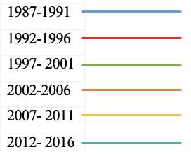
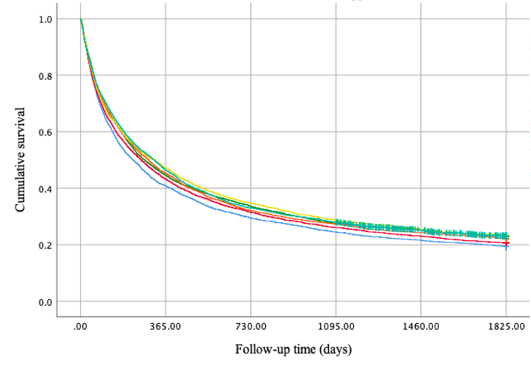
a. Non-cardia cancer, all patients

1987-1991 (n) | 5145 | 2100 | 1512 | 1260 | 1109 | 995
1992-1996 (n) | 4317 | 1866 | 1359 | 1126 | 992 | 890
1997- 2001 (n) | 3682 | 1644 | 1236 | 1015 | 932 | 844
2002-2006 (n) | 3493 | 1582 | 1122 | 954 | 848 | 773
2007- 2011 (n) | 3169 | 1494 | 1100 | 913 | 808 | 733
2012- 2016 (n) | 2696 | 1250 | 890 | 755 | 591 | 402

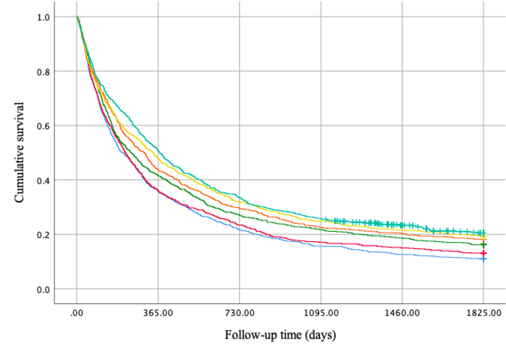
b. Cardia cancer, all patients

1987-1991 (n) | 740 | 264 | 160 | 116 | 93 | 80
1992-1996 (n) | 727 | 262 | 170 | 124 | 109 | 94
1997- 2001 (n) | 778 | 323 | 210 | 169 | 145 | 125
2002-2006 (n) | 704 | 307 | 208 | 159 | 143 | 127
2007- 2011 (n) | 763 | 365 | 243 | 190 | 165 | 146
2012- 2016 (n) | 706 | 357 | 237 | 182 | 127 | 85

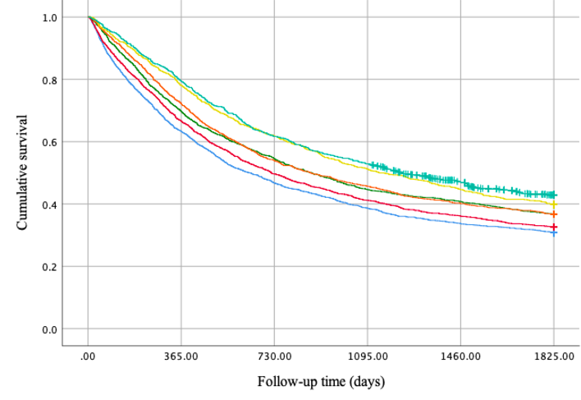

c. Non-cardia cancer, surgery

1987-1991 (n) | 2216 | 1403 | 1035 | 857 | 746 | 682
1992-1996 (n) | 1950 | 1298 | 968 | 803 | 704 | 635
1997- 2001 (n) | 1627 | 1135 | 887 | 726 | 663 | 597
2002-2006 (n) | 1395 | 1008 | 753 | 638 | 560 | 511
2007- 2011 (n) | 1085 | 847 | 670 | 556 | 484 | 431
2012- 2016 (n) | 796 | 633 | 491 | 421 | 322 | 217

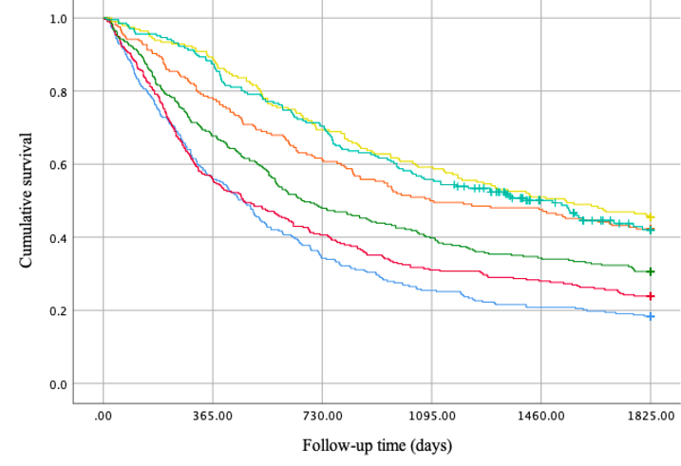
d. Cardia cancer, surgery

1987-1991 (n) | 283 | 158 | 97 | 72 | 59 | 51
1992-1996 (n) | 293 | 164 | 119 | 91 | 82 | 69
1997- 2001 (n) | 294 | 199 | 141 | 117 | 101 | 89
2002-2006 (n) | 206 | 161 | 126 | 103 | 98 | 86
2007- 2011 (n) | 196 | 174 | 136 | 116 | 100 | 88
2012- 2016 (n) | 206 | 180 | 145 | 115 | 75 | 48

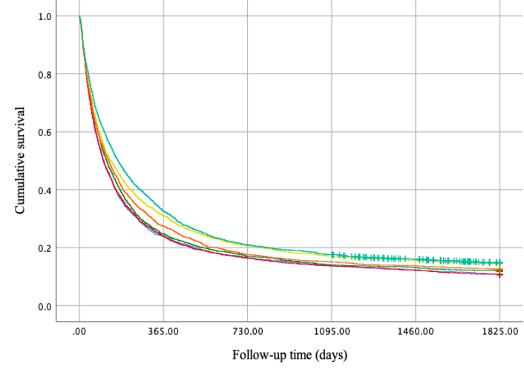

e. Non-cardia cancer, no surgery

1987-1991 (n) | 2929 | 698 | 477 | 403 | 363 | 312
1992-1996 (n) | 2367 | 568 | 391 | 323 | 288 | 254
1997- 2001 (n) | 2055 | 509 | 349 | 289 | 269 | 246
2002-2006 (n) | 2098 | 574 | 369 | 316 | 288 | 261
2007- 2011 (n) | 2084 | 647 | 430 | 357 | 324 | 301
2012- 2016 (n) | 1900 | 617 | 399 | 334 | 269 | 184

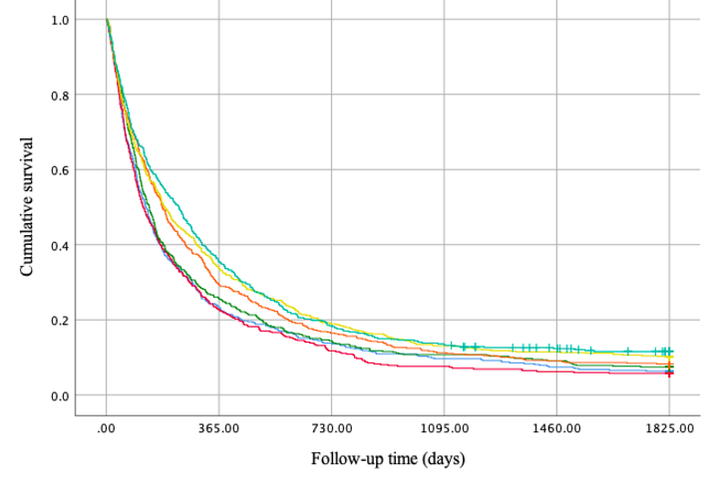

f. Cardia cancer, no surgery

1987-1991 (n) | 457 | 106 | 63 | 44 | 34 | 28
1992-1996 (n) | 434 | 98 | 51 | 33 | 27 | 24
1997-2001 (n) | 484 | 124 | 69 | 52 | 44 | 35
2002-2006 (n) | 498 | 146 | 82 | 56 | 45 | 40
2007- 2011 (n) | 567 | 191 | 107 | 74 | 65 | 57
2012- 2016 (n) | 500 | 177 | 92 | 67 | 52 | 36

Supplementary Figure 2: Kaplan-Meier survival curves showing 5-year survival rate for gastric non-cardia cancer (a) and gastric cardia cancer (b) in total, for gastric non-cardia cancer (c) and gastric cardia cancer (d) undergoing surgery, and for gastric non-cardia cancer (e) and gastric cardia cancer (f) not undergoing surgery, stratified by 5-year time periods.

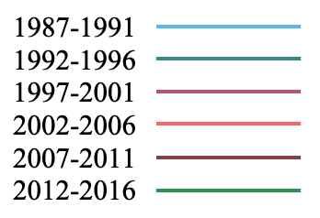
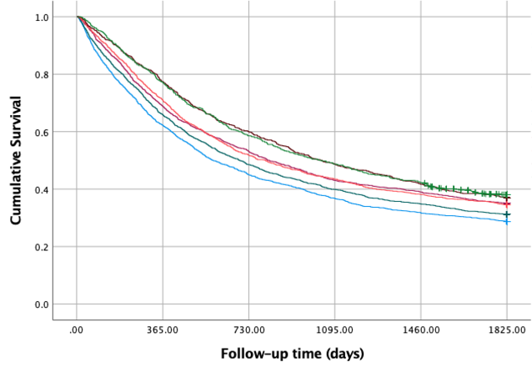
- Non-cardia adenocarcinoma, surgery

1987-1991 (n) | 2051 | 1276 | 923 | 755 | 650 | 588
1992-1996 (n) | 1817 | 1197 | 882 | 725 | 633 | 566
1997- 2001 (n) | 1505 | 1037 | 800 | 648 | 587 | 526
2002-2006 (n) | 1293 | 918 | 671 | 563 | 493 | 446
2007- 2011 (n) | 995 | 770 | 596 | 485 | 415 | 367
2012- 2016 (n) | 632 | 488 | 370 | 308 | 267 | 182

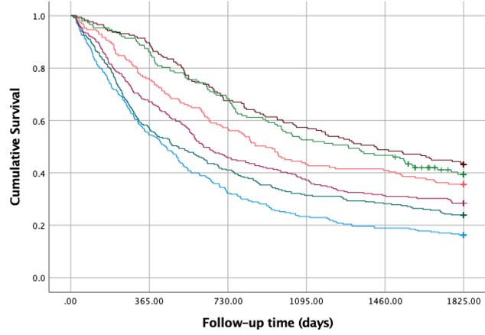
- Cardia adenocarcinoma, surgery

1987-1991 (n) | 270 | 147 | 87 | 63 | 51 | 43
1992-1996 (n) | 280 | 160 | 115 | 88 | 79 | 66
1997- 2001 (n) | 271 | 182 | 124 | 101 | 85 | 76
2002-2006 (n) | 171 | 130 | 97 | 74 | 70 | 60
2007- 2011 (n) | 176 | 157 | 119 | 101 | 86 | 75
2012- 2016 (n) | 152 | 131 | 104 | 80 | 71 | 45

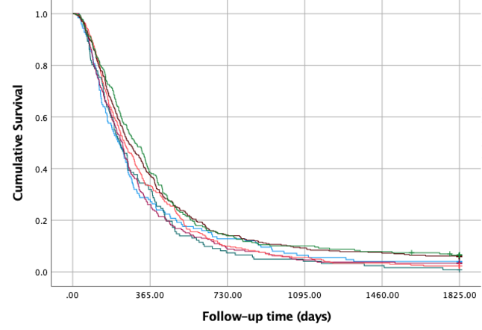

- Non-cardia adenocarcinoma, chemotherapy only

1987-1991 (n) | 125 | 35 | 16 | 8 | 5 | 4
1992-1996 (n) | 122 | 39 | 9 | 5 | 3 | 0
1997- 2001 (n) | 238 | 62 | 21 | 11 | 9 | 7
2002-2006 (n) | 302 | 101 | 30 | 17 | 10 | 6
2007- 2011 (n) | 357 | 134 | 51 | 33 | 26 | 20
2012- 2016 (n) | 229 | 88 | 32 | 23 | 18 | 12

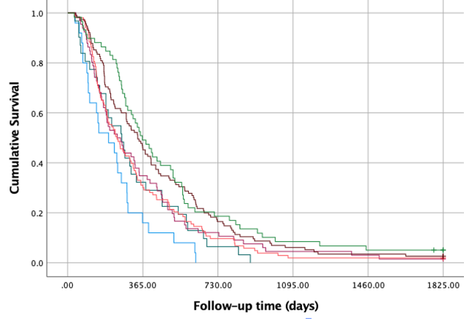

- Cardia adenocarcinoma, Chemotherapy only

1987-1991 (n) | 25 | 4 | - | - | - | -
1992-1996 (n) | 31 | 10 | 2 | - | - | -
1997- 2001 (n) | 66 | 23 | 8 | 3 | 2 | 0
2002-2006 (n) | 103 | 31 | 10 | 2 | 0 | 0
2007- 2011 (n) | 115 | 52 | 19 | 7 | 4 | 2
2012- 2016 (n) | 59 | 29 | 11 | 5 | 3 | 1

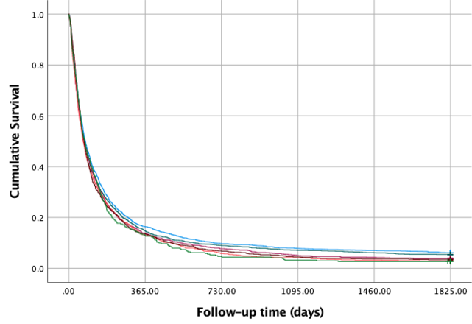

- Non-cardia adenocarcinoma, no treatment

1987-1991 (n) | 2015 | 330 | 196 | 158 | 142 | 123
1992-1996 (n) | 1537 | 227 | 139 | 109 | 94 | 81
1997- 2001 (n) | 1061 | 146 | 82 | 54 | 46 | 40
2002-2006 (n) | 1013 | 132 | 59 | 42 | 33 | 27
2007- 2011 (n) | 859 | 116 | 58 | 39 | 32 | 28
2012- 2016 (n) | 339 | 44 | 16 | 11 | 9 | 7

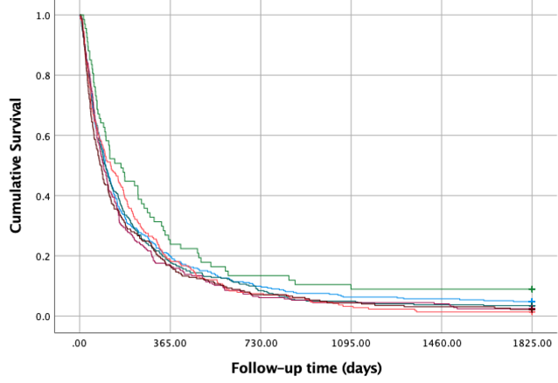

- Cardia adenocarcinoma, no treatment

1987-1991 (n) | 332 | 66 | 33 | 21 | 19 | 15
1992-1996 (n) | 319 | 57 | 27 | 16 | 12 | 10
1997- 2001 (n) | 245 | 41 | 15 | 11 | 10 | 5
2002-2006 (n) | 215 | 40 | 16 | 7 | 3 | 2
2007- 2011 (n) | 225 | 38 | 16 | 10 | 7 | 4
2012- 2016 (n) | 67 | 16 | 9 | 6 | 5 | 5

Supplementary Figure 3: Kaplan-Meier survival curves showing 5-year survival rate for histologically confirmed gastric non-cardia adenocarcinoma (a) and gastric cardia adenocarcinoma (b) undergoing surgery, for gastric non-cardia adenocarcinoma (c) and gastric cardia adenocarcinoma (d) undergoing chemotherapy only, and for gastric non-cardia adenocarcinoma (e) and gastric cardia adenocarcinoma (f) not undergoing treatment, stratified by 5-year time periods.
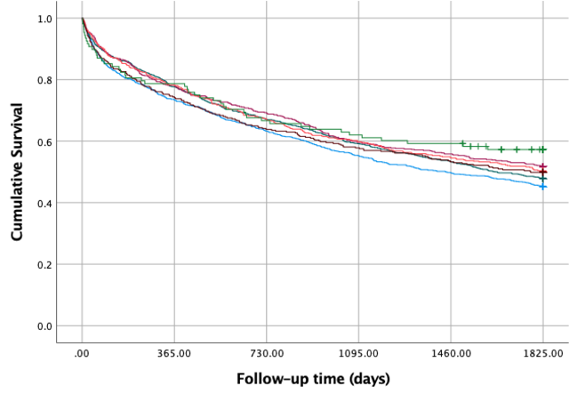

- Non-cardia adenocarcinoma, local stage

1987-1991 (n) | 1092 | 802 | 691 | 604 | 543 | 493
1992-1996 (n) | 960 | 745 | 644 | 568 | 512 | 458
1997- 2001 (n) | 609 | 476 | 421 | 363 | 340 | 314
2002-2006 (n) | 488 | 382 | 328 | 292 | 266 | 244
2007- 2011 (n) | 351 | 261 | 224 | 203 | 187 | 174
2012- 2016 (n) | 108 | 85 | 72 | 67 | 64 | 47

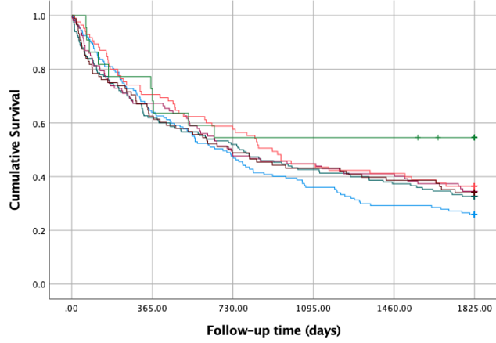

- Cardia adenocarcinoma, local stage

1987-1991 (n) | 147 | 94 | 70 | 53 | 43 | 37
1992-1996 (n) | 150 | 93 | 78 | 64 | 56 | 48
1997- 2001 (n) | 107 | 72 | 51 | 48 | 44 | 36
2002-2006 (n) | 85 | 60 | 49 | 38 | 35 | 30
2007- 2011 (n) | 88 | 55 | 43 | 38 | 34 | 29
2012- 2016 (n) | 22 | 15 | 12 | 12 | 12 | 9

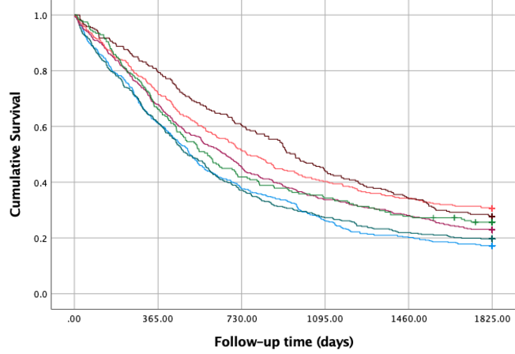

- Non-cardia adenocarcinoma, locally advanced stage

1987-1991 (n) | 505 | 310 | 190 | 132 | 102 | 86
1992-1996 (n) | 447 | 273 | 166 | 122 | 98 | 87
1997- 2001 (n) | 459 | 312 | 209 | 155 | 129 | 104
2002-2006 (n) | 350 | 251 | 180 | 141 | 120 | 106
2007- 2011 (n) | 267 | 212 | 161 | 118 | 91 | 73
2012- 2016 (n) | 198 | 131 | 83 | 68 | 55 | 45

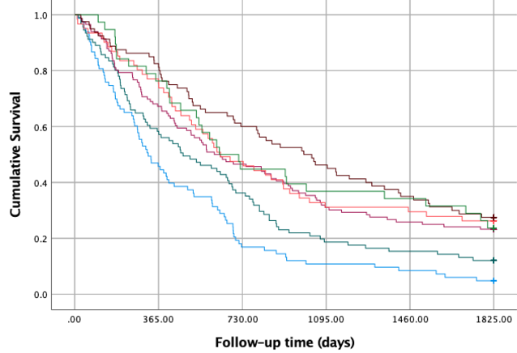

- Cardia adenocarcinoma, locally advanced stage

1987-1991 (n) | 83 | 38 | 14 | 9 | 7 | 3
1992-1996 (n) | 91 | 53 | 33 | 17 | 14 | 10
1997- 2001 (n) | 116 | 78 | 54 | 36 | 30 | 26
2002-2006 (n) | 61 | 46 | 29 | 19 | 18 | 15
2007- 2011 (n) | 80 | 65 | 48 | 37 | 28 | 21
2012- 2016 (n) | 38 | 29 | 17 | 14 | 13 | 8

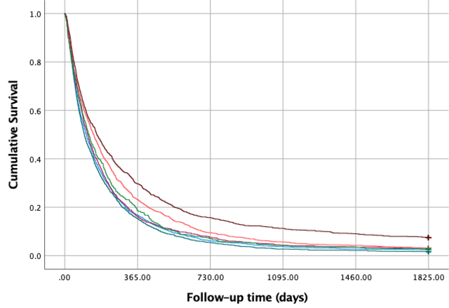

- Non-cardia adenocarcinoma, advanced stage

1987-1991 (n) | 1892 | 318 | 114 | 71 | 53 | 44
1992-1996 (n) | 1472 | 225 | 80 | 40 | 32 | 24
1997- 2001 (n) | 1203 | 195 | 90 | 51 | 43 | 36
2002-2006 (n) | 1286 | 299 | 122 | 73 | 55 | 39
2007- 2011 (n) | 1243 | 369 | 195 | 140 | 112 | 91
2012- 2016 (n) | 514 | 96 | 36 | 22 | 18 | 13

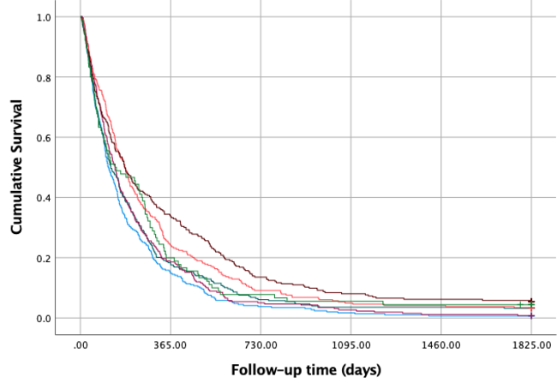

- Cardia adenocarcinoma, advanced stage

1987-1991 (n) | 290 | 43 | 11 | 5 | 2 | 1
1992-1996 (n) | 278 | 50 | 17 | 10 | 10 | 8
1997- 2001 (n) | 258 | 48 | 13 | 7 | 3 | 1
2002-2006 (n) | 263 | 64 | 24 | 13 | 11 | 8
2007- 2011 (n) | 273 | 92 | 37 | 22 | 17 | 14
2012- 2016 (n) | 90 | 18 | 7 | 5 | 4 | 2

Supplementary Figure 4: Kaplan-Meier survival curves showing 5-year survival rate for histologically confirmed gastric non-cardia adenocarcinoma (a) and gastric cardia adenocarcinoma (b) in local stage, for gastric non-cardia adenocarcinoma (c) and gastric cardia adenocarcinoma (d) in locally advanced stage, and for gastric non-cardia adenocarcinoma (e) and gastric cardia adenocarcinoma (f) in advanced stage, stratified by 5-year time periods.

