Supplemental Materials for

Oncological outcomes of conversion therapy in gastric cancer patients with peritoneal metastasis: A large-scale retrospective cohort study

Zhongyin Yang^{1,†}, Sheng Lu^{1,†}, Min Shi^{2,†}, Hong Yuan², Zhenqiang Wang¹, Zhentian Ni¹, Changyu He ¹, Xuexin Yao¹, Yanan Zheng¹, Zhenglun Zhu¹, Wentao Liu¹, Jun Zhang², Chen Li¹, Min Yan¹, Chao Yan^{1,*} , Zhenggang Zhu¹

Figure S1 Kaplan-Meier curve of median OS (A) and PFS (B) of patients with and without history of chemotherapy.

Figure S2 Kaplan-Meier curve of median OS and PFS of patients with Borrmann type IV cancer and other types (A, B). Kaplan Meier curve of median OS and PFS of patients with LNM > 0.14 and LNM ≤ 0.14 (C, D). Kaplan-Meier curve of median OS and PFS of patients with TRG 0-1, 2 and 3 (E, F).
Figure S3 Kaplan-Meier curve of median OS and PFS of patients in the entire group who underwent conversion therapy with the PS+ip PTX and SOX+ip PTX regimens (A, B). Kaplan-Meier curve of median OS and PFS of patients in the CS group who underwent conversion therapy with the PS+ip PTX and SOX+ip PTX regimens (C, D). Kaplan-Meier curve of median OS and PFS of patients in the CS group who underwent conversion therapy with the PS+ip PTX and SOX+ip PTX regimens after PSM (E, F).

Figure S4 Kaplan-Meier curve of median OS and PFS of patients with PCI 0-9, 10-25 and 25-39.
Figure S5 Kaplan-Meier curve of median OS and PFS of patients with dMMR and pMMR (A, B).
Figure S6 The number of patients who underwent R0 and R2 resection from the year of 2015 to 2021 in our center.

Table S1 Clinicopathological characteristics in patients undergo CS.
Variables | n | percent
Operation time
Median, min | 240.0 (126.0-427.0)
Estimated blood loss
Median, ml | 60.0 (20.0-800.0)
Length of postoperative hospital stay
Median, day | 12.0 (7.0-82.0)
Sex
Male | 43 | 38.1
Female | 70 | 61.9
Preoperative chemotherapy courses
< 6 | 47 | 41.6
≥ 6 | 66 | 58.4
Type of gastrectomy
Distal | 33 | 29.2
Total | 80 | 70.8
Extent of resection
R0 | 90 | 79.6
R2 | 23 | 20.4
Combination of resection
Ovary | 23 | 20.4
Gall bladder | 4 | 3.5
Distal pancreas and spleen | 2 | 1.8
Colon | 2 | 1.8
Primary tumor location
U | 12 | 10.6
M | 74 | 65.5
L | 27 | 23.9
Gross type
Borrmann I | 4 | 3.5
Borrmann II | 6 | 5.3
Borrmann III | 84 | 74.3
Borrmann IV | 19 | 16.8
Tumor size (cm)
＜5.5 | 68 | 60.2
≥5.5 | 45 | 39.8
Resected lymph nodes
＜16 | 13 | 11.5
≥16 | 100 | 88.5
Metastatic lymph node ratio
≤0.14 | 54 | 47.8
＞0.14 | 59 | 52.2
Pathological tumor stage (ypT)
ypT0-1 | 9 | 7.9
ypT2 | 12 | 10.6
ypT3 | 29 | 25.7
ypT4 | 63 | 55.8
Pathological nodal stage (ypN)
ypN0 | 25 | 22.1
ypN1 | 19 | 16.8
ypN2 | 21 | 18.6
ypN3 | 48 | 42.5
TRG
0-1 | 29 | 25.7
2 | 53 | 46.9
3 | 31 | 27.4
MMR status
dMMR | 6 | 5.3
pMMR | 107 | 94.7

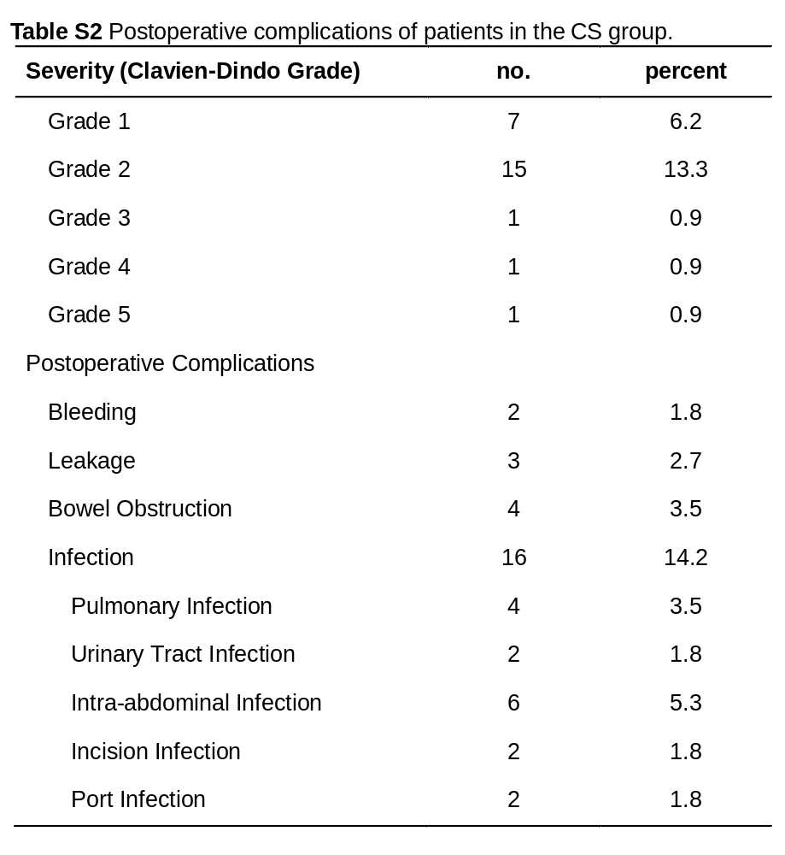

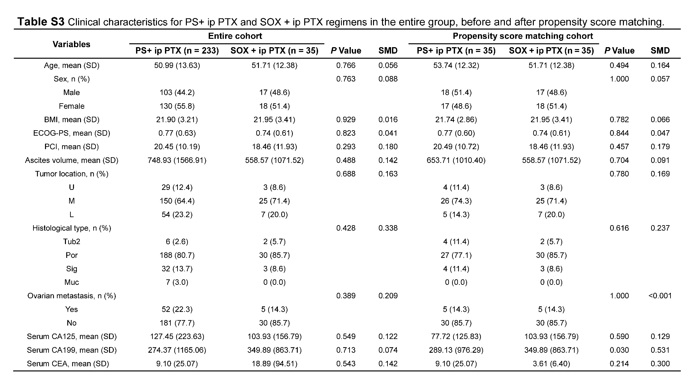
Table S4 Multivariable analysis for female patients with or without ovariectomy in the NCS group.
Variables | HR | 95% CI | P Value
Age (year)
> 60 | 1.00 |  | 0.570
≤ 60 | 0.62 | 0.11 - 3.29
BMI
> 20 | 1.00 |  | 0.517
≤ 20 | 0.73 | 0.28 – 1.19
ECOG-PS
0 - 1 | 1.00 |  | 0.624
2 | 0.59 | 0.07 -4.82
P Stage
P1a/P1b | 1.00 |  | 0.180
P1c | 0.15 | 0.01 – 2.39
Amount of ascites, mL
≤ 100 | 1.00 |  | 0.417
> 100 | 0.60 | 0.17 – 2.06
PCI
> 9 | 1.00 |  | 0.029
≤ 9 | 0.02 | 0.00 – 0.66
Tumor location
L | 1.00 |  | 0.008
U/M | 5.32 | 1.56 – 18.17
Histological Type
tub2/por | 1.00 |  | 0.270
sig/muc | 0.42 | 0.09 – 1.95
Serum CA125, U/ml
> 47.4 | 1.00 |  | 0.978
≤ 47.4 | 1.02 | 0.34 – 3.07
Serum CA19-9, U/ml
> 47.6 | 1.00 |  | 0.326
≤ 47.6 | 0.62 | 0.24 – 1.60
Serum CEA, ng/ml
> 0.7 | 1.00 |  | 0.170
≤ 0.7 | 3.15 | 0.61 – 16.28
Ovariectomy
With | 1.00 |  | 0.001
Without | 13.34 | 3.02 – 58.98
History of chemotherapy
With | 1.00 |  | 0.643
Without | 1.31 | 0.42 – 4.15

Table S5 Adjuvant chemotherapy regimens after conversion surgery.
Patient ID | First Line Adjuvant Regimen | Second Line Adjuvant Regimen | Third Line Adjuvant Regimen | Later Line Adjuvant Regimen
1 | PS + ip PTX | S-1 + ip PTX | / | /
2 | PS + ip PTX | / | / | /
3 | PS + ip PTX | S-1 + ip PTX | PS | /
4 | PS + ip PTX | S-1 + ip PTX | PS | S-1
5 | PS + ip PTX | / | / | /
6 | PS + ip PTX | POS + ip PTX | FOLFIRI | /
7 | PS + ip PTX | / | / | /
8 | PS + ip PTX | S-1 + ip PTX | PS + ip PTX | CPT-11
9 | PS + ip PTX | / | / | /
10 | PS + ip PTX | / | / | /
11 | PS + ip PTX | S-1 + ip PTX | PS + ip PTX | CPT-11
12 | PS + ip PTX | S-1 + ip PTX | / | /
13 | PS + ip PTX | / | / | /
14 | S-1 + ip PTX | PS | S-1 | /
15 | PS + ip PTX | S-1 + ip PTX | / | /
16 | S-1 + ip PTX | PS + ip PTX | S-1 | /
17 | PS + ip PTX | / | / | /
18 | PS + ip PTX | PS | / | /
19 | SOX + ip PTX | DS | CapeOX | /
20 | PS + ip PTX | / | / | /
21 | PS + ip PTX | CPT-11 | / | /
22 | PS + ip PTX | / | / | /
23 | PS + ip PTX | / | / | /
24 | S-1 + ip PTX | PS + ip PTX | S-1 | /
25 | PS + ip PTX | / | / | /
26 | PS + ip PTX | CPT-11 | / | /
27 | PS + ip PTX | / | / | /
28 | PS + ip PTX | S-1 + ip PTX | S-1 | /
29 | PS + ip PTX | / | / | /
30 | PS + ip PTX | Cape + ip PTX | CapeOX + ip PTX | /
31 | PS + ip PTX | CapeOX | / | /
32 | PS + ip PTX | S-1 + ip PTX | PS + ip PTX | PS
33 | S-1 + ip PTX | PS + ip PTX | / | /
34 | PS + ip PTX | CapeOX | ip CDDP | /
35 | S-1 + ip PTX | PS + ip PTX | S-1 + ip PTX | PS + ip PTX
36 | PS + ip PTX | / | / | /
37 | S-1 + ip PTX | PS + ip PTX | FOLFOX | /
38 | S-1 + ip PTX | PS + ip PTX | FOLFOX | /
39 | PS + ip PTX | CaoeOX | / | /
40 | S-1 + ip PTX | / | / | /
41 | S-1 + ip PTX | S-1 | / | /
42 | PS + ip PTX | / | / | /
43 | PS + ip PTX | / | / | /
44 | S-1 + ip PTX | PS + ip PTX | PS + ip PTX + ip CDDP | /
45 | PS + ip PTX | S-1 + ip PTX | PS + ip PTX | AP
46 | PS + ip PTX | S-1 + ip PTX | Cape + ip PTX | /
47 | PS + ip PTX | POS + ip PTX | / | /
48 | PS + ip PTX | / | / | /
49 | PS + ip PTX | S-1 + ip PTX | PS + ip PTX | CPT-11
50 | S-1 + ip PTX | PS + ip PTX | / | /
51 | PS + ip PTX | S-1 + ip PTX | PS + ip PTX | /
52 | PS + ip PTX | / | / | /
53 | PS + ip PTX | S-1 + ip PTX | PS + ip PTX | CapeOX —> FOLFIRI
54 | PS + ip PTX | S-1 | SOX + ip PTX | /
55 | PX + ip PTX | S-1 + ip PTX | / | /
56 | S-1 + ip PTX | SOX + ip PTX | S-1 + ip PTX | /
57 | S-1 + ip PTX | SOX + ip PTX | S-1 + ip PTX | S-1 + ip PTX + ip CDDP
58 | PS + ip PTX | / | / | /
59 | PS + ip PTX | FOLFIRI + ip PTX + ip CDDP | / | /
60 | PS + ip PTX | PS | / | /
61 | SOX + ip PTX | PS + ip PTX | / | /
62 | S-1 + ip PTX | S-1 | / | /
63 | S-1 + ip PTX | DOX + DOC IP | PS + ip PTX | FOLFOX —> CPT-11 —> PD-1
64 | SOX + ip PTX | S-1 + ip PTX | / | /
65 | PS + ip PTX | PS + ip PTX + ip CDDP | / | /
66 | SOX + ip PTX | PS + ip PTX | S-1 + ip PTX | /
67 | PS + ip PTX | nab-PS + ip nab-PTX + ip CDDP | PS + ip PTX | /
68 | PS + ip PTX | SOX + ip PTX | / | /
69 | PS + ip PTX | / | / | /
70 | PS + ip PTX | PS + ip PTX + PD-1 | / | /
71 | PS + ip PTX | / | / | /
72 | SOX + ip PTX | / | / | /
73 | PS + ip PTX | S-1 + ip PTX | CapeOX | nab-PTX + ip nab-PTX —> ip PTX
74 | S-1 + ip PTX | PS + ip PTX | / | /
75 | PS + ip PTX | S-1 + ip PTX | ip PTX + ip CDDP | /
76 | PS + ip PTX | / | / | /
77 | PS + ip PTX | PS | / | /
78 | PS + ip PTX | S-1 + ip PTX | / | /
79 | PS + ip PTX | S-1 + ip PTX | PS-P | S-1
80 | PS + ip PTX | / | / | /
81 | PS + ip PTX | PS + ip PTX + ip CDDP | CapeOX-P + ip PTX | /
82 | PS + ip PTX | / | / | /
83 | S-1 + ip PTX | PS + ip PTX | CapeOX | Cape-H —> Cape-H + ip PTX  —> Cape-H + ip PTX + ip CDDP  —> H + ip PTX + ip CDDP + PD-1
84 | S-1 + ip PTX | SOX + ip PTX | S-1 + ip PTX | PS + ip PTX + ip CDDP —> PD-1
85 | PS + ip PTX | DX | RegoNivo | /
86 | PS + ip PTX | nab-PS-AP + ip nab-PTX | PD-1 | /
87 | PS + ip PTX | S-1 + ip PTX | / | /
88 | PS + ip PTX | S-1 + ip PTX | PS + ip PTX | /
89 | PS + ip PTX | S-1 + ip PTX | / | /
90 | SOX + ip PTX | / | / | /
91 | PS + ip PTX | / | / | /
92 | SOX + ip PTX | / | / | /
93 | PS + ip PTX | / | / | /
94 | PS + ip PTX | PS + ip PTX + ip CDDP | PD-1 | /
95 | SOX + ip PTX | / | / | /
96 | SOX + ip PTX | S-1 + ip PTX | S-1 | /
97 | nab-PS + ip PTX | ip PTX | / | /
98 | SOX + ip PTX | S-1 + ip PTX | PD-1 + ip PTX | /
99 | S-1 + ip PTX | / | / | /
100 | PS + ip PTX + ip CDDP | PS + ip PTX | CapeOX-P | /
101 | PS + ip PTX | PS + ip PTX + ip CDDP | PS + ip PTX + ip CDDP + PD-1 | /
102 | PS + ip PTX | / | / | /
103 | PS + ip PTX | PS + ip PTX + ip CDDP | / | /
104 | PS + ip PTX | PS + ip PTX + ip CDDP + PD-1 | / | /
105 | PS + ip PTX | S-1 + ip PTX | / | /
106 | PS + ip PTX | S-1 + ip PTX | CapeOX + ip PTX + PD-1 | Cape + ip PTX + ip CDDP + PD-1  —> CPT-11 —> Lenvatinib + PD-1
107 | PS + ip PTX + ip CDDP | / | / | /
108 | nab-PS + ip nab-PTX | nab-PS + ip nab-PTX + PD-1 | S-1 + ip nab-PTX | nab-PS + ip nab-PTX + ip CDDP
109 | S-1 + ip PTX | PS + ip PTX | S-1 + ip PTX | /
110 | PS + ip PTX | / | / | /
111 | SOX + ip PTX | S-1 + ip PTX | / | /
112 | PS + ip PTX + ip CDDP | / | / | /
113 | PS + ip PTX | / | / | /

