Supplementary Figure 1:
Supplementary Figure 1: TLR6 mRNA expression (A) in untreated GES-1 cells (F0), GES-1 cells at 1st passage (F1), GES-1 cells at 10th passage (F10), GES-1 cells at 20th passage (F20) and GES-1 cells at 30th passage (F30). TLR6 mRNA expression (B) in MKN-45 cells, MKN-45 cells+lysate F1 cells (F1) and MKN-45+lysate F30 cells (F30). All data represents means ± SEM. ***P <0 .001, **P <0 .01.

Supplementary Figure 2:
Supplementary Figure 2: The levels of IL-8, IL-1β, Fas, IFN-γ, IL-23, CD163 (A) in untreated GES-1 cells (control), lysate-1 cells and lysate-30 cells. IL-1β mRNA expression (B) and IL-8 mRNA expression (C) in untreated GES-1 cells (F0), GES-1 cells at 1st passage (F1) and GES-1 cells at 30th passage (F30).

Supplementary Figure 3:

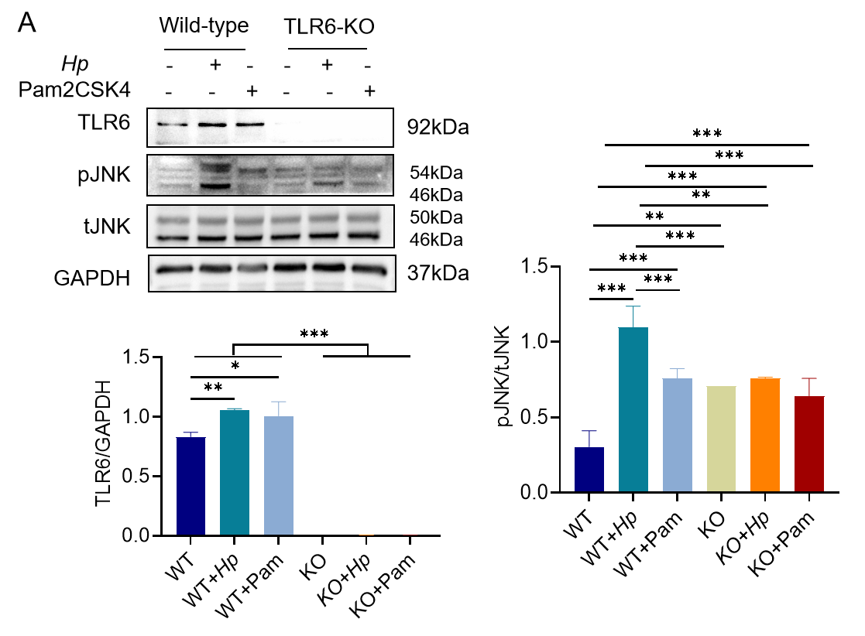
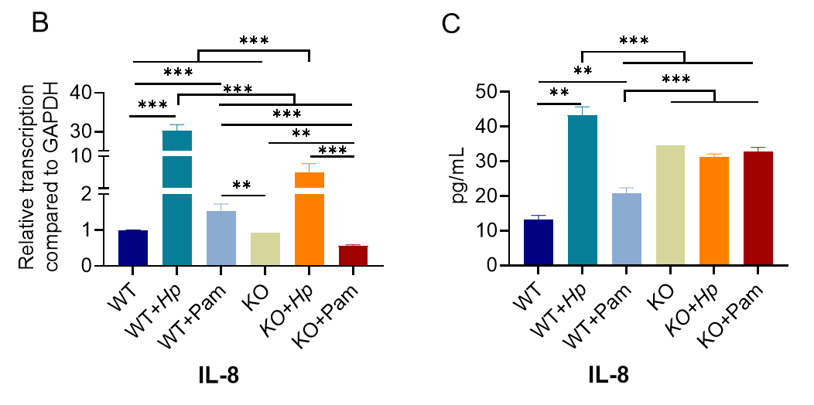
Supplementary Figure 3: pJNK and TLR6 expression (A) in WT cells, WT cells co-culture with H. pylori for 24 h (WT+Hp), WT cells co-culture with 2μg/ml Pam2CSK4 for 24 h (WT+Pam), KO cells, KO cells co-culture with H. pylori for 24 h (KO+Hp), KO cells co-culture with 2μg/ml Pam2CSK4 for 24 h (KO+Pam). IL-8 mRNA expression (B) and supernatant IL-8 content (C) in WT cells, WT+Hp cells, WT+Pam cells, KO cells, KO+Hp cells, and KO+Pam cells. All experiment were performed in triplicate and all data represents means ± SEM. ***P < 0.001, **P < 0.01, * P < 0.05.

Supplementary Table 1
Infection weeks | Dysplasia | Atrophic gastritis | Superficial gastritis | No typical lesion | Total number
0 | 0 | 0 | 0 | 3 | 3
5 | 0 | 0 | 1 | 5 | 6
10 | 0 | 0 | 3 | 3 | 6
15 | 0 | 2 | 0 | 4 | 6
20 | 0 | 1 | 0 | 4 | 5
25 | 0 | 0 | 0 | 6 | 6
30 | 2 | 2 | 0 | 2 | 6
35 | 3 | 0 | 0 | 2 | 5
40 | 0 | 0 | 1 | 4 | 5
45 | 0 | 0 | 0 | 5 | 5
50 | 0 | 0 | 1 | 4 | 5
55 | 0 | 2 | 1 | 3 | 6
60 | 0 | 0 | 1 | 5 | 6
65 | 0 | 0 | 1 | 5 | 6
70 | 1 | 0 | 1 | 4 | 6
75 | 0 | 0 | 0 | 6 | 6
80 | 0 | 1 | 0 | 4 | 5
90 | 0 | 1 | 0 | 5 | 6
Total number | 6 | 9 | 10 | 74 | 99

Supplementary Table 2 The specific primers of TLR and GAPDH
 | Sense primer ( 5'－3') | Antisense primer ( 5'－3')
TLR1 | ATTCAGTTTCCCACCCATCG | GCCAGCCCTCTAACACTTCA
TLR3 | TCCACCACCAGCAATACAAC | AAGCCAAGCAAAGGAATCG
TLR4 | CTCCTGCGTGAGACCAGAAA | CCGTGATAAAACGGCAGCAT
TLR5 | CACAGTCACCAAACCAGGGA | GGGCAAAGTCAATTGCCAGG
TLR6 | GCAGGGGACAATCCATTCCA | AGAATCAGGCCAGCCCTCTA
TLR8 | AAACTTGACCCAACTTCGATACCTAA | GATCCAGCACCTTCAGATGAGG
TLR9 | TGCCCAAACTGGAAGTCCTC | TAAGGTTGAGCTCTCGCAGC
GAPDH | CGACAGTCAGCCGCATCTT | CCAATACGACCAAATCCGTTG
IL-1β | GGCTGCTCTGGGATTCTCTT | ATTTCACTGGCGAGCTCAGG
Rac1 | AAACCGGTGAATCTGGGCTT | TCGGCAATCGGCTTGTCTTT
PI3K | CATCACTTCCTCCTGCTCTAT | CAGTTGTTGGCAATCTTCTTC
Myd88 | GGACCCAGCATTGGGCATA | CGATGAGCTCACTAGCAATAGACC
p38 | TATGCGTCTGACAGGAACAC | GATCGGCCACTGGTTCATCA
JNK | GGAAAACGCTGACTCAGAACAC | CGGGTGTTGGAGAGCTTCAT
JUN | GGATCAAGGCGGAGAGGAGA | GGTTAGCATGAGTTGGCAC
Hp23srRNA | TAAGGCGCGTGAAAGAACTCTGGTTAA | TCGGGAGGGACTCTTTGCTGAGA
Hp23srRNA-probe | FAM-ACTCTGCAAACTAGCACCGTAAGTTCGCG-HEX
Gerbil-GAPDH | TTCAACGGCACAGTCAAGGC | GCCTTCTCCATGGTGGTGAAG
Gerbil-GAPDH-probe | FAM-CCC ATC ACC ATC TTC CAG GAG CGA GA-HEX

