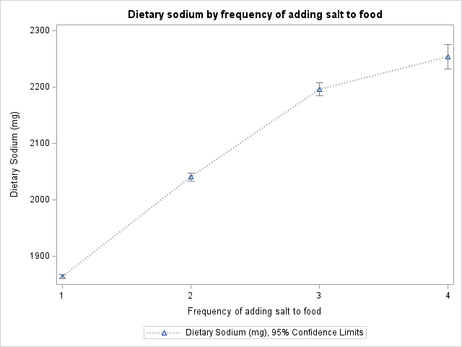

Supplemental figure 2. Association between dietary sodium estimated from 24-h diet recall and the frequencyª of adding salt to food at table

ª Frequency of adding salt to food: 1- never/rarely; 2-sometimes; 3-usually; 4-always. All associations were statistically significant, with P-values for linear trend across categories of adding salt: P<0.001.

