Claudin-18 status and its correlation with HER2 and PD-L1 expression in gastric cancer with peritoneal dissemination

Haruki Ogawa M.D.,^{1,2} Hiroyuki Abe M.D., Ph.D.,¹ Koichi Yagi M.D., Ph.D.,² Yasuyuki Seto, M.D., Ph.D.² & Tetsuo Ushiku M.D., Ph.D.¹
1 Department of Pathology, Graduate School of Medicine, the University of Tokyo, 7-3-1 Hongo, Bunkyo-ku, Tokyo 113-0033, Japan.
2 Department of Gastrointestinal Surgery, Graduate School of Medicine, the University of Tokyo, 7-3-1 Hongo, Bunkyo-ku, Tokyo 113-0033, Japan.
H.O. and H.A. equally contributed to this work.
Correspondence:
Tetsuo Ushiku, MD, PhD
Department of Pathology, Graduate School of Medicine, The University of Tokyo
Tel: 81-3-5841-3341 E-mail: usikut@g.ecc.u-tokyo.ac.jp

Article type: original article
Submitted to Journal: Gastric Cancer

Supplementary Figure 1. Correlation between CLDN18 status and overall survival.
- 40% cut-off. (b) 75% cut-off.

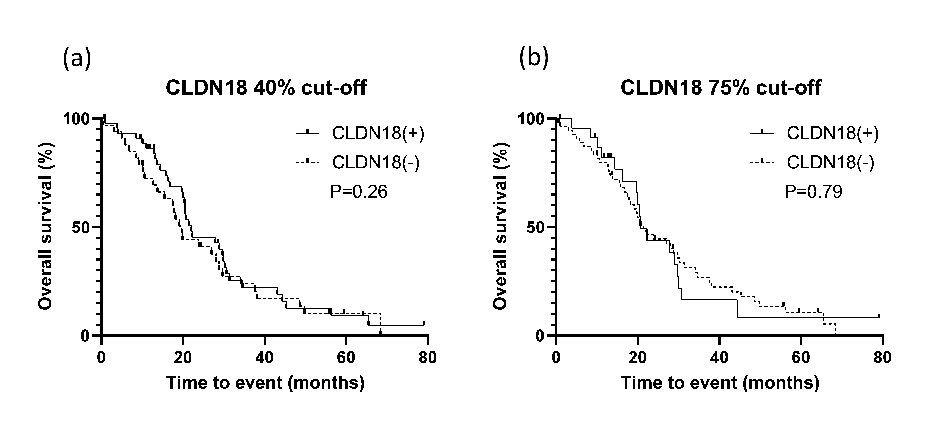

Supplementary Figure 2. Comparison of CLDN18 expression between biopsy and surgical specimens
There was no significant difference between the biopsy and surgical specimens, although several examples show discrepancies across the cut-offs.

