Supplementary Appendix to
Comparative Effectiveness of Sodium-Glucose Cotransporter-2 Inhibitors for New-Onset Gastric Cancer and Gastric Diseases in Patients with Type 2 Diabetes Mellitus: A Population-Based Cohort Study
Table of Contents
Supplementary Figure 1A: Distribution of date of T2DM diagnosis amongst the patients on SGLT2I, DPP4I, and GLP1a. 3
SGLT2I: Sodium-glucose cotransporter-2 inhibitors; DPP4I: Dipeptidyl peptidase-4 inhibitors; Glucagon-like peptide-1 receptor agonist (GLP1a). 3
Supplementary Figure 1B: Distribution of duration from medication initiation to outcome for SGLT2I, DPP4I, and GLP1a 4
SGLT2I: Sodium-glucose cotransporter-2 inhibitors; DPP4I: Dipeptidyl peptidase-4 inhibitors; Glucagon-like peptide-1 receptor agonist (GLP1a). 4
Supplementary Figure 1C: Bar chart of drug initialization dates for SGLT2I, DPP4I, and GLP1a in 2015. 5
SGLT2I: Sodium-glucose cotransporter-2 inhibitors; DPP4I: Dipeptidyl peptidase-4 inhibitors; Glucagon-like peptide-1 receptor agonist (GLP1a). 5
Supplementary Figure 2. Propensity score matching comparisons and proportional hazard assumption checking with parallel lines for SGLT2I v.s. DPP4I before and after 1:1 matching with nearest neighbor search strategy with calliper of 0.1 7
Supplementary Figure 3. Cumulative incidence curves for new onset gastric outcomes and all-cause mortality stratified by drug exposure effects of SGLT2I and DPP4I before propensity score matching (1:1). 10
Supplementary Figure 4. Marginal effects of diabetes duration with 95% Cis on new onset adverse gastric events and all-cause mortality stratified by drug use. 13
Supplementary Figure 5A. Cumulative incidence curves for new onset gastric outcomes and all-cause mortality stratified by combinations of age and drug exposure effects of SGLT2I and DPP4I before propensity score matching. 16
Supplementary Figure 5B. Cumulative incidence curves for new onset gastric outcomes and all-cause mortality stratified by combinations of age and drug exposure effects of SGLT2I and DPP4I in the matched cohort. 19
Supplementary Figure 6A. Cumulative incidence curves for new onset gastric outcomes and all-cause mortality stratified by combinations of gender and drug exposure effects of SGLT2I and DPP4I before propensity score matching. 22
Supplementary Figure 6B. Cumulative incidence curves for new onset gastric outcomes and all-cause mortality stratified by combinations of gender and drug exposure effects of SGLT2I and DPP4I in the matched cohort. 25
Supplementary Table 1. The International Classification of Diseases, Clinical Modification (ICD-9-CM) codes for definitions of past comorbidities and outcomes. 26
Supplementary Table 2. Calculations for variability measure 28
Supplementary Table 3. Multivariable Cox regression models with adjustments to predict new gastric cancer and gastric diseases in the SGLT2I v.s. DPP4I matched cohort. 29
Supplementary Table 4. Sensitivity analysis: Three-arm (only SGLT2I, only DPP4I, and only GLP1a) analysis results using stabilized IPTW. 30
Supplementary Table 5. Sensitivity analyses: Exposure effects of SGLT2I v.s. DPP4I on new onset gastric diseases in the SGLT2I v.s. DPP4I matched cohort across different hazard models and matching methods. 31
Supplementary Table 6. Sensitivity analysis: Excluding patients with CKD stage 4/5 (eGFR <30), peritoneal dialysis or haemodialysis in the SGLT2I v.s. DPP4I matched cohort. 32
Supplementary Table 7. Sensitivity analysis: Consideration of 1-year lag time effects in the SGLT2I v.s. DPP4I matched cohort. 32
Supplementary Table 8. Sensitivity analysis: As-treated approach of SGLT2I v.s. DPP4I on new onset gastric diseases in the SGLT2I v.s. DPP4I matched cohort 33
Supplementary Table 9. Falsification analysis: Exposure effects of SGLT2I v.s. DPP4I on new onset venous thromboembolism in the SGLT2I v.s. DPP4I matched cohort after 1:1 propensity score matching 33
Supplementary Table 10. The basic characteristics of the SGLT2I, DPP4I and GLP1a patients in the 3-arm analysis. 34

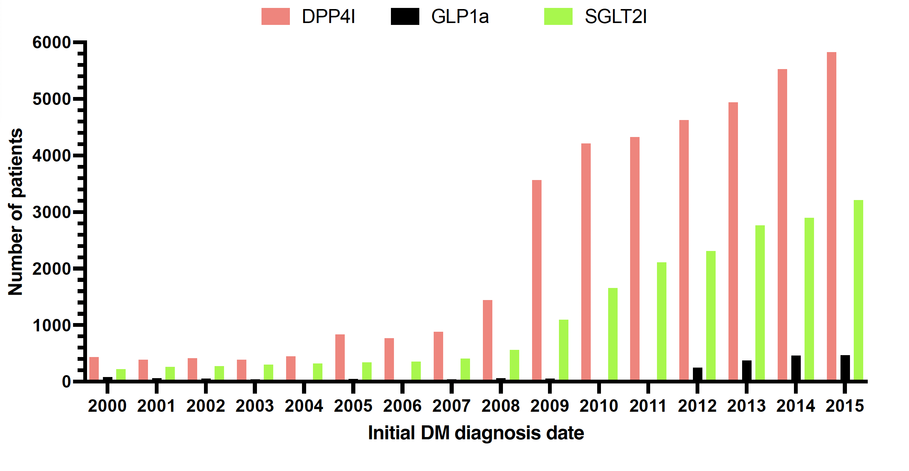

Supplementary Figure 1A: Distribution of date of T2DM diagnosis amongst the patients on SGLT2I, DPP4I, and GLP1a.

SGLT2I: Sodium-glucose cotransporter-2 inhibitors; DPP4I: Dipeptidyl peptidase-4 inhibitors; Glucagon-like peptide-1 receptor agonist (GLP1a).

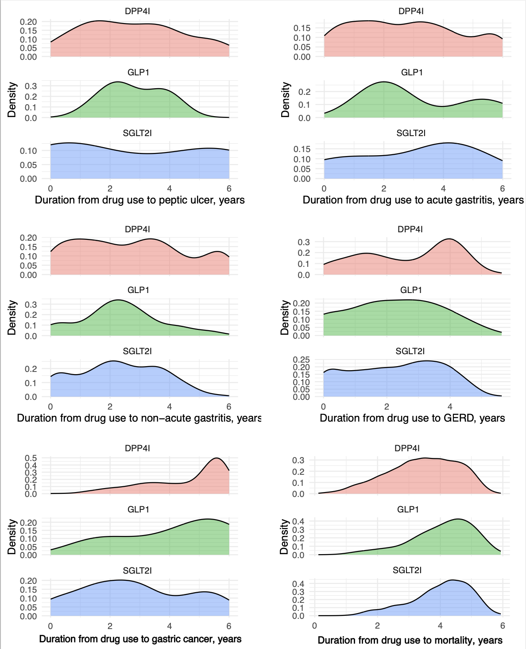

Supplementary Figure 1B: Distribution of duration from medication initiation to outcome for SGLT2I, DPP4I, and GLP1a

SGLT2I: Sodium-glucose cotransporter-2 inhibitors; DPP4I: Dipeptidyl peptidase-4 inhibitors; Glucagon-like peptide-1 receptor agonist (GLP1a).

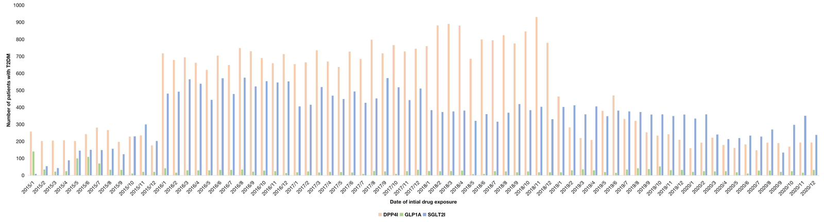

Supplementary Figure 1C: Bar charts of the first prescription dates for the different drug classes of SGLT2I, DPP4I, and GLP1a.

SGLT2I: Sodium-glucose cotransporter-2 inhibitors; DPP4I: Dipeptidyl peptidase-4 inhibitors; Glucagon-like peptide-1 receptor agonist (GLP1a).

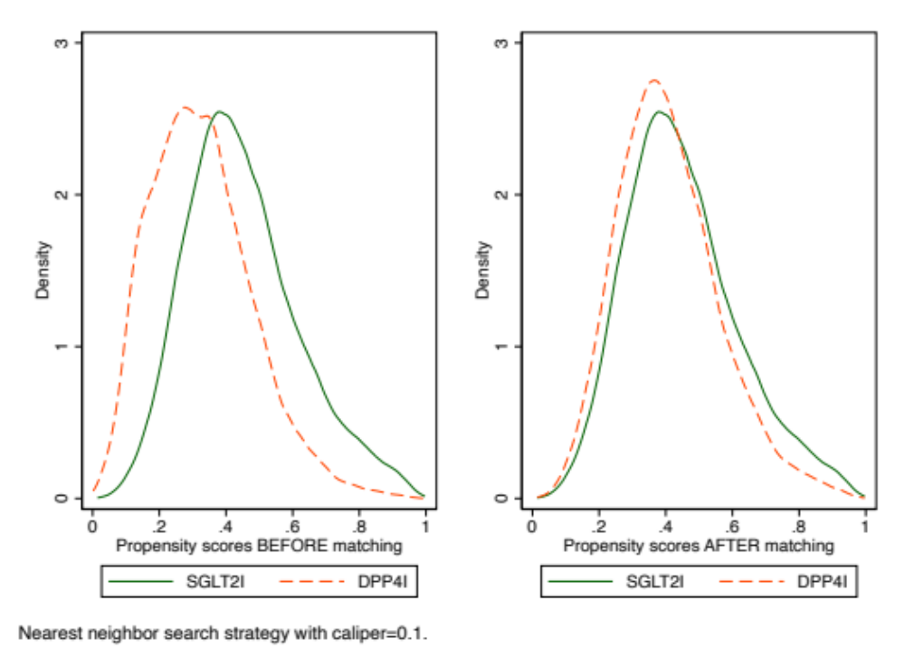

Supplementary Figure 2. Propensity score matching comparisons and proportional hazard assumption checking with parallel lines for SGLT2I v.s. DPP4I before and after 1:1 matching with nearest neighbor search strategy with calliper of 0.1
SGLT2I: Sodium-glucose cotransporter-2 inhibitors; DPP4I: Dipeptidyl peptidase-4 inhibitors.

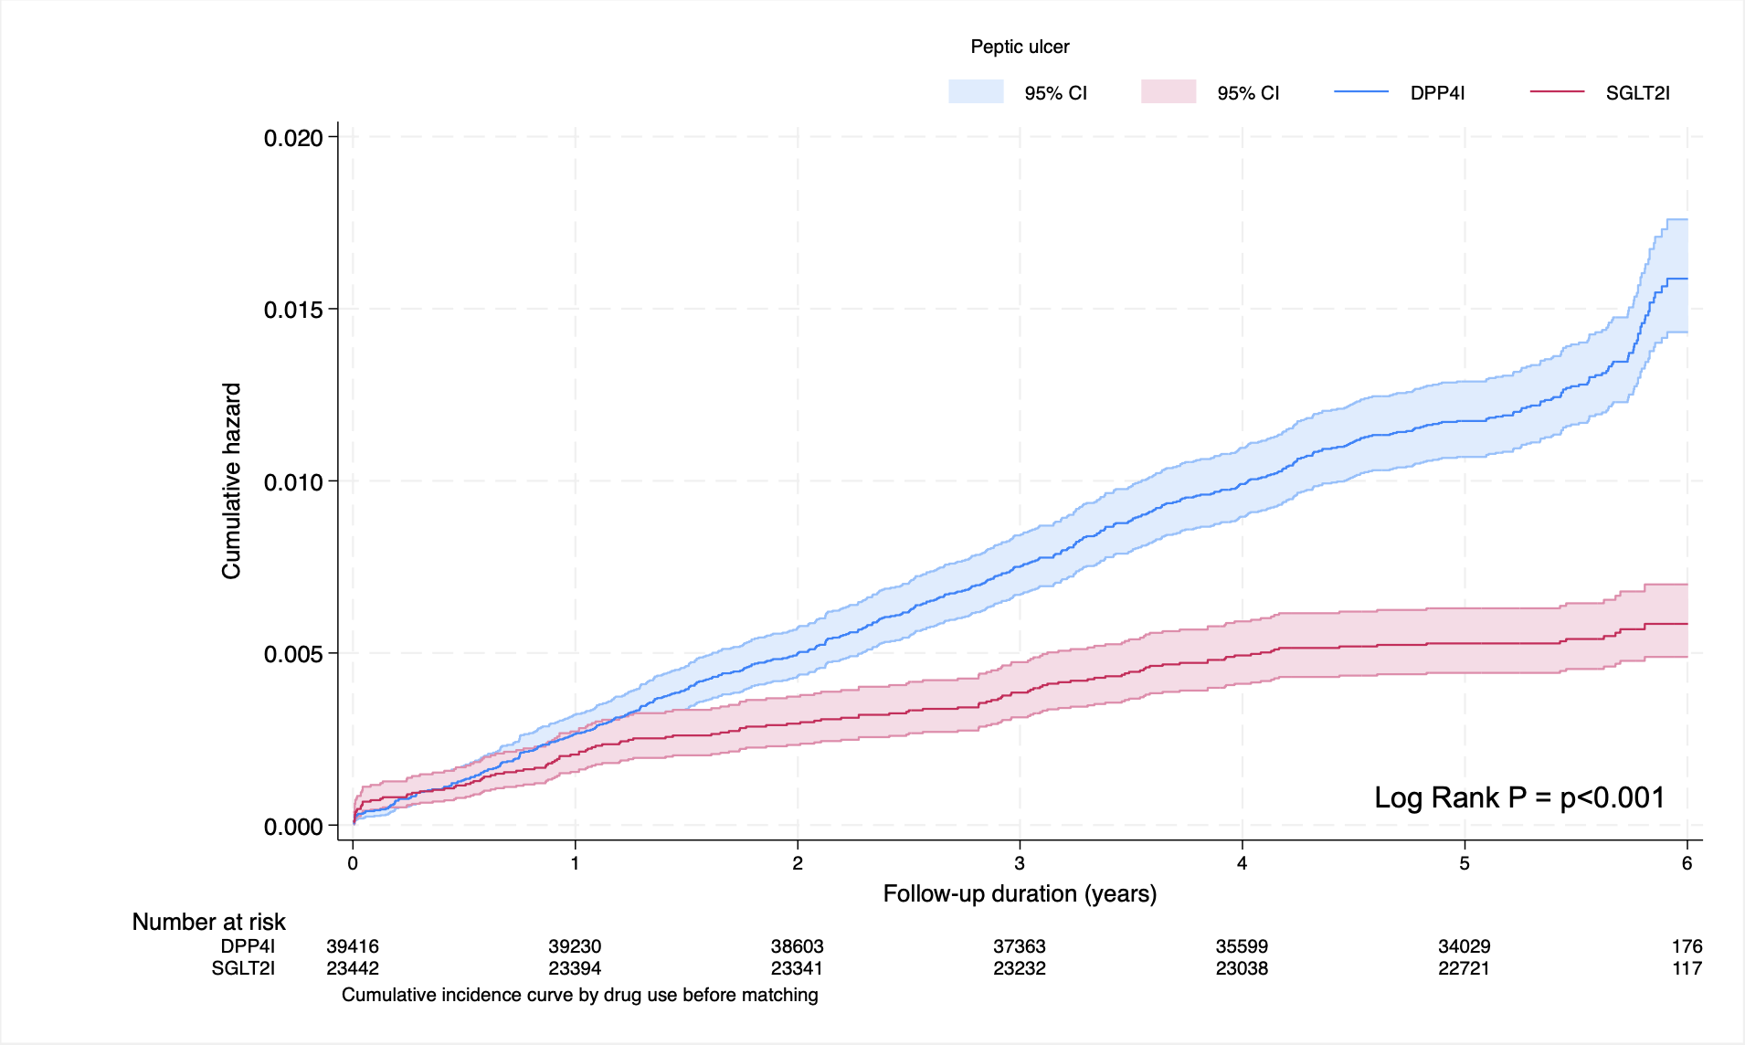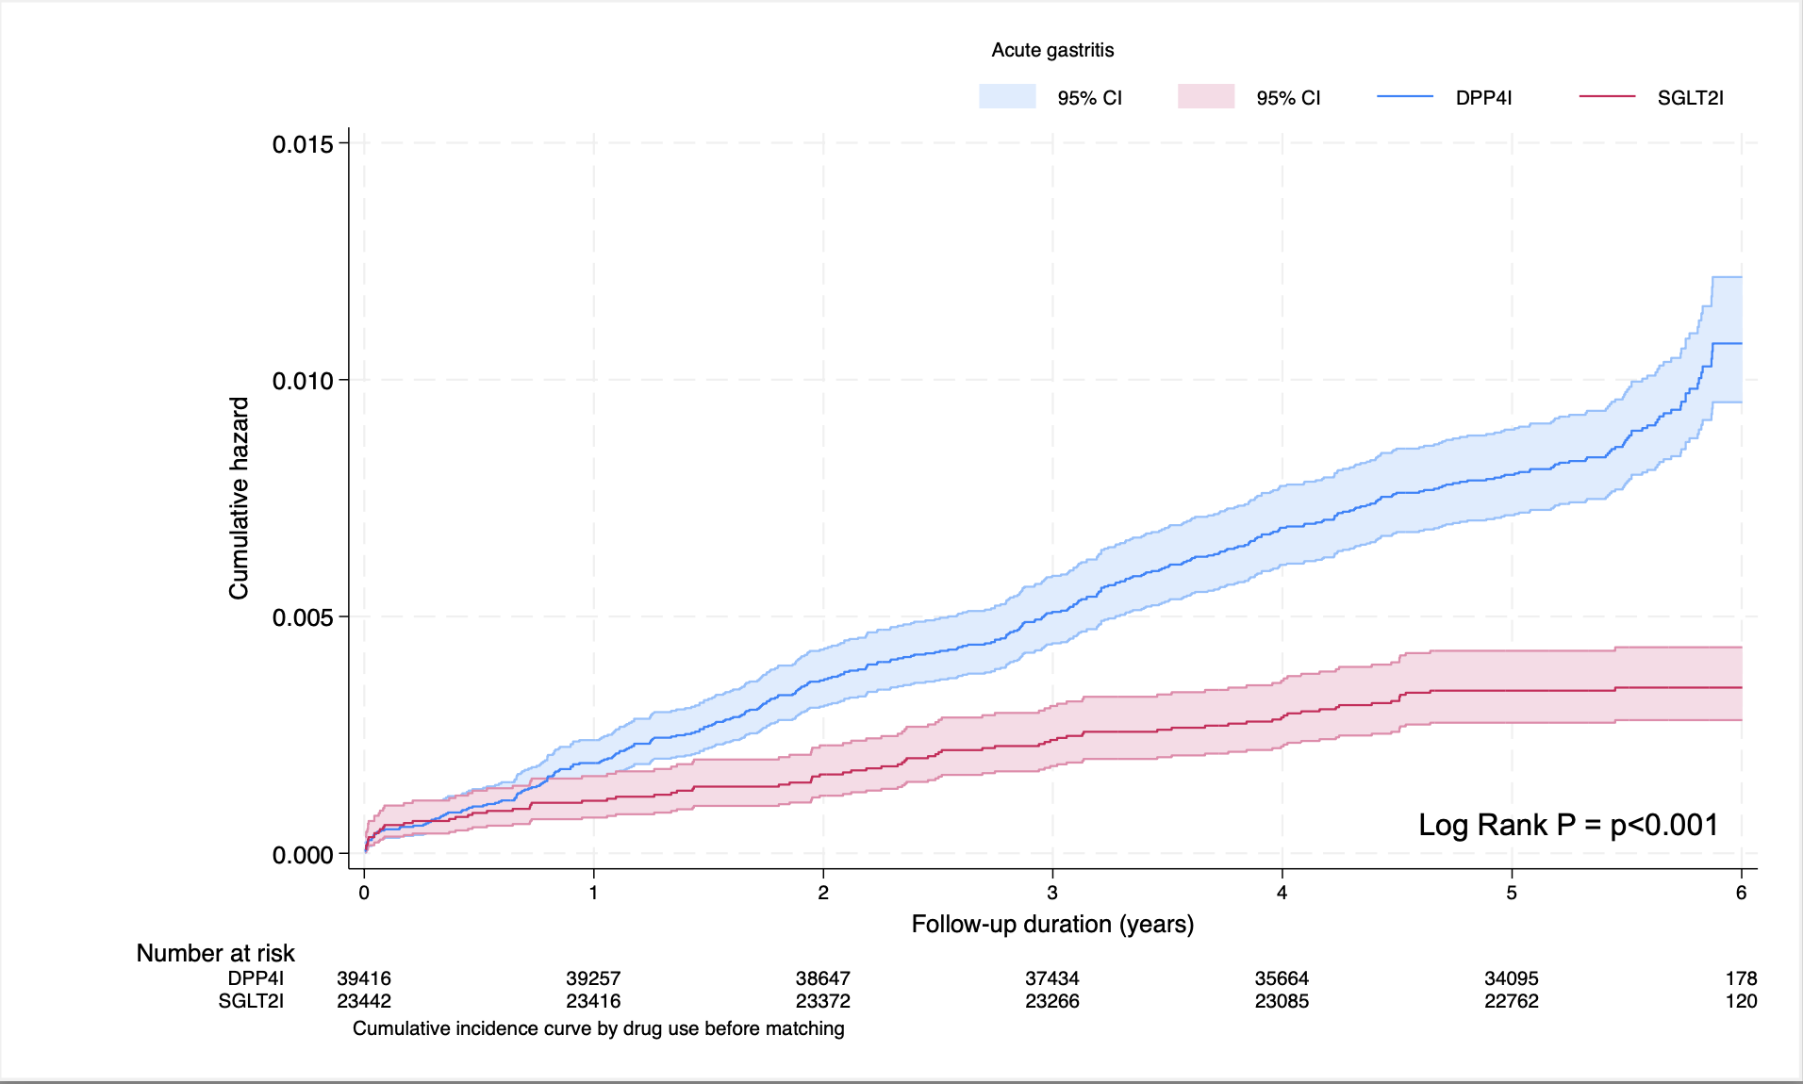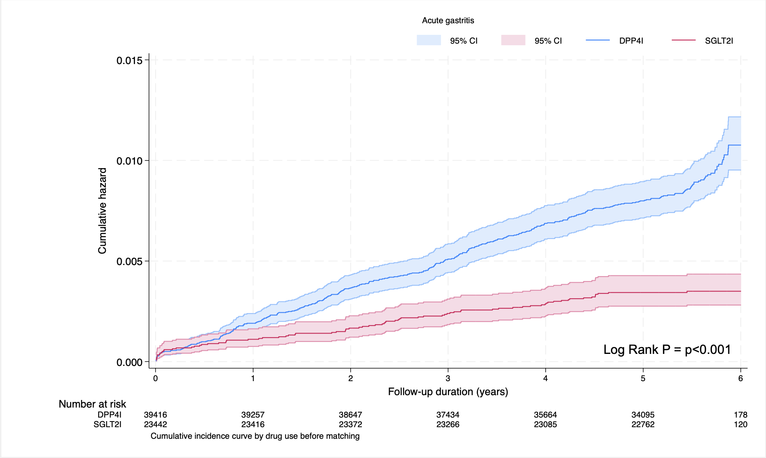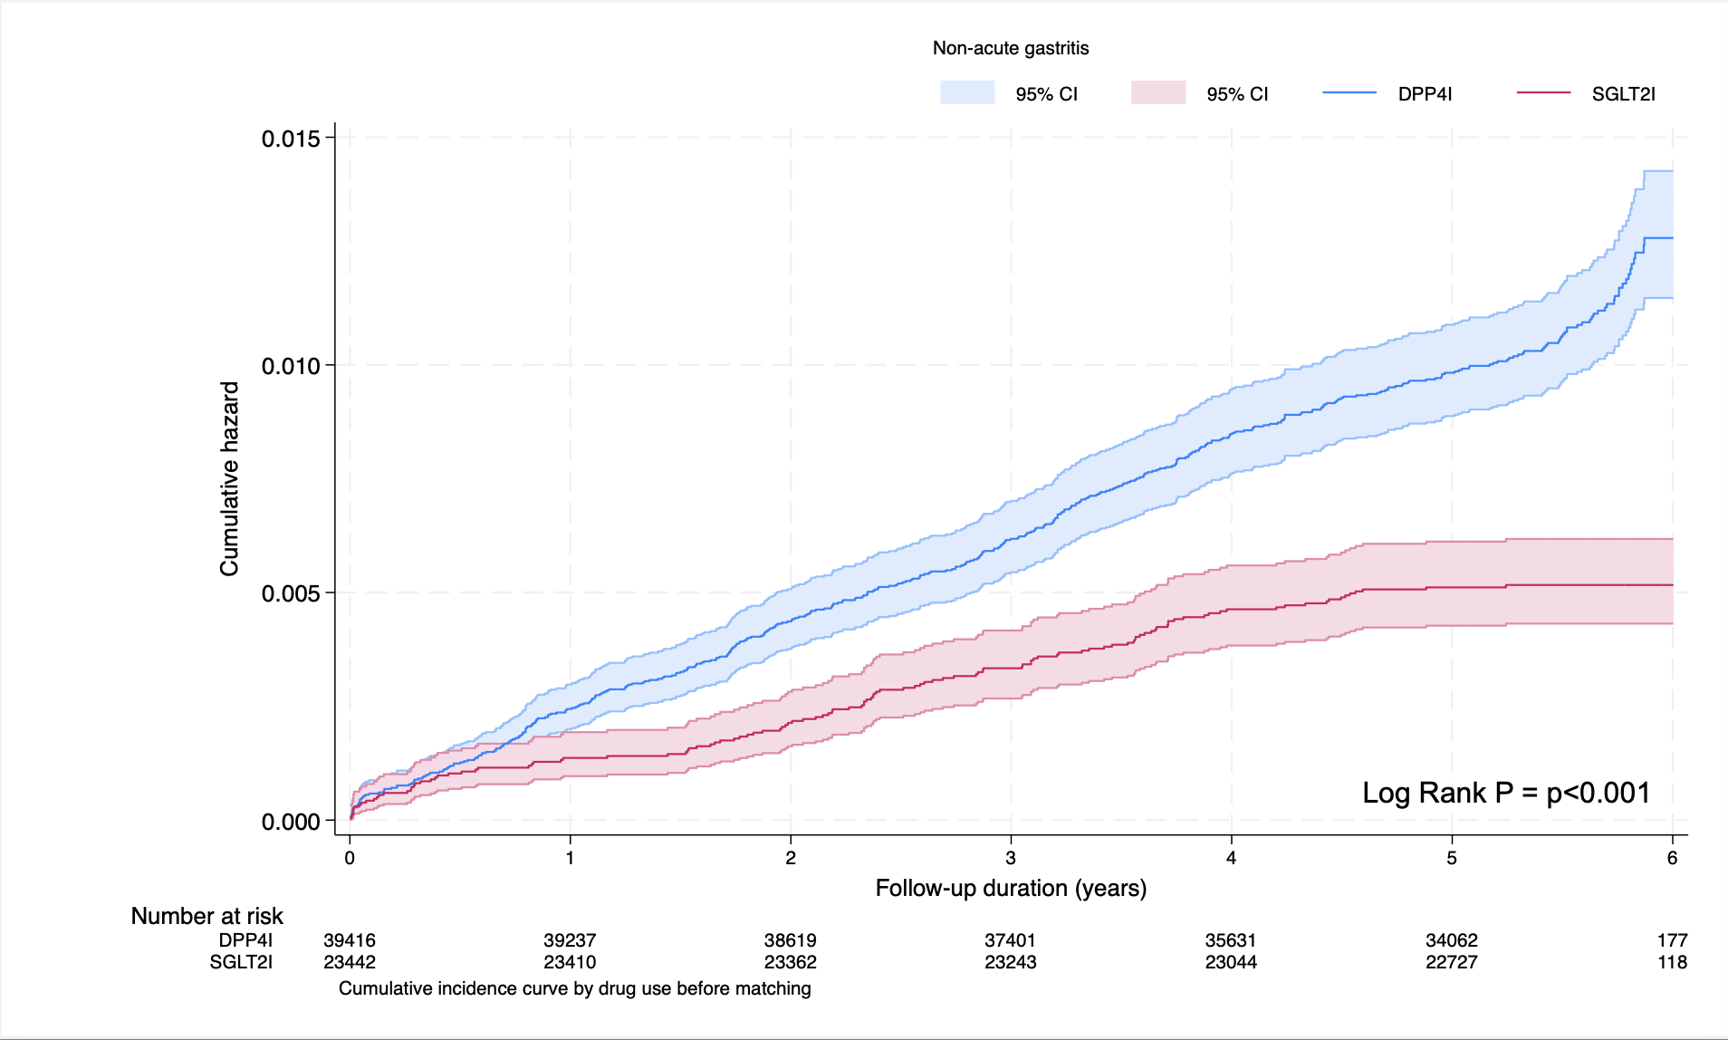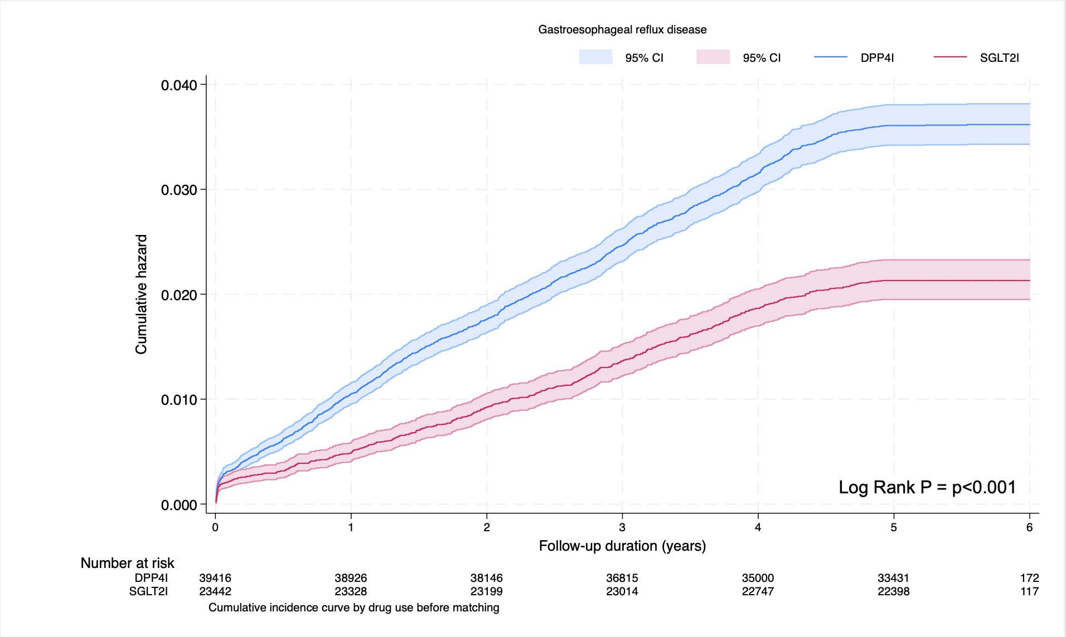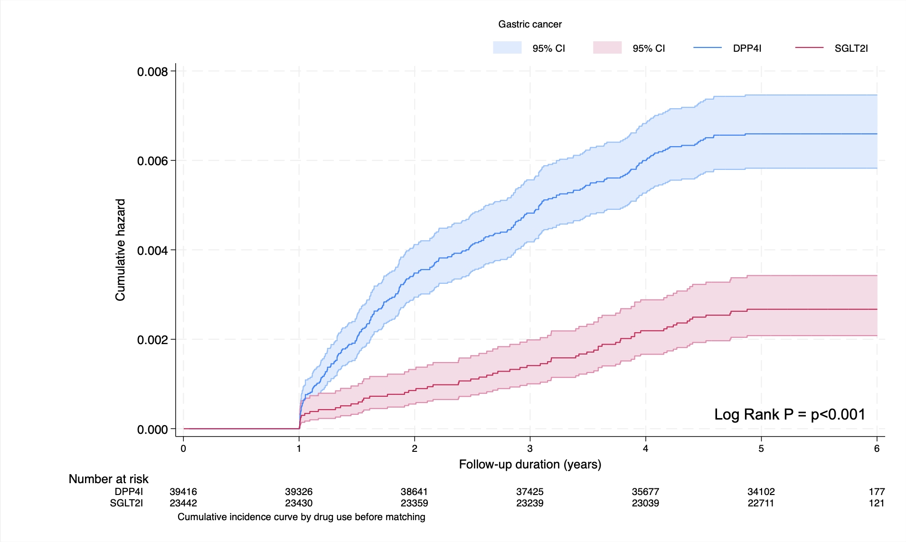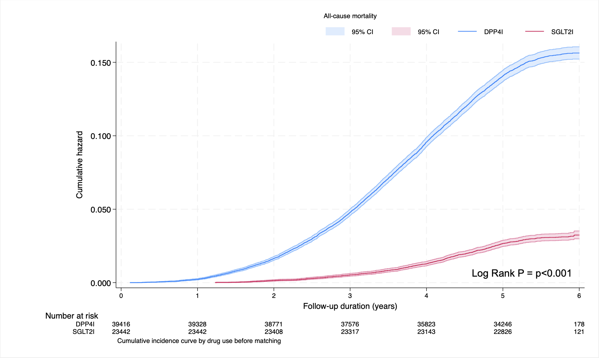

Supplementary Figure 3. Cumulative incidence curves for new onset gastric outcomes and all-cause mortality stratified by drug exposure effects of SGLT2I and DPP4I before propensity score matching (1:1).
SGLT2I: Sodium-glucose cotransporter-2 inhibitors; DPP4I: Dipeptidyl peptidase-4 inhibitors.

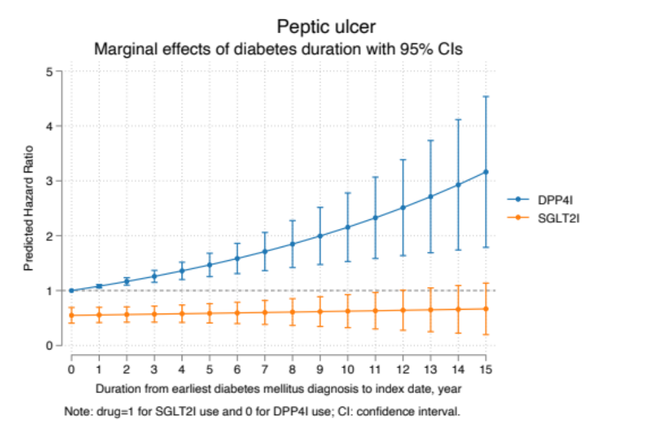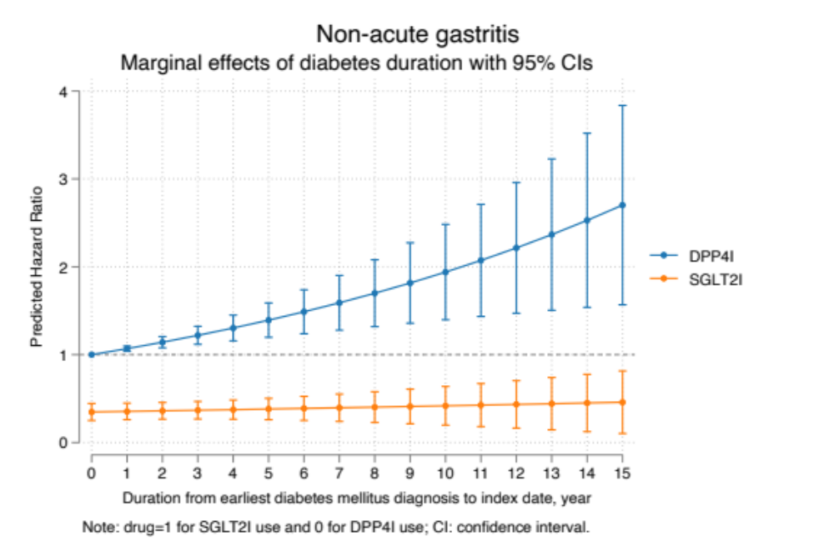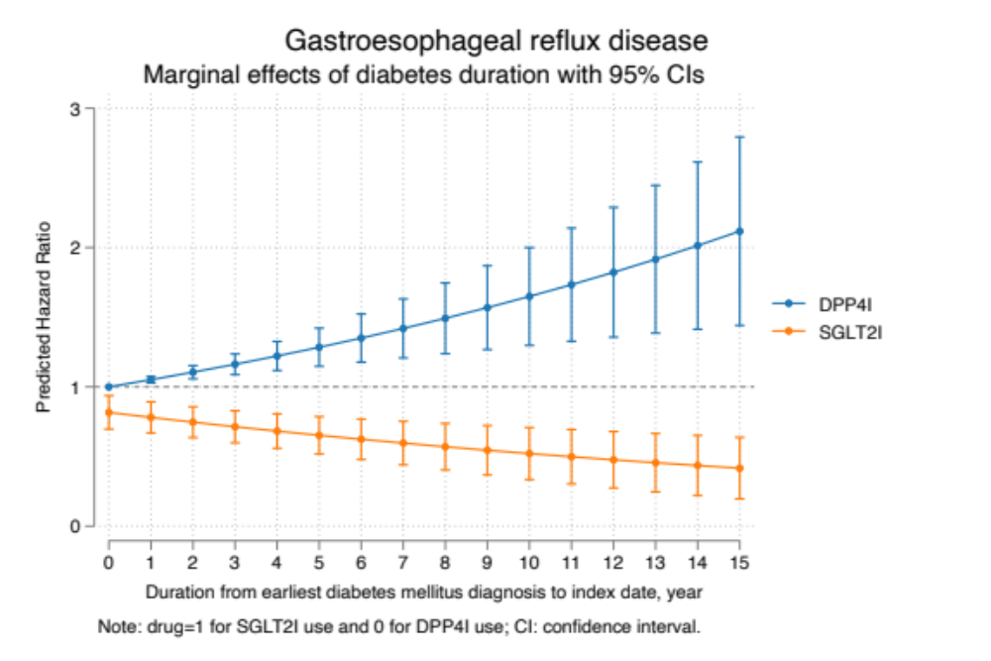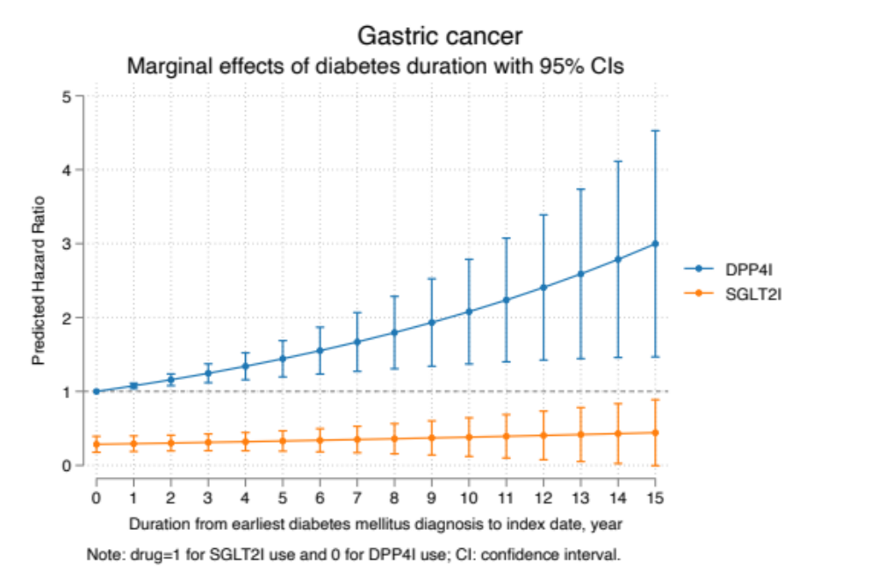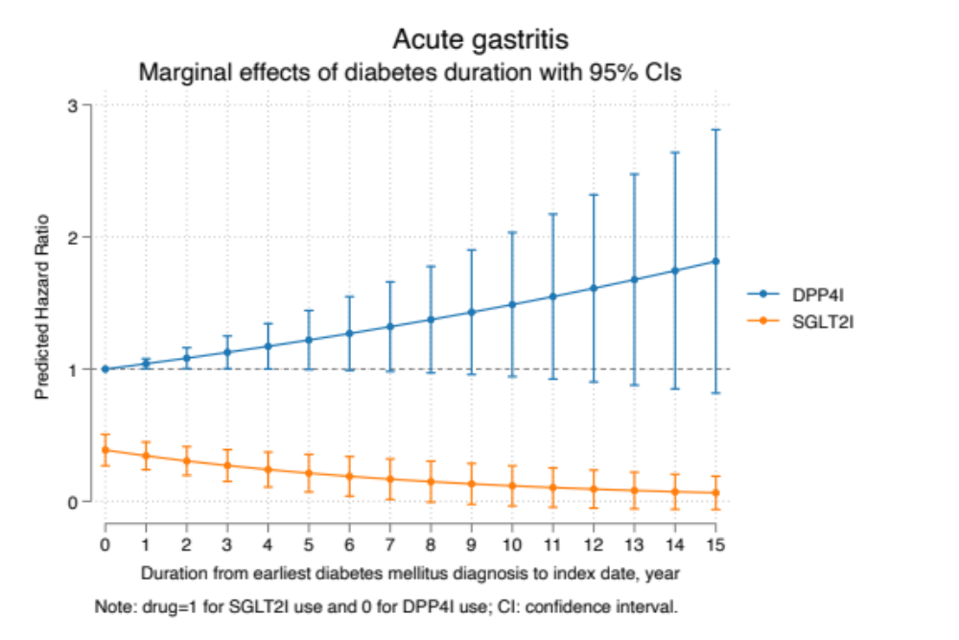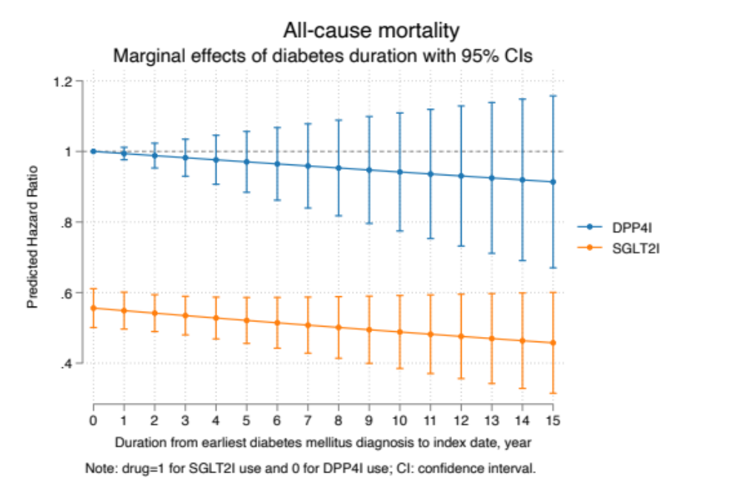

Supplementary Figure 4. Marginal effects of diabetes duration with 95% Cis on new onset adverse gastric events and all-cause mortality stratified by drug use.
SGLT2I: Sodium-glucose cotransporter-2 inhibitors; DPP4I: Dipeptidyl peptidase-4 inhibitors.

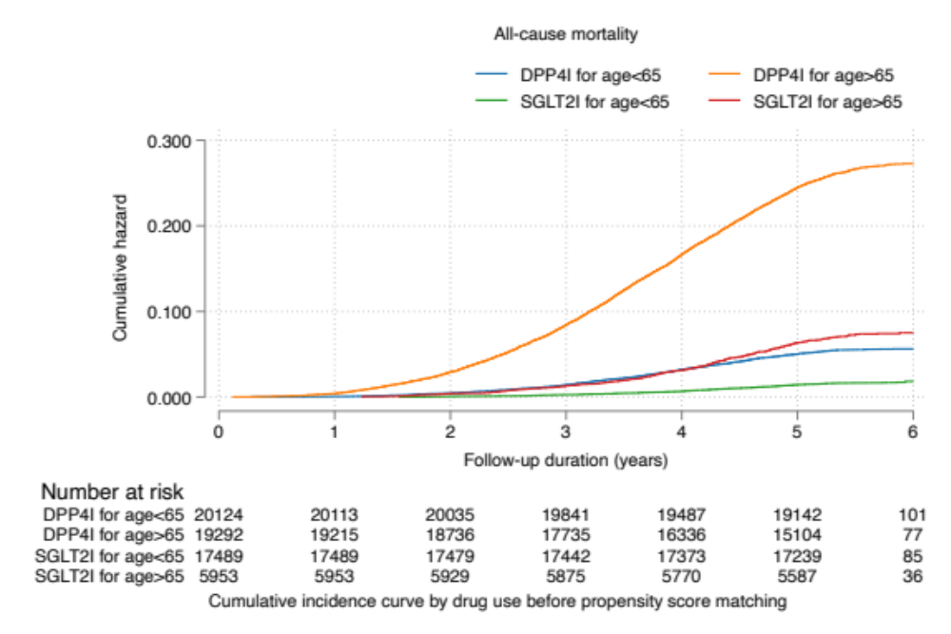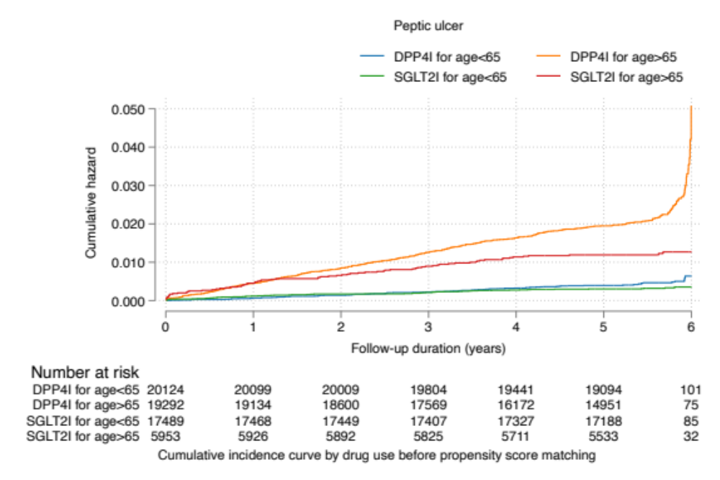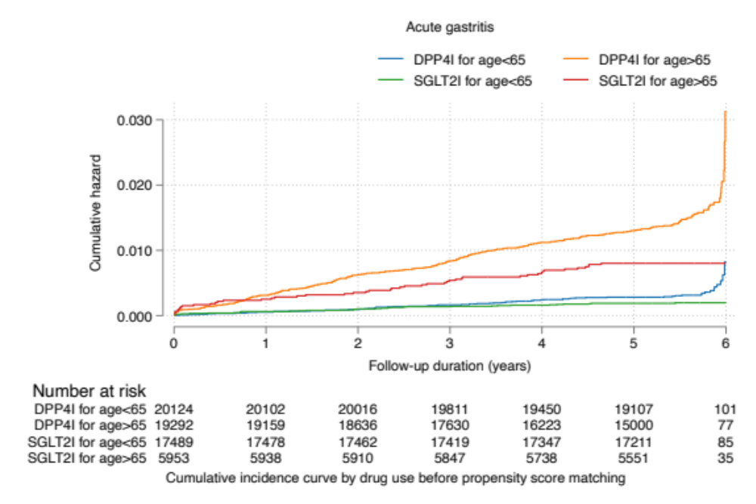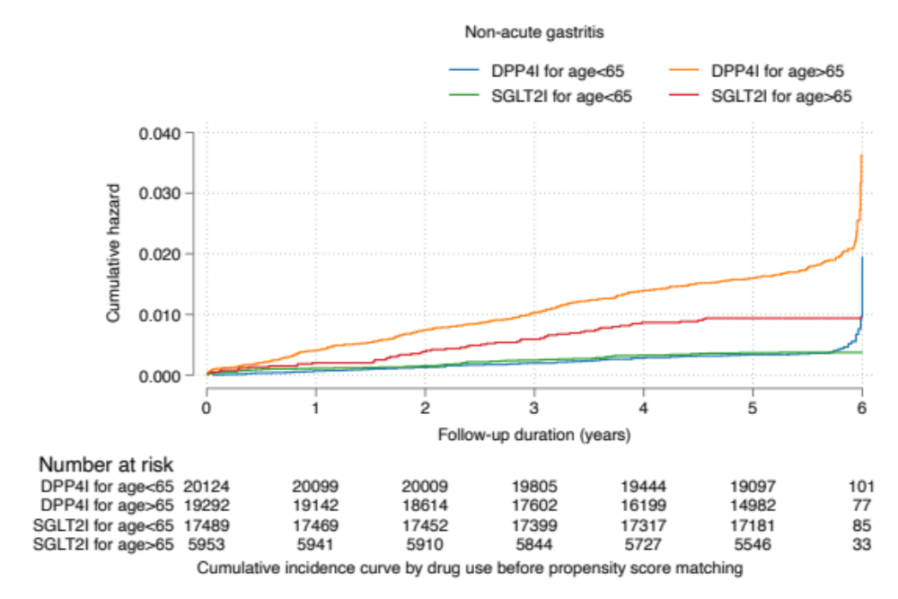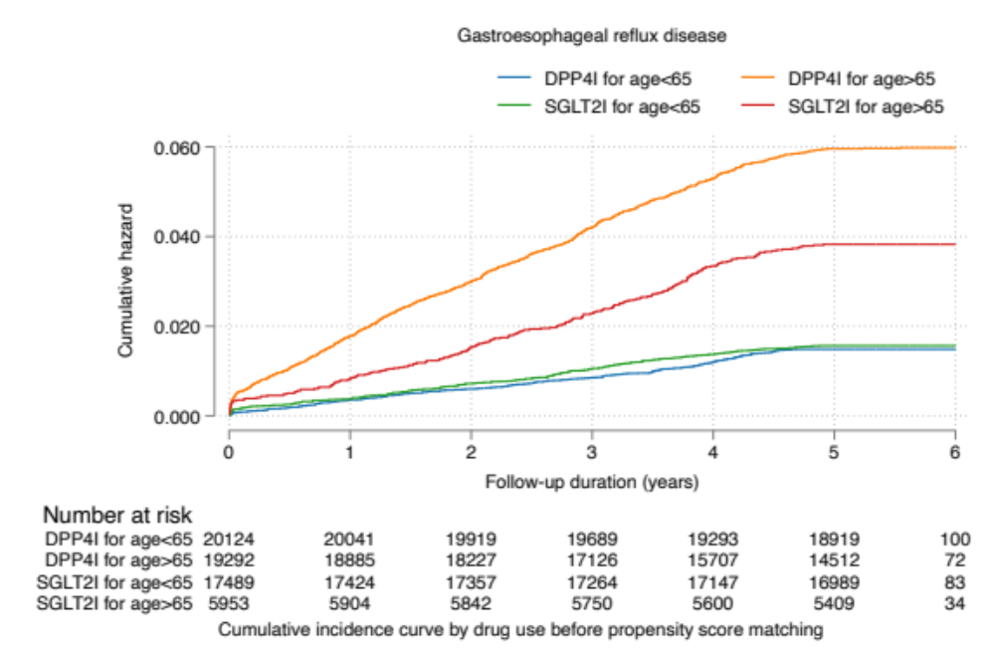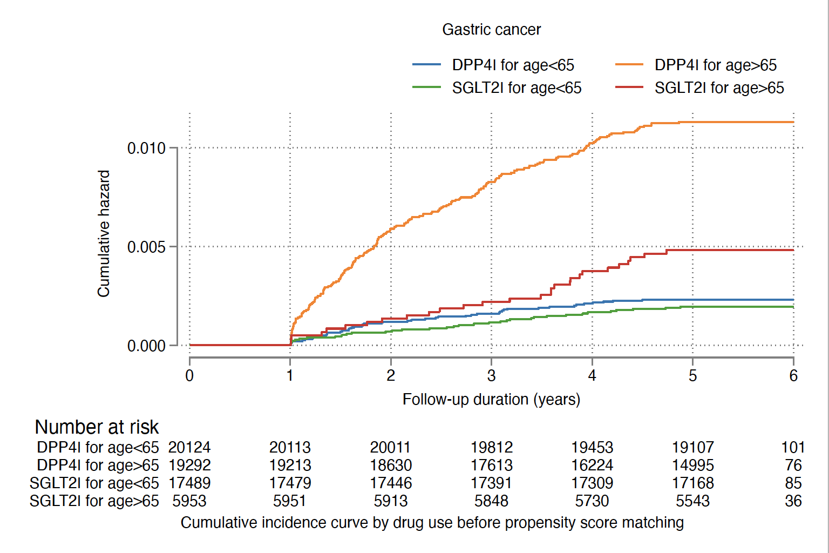

Supplementary Figure 5A. Cumulative incidence curves for new onset gastric outcomes and all-cause mortality stratified by combinations of age and drug exposure effects of SGLT2I and DPP4I before propensity score matching.
SGLT2I: Sodium-glucose cotransporter-2 inhibitors; DPP4I: Dipeptidyl peptidase-4 inhibitors.

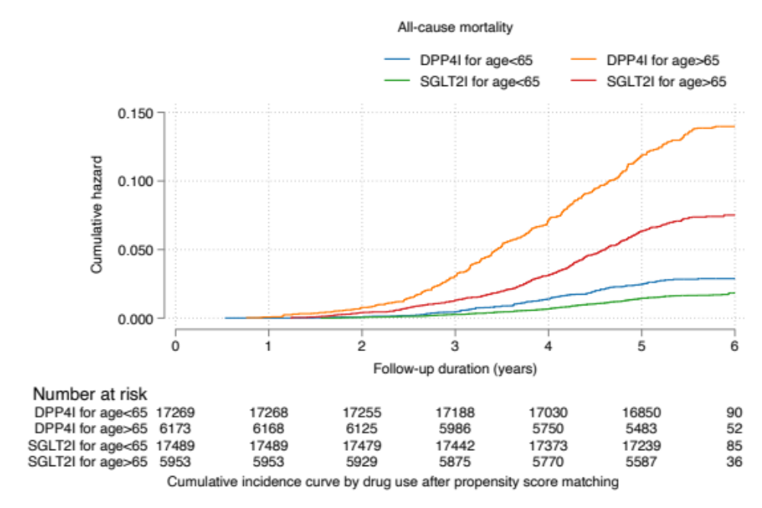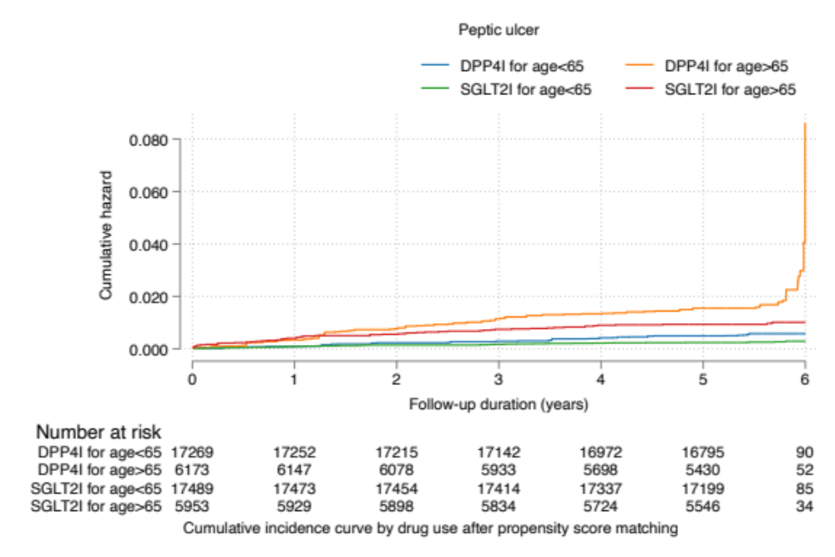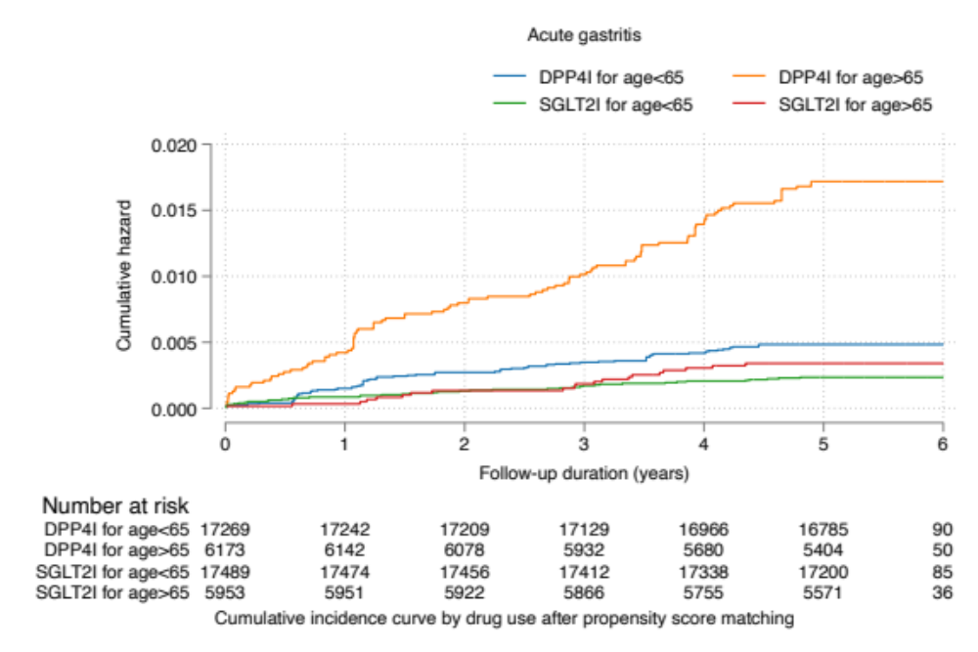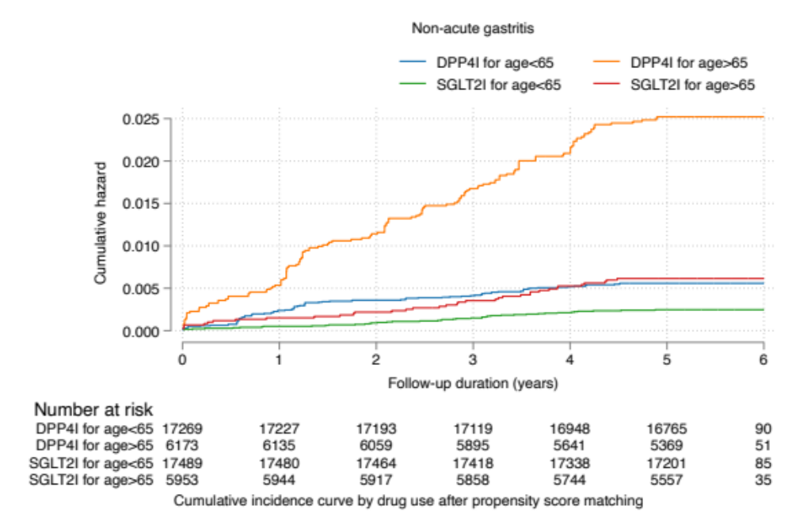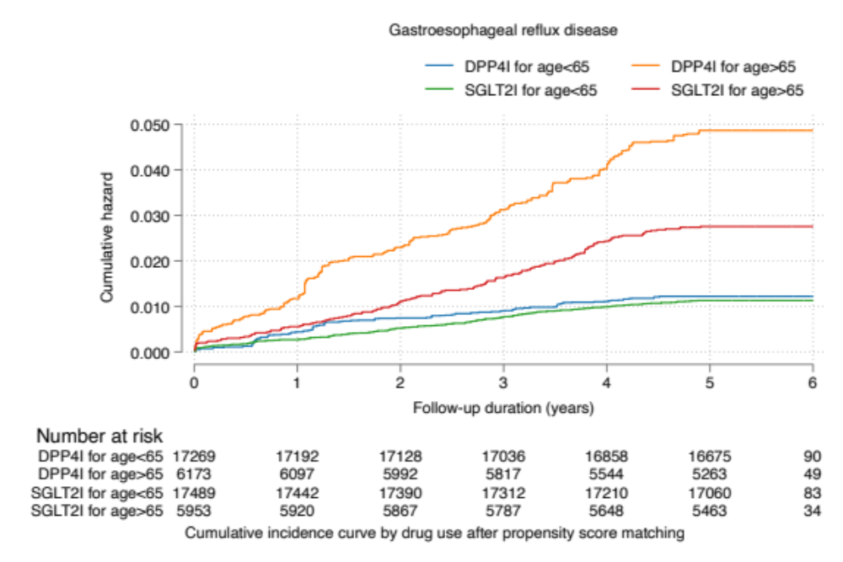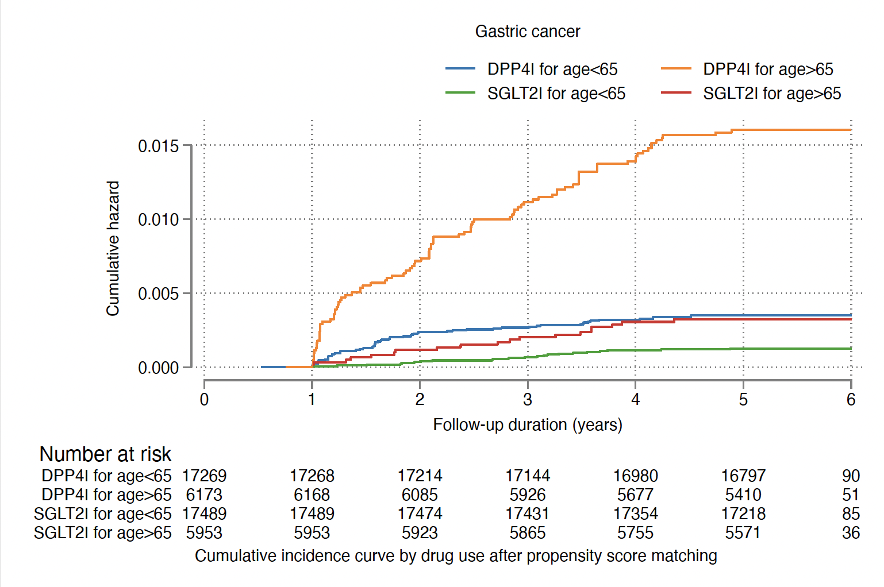

Supplementary Figure 5B. Cumulative incidence curves for new onset gastric outcomes and all-cause mortality stratified by combinations of age and drug exposure effects of SGLT2I and DPP4I in the matched cohort.
SGLT2I: sodium glucose cotransporter-2 inhibitor; DPP4I: dipeptidyl peptidase-4 inhibitor

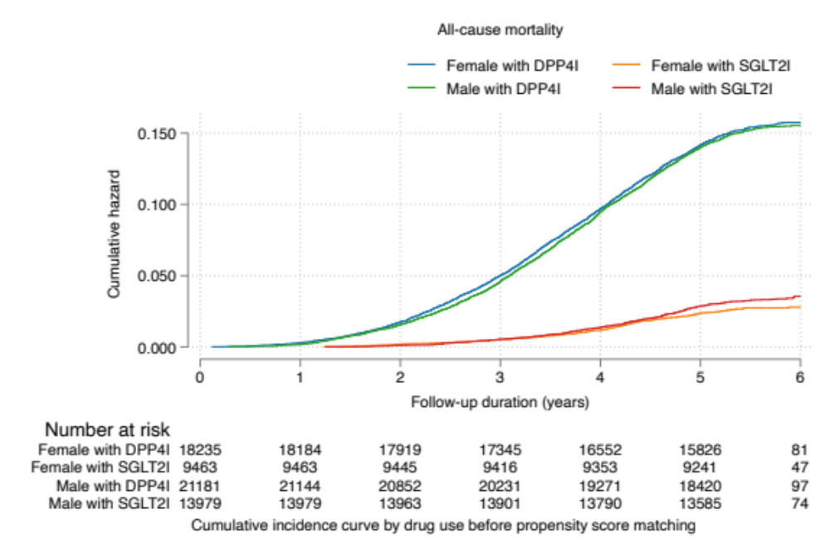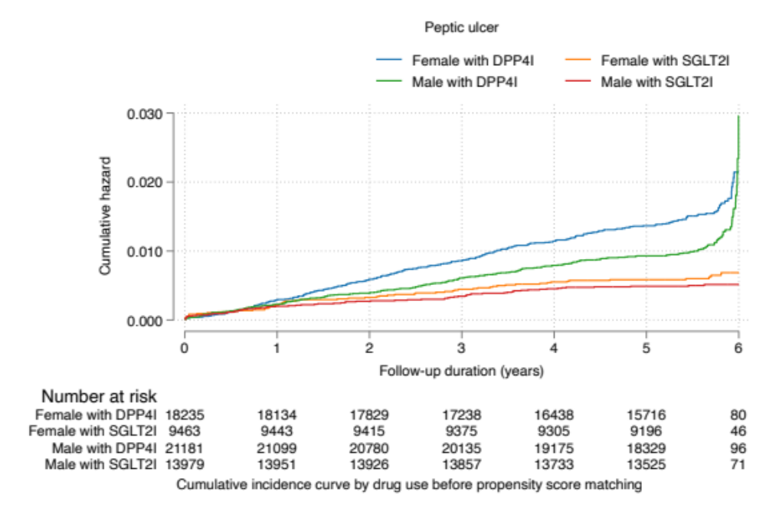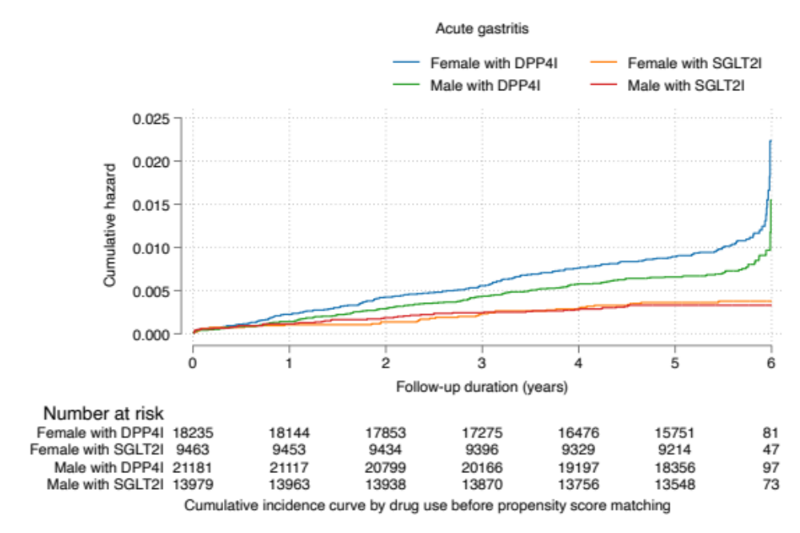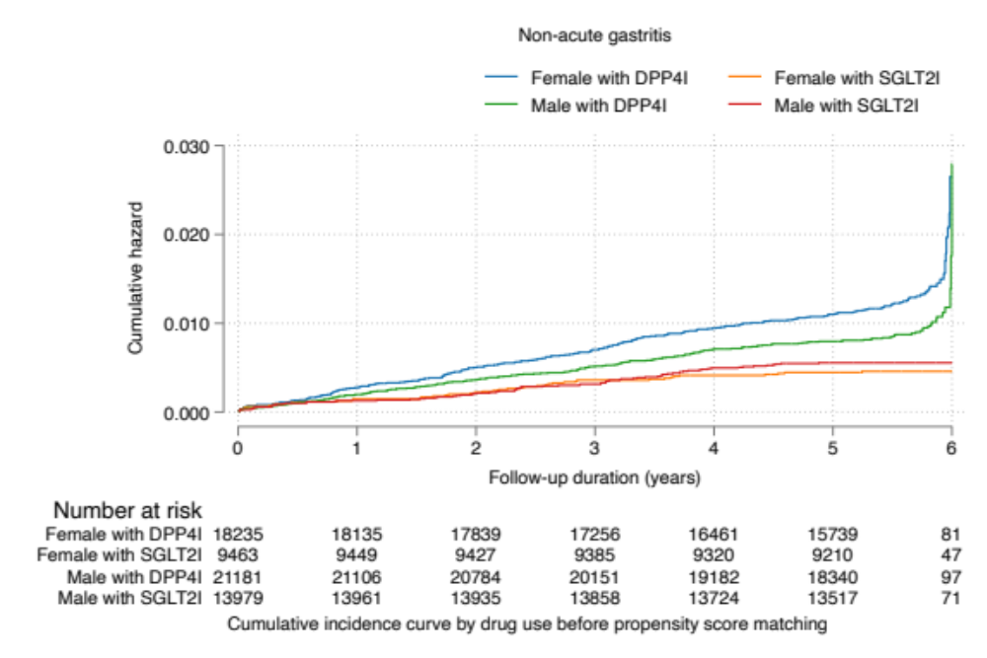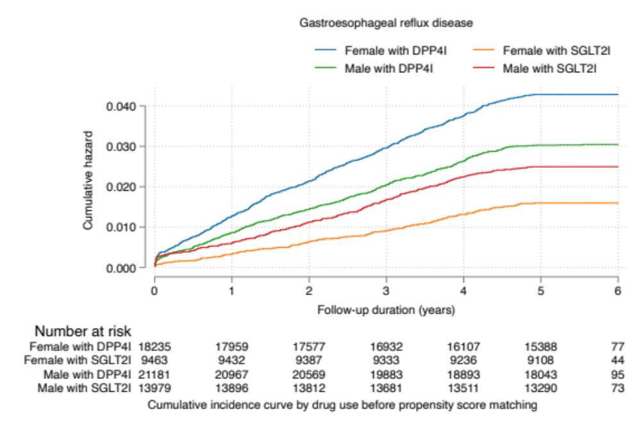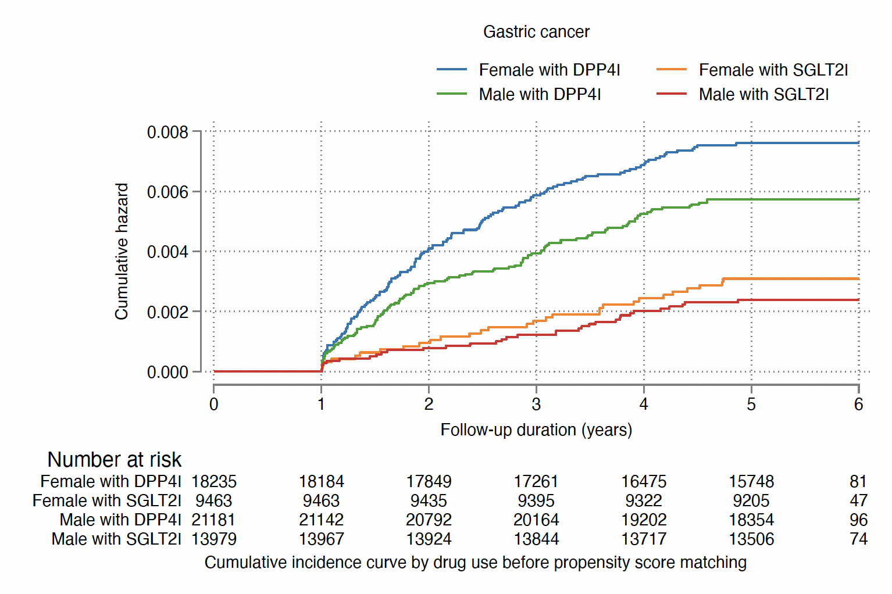

Supplementary Figure 6A. Cumulative incidence curves for new onset gastric outcomes and all-cause mortality stratified by combinations of gender and drug exposure effects of SGLT2I and DPP4I before propensity score matching.
SGLT2I: Sodium-glucose cotransporter-2 inhibitors; DPP4I: Dipeptidyl peptidase-4 inhibitors.

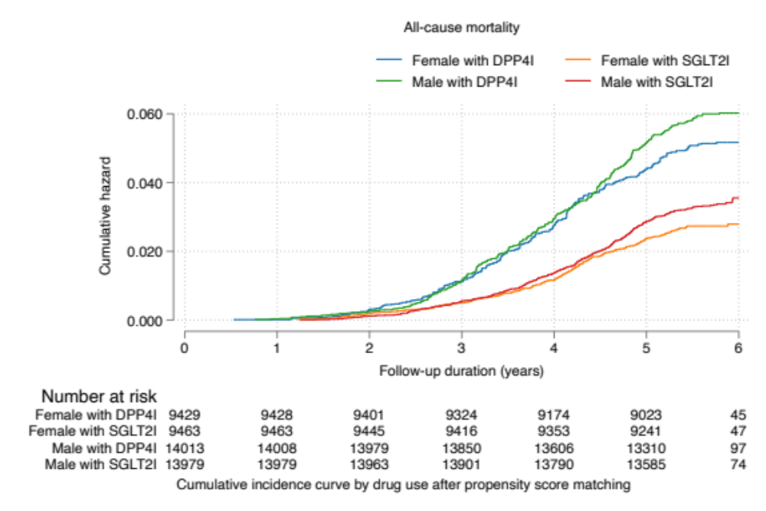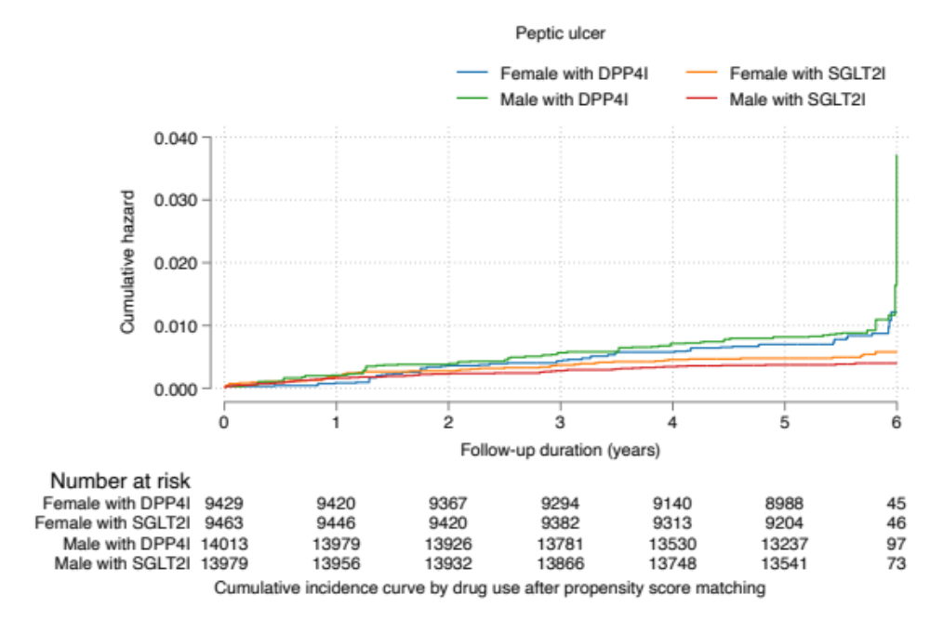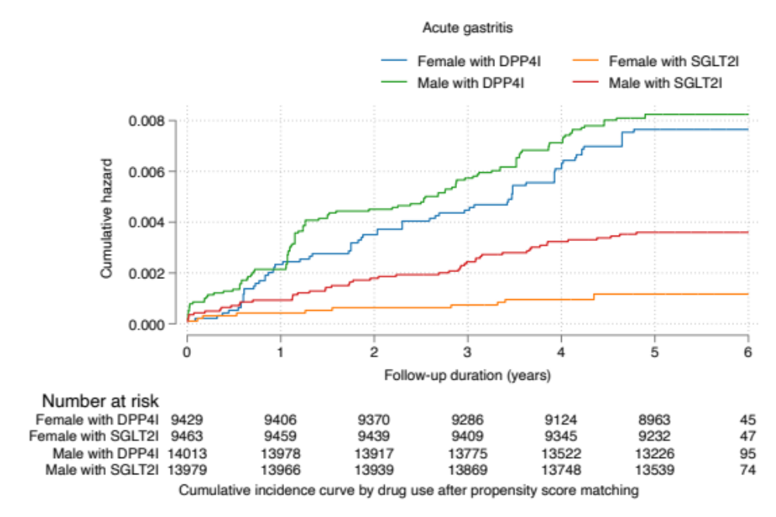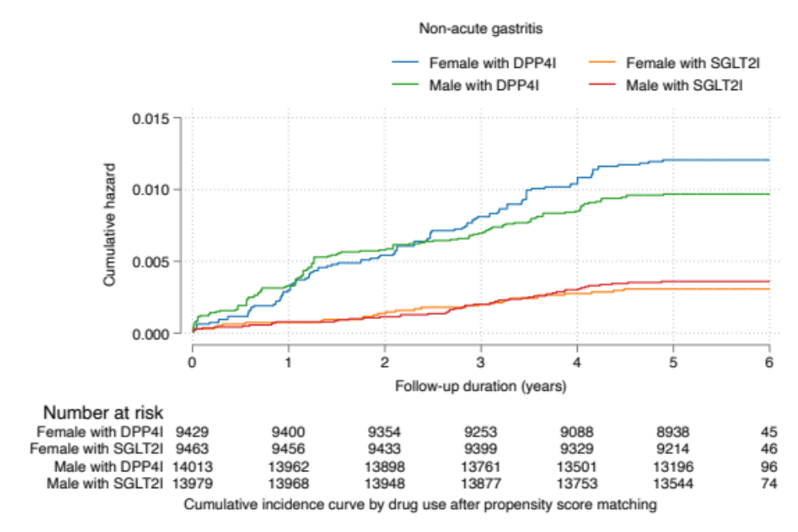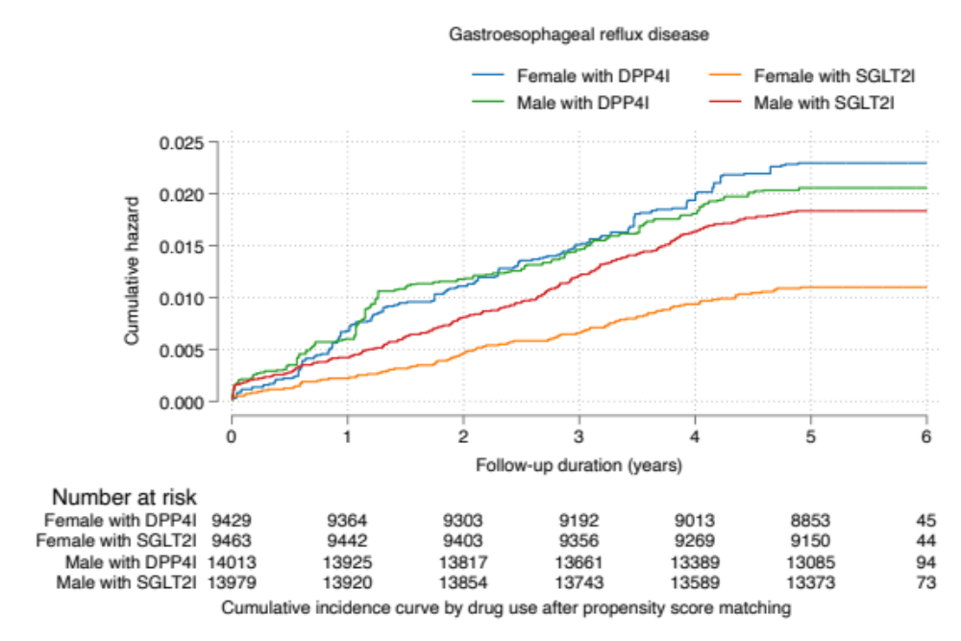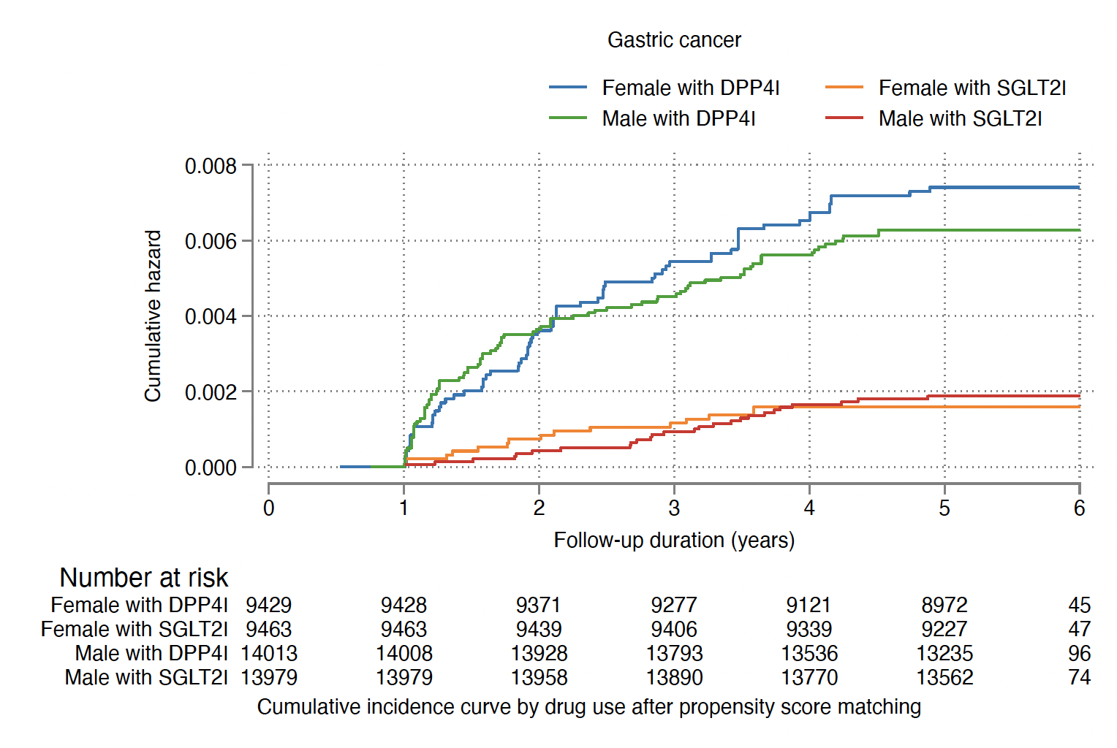

Supplementary Figure 6B. Cumulative incidence curves for new onset gastric outcomes and all-cause mortality stratified by combinations of gender and drug exposure effects of SGLT2I and DPP4I in the matched cohort.
SGLT2I: Sodium-glucose cotransporter-2 inhibitors; DPP4I: Dipeptidyl peptidase-4 inhibitors.

Supplementary Table 1. The International Classification of Diseases, Clinical Modification (ICD-9-CM) codes for definitions of past comorbidities and outcomes.
HBV: hepatitis B virus; HCV: hepatitis C virus
Adverse gastric outcomes of interest
Peptic ulcer: 531–533
Acute gastritis: 535.0
Non-acute gastritis: 535.1–535.4, 535.7
Gastroesophageal reflux disease: 530.81, 530.11
Gastric cancer: 151, 151.0, 151.1, 151.2, 151.3, 151.4, 151.5, 151.6, 151.8, 151.9, 230.2
Past comorbidities
Cancer: 140-239, excluded gastric cancer
Hypertension: 401 401.1 401.9 402 402.01 402.1 402.11 402.9 402.91 403 403.01 403.1 403.11 403.9 403.91 404 404.01 404.02 404.03 404.1 404.11 404.12 404.13 404.9 404.91 404.92 404.93 405 405.01 405.09 405.1 405.11 405.19 405.9 405.91 405.99 437.2
Chronic liver disease and cirrhosis: 571.0 571.1 571.2 571.3 571.40 571.41 571.42 471.49 571.5 571.6 571.8, 571.9
HBV infection: 070.20–070.23, 070.30–070.33, V02.61
HCV infection: 070.41, 070.44, 070.51, 070.54, 070.7, 070.70, 070.71
History of acute liver injury: 570 572.2
Other liver disease: 275.1 275.0 572.0 572.4 572.1 572.3 572.8 573.0 573.4 573.8 573.9
Autoimmune diseases: 136.1, 359.79, 359.71, 443.1, 446, 555, 556.8~556.9, 556.0~556.6, 695.4, 710, 714, 720, 725
Polyps: 569.0, 211.3
Gastrointestinal bleeding: 578.9
Heart failure: 428 428 428.1 428.2 428.2 428.21 428.22 428.23 428.3 428.3 428.31 428.32 428.33 428.4 428.4 428.41 428.42 428.43 428.9 398.91 402.01 402.11 402.91 404.01 404.03 404.11 404.13 404.91 404.93
Atrial fibrillation: 427.31 429.4
Stroke/transient ischemic attack: 435 435.1 435.2 435.3 435.8 435.9 433.81 433.91 434 436 437 437.1 433.31 433.01 434.01 434.1 434.11 434.9 434.91 437.2 437.3 437.4 437.5 437.6 437.7 437.8 437.9 430 431 432 432.1 432.9
Ischemic heart disease: 410.01 410.02 410.1 410.11 410.12 410.2 410.21 410.22 410.3 410.31 410.32 410.4 410.41 410.42 410.5 410.51 410.52 410.6 410.61 410.62 410.7 410.71 410.72 410.8 410.81 410.82 410.9 410.91 410.92 411 411.1 411.8 411.81 411.89 413 413.1 413.9 414 414.01 414.02 414.03 414.04 414.05 414.06 414.07 414.1 414.11 414.12 414.19 414.2 414.3 414.4 414.8 414.9 410 412
Peripheral vascular disease: 250.7 443.9 443 443.1 443.2 443.21 443.22 443.23 443.24 443.29 443.8 443.81 443.82 443.89 441 443.9 785.4 V43.4
Acute myocardial infarction: 410 410.01 410.02 410.1 410.11 410.12 410.2 410.21 410.22 410.3 410.31 410.32 410.4 410.41 410.42 410.5 410.51 410.52 410.6 410.61 410.62 410.7 410.71 410.72 410.8 410.81 410.82 410.9 410.91 410.92
H. pylori infection: 041.86 (ICD-9 codes) + MIS data + H. pylori eradication therapy
Renal diseases: 582 582.1 582.2 582.4 582.8 582.81 582.89 582.9 583 583 583.1 583.2 583.4 583.6 583.7 585 585.1 585.2 585.3 585.4 585.5 585.6 585.9 586 588 588 588.1 588.8 588.81 588.89 588.9
Venous thromboembolism: 415.1 451, 453.1 453.2 453.3 453.8 453.9

Supplementary Table 2. Calculations for variability measure
Variability measure | Definition
Standard deviation (SD) | $$\sqrt{\frac{\sum_{i=1}^{Number of measurements}{{({test}_{i}-individual mean)}^{2}}}{Number of measurements}}$$
Variance | $$\frac{\sum_{i=1}^{Number of measurements}{{({test}_{i}-individual mean)}^{2}}}{Number of measurements}$$
Standard deviation/Initial (SD/initial) | $$\frac{SD}{individual initial value}$$
Coefficient of variation (CV) | $$\frac{SD}{individual mean}$$

.

Supplementary Table 3. Multivariable Cox regression models with adjustments to predict new gastric cancer and gastric diseases in the SGLT2I v.s. DPP4I matched cohort.
HR: hazard ratio; CI: confidence interval; SGLT2I: sodium glucose cotransporter-2 inhibitor; DPP4I: dipeptidyl peptidase-4 inhibitor.
Model 1 adjusted for significant demographics.
Model 2 adjusted for significant demographics, and past comorbidities.
Model 3 adjusted for significant demographics, past comorbidities, and non-SGLT2I/DPP4I medications.
Model 4 adjusted for significant demographics, past comorbidities, non-SGLT2I/DPP4I medications, abbreviated MDRD, and NLR
Model 5 adjusted for significant demographics, past comorbidities, non-SGLT2I/DPP4I medications, abbreviated MDRD, NLR, fasting glucose, HbA1c, and duration from earliest diabetes mellitus date to initial drug exposure date.
Characteristics | Peptic ulcer  HR [95% CI];P value | Acute gastritis  HR [95% CI];P value | Non acute gastritis  HR [95% CI];P value | Gastroesophageal reflux disease  HR [95% CI];P value | Gastric cancer  HR [95% CI];P value | All-cause mortality  HR [95% CI];P value
Model 1 | 0.50[0.39-0.63];<0.0001 | 0.33[0.25-0.45];<0.0001 | 0.33[0.25-0.42];<0.0001 | 0.73[0.64-0.83];<0.0001 | 0.27[0.19-0.38];<0.0001 | 0.56[0.51-0.62];<0.0001
Model 2 | 0.49[0.38-0.62];<0.0001 | 0.33[0.25-0.44];<0.0001 | 0.32[0.25-0.41];<0.0001 | 0.71[0.62-0.81];<0.0001 | 0.26[0.18-0.37];<0.0001 | 0.55[0.50-0.60];<0.0001
Model 3 | 0.534[0.419-0.680];<0.0001 | 0.387[0.288-0.520];<0.0001 | 0.342[0.264-0.443];<0.0001 | 0.798[0.693-0.918];0.0016 | 0.277[0.195-0.392];<0.0001 | 0.63[0.57-0.69];<0.0001
Model 4 | 0.58[0.43-0.78];0.0003 | 0.30[0.20-0.44];<0.0001 | 0.32[0.23-0.43];<0.0001 | 0.60[0.50-0.72];<0.0001 | 0.27[0.18-0.41];<0.0001 | 0.73[0.64-0.83];<0.0001
Model 5 | 0.66[0.47-0.91];0.0118 | 0.31[0.20-0.48];<0.0001 | 0.35[0.25-0.49];<0.0001 | 0.62[0.50-0.76];<0.0001 | 0.30[0.19-0.48];<0.0001 | 0.77[0.66-0.89];0.0003

Supplementary Table 4. Sensitivity analysis: Three-arm (only SGLT2I, only DPP4I, and only GLP1a) analysis results using stabilized IPTW.
The following exclusion criteria applied
1. With prior peptic ulcer, gastritis, gastroesophageal reflux disease, and gastric cancer (N=108)
2. Patients who died within 30 days after initial drug exposure (N=167)
3. Without complete demographics (N=19)
4. Under 18 years old (N=108)
5. Used at least two drugs from SGLT21, DPP4I, and GLP1a (N=12956)
6. New onset gastric cancer development less than 1 year after drug exposure (N=29)

HR: hazard ratio; CI: confidence interval; SGLT2I: sodium glucose cotransporter-2 inhibitor; DPP4I: dipeptidyl peptidase-4 inhibitor.
Model | Peptic ulcer  HR [95% CI];P value | Acute gastritis  HR [95% CI];P value | Non acute gastritis  HR [95% CI];P value | Gastroesophageal reflux disease  HR [95% CI];P value | Gastric cancer  HR [95% CI];P value | All-cause mortality  HR [95% CI];P value
DPP4I v.s. SGLT2I | 2.19[1.76-2.72];<0.0001 | 3.06[2.33-4.01];<0.0001 | 2.25[1.89-2.68];<0.0001 | 1.58[1.40-1.78];<0.0001 | 2.18[1.69-2.80];<0.0001 | 2.57[2.36-2.79];<0.0001
GLP1a v.s. SGLT2I | 1.57[0.80-3.05];=0.1864 | 1.03[0.49-2.19];=0.9343 | 1.51[0.99-2.32];=0.5818 | 1.43[1.04-1.97];=0.0299 | 2.47[1.27-4.81];=0.0079 | 0.84[0.61-1.15];= 0.2659

Supplementary Table 5. Sensitivity analyses: Exposure effects of SGLT2I v.s. DPP4I on new onset gastric diseases in the SGLT2I v.s. DPP4I matched cohort across different hazard models and matching methods.
SGLT2I: Sodium-glucose cotransporter-2 inhibitors; DPP4I: Dipeptidyl peptidase-4 inhibitors; HR: hazard ratio; CI: confidence interval
Model | Peptic ulcer  HR [95% CI];P value | Acute gastritis  HR [95% CI];P value | Non acute gastritis  HR [95% CI];P value | Gastroesophageal reflux disease  HR [95% CI];P value | Gastric cancer  HR [95% CI];P value | All-cause mortality  HR [95% CI];P value
Cause-specific hazard models | 0.52[0.41-0.67];<0.0001 | 0.354[0.265-0.474];<0.0001 | 0.348[0.270-0.449];<0.0001 | 0.756[0.659-0.867];0.0001 | 0.282[0.199-0.398];<0.0001 | 0.60[0.55-0.66];<0.0001
Sub-distribution hazard models | 0.49[0.38-0.62];<0.0001 | 0.33[0.24-0.44];<0.0001 | 0.32[0.25-0.41];<0.0001 | 0.71[0.62-0.82];<0.0001 | 0.26[0.19-0.37];<0.0001 | 0.55[0.50-0.60];<0.0001
PS stratification | 0.66[0.47-0.91];0.0124 | 0.31[0.20-0.49];<0.0001 | 0.34[0.24-0.48];<0.0001 | 0.62[0.50-0.76];<0.0001 | 0.30[0.19-0.47];<0.0001 | 0.77[0.66-0.89];0.0003
PS with IPTW | 0.52[0.40-0.67];<0.0001 | 0.35[0.25-0.48];<0.0001 | 0.33[0.26-0.44];<0.0001 | 0.67[0.57-0.78];<0.0001 | 0.27[0.19-0.39];<0.0001 | 0.64[0.58-0.72];<0.0001
PS with SIPTW | 0.48[0.38-0.61];<0.0001 | 0.33[0.24-0.43];<0.0001 | 0.32[0.25-0.41];<0.0001 | 0.71[0.62-0.81];<0.0001 | 0.26[0.18-0.37];<0.0001 | 0.55[0.50-0.60];<0.0001

Supplementary Table 6. Sensitivity analysis: Excluding patients with CKD stage 4/5 (eGFR <30), peritoneal dialysis or haemodialysis in the SGLT2I v.s. DPP4I matched cohort.
SGLT2I: Sodium-glucose cotransporter-2 inhibitors; DPP4I: Dipeptidyl peptidase-4 inhibitors; HR: hazard ratio; CI: confidence interval
 | Peptic ulcer HR [95% CI];P value | Acute gastritis HR [95% CI];P value | Non-acute gastritis HR [95% CI];P value | Gastroesophageal reflux disease HR [95% CI];P value | Gastric cancer HR [95% CI];P value | All-cause mortality HR [95% CI];P value
SGLT2I v.s. DPP4I | 0.45[0.35-0.58];<0.0001 | 0.29[0.21-0.40];<0.0001 | 0.31[0.24-0.40];<0.0001 | 0.59[0.51-0.69];<0.0001 | 0.25[0.18-0.36];<0.0001 | 0.55[0.50-0.61];<0.0001

Supplementary Table 7. Sensitivity analysis: Consideration of 1-year lag time effects in the SGLT2I v.s. DPP4I matched cohort.
SGLT2I: Sodium-glucose cotransporter-2 inhibitors; DPP4I: Dipeptidyl peptidase-4 inhibitors; HR: hazard ratio; CI: confidence interval
 | Peptic ulcer  HR [95% CI];P value | Acute gastritis  HR [95% CI];P value | Non-acute gastritis  HR [95% CI];P value | Gastroesophageal reflux disease  HR [95% CI];P value | Gastric cancer  HR [95% CI];P value | All-cause mortality  HR [95% CI];P value
SGLT2I v.s. DPP4I | 0.36[0.27-0.48];<0.0001 | 0.33[0.23-0.46];<0.0001 | 0.35[0.26-0.47];<0.0001 | 0.79[0.67-0.92];0.0028 | 0.26[0.18-0.37];<0.0001 | 0.55[0.50-0.61];<0.0001

Supplementary Table 8. Sensitivity analysis: As-treated approach of SGLT2I v.s. DPP4I on new onset gastric diseases in the SGLT2I v.s. DPP4I matched cohort
SGLT2I: Sodium-glucose cotransporter-2 inhibitors; DPP4I: Dipeptidyl peptidase-4 inhibitors; HR: hazard ratio; CI: confidence interval
 | Peptic ulcer  HR [95% CI];P value | Acute gastritis  HR [95% CI];P value | Non-acute gastritis  HR [95% CI];P value | Gastroesophageal reflux disease  HR [95% CI];P value | Gastric cancer  HR [95% CI];P value | All-cause mortality  HR [95% CI];P value
SGLT2I v.s. DPP4I | 0.40[0.33-0.48];<0.0001 | 0.23[0.18-0.29];<0.0001 | 0.32[0.28-0.38];<0.0001 | 0.57[0.52-0.64];<0.0001 | 0.28[0.23-0.36];<0.0001 | 0.19[0.18-0.21];<0.0001

Supplementary Table 9. Falsification analysis: Exposure effects of SGLT2I v.s. DPP4I on new onset venous thromboembolism in the SGLT2I v.s. DPP4I matched cohort after 1:1 propensity score matching
SGLT2I: Sodium-glucose cotransporter-2 inhibitors; DPP4I: Dipeptidyl peptidase-4 inhibitors; HR: hazard ratio; CI: confidence interval
Adjusted for significant demographics, past comorbidities, non-SGLT2I/DPP4I medications, abbreviated MDRD, NLR, fasting glucose, HbA1c, and duration from earliest diabetes mellitus date to initial drug exposure date.
 | Number of events, Count(%) | Time to venous thromboembolism, days | Adjusted hazard ratio, HR [95% CI] | P value
SGLT2I | 192(0.81%) | 2051.0(1949.0-2126.0) | 1.21[0.98-1.53] | 0.1034
DPP4I | 159(0.67%) | 2042.0(1935.0-2122.0) | 1 [Reference] | N/A

Supplementary Table 10. The basic characteristics of the SGLT2I, DPP4I and GLP1a patients in the 3-arm analysis.
SGLT2I: sodium glucose cotransporter-2 inhibitor; DPP4I: dipeptidyl peptidase-4 inhibitor; SD: standard deviation; RMS: Rooted mean square; CV: Coefficient of variation; MDRD: modification of diet in renal disease; ACEI: angiotensin-converting enzyme inhibitors; ARB: angiotensin II receptor blockers; HBV: hepatitis B virus; HCV: hepatitis C virus; ª: N (%); ^{b}: Median (IQR); ^{c}: Mean (SD)
Characteristics | All  (N=46884) | DPP4I users (N=22052) | GLP1a users (N=2951) | SGLT2I users (N=21881) | P value
Demographics
Female gender ª | 18892 (40.3) | 8759 (39.7) | 1321 (44.8) | 8812 (40.3) | <0.001
Male gender ª | 27992 (59.7) | 13293 (60.3) | 1630 (55.2) | 13069 (59.7)
Baseline age, years ^{b} | 58.1 (13.6) | 58.7 (13.5) | 53.2 (12.8) | 58.3 (13.9) | <0.001
Past Comorbidities
Charlson comorbidity index ^{b} | 1.0 (1.0) | 1.0 (1.0) | 1.0 (2.0) | 1.0 (1.0) | <0.001
Duration from earliest diabetes mellitus diagnosis date-baseline date, day ^{b} | 6.1 (8.8) | 5.5 (8.8) | 6.0 (8.5) | 6.7 (8.7) | <0.001
Hypertension ^{c} | 10149 (21.6) | 4641 (21.0) | 659 (22.3) | 4849 (22.2) | 0.012
Heart failure ^{c} | 1242 (2.6) | 582 (2.6) | 71 (2.4) | 589 (2.7) | 0.657
Ischemic heart disease ^{c} | 5575 (11.9) | 2586 (11.7) | 229 (7.8) | 2760 (12.6) | <0.001
Atrial fibrillation ^{c} | 1045 (2.2) | 515 (2.3) | 20 (0.7) | 510 (2.3) | <0.001
Acute myocardial infarction ^{c} | 1565 (3.3) | 748 (3.4) | 57 (1.9) | 760 (3.5) | <0.001
Peripheral vascular disease ^{c} | 384 (0.8) | 185 (0.8) | 18 (0.6) | 181 (0.8) | 0.425
Renal diseases ^{c} | 301 (0.6) | 144 (0.7) | 16 (0.5) | 141 (0.6) | 0.777
Stroke/transient ischemic attack ^{c} | 1221 (2.6) | 590 (2.7) | 50 (1.7) | 581 (2.7) | 0.006
Gastrointestinal bleeding ^{c} | 815 (1.7) | 389 (1.8) | 35 (1.2) | 391 (1.8) | 0.059
H. pylori infection ^{c} | 2388 (5.1) | 1104 (5.0) | 146 (4.9) | 1138 (5.2) | 0.607
Autoimmune disease tissue ^{c} | 480 (1.0) | 222 (1.0) | 31 (1.1) | 227 (1.0) | 0.94
Cancer ^{c} | 894 (1.9) | 433 (2.0) | 37 (1.3) | 424 (1.9) | 0.027
Chronic liver disease and cirrhosis ^{c} | 1245 (2.7) | 574 (2.6) | 103 (3.5) | 568 (2.6) | 0.014
HBV infection ^{c} | 2365 (5.0) | 1083 (4.9) | 126 (4.3) | 1156 (5.3) | 0.028
HCV infection ^{c} | 140 (0.3) | 68 (0.3) | 6 (0.2) | 66 (0.3) | 0.613
Other liver diseases ^{c} | 441 (0.9) | 215 (1.0) | 20 (0.7) | 206 (0.9) | 0.291
Diabetic retinopathy ^{c} | 3038 (6.5) | 1309 (5.9) | 261 (8.8) | 1468 (6.7) | <0.001
Medication Prescriptions
Metformin ^{c} | 43866 (93.6) | 20603 (93.4) | 2909 (98.6) | 20354 (93.0) | <0.001
Sulphonylurea ^{c} | 34646 (73.9) | 16861 (76.5) | 1795 (60.8) | 15990 (73.1) | <0.001
Insulin ^{c} | 24030 (51.3) | 10931 (49.6) | 2407 (81.6) | 10692 (48.9) | <0.001
Acarbose ^{c} | 1581 (3.4) | 666 (3.0) | 169 (5.7) | 746 (3.4) | <0.001
Thiozolidinedone ^{c} | 12007 (25.6) | 4922 (22.3) | 1447 (49.0) | 5638 (25.8) | <0.001
H2 antagonists ^{c} | 21747 (46.4) | 10297 (46.7) | 1392 (47.2) | 10058 (46.0) | 0.21
Proton pump inhibitors ^{c} | 13720 (29.3) | 6128 (27.8) | 1284 (43.5) | 6308 (28.8) | <0.001
ACEI/ARB ^{c} | 20270 (43.2) | 9427 (42.7) | 1525 (51.7) | 9318 (42.6) | <0.001
Antibiotics ^{c} | 30127 (64.3) | 14260 (64.7) | 2049 (69.4) | 13818 (63.2) | <0.001
Antihypertensive drugs ^{c} | 2688 (5.7) | 1113 (5.0) | 174 (5.9) | 1401 (6.4) | <0.001
Antihepatitis ^{c} | 923 (2.0) | 444 (2.0) | 37 (1.3) | 442 (2.0) | 0.015
Statins and fibrates ^{c} | 32519 (69.4) | 14798 (67.1) | 2219 (75.2) | 15502 (70.8) | <0.001
HCV treatment drugs ^{c} | 723 (1.5) | 348 (1.6) | 29 (1.0) | 346 (1.6) | 0.039
HBV treatment drugs ^{c} | 878 (1.9) | 425 (1.9) | 32 (1.1) | 421 (1.9) | 0.005
Antiplatelets ^{c} | 11382 (24.3) | 5312 (24.1) | 577 (19.6) | 5493 (25.1) | <0.001
Lipid-lowering drugs ^{c} | 20875 (44.5) | 9879 (44.8) | 1343 (45.5) | 9653 (44.1) | 0.191
Non-steroidal anti-inflammatory drugs ^{c} | 10721 (22.9) | 5068 (23.0) | 542 (18.4) | 5111 (23.4) | <0.001
Diuretics ^{c} | 11021 (23.5) | 5101 (23.1) | 744 (25.2) | 5176 (23.7) | 0.034
Beta-blockers ^{c} | 9052 (19.3) | 4234 (19.2) | 545 (18.5) | 4273 (19.5) | 0.336
Calcium channel blockers ^{c} | 15982 (34.1) | 7535 (34.2) | 1134 (38.4) | 7313 (33.4) | <0.001
Liver and Renal Functions
Urea, mmol/L ^{b} | 5.4 (2.2) | 5.5 (2.3) | 5.3 (2.1) | 5.4 (2.2) | <0.001
Creatinine, μmol/L ^{b} | 76.0 (27.0) | 77.0 (28.0) | 73.0 (27.1) | 75.0 (26.3) | <0.001
Bilirubin, μmol/L ^{b} | 10.4 (5.8) | 10.3 (6.0) | 10.0 (5.7) | 10.6 (6.0) | <0.001
Lipid/Glucose profiles
Triglyceride, mmol/L ^{b} | 1.4 (1.1) | 1.4 (1.1) | 1.7 (1.3) | 1.4 (1.1) | <0.001
Low-density lipoprotein, mmol/L ^{b} | 2.3 (1.0) | 2.3 (1.0) | 2.3 (0.9) | 2.3 (1.0) | 0.402
High-density lipoprotein, mmol/L ^{b} | 1.1 (0.3) | 1.1 (0.4) | 1.1 (0.4) | 1.1 (0.3) | <0.001
Total cholesterol, mmol/L ^{b} | 4.2 (1.2) | 4.2 (1.2) | 4.3 (1.0) | 4.2 (1.2) | <0.001
Baseline-Fasting glucose, mmol/L ^{b} | 8.4 (3.5) | 8.4 (3.2) | 9.6 (4.8) | 8.4 (3.6) | <0.001
Baseline-Haemoglobin A1C, % ^{b} | 8.0 (1.8) | 7.9 (1.6) | 8.7 (2.0) | 7.9 (1.8) | <0.001

