Online Resources
The authors have provided this appendix to give readers additional information about their work.

Supplement to: Shigenori Kadowaki, Tomoyuki Otsuka, Keiko Minashi, Shinichi Nishina, Hiroshi Yabusaki, Chiaki Inagaki, et al. An Observational Study of the Effectiveness and Safety of Nivolumab plus Chemotherapy for Untreated Advanced or Recurrent Gastric Cancer in Japanese Real-World Settings: Interim analysis of the G-KNIGHT study
Table of Contents
Online Resource 1. List of investigators 3
Online Resource 2. Study objectives 4
Online Resource 3. Supplementary methods 5
Online Resource 4. Patient diagram 6
Online Resource 5. Patient characteristics by PD-L1 CPS and combination chemotherapy 7
Online Resource 6. DOT by nivolumab plus chemotherapy regimen 8
Online Resource 7. Details of second line treatment 9
Online Resource 8. Association of patient characteristics and rwPFS 10
Online Resource 9. Summary of safety by age and ECOG PS 11
Online Resource 10. Time from nivolumab plus chemotherapy to onset of any grade irAEs 12
Online Resource 11. Time from nivolumab plus chemotherapy to onset of grade ≥ 3 irAEs 13
Online Resource 12. Time from onset to recovery of any grade irAEs 14
Online Resource 13. Time from onset to recovery of grade ≥ 3 irAEs 15

Online Resource 1. List of investigators
Site name | Investigator name
Aichi Cancer Center Hospital | Shigenori Kadowaki
Chiba Cancer Center | Keiko Minashi
Chiba University Hospital | Hisahiro Matsubara
Fujita Health University Hospital | Hiroshi Matsuoka
Fukui University Hospital | Takanori Goi
Gunma Prefectural Cancer Center | Hisashi Hosaka
Hyogo Cancer Center | Masahiro Tsuda
Kanagawa Cancer Center | Nozomu Machida
Kanazawa University Hospital | Noriyuki Inaki
Kindai University Hospital | Chiaki Inagaki
Kobe City Medical Center General Hospital | Hisateru Yasui
Kumamoto University Hospital | Satoshi Ida
Kurashiki Central Hospital | Shinichi Nishina
Kyorin University Hospital | Fumio Nagashima
Kyoto University Hospital | Junichi Matsubara
NHO Shikoku Cancer Center | Tomohiro Nishina
Niigata Cancer Center Hospital | Hiroshi Yabusaki
Osaka International Cancer Institute | Tomoyuki Otsuka
Osaka Red Cross Hospital | Takehiko Tsumura
Shiga General Hospital | Kazuyoshi Matsumura
St. Marianna University Hospital | Hiroyuki Arai
Tokai University Hospital | Masashi Matsushima
Wakayama Medical University Hospital | Takao Maekita
All sites are Cancer Care Coordination Core Hospitals designated by the Ministry of Health, Labour and Welfare, established to provide high-quality cancer treatment throughout the country.

Online Resource 2. Study objectives
Primary | - ORR  - rwPFS  - Incidence of irAE  - Incidence of TRAE leading to treatment discontinuation
Secondary | - OS  - DOT  - DOR  - DOT of second line treatment  - rwPFS, ORR, and DOT of nivolumab in third or later line treatment  - OS, rwPFS, ORR, DOT, and so on by patient characteristics  - TNT  - Proportion of patients received second line treatment  - Safety by patient characteristics
Exploratory | - Degree of PD-L1 CPS  - OS and rwPFS by duration of chemotherapy in nivolumab plus chemotherapy  - Association of OS and treatment sequence
Abbreviations: CPS, combined positive score; DOR, duration of response; DOT, duration of treatment; irAE, immune-related adverse event; ORR, objective response rate; OS, overall survival; PD-L1, programmed cell death ligand 1; rwPFS, real-world progression-free survival; TNT, time to next treatment; TRAE, treatment-related adverse event

Online Resource 3. Supplementary methods
Real-world progression-free survival was defined as the time from the date of nivolumab plus chemotherapy initiation to the date of the first documented progressive disease (PD) according to Response Evaluation Criteria in Solid Tumors (RECIST) v1.1, or death, whichever occurred first. Patients who underwent surgery after nivolumab plus chemotherapy were censored at the date of the surgery in the rwPFS analysis. Duration of response was defined as the time from the date of the first documented partial response or complete response after the nivolumab plus chemotherapy initiation to the date of the first documented PD or the date of death from any cause, whichever occurred first. Overall survival was defined as the time from the date of nivolumab plus chemotherapy initiation to the date of death from any cause. PD was determined not only by radiological progression based on RECIST v1.1, but also by clinical progression, which was assessed by worsening of disease status based on clinical symptoms, physical findings, tumor markers, and various test values. Time-to-next treatment was defined as the time from the date of nivolumab plus chemotherapy initiation to the date of second line treatment initiation or death, whichever occurred first. Duration of treatment was defined as the period from the initiation of first-line therapy to the physician-determined end date of treatment.

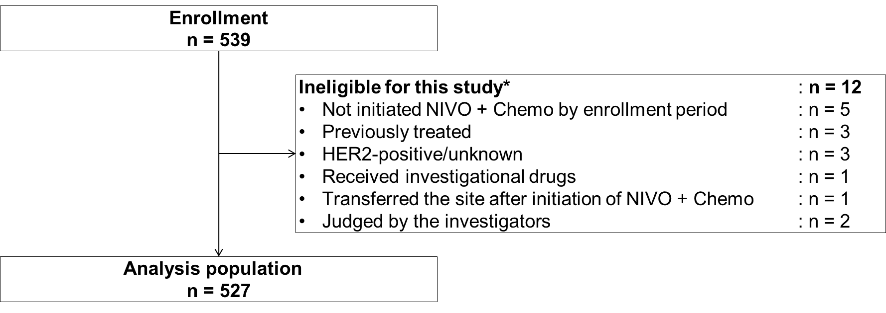

Online Resource 4. Patient diagram
* Some patients did not meet multiple criteria.
Abbreviations: HER2, human epidermal growth factor receptor 2; NIVO + Chemo, nivolumab plus chemotherapy.

Online Resource 5. Patient characteristics by PD-L1 CPS and combination chemotherapy
 | PD-L1 CPS |  |  |  | Combination chemotherapy
 | < 1 | 1–5 | ≥ 5 |  | SOX | CapeOX | FOLFOX
Characteristics, n (%) | n = 89 | n = 143 | n = 216 |  | n = 387 | n = 34 | n = 106
Age, years
Median (range) | 70.3 (34–85) | 70.2 (25–87) | 70.2 (25–87) |  | 70.4 (25-87) | 71.6 (51–82) | 68.8 (24–87)
< 65 | 27 (30.3) | 51 (35.7) | 71 (32.9) |  | 124 (32.0) | 8 (23.5) | 40 (37.7)
≥ 65, < 75 | 46 (51.7) | 49 (34.3) | 90 (41.7) |  | 162 (41.9) | 16 (47.1) | 44 (41.5)
≥ 75 | 16 (18.0) | 43 (30.1) | 55 (25.5) |  | 101 (26.1) | 10 (29.4) | 22 (20.8)
Male | 60 (67.4) | 93 (65.0) | 147 (68.1) |  | 256 (66.1) | 26 (76.5) | 63 (59.4)
ECOG PS
0 | 45 (50.6) | 69 (48.3) | 103 (47.7) |  | 212 (54.8) | 18 (52.9) | 25 (23.6)
1 | 33 (37.1) | 62 (43.4) | 98 (45.4) |  | 158 (40.8) | 15 (44.1) | 51 (48.1)
2–4 | 9 (10.1) | 10 (7.0) | 12 (5.6) |  | 9 (2.3) | 0 | 27 (25.5)
Unknown | 2 (2.2) | 2 (1.4) | 3 (1.4) |  | 8 (2.1) | 1 (2.9) | 3 (2.8)
Disease status
Advanced | 59 (66.3) | 124 (86.7) | 192 (88.9) |  | 334 (86.3) | 14 (41.2) | 96 (90.6)
Recurrent or relapse | 30 (33.7) | 19 (13.3) | 24 (11.1) |  | 53 (13.7) | 20 (58.8) | 10 (9.4)
Metastasis
Liver | 12 (13.5) | 42 (29.3) | 61 (28.2) |  | 94 (24.2) | 10 (29.4) | 26 (24.5)
Peritoneal dissemination | 52 (58.4) | 69 (48.3) | 95 (44.0) |  | 170 (43.9) | 8 (23.5) | 65 (61.3)
Lymph node | 39 (43.8) | 84 (58.7) | 126 (58.3) |  | 214 (55.3) | 17 (50.0) | 60 (56.6)
No. of metastasis
0 | 6 (6.7) | 7 (4.9) | 12 (5.6) |  | 32 (8.3) | 4 (11.8) | 4 (3.8)
1 | 53 (59.6) | 69 (48.3) | 106 (49.1) |  | 198 (51.2) | 21 (61.8) | 42 (39.6)
≥ 2 | 30 (33.7) | 67 (46.9) | 98 (45.4) |  | 157 (40.6) | 9 (26.5) | 60 (56.6)
Previous surgery | 38 (42.7) | 37 (25.9) | 43 (19.9) |  | 96 (24.8) | 24 (70.6) | 19 (17.9)
PD-L1 CPS IHC 28-8
Tested | 89 (100) | 143 (100) | 216 (100) |  | 328 (84.8) | 28 (82.4) | 95 (89.6)
< 1 | 89 (100) | 0 | 0 |  | 63/328 (19.2) | 5/28 (17.9) | 21/95 (22.1)
1–5 | 0 | 143 (100) | 0 |  | 102/328 (31.1) | 11/28 (39.3) | 30/95 (31.6)
≥ 5 | 0 | 0 | 216 (100) |  | 163/328 (49.7) | 10/28 (35.7) | 43/95 (45.3)
Unclear | 0 | 0 | 0 |  | 0 | 2/28 (7.1) | 1/95 (1.1)
Untested | 0 | 0 | 0 |  | 29 (7.5) | 2 (5.9) | 6 (5.7)
Unknown | 0 | 0 | 0 |  | 30 (7.8) | 4 (11.8) | 5 (4.7)
MSI status
Tested | 50 (56.2) | 69 (48.3) | 79 (36.6) |  | 146 (37.7) | 15 (44.1) | 59 (55.7)
MSS | 43/50 (86.0) | 64/69 (92.8) | 66/79 (83.5) |  | 125/146 (85.6) | 14/15 (93.3) | 53/59 (89.8)
MSI-low | 0 | 0 | 3/79 (3.8) |  | 3/146 (2.1) | 0 | 0
MSI-high | 1/50 (2.0) | 2/69 (2.9) | 8/79 (10.1) |  | 9/146 (6.2) | 0 | 4/59 (6.8)
Unclear | 6/50 (12.0) | 3/69 (4.3) | 2/79 (2.5) |  | 9/146 (6.2) | 1/15 (6.7) | 2/59 (3.4)
Untested | 21 (23.6) | 35 (24.5) | 84 (38.9) |  | 131 (33.9) | 6 (17.6) | 29 (27.4)
Unknown | 18 (20.2) | 39 (27.3) | 53 (24.5) |  | 110 (28.4) | 13 (38.2) | 18 (17.0)
Ascites
Without | 44 (49.4) | 72 (50.3) | 116 (53.7) |  | 215 (55.6) | 18 (52.9) | 38 (35.8)
With | 34 (38.2) | 58 (40.6) | 84 (38.9) |  | 135 (34.9) | 9 (26.5) | 60 (56.6)
Mild to moderate | 23/34 (67.6) | 51/58 (87.9) | 62/84 (73.8) |  | 106/135 (78.5) | 8/9 (88.9) | 43/60 (71.7)
Massive | 5/34 (14.7) | 4/58 (6.9) | 13/84 (15.5) |  | 13/135 (9.6) | 0 | 10/60 (16.7)
Unclear | 6/34 (17.6) | 3/58 (5.2) | 9/84 (10.7) |  | 16/135 (11.9) | 1/9 (11.1) | 7/60 (11.7)
Unknown | 11 (12.4) | 13 (9.1) | 16 (7.4) |  | 37 (9.6) | 7 (20.6) | 8 (7.5)
Abbreviations: CapeOX, capecitabine/oxaliplatin; CPS, combined positive score; ECOG PS, Eastern Cooperative Oncology Group performance status; FOLFOX, 5-fluorouracil/leucovorin/oxaliplatin; IHC, immunohistochemistry; MSI, microsatellite instability; MSS, microsatellite stable; PD-L1, programmed cell death ligand 1; SOX, S-1/oxaliplatin.
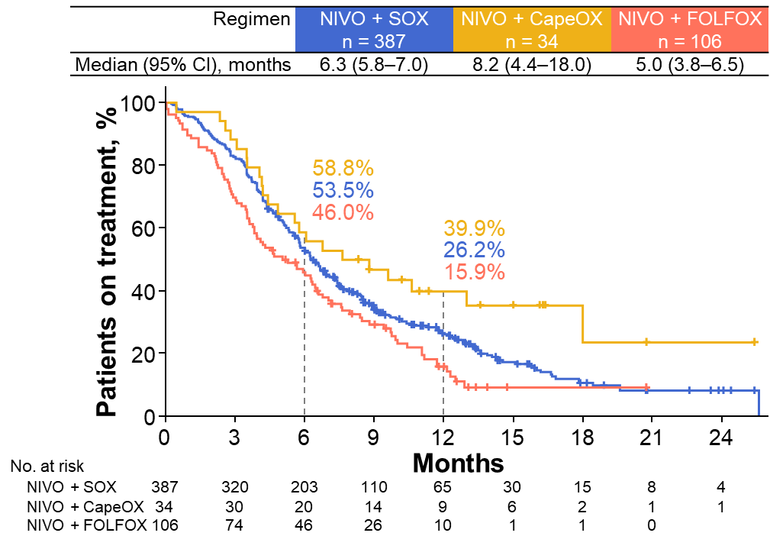

Online Resource 6. DOT by nivolumab plus chemotherapy regimen
DOT was defined as the period from the initiation of first-line therapy to the physician-determined end date of treatment.
A total of 11 patients were treated with multiple regimens, and they were categorized by the regimen with the longest duration of treatment in each patient.
Abbreviations: CapeOX, capecitabine/oxaliplatin; DOT, duration of treatment; FOLFOX, 5-fluorouracil/leucovorin/oxaliplatin; NIVO + Chemo, nivolumab plus chemotherapy; SOX, S-1/oxaliplatin.

Online Resource 7. Details of second line treatment
Parameters | Overall  n = 196/413 (47.5)*
Time to next line treatment, months, median (range) | 6.7 (0.7–21.0)
Second line treatment regimen, n (%)
Ramucirumab plus paclitaxel† | 79 (40.3)
Ramucirumab plus nab-paclitaxel† | 79 (40.3)
nab-paclitaxel | 9 (4.6)
Ramucirumab plus irinotecan | 4 (2.0)
Docetaxel | 2 (1.0)
Irinotecan | 1 (0.5)
Ramucirumab | 3 (1.5)
Pembrolizumab | 1 (0.5)
Others | 19 (9.7)
Treatment status, n (%)
On-going | 56 (28.6)
Discontinued | 140 (71.4)
Discontinued reason, n (%)
Ineffective | 100 (51.0)
Adverse event | 18 (9.2)
Patient requests | 5 (2.6)
Death | 4 (2.0)
Other reasons | 12 (6.1)
Unknown | 1 (0.5)
* A total of 114 patients who were still receiving nivolumab plus chemotherapy were excluded from total population. † One patient received both paclitaxel plus ramucirumab and nab-paclitaxel plus ramucirumab as second-line therapy.

Online Resource 8. Association of patient characteristics and rwPFS
 |  |  | PD or death*, n (%) |  | Univariable analysis |  |  | Multivariable analysis
Subgroup |  | n* | Without | With | HR (95% CI) | P-value |  | Adjusted HR (95% CI) | P-value
Sex | Male | 344 | 120 (34.9) | 224 (65.1) |  | 0.268 |  |  | 0.537
 | Female | 182 | 55 (30.2) | 127 (69.8) | 1.13 (0.91–1.41) |  |  | 1.09 (0.82–1.46)
Age | < 75 years | 393 | 129 (32.8) | 264 (67.2) |  | 0.629 |  |  | 0.511
 | ≥ 75 years | 133 | 46 (34.6) | 87 (65.4) | 0.94 (0.74–1.20) |  |  | 1.11 (0.82–1.49)
ECOG PS | 0–1 | 478 | 167 (34.9) | 311 (65.1) |  | <0.001 |  |  | 0.006
 | 2–4 | 36 | 5 (13.9) | 31 (86.1) | 2.84 (1.96–4.12) |  |  | 2.04 (1.23–3.38)
PD-L1 CPS | < 1 | 88 | 28 (31.8) | 60 (68.2) |  | 0.754 |  |  | 0.222
 | 1–5 | 143 | 49 (34.3) | 94 (65.7) | 1.12 (0.81–1.55) |  |  | 1.17 (0.79–1.73)
 | ≥ 5 | 216 | 76 (35.2) | 140 (64.8) | 1.03 (0.76–1.39) |  |  | 0.90 (0.62–1.30)
Surgical history for gastric cancer | Without | 388 | 115 (29.6) | 273 (70.4) |  | 0.038 |  |  | 0.991
 | With | 138 | 60 (43.5) | 78 (56.5) | 0.77 (0.59–0.99) |  |  | 1.00 (0.71–1.41)
Peritoneal dissemination metastasis | Without | 283 | 100 (35.3) | 183 (64.7) |  | 0.848
 | With | 243 | 75 (30.9) | 168 (69.1) | 1.02 (0.83–1.26)
Number of metastatic sites | ≤ 1 | 260 | 95 (36.5) | 165 (63.5) |  | 0.013 |  |  | 0.167
 | ≥ 2 | 226 | 62 (27.4) | 164 (72.6) | 1.32 (1.06–1.63) |  |  | 1.24 (0.92–1.67)
Liver metastasis | Without | 396 | 141 (35.6) | 255 (64.4) |  | 0.042 |  |  | 0.498
 | With | 130 | 34 (26.2) | 96 (73.8) | 1.28 (1.01–1.62) |  |  | 1.13 (0.79–1.63)
Disease status | Advanced | 443 | 145 (32.7) | 298 (67.3) |  | 0.038
 | Recurrent or relapse | 83 | 30 (36.1) | 53 (63.9) | 0.73 (0.54–0.98)
Ascites | Without | 270 | 113 (41.9) | 157 (58.1) |  | <0.001 |  |  | 0.001
 | Mild to moderate | 157 | 33 (21.0) | 124 (79.0) | 1.69 (1.33–2.14) |  |  | 1.26 (0.94–1.70)
 | Massive | 23 | 3 (13.0) | 20 (87.0) | 3.07 (1.92–4.91) |  |  | 2.79 (1.60–4.86)
Albumin | Per 1 g/dL increase | 520 | 174 (33.5) | 346 (66.5) | 0.65 (0.55–0.77) | <0.001 |  | 0.76 (0.61–0.96) | 0.020
Lactate dehydrogenase | Per 1 U/L increase | 516 | 173 (33.5) | 343 (66.5) | 1.00 (1.00–1.00) | 0.003 |  | 1.00 (1.00–1.00) | 0.382
Glasgow prognostic score† | 0 | 254 | 111 (43.7) | 143 (56.3) |  | <0.001
 | 1 | 208 | 53 (25.5) | 155 (74.5) | 1.43 (1.14–1.79)
 | 2 | 48 | 8 (16.7) | 40 (83.3) | 2.40 (1.69–3.41)
C-reactive protein | Per 1 mg/dL increase | 510 | 172 (33.7) | 338 (66.3) | 1.09 (1.05–1.13) | <0.001
White blood cell | Per 1 count/mm³ increase | 519 | 174 (33.5) | 345 (66.5) | 1.00 (1.00–1.00) | <0.001
Hemoglobin | Per 1 g/dL increase | 519 | 174 (33.5) | 345 (66.5) | 0.93 (0.88–0.98) | 0.010
Neutrophil | Per 1 count/mm³ increase | 350 | 122 (34.9) | 228 (65.1) | 1.00 (1.00–1.00) | 0.001
Alkaline phosphatase | Per 10 U/L increase | 520 | 174 (33.5) | 346 (66.5) | 1.02 (1.01–1.02) | <0.001
Variables included in the multivariable analysis were selected according to their clinical relevance, statistical significance in the univariable analysis (cutoff, p < 0.05), and correlation between variables.
* The number of patients indicates those included in the univariable analysis.
† Patients who had both a serum C-reactive protein > 1.0 mg/dL and albumin < 3.5 g/dL were allocated a GPS of 2. Patients with only one of the abnormal values were allocated a GPS of 1, and patients who had neither been allocated a GPS of 0.
Abbreviations: CI, confidence interval; CPS, combined positive score; ECOG PS, Eastern Cooperative Oncology Group performance status; HR, hazard ratio; PD, progressive disease; PD-L1, programmed cell death ligand 1; rwPFS, real-world progression-free survival.

Online Resource 9. Summary of safety by age and ECOG PS
 | Age |  |  | ECOG PS*
 | < 75 years | ≥ 75 years |  | 0 | 1 | 2–4
Category | n = 394 | n = 133 |  | n = 255 | n = 224 | n = 36
Any grade TRAE, n (%) | 361 (91.6) | 120 (90.2) |  | 239 (93.7) | 204 (91.1) | 28 (77.8)
Grade 3–4 TRAE, n (%) | 171 (43.4) | 42 (31.6) |  | 102 (40.0) | 88 (39.3) | 19 (52.8)
TRAE leading to discontinuation, n (%) | 37 (9.4) | 18 (13.5) |  | 23 (9.0) | 28 (12.5) | 2 (5.6)
Any grade irAE, n (%) | 102 (25.9) | 34 (25.6) |  | 73 (28.6) | 53 (23.7) | 6 (16.7)
Grade 3–4 irAE, n (%) | 35 (8.9) | 6 (4.5) |  | 18 (7.1) | 21 (9.4) | 1 (2.8)
Treatment-related death | 3 (0.8) | 2 (1.5) |  | 1 (0.4) | 3 (1.3) | 0
The severity of AEs was assessed according to Common Terminology Criteria for Adverse Events v5.0 by the investigators. AE information, such as whether the event was an irAE, its severity, and its causal relationship with the treatment, and its outcome, was assessed by the investigators.
* ECOG PS was unknown for a total of 12 patients.
Abbreviations: AE, adverse event; ECOG PS, Eastern Cooperative Oncology Group performance status; irAE, immune-related adverse event; TRAE, treatment-related adverse event.

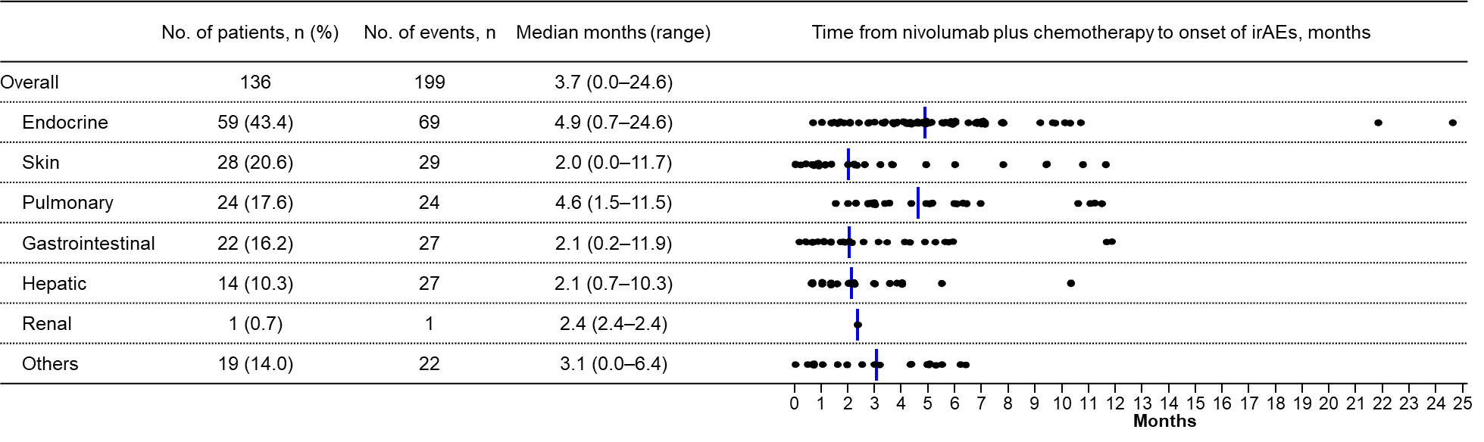

Online Resource 10. Time from nivolumab plus chemotherapy to onset of any grade irAEs
Blue vertical lines represent the median value. The severity of AEs was assessed according to Common Terminology Criteria for Adverse Events v5.0 by the investigators. AE information, such as whether the event was an irAE, its severity, and its causal relationship with the treatment, and its outcome, was assessed by the investigators.
Abbreviation: AE, adverse event; irAE, immune-related adverse event

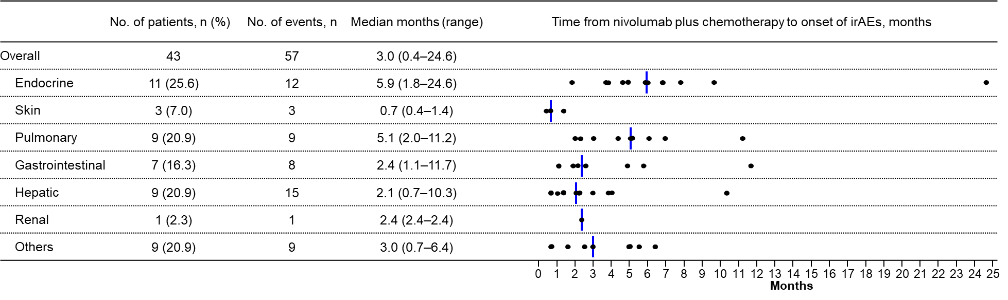

Online Resource 11. Time from nivolumab plus chemotherapy to onset of grade ≥ 3 irAEs
Blue vertical lines represent the median value. The severity of AEs was assessed according to Common Terminology Criteria for Adverse Events v5.0 by the investigators. AE information, such as whether the event was an irAE, its severity, and its causal relationship with the treatment, and its outcome, was assessed by the investigators.
Abbreviation: AE, adverse event; irAE, immune-related adverse event

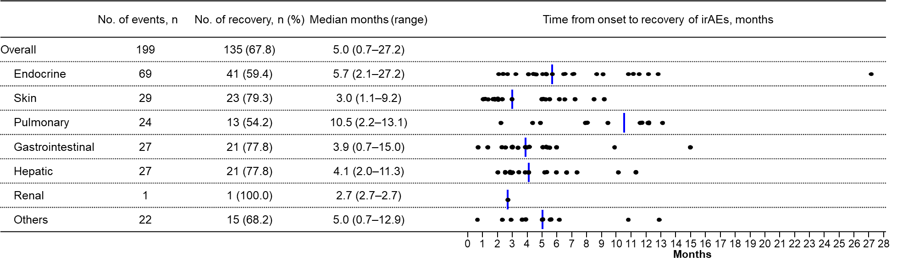

Online Resource 12. Time from onset to recovery of any grade irAEs
Blue vertical lines represent the median value. The severity of AEs was assessed according to Common Terminology Criteria for Adverse Events v5.0 by the investigators. AE information, such as whether the event was an irAE, its severity, its causal relationship to treatment, and its outcome, was analyzed according to investigator assessment. Recovery included recovered, recovering, and recovered but with sequelae.
Abbreviation: AE, adverse event; irAE, immune-related adverse event

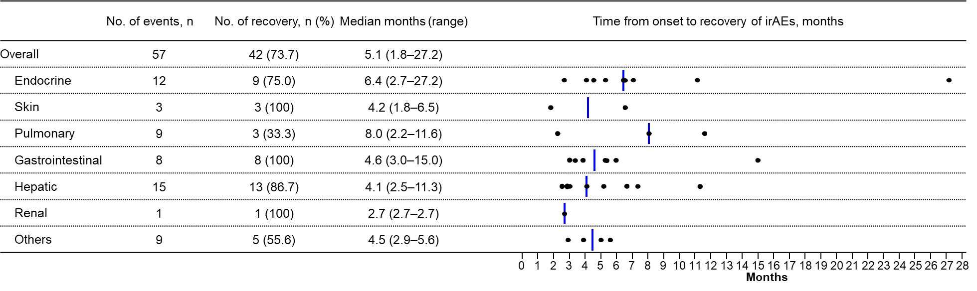

Online Resource 13. Time from onset to recovery of grade ≥ 3 irAEs
Blue vertical lines represent the median value. The severity of AEs was assessed according to Common Terminology Criteria for Adverse Events v5.0 by the investigators. AE information, such as whether the event was an irAE, its severity, its causal relationship to treatment, and its outcome, was analyzed according to investigator assessment. Recovery included recovered, recovering, and recovered but with sequelae.
Abbreviation: AE, adverse event; irAE, immune-related adverse event

