Supplementary information:
Is reduced ferredoxin the physiological electron donor for MetVF-type methylenetetrahydrofolate reductases in acetogenesis?
A hypothesis
International Microbiology
Christian Öppinger^{1*}, Florian Kremp^{1*} and Volker Müller ^{1#}

¹Department of Molecular Microbiology & Bioenergetics, Institute of Molecular Biosciences, Johann Wolfgang Goethe University, Max-von-Laue Str. 9, D-60438 Frankfurt, Germany

*These authors contributed equally to this study
#Corresponding author. Mailing address: Department of Molecular Microbiology & Bioenergetics, Institute of Molecular Biosciences, Johann Wolfgang Goethe University, Max-von-Laue-Str. 9, D-60438 Frankfurt, Germany. Phone: 49-69-79829507. Fax: 49-69-79829306. E-mail: vmueller@bio.uni-frankfurt.de.

Running title: The MetVF-type MTHFR

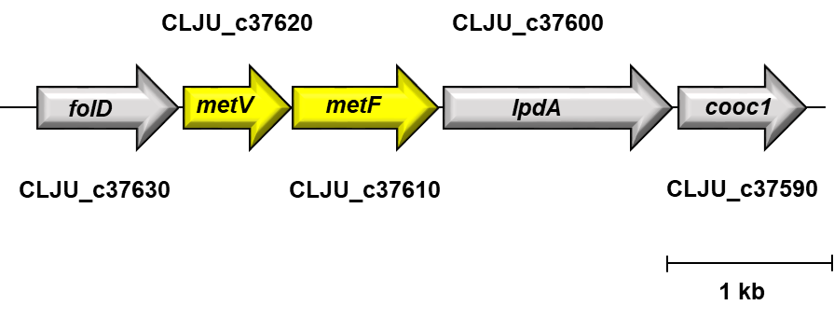
Supplementary Figure 1 Genetic organization of the methylene-THF reductase in C. ljungdahlii. The MTHFR encoding genes metV (CLJU_c37620) and metF (CLJU_c37610) are located downstream of folD (CLJU_c37630) that codes for a bifunctional methylene-THF dehydrogenase/methylene-THF cyclohydrolase. Downstream of metF a dihydrolipoamide dehydrogenase (lpdA, CLJU_c37600) and the nickel-insertion protein of the CODH/ACS (cooC1, CLJU_c37590) are encoded

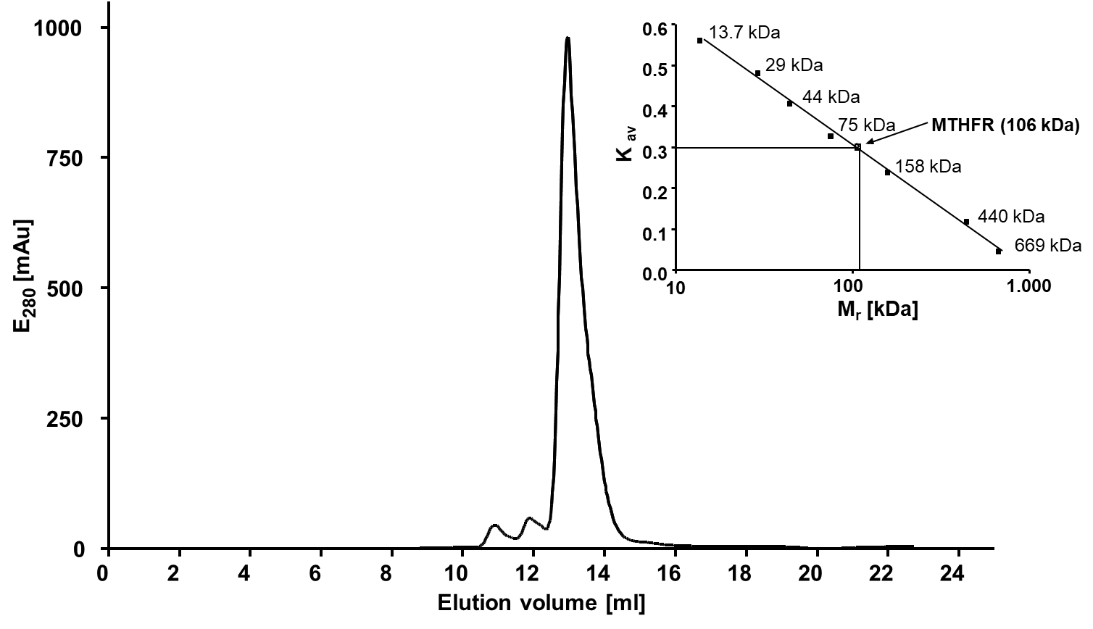
Supplementary Figure 2 Molecular mass determination of the MTHFR. The molecular mass of the MTHFR was determined by analytical gel filtration. The MTHFR was loaded onto a Superdex® 200 Increase column previously equilibrated with buffer D (50 mM Tris-HCl, 20 mM MgSO₄, 20% glycerol, 250 mM NaCl 2 mM DTE, 4 µM resazurin, pH 7.6). Elution was performed with a flow of 0.2 ml/min. The molecular mass was calculated according to K_{av} = (V_{e} – V₀)/(V_{c} - V₀₎ with V₀ = 8.23 ml, V_{c} = 24 ml and V_{e} = 12.95 ml

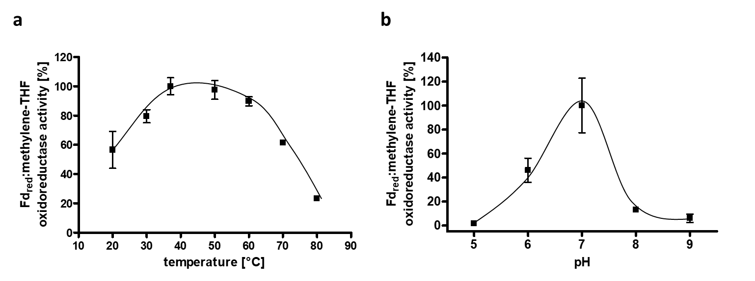
Supplementary Figure 3 Influence of temperature and pH to the catalytic activity of the MTHFR. To determine the influence of temperature, the MTHFR was measured in NaP_{i} buffer as described in materials and methods (a). To determine the influence of the pH a combined buffer was used and the measurements were performed at 24°C (b). 100 % activity correspond to 34.7 U/mg (a) and to 486 mU/mg (b). Each measurement was performed in duplicate

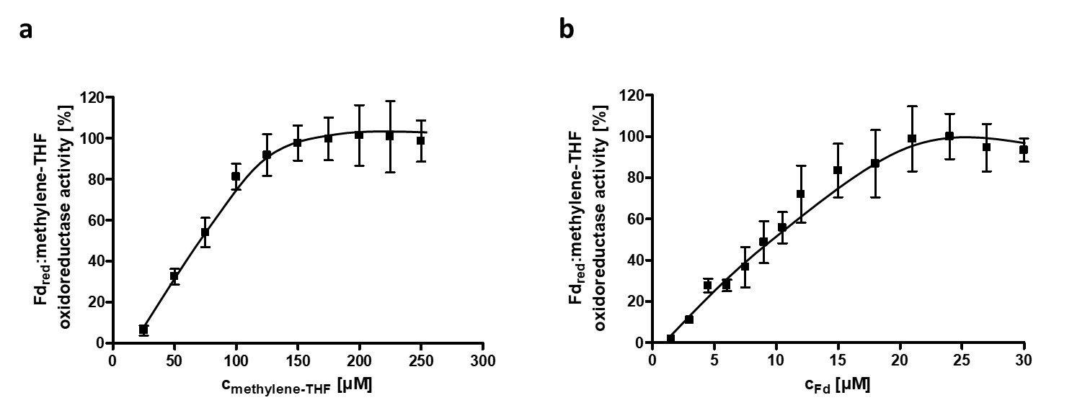
Supplementary Figure 4 K_{m}-value determination for methylene-THF and Fd_{red} in the Fd_{red}:methylene-THF oxidoreductase activity of the MTHFR. The measurements were performed in triplicates as described in materials and methods with different amounts of either methylene-THF (a) or Fd_{red} (b). 100 % activity correspond to 48.8 U/mg (a) and to 71.7 U/mg (b)

