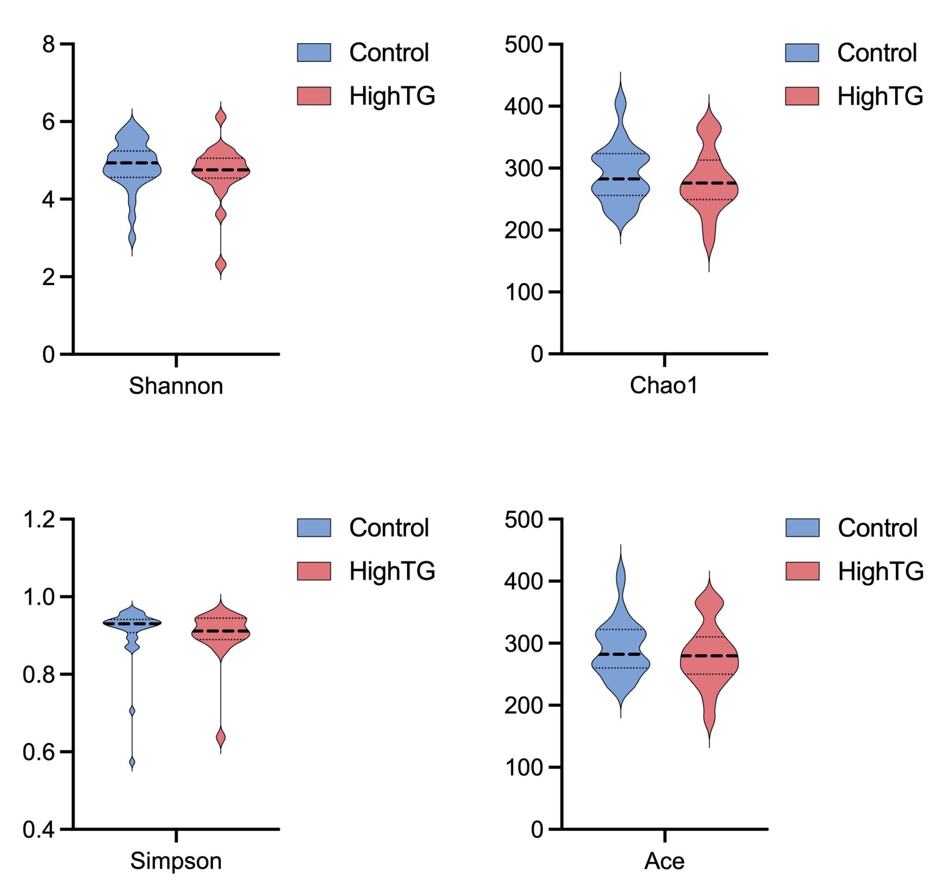

Fig. S1 Gut microbial α-diversity comparison between HTG and control groups. A: Violin plots illustrate the distribution of Shannon indices, with no significant differences observed between groups; B: Violin plots illustrate the distribution of Chao1 indices, with no significant differences observed between groups; C: Violin plots illustrate the distribution of Simpson indices, with no significant differences observed between groups; D: Violin plots illustrate the distribution of ACE indices, with no significant differences observed between groups. The plots combine kernel density estimation and boxplot elements, where the thick black bar represents the median, the thin black bar shows the interquartile range.

