SUPPLEMENTARY MATERIALS
Supplementary Table 1. Lytic efficacy of the bacteriophage cocktail (SA1306KAY and SA1298KAY) against S. aureus D4508 in tryptic soy broth (TSB) at 37 °C and in milk during storage at 4°C.
 | In-vitro lytic activity in TSB (log CFU/mL)
Time | C2 | P2 |  | Reduction | C4 | P4 | Reduction
0 min | 2.19 ± 0.41 | - |  | - | 4.29 ± 0.08 | - | -
30 min | 2.87 ± 0.05 | 2.16 ± 0.23 |  | 0.71 | 4.30 ± 0.00 | 3.57 ± 0.06 | 0.73
60 min | 3.37 ± 0.17 | 2.01 ± 0.09 |  | 1.36 | 4.75 ± 0.00 | 3.52 ± 0.05 | 1.23
90 min | 3.51 ± 0.16 | 1.89 ± 0.41 |  | 1.62 | 5.38 ± 0.40 | 3.09 ± 0.05 | 2.29
3 h | 3.70 ± 0.22 | nd |  | 3.70 | 5.75 ± 0.23 | 2.39 ± 0.22 | 3.36
6 h | 4.31 ± 0.22 | nd |  | 4.31 | 6.62 ± 0.02 | 2.56 ± 0.06 | 4.06
24 h | 9.16 ± 0.06 | 5.77 ± 0.01 |  | 3.39 | 9.42 ± 0.15 | 7.82 ± 0.01 | 1.60
 | Lytic activity in milk (log CFU/mL)
Time | C2 |  | P2 | Reduction | C4 | P4 | Reduction
0 min | 2.77 ± 0.01 |  | - | - | 4.72 ± 0.03 | - | -
1 h | 2.67 ± 0.17 |  | 2.30 ± 0.00 | 0.37 | 4.58 ± 0.02 | 4.32 ± 0.02 | 0.26
3 h | 2.75 ± 0.02 |  | 2.22 ± 0.02 | 0.53 | 4.64 ± 0.06 | 3.20 ± 0.00 | 1.44
6 h | 2.73 ± 0.06 |  | 1.79 ± 0.07 | 0.94 | 4.56 ± 0.12 | 3.17 ± 0.03 | 1.39
24 h | 2.82 ± 0.01 |  | 1.94 ± 0.03 | 0.88 | 4.67 ± 0.01 | 3.72 ± 0.01 | 0.95
nd: not detected [under the detection limit (1 log CFU/mL)]; C2: Control group with 2 log CFU/mL bacteria; C4: Control group with 4 log CFU/mL bacteria; P2: Phage added group with 2 log CFU/mL bacteria; P4: Phage added group with 4 log CFU/mL bacteria. Phage cocktail titer: 8 log PFU/ml.

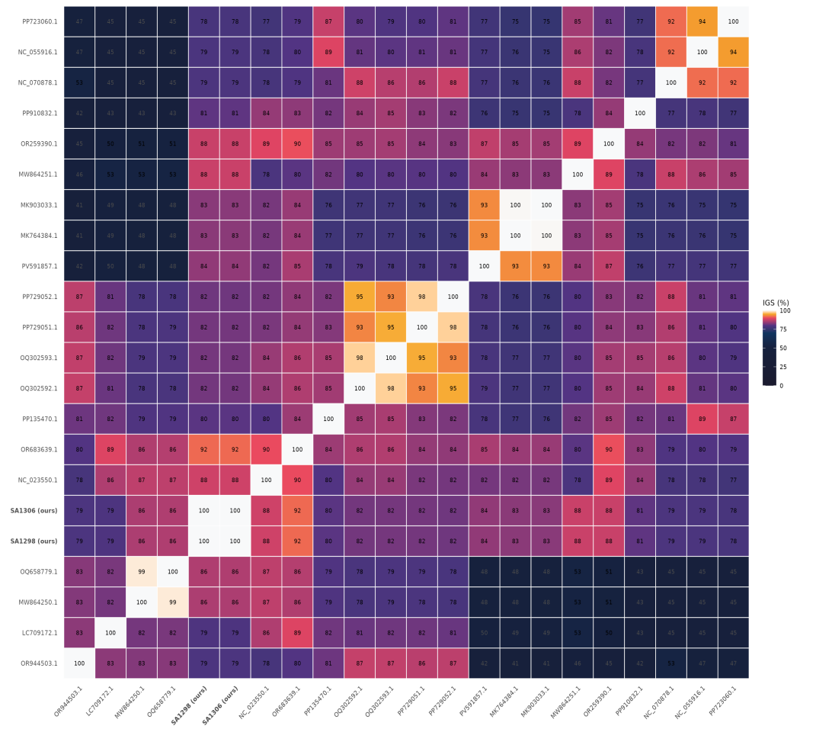
Supplementary Figure 1. VIRIDIC-based intergenomic similarity heatmap of SA1298KAY, SA1306KAY, and 20 different reference Rosenblumvirus genomes.
Pairwise nucleotide similarity values were calculated using VIRIDIC and visualized as a heatmap matrix. The analysis included 20 complete Rosenblumvirus genomes, including SA1298KAY and SA1306KAY, selected from BLAST-supported matches and publicly available Rosenblumvirus genomes. SA1298KAY and SA1306KAY clustered with closely related Rosenblumvirus phages, supporting their taxonomic placement within this genus.

