Analysis of chromosomal numbers, mitochondrial genome and full-length transcriptome in Onychostoma brevibarba reveal their genetic signatures

Fangzhou Hu^{ab1}, Jingjing Fan ^{a1}, Chang Wu ^{a1}, Ming Zhuª, Yunfan Zhouª, Shi Wangª, Chun Zhangª, Min Taoª, Rurong Zhaoª, Chenchen Tangª, Kaikun Luoª, Qinbo Qinª, Ming Ma^{b}, Bo Chen^{b}, Shaojun Liu ^{a*}

ªState Key Laboratory of Developmental Biology of Freshwater Fish, College of Life Sciences, Hunan Normal University，Changsha, 410081, Hunan, P. R. of China

^{b}Key Laboratory of Phytochemical R&D of Hunan Province, Key Laboratory of Chemical Biology & Traditional Chinese Medicine Research, Ministry of Education, Hunan Normal University, Changsha 410081, China.

¹These authors contributed equally to this work.

*Correspondence and requests for materials should be addressed to S.L. (email: lsj@hunnu.edu.cn).
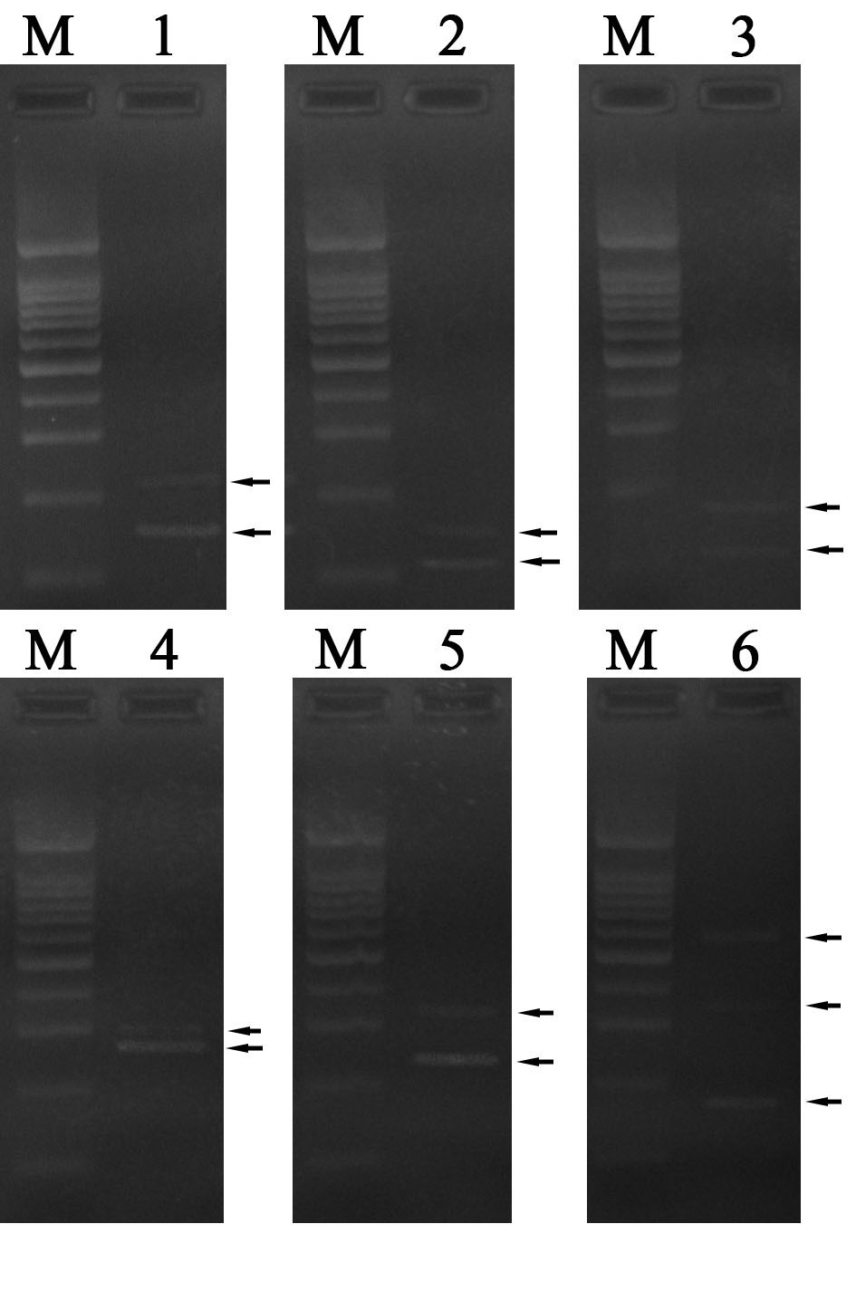
Supplementary Figure 1 RT-PCR validation of AS events and isoforms in 6 candidate genes. Arrows, PCR products; M, DNA 100 bp ladder; 1, PB.2068; 2, PB.6640; 3, PB.8151; 4, PB.7072; 5, PB4006; 6, PB.7104.

