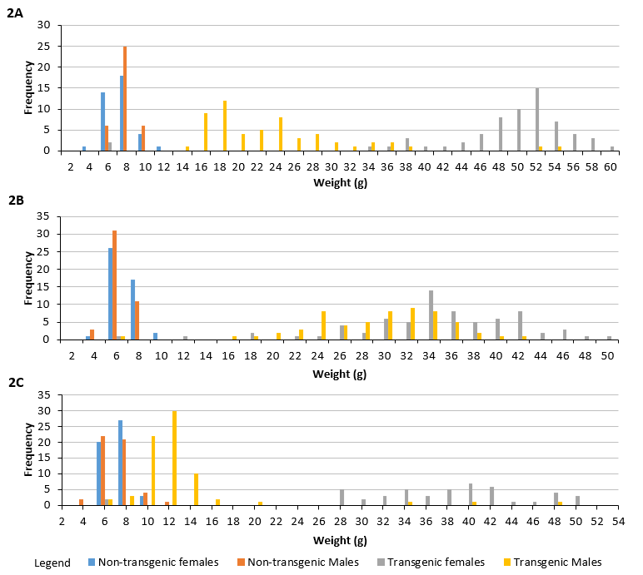

Supplemental Figure 2 Frequency distribution of weight at 5 months of age of A) a 5750A family created from a 5750A sire and non-transgenic dam, B) a M77 family created from a non-transgenic sire and M77 dam, C) a 5750A family created from a non-transgenic male and 5750A dam, this family exhibited overlap in size between transgenic males and non-transgenic male and females.

