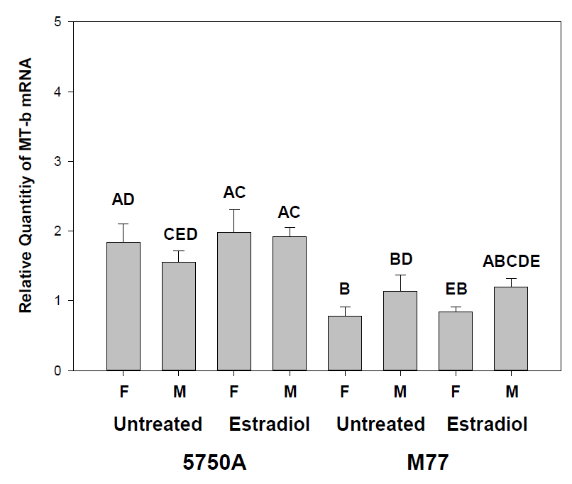
Supplemental Figure 3 Relative metallothionein-b (MT-b) mRNA levels from liver samples of estradiol treated and untreated males (M) and females (F) of the 5750A and M77 strains of GH transgenic coho salmon. The bars represent the mean ± standard error. Capital letters above the bars (A, B, C, D) represent statistically significant differences between the means.

