Supplementary File
Identification of a novel β-defensin gene in gilthead seabream (Sparus aurata)
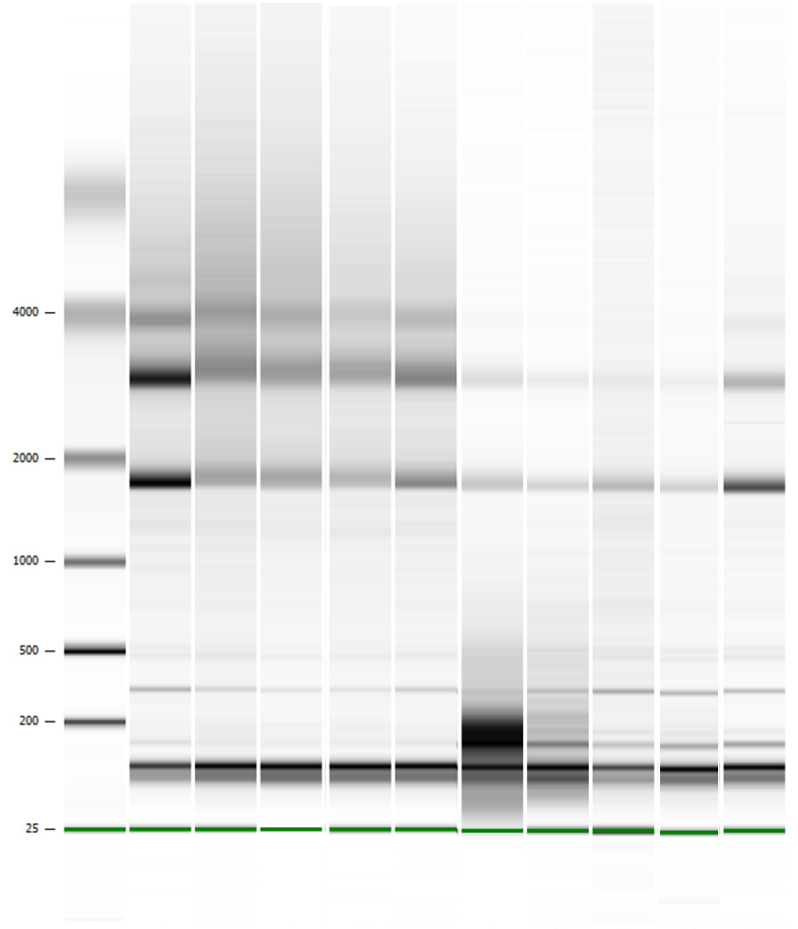
Fig. S1. Gel image of RNA samples on the Agilent Technologies 2100 bioanalyzer. Lane 1 contains the ladder (4,000-25 nt). Lanes 2-5 contain liver RNA samples; lanes 6-10 contain spleen RNA samples. Distinct 18S and 28S RNAs bands indicate high-quality RNA.

