Pangenome dynamics and functional diversification in the marine genus Pseudoalteromonas: association to colony pigmentation

Jéssica Scherer¹ ², Renato Kulakowski Corá², Diego Bonatto³, Alexandre José Macedo¹ ² *

¹ Laboratório de Biofilmes e Diversidade Microbiana, Faculdade de Farmácia e Centro de Biotecnologia, Universidade Federal do Rio Grande do Sul, Porto Alegre 91501-970, Rio Grande do Sul, Brazil.
² Regenera Moléculas do Mar – Avenida Ipiranga 6681, prédio 96D, sala 210 – CEP 90160-091, Partenon, Porto Alegre, RS, Brazil.
³ Laboratório de Biologia Molecular e Computacional, Centro de Biotecnologia da UFRGS, Departamento de Biologia Molecular e Biotecnologia, Universidade Federal do Rio Grande do Sul, Porto Alegre, RS, Brazil.

*Correspondence: alexandre.macedo@ufrgs.br

Supplementary materials

Table S1. The accession numbers and general attributes of the Pseudoalteromonas spp. genomes used in pangenome.

Species as originally identified | Strain | Accession Genome | Size (b) | G + C (mol%) | Completeness (%) | Contamination (%) | Isolation source | Colour
Pseudoalteromonas xiamenensis | CGMCC 1.12157 | GCF_042431545.1-RS_2024_09_29 | 4622515 | 43 | 99.7 | 1 | Seawater | Red
Pseudoalteromonas viridis | BBR56 | GCF_017742995.1-RS_2025_04_28 | 5549631 | 49.5 | 98.95 | 0.51 | Seawater | Red
Pseudoalteromonas undina | DSM 6065 | GCF_000238275.3-RS_2025_03_28 | 4027610 | 40 | 99.82 | 0.25 | Seawater | Non-pigmented
Pseudoalteromonas umbrosa | B95 | GCF_030125375.1-RS_2025_03_02 | 6189459 | 41.5 | 99.95 | 2.63 | Montipora capitata Coral | Brown
Pseudoalteromonas ulvae | TC14 | GCF_002156545.1-RS_2025_04_27 | 4586484 | 41.5 | 99.95 | 0.7 | Biofilm Toulon harbor | Purple
Pseudoalteromonas tunicata | D2 | GCF_003568825.1-RS_2025_03_28 | 4967522 | 40 | 99.7 | 0.13 | Tunicate Ciona intestinalis | Green
Pseudoalteromonas translucida | TAC125 | GCF_000026085.1-RS_2024_12_13 | 3850272 | 40 | 99.98 | 0.25 | Antarctic coastal sea water | Non-pigmented
Pseudoalteromonas tetraodonis |  | GCF_046712425.1-RS_2025_01_16 | 3910324 | 40 | 98.18 | 0.51 | Sea ice | Non-pigmented
Pseudoalteromonas spongiae UST010723-006 | UST010723-006 | GCF_000238255.3-RS_2025_03_29 | 4752413 | 41 | 99.94 | 0.38 | Sponge Mycale adhaerens | Orange
Pseudoalteromonas simplex | A520 | GCF_015278155.1-RS_2024_12_09 | 4501926 | 41 | 99.95 | 0.25 | Sphoeroides spengleri | Yellow
Pseudoalteromonas shioyasakiensis | JCM 18891 | GCF_001550135.1-RS_2025_04_22 | 4807552 | 41.5 | 99.95 | 01.07 | Sediment ocean | Non-pigmented
Pseudoalteromonas ruthenica | S3137 | GCF_000967625.1-RS_2025_03_28 | 4066635 | 47.5 | 99.49 | 0.72 | Seaweed | Orange
Pseudoalteromonas rubra | DSM 6842 | GCF_000238295.3-RS_2025_04_06 | 6143755 | 48 | 99.71 | 0.93 | Seawater | Red
Pseudoalteromonas rhizosphaerae | hCg-42 | GCF_028885455.1-RS_2025_05_12 | 5358982 | 40.5 | 10000% | 4.86 | Magallana gigas hemolymph | Non-pigmented
Pseudoalteromonas qingdaonensis | YIC-827 | GCF_038739665.1-RS_2025_05_02 | 3265653 | 49 | 97.56 | 0.67 | Intestines of marine benthic organisms | Non described
Pseudoalteromonas prydzensi | ACAM 620 | GCF_014925355.1-RS_2024_11_20 | 5205557 | 41 | 99.75 | 2.15 | Sea ice | Non-pigmented
Pseudoalteromonas piscicida | WCPW15003 | GCF_019797925.1-RS_2025_03_30 | 5380608 | 43.5 | 90.15 | 6.55 | Mariculture | Orange
Pseudoalteromonas piratica | OCN003 | GCF_000788395.1-RS_2024_12_09 | 4815987 | 40 | 100 | 1.44 | Montipora capitata coral fragment | Yellow
Pseudoalteromonas phenolica | KCTC 12086 | GCF_001444405.1-RS_2025_03_03 | 4868993 | 40.5 | 99.95 | 1.12 | Seawater | Brown
Pseudoalteromonas pernae | YIC-656 | GCF_039831865.1-RS_2025_08_15 | 3973550 | 45.5 | 99.41 | 0.59 | Intestinal tract of Perna mussels (Bivalvia: Mytilidae) | Non described
Pseudoalteromonas peptidolytica | NBRC 101021 | GCF_007989895.1-RS_2025_09_09 | 5036479 | 42.5 | 99.49 | 1.22 | Seawater | Yellow
Pseudoalteromonas ostreae | hOe-124 | GCF_029023665.1-RS_2025_05_12 | 4735317 | 40.5 | 99.12 | 1.26 | Magallana gigas hemolymph | Orange
Pseudoalteromonas obscura | P94 | GCF_030135505.1-RS_2025_03_02 | 6295190 | 42.5 | 99.7 | 0.41 | Montipora capitata | Purple
Pseudoalteromonas nigrifaciens | KMM 661 | GCF_002221505.1-RS_2025_04_22 | 4274777 | 40 | 99.92 | 0.54 | Mussels | Brown
Pseudoalteromonas neustonica | PAMC 28425 | GCF_001653135.1-RS_2025_08_12 | 4972584 | 39.5 | 99.75 | 0.88 | Seawater | Orange
Pseudoalteromonas mariniglutinosa | NCIMB 1770 | GCF_021613355.1-RS_2025_03_11 | 5031620 | 41 | 99.49 | 1.47 | Diatom seawater | Non-pigmented
Pseudoalteromonas marina | 13-15 | GCF_900141965.1-RS_2025_04_27 | 4099967 | 40 | 100 | 0.13 | Tidal flat sediment | Yellow
Pseudoalteromonas maricaloris | SCSIO 43202 | GCF_024746855.1-RS_2025_02_16 | 5416459 | 43.5 | 100 | 0.41 | Galaxea fascicularis | Yellow
Pseudoalteromonas luteoviolacea | H2 | GCF_006704145.1-RS_2025_04_27 | 6043625 | 42 | 96.42 | 6.78 | Coral reef | Purple
Pseudoalteromonas lipolytica | HJ51 | GCF_003515105.1-RS_2025_04_22 | 4733916 | 41.5 | 99.95 | 01.01 | Seawater | Non-pigmented
Pseudoalteromonas issachenkonii | KMM 3549 | GCF_002310795.1-RS_2025_04_22 | 4132618 | 40.5 | 99.95 | 0.51 | Brown alga seawater Fucus evanescens | Non-pigmented
Pseudoalteromonas holothuriae | CIP 111854 | GCF_945859825.1-RS_2025_03_02 | 5177136 | 40.5 | 99.75 | 0.83 | Wild sea cucumbers | Brown
Pseudoalteromonas haloplanktis | CIP 103197 | GCF_945859885.1-RS_2025_03_16 | 3972527 | 40 | 86.02 | 4.2 | Seawater | Non-pigmented
Pseudoalteromonas gelatinilytica | NH153 | GCF_001641615.1-RS_2025_03_28 | 4797622 | 41.5 | 99.95 | 0.65 | Seawater | Non-pigmented
Pseudoalteromonas galatheae | S4498 | GCF_005886105.2-RS_2024_12_11 | 5366397 | 43 | 99.62 | 0.67 | Shrimp | Yellow
Pseudoalteromonas fuliginea | KMM 216 | GCF_000690055.1-RS_2025_08_06 | 4766895 | 39 | 99.75 | 0.57 | Bay | Brown
Pseudoalteromonas fenneropenaei | KCTC 42730 | GCF_042643375.1-RS_2024_10_06 | 4651258 | 45.5 | 99.7 | 0.8 | Sediment of a pond containing farmed Fenneropenaeus | Non-pigmented
Pseudoalteromonas espejian | DSM 9414 | GCF_002221525.1-RS_2025_05_03 | 4500451 | 40.5 | 99.49 | 0.51 | Seawater | Non-pigmented
Pseudoalteromonas distincta | 16-SW-7 | GCF_005877035.1-RS_2025_08_18 | 4531445 | 39.5 | 100 | 0.38 | Seawater | Orange
Pseudoalteromonas denitrifican | DSM 6059 | GCF_900112265.1-RS_2025_05_03 | 6094166 | 34.5 | 97.22 | 3.67 | Fjord system off | Red
Pseudoalteromonas citrea | DSM 8771 | GCF_000238375.3-RS_2025_03_23 | 5434598 | 41 | 99.75 | 0.13 | Seawater | Yellow
Pseudoalteromonas carrageenovora | ATCC43555T | GCF_900239935.1-RS_2024_12_13 | 4584980 | 39.5 | 99.21 | 0.25 | Pool of bacteria from marine waters and algae | Non-pigmented
Pseudoalteromonas caenipelagi | JBTF-M23 | GCF_013140855.1-RS_2025_08_07 | 5082770 | 42 | 99.92 | 0.7 | Tidal flat | Yellow
Pseudoalteromonas byunsanensis | JCM 12483 | GCF_001854475.1-RS_2025_05_02 | 4743224 | 42.5 | 99.75 | 1.37 | Tidal flat | Purple
Pseudoalteromonas aurantia | 208 | GCF_014858725.1-RS_2024_11_18 | 5602374 | 41 | 100 | 0.48 | Seawater | Orange
Pseudoalteromonas atlantica | NBRC 103033 | GCF_007988745.1-RS_2024_11_18 | 4468419 | 41 | 99.24 | 0.25 | Palmaria palmata | Non-pigmented
Pseudoalteromonas ardens | R96 | GCF_030125445.1-RS_2025_03_02 | 5937012 | 48 | 99.96 | 0.76 | Montipora capitata | Red
Pseudoalteromonas arctica | A 37-1-2 | GCF_000238395.3-RS_2024_09_03 | 4721971 | 39 | 99.75 | 0.38 | Seawater | Orange
Pseudoalteromonas arabiensis | JCM 17292 | GCF_001550155.1-RS_2025_03_28 | 4459111 | 41 | 99.95 | 0.43 | Ocean sediment | Non-pigmented
Pseudoalteromonas apostichopi | FE4 | GCF_030297135.1-RS_2025_06_30 | 4455557 | 41 | 99.95 | 0.13 | fertilized egg Apostichopus japonicus | Non-pigmented
Pseudoalteromonas amylolytica | JW1 | GCF_001854605.1-RS_2025_03_28 | 4856394 | 43.5 | 99.49 | 0.54 | Seawater | Purple
Pseudoalteromonas aliena | EH1 | GCF_001999225.1-RS_2025_03_05 | 4594697 | 39 | 100 | 0.66 | Seawater | Brown
Pseudoalteromonas agarivorans | DK3 | GCF_024518735.1-RS_2025_03_30 | 4465559 | 41 | 100 | 0.57 | Algae | Non-pigmented

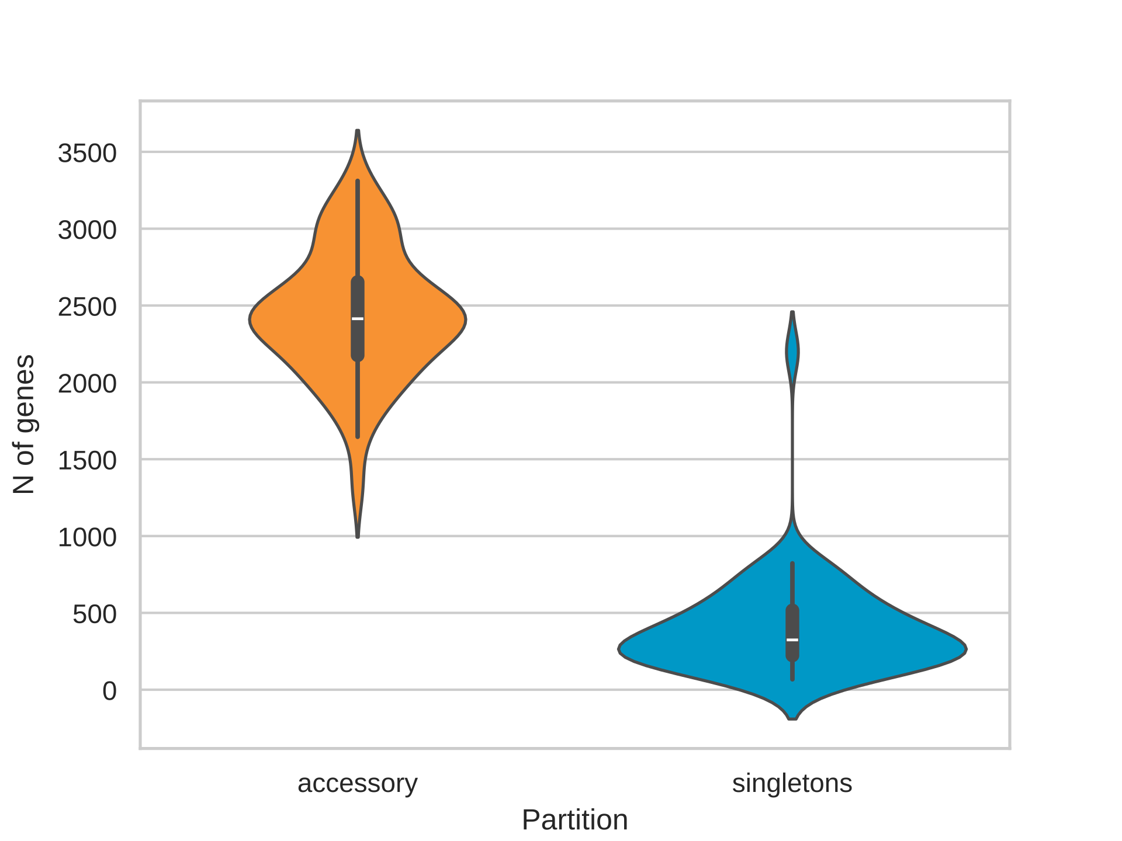
Fig. S1. Distribution of accessory and singletons genes in Pseudoalteromonas genomes. Violin plots illustrate the distribution and density of accessory (orange) and singleton (blue) gene families across the analyzed genomes. The vertical range indicates variability in gene counts among genomes, whereas the violin width represents the density of observations

a)
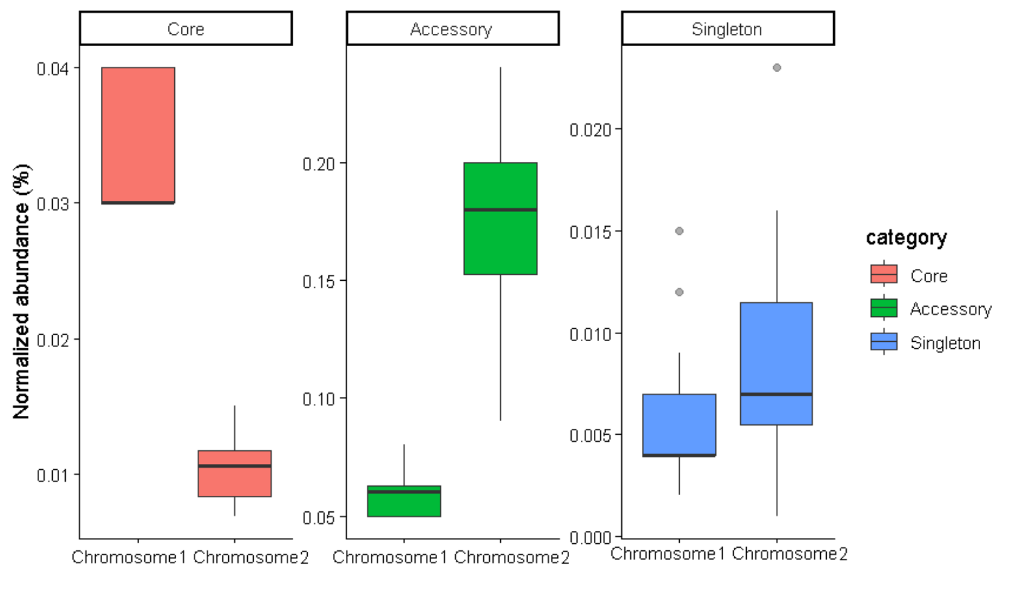
b)
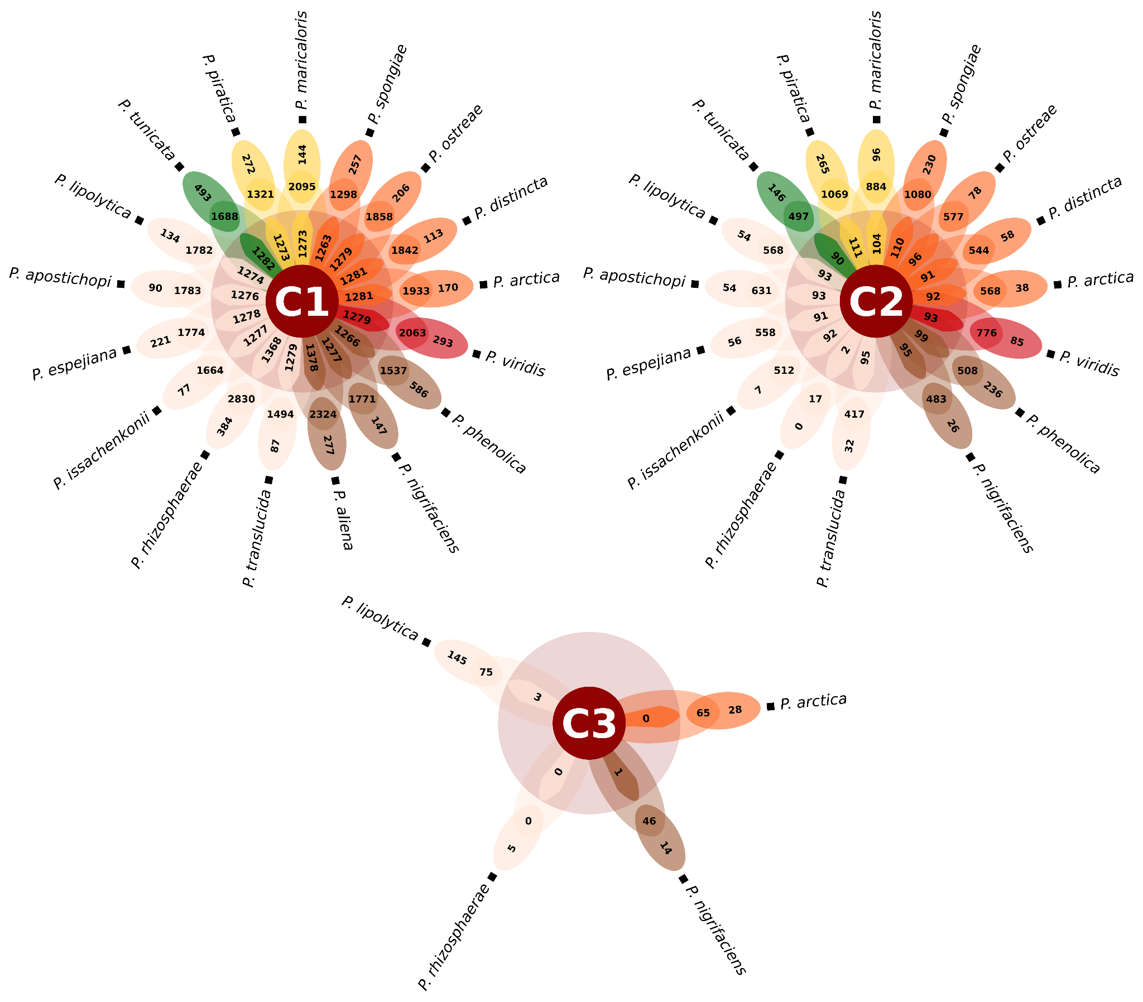
Fig. S2 Genomic distribution of pangenome Pseudoalteromonas spp. by categories across replicons of 16 genomes. a) Boxplot normalized abundance (%) of Core, Accessory, and Singleton gene categories evaluated in bacterial Chromosome 1 and chromosome 2. Boxplots display the median (horizontal line), interquartile range (box), and potential outliers (dots), with individual vertical axes scaled freely to optimize category visualization. b) Distribution of genes in the genomes of Pseudoalteromonas spp.by flower plots showing the core gene number (in the center), accessory gene number (in the petals), and strain-specific gene number (at the tip of the petals). C1: Chromosome 1, C2: Chromosome 2, C3: Plasmide.
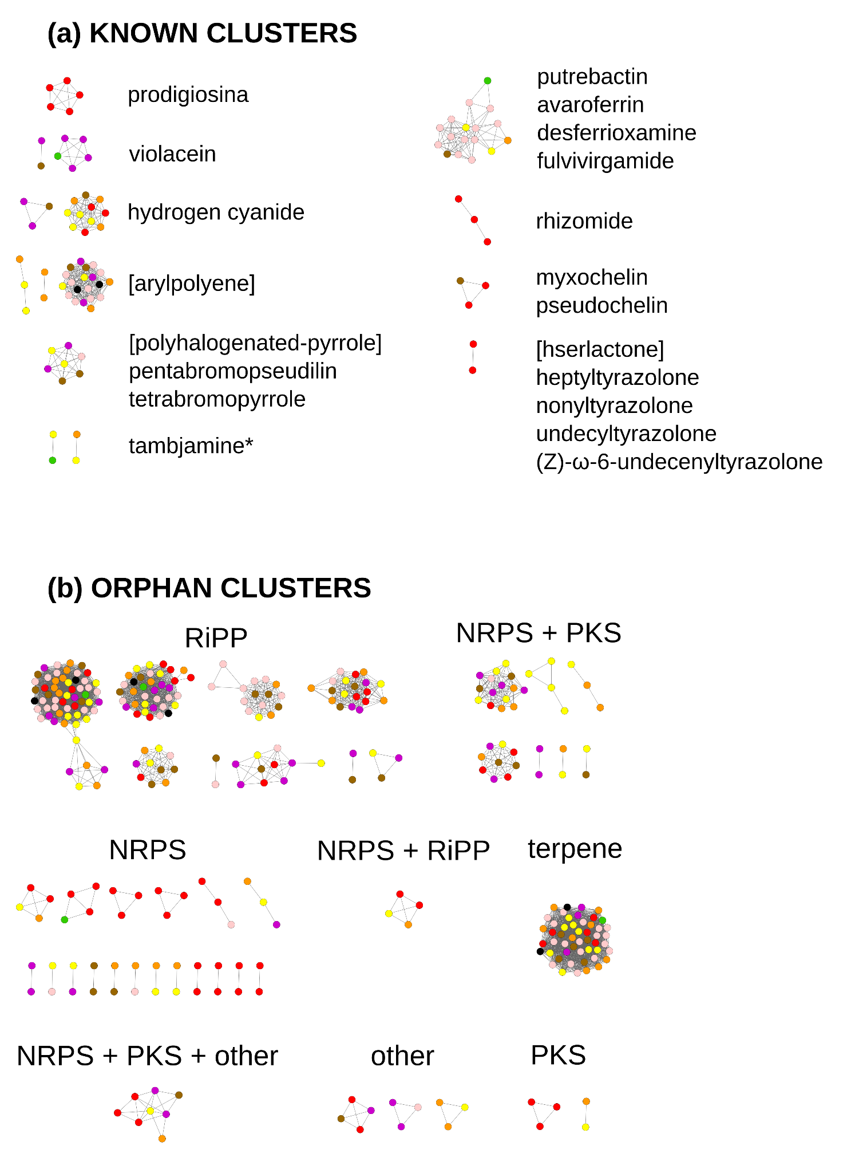
Fig. S3 Global network view of biosynthetic gene clusters BGCs across Pseudoalteromonas genomes, grouped into major biosynthetic families. Each node represents a biosynthetic gene cluster (BGC) with node color indicating the pigmentation of the corresponding strain and edges indicate similarity relationships identified by BIG-SCAPE. A) Non-Ribosomal Peptide Synthetase (RiPPs). B) Ribosomally synthesized and Post-translationally modified Peptides (NRPS). C) Polyketide Synthase (PKS). D) Others. E) Terpene. Only biosynthetic gene clusters classified with high confidence were considered for analysis, with the exception of the indication (*) cluster, which was included based on manual curation following in-depth cluster analysis
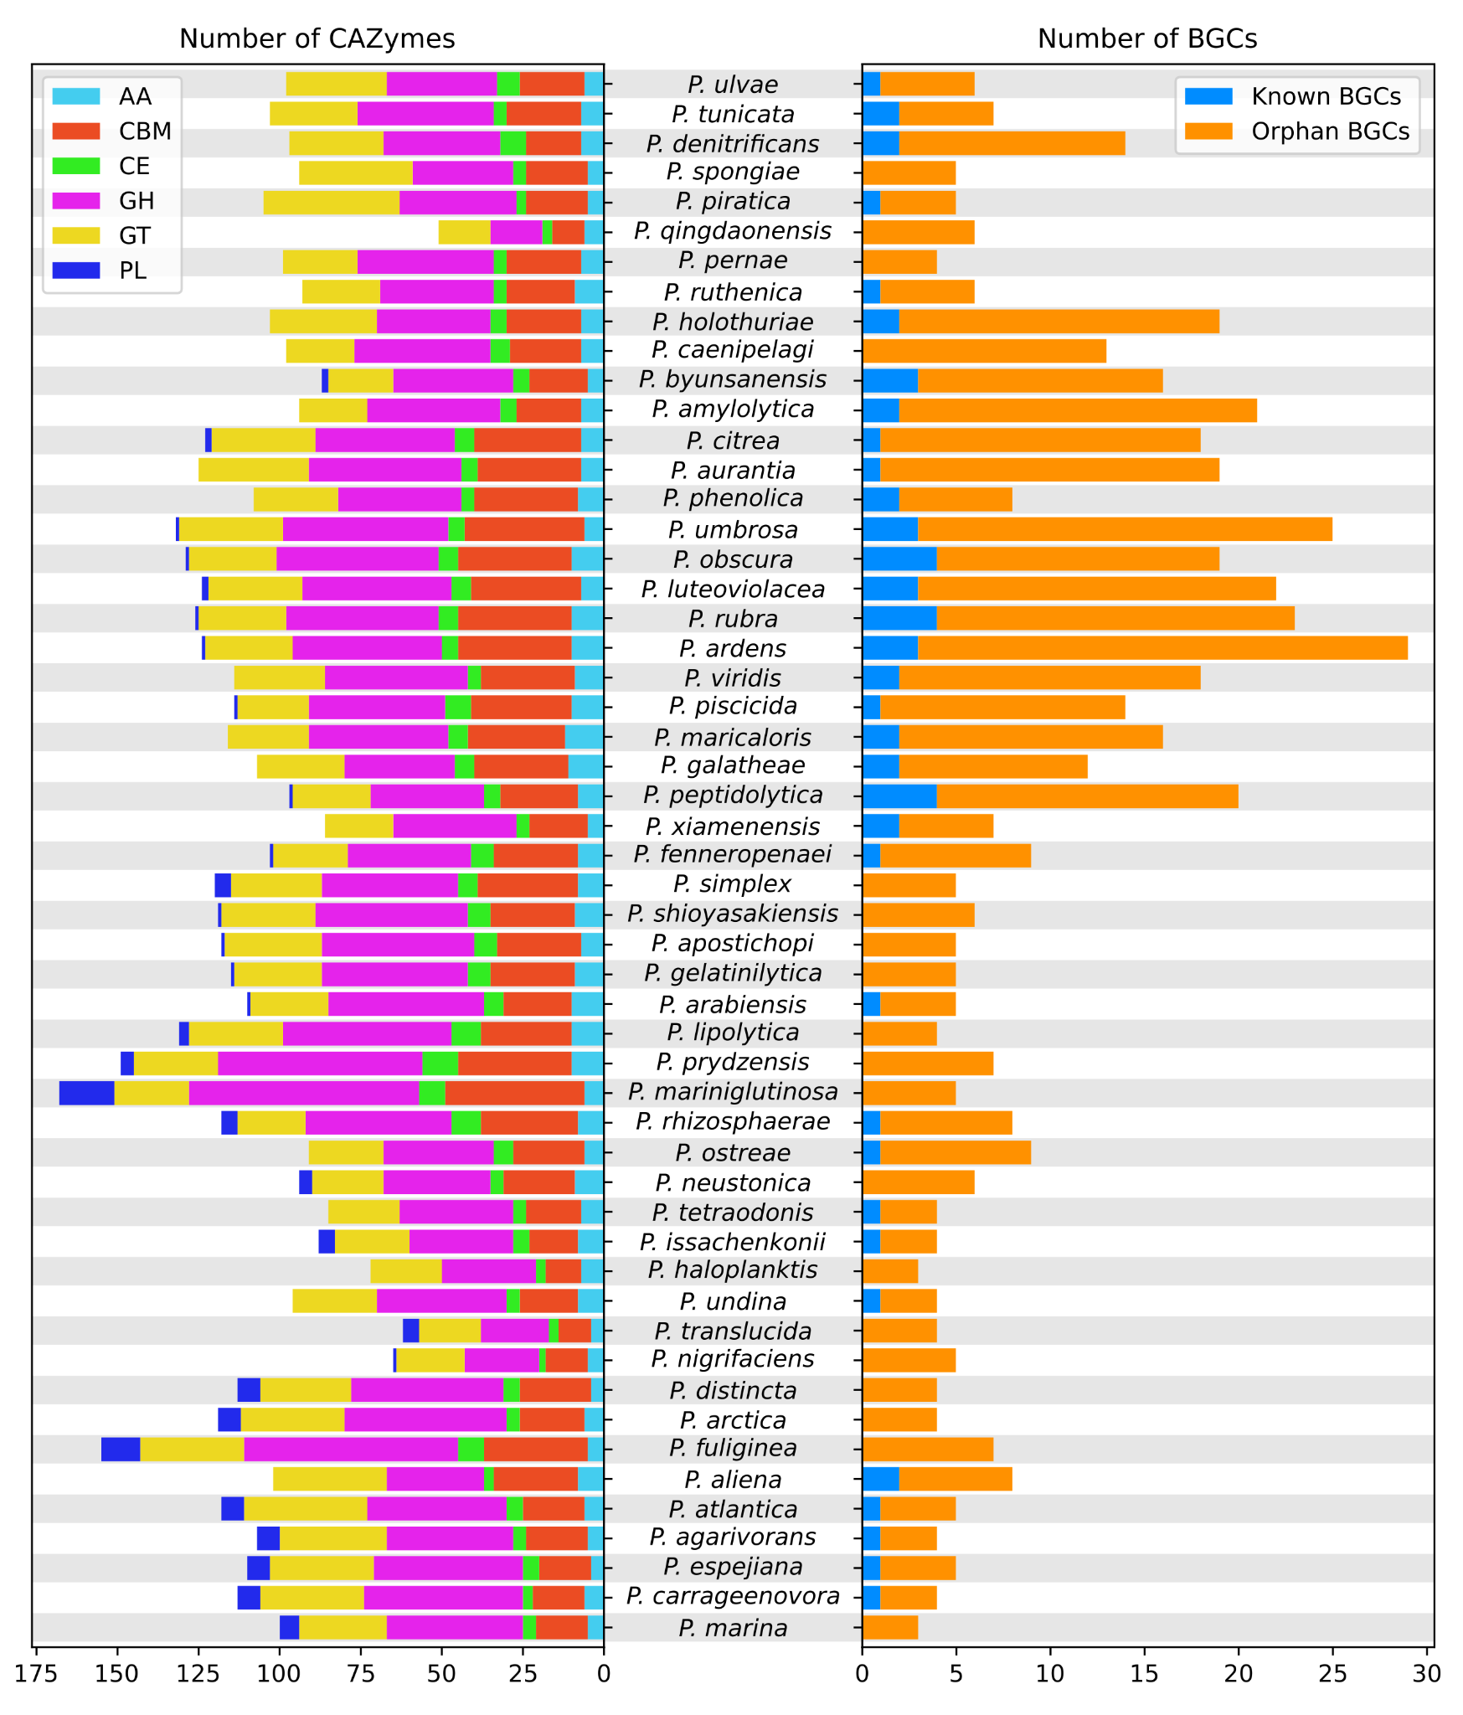
Fig. S4 Species-level comparison of functional repertoires in Pseudoalteromonas. For each species, the total number of carbohydrate-active enzymes (CAZymes) is shown on the left, while the number of biosynthetic gene clusters (BGCs) predicted by antiSMASH is shown on the right. Species names are positioned centrally to facilitate direct comparison. The proportion of known and orphans BGCs are indicated by color, as well as the CAZyme families. AA: Auxiliary Activities; CBM: Carbohydrate-Binding Modules; CE: Carbohydrate Esterases; GH: Glycoside Hydrolases; GT: GlycosylTransferases; PL: Polysaccharide Lyases
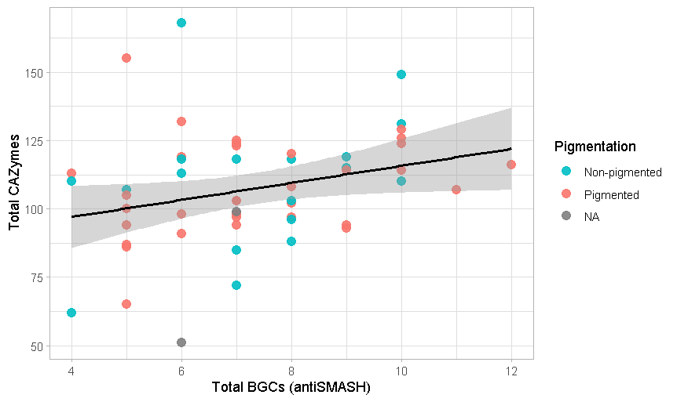
Fig. S5 Relationship between biosynthetic gene clusters (BGCs) and carbohydrate-active enzymes (CAZymes) in Pseudoalteromonas by pigmentation. The scatter plot shows the total number of antiSMASH-predicted BGCs versus CAZyme counts for each genome

- 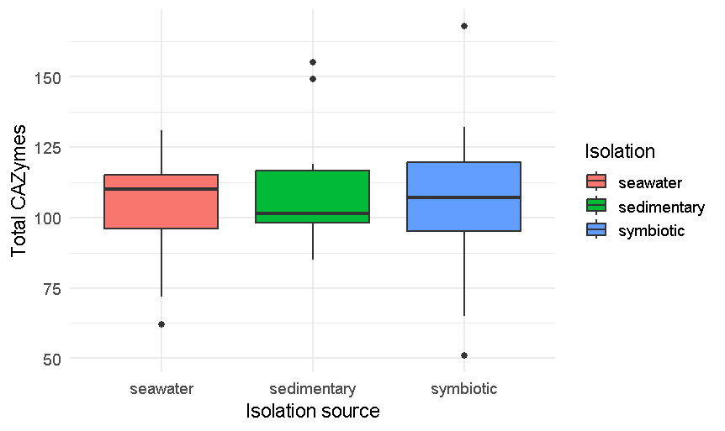

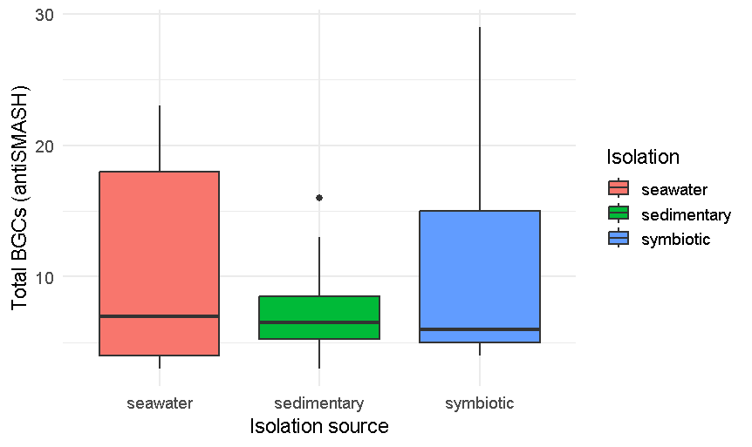
Fig. S6 Relationship between isolation source and a) CAZYmes data and b) biosynthetic gene clusters (BGCs)

