Supplementary Information

Appendix A. General Template for RLQ US
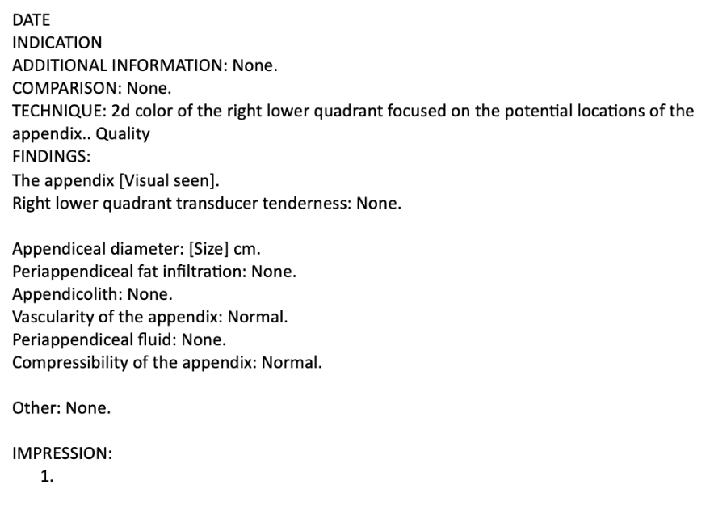

Appendix B. General Template for MR Abdomen and Pelvis Without Contrast
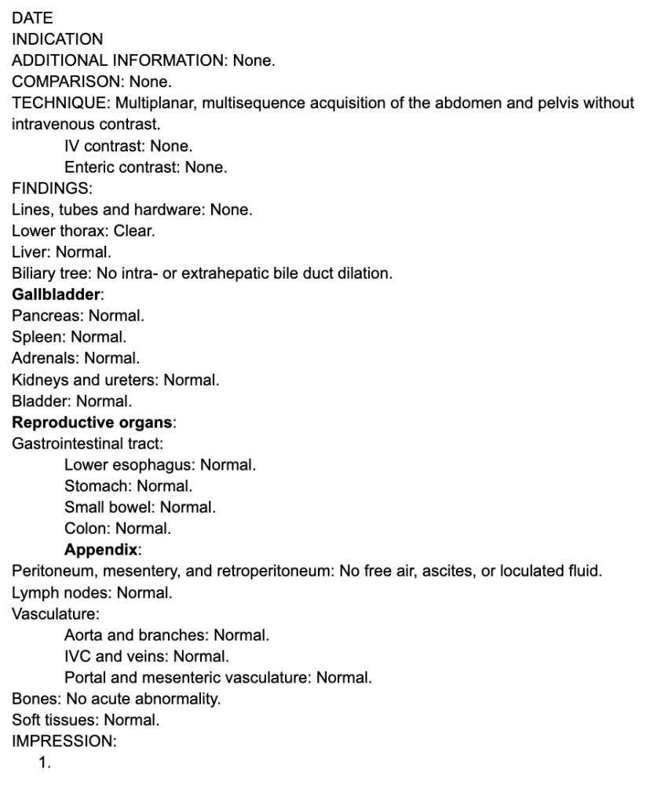

Appendix C. Rapid MRI Protocol
SEQUENCE | PLANE
Single-shot T2-weighted (SSh T2) | Coronal
Single-shot T2-weighted fat-suppressed (SSh T2 Fat) | Coronal
Single-shot T2-weighted (SShot T2) | Axial
Single-shot T2-weighted (SShot T2) | Sagittal
Spin echo diffusion-weighted imaging (Spin Echo DWI) | Axial
Female only axial 3D | Axial

STARD 2015 Checklist for Reporting Diagnostic Accuracy Studies:
Section & Topic | No | Item | Notes
TITLE OR ABSTRACT
 | 1 | Identification as a study of diagnostic accuracy using at least one measure of accuracy  (such as sensitivity, specificity, predictive values, or AUC) | p. 1 (Abstract)  Diagnostic accuracy study measuring sensitivity and specificity
ABSTRACT
 | 2 | Structured summary of study design, methods, results, and conclusions  (for specific guidance, see STARD for Abstracts) | p. 1
INTRODUCTION
 | 3 | Scientific and clinical background, including the intended use and clinical role of the index test | p. 2
 | 4 | Study objectives and hypotheses | p. 2
METHODS
Study design | 5 | Whether data collection was planned before the index test and reference standard were performed (prospective study) or after (retrospective study) | p. 2  Retrospective
Participants | 6 | Eligibility criteria | p. 3
 | 7 | On what basis potentially eligible participants were identified  (such as symptoms, results from previous tests, inclusion in registry) | p. 3
 | 8 | Where and when potentially eligible participants were identified (setting, location, and dates) | p. 2-3  CMHH, 01/01/2019 - 06/30/2019
 | 9 | Whether participants formed a consecutive, random or convenience series | p. 3  Consecutive
Test methods | 10a | Index test, in sufficient detail to allow replication | p. 3  Ultrasound
 | 10b | Reference standard, in sufficient detail to allow replication | p. 3  Rapid Magnetic Resonance Imaging
 | 11 | Rationale for choosing the reference standard (if alternatives exist) | n/a
 | 12a | Definition of and rationale for test positivity cut-offs or result categories  of the index test, distinguishing pre-specified from exploratory | p. 3-4  Definition of diagnostic vs nondiagnostic imaging
 | 12b | Definition of and rationale for test positivity cut-offs or result categories  of the reference standard, distinguishing pre-specified from exploratory | p. 3-4
 | 13a | Whether clinical information and reference standard results were available  to the performers/readers of the index test | p. 3  One blinded member reviewed EMR and data, all imaging reads blinded due to retrospective nature of study
 | 13b | Whether clinical information and index test results were available  to the assessors of the reference standard | p. 3
Analysis | 14 | Methods for estimating or comparing measures of diagnostic accuracy | p. 4  Sensitivity, Specificity calculated for diagnostic (unequivocally positive or negative) studies and for diagnostic + nondiagnostic (equivocal or when appendix not visualized)
 | 15 | How indeterminate index test or reference standard results were handled | p. 4  Further imaging/combination of imaging modalities were obtained
 | 16 | How missing data on the index test and reference standard were handled | p. 3  Exclusion criteria
 | 17 | Any analyses of variability in diagnostic accuracy, distinguishing pre-specified from exploratory | p. 4  By imaging modality or combination utilized
 | 18 | Intended sample size and how it was determined | p. 5  Based on all consecutive eligible patients in the study period
RESULTS
Participants | 19 | Flow of participants, using a diagram | p. 6 (Figure 1)
 | 20 | Baseline demographic and clinical characteristics of participants | p. 5 (Tables 1-2)
 | 21a | Distribution of severity of disease in those with the target condition | p. 6  (Appendicitis/Positive/Pathology)
 | 21b | Distribution of alternative diagnoses in those without the target condition | p. 5  No Appendicitis/Negative)
 | 22 | Time interval and any clinical interventions between index test and reference standard | p. 5  n/a, Length of Stay (LOS)
Test results | 23 | Cross tabulation of the index test results (or their distribution)  by the results of the reference standard | p. 6, 15 (Table 3)
 | 24 | Estimates of diagnostic accuracy and their precision (such as 95% confidence intervals) | p. 6  Sensitivity and Specificity with 95% confidence intervals
 | 25 | Any adverse events from performing the index test or the reference standard | None reported.
DISCUSSION
 | 26 | Study limitations, including sources of potential bias, statistical uncertainty, and generalizability | p. 8
 | 27 | Implications for practice, including the intended use and clinical role of the index test | p. 7-8
OTHER INFORMATION
 | 28 | Registration number and name of registry | n/a
 | 29 | Where the full study protocol can be accessed | Study methods, analyses, and protocols are described in the manuscript; no separate protocol was published.
 | 30 | Sources of funding and other support; role of funders | n/a

