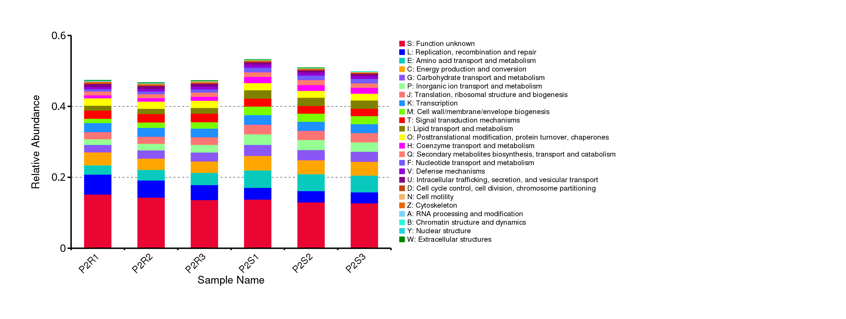
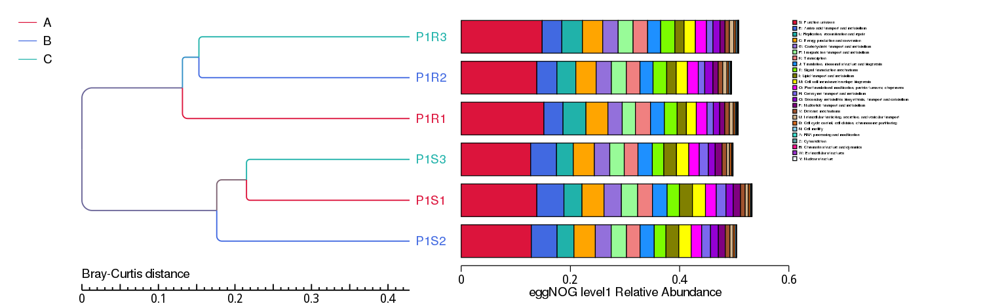
Figure S1. Abundance of Clusters of Orthologous Groups (COGs) aligned with orthologous gene classifications (A-Z) within disparate samples from the rhizospheric (R) and bulk (S) soil microbiomes of Moringa oleifera. Further information is available in Table S4.
Abundance

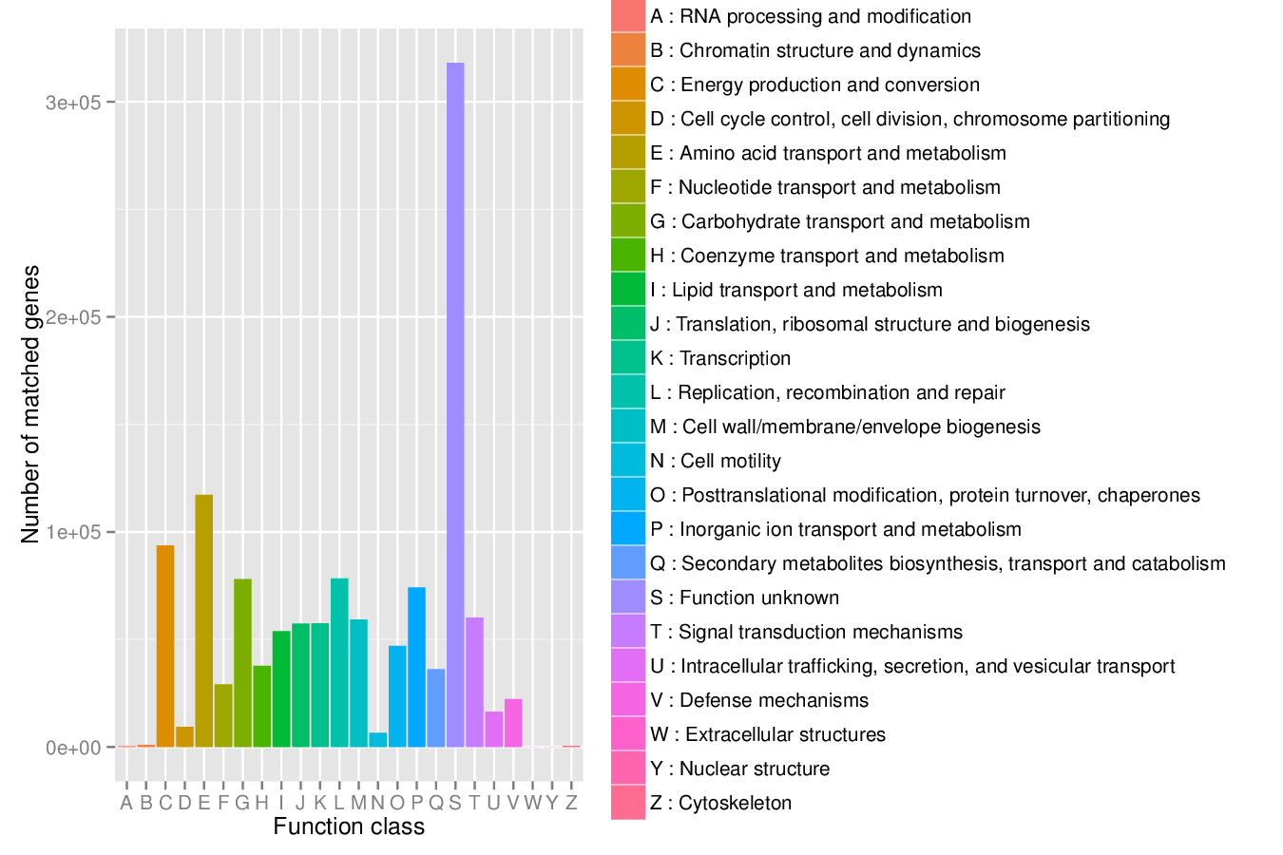
Figure S2. The number of orthologous genes across various classifications within the Clusters of Orthologous Groups (COGs) in the rhizospheric and bulk soil microbiomes of Moringa oleifera. Further information is available in Table S3.
Functional Category

Figure S3. The top 200 orthologous genes, determined by the number of gene queries (≥ 660), across the rhizospheric and bulk soil microbiomes of Moringa oleifera. The blue columns denote orthologous genes exhibiting a heightened relative abundance in the rhizospheric microbiome compared to the bulk soil microbiome. Further information is available in Table S5.

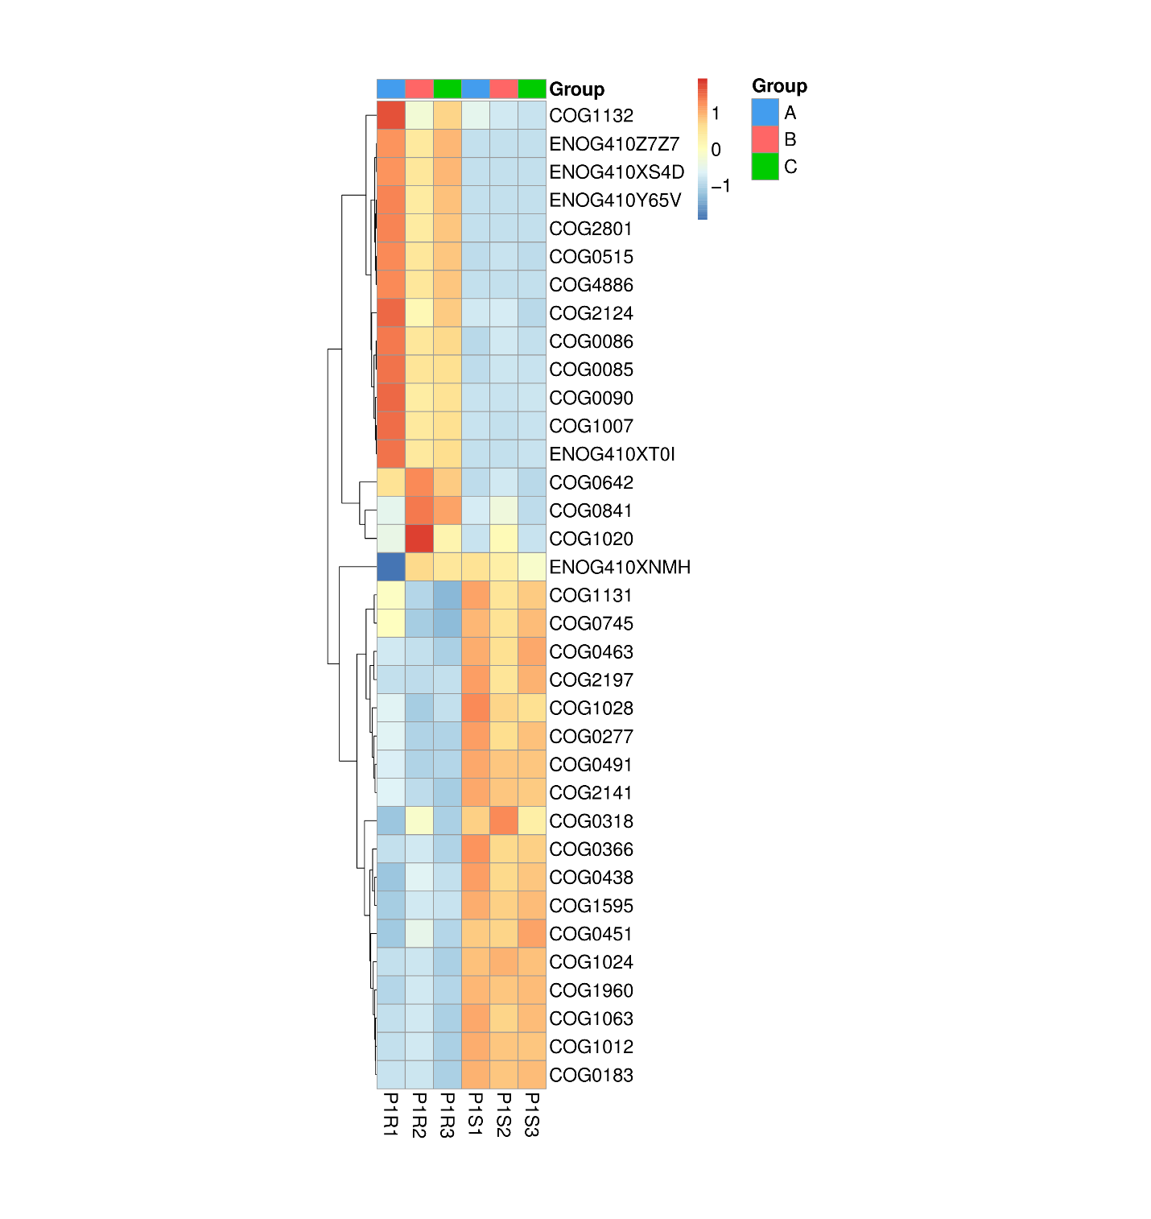
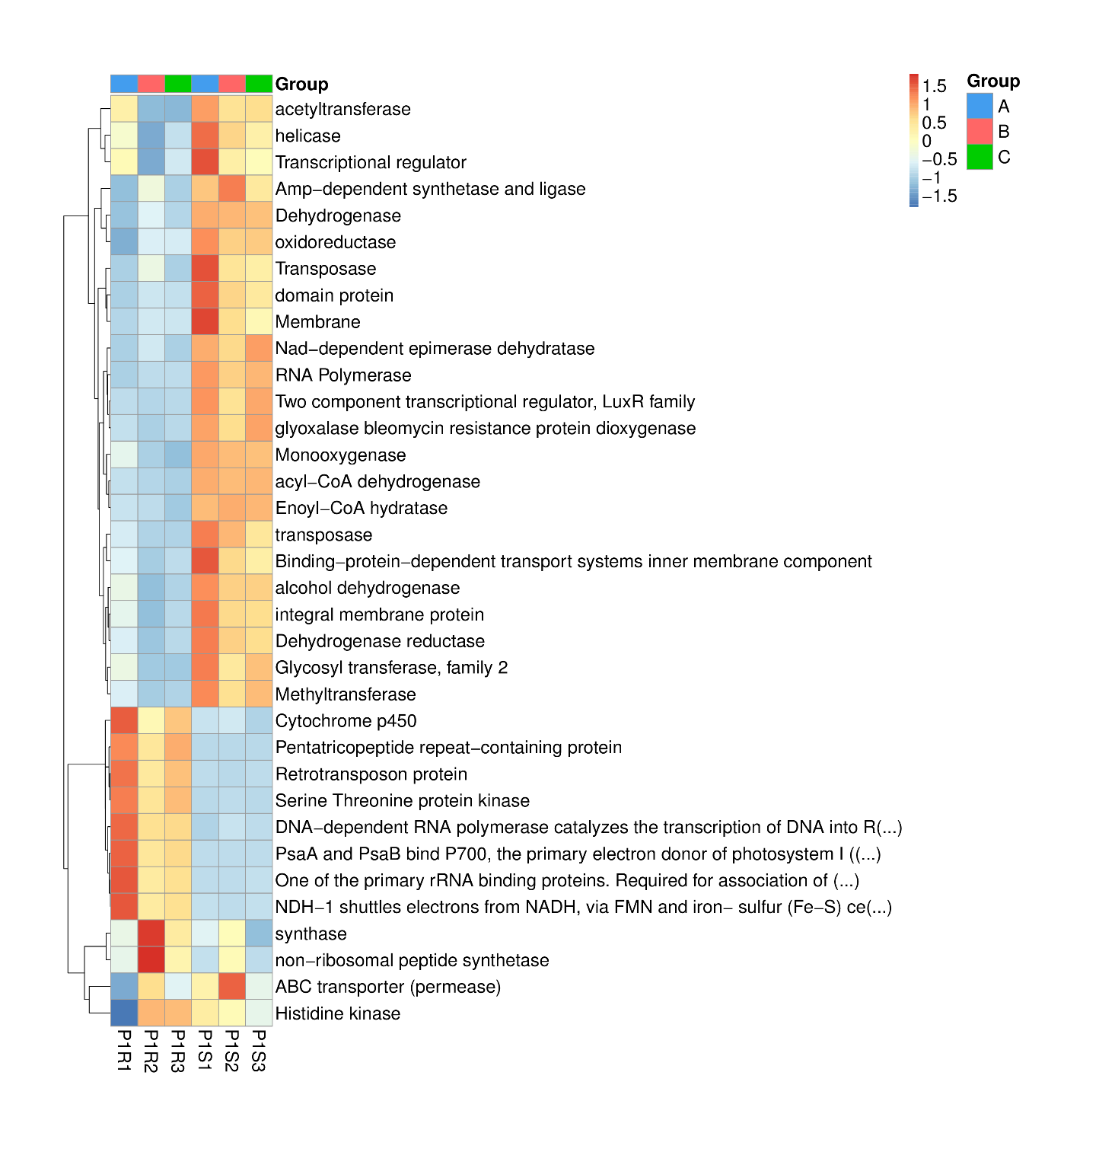
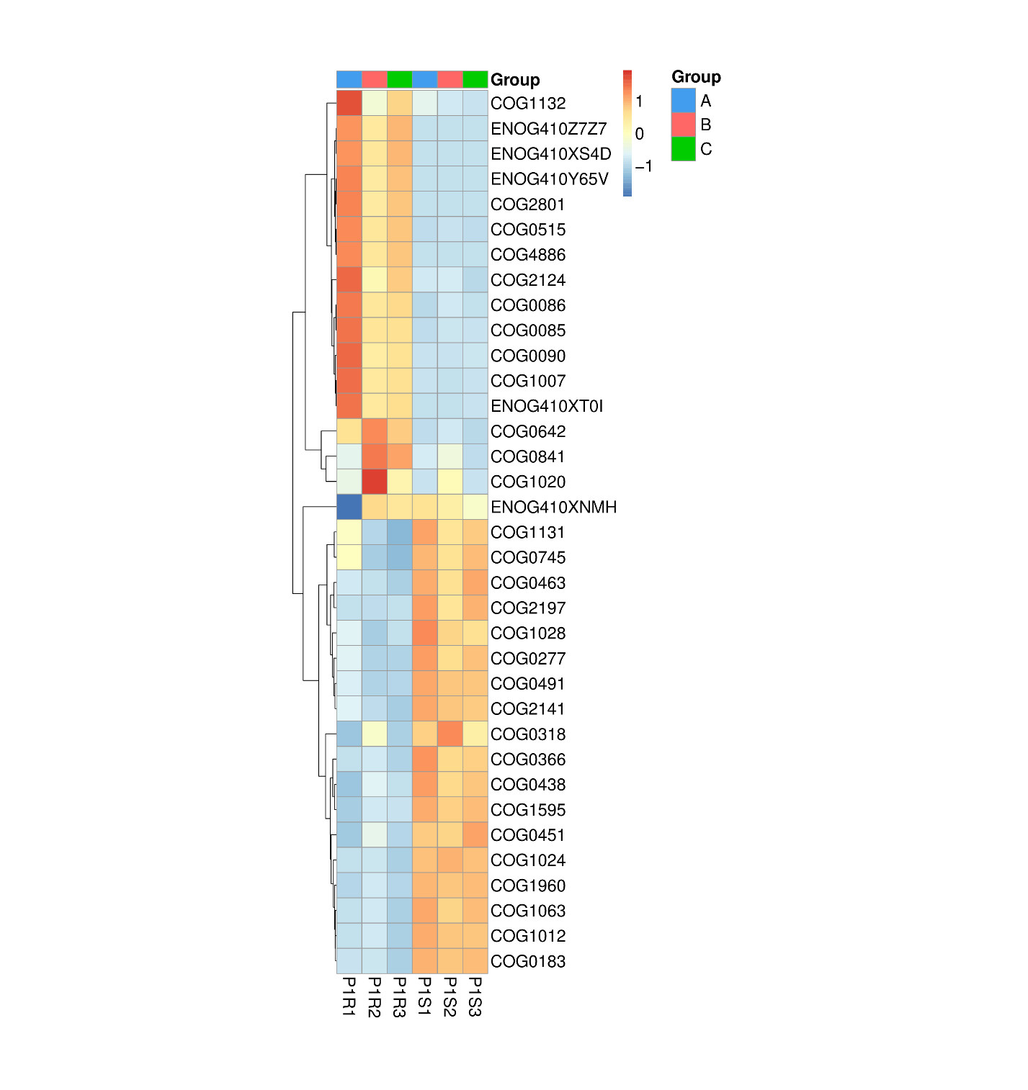
Figure S4. Heatmap depicting the relative abundance of orthologous genes predominantly found in the rhizospheric (R) versus bulk (S) soil microbiomes of Moringa oleifera, with genes among the top 200 most prevalent orthologs, based on ≥ 660 gene queries. The red bidirectional arrow accentuates the orthologous genes exhibiting high abundance in the rhizospheric (R) soil microbiome relative to their bulk soil counterparts. The blue arrow highlights an orthologous gene with a query frequency as low as seven, signifying its exclusion from further analysis due to its minimal prevalence.
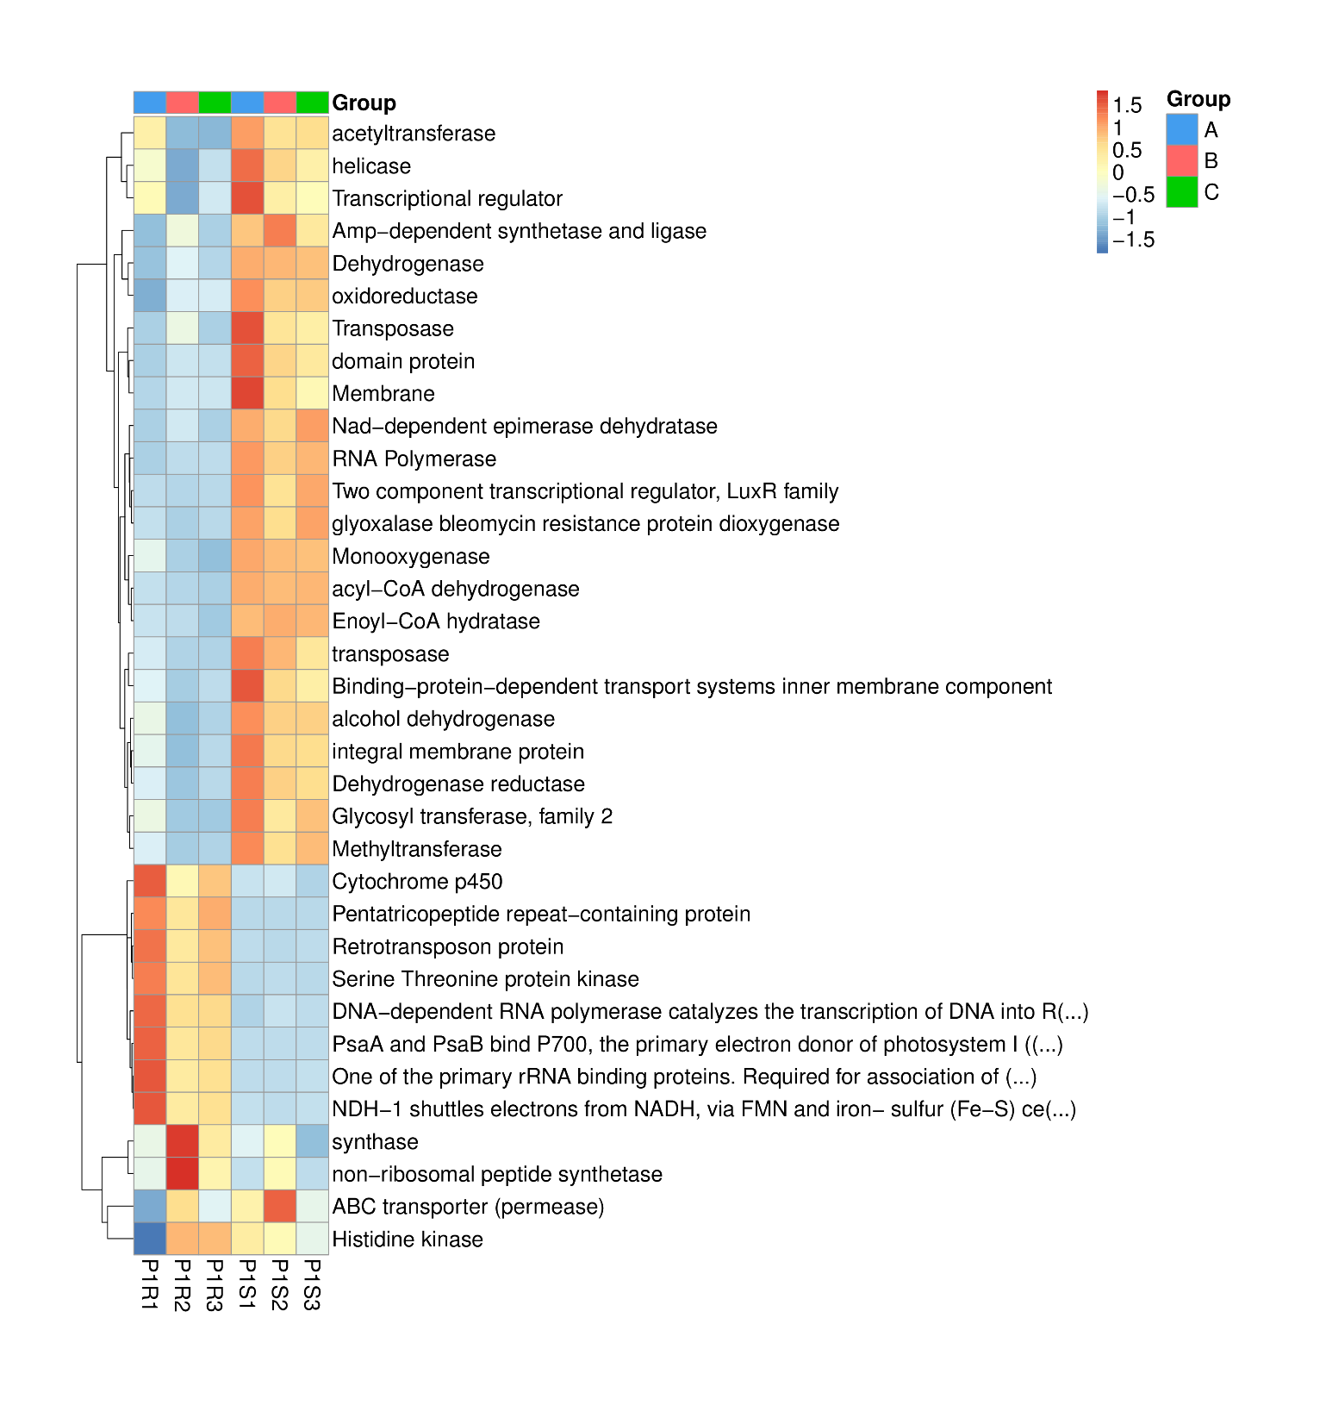
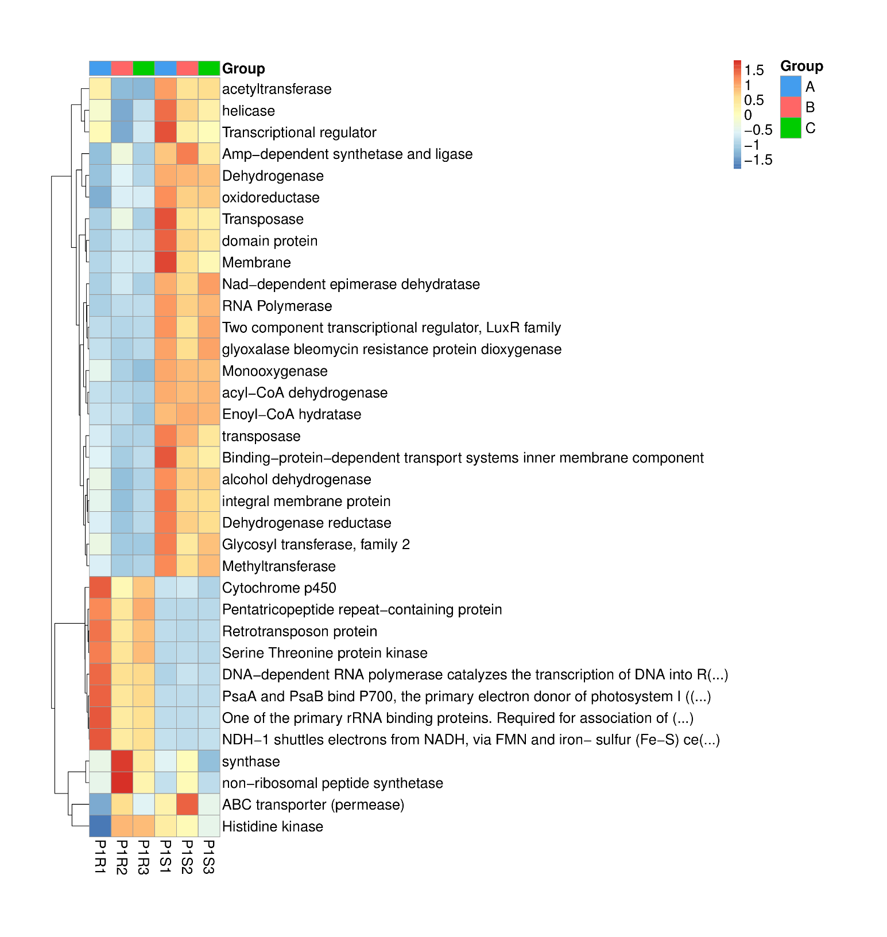
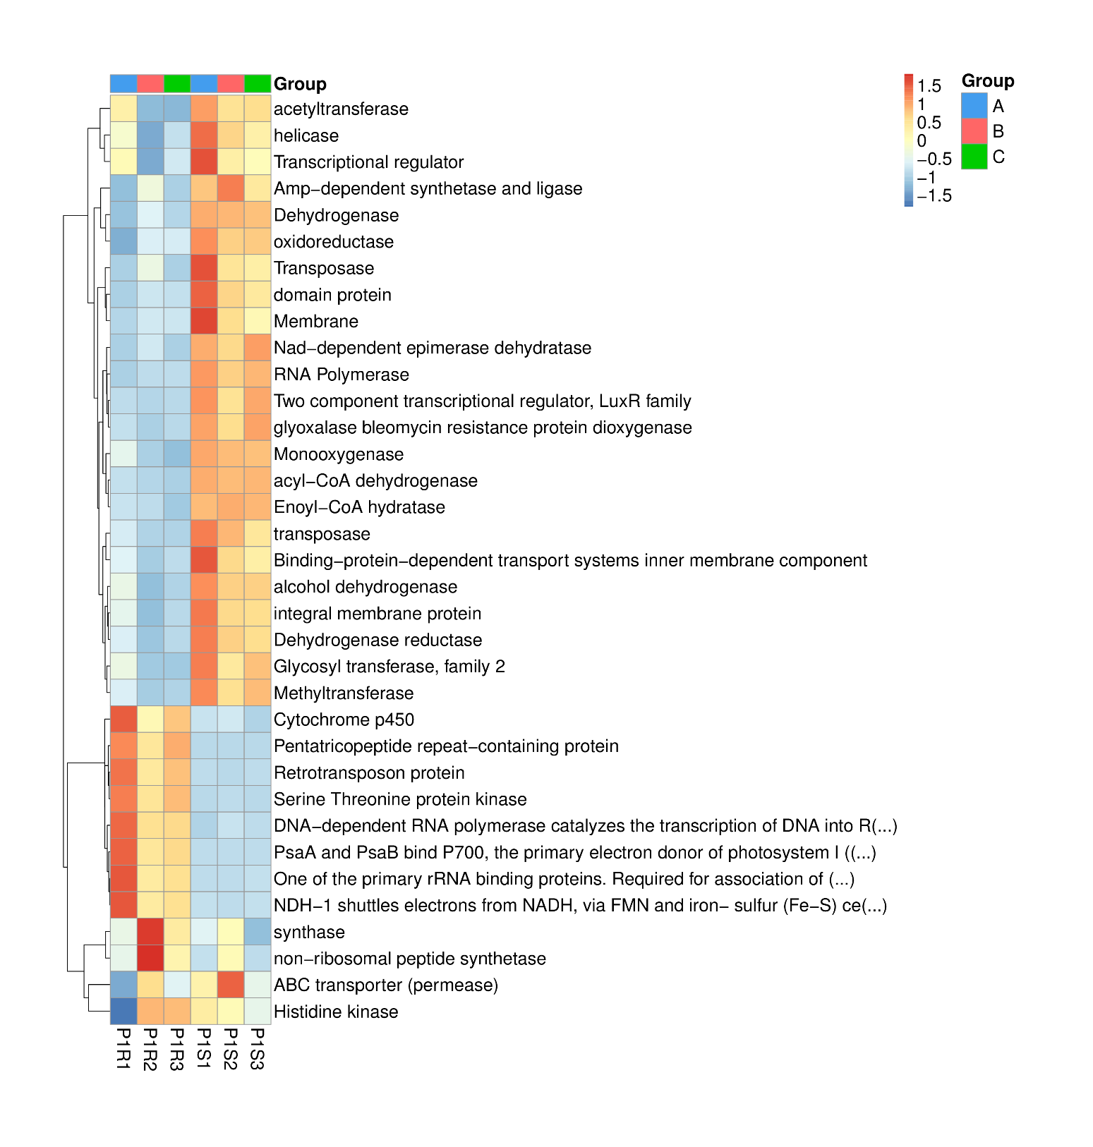
Figure S5. Heatmap depicting the relative abundance of proteins/enzymes encoded by orthologous genes predominantly present in the rhizospheric (R) versus bulk (S) soil microbiomes of Moringa oleifera. These genes are among the top 200 most prevalent orthologous genes, with ≥ 660 gene queries. The red bidirectional arrow highlights the proteins/enzymes exhibiting significantly higher abundance in the rhizospheric (R) soil microbiome compared to the bulk soil microbiome. The blue arrow directs attention to a protein encoded by an orthologous gene with a query number as low as seven, indicating its exclusion from further analysis due to its minimal prevalence.

