Linking Genomic and Proteomic Signatures to Brain Amyloid Burden: Insights from GR@ACE/DEGESCO
Raquel Puerta^{1,2†}, Itziar de Rojas^{1,3†}, Pablo García-González^{1,3}, Clàudia Olivé¹, Oscar Sotolongo-Grau¹, Ainhoa García-Sánchez¹, Fernando García-Gutiérrez¹, Laura Montrreal¹, Juan Pablo Tartari¹, Ángela Sanabria^{1,3}, Vanesa Pytel^{1,3}, Carmen Lage^{4,3}, Inés Quintela⁵, Nuria Aguilera¹, Eloy Rodriguez-Rodriguez^{4,3}, Alarcón-Martín Emilio¹, Adelina Orellana^{1,3}, Pau Pastor^{6,7}, Jordi Pérez-Tur^{8,3,9}, Gerard Piñol-Ripoll^{10,11}, Adolfo Lopez de Munain^{12,13,3,14}, Jose María García-Alberca^{15,3}, Jose Luís Royo¹⁶, María J. Bullido^{17,3,18,19}, Victoria Álvarez^{20,21}, Luis Miguel Real^{22,23}, Arturo Corbatón Anchuelo²⁴, Dulcenombre Gómez-Garre^{24,25,26}, María Teresa Martínez Larrad^{24,27}, Emilio Franco-Macías²⁸, Pablo Mir^{29,3}, Miguel Medina^{3,30}, Raquel Sánchez-Valle³¹, Oriol Dols-Icardo³², María Eugenia Sáez³³, Ángel Carracedo^{5,34}, Lluís Tárraga^{1,3}, Montse Alegret^{1,3}, Sergi Valero^{1,3}, Marta Marquié^{1,3}, Mercè Boada^{1,3}, Pascual Sánchez Juan^{35,3}, Jose Enrique Cavazos^{36,37}, Alfredo Cabrera-Socorro³⁸, Amanda Cano^{1,3¥,}, Agustín Ruiz^{1,3,37,39 ¥,*} for the Alzheimer's Disease Neuroimaging Initiative.
¹Ace Alzheimer Center Barcelona – Universitat Internacional de Catalunya, Spain. ²Doctorate in Biotechnology, Facultat de Farmàcia i Ciències de l'Alimentació, Universitat de Barcelona, Avda. Diagonal 643, 08028 Barcelona, Universitat de Barcelona, Spain. ³CIBERNED, Network Center for Biomedical Research in Neurodegenerative Diseases, National Institute of Health Carlos III, Madrid, Spain. ⁴Marqués de Valdecilla University Hospital- IDIVAL-Universidad de Cantabria, Spain. ⁵Grupo de Medicina Xenómica, Centro Nacional de Genotipado (CEGEN-PRB3-ISCIII). Universidade de Santiago de Compostela, Santiago de Compostela, Spain. ⁶Unit of Neurodegenerative diseases, Department of Neurology, University Hospital Germans Trias i Pujol, Badalona, Barcelona, Spain. ⁷The Germans Trias i Pujol Research Institute (IGTP), Badalona, Barcelona, Spain. ⁸Unitat de Genètica Molecular, Institut de Biomedicina de València-CSIC, Valencia, Spain. ⁹Unidad Mixta de Neurologia Genètica, Instituto de Investigación Sanitaria La Fe, Valencia, Spain. ¹⁰Unitat Trastorns Cognitius, Hospital Universitari Santa Maria de Lleida, Lleida, Spain. ¹¹Institut de Recerca Biomedica de Lleida (IRBLLeida), Lleida, Spain. ¹²Department of Neurology. Hospital Universitario Donostia. San Sebastian, Spain. ¹³Department of Neurosciences. Faculty of Medicine and Nursery. University of the Basque Country, San Sebastián, Spain. ¹⁴Neurosciences Area. Instituto Biodonostia. San Sebastian, Spain. ¹⁵Alzheimer Research Center & Memory Clinic, Andalusian Institute for Neuroscience, Málaga, Spain. ¹⁶Departamento de Especialidades Quirúrgicas, Bioquímica e Inmunología. School of Medicine. University of Malaga. Málaga, Spain. ¹⁷Centro de Biología Molecular Severo Ochoa (UAM-CSIC). ¹⁸Instituto de Investigación Sanitaria ‘Hospital la Paz’ (IdIPaz), Madrid, Spain. ¹⁹Universidad Autónoma de Madrid. ²⁰Laboratorio de Genética. Hospital Universitario Central de Asturias, Oviedo, Spain. ²¹Instituto de Investigación Sanitaria del Principado de Asturias (ISPA). ²²Instituto de Biomedicina de Sevilla/Hospital Universitario Virgen de Valme/CSIC/Dpto de Bioquímica Médica, Biología Molecular e Inmunología/Universidad de Sevilla. Spain. ²³CIBERINFEC, Instituto de Salud Carlos III, Madrid, Spain. ²⁴Instituto de Investigación Sanitaria del Hospital Clínico San Carlos (IdISSC), Hospital Clínico San Carlos. ²⁵Laboratorio de Riesgo Cardiovascular y Microbiota, Hospital Clínico San Carlos; Departamento de Fisiología, Facultad de Medicina, Universidad Complutense de Madrid (UCM). ²⁶Biomedical Research Networking Center in Cardiovascular Diseases (CIBERCV), Madrid, Spain. ²⁷Centro de Investigación Biomédica en Red de Diabetes y Enfermedades Metabólicas Asociadas (CIBERDEM). ²⁸Dementia Unit, Department of Neurology, Hospital Universitario Virgen del Rocío, Instituto de Biomedicina de Sevilla (IBiS), Sevilla, Spain. ²⁹Unidad de Trastornos del Movimiento, Servicio de Neurología y Neurofisiología. Instituto de Biomedicina de Sevilla (IBiS), Hospital Universitario Virgen del Rocío/CSIC/Universidad de Sevilla, Seville, Spain. ³⁰CIEN Foundation/Queen Sofia Foundation Alzheimer Center. ³¹Alzheimer's disease and other cognitive disorders unit. Service of Neurology. Hospital Clínic of Barcelona. Institut d'Investigacions Biomèdiques August Pi i Sunyer, University of Barcelona, Barcelona, Spain. ³²Department of Neurology, Sant Pau Memory Unit, Sant Pau Biomedical Research Institute, Hospital de la Santa Creu i Sant Pau, Universitat Autònoma de Barcelona,Barcelona, Spain. ³³CAEBI, Centro Andaluz de Estudios Bioinformáticos, Sevilla, Spain. ³⁴Fundación Pública Galega de Medicina Xenómica- CIBERER-IDIS, Santiago de Compostela, Spain. ³⁵Reina Sofia Alzheimer Centre, CIEN Foundation, ISCIII, Madrid, Spain. ³⁶South Texas Alzheimer's Disease Research Center, San Antonio, Texas, USA. ³⁷Glenn Biggs Institute for Alzheimer’s & Neurodegenerative Diseases, University of Texas Health Science Center at San Antonio, 7703 Floyd Curl Dr, San Antonio, Texas, 78229 USA. ³⁸Neuroscience Therapeutic Area, Janssen Research & Development, Turnhoutseweg 30, 2340 Beerse, Belgium. ³⁹Department of Microbiology, Immunology and Molecular Genetics. Long School of Medicine. University of Texas Health Science Center, San Antonio, Texas, USA.

Supplementary Figures

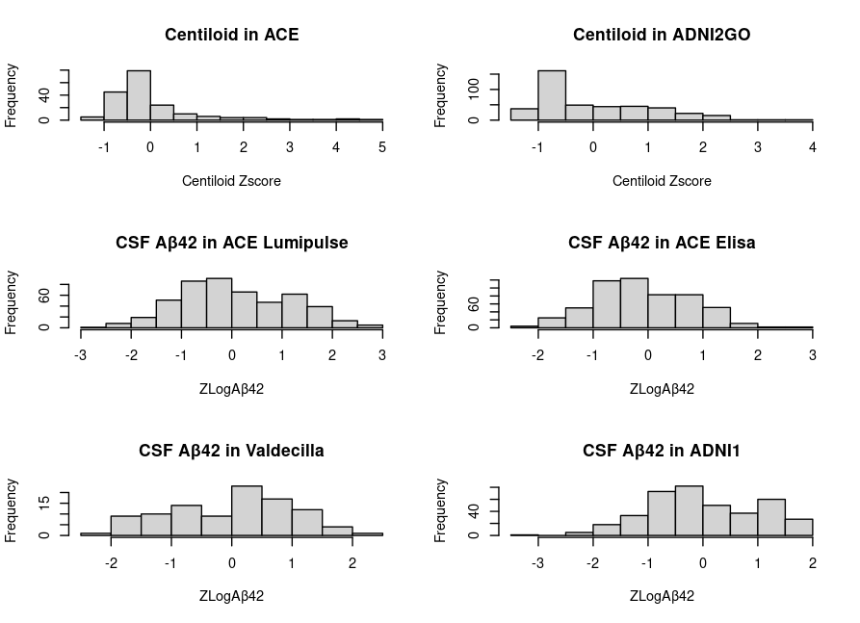
Supplementary Figure 1. Histograms of the CSF and PET endophenotypes distribution after the data harmonization.

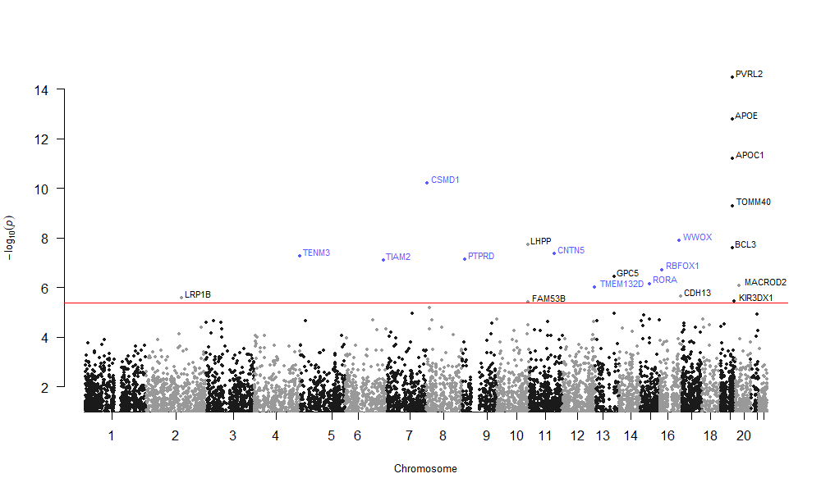
Supplementary Figure 2. Manhattan plot of the gene-based analysis of MAGMA (FUMA). Genes highlighted in blue were previously related to AD and its endophenotypes. Red line: significance threshold at P<4.235e-06.

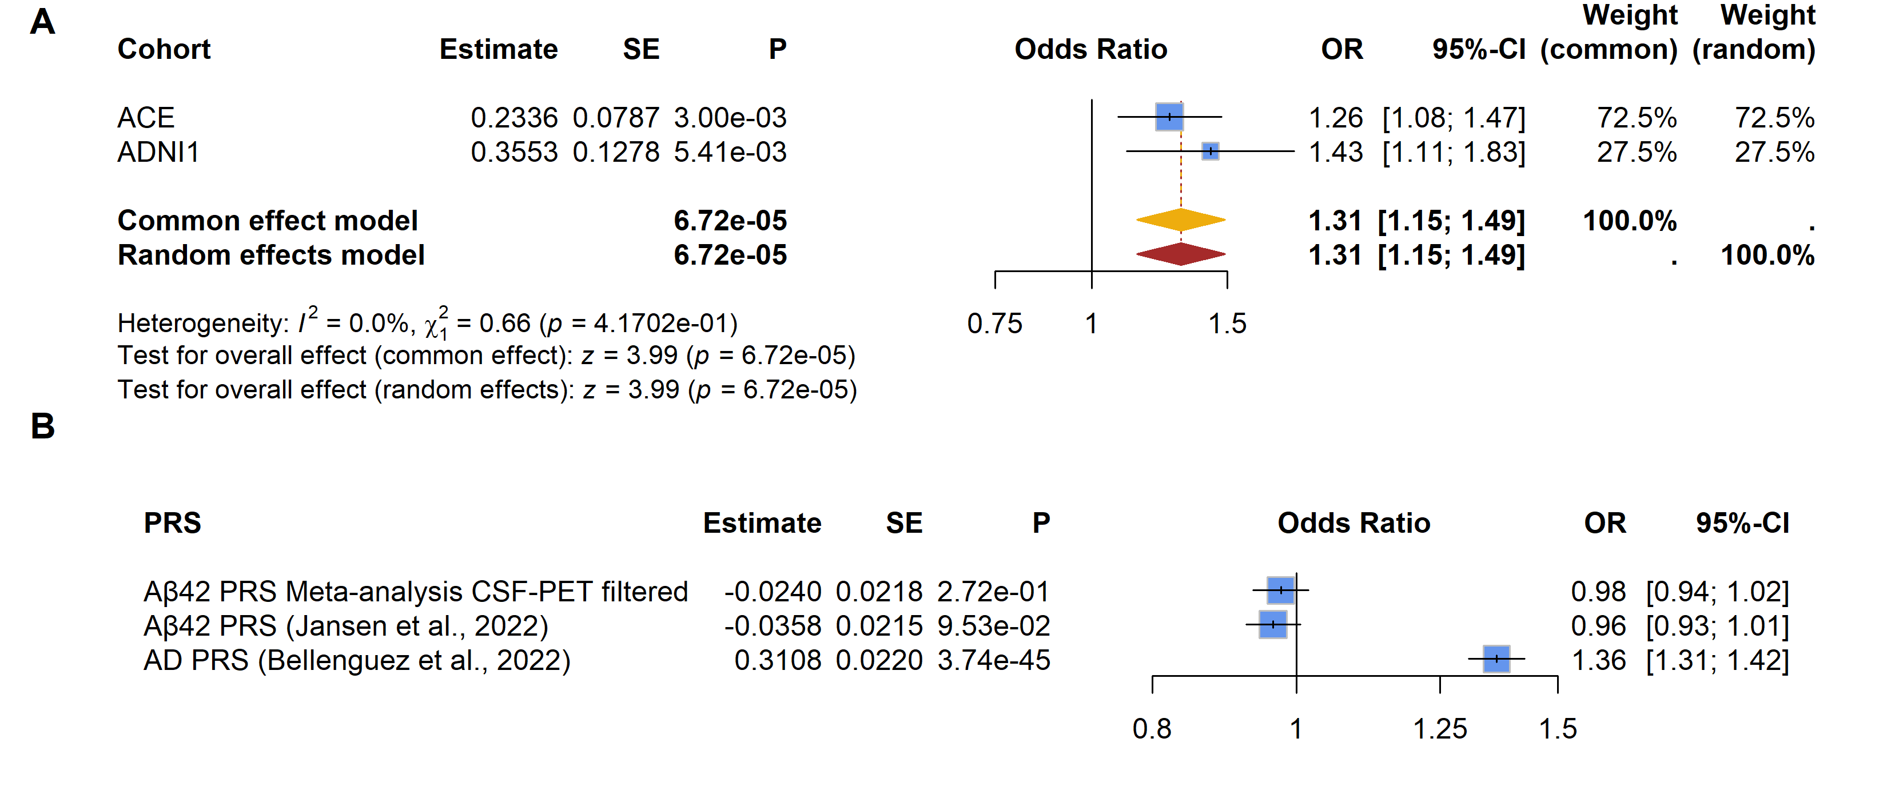Supplementary Figure 3. Sensitivity analysis on the PRS associations. A) Associations of the AD PRS (76 SNPs from Bellenguez et al., 2022) with the disease status (controls: A-T-N-, cases: A+, excluding MCI individuals with T- or N-). B) Association analyses between the AD PRS (76 SNPs from Bellenguez et al., 2022), CSF Aβ42 levels (30 SNPs from Jansen et al., 2022, 9 SNPs from our meta-analysis) and the disease status excluding MCI individuals. The GR@ACE cohort included 7,437 cases and 8,561 controls.

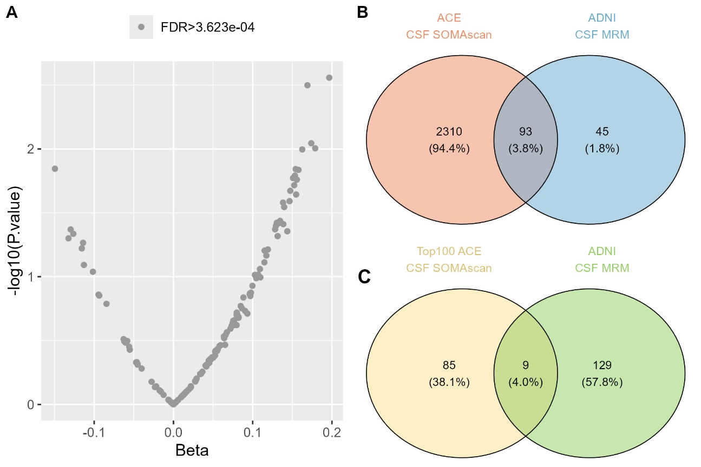
Supplementary Figure 4. Associations between CSF MRM proteomic measures and CSF Aβ42 levels in the ADNI cohort. A) Volcano plot considering 138 CSF MRM proteins. The significance threshold was set to FDR < 3.623e-04. B) Venn diagram of the unique UniProt proteins represented in the association analysis of CSF SOMAscan proteome (ACE CSF cohort) and the CSF MRM proteome (ADNI cohort). C) Venn diagram of the proteins analysed in the CSF MRM association analysis with CSF Aβ42 levels that were also represented in the top 100 ranking of significant proteins in ACE CSF SOMAscan association analysis.

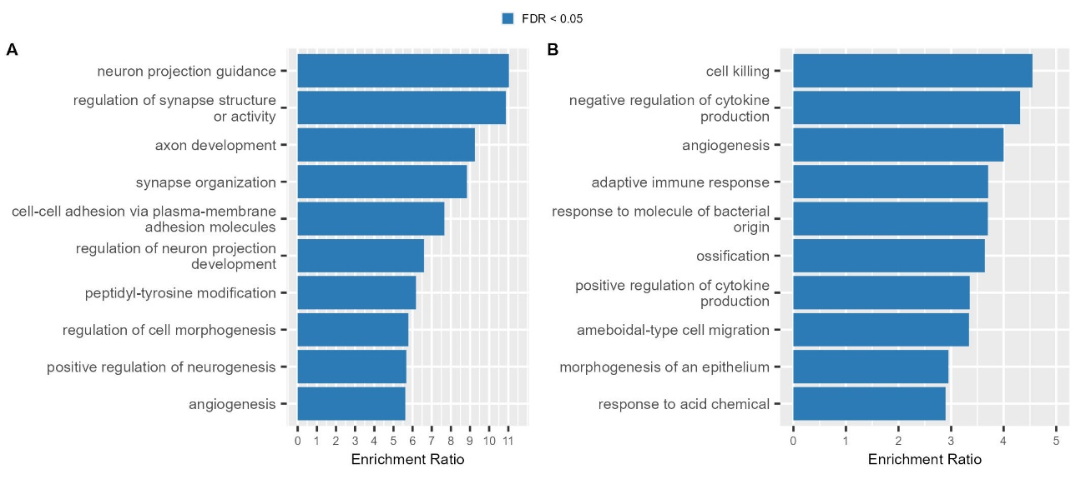
Supplementary Figure 5. Top10 enriched mechanisms of the ORA analysis using the WebGestalt tool. A) Considering proteins significantly associated with CSF Aβ42 levels (n=1,387), and B) considering the complete set of proteins (n=2,648) included in CSF proteome analyses.

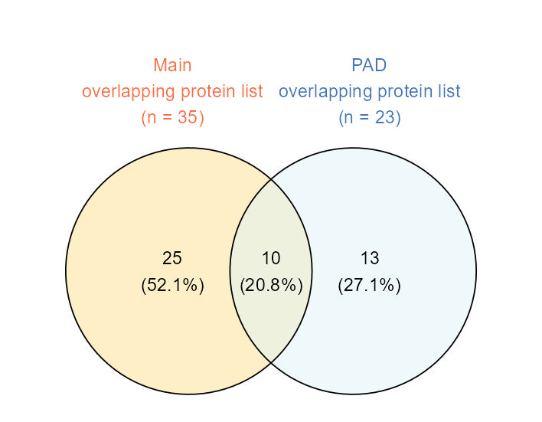
Supplementary Figure 6. Venn diagram of the overlapping loci/proteins in genomic and proteomic analysis considering the PAD (light blue) and our CSF-PET meta-analysis (yellow).

Supplementary Material

1. Bash and R code for the SNP filtering
############################################################
# CSF-PET meta-analysis & concordant SNP filtering #
############################################################
# Raquel Puerta ~ rpuerta@fundacioace.org

# BASH:
#### Meta-analysis with METAL ####
# Documentation: https://genome.sph.umich.edu/wiki/METAL_Documentation

# META-ANALYSIS: Sample Size weighted WITH effect // CSF-PET
MINMAXFREQ OFF
AVERAGEFREQ ON
GENOMICCONTROL OFF
OUTFILE MetaAnalysis-SampleSize-effect_CSF-PET_M4. tbl
SCHEME SAMPLESIZE

MARKER ID
ALLELE REF ALT
EFFECT BETA
STDERR SE
PVAL P
FREQLABEL A1_FREQ
WEIGHTLABEL OBS_CT
SEPARATOR TAB
VERBOSE OFF

PROCESS /path/tofile/SummaryStatistics_GWAS.txt
PROCESS /path/tofile/SummaryStatistics_GWAS.txt
PROCESS /path/tofile/SummaryStatistics_GWAS.txt
PROCESS /path/tofile/SummaryStatistics_GWAS.txt
PROCESS /path/tofile/SummaryStatistics_GWAS.txt
PROCESS /path/tofile/SummaryStatistics_GWAS.txt

ANALYZE HETEROGENEITY

QUIT

# META-ANALYSIS: Sample Size weighted WITHOUT effect // CSF-PET
MINMAXFREQ OFF
AVERAGEFREQ ON
GENOMICCONTROL OFF
OUTFILE MetaAnalysis-SampleSize_CSF-PET_M4. tbl
SCHEME SAMPLESIZE

MARKER ID
ALLELE REF ALT
# EFFECT BETA
STDERR SE
PVAL P
FREQLABEL A1_FREQ
WEIGHTLABEL OBS_CT
SEPARATOR TAB
VERBOSE OFF

PROCESS /path/tofile/SummaryStatistics_GWAS.txt
PROCESS /path/tofile/SummaryStatistics_GWAS.txt
PROCESS /path/tofile/SummaryStatistics_GWAS.txt
PROCESS /path/tofile/SummaryStatistics_GWAS.txt
PROCESS /path/tofile/SummaryStatistics_GWAS.txt
PROCESS /path/tofile/SummaryStatistics_GWAS.txt

ANALYZE HETEROGENEITY

QUIT

#########

# R:

#### Accepted beta directions for CSF and PET ####
# 1) At least half of the datasets with available information (Direction!=?)
# 2) Consistent beta direction in CSF and PET meta-GWAS
# 2.1) CSF amyloid + / PET amyloid -
# 2.2) CSF amyloid - / PET amyloid +

#### Create CSF beta directions combinations & select accepted beta directions ####
csfN <- expand.grid(c("-","?"),c("-","?"),c("-","?"),c("-","?"))
csfN$CSF_neg <- apply(csfN, paste, collapse="", MARGIN=1)
csfN <- csfN[-grep("\\?\\?\\?|\\?\\-\\?\\?|\\?\\?\\-\\?",csfN$CSF_neg),]
# write.table(csfN$CSF_neg, file="CSFdirectionsNEG.txt", row.names=F, quote=F, sep="\t", col.names=F)

csfP <- expand.grid(c("+","?"),c("+","?"),c("+","?"),c("+","?"))
csfP$CSF_pos <- apply(csfP, paste, collapse="", MARGIN=1)
csfP <- csfP[-grep("\\?\\?\\?|\\?\\+\\?\\?|\\?\\?\\+\\?",csfP$CSF_pos),]
# write.table(csfP$CSF_pos, file="CSFdirectionsPOS.txt", row.names=F, quote=F, sep="\t", col.names=F)

#### Create PET beta directions combitations & select accepted beta directions ####
petN <- expand.grid(c("-","?"),c("-","?"))
petN$PET_neg <- apply(petN, paste, collapse="", MARGIN=1)
petN <- petN[-grep("\\?\\?",petN$PET_neg),]
# write.table(petN$PET_neg, file="PETdirectionsNEG.txt", row.names=F, quote=F, sep="\t", col.names=F)

petP <- expand.grid(c("+","?"),c("+","?"))
petP$PET_pos <- apply(petP, paste, collapse="", MARGIN=1)
petP <- petP[-grep("\\?\\?",petP$PET_pos),]
# write.table(petP$PET_pos, file="PETdirectionsPOS.txt", row.names=F, quote=F, sep="\t", col.names=F)

#### Load direction tables ####
csfP <- read.table("CSFdirectionsPOS.txt",h=F)
csfN <- read.table("CSFdirectionsNEG.txt",h=F)

petP <- read.table("PETdirectionsPOS.txt",h=F)
petN <- read.table("PETdirectionsNEG.txt",h=F)

#### Combine accepted beta directions ####
resultNEG <- data.frame()
for(i in 1:nrow(csfN)[1]){
for (j in 1:length(petP$V1)){
temp <- paste0(csfN[i,"V1"],petP[j,"V1"])
resultNEG <- rbind(resultNEG,temp)
}
}

resultPOS <- data.frame()
for(i in 1:nrow(csfP)[1]){
for (j in 1:length(petN$V1)){
temp <- paste0(csfP[i,"V1"],petN[j,"V1"])
resultPOS <- rbind(resultPOS,temp)
}
}

result <- rbind(resultNEG,resultPOS)

#### Save Accepted beta directions ####
write.table(result, file="GoodDirections_MetaSampleSize_M4.txt",quote=F, row.names = F)

#########

# BASH:
# N of SNPs that passed the beta direction and missingness filtering:
fgrep -wf GoodDirections_MetaSampleSize_M4.txt MetaAnalysis-SampleSize-effect_CSF-PET_M4.1tbl |wc
# 376599

wc /path/tofile/MetaAnalysis-SampleSize_CSF-PET_M4.1tbl
# 7643193
#There were a total of 4,9272470288% of variants with opposite effect size direction in CSF-PET

#### Select meta-analysis SNPs that passed the filtering ####
fgrep -wf GoodDirections_MetaSampleSize_M4.txt MetaAnalysis-SampleSize-effect_CSF-PET_M4.1tbl | cut -f 2 > Directions_SampleSize-effect_CSF-PET_M4.txt
fgrep -wf Directions_SampleSize-effect_CSF-PET_M4.txt MetaAnalysis-SampleSize_CSF-PET_M4.1tbl > MetaAnalysis-SampleSize_CSF-PET-dirAccepted_M4.1tbl

#### Add the column of directions in the sample size weighted meta-analysis without effect ####
cut -f 2,14 MetaAnalysis-SampleSize-effect_CSF-PET_M4.1tbl > MetaAnalysis-SampleSize-effect_CSF-PET_directions_M4.1tbl

#########

# R:
data <- read.table("MetaAnalysis-SampleSize_CSF-PET_M4.1tbl", h=T)
dir <- read.table("/path/tofile/MetaAnalysis-SampleSize-effect_CSF-PET_directions_M4.1tbl", h=T)
names(dir)<-c("MarkerName","Direction_new")
all <- merge(data, dir, by="MarkerName", all.x=T)
# write.table(all, file="MetaAnalysis-SampleSize_CSF-PET-dir_M4.1tbl", quote=F, row.names=F, sep="\t", dec=".")

2. AD risk and reported amyloidosis genes in the literature
We analysed the effect of AD genes described in Bellenguez et al in our Aβ endophenotype study. A total of 12 genes were not considered for replication due to low frequency or missingness in the imputation process. Although the extensive filter of genetic markers did not allow us to evaluate all markers, rs679515-CR1 was significantly replicated in our amyloid burden meta-analysis (P<0.05). Interestingly, this variant was not significant independently in CSF or PET meta-GWAS, but the combination of Aβ endophenotypes allowed us to gain power and replicate it. Additionally, the genetic marker located in the rs6943429-UMAD1 gene had a consistent effect in the combined Aβ burden meta-analysis but did not reach significance. Moreover, the rs113706587-RASGEF1C loci were only significantly replicated in the PET meta-analysis. In contrast, both rs6014724-CASS4 and rs6605556-HLA-DQA1 markers were significantly replicated in the CSF Aβ42 meta-analysis and also had a consistent effect size direction in the PET centiloid meta-analysis. Thirty-five and thirty-four additional genetic markers had a consistent effect with what was observed in Bellenguez et al study in CSF Aβ42 and PET centiloid meta-analysis, respectively (Supplementary Table 2).
Regarding the genetic variants reported in Jansen et al for amyloidosis, the rs429358-APOE variant was significantly replicated in all Aβ meta-analyses while the rs4844610-CR1 variant had a consistent effect in all meta-analyses: it was nominally replicated in CSF Aβ42 and significantly replicated in the final Aβ burden combined meta-analysis (P<0.05; Supplementary Table 3). Finally, we also aimed to replicate markers associated to neuropathological features described in Beecham et al. The rs6857 and rs429358 were significantly replicated in all meta-analysis as well as the meta-analysis of CSF-PET endophenotypes. These variants were both located in the APOE region and associated with NFTs, neuritic plaques and other phenotypes (Supplementary Table 4).

