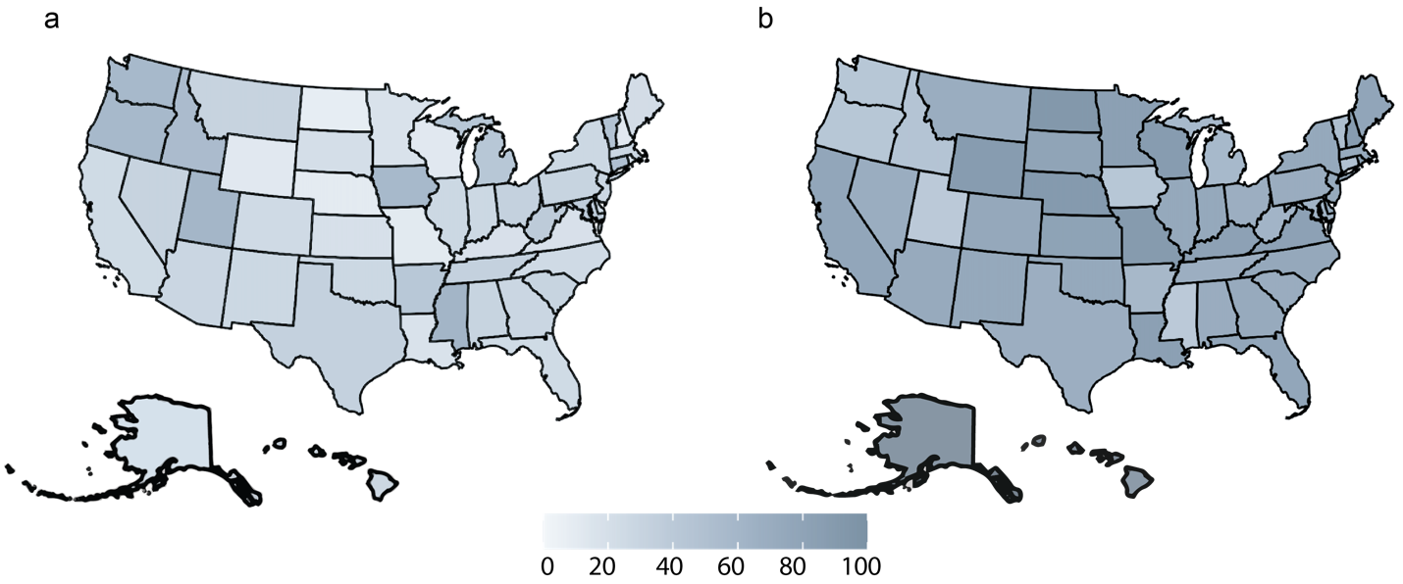

Figure S1 U.S. maps showing (a) the demographics of individuals with peanut allergy and (b) cases of peanut-induced anaphylaxis. The maps were recreated using data reported by Food Allergy Research and Education (FARE).
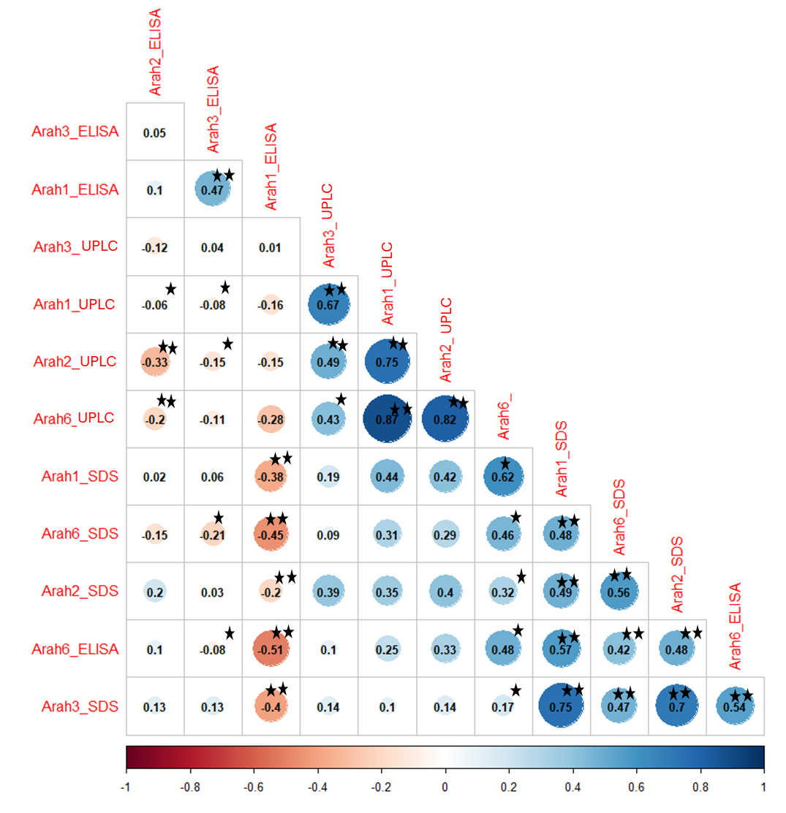

Figure S2 Correlation plots showing Pearson correlation coefficients among protein estimates for Ara h1, Ara h2, Ara h3, and Ara h6 across 23 selected U.S. peanut mini-core accessions. Arah1_ELISA, Arah2_ELISA, Arah3_ELISA, and Arah6_ELISA represent protein estimates for Ara h1, Ara h2, Ara h3, and Ara h6 obtained using ELISA. Arah1_HPLC, Arah2_HPLC, Arah3_HPLC, and Arah6_HPLC represent protein estimates obtained using HPLC, while Arah1_SDS, Arah2_SDS, Arah3_SDS, and Arah6_SDS represent protein estimates derived from SDS-PAGE–based densitogram analysis. Statistical significance is indicated by superscripts associated with the correlation values: * indicates significance at P < 0.05, and ** indicates significance at P < 0.001. Blue-colored filled circles indicate positive correlations, whereas orange-colored circles indicate negative correlations. The strength of the correlation is represented by the color intensity: darker shades indicate stronger correlations, while lighter shades indicate weaker correlations.
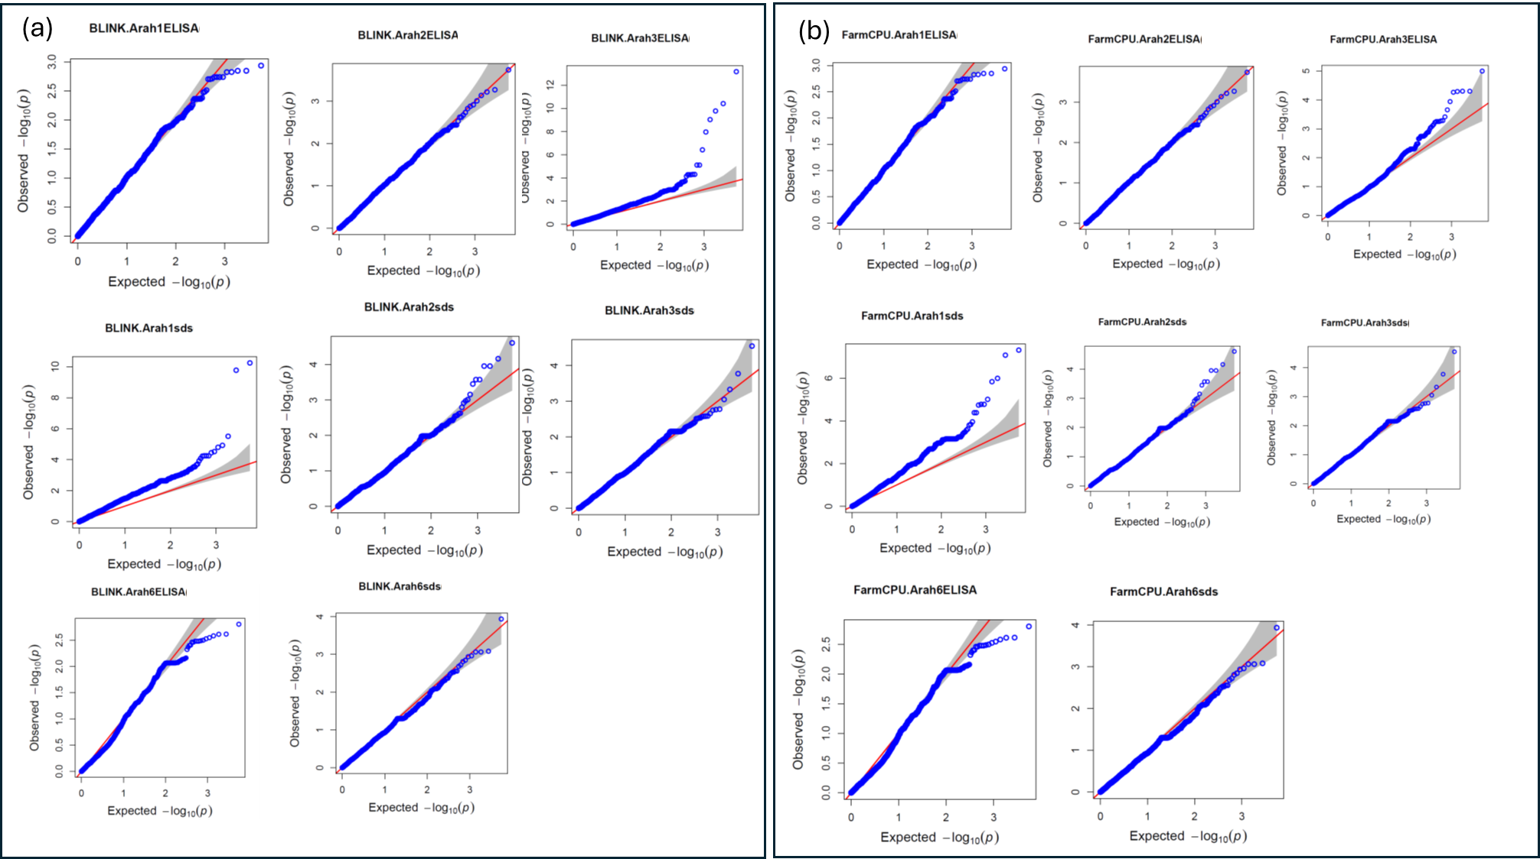

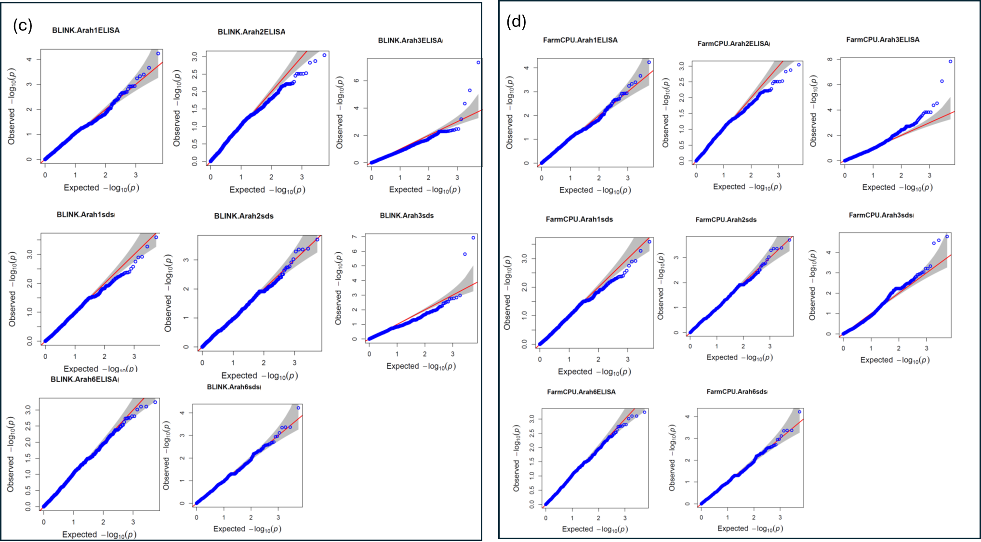

Figure S3 QQ plots showing the distribution of p-values for marker–trait associations identified using (a) BLINK with raw protein estimates, (b) FarmCPU with raw protein estimates, (c) BLINK with log-transformed protein estimates, and (d) FarmCPU with log-transformed protein estimates.

